The GlideScope Video Laryngoscope: A 2013 Comprehensive Update
D. John Doyle MD, PhD

Address for Correspondence:
D. John Doyle MD PhD
Professor of Anesthesiology
Cleveland Clinic Lerner College of Medicine of Case Western Reserve University
Staff Anesthesiologist
Department of General Anesthesiology
Cleveland Clinic
9500 Euclid Avenue, E31
Cleveland, Ohio, 44195, USA
doylej@ccf.org (professional)
djdoyle@hotmail.com (personal)
Tel 216-444-1927
Fax 216-444-9247
Cell 216-903-4700

Financial & Competing Interests Disclosure:
The author has no relevant affiliations or financial involvement with any organization or entity with a financial interest in or financial conflict with the subject matter or materials discussed in the manuscript. This includes employment, consultancies, honoraria, stock ownership or options, expert testimony, grants or patents received or pending, or royalties. No writing assistance was utilized in the production of this manuscript.

MetaData:
November 2, 2013
45 pages
146 references
GlideScope Review Rev 010.docx
GlideScope Review Rev 010.pdf

Outline
Introduction
GlideScope Design
GlideScope Use
Usage Tips

Endotrol Tubes
Prediction of Difficult GS Intubation
Force and Pressure Distribution

GlideScope Use in Obese Patients
GlideScope Use in Infants and Children
Cervical Spine Movement
GlideScope Use as an Adjunct to FOB
GlideScope-Assisted Nerve Integrity Monitoring (NIM) Tube Placement

GlideScope-Assisted Placement of Nasotracheal Tubes

GlideScope-Assisted Placement of Double-Lumen Tracheal Tubes

GlideScope-Assisted Retrieval of Foreign Bodies from the Airway

GlideScope-Assisted Placement of Nasogastric Tubes

Complications Associated with the GlideScope
The Laryngoscopy Debate

Abbreviations

BURP backward, upward and right-sided pressure
C&L Cormack and Lehane (view at laryngoscopy)
DL direct laryngoscopy
ETT endotracheal tube
FB flexible bronchoscope
FOB fiberoptic bronchoscopy
GS GlideScope video laryngoscope
N Newtons (unit of force)
NGT nasogastric tube
NIM nerve integrity monitoring
s seconds (unit of time)

Figures
Figure 1. Videolaryngoscope Taxonomy (Healy)
Figure 2. The GlideScope Family
Figure 3. Sample View at Laryngoscopy
Figure 4. Stylet Configuration
Figure 5. C&L Data (Healy Study)
Figure 6. Nasotracheal Intubation Data I (Jones)
Figure 7. Nasotracheal Intubation Data II (Jones)

Tables
Table 1. The GlideScope Family
Table 2. Expert Tips

Introduction
For many individuals the advent of modern airway management begins with Miller’s straight-blade laryngoscope (Miller 1941), itself an improvement over earlier developments (Bailey 1996). The curved laryngoscope blade in common use today, designed to fit into the vallecula and lift the epiglottis anteriorally, was first described 70 years ago (Macintosh 1943). Since that time, considerable thought has gone into establishing the optimal design and use of laryngoscopes (McIntyre 1989; Marks et al. 1993; Arino et al. 2003; Greenland et al. 2008; Levitan et al. 2011).
The advent of technical methods to go beyond traditional line-of-sight laryngoscopic techniques led to a variety of optical and rigid fiberoptic designs (e.g., Bullard, Airtraq) (Cheyne and Doyle 2010) and later, electronic devices to facilitate laryngoscopy (videolaryngoscopes). Developments in videolaryngoscopy have been reviewed by Van Zundert et al. (2007), Pott and Murray (2008), Sakles et al. (2008), Hurford (2010), Griesdale et al. (2012) and Healy et al. (2012).
Descriptions of the early use of the GlideScope videolaryngoscope have been provided by Agro et al. (2003), Cooper (2003, 2005), Cooper et al. (2005), Doyle (2004, 2005) and Rai et al. (2005). Subsequently, an overwhelming number of publications on the design and use of the GlideScope (GS) and other videolaryngoscopes have been published, as noted in some of the above cited reviews. This review aims to update the reader with respect to the art and science of the GlideScope videolaryngoscope, its relation to other airway management products and it application to various clinical scenarios. Out of necessity we have specifically not reviewed other videolaryngoscope designs except as they related to the GlideScope in comparative studies.
GlideScope Design
Healy et al. (2012) has provided a taxonomy of videolaryngoscope designs that helps one understand the design of the GS in relation to other videolaryngoscope designs (Figure 1). Figure 2 and Table 1 illustrates the various members of the GS family of airway products. The reusable GS designs utilize a high-resolution microminiature video camera embedded into a plastic laryngoscope blade. A second design uses a transparent disposable blade that fits over a long thin “video baton” (Figure 2). The blades are angled at 60 degrees up from the horizontal. The main advantage of the version utilizing disposable blades is that the GS can be made available for reuse in a mere few seconds, eliminating the logistical difficulties of disinfection between uses (simply swap out the blade), while the reusable unit requires high-level disinfection between uses, a process that makes the GS otherwise unavailable. (Detailed cleaning instructions are available at the manufacturer's Web site.)
Two latest generation GS designs are a reusable unit (AVL Reusable) that is available in 4 sizes (GVL 2,3,4,5) as well as a version featuring disposable blades (AVL Single Use) that is available in 6 sizes (GVL 0, 1, 2, 2.5, 3, 4) in association with two sizes of video batons. Both units feature an HDMI output for optional connection to external monitors, a built-in educational tutorial to familiarize users with the unit, and a USB port where recorded videos can be saved onto a flash drive.

GlideScope Use
The curved blade shape of the GlideScope is simple to place, and users quickly feel comfortable inserting the device and distracting the tongue and jaw, in a manner similar to direct laryngoscopy. Users should use the GS like a regular Macintosh laryngoscope with the exception that they should intubate with the head in the neutral position and that they should watch the LCD display monitor instead of looking directly only after the ETT is placed into the oeopharynx (see discussion on complications). Note that the image provided by the GlideScope (Figure 3) is looking upward toward the larynx from within the hypopharynx, and consequently is not dependent on patient head-neck position. A neutral position (face plane parallel to the ceiling) allows more oropharyngeal space compared to atlanto-occipital extension, which narrows the hypopharyngeal space.
As a rule, few difficulties are encountered in obtaining an adequate view in the few seconds it takes most users to learn to manipulate the GS. In some cases the view is improved with posterior displacement of the trachea, but in most cases this maneuver is not helpful (see discussion on usage tips). The fact that several individuals can simultaneously witness the intubation on the LCD display is of enormous teaching value and can be clinically valuable in difficult cases where significant pathology is found. The GS works fairly well in the presence of blood and secretions (a consequence of the protected camera position on the blade) but the presence of vomitus, hemoptysis or hematemesis can impair the view; in such cases it is wise to suction the oropharynx thouroughly prior to insertion.
Many users find that the principal limitation in using the GS was not in getting a good view of the glottis, but rather in manipulating the endotracheal tube (ETT) through the vocal cords. Using an ordinary ETT without a stylet results in a floppy ETT that is very hard to direct through the cords, and successful placement almost always requires some form of stylet, such as a Mallinckrodt Satin-Slip® Intubating Stylet, or the GlideRite Stylet (Figure 4) in order to avoid the ETT from ending up in an excessively posterior position.
Studies showing the GS to be easier to use than DL are numerous. Healy et al. (2012) compared the Glidescope, CMAC, and storz DCI with the Macintosh laryngoscope during simulated manikin difficult laryngoscopy. All three of the methods of video laryngoscopy studied were found superior to the Macintosh laryngoscope (Figure 5).
Usage Tips
Experience shows that the principal limitation in using the GS is not in getting a good view of the glottis, but rather in manipulating the tracheal tube through the vocal cords. Successful tracheal tube placement is usually best achieved by using a stylet formed in the shape of a ‘hockey stick’ (with a 90° bend) to help ensure that the tube is directed sufficiently anteriorly to enter the glottis (Figure 4). Once the tube enters the glottis, it is can also be helpful to withdraw the stylet by about 3 cm, followed by advancing the tube slightly, so as to avoid it hitting against the tracheal wall (Doyle 2005).
Walls et al. (2010) described a patient who could not be intubated with the GlideScope despite a CL grade 1 laryngoscopic view because "the trachea formed a steep posterior angle with the laryngeal/glottic axis" with the ETT tip consequently becoming stuck against the anterior tracheal wall. Intubation was successful upon rotating the ETT 180 degrees, thereby redirecting the ETT posteriorally and subsequently into the trachea.
Corda et al. (2012) found that a jaw thrust maneuver was often helpful in improving the glottic view when the GlideScope is used, but that no significant improvement was noted with cricoid pressure. They "recommend the use of jaw thrust as a first-line maneuver to aid in glottic visualization and tracheal intubation during GlideScope videolaryngoscopy."
Table 2 provides additional tips. Other potentially helpful suggestions have been offered by Heitz and Mastrando (2005), Kramer and Osborn (2006), Bader et al. (2006), Dupanovic et al. (2006), Dow and Parsons (2007), Cho and Kil (2008), Bezinover et al. (2009), Conklin et al. (2010), Sharma (2011), Xue et al. (2011), Zeidan and Al-Temyatt (2011), Corda et al. (2012) and Singh et al. (2013).

Endotrol Tubes
The Endotrol-tracheal tube has a control that allows the tube tip to be positioned to a more anterior position. Imagining that this feature might be helpful for intubation using the GS, Cattano et al. (2012) conducted a study in which two of the study arms compared the GS used in conjunction with the Endotrol ETT (but employing no stylet) against the GS using a GlideRite-styletted standard ETT. The authors concluded that "the Endotrol ETT, as compared to a standard ETT with a non-malleable stylet, is associated with longer intubation times and a subjective increase in difficulty of use."

Prediction of Difficult GS Intubation
While GS generally provides for a superior glottis view compared to DL, predictive features specific to difficult GS intubation have not been identified to the extent that they have for DL. Tremblay et al. (2008) recorded demographic and morphometric factors for 400 patients undergoing tracheal intubation. After induction, DL was performed to determine the Cormack / Lehane grade of glottic visualization (Cormack and Lehane 1984; Kharbouch and Peel 2007), followed by intubation using the GS. After their data analysis, the only predictors of difficulty with GS intubation (e.g., multiple attempts) turned out to be high Cormack / Lehane grades during direct laryngoscopy, a high upper lip bite test score (Khan et al. 2003), and a short sternothyroid distance. Of these, only the last two, of course, can be assessed at the bedside.
Adnet's intubation difficulty scale (IDS) (Adnet et al. 1997) has been used extensively as a metric to define difficult intubation. It has used extensively to compare methods of intubation. For example, Yousef et al. (2012) used the IDS to compare the GlideScope, the LMA CTrach™ and direct laryngoscopy in a population of 90 obese patients. The authors found that “easy, moderately difficult, and difficult tracheal intubation as defined by the intubation difficulty score (0, 1-5, and >5) were met in 12, 11, and 7 patients of the DL group, respectively, while, tracheal intubation was easy in (29, 28 patients) and moderately difficult in only (1, 2 patients) in the GVL and CT groups, respectively. “ The authors concluded that “the GlideScope videolaryngoscope improved intubation time for tracheal intubation with less upper airway morbidity compared with the LMACTrach and Macintosh direct laryngoscope.”
However, a study by McElwain et al. (2011) found that the correlation between the IDS score and both user rated difficulty and the time needed for tracheal intubation was significantly stronger for the Macintosh laryngoscope than for the indirect laryngoscopes studied (GlideScope, Pentax AWS, Airtraq). These findings led the authors to conclude that the IDS “performs less well with indirect laryngoscopes than with the Macintosh laryngoscope” and that clinicians should use “caution with the use of this score with indirect laryngoscopes.”
Force and Pressure Distribution
Because forces applied to airway soft tissues by direct laryngoscopy may cause injury as well as an endocrine stress response, a number of investigators have studied the forces applied during laryngoscopy and intubation.
Hirabayashi et al. (2010) considered the possibility that a reduction in forces applied during GS laryngoscopy might result in reduced anterior airway anatomy distortion, providing a possible explanation of the perception that nasotracheal intubation with the GS is easier than when DL is used. To study this hypothesis that authors studied 20 patients in a protocol where each patient underwent laryngoscopy using both the GS and DL with Macintosh blade. During each laryngoscopy, a radiograph was taken when the best view of the larynx was obtained, and these radiographs were then studied for anterior airway distortion and cervical spine movement. The distance between the epiglottis and the posterior pharyngeal wall during GS use was found to be reduced by 21% as compared to Macintosh laryngoscopy. The authors concluded that “both anterior airway distortion and cervical spine movement during laryngeal visualization” were reduced for with use of the GS.
Russell et al. (2012) compared the forces used with the Macintosh laryngoscope vs. the GlideScope in 24 adult patients using three FlexiForce pressure sensors attached along the concavesurface of each blade. Compared with the Macintosh laryngoscope, the authors found lower median peak force (9 N vs 20 N), average force (5 N vs 11 N) and impulse force (98 N vs 150 N) with the GlideScope. Methodological comments on this study have been provided by Pieters et al. (2012). A similar study using manikins has been published by the same team (Lee et al. 2013).
Carassiti et al. (2013) similarly compared the Macintosh laryngoscope vs. the GlideScope in a study of 30 adult patients using film pressure transducers. They found that the force applied using the GlideScope was much lower than with the Macintosh (8 N vs. 40 N on average). They also noted that when using the Macintosh laryngoscope, forces were concentrated mostly on the tip, whereas the GlideScope “distributes the forces more homogeneously to the tissue”, reducing the potential for injury. An earlier manikin study of similar design was published by Carassiti et al. (2012). Methodological comments on this last study have been provided by Fiadjoe and Stricker (2012).

GlideScope Use in Obese Patients
Mask ventilation as well as intubation can be problematic in morbidly obese patients. These patients are also at increased risk of hypoxemia during tracheal intubation (Kristensen 2019; Aceto et al. 2013; Murphy and Wong 2013). Consequently, a number of studies have examined whether the GlideScope might be helpful in such cases.
Andersen et al. (2011) compared GS intubation with the Macintosh direct laryngoscope (DL) in a group of 100 consecutive morbidly obese patients. The authors found that “laryngoscopic views were better in group GS with Cormack-Lehane grades 1/2/3/4 distributed as 35/13/2/0 vs. 23/13/10/4 in group DL” and also found that better IDS scores with use of the GS. However, intubation times were longer in the GS than in the DL group (average of 48 s vs 32 s ), although the authors noted that that the “increased intubation time was of no clinical consequence as no patients became hypoxemic.”

A study by Ydemann et al. (2012) compared the GS with the Fastrach (FT) in intubating 100 obese patients. Average GS intubation time was 49 s, with 61 s using the FT, a difference that was not statistically significant. The authors experienced one esophageal intubation using the GS and six when using the FT. Although the authors wrote that the GS and the FT should be “considered to be equally good when intubating morbidly obese patients” the possibility that the study was underpowered to detect differences between the two should also be considered.

Motivated by concerns about delayed gastric emptying in obese patients, a study by Gupta and Rusin (2012) compared rapid-sequence GS intubation in patients induced in the semi-erect position with rapid-sequence GS intubation in the standard supine position. Although “no differences were observed in the intubation parameters or patient safety” desaturation episodes occurred 50% less frequently in the semierect group, a finding that did not reach statistical significance.

A study of 150 obese patients by Maassen et al. (2009) compared the GlideScope Ranger, Storz V-Mac, and McGrath Series 5 videolaryngoscopes against DL in a cross-over study design. All 3 videolaryngoscopes provided an equal or better view of the glottis as compared to DL. The authors found that the number of attempts necessary to intubate the trachea differed significantly among the devices (average 2.6 attempts for the GS, 1.4 for the Storz, and 2.9 for the McGrath). The average intubation times were 33 s for the GS, 17 s for the Storz, and 41 s for the McGrath VLS. The authors concluded that that Storz V-Mac “had a better overall satisfaction score (and) intubation time” and required a “reduced number of intubation attempts” compared to the other devices tested. One possible criticism of this study was the use of a “very stringent” definition of an intubation attempt, as “each approach of the ETT to the glottic entrance, even without complete withdrawal of the ETT out of the mouth” counted as an attempt. A more serious criticism is that a rigid stylet was employed only “if intubation was not feasible after 2 intubation attempts” despite that fact that routine use of a stylet is recommended by the manufacturers of both the GS and the McGrath devices.

A study by Abdelmalak et al. (2011) compared GS intubation with flexible fibreoptic intubation in 75 obese patients randomly assigned to one of these two intubation methods following the induction of general anesthesia. Although it was hypothesized that tracheal intubation with the GlideScope would be advantageous compared with flexible fibreoptic intubation, no significant differences were found for the time needed to intubate, the difficulty of intubation, the success rate for the first attempt, the number of attempts, the incidence of hypoxemia, the amount of post-intubation bleeding and the incidence of sore throat. While the authors concluded that “for experienced users, the time required to intubate the trachea in anaesthetised obese patients is similar with the GlideScope and a flexible bronchoscope” the much steeper learning curve associated with use of flexible fibreoptic intubation as compared to intubation using the GS suggests that these findings likely apply only to clinicians very experienced with flexible fibreoptic intubation.
GlideScope Use in Infants and Children
The GlideScope can also be used in neonates and pediatric patients. Trevisanuto (2006) described their initial experience with GS use in five neonates and outlined the difficulties encountered. Kim et al. (2008) compared the use of the GlideScope with direct laryngoscopy in 203 children. The view of the glottis was scored (Cormack and Lehane (C&L) grade) with and without BURP (backward, upward and right-sided pressure) (Snider et al. 2005; Hirabayashi and Otsuka 2010) in both instances. The GlideScope improved the view without BURP in the patients with C&L grade 2 (16/26) and with C&L grades 3 and 4 (7/11). The view with BURP was also improved by the GlideScope in C&L grade 2 (4/9) and with C&L grades 3 and 4 (4/5). The average time for intubation was 36.0 s in the GS group and 23.8 s in the DL group. The authors concluded that "in children, the GlideScope provided a laryngoscopic view equal to or better than that of direct laryngoscopy but required a longer time for intubation."
Lee et al. (2013) evaluated the usefulness of the GS for improving the laryngoscopic view in 23 pediatric patients whose Cormack and Lehane grade under direct laryngoscopy was 3 or 4 and concluded that a Glidescope one size smaller than the usual blade based on weight "significantly improved the laryngoscopic view" when compared with DL or with the GS blade based on weight.

Cervical Spine Movement
A number of investigators have studied the question as to the best airway management technique in the patient with suspected cervical spine injury, since in patients with possible cervical spine injury movement head and neck should be minimized (Siddiqui 2009).
Turkstra et al. (2005) used fluoroscopy to study 36 normal adult patients immobilized with in-line stabilization in a crossover trial of either Trachlight (Intubating Lighted Stylet) or GlideScope intubation to DL. While cervical spine motion using the GS was reduced 50% as compared to DL at the C2-5 segment, no difference was found at the other segments studied. As with other studies, GS laryngoscopy took significantly longer than with DL. The authors found that the best results were obtained using a Trachlight. (More information on Trachlight intubation is available in a comprehensive review by Agro et al. (2001).)
Robitaille et al. (2008) similarly compared cervical spine motion during GS vs DL intubation in 20 patients using continuous fluoroscopy. Manual in-line stabilization of the head was carried out by an assistant. Although no significant difference in average segmental spine movement was found at any segmental level, glottis visualization was “significantly better” with GS use.
Wong et al. (2009) studied cervical spine motion during flexible bronchoscopy as compared with the GS when no cervical immobilization was used, hypothesizing that the GS would not cause significantly greater cervical spine movement than fibreoptic bronchoscopy. To study this matter, 28 adults without cervical disease requiring intubation for radiographic procedures were randomized to either the GS or the flexible bronchoscope (FB), with continuous fluoroscopy used to assess cervical spine movement during intubation. Cervical spine movement was compared both during laryngoscopy and with tongue pull and jaw thrust maneuvers. The authors found that use of the GS during intubation under general anesthesia resulted in greater cervical movement than FB, and that the jaw thrust maneuver, often used to facilitate FB, also resulted in cervical spine movement.
Kill et al. (2013) studied cervical spine movement in patients with an unsecured cervical spine, comparing conventional DL with use of the GS in 60 anesthetized patients. Using video motion analysis taken with a lateral view, the maximum extension angle was measured with reference to standardized anatomical points. The authors found that Intubation by physicians with some experience in videolaryngoscopy was associated with a reduced angle deviation compared to inexperienced physicians. As with other studies, GS intubation time (median 24 s) exceeded the time needed for DL (53 s). In 3 patients randomized to DL where intubation by DL failed, intubation was successful following GS use. The authors concluded that “GlideScope videolaryngoscopy reduces movements of the cervical spine in patients with unsecured cervical spines and therefore might reduce the risk of secondary damage during emergency intubation of patients with cervical spine trauma.”
GS Use as an Adjunct to FOB
The GS can also be useful in some cases of difficult fibreoptic intubation (Doyle 2004b; Mannion and O'Donnell 2009). Here, the GS is introduced in the usual manner, followed by introduction of the fibreoptic bronchoscope. Such an arrangement provides simultaneous ‘micro’ and ‘macro’ views that can be particularly helpful. In the teaching setting, the instructor is able to use the video laryngoscopy device to see the tip of the bronchoscope as controlled by the student, so the instructor can provide real-time guidance to supplement the view provided by the bronchoscope. When used for purely clinical purposes, the GlideScope can assist in a fiberoptic intubation by providing an alternative view of the airway; such a view can be helpful, for example, in the case of a bloody airway or severely distorted anatomy. Also, should the tracheal tube get caught on the arytenoids or other laryngeal structures, it becomes evident on the GS display, and appropriate corrective action (such as twisting the tube) can easily be taken. Also note that the procedure can be performed either awake or under general anesthesia depending on the clinical circumstances.
GlideScope-assisted Nerve Integrity Monitoring (NIM) Tube Placement

The Nerve Integrity Monitoring (NIM) tube is often used for intra-operative recurrent laryngeal nerve monitoring during thyroid and parathyroid surgery (Sarı et al. 2010; Randolph et al. 2011). Positioning of this special tube with its embedded electrodes to the correct depth is critically important (Lu et al. 2008). This positioning is most easily achieved using the GS, as it allows both the anesthesiologist and the surgical team to witness correct placement of the NIM tube with outstanding clarity (Berkow et al. 2011; Kanotra et al. 2012; Nekhendzy et al. 2012).

GlideScope-Assisted Placement of Nasotracheal Tubes
In addition to facilitating orotraheal intubation, the GS can be useful for the placement of nasotracheal tubes (Hirabayashi 2006; Jones et al. 2008; Bellazzini and Repplinger 2009; Muallem and Baraka 2009; Xue et al. 2011; Das et al. 2012; Lili et al. 2013). Unlike that case when DL is used, Magill forceps are not employed; instead, to position the tube into the glottis one uses a combination of rotating the tube, flexion of the patient's neck and /or minimal rotation of the patient's head. Jones et al. (2008) offer the following additional tip: once the tube tip of has entered the vocal cords, it is often helpful to reduce the distraction of the anterior neck tissues by lowering the GS, advancing the tube into the trachea, and then lifting the GS back up to ensure the tube is still between the vocal cords. Figures 6 and 7 show the results of their study.
An important reason that Magill forceps are not employed with GS-assisted placement of nasotracheal tubes is that the design of the forceps is optimized for use with DL. Boedeker has developed a curved forceps design optimized for videolaryngoscopy (Boedeker et al. 2012); the curve of these forceps “allows both the tip of the forceps and the glottic opening to be simultaneously visible in the field of view during videolaryngoscopy” making them suitable for both nasotracheal tube positioning as well as for the removal of glottic foreign bodies.
Galgon and Ketzler (2012) have described how the GS might be used to assist in the conversion from a nasotracheal tube to an orotracheal tube in a patient with a known difficult airway. The technique used was described as follows:
The GlideScope videolaryngoscope was inserted, achieving a full view of the glottic inlet with the nasotracheal tube in situ. An endotracheal tube (ETT) loaded on a GlideRite Rigid Stylet was advanced through the oropharynx into view. Advancement of this ETT to the glottic opening was tested and achieved. With both tracheal tubes in view, the nasotracheal tube cuff was deflated and withdrawn from the glottic opening. While maintaining videoscopic visualization, the orotracheal tube was advanced through the vocal cords into the trachea.
A similar approach can be used to assist in the conversion from an orotracheal tube to a nasotracheal tube (Liu et al. 2010; Sun et al. 2010; Xue et al. 2010).

GlideScope-Assisted Placement of Double-Lumen Tracheal Tubes
The GS has proven to be useful in a number of cases where Double-Lumen Tube (DLT) placement was expected or proved to be difficult by DL. A case report by Hernandez and Wong (2005) offers some suggestions for left DLT placement using the GS:
We suggest bending the stylet of the DLT so that the distal 16 to 20 cm of the DLT curve follows the curve of the Glidescope, and the other end of the DLT angles out to the right side. After the bronchial cuff passes through the VC, withdraw the stylet of the DLT about 2 cm. Then, rotate the DLT 90° counterclock-wise while advancing the DLT to the desired depth.
Other reports on the use of the GS with DLTs have been provided by Chen et al. (2008) and Bustamante et al. (2010). Onrubia et al. (2013) describe a case of GlideScope-assisted awake DLT insertion under topical anesthesia in a patient known to be difficult to intubate. Bussières et al. (2012) have described a special stylet specifically designed for use of the GlideScope® with insertion of DLTs.

GlideScope-Assisted Retrieval of Foreign Bodies from the Airway
The GlideScope can be a useful adjunct in attempting to retrieve foreign bodies from the airway. The use of the GS in the removal of foreign bodies impacted at the hypopharyngeal level has been described by Morris et al. (2009), Je et al. (2012), Cheng et al. (2013), Corso et al. (2013) and Cagini et al. (2013). The use of the GS in the removal of intratracheal foreign bodies has been described by Bose et al. (2013). An important potential advantage of using the GS in the case of hypopharyngeal foreign bodies is the fact that general anesthesia can often be avoided, using only conscious sedation in conjunction with topical anesthesia, while the greatly magnified view provided by the GS "represents a great improvement in identifying and removing .. even small and thin foreign bodies not recognized by radiological and otolaryngology examination and not readily detected by direct endoscopy" (Cagini et al. 2013).

GlideScope-Assisted Placement of Nasogastric Tubes

Given that intraoperative nasogastric tube (NGT) insertion is often difficult, a number of techniques to facilitate this procedure have been described (e.g., Chun 2009; Harvey and Cave 2010; Tsai et al. 2012). Lai et al. (2006) suggested that the insertion of NGTs could be facilitated in intubated patients using the GlideScope as follows:

The blade of the GlideScope® was inserted first into the patient's mouth to get the views of the pharyngeal and laryngeal area then the nasogastric tube was inserted via the nostril with lubrication until it reached the pharyngeal area. After that, the cuff of the tracheal tube was released and the nasogastric tube was advanced gently with the patient's chin lifted.

Moharari et al. (2010) conducted an 80 patient clinical trial of NGT placement by the above means, employing random allocation to traditional (blind) NGT insertion or to insertion with the assistance of a GlideScope. NGT placement was not successful within 3 attempts in 4 of the control group patients and in 1 patient in the GlideScope group. The mean insertion time in the GlideScope group was 27.7 s shorter than in the control group, while complications such as pharyngeal bleeding or mucosal injury were reported in 14 patients of the control group but only 8 patients in the GlideScope group.

Complications Associated with the GlideScope
Perforation of the palatopharyngeal arch or soft palate is a rare but potentially important complication associated with use of the video laryngoscopy (Cooper 2007; Choo et al. 2007; Vincent et al. 2007; Hsu et al. 2007; Leong et al. 2008; Hsu et al. 2008; Nestler et al. 2013). Other types complications have also been reported: Magboul and Joel (2010) described a possible lingual nerve injury from the Gliderite rigid stylet used in conjunction with the GS.
To avoid such injuries, the following four-step technique is suggested when using the GS (Thong and Goh 2013):
- The GlideScope® is first introduced into the midline of the oral pharynx with the left hand.
- The epiglottis is identified on the screen and the scope is manipulated to obtain the best glottic view.
- The endotracheal tube is then guided into position near the tip of the laryngoscope by direct vision.
- When the distal tip of the endotracheal tube disappears from direct view, it should be viewed on
the monitor. Gently rotate or angle the tube to redirect as needed.
Weissbrod and Merati (2011) have further suggested that such complications might be eliminated by using the GS in conjunction with a flexible bronchoscope acting as a "smart" stylet. In such case the bronchoscope is not used for its imaging capacity, but instead used as a “manipulatable stylet for the endotracheal tube”.
The Larygoscopy Debate
For many individuals in the airway community a debate has arisen as to the appropriate role of the GS in clinical airway management (Cooper 2007; Rothfield and Russo 2012; El-Orbany 2012; Lee and van Zundert 2012) . One question is whether medical students and residents should be taught the use of the GS before being taught DL, the arguments in favor of this approach is that the teacher sees exactly what is happening when the GS is in use and, additionally, the excellent view provided by the GS familiarizes the learner with the glottic structures in a manner that helps with the learning of DL. Complicating this issue is the availability of the GlideScope Direct, a videolaryngoscope specifically designed to assist with the teaching of DL (Viernes et al. 2009).
Another debate is whether clinicians who intubate only occasionally (e.g., paramedics) might best serve their patients by being trained only on use of the GS, especially because of the abundant literature supporting the notion that learning GS use is easier than learning DL (Nouruzi-Sedeh et al. 2012; Griesdale 2012). Cooper (2007) provides the following commentary in these and related airway issues:
DL is a legacy technique; it was introduced at a time when there were no alternatives. We now have a wealth of supraglottic airway devices and are able to safely avoid tracheal intubation in a significant number of patients. But when tracheal intubation is deemed appropriate, fiberoptic and video technology can generally provide a laryngeal view, even in patients in whom this was previously presumed to be difficult or impossible. Our current airway assessment is predicated on DL. An anticipated difficult DL does not mean that laryngoscopy will be difficult if DL is not employed.
and
We should not reserve the best methods for only our most difficult patients; they should be offered to all our patients. This will provide our patients with the best care. It will ensure that we gain experience with the techniques we select and an appreciation of their limitations and value.

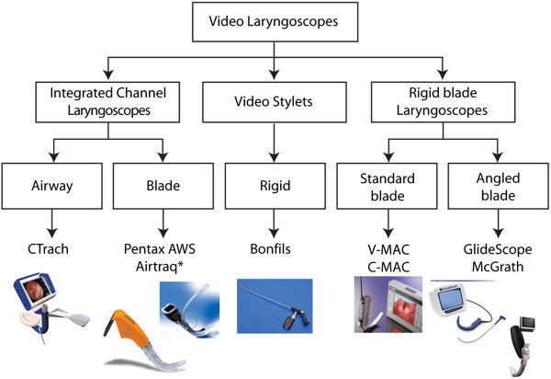
Figure 1. A classification of videolaryngoscopic devices provided by Healy et al. (2012). In this system videolaryngoscopes are classified according their shape and form: Left: videolaryngoscopes with an integrated channel (to guide placement of the endotracheal tube). Middle: videolaryngoscopes taking the form of a videostylet (with the endotracheal tube placed around the device). Right: videolaryngoscopes with a rigid blade (without a channel, the endotracheal tube requiring some kind of independent stylet to guide placement).

From: Healy DW, Maties O, Hovord D, Kheterpal S. A systematic review of the role of videolaryngoscopy in successful orotracheal intubation. BMC Anesthesiol. 2012 Dec14;12:32. doi: 10.1186/1471-2253-12-32. PubMed PMID: 23241277; PubMed Central PMCID: PMC3562270.

Copyright ©2012 Healy et al.; licensee BioMed Central Ltd. This is an Open Access article distributed under the terms of the Creative Commons Attribution License (http://creativecommons.org/licenses/by/2.0), which permits unrestricted use, distribution, and reproduction in any medium, provided the original work is properly cited.
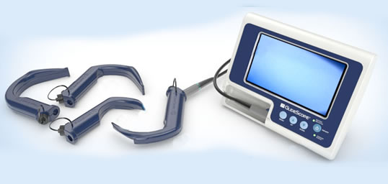
Figure 2. Some Members of the GlideScope Family. Top: The GVL family of reusable GlideScopes. Technical specifications are available in Table 2. (Image Credit: http://www.technomedsystems.in/sub-images/glidescope-big.jpg). Middle: The GlideRite Rigid Stylet. This stylet matches the angulation of the GlideScope video laryngoscope for improved maneuverability of the endotracheal tube (ETT). (Image Credit: http://www.technomed systems.in /sub-images/rigid-stylet-big.jpg). Bottom: The GlideScope Direct, designed to assist in the teaching of direct laryngoscopy. (Image Credit: http://www.hindawi. com/journals/arp/2012/820961.fig.001.jpg).
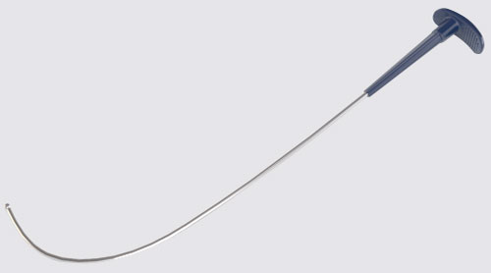
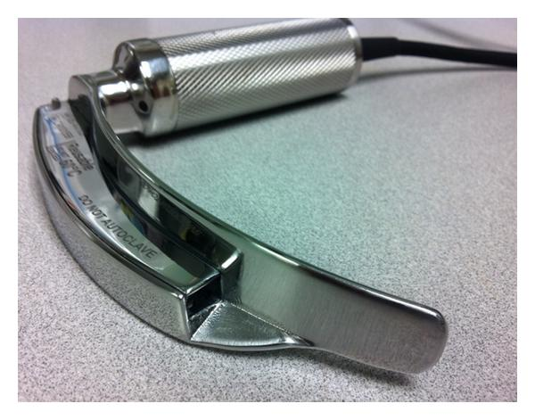

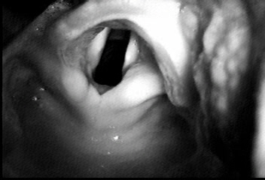 | 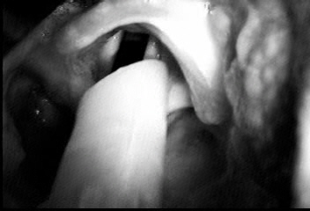
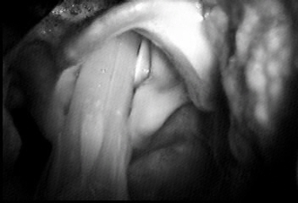 | 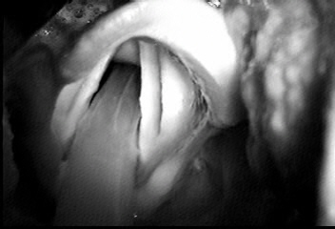

Figure 3. Views of an endotracheal tube passing into the glottis. (From Dr. Doyle’s Case 112 taken using the original monochrome GlideScope).

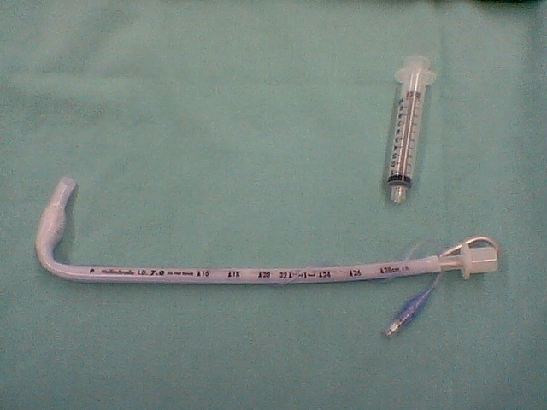
Figure 4. ETT bent at a 90 degree angle (“hockey stick”) for use with the GlideScope. Compare with the reusable GlideRite stylet shown in Figure 2.

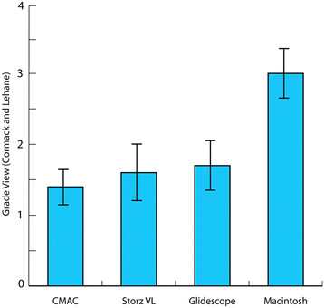
Figure 5. Results of a manikin-based difficult airway study by Healy et al. (2012) showing that the three vidolaryngoscopes studied provided better Cormack-Lehane views than the Macintosh laryngoscope.
From: Healy DW, Picton P, Morris M, Turner C. Comparison of the Glidescope, CMAC, storz DCI with the Macintosh laryngoscope during simulated difficult laryngoscopy: a manikin study. BMC Anesthesiol. 2012 Jun 21;12:11. doi: 10.1186/1471-2253-12-11. PubMed PMID: 22720884; PubMed Central PMCID: PMC3519500.
Copyright ©2012 Healy et al.; licensee BioMed Central Ltd. This is an Open Access article distributed under the terms of the Creative Commons Attribution License (http://creativecommons.org/licenses/by/2.0), which permits unrestricted use, distribution, and reproduction in any medium, provided the original work is properly cited.

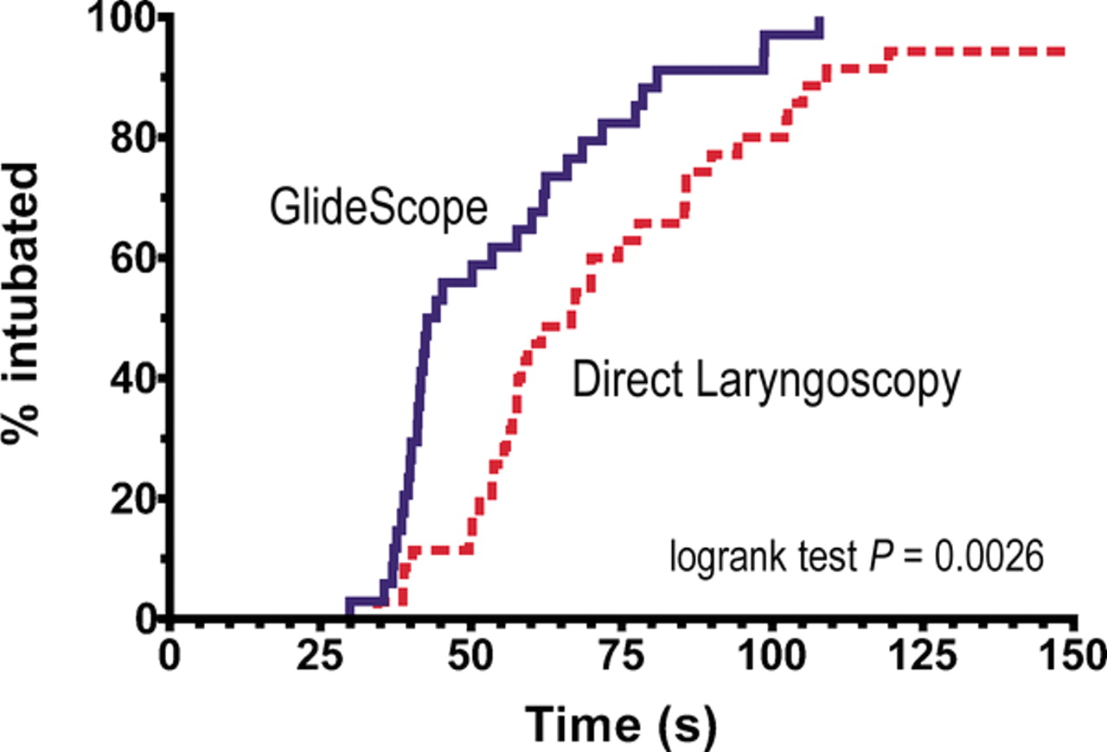

Figure 6. Kaplan–Meier plot demonstrating the success of nasotracheal intubation as a function of time.

From: Jones PM, Armstrong KP, Armstrong PM, Cherry RA, Harle CC, Hoogstra J, Turkstra TP. A comparison of glidescope videolaryngoscopy to direct laryngoscopy for nasotracheal intubation. Anesth Analg. 2008 Jul;107(1):144-8. doi: 10.1213/ane.0b013e31816d15c9. PubMed PMID: 18635480.

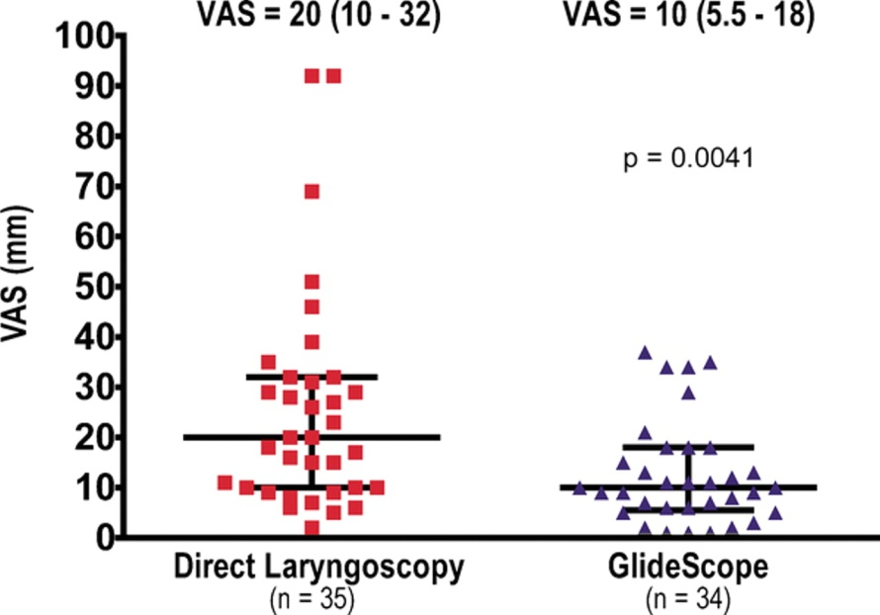

Figure 7. Ease of intubation by operators as measured on a 100 mm Visual Analog Scale (VAS). The markings on the data collection form filled out by the operators was marked “easy” (at 0 mm) and “difficult” (at 100 mm). Bars and text indicate median VAS and the interquartile range.

From: Jones PM, Armstrong KP, Armstrong PM, Cherry RA, Harle CC, Hoogstra J, Turkstra TP. A comparison of glidescope videolaryngoscopy to direct laryngoscopy for nasotracheal intubation. Anesth Analg. 2008 Jul;107(1):144-8. doi: 10.1213/ane.0b013e31816d15c9. PubMed PMID: 18635480.

GVL 2:  Patient weight: 1.8 - 10 kg  Blade length (tip to handle): 47 mm  Thickness (height) at camera: 14.5 mm  Width at camera: 18 mm  GVL 3:  Patient weight: 10 kg - Adult  Blade length (tip to handle): 82 mm  Thickness (height) at camera: 14.5 mm  Width at camera: 20 mm | GVL 4:  Patient weight: 40 kg – Morbidly Obese  Blade length (tip to handle): 102 mm  Thickness (height) at camera: 14 mm  Width at camera: 27 mm  GVL 5:  Patient weight: 40 kg – Morbidly Obese  Blade length (tip to handle): 102 mm  Thickness (height) at camera: 14 mm  Width at camera: 27 mm

Table 1 - Some technical specifications for the GVL members of the GS family (Figure 2).

Table 2 Some Expert Tips for Successful GlideScope Use
1. Use the device for most easy / routine cases until you are very comfortable with its use. That way, when you need it for a particularly difficult airway case you will already be quite familiar with the mechanics of the device. In one study (Aziz et al. 2011), primary intubation with the device was successful in 98 percent of 1,755 cases and rescued failed direct laryngoscopy in 94 percent of 239 cases.
2. When placing the GlideScope, insert it slightly to the left of the midline to ensure adequate room to the right of the device to get the tube into the mouth. This is particularly important when large diameter tubes are inserted, such as the double lumen tubes used for thoracic surgery or the wide-diameter tubes with embedded electrodes used in many thyroid surgery cases.
3. When placing the endotracheal tube, start by placing it gently under direct vision and then switch to the monitor view once it is has been gently placed deep into the oropharynx. This two-phase approach is recommended to reduce the chance of causing harm or injury to one of the tonsillar pillars or to the soft palate.
4. The angulation of the tip of the endotracheal tube is very important. Too little a bend, and the endotracheal tube tip points to the esophagus and not the glottic aperture; too much of a bend and the endotracheal tube tip tends to get caught on the anterior tracheal wall. A reusable rigid stylet that matches the angulation of the blade is available; it has been shown to be equal in efficacy to a disposable malleable stylet.
5. It is not uncommon that videolaryngoscopy users achieve an excellent view of the glottis but experience difficulty advancing the endotracheal tube into the glottic aperture because of the tube abutting against the anterior tracheal wall. If this happens, withdrawing the stylet by 3 to 5 cm tends to straighten the tip of the tube and propel it in the right direction. Other techniques, such as the "gear stick" technique (Dupanovic 2006), the "reverse loading" technique (Dow and Parsons 2007) or the "J-shape" technique (Bader et al. 2006) also can be helpful.
6. Paradoxically, maximizing the size of the glottic view with full and complete advancement of the GlideScope into the oropharynx may adversely impact on the ease of intubation. With more limited advancing of the device, the "approach angle" of the endotracheal tube is often more amenable to easy passage of the tube into the glottis. That is, the position that provides the best glottic view is generally not the position that makes intubation the easiest, where a "good enough" view is usually the most favorable. Where a suboptimal view is obtained, use of an airway introducer (Eschmann guide) (Falcó-Molmeneu et al. 2006) can sometimes be helpful.
7. Nasal intubations are surprisingly easy. No stylet is used. Manipulate (flex or extend) the head to ensure easy passage of the tube. Forceps are rarely needed. However, use of regular Magill forceps is difficult in this setting; rather, use a pair of curved intubating forceps should the need arise.
8. Using the GlideScope for awake intubation can be valuable when fiberoptic scopes are unavailable. It is accomplished after the patient's airway has first been well anesthetized with lidocaine or other drug.
9. Remember that the GlideScope can be useful in swapping out endotracheal tubes (Peral et al. 2006).
10. Finally, remember that there are situations where the video laryngoscope will fail you, and that these are often unexpected. Always have a backup plan for this eventuality. For me, this usually involves asleep fiberoptic intubation, asleep fiberoptic intubation in conjunction with the GlideScope (as described above), insertion of a supraglottic airway followed by use of a 4 mm fiberscope jacketed by an Aintree catheter, or simply waking up the patient.

References
1. Abdelmalak BB, Bernstein E, Egan C, Abdallah R, You J, Sessler DI, et al. GlideScope(R) vs flexible fibreoptic scope for elective intubation in obese patients. Anaesthesia. 2011 Jul;66(7):550-5.
2. Aceto P, Perilli V, Modesti C, Ciocchetti P, Vitale F, Sollazzi L. Airway management in obese patients. Surg Obes Relat Dis. 2013 May 6.
3. Adnet F, Borron SW, Racine SX, Clemessy JL, Fournier JL, Plaisance P, et al. The intubation difficulty scale (IDS): proposal and evaluation of a new score characterizing the complexity of endotracheal intubation. Anesthesiology. 1997 Dec;87(6):1290-7.
4. Agro F, Barzoi G, Montecchia F. Tracheal intubation using a Macintosh laryngoscope or a GlideScope in 15 patients with cervical spine immobilization. Br J Anaesth. 2003 May;90(5):705-6.
5. Agro F, Hung OR, Cataldo R, Carassiti M, Gherardi S. Lightwand intubation using the Trachlight: a brief review of current knowledge. Can J Anaesth. 2001 Jun;48(6):592-9.
6. Andersen LH, Rovsing L, Olsen KS. GlideScope videolaryngoscope vs. Macintosh direct laryngoscope for intubation of morbidly obese patients: a randomized trial. Acta Anaesthesiol Scand. 2011 Oct;55(9):1090-7.
7. Arino JJ, Velasco JM, Gasco C, Lopez-Timoneda F. Straight blades improve visualization of the larynx while curved blades increase ease of intubation: a comparison of the Macintosh, Miller, McCoy, Belscope and Lee-Fiberview blades. Can J Anaesth. 2003 May;50(5):501-6.
8. Armstrong J, John J, Karsli C. A comparison between the GlideScope Video Laryngoscope and direct laryngoscope in paediatric patients with difficult airways - a pilot study. Anaesthesia. 2010 Apr;65(4):353-7.
9. Bader SO, Heitz JW, Audu PB. Tracheal intubation with the GlidesScope videolaryngoscope, using a "J" shaped endotracheal tube. Can J Anaesth. 2006 Jun;53(6):634-5.
10. Bailey B. Laryngoscopy and laryngoscopes--who's first?: the forefathers/four fathers of laryngology. Laryngoscope. 1996 Aug;106(8):939-43.
11. Bellazzini MA, Repplinger MD. Videolaryngoscope-assisted nasotracheal intubation for the difficult airway in trauma. Air Med J. 2009 Jul-Aug;28(4):198-200.
12. Berkow L, Dackiw AP, Tufano RP. Use of the GlideScope for placement of a recurrent laryngeal nerve monitoring endotracheal tube. J Clin Anesth. 2011 Feb;23(1):81-3.
13. Bezinover D, Desciak M, Vaida SJ, Pott L. Using a long semi-rigid catheter with a controllable tip to facilitate tracheal intubation with a GlideScope. Can J Anaesth. 2009 Oct;56(10):775-6.
14. Boedeker BH, Bernhagen MA, Miller DJ, Doyle DJ. Comparison of the Magill forceps and the Boedeker (curved) intubation forceps for removal of a foreign body in a Manikin. J Clin Anesth. 2012 Feb;24(1):25-7.
15. Bose S, Licina M, Bustamante S. GlideScope videolaryngoscope-assisted retrieval of an intratracheal foreign body. J Clin Anesth. 2013 Mar;25(2):138-40.
16. Bussieres JS, Martel F, Somma J, Morin S, Gagne N. A customized stylet for GlideScope(R) insertion of double lumen tubes. Can J Anaesth. 2012 Apr;59(4):424-5.
17. Bustamante S, Parra-Sanchez I, Apostolakis J. Sequential rotation to insert a left double-lumen endotracheal tube using the GlideScope. Can J Anaesth. 2010 Mar;57(3):282-3.
18. Cagini L, Ragusa M, Vannucci J, Andolfi M, Cirulli P, Scialpi M, et al. Glide video laryngoscope for the management of foreign bodies impacted at the hypopharyngeal level in adults. Minerva Anestesiol. 2013 Jul 1.
19. Carassiti M, Biselli V, Cecchini S, Zanzonico R, Schena E, Silvestri S, et al. Force and pressure distribution using Macintosh and GlideScope laryngoscopes in normal airway: an in vivo study. Minerva Anestesiol. 2013 May;79(5):515-24.
20. Carassiti M, Zanzonico R, Cecchini S, Silvestri S, Cataldo R, Agro FE. Force and pressure distribution using Macintosh and GlideScope laryngoscopes in normal and difficult airways: a manikin study. Br J Anaesth. 2012 Jan;108(1):146-51.
21. Cattano D, Artime C, Maddukuri V, Daily WH, Altamirano A, Normand KC, et al. Endotrol-tracheal tube assisted endotracheal intubation during video laryngoscopy. Intern Emerg Med. 2012 Feb;7(1):59-63.
22. Chen A, Lai HY, Lin PC, Chen TY, Shyr MH. GlideScope-assisted double-lumen endobronchial tube placement in a patient with an unanticipated difficult airway. J Cardiothorac Vasc Anesth. 2008 Feb;22(1):170-2.
23. Cheng Y, Xue FS, Cui XL. Removal of a laryngeal foreign body under videolaryngoscopy. Resuscitation. 2013 Jan;84(1):e1-2.
24. Cheyne DR, Doyle P. Advances in laryngoscopy: rigid indirect laryngoscopy. F1000 Med Rep. 2010;2:61.
25. Cho JE, Kil HK. A maneuver to facilitate endotracheal intubation using the GlideScope. Can J Anaesth. 2008 Jan;55(1):56-7.
26. Choo MK, Yeo VS, See JJ. Another complication associated with videolaryngoscopy. Can J Anaesth. 2007 Apr;54(4):322-4.
27. Chun DH, Kim NY, Shin YS, Kim SH. A randomized, clinical trial of frozen versus standard nasogastric tube placement. World J Surg. 2009 Sep;33(9):1789-92.
28. Conklin LD, Cox WS, Blank RS. Endotracheal tube introducer-assisted intubation with the GlideScope video laryngoscope. J Clin Anesth. 2010 Jun;22(4):303-5.
29. Cooper R. Is direct laryngoscopy obsolete? Internet Journal of Airway Management 2007 July 9;4.
30. Cooper RM. Use of a new videolaryngoscope (GlideScope) in the management of a difficult airway. Can J Anaesth. 2003 Jun-Jul;50(6):611-3.
31. Cooper RM. The GlideScope videolaryngoscope. Anaesthesia. 2005 Oct;60(10):1042.
32. Cooper RM. Complications associated with the use of the GlideScope videolaryngoscope. Can J Anaesth. 2007 Jan;54(1):54-7.
33. Cooper RM, Pacey JA, Bishop MJ, McCluskey SA. Early clinical experience with a new videolaryngoscope (GlideScope) in 728 patients. Can J Anaesth. 2005 Feb;52(2):191-8.
34. Corda DM, Riutort KT, Leone AJ, Qureshi MK, Heckman MG, Brull SJ. Effect of jaw thrust and cricoid pressure maneuvers on glottic visualization during GlideScope videolaryngoscopy. J Anesth. 2012 Jun;26(3):362-8.
35. Cormack RS, Lehane J. Difficult tracheal intubation in obstetrics. Anaesthesia. 1984 Nov;39(11):1105-11.
36. Cormack RS, Lehane J. Difficult tracheal intubation in obstetrics. Anaesthesia. 1984 Nov;39(11):1105-11.
37. Corso RM, Agnoletti V, Piraccini E, Cicero GC, Vicini CV, Gambale G. The use of videolaryngoscopy for the emergency removal of hypopharyngeal foreign bodies. Anaesth Intensive Care. 2013 Mar;41(2):273-5.
38. Cui XL, Xue FS, Cheng Y, Li RP. Comparative performance of GlideScope video laryngoscope and Macintosh laryngoscope in children with immobilized cervical spine. Pediatr Emerg Care. 2013 May;29(5):690.
39. Das S, Mandal MC, Sah SK, Ghosh PS. Videoendoscope-guided nasotracheal intubation in ankylozing spondylitis. J Anaesthesiol Clin Pharmacol. 2012 Jan;28(1):141-3.
40. Dow WA, Parsons DG. 'Reverse loading' to facilitate Glidescope intubation. Can J Anaesth. 2007 Feb;54(2):161-2.
41. Doyle DJ. Awake intubation using the GlideScope video laryngoscope: initial experience in four cases. Can J Anaesth. 2004 May;51(5):520-1.
42. Doyle DJ. GlideScope-assisted fiberoptic intubation: a new airway teaching method. Anesthesiology. 2004 Nov;101(5):1252.
43. Doyle DJ. The GlideScope video laryngoscope. Anaesthesia. 2005 Apr;60(4):414-5.
44. Dupanovic M, Diachun CA, Isaacson SA, Layer D. Intubation with the GlideScope videolaryngoscope using the "gear stick technique". Can J Anaesth. 2006 Feb;53(2):213-4.
45. El-Orbany M. Will direct laryngoscopy become an extinct skill? Acta Anaesthesiol Scand. 2012 Feb;56(2):260.
46. Falco-Molmeneu E, Ramirez-Montero F, Carregui-Tuson R, Santamaria-Arribas N, Gallen-Jaime T, Vila-Sanchez M. The modified Eschmann guide to facilitate tracheal intubation using the GlideScope. Can J Anaesth. 2006 Jun;53(6):633-4.
47. Fiadjoe JE, Gurnaney H, Dalesio N, Sussman E, Zhao H, Zhang X, et al. A prospective randomized equivalence trial of the GlideScope Cobalt(R) video laryngoscope to traditional direct laryngoscopy in neonates and infants. Anesthesiology. 2012 Mar;116(3):622-8.
48. Fiadjoe JE, Stricker P. Force and pressure distribution using Macintosh and GlideScope laryngoscopes. Br J Anaesth. 2012 Apr;108(4):698; author reply
49. Galgon RE, Ketzler JT. The GlideScope for videolaryngoscopy-assisted nasotracheal-to-orotracheal tube exchange in the intensive care unit in a patient with a known difficult airway. J Clin Anesth. 2012 Aug;24(5):412-4.
50. Gray H. Use of Cormack and Lehane grading with videolaryngoscopy. Anaesth Intensive Care. 2013 Jan;41(1):123; author reply -4.
51. Greenland KB, Eley V, Edwards MJ, Allen P, Irwin MG. The origins of the sniffing position and the Three Axes Alignment Theory for direct laryngoscopy. Anaesth Intensive Care. 2008 Jul;36 Suppl 1:23-7.
52. Griesdale DE, Liu D, McKinney J, Choi PT. Glidescope(R) video-laryngoscopy versus direct laryngoscopy for endotracheal intubation: a systematic review and meta-analysis. Can J Anaesth. 2012 Jan;59(1):41-52.
53. Griesdale DE, Liu D, McKinney J, Choi PT. Glidescope(R) video-laryngoscopy versus direct laryngoscopy for endotracheal intubation: a systematic review and meta-analysis. Can J Anaesth. 2012 Jan;59(1):41-52.
54. Gupta D, Rusin K. Videolaryngoscopic endotracheal intubation (GlideScope) of morbidly obese patients in semi-erect position: a comparison with rapid sequence induction in supine position. Middle East J Anesthesiol. 2012 Oct;21(6):843-50.
55. Harvey M, Cave G. A novel method to assist gastric tube insertion: a case series. Emerg Med J. 2010 Aug;27(8):613-5.
56. Healy DW, Maties O, Hovord D, Kheterpal S. A systematic review of the role of videolaryngoscopy in successful orotracheal intubation. BMC Anesthesiol. 2012;12:32.
57. Healy DW, Maties O, Hovord D, Kheterpal S. A systematic review of the role of videolaryngoscopy in successful orotracheal intubation. BMC Anesthesiol. 2012;12:32.
58. Heitz JW, Mastrando D. The use of a gum elastic bougie in combination with a videolaryngoscope. J Clin Anesth. 2005 Aug;17(5):408-9.
59. Hernandez AA, Wong DH. Using a Glidescope for intubation with a double lumen endotracheal tube. Can J Anaesth. 2005 Jun-Jul;52(6):658-9.
60. Hirabayashi Y. GlideScope videolaryngoscope facilitates nasotracheal intubation. Can J Anaesth. 2006 Nov;53(11):1163-4.
61. Hirabayashi Y, Fujita A, Seo N, Sugimoto H. Distortion of anterior airway anatomy during laryngoscopy with the GlideScope videolaryngoscope. J Anesth. 2010 Jun;24(3):366-72.
62. Hirabayashi Y, Otsuka Y. The BURP manoeuvre for better glottic view using the paediatric GlideScope. Anaesthesia. 2010 Aug;65(8):862-3.
63. Hsu WT, Hsu SC, Lee YL, Huang JS, Chen CL. Penetrating injury of the soft palate during GlideScope intubation. Anesth Analg. 2007 Jun;104(6):1609-10; discussion 11.
64. Hsu WT, Tsao SL, Chen KY, Chou WK. Penetrating injury of the palatoglossal arch associated with use of the GlideScope videolaryngoscope in a flame burn patient. Acta Anaesthesiol Taiwan. 2008 Mar;46(1):39-41.
65. Hurford WE. The video revolution: a new view of laryngoscopy. Respir Care. 2010 Aug;55(8):1036-45.
66. Ilies C, Fudickar A, Thee C, Dutschke P, Hanss R, Doerges V, et al. Airway management in pediatric patients using the Glidescope Cobalt(R): a feasibility study. Minerva Anestesiol. 2012 Sep;78(9):1019-25.
67. Je SM, Kim MJ, Chung SP, Chung HS. Comparison of GlideScope((R)) versus Macintosh laryngoscope for the removal of a hypopharyngeal foreign body: a randomized cross-over cadaver study. Resuscitation. 2012 Oct;83(10):1277-80.
68. Jones PM, Armstrong KP, Armstrong PM, Cherry RA, Harle CC, Hoogstra J, et al. A comparison of glidescope videolaryngoscopy to direct laryngoscopy for nasotracheal intubation. Anesth Analg. 2008 Jul;107(1):144-8.
69. Jones PM, Turkstra TP, Armstrong KP, Armstrong PM, Cherry RA, Hoogstra J, et al. Effect of stylet angulation and endotracheal tube camber on time to intubation with the GlideScope. Can J Anaesth. 2007 Jan;54(1):21-7.
70. Kanotra SP, Kuriloff DB, Lesser J, Rest-Flarer F. GlideScope-assisted nerve integrity monitoring tube placement for intra-operative recurrent laryngeal nerve monitoring. J Laryngol Otol. 2012 Dec;126(12):1271-3.
71. Karsli C, Der T. Tracheal intubation in older children with severe retro/micrognathia using the GlideScope Cobalt Infant Video Laryngoscope. Paediatr Anaesth. 2010 Jun;20(6):577-8.
72. Kaufmann J, Laschat M, Hellmich M, Wappler F. A randomized controlled comparison of the Bonfils fiberscope and the GlideScope Cobalt AVL video laryngoscope for visualization of the larynx and intubation of the trachea in infants and small children with normal airways. Paediatr Anaesth. 2013 Mar 18.
73. Khan ZH, Kashfi A, Ebrahimkhani E. A comparison of the upper lip bite test (a simple new technique) with modified Mallampati classification in predicting difficulty in endotracheal intubation: a prospective blinded study. Anesth Analg. 2003 Feb;96(2):595-9, table of contents.
74. Kharbouch H, Peel W. Updating the Cormack and Lehane classification. Anaesthesia. 2007 Jul;62(7):754.
75. Kharbouch H, Peel W. Updating the Cormack and Lehane classification. Anaesthesia. 2007 Jul;62(7):754.
76. Kill C, Risse J, Wallot P, Seidl P, Steinfeldt T, Wulf H. Videolaryngoscopy with glidescope reduces cervical spine movement in patients with unsecured cervical spine. J Emerg Med. 2013 Apr;44(4):750-6.
77. Kim JT, Na HS, Bae JY, Kim DW, Kim HS, Kim CS, et al. GlideScope video laryngoscope: a randomized clinical trial in 203 paediatric patients. Br J Anaesth. 2008 Oct;101(4):531-4.
78. Kramer DC, Osborn IP. More maneuvers to facilitate tracheal intubation with the GlideScope. Can J Anaesth. 2006 Jul;53(7):737.
79. Kristensen MS. Airway management and morbid obesity. Eur J Anaesthesiol. 2010 Nov;27(11):923-7.
80. Lai HY, Wang PK, Yang YL, Lai J, Chen TY. Facilitated insertion of a nasogastric tube in tracheal intubated patients using the GlideScope. Br J Anaesth. 2006 Nov;97(5):749-50.
81. Lee C, Russell T, Firat M, Cooper RM. Forces generated by Macintosh and GlideScope(R) laryngoscopes in four airway-training manikins. Anaesthesia. 2013 May;68(5):492-6.
82. Lee JH, Park YH, Byon HJ, Han WK, Kim HS, Kim CS, et al. A comparative trial of the GlideScope(R) video laryngoscope to direct laryngoscope in children with difficult direct laryngoscopy and an evaluation of the effect of blade size. Anesth Analg. 2013 Jul;117(1):176-81.
83. Lee RA, van Zundert AA. Ensuring direct laryngoscopy will not become an extinct skill. Acta Anaesthesiol Scand. 2012 Jul;56(6):803.
84. Lees M, Seal RF, Spady D, Csanyi-Fritz Y, Robinson JL. Randomized trial of success of pediatric anesthesiologists learning to use two video laryngoscopes. Paediatr Anaesth. 2013 May;23(5):435-9.
85. Leong WL, Lim Y, Sia AT. Palatopharyngeal wall perforation during Glidescope intubation. Anaesth Intensive Care. 2008 Nov;36(6):870-4.
86. Levitan RM, Heitz JW, Sweeney M, Cooper RM. The complexities of tracheal intubation with direct laryngoscopy and alternative intubation devices. Ann Emerg Med. 2011 Mar;57(3):240-7.
87. Lili X, Zhiyong H, Jianjun S. A Comparison of the GlideScope With the Macintosh Laryngoscope for Nasotracheal Intubation in Patients With Ankylosing Spondylitis. J Neurosurg Anesthesiol. 2013 Jun 11.
88. Liu HP, Xue FS, Guo XL, Liao X. Orotracheal to nasotracheal intubation exchange in pediatric patients with a difficult airway. Paediatr Anaesth. 2010 Apr;20(4):377-9.
89. Lu IC, Chu KS, Tsai CJ, Wu CW, Kuo WR, Chen HY, et al. Optimal depth of NIM EMG endotracheal tube for intraoperative neuromonitoring of the recurrent laryngeal nerve during thyroidectomy. World J Surg. 2008 Sep;32(9):1935-9.
90. Maassen R, Lee R, Hermans B, Marcus M, van Zundert A. A comparison of three videolaryngoscopes: the Macintosh laryngoscope blade reduces, but does not replace, routine stylet use for intubation in morbidly obese patients. Anesth Analg. 2009 Nov;109(5):1560-5.
91. Macintosh R. A new laryngoscope. Lancet. 1943;1:205.
92. Magboul MM, Joel S. The video laryngoscopes blind spots and possible lingual nerve injury by the Gliderite rigid stylet--case presentation and review of literature. Middle East J Anesthesiol. 2010 Oct;20(6):857-60.
93. Mannion S, O'Donnell BD. Turning the corner on intubation: fibrescope-assisted videolaryngoscopy. Can J Anaesth. 2009 Nov;56(11):878-9.
94. Marks RR, Hancock R, Charters P. An analysis of laryngoscope blade shape and design: new criteria for laryngoscope evaluation. Can J Anaesth. 1993 Mar;40(3):262-70.
95. McElwain J, Simpkin A, Newell J, Laffey JG. Determination of the utility of the Intubation Difficulty Scale for use with indirect laryngoscopes. Anaesthesia. 2011 Dec;66(12):1127-33.
96. McIntyre JW. Laryngoscope design and the difficult adult tracheal intubation. Can J Anaesth. 1989 Jan;36(1):94-8.
97. Miller R. A new laryngoscope. Anesthesiology. 1941;2(3):317–20.
98. Moharari RS, Fallah AH, Khajavi MR, Khashayar P, Lakeh MM, Najafi A. The GlideScope facilitates nasogastric tube insertion: a randomized clinical trial. Anesth Analg. 2010 Jan 1;110(1):115-8.
99. Morris LM, Wax MK, Weber SM. Removal of hypopharyngeal foreign bodies with the GlideScope video laryngoscope. Otolaryngol Head Neck Surg. 2009 Sep;141(3):416-7.
100. Muallem M, Baraka A. The use of the GlideScope to facilitate nasotracheal intubation: in patients with a difficult airway. Eur J Anaesthesiol. 2009 Feb;26(2):179.
101. Murphy C, Wong DT. Airway management and oxygenation in obese patients. Can J Anaesth. 2013 Jul 9.
102. Nekhendzy V, Lopez JR, Damrose EJ. A method of securing the Xomed endotracheal tube for accurate monitoring of the recurrent laryngeal nerve. J Clin Anesth. 2012 May;24(3):259-60.
103. Nestler C, Reske AP, Reske AW, Pethke H, Koch T. Pharyngeal wall injury during videolaryngoscopy-assisted intubation. Anesthesiology. 2013 Mar;118(3):709.
104. Nouruzi-Sedeh P, Schumann M, Groeben H. Laryngoscopy via Macintosh blade versus GlideScope: success rate and time for endotracheal intubation in untrained medical personnel. Anesthesiology. 2009 Jan;110(1):32-7.
105. Onrubia X, Lluch-Oltra A, Armero R, Baldo J. Use of GlideScope for double lumen endotracheal tube insertion in an awake patient with difficult airway. Rev Esp Anestesiol Reanim. 2013 Jul 9.
106. Paolini JB, Donati F, Drolet P. Review article: video-laryngoscopy: another tool for difficult intubation or a new paradigm in airway management? Can J Anaesth. 2013 Feb;60(2):184-91.
107. Peral D, Porcar E, Bellver J, Higueras J, Onrubia X, Barbera M. Glidescope video laryngoscope is useful in exchanging endotracheal tubes. Anesth Analg. 2006 Oct;103(4):1043-4.
108. Piepho T, Weinert K, Heid FM, Werner C, Noppens RR. Comparison of the McGrath(R) Series 5 and GlideScope(R) Ranger with the Macintosh laryngoscope by paramedics. Scand J Trauma Resusc Emerg Med. 2011;19(1):4.
109. Pieters B, van Zundert A, Lee R. Measurement of forces during direct laryngoscopy and videolaryngoscopy. Anaesthesia. 2012 Oct;67(10):1182-3; author reply 3.
110. Pott LM, Murray WB. Review of video laryngoscopy and rigid fiberoptic laryngoscopy. Curr Opin Anaesthesiol. 2008 Dec;21(6):750-8.
111. Rai MR, Dering A, Verghese C. The Glidescope system: a clinical assessment of performance. Anaesthesia. 2005 Jan;60(1):60-4.
112. Randolph GW, Dralle H, Abdullah H, Barczynski M, Bellantone R, Brauckhoff M, et al. Electrophysiologic recurrent laryngeal nerve monitoring during thyroid and parathyroid surgery: international standards guideline statement. Laryngoscope. 2011 Jan;121 Suppl 1:S1-16.
113. Redel A, Karademir F, Schlitterlau A, Frommer M, Scholtz LU, Kranke P, et al. Validation of the GlideScope video laryngoscope in pediatric patients. Paediatr Anaesth. 2009 Jul;19(7):667-71.
114. Robitaille A, Williams SR, Tremblay MH, Guilbert F, Theriault M, Drolet P. Cervical spine motion during tracheal intubation with manual in-line stabilization: direct laryngoscopy versus GlideScope videolaryngoscopy. Anesth Analg. 2008 Mar;106(3):935-41, table of contents.
115. Rothfield KP, Russo SG. Videolaryngoscopy: should it replace direct laryngoscopy? a pro-con debate. J Clin Anesth. 2012 Nov;24(7):593-7.
116. Russell T, Khan S, Elman J, Katznelson R, Cooper RM. Measurement of forces applied during Macintosh direct laryngoscopy compared with GlideScope(R) videolaryngoscopy. Anaesthesia. 2012 Jun;67(6):626-31.
117. Sakles JC, Rodgers R, Keim SM. Optical and video laryngoscopes for emergency airway management. Intern Emerg Med. 2008 Jun;3(2):139-43.
118. Sari S, Erbil Y, Sumer A, Agcaoglu O, Bayraktar A, Issever H, et al. Evaluation of recurrent laryngeal nerve monitoring in thyroid surgery. Int J Surg. 2010;8(6):474-8.
119. Sharma R. A new maneuver for endotracheal tube insertion during difficult GlideScope(R) intubation: a suggestion. J Emerg Med. 2011 Apr;40(4):443; author reply 4-5.
120. Siddiqui AK. Airway management for cervical spine injury. Saudi Med J. 2009 Sep;30(9):1133-7.
121. Singh M, Kumari K, Kapoor D, Singh J. "180 degrees upside down maneuver" for ease of endotracheal tube insertion with the GlideScope in patients with limited mouth opening. J Clin Anesth. 2013 May;25(3):243.
122. Snider DD, Clarke D, Finucane BT. The "BURP" maneuver worsens the glottic view when applied in combination with cricoid pressure. Can J Anaesth. 2005 Jan;52(1):100-4.
123. Sun HT, Xue FS, Zhang YM, Liao X. Conversion of orotracheal to nasotracheal intubation in pediatric patients with a difficult airway. Paediatr Anaesth. 2010 Mar;20(3):279-81.
124. Taub PJ, Silver L, Gooden CK. Use of the GlideScope for airway management in patients with craniofacial anomalies. Plast Reconstr Surg. 2008 Apr;121(4):237e-8e.
125. Thong S, Goh S. Reported complications associated with the use of GlideScope® video laryngoscope-How can they be prevented? OA Anaesthetics 2013 Mar 01;1(1):1.
126. Tremblay MH, Williams S, Robitaille A, Drolet P. Poor visualization during direct laryngoscopy and high upper lip bite test score are predictors of difficult intubation with the GlideScope videolaryngoscope. Anesth Analg. 2008 May;106(5):1495-500, table of contents.
127. Trevisanuto D, Fornaro E, Verghese C. The GlideScope video laryngoscope: initial experience in five neonates. Can J Anaesth. 2006 Apr;53(4):423-4.
128. Tsai YF, Liu FC, Lin CC, Lee WC, Yu HP. Tying a slipknot to an intubation stylet for facilitating insertion of a nasogastric tube in liver transplant recipients: a prospective, randomized study. Transplant Proc. 2012 Mar;44(2):438-41.
129. Turkstra TP, Craen RA, Pelz DM, Gelb AW. Cervical spine motion: a fluoroscopic comparison during intubation with lighted stylet, GlideScope, and Macintosh laryngoscope. Anesth Analg. 2005 Sep;101(3):910-5, table of contents.
130. Turkstra TP, Harle CC, Armstrong KP, Armstrong PM, Cherry RA, Hoogstra J, et al. The GlideScope-specific rigid stylet and standard malleable stylet are equally effective for GlideScope use. Can J Anaesth. 2007 Nov;54(11):891-6.
131. Van Zundert A, Stessel B, De Ruiter F, Giebelen D, Weber E. Video-assisted laryngoscopy: a useful adjunct in endotracheal intubation. Acta Anaesthesiol Belg. 2007;58(2):129-31.
132. Viernes D, Goldman AJ, Galgon RE, Joffe AM. Evaluation of the GlideScope Direct: A New Video Laryngoscope for Teaching Direct Laryngoscopy. Anesthesiol Res Pract. 2012;2012:820961.
133. Vincent RD, Jr., Wimberly MP, Brockwell RC, Magnuson JS. Soft palate perforation during orotracheal intubation facilitated by the GlideScope videolaryngoscope. J Clin Anesth. 2007 Dec;19(8):619-21.
134. Vlatten A, Litz S, MacManus B, Launcelott S, Soder C. A comparison of the GlideScope video laryngoscope and standard direct laryngoscopy in children with immobilized cervical spine. Pediatr Emerg Care. 2012 Dec;28(12):1317-20.
135. Walls RM, Samuels-Kalow M, Perkins A. A new maneuver for endotracheal tube insertion during difficult GlideScope intubation. J Emerg Med. 2010 Jul;39(1):86-8.
136. Weissbrod PA, Merati AL. Reducing injury during video-assisted endotracheal intubation: the "smart stylet" concept. Laryngoscope. 2011 Nov;121(11):2391-3.
137. White M, Weale N, Nolan J, Sale S, Bayley G. Comparison of the Cobalt Glidescope video laryngoscope with conventional laryngoscopy in simulated normal and difficult infant airways. Paediatr Anaesth. 2009 Nov;19(11):1108-12.
138. Wong DM, Prabhu A, Chakraborty S, Tan G, Massicotte EM, Cooper R. Cervical spine motion during flexible bronchoscopy compared with the Lo-Pro GlideScope. Br J Anaesth. 2009 Mar;102(3):424-30.
139. Xue FS, Liu HP, Liao X, Yuan YJ, Liu JH. Performance of GlideScope((R)) videolaryngoscope for nasotracheal intubation in children. Paediatr Anaesth. 2011 Oct;21(10):1075-6.
140. Xue FS, Liu HP, Liu JH, Liao X, Zhang YM. Facilitating endotracheal intubation using the GlideScope video laryngoscope in children with difficult airways. Paediatr Anaesth. 2009 Sep;19(9):918-9.
141. Xue FS, Liu HP, Xiong J, Guo XL, Liao X. Facilitating smooth insertion of an endotracheal tube into the trachea under GlideScope((R)) video laryngoscope. J Emerg Med. 2011 Apr;40(4):443-4; author reply 4-5.
142. Xue FS, Tian M, Liao X, Xu YC. Safe and successful intubation using the GlideScope videolaryngoscope in children with craniofacial anomalies. Plast Reconstr Surg. 2009 Mar;123(3):1127-9; author reply 9.
143. Xue FS, Zhang YM, Yuan YJ, Liu JH, Liao X. Orotracheal to nasotracheal tube exchange in children. Minerva Anestesiol. 2010 Apr;76(4):302-3.
144. Ydemann M, Rovsing L, Lindekaer AL, Olsen KS. Intubation of the morbidly obese patient: GlideScope((R)) vs. Fastrach. Acta Anaesthesiol Scand. 2012 Jul;56(6):755-61.
145. Yousef G, Abdalgalil D, Ibrahim T. Orotracheal intubation of morbidly obese patients, comparison of GlideScope® video laryngoscope and the LMA CTrach™ with direct laryngoscopy. Anesth Essays Res 2012;6:174-9.
146. Zeidan A, Al-Temyatt S. The use of Goldfinger(R) to facilitate glidescope tracheal intubation in a morbidly obese patient. Anesth Analg. 2011 Mar;112(3):738-9.

