Laser Resonators

The Light Amplification by Stimulated Emission of Radiation, abbreviated as Laser, is one of the most influential inventions of the 20th century. The following paper will discuss the results of an experiment performed on a Neodymium doped YAG (Nd:YAG) laser, a highly common tool in the world of academic research. Different properties and features were examined including relations between pump parameters and lasing power, Transverse-Modes and Passive Q-Switching.

- Motivation
Understanding the properties of Laser is important for doing research and creating new tools of research in condensed matter physics. Also, the laser has a wide variety of applications in other areas such as medicine, industry, etc.
As stated prior, the Nd:YAG specifically is extremely common in use. As such, it is very beneficial to be familiar with the way it operates, its different characteristics and behaviours, and how to achieve lasing with it.

- Theoretical Background
  - 4-Level Systems
A 4-level system is a system in which there are 4 possible energy levels. A change of the energy level may be accompanied by the emission or absorption of a photon, following the law of conservation of energy.
Furthermore, an emission of a photon can be either spontaneous or stimulated. The difference between the two is that while a spontaneous emission happens without any external interactions, a stimulated emission is caused by a collision of the excited system and a photon having a specific amount of energy matching the change. The collision, in turn, causes the emission of another photon with the exact same parameters (wave vector, polarization, energy) as the colliding photon.

2.2 Population Inversion and Pumping
In order to achieve lasing, there must occur population inversion of the 4-level system, which means that there are more atoms in an excited state than there are atoms at the ground level state. Population inversion is accomplished by usage of an optical pump, a source of energy that is constantly bringing the atoms of the system to an excited state.

2.3 Optical Resonator
Bringing the system to population inversion is not enough to realize a strong and coherent laser beam. Without a resonator, there will be almost exclusively only spontaneous emission. Thus, no coherent and amplified beam would be produced. An optical resonator is a device which consists of two mirrors, one highly reflective and one which is a little transparent (but still mostly reflective). When a pumped crystal is inside the resonator, most of the photons emitted by it will reflect off the mirrors. These photons will then, with some probability, collide with excited atoms within it, which will cause stimulated emission (amplification). This process will happen many times and will produce a coherent, amplified beam. That is what is called achieving lasing.
There are three kinds of optical resonators – planar, hemispherical and spherical. A planar resonator is one in which the two mirrors are planar. For a hemispherical mirror resonator, one mirror is spherical while the other is planar. When two spherical mirrors are in use, the resonator is termed spherical.

2.4 Transverse Electromagnetic Modes
Tranverse Electromagnetic Modes, or TEM, are ameasurements of electromagnetic radiation perpendicular to the laser beam propagation path. TEM00, for example, is a 2d Gaussian beam. The other modes can be created if the optical system is misaligned resulting from new boundary conditions on a spherical mirror. I resentenced all until now. I think this needs to be rewritten… TEMs are measurements? Each specific mode is noted TEM_{ij}, where i and j denote the number of intensity spots minus one in the X axis (i) and Y axis (j) which are observed.
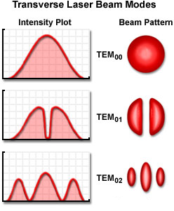
Figure 1 Transverse Modes corresponding as seen from beam pattern as from the intensity plot
The intensity profile of Hermite-Gaussian beam is:

$$\left(1\right) I_{l,m}\left(x,y,z\right)== {\left|A_{lm}\right|}^{2}{\left[\frac{W_{0}}{W\left(z\right)}\right]}^{2}G_{l}^{2}\left[\frac{\sqrt{2}x}{W\left(z\right)}\right]G_{m}^{2}\left[\frac{\sqrt{2}y}{W\left(z\right)}\right]$$

Where $A_{lm}$ the amplitude of the beam profile, $W\left(z\right)=W_{0}{\left[1+ {\left(\frac{z_{0}}{z}\right)}^{2}\right]}^{\frac{1}{2}}$ is a measure of the beam’s width along the z propagation axis, with $z_{0}$ which determined from boundary conditions. $G_{l}$ and $G_{m}$ are known as the Hermite-Gaussian functions - $G_{l}\left(u\right)=H_{l}\left(u\right)\exp\left(-\frac{u^{2}}{2}\right)$.
In the current experiment, the transverse modes intensity was simplified by taking $l$ to zero.

2.5 Diode Laser wavelength parameter dependence
Two parameters govern which wavelength comes out of the diode laser – temperature and current applied on it. The change of these parameters alters the refractive index and active zone length in the diode laser and in result alters the emitted wavelength. As seen in figure (3), to emit constant $λ$ one has to increase current and decrease temperature.
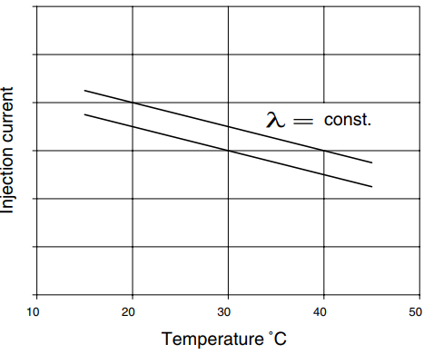
Figure 2 Injection current versus temperature for constant wavelength, shown for two different wavelengths
2.6 Q-Switching
Q-switching is the process of changing the Q-factor of the resonator, which in turn causes the pulsation of the laser output instead of a continuous beam.
Passive Q-switching is achieved using a saturable absorber, which becomes transparent once it becomes saturated with the energy absorbed by it. Thus, for a passive Q-switch, more energy is stored in the form of high population inversion (because there is effective no resonator involved), and then is almost instantly released as a gaussian-resembling laser pulse once the threshold for the switch is achieved.

- Experimental setup
The experiment setup (appendix A) includes a diode laser, which serves as a pump for a Nd:YAG laser. Temperature and current control were available for the diode laser. A spherical mirror reflecting the light from the diode laser (~810 nm) and transmitting the light from the Nd:YAG (1064 nm) was mounted further down the optical rail. An ND filter was put between the power meter and the spherical mirror crystal to prevent saturation in the power meter. Optimal alignment was achieved using the maximum value in the power meter.
A camera with a focusing lens and an ND filter was used to photo the TEMs. Also, a photodiode and an oscilloscope were used to record the pulse intensity versus time. Specific models can be found in appendix A.

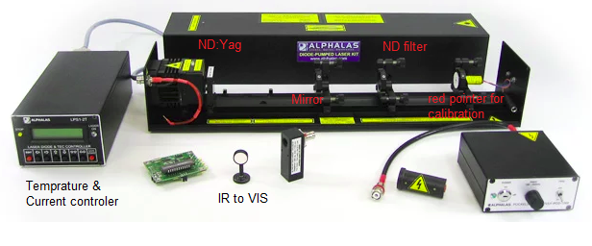
Figure 3 Experimental Setup
- Experimental process
The first set of measurements was done in order to calculate $P_{diode}(I_{diode})$ of the diode laser.
Following measurements were made to get the relationship $P_{YAG}(I_{diode},T_{diode})$ by setting a constant temperature between $20°C$ and $30°C$ and varying the current in the range of $1.15-2.08 A$.
Afterwards, the system was set for the optimal settings to produce maximum YAG laser power, and TEMS were achieved by tilting the spherical mirror and using a screen and camera.
Q-switch measurements were performed later, using the photodiode and the scope, trying to achieve a behavior of the signal as function of pump power.

- Measurement and Analysis
5.1 Power Calibration
The power measurements as given by the power meter had to be calibrated in order to receive real Watts. There were three needed factors. Firstly, there is a correction coefficient which takes into account the spectral sensitivity of the meter, according to figure 13 in appendix F.
Secondly, there is a filter mounted upon the optical axis which must be considered. Figure 3 shows the transmission rate of the filter as function of wavelength. To fix the measurements, the results must be divided by the transmission rate. As the wavelength of the pump beam is a bit higher than $800nm$, it means that the pump power as measured must be multiplied by 5.
Lastly, the pump beam diverges, and so not all of it falls upon the detector when measured. To obtain the actual pump power, then, a geometrical factor must be used. The ratio between the area of the detector eye and the area of the beam projection upon the detector plane is assumed to be approximately equal to the ratio of the measured power and the total pump power. The detector eye is circular, and so by measuring its radius with a ruler we have calculated its area according to the formula for circle area. The area of the beam projection has varied between measurements, and so it could not be measured directly. Instead, to obtain the projection area for each measurement, we used:

$$\left(2\right) A={\left(\frac{r}{r_{0}}\right)}^{2}*A_{0}$$
Where $A$ is the projection area, $A_{0}$ is the projection area measured for one specific reference location $r_{0}$, and $r$ is the location of the photodetector eye.

The real power is then calculated according to:
(3) $P=P_{m}*\frac{A}{A_{d}}$
Where $P$ is the real power, $P_{m}$ is the measured power, $A$ is the projection area and $A_{d}$ is the area of the detector.

5.2 Resonator Stability
The effect of the optical resonator length on lasing was tested.
The stability criterion from the theoretical background was shown to be consistent with the experiment, as it was much harder to achieve lasing at longer resonator lengths. The largest resonator length for which lasing was achieved when the spherical mirror was set at 24.8 cm along the optical axis.

Q-switching
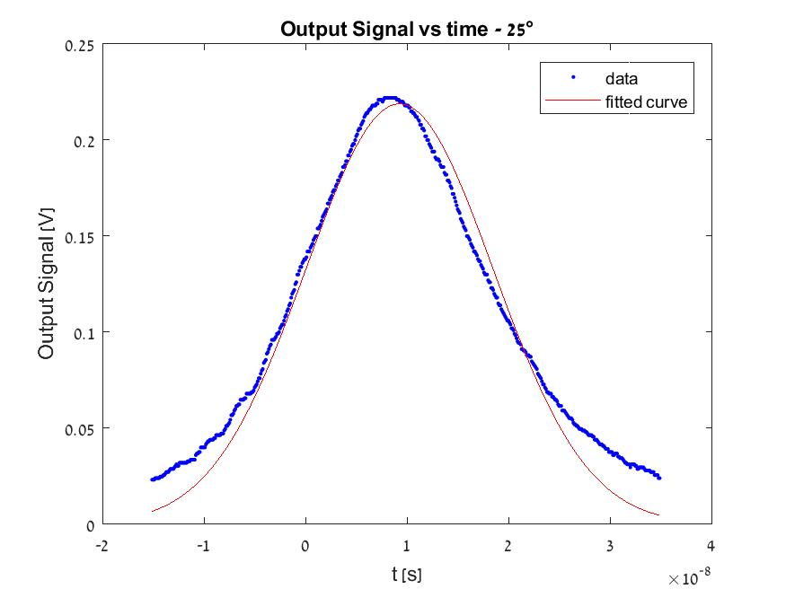
Figure 4 Gaussian fit of the Q Switched signal when T of diode is $25°C.$

As can be seen from the graph above, the laser output indeed becomes a pulse once the Cr:YAG crystal is mounted upon the optical axis. It is also evident that the pulse highly resembles a Gaussian in form, but not perfectly.
Viewing the graphs for pulses at different temperatures shows that the temperature highly affects the width and peak of the output. For the temperature range tested, It was found that the behaviour of both the FWHM and amplitude of the fit function to have extrema points for $25°C$, as can be seen from the following table data and from appendix E where the fit graphs are included.

Temperature  $$(°C)$$ | FWHM ${(10}^{-8}s)$ | Amplitude  $$({10}^{-1}V)$$
$$23$$ | $$2.72$$ | $$1.37$$
$$24$$ | $$2.41$$ | $$1.80$$
$$25$$ | $$2.17$$ | $$2.19$$
$$26$$ | $$2.53$$ | $$1.66$$
$$27$$ | $$2.92$$ | $$1.44$$
Table 1 Amplitude and FWHM per temperature

No adequate fit had been found for either the amplitude or FWHM as function of temperature. Of course, a 5th order polynomic function could be used, but there is no physical justification for such a fit.
Regardless, the phenomenon can be explained simply by claiming again that the temperature affects the pumping frequency, which in turn affects the level of population inversion in the YAG. It just happens to be that for the given set of measurements, the population inversion was highest at $25°C$ due to better absorption of the pumping beam. The Q-switch of the resonator then caused shorter and stronger pulses, as the amplification in the resonator occurred very quickly due to the high inversion.

5.3 Laser Intensity as function of Temperature and Current of Diode laser
The dependence of the laser diode upon the temperature and the current is shown above in section 2.5. Both parameters contribute to a change in $λ$, the wavelength coming into the Nd:YAG crystal.
By measuring the YAG laser intensity as a function of these parameters, we get a 3-dimensional graph that can be seen in appendix B.
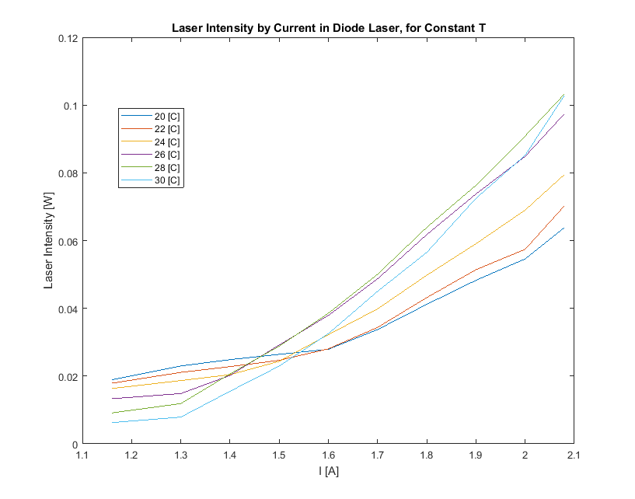
Figure 5 Nd:YAG Laser Intensity as function of current for different working temperatures of the pump laser.
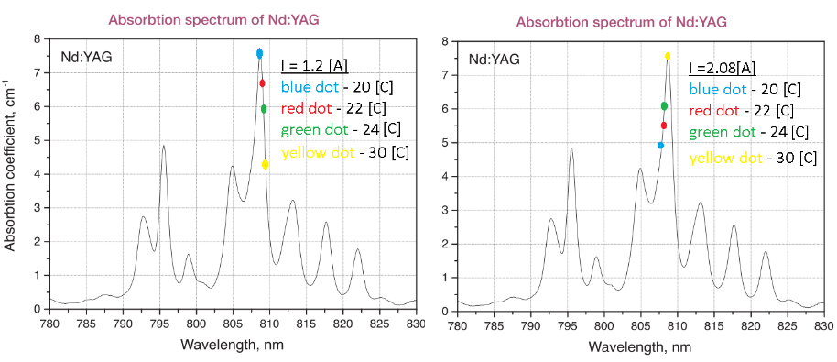
Figure 5 reveals an interesting behavior. For lower currents, greater intensities are achieved for lower temperatures. However, for higher currents, the behavior is quite opposite, as now higher temperature lines get the greater intensity values.
Figure 6 “The Walking Dots” – positive current change decreases diode laser emission wavelength and causes them to cross the peak.
An attempt to explain this phenomenon may be found by looking at the YAG absorption spectrum and asking – what is the pump wavelength for a given state of constant I and different temperatures. A schematic explanation is found in figure 6.
According to the theoretical background, lowering the current without changing the temperature results in decreasing the emission wavelength of the diode laser. Thus, the dots, representing each a constant temperature at a constant current, “walk” to the left side of the graph when we change the current to higher values. This “walk” continues until getting to the highest current possible, where it can be seen clearly that now the yellow ($30°C$) dot resides on the top of the peak, meaning the intensity is highest for this temperature.
While this schematic view may explain the experiment results in the limits of the current range, in the middle the situation is a little bit more problematic since there is no “one dot is on the peak” behavior. Since we do not know $λ(T,I)$, it is hard to say what is exactly going on. It can be said, though, that the “walking velocity” of the dots, is temperature dependent, as $\frac{∂λ(T,I)}{∂I}= f(T,λ)$, where $f$is an unknown function. A spectrometer should be used to identify this relations for better investigation.
Also, one may argue the validity of this theory closer to the edges too since the green (28$°C$) and the cyan (30$°C$) lines both meet at the 2.08$A$ edge, which can be explained by the low range of measurements and lack of averaging procedures. In any case, a more sophisticated measurement that takes into account more range across T and I, averaging, and increasing the measurements resolution is needed.
Another interesting thing to notice is that the initial linear behavior is replaced by a line with a bigger slope in general (most notably in the 30$°C$ to 26$°C$, where the change happens at 1.3$A$), in correspondence with the theoretical claim that there is a lasing threshold (as seen in appendix D). From a linear fit to the points after $1.3A$ for the 26$°C$ to 30$°C$ graph $P_{th} ≈$ $1.3 W$ has been calculated. The calculated $P_{th}$is clearly dependent on the temperature.

In figure 7, the blue, red and yellow lines are descending while the others show at least some ascending behavior. This might reflect descending from an absorption peak for these colors. It can be asked why most of the lines stop ascending and start to descend at 28$°C$. The answer, according to the proposed theory, is that somewhere near $28°C$ the peak is crossed by the dots. The reason why the maximum seems to be at the same temperature for most is that the measurements lack resolution. An extraction of the function $λ\left(T,I\right)$ from measurements using a spectrometer is needed in order to disapprove or approve the ‘walking dots’ in this context.

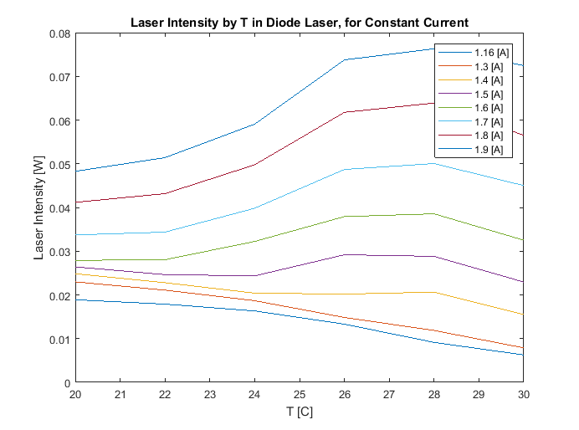
Figure 7 Nd:YAG Laser intensity as function of Temperature for constant currents in the Diode Laser.

5.4 Tranverse Modes
By setting the mirror as far as possible (24.5 cm) and using the lowest camera gain (to decrease noise from the background) the transverse modes from TEM00 to TEM05 were observed. Although we captured the TEM modes with many mirror distances, they appeared to be the most visible in this chosen configuration. This comes from the fact that the TEM modes intensity profile gets magnified by the factor proportional to $W\left(z\right)$ term in eq. (1), but maintains the same profile. Then, for each image, a central stripe of pixels was chosen by hand by picking the center of the TEM circles, and an average of 5 lines of pixels above and below it was taken to smoothen the data. Fits were made using the least squares method and can be observed in figure 8 as well as in appendix G. Qualitatively, the fits look quite like the measurement. However, some issues appear – asymmetries in the peaks appear, where the first peak and the last are almost always asymmetric by approximately 10-20% and the peaks in the middle are not in the same height too (the most notable example of that is the fit of TEM₀₄). It might be suspected that these asymmetries are coming from the imperfection of the mirror itself (as we noticed that it has uneven surface when being looked from different angles) or misalignment of the optical system. The latter reason was attempted to be fixed by gently changing the configuration of the system, however no success was achieved.
While the fits were made to a single function in the form of $a*G\left(bx\right)+c$ where $G(x)$ is $H_{l}\left(x\right).*exp⁡[-\frac{x^{2}}{2}]$ and $a,b,c$ are free parameters, a better fit can be achieved by fitting a superposition of TEM’s. It should be noted that TEM01 is 0 at $x=0 ,$ according to theory, while the fit function value is actually 0.08 at $x=0.$ That comes from even order Hermite polynomials that do not have zero value at x = 0, that are comprising the superposition.

5.6 2D TEM
In the hemispherical mirror configuration used in the experiment it was observed that the TEMs were always in the form of $TEM_{0n}$. An explanation for that is that the diode laser pump beam is rectangular, meaning that this single stripe is responsible for the symmetry of the TEMs. A rectangular beam has a favorable axis, and the TEMs are created along it when the mirror is tilted. The shorter axis of the rectangular beam is small and the TEMs which are created by tilting the mirror are almost unnoticeable. In order to verify this we need to test the system using a spherical pump beam. Evidence of the above may be found in the article (_), where they have used different pump shapes in order to create different beam shapes.
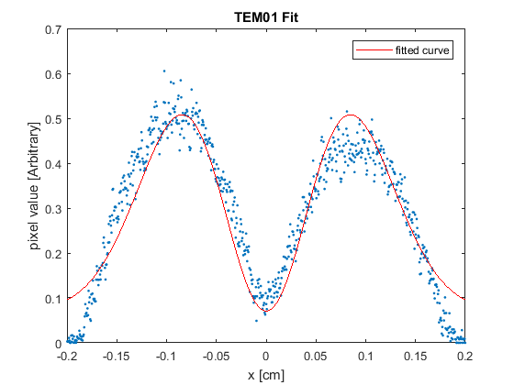
Figure 8 TEM₀₁ fit using least squares method

- Conclusions
Different aspects of laser parameters were tested. It was found that the stability criterion depending on the resonating length resembles the expectations. The dependence of the YAG laser power on the temperature and the current in the diode laser was checked, and no strongly agreeable explanation was found, however, a theory was proposed. Methods of further investigation were proposed for the matter. The TEMs achieved fit the corresponding TEM formulas quite well, and in order to achieve more accurate results a superposition of TEMs should be taken into account. Also, an explanation of the one index TEM behavior was proposed and a method to check it was given.
The observed behavior for Q-switching matched the expected theoretical results. Also, satisfactory explanations were found for the temperature dependency of the pulse width and amplitude. It is therefore our opinion that the experiment was successful for that part.

Appendix A
Experimental Apparatus
• Pump laser diode with Peltier cooler and attached pump optics
• Laser diode driver & thermoelectric controller LDD1-1T (optional: LPS1-2T, microprocessor-controlled)
• Laser crystal Nd:YAG (Nd:YVO₄ optional), with a heat sink
• Set of two laser cavity mirrors (flat/curved)
• Cr4+:YAG passive Q-switch, AR/AR coated
• Mirror and crystal mounts (3 pieces)
• Optical bench • Diode laser module (670 mm) for aligning the laser cavity, with holder
• Infrared-to-visible converter (model IR-VIS-15-B), Ø 15 mm, for aligning the IR laser and mode analysis (also suitable for high-power lasers)
- Ultrafast photo detector (model UPD-300-SP) with rise time <300 ps, spectral range 320 - 1100 nm, external power supply, suitable for observing the relaxation oscillations and pulse duration of the Q-switched mode
- CCD linear array (model CCD-2000M) with 2048 pixels, high sensitivity, driver electronics and power supply, suitable for laser beam analysis, M² measurements, autocorrelators, etc

Appendix B

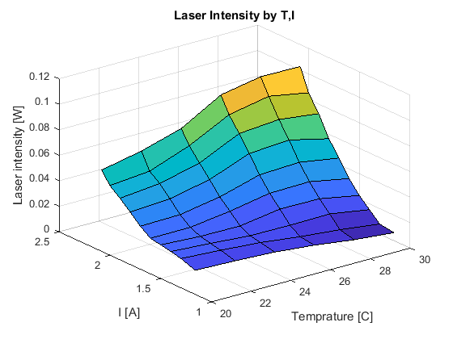
Figure 9 Laser Intensity as function of temperature and injection current

Appendix C
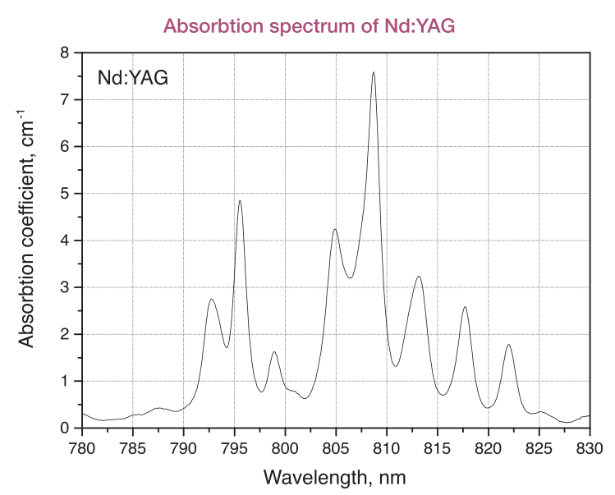
Figure 10 Nd: YAG absorbtion spectrum
Appendix D
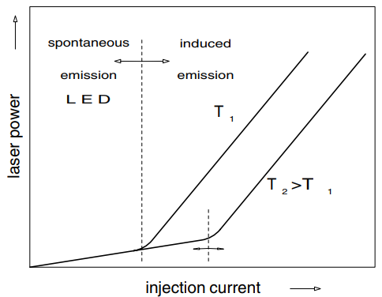
Figure 11 Diode Laser Power for different T's by injection current

Appendix E
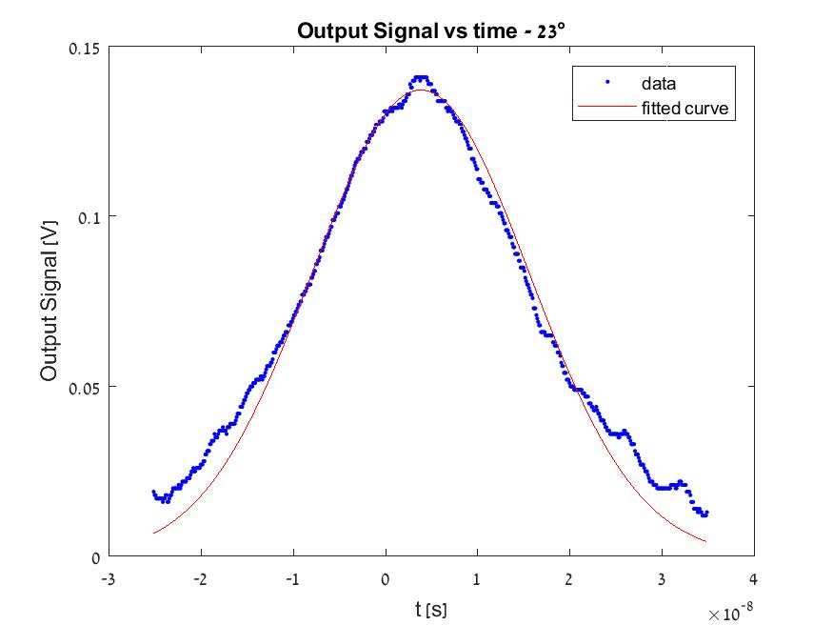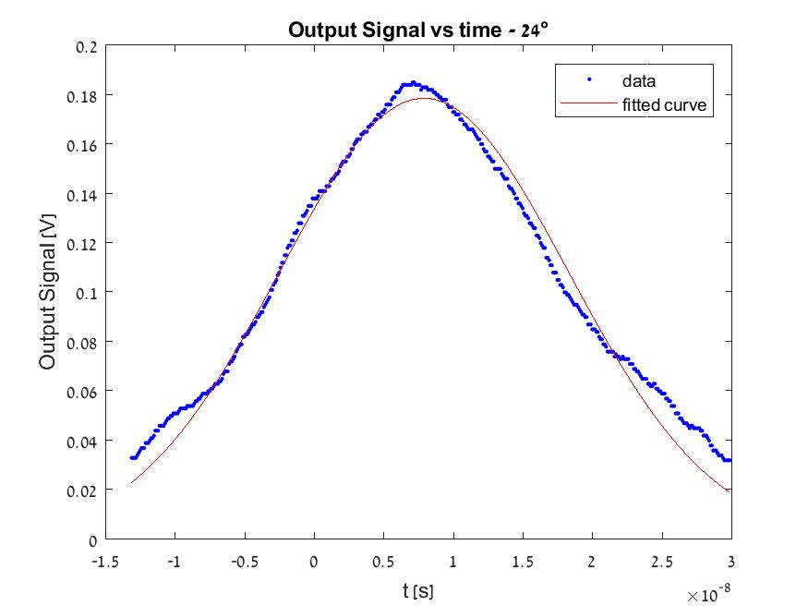
Figure 12 Q-switch output signal for different temperatures
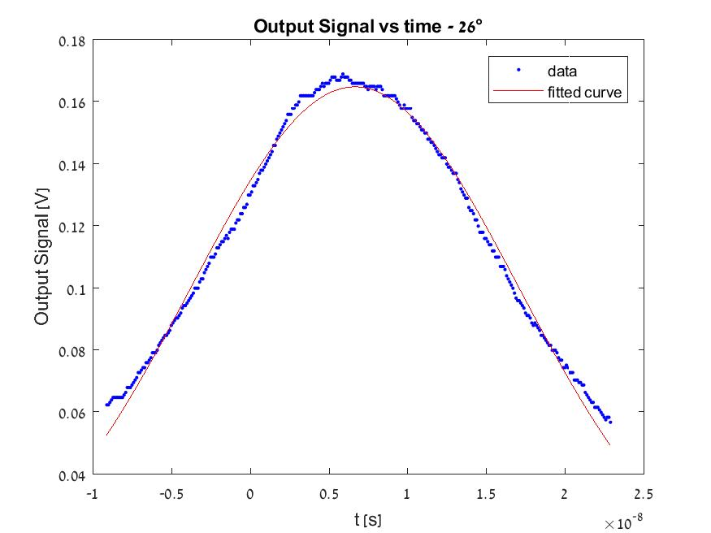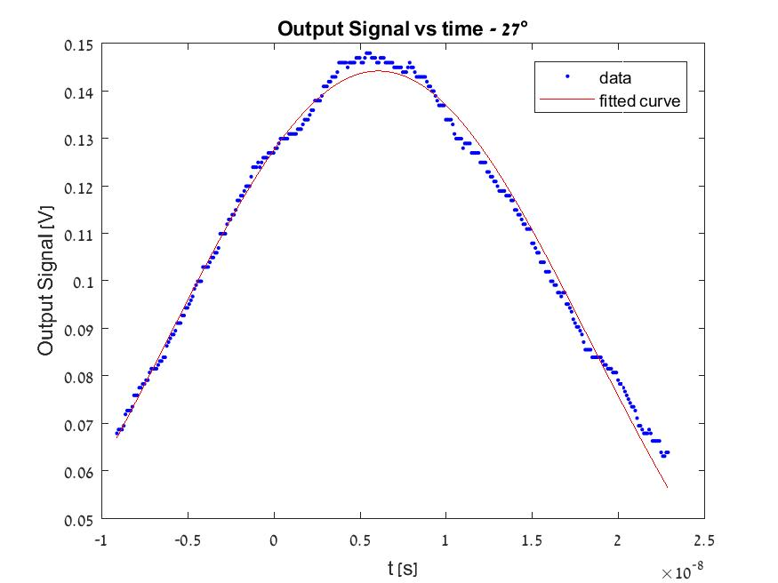

Appendix F

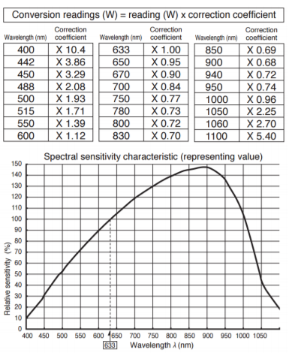
Figure 13 Spectral sensitivity conversion factor
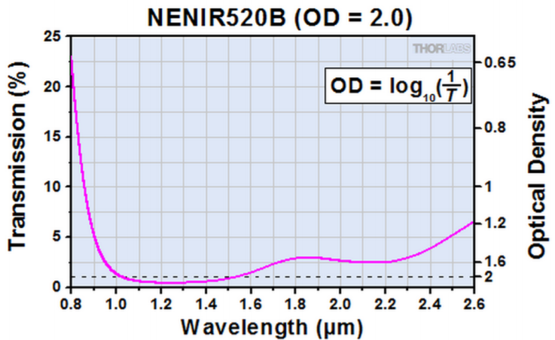
Figure 14 Filter transmission

Appendix G

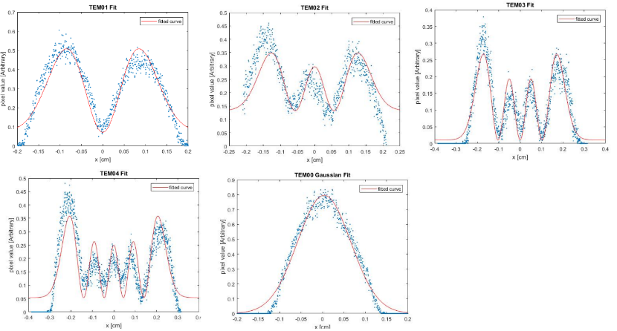
Figure 15 TEM fits

Appendix H
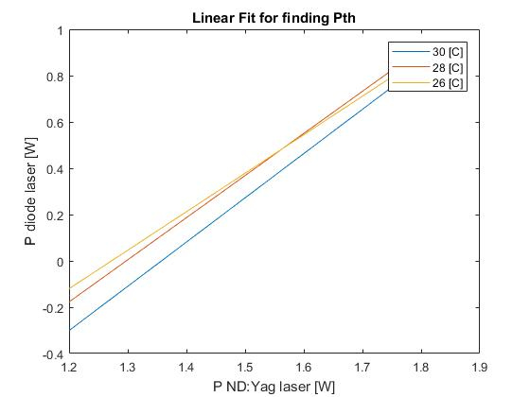
Figure 16 Linear fit for finding Pth. Notice that P diode laser power is smaller than Nd:YAG laser power. It is unclear why, it might be coming from incorrect specification of the instruments or human errors.

References
- “Generation of Hermite–Gaussian modes and vortex arrays based on two-dimensional gain distribution controlled microchip laser”, Weipeng Kong, Atsushi Sugita, and Takunori Taira, July 1, 2012 / Vol. 37, No. 13 / OPTICS LETTERS 2661
- Diode-Pumped Solid-State, Laser Kit, LASKIT-500
- Image of absobtion versus wavelength taken from https://www.crytur.cz/products/laser-rods-neodymium-doped/

- “Next-generation DNA sequencing”, Jay Shendure, Hanlee Ji (2008), Nature Biotechnology, Volume 26, Issue 10, Pages 1135-145.

“Attosecond spectroscopy in condensed matter”, A. L. Cavalieri, N. Muller, Th. Uphues, V. S. Yakovlev, A. Baltuska, B. Horvath, B. Schmidt, L. Blumel, R. Holzwarth, S. Hendel, M. Drescher, U. Kleineberg, P. M. Echenique, R. Kienberger, F. Krausz, U. Heinzmann (2007), Nature Letters, Volume 449, pages 1029–1032.
“Shock pressures induced in condensed matter by laser ablation”, Damian C. Swift, Thomas E. Tierney IV, Roger A. Kopp, J. Tinka Gammel (2004), Physical Review E, Volume 69, Issue 3, 036406.
"Theoretical investigations of the processes of selective laser interaction with melanin granules in pigmented tissues for laser applications in medicine", V. K. PustovalovB. Jean
"Heat localization for targeted tumor treatment with nanoscale near-infrared radiation absorbers", Bin Xie, Ravi Singh, F M Torti, Pawel Keblinski and Suzy Torti
“Cutting of 1.2 mm thick austenitic stainless steel sheet using pulsed and CW Nd:YAG laser”, K. Abdel Ghany, M. Newishy (2005), Journal of Materials Processing Technology, Volume 168, Issue 3, Pages 438-447.
“Additive Manufacturing by selective laser melting the realizer desktop machine and its application for the dental industry”, Andreas Gebhardt, Frank-Michael Schmidt, Jan-Steffen Hötter, Wolfgang Sokalla, Patrick Sokalla (2010), Physics Procedia, Volume 5, Part B, pages 543-549.
“Fundamentals Of Photonics” – Bahaa E.A Saleh
“Diodelaser Pumped Nd: YAG Laser” - Prof. Dr.-Ing. Dickmann

