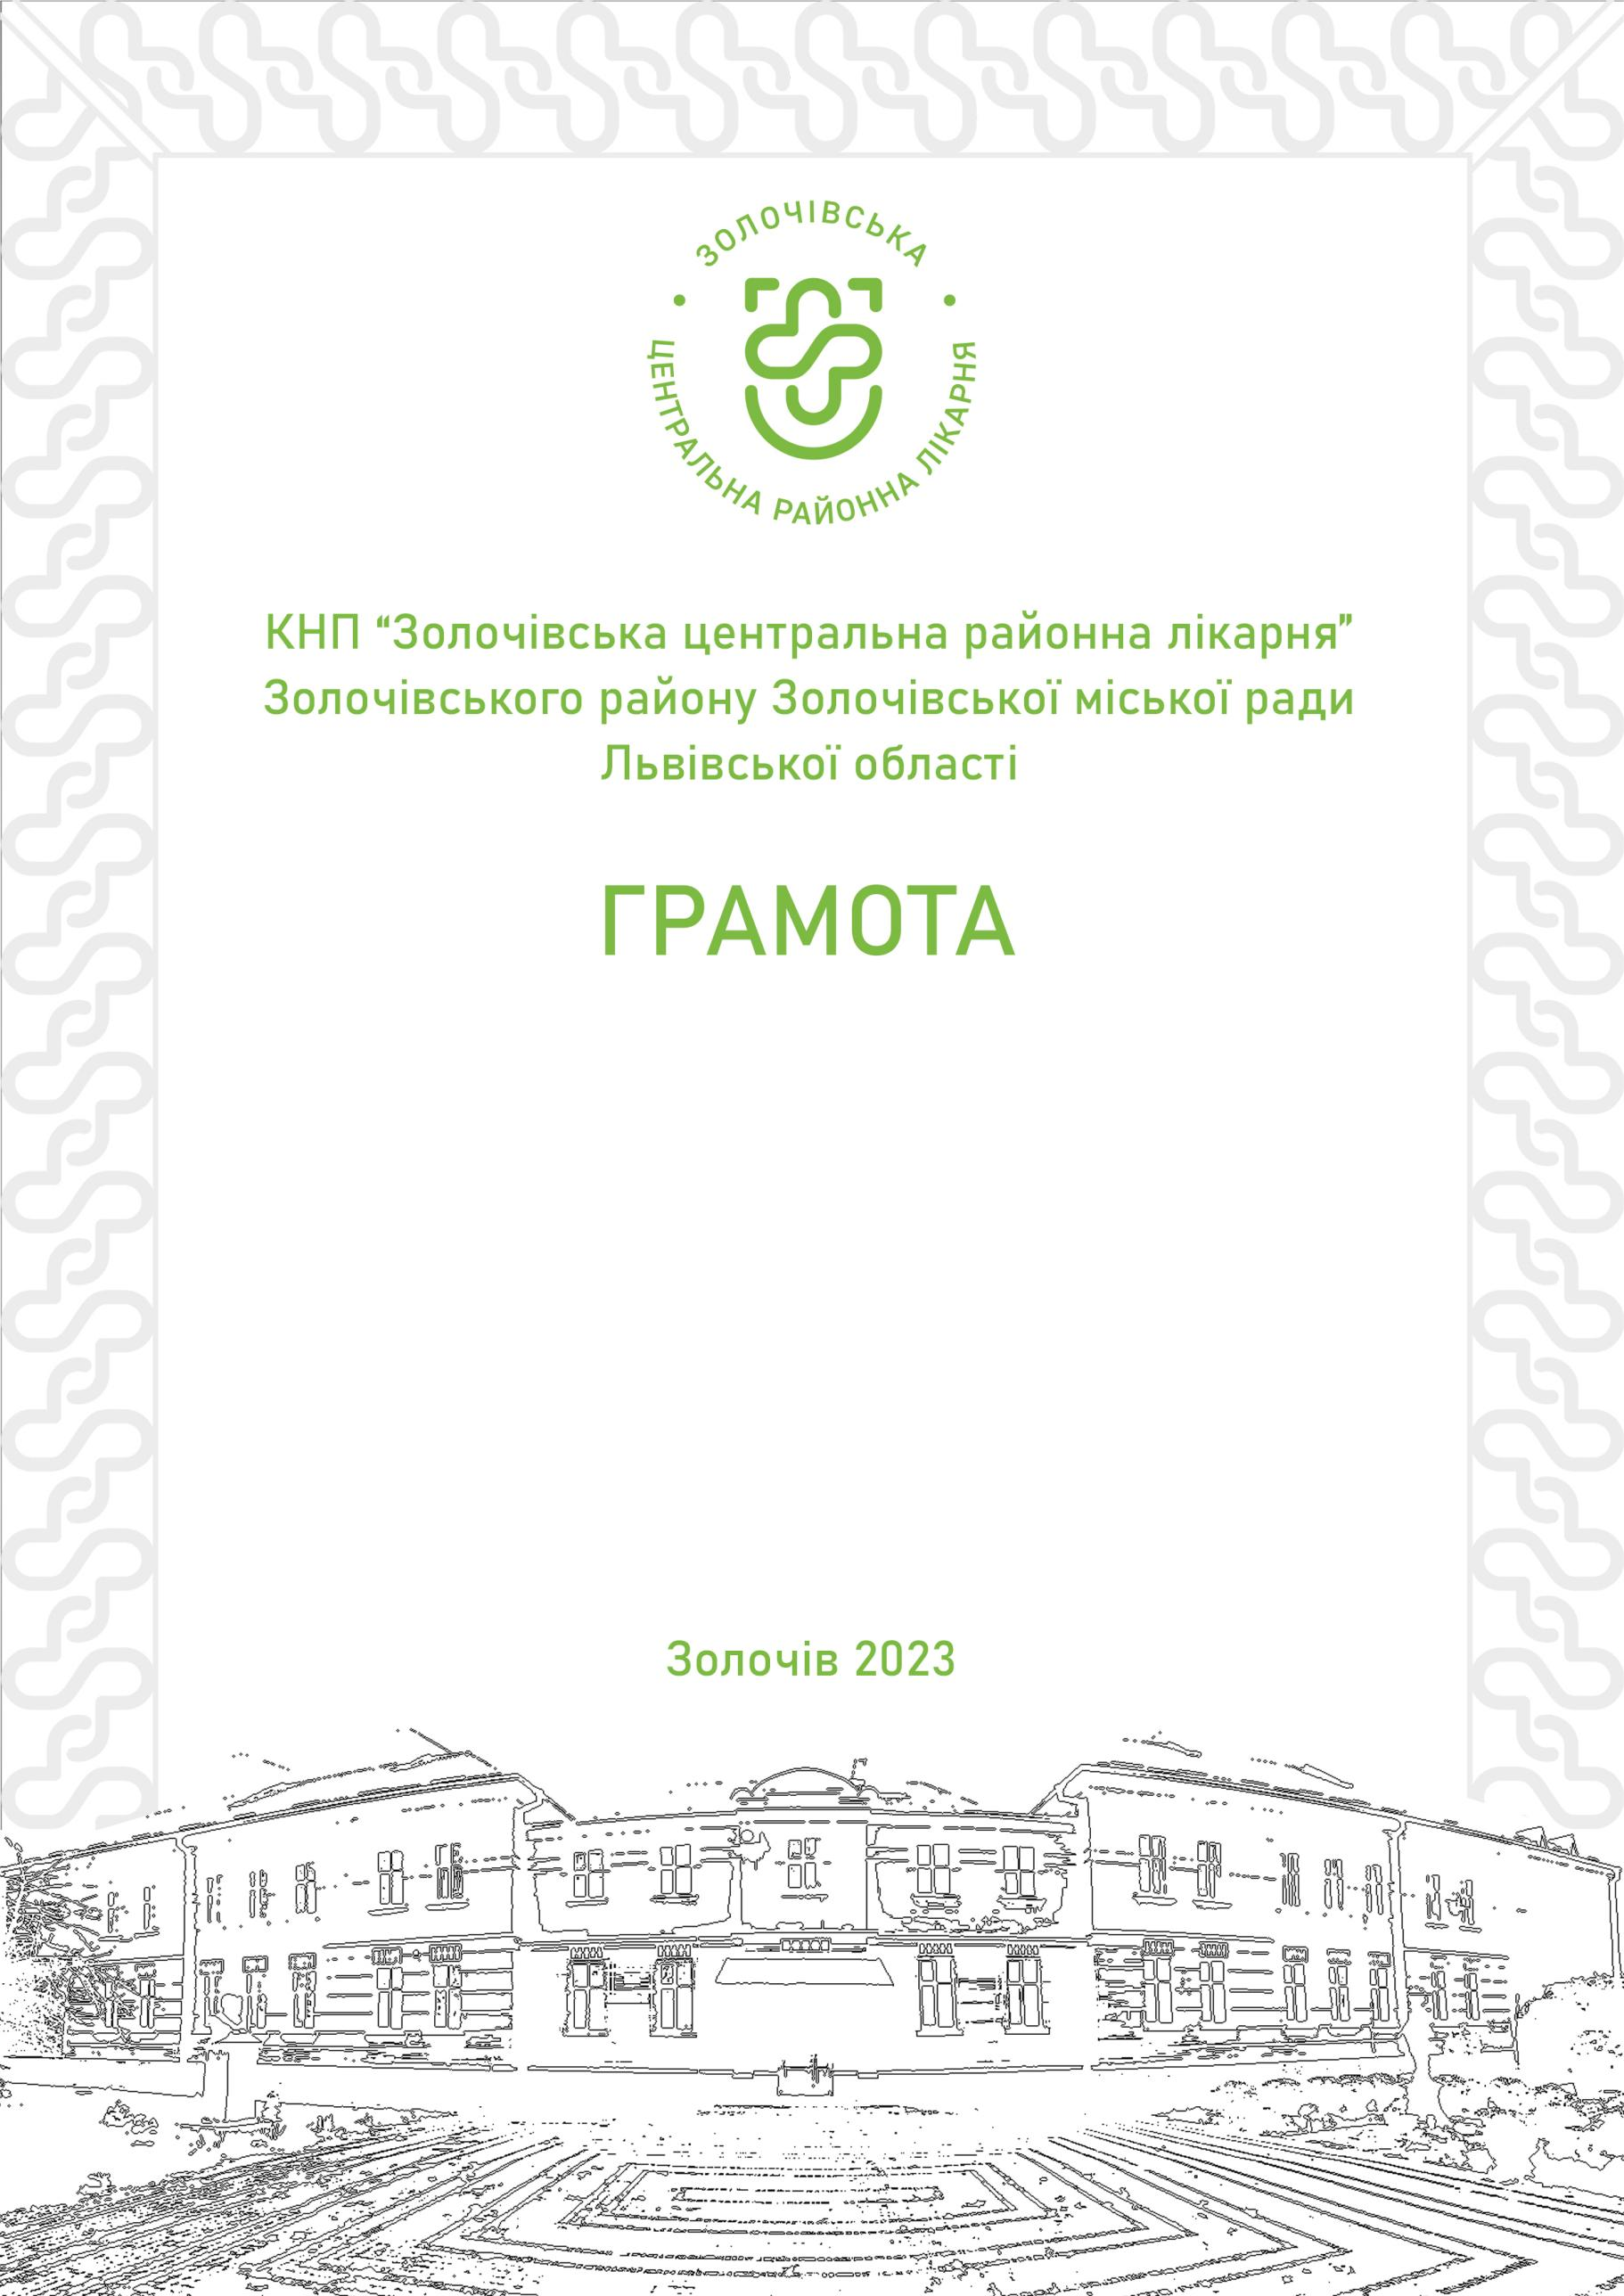
Municipal non-profit enterprise Zolochiv Central District Hospital
GRATITUDE

Jan Björn

for an active public position,
promoting medical care
and SUPPORT.

Director Taras Yatsunskyi
Zolochiv 2024

