Regular and degenerate perturbation theory
(From Richard Fitzpatrick The University of Texas at Austin )

Regular perturbation theory with two states

Let us begin by considering time-independent perturbation theory, in which the modification to the Hamiltonian, , has no explicit dependence on time. It is usually assumed that the unperturbed Hamiltonian, , is also time-independent.
Consider the simplest non-trivial system, in which there are only two independent eigenkets of the unperturbed Hamiltonian. These are denoted
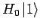 |  | 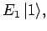 | (588)
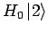 |  | 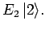 | (589)

It is assumed that these states, and their associated eigenvalues, are known. Since is, by definition, an Hermitian operator, its two eigenkets are orthonormal and form a complete set. The lengths of these eigenkets are both normalized to unity. Let us now try to solve the modified energy eigenvalue problem
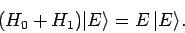 | (590)

In fact, we can solve this problem exactly. Since, the eigenkets of form a complete set, we can write
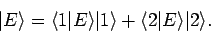 | (591)

Right-multiplication of Eq. (590) by and yields two coupled equations, which can be written in matrix form:
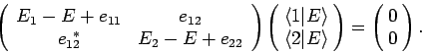 | (592)

Here,
 |  | 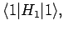 | (593)
 |  | 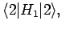 | (594)
 |  | 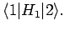 | (595)

In the special (but common) case of a perturbing Hamiltonian whose diagonal matrix elements (in the unperturbed eigenstates) are zero, so that
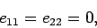 | (596)

the solution of Eq. (592) (obtained by setting the determinant of the matrix equal to zero) is
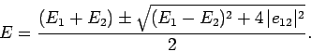 | (597)

Let us expand in the supposedly small parameter
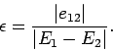 | (598)

We obtain
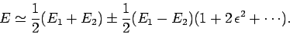 | (599)

The above expression yields the modifications to the energy eigenvalues due to the perturbing Hamiltonian:
 |  | 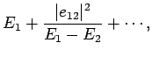 | (600)
 |  | 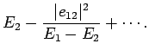 | (601)

Note that causes the upper eigenvalue to rise, and the lower eigenvalue to fall. It is easily demonstrated that the modified eigenkets take the form
 |  | 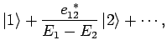 | (602)
 |  | 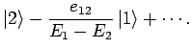 | (603)

Thus, the modified energy eigenstates consist of one of the unperturbed eigenstates with a slight admixture of the other. Note that the series expansion in Eq. (599) only converges if 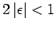. This suggests that the condition for the validity of the perturbation expansion is
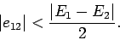 | (604)

In other words, when we say that needs to be small compared to , what we really mean is that the above inequality needs to be satisfied.

Regular perturbation theory with several states

Let us now generalize our perturbation analysis to deal with systems possessing more than two energy eigenstates. The energy eigenstates of the unperturbed Hamiltonian, , are denoted
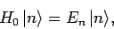 | (605)

where runs from 1 to . The eigenkets are orthonormal, form a complete set, and have their lengths normalized to unity. Let us now try to solve the energy eigenvalue problem for the perturbed Hamiltonian:
(606)

We can express 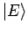as a linear superposition of the unperturbed energy eigenkets,
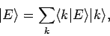 | (607)

where the summation is from to . Substituting the above equation into Eq. (606), and right-multiplying by 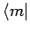, we obtain
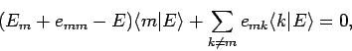 | (608)

where
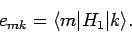 | (609)

Let us now develop our perturbation expansion. We assume that
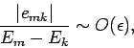 | (610)

for all 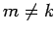, where 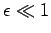is our expansion parameter. We also assume that
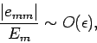 | (611)

for all . Let us search for a modified version of the th unperturbed energy eigenstate, for which
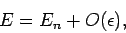 | (612)

and
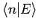 |  |  | (613)
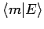 |  | 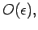 | (614)

for 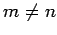. Suppose that we write out Eq. (608) for , neglecting terms which are 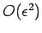according to our expansion scheme. We find that
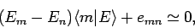 | (615)

giving
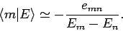 | (616)

Substituting the above expression into Eq. (608), evaluated for , and neglecting 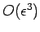terms, we obtain
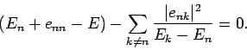 | (617)

Thus, the modified th energy eigenstate possesses an eigenvalue
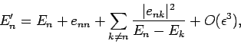 | (618)

and a eigenket
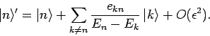 | (619)

Note that
(620)

Thus, the modified eigenkets remain orthonormal and properly normalized to .

Degenerate perturbation theory

Let us now consider systems in which the eigenstates of the unperturbed Hamiltonian, , possess degenerate energy levels. It is always possible to represent degenerate energy eigenstates as the simultaneous eigenstates of the Hamiltonian and some other Hermitian operator (or group of operators). Let us denote this operator (or group of operators) . We can write
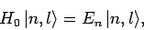 | (651)

and
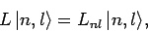 | (652)

where 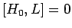. Here, the and the are real numbers which depend on the quantum numbers , and and , respectively. It is always possible to find a sufficient number of operators which commute with the Hamiltonian in order to ensure that the are all different. In other words, we can choose such that the quantum numbers and uniquely specify each eigenstate. Suppose that for each value of there are different values of : i.e., the th energy eigenstate is -fold degenerate.
In general, does not commute with the perturbing Hamiltonian, . This implies that the modified energy eigenstates are not eigenstates of . In this situation, we expect the perturbation to split the degeneracy of the energy levels, so that each modified eigenstate 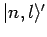acquires a unique energy eigenvalue 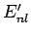. Let us naively attempt to use the standard perturbation theory of Sect. 6.3 to evaluate the modified energy eigenstates and energy levels. A direct generalization of Eqs. (618) and (619) yields
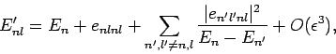 | (653)

and
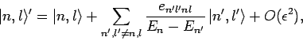 | (654)

where
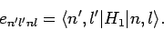 | (655)

It is fairly obvious that the summations in Eqs. (653) and (654) are not well-behaved if the th energy level is degenerate. The problem terms are those involving unperturbed eigenstates labeled by the same value of , but different values of : i.e., those states whose unperturbed energies are . These terms give rise to singular factors 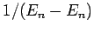in the summations. Note, however, that this problem would not exist if the matrix elements, 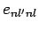, of the perturbing Hamiltonian between distinct, degenerate, unperturbed energy eigenstates corresponding to the eigenvalue were zero. In other words, if
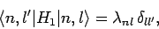 | (656)

then all of the singular terms in Eqs. (653) and (654) would vanish.
In general, Eq. (656) is not satisfied. Fortunately, we can always redefine the unperturbed energy eigenstates belonging to the eigenvalue in such a manner that Eq. (656) is satisfied. Let us define new states which are linear combinations of the original degenerate eigenstates corresponding to the eigenvalue :
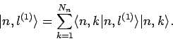 | (657)

Note that these new states are also degenerate energy eigenstates of the unperturbed Hamiltonian corresponding to the eigenvalue . The 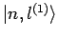are chosen in such a manner that they are eigenstates of the perturbing Hamiltonian, . Thus,
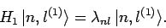 | (658)

The are also chosen so that they are orthonormal, and have unit lengths. It follows that
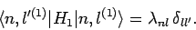 | (659)

Thus, if we use the new eigenstates, instead of the old ones, then we can employ Eqs. (653) and (654) directly, since all of the singular terms vanish. The only remaining difficulty is to determine the new eigenstates in terms of the original ones.
Now
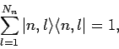 | (660)

where 1 denotes the identity operator in the sub-space of all unperturbed energy eigenkets corresponding to the eigenvalue . Using this completeness relation, the operator eigenvalue equation (658) can be transformed into a straightforward matrix eigenvalue equation:
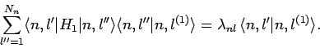 | (661)

This can be written more transparently as
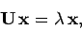 | (662)

where the elements of the 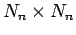Hermitian matrix are
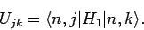 | (663)

Provided that the determinant of is non-zero, Eq. (662) can always be solved to give eigenvalues (for to ), with corresponding eigenvectors . The eigenvectors specify the weights of the new eigenstates in terms of the original eigenstates: i.e.,
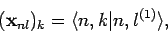 | (664)

for to . In our new scheme, Eqs. (653) and (654) yield
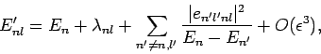 | (665)

and
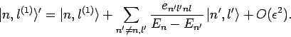 | (666)

There are no singular terms in these expressions, since the summations are over 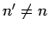: i.e., they specifically exclude the problematic, degenerate, unperturbed energy eigenstates corresponding to the eigenvalue . Note that the first-order energy shifts are equivalent to the eigenvalues of the matrix equation (662).

