Neutrino Mass
Abstract:
$β$ decay process of ${Tl}_{81}^{204}$ was analyzed in order to achieve upper bound for neutrino mass. Results were controversial as the upper bound of the mass turned out negative. Review and deeper understanding of the experimental system and procedures is discussed thoroughly.
Introduction:
Nuclear physics is the study of the atomic nucleus. The nucleus is made of electrically charged Protons and neutrally charged Neutrons. Common notation we will use here describes a nucleus as $X_{Z}^{A}$ where A is the mass number, Z is the atomic number and X is the nucleus type.
Many nuclei are unstable and emit $α, β$ and $γ$ to reach a more stable energy level. The weak force is responsible for all three types of the decays. We will briefly introduce them:
$α$ decay - A helium nucleus is emitted from the parent nucleus at discrete energy levels. The $α$ particles emitted have typical energies of about 5 MeV.
$γ$ decay – Emission of a high energy photon in the process of de-excitation of a nucleus. Typical energies are between KeV and MeV and are discrete as well.
$β$ decay – An electron or positron is emitted or captured by a nucleus, changing a nucleon to proton or vise-versa. Historically, the continuous energy spectrum of the emitted $β$ particles and energy and angular momentum conservation violations led to Pauli’s proposal that these decays are accompanied by neutrino or anti-neutrino particles [1]. Neutrino and anti-neutrino particles that are considered today almost massless, as was shown experimentally [2], and have neutral charge.
The three $β$ decays are:
$X_{Z}^{A}→Y_{Z+1}^{A}+e+\overline{ν_{e}}$ (1.1 a)
$X_{Z}^{A}→Y_{Z-1}^{A}+e^{+}+ν_{e}$ (1.1 b)
$X_{Z}^{A}+e→Y_{Z-1}^{A}+ν_{e}$ (1.1 c)
Considering the process described in equation (1.1 a) we get from energy conservation:
$T_{Y}+T_{e}+T_{\overline{ν}}= \left(M_{X}-M_{Y}-M_{e}-M_{\overline{ν}} \right)c^{2}≡∆Mc^{2}$(1.2)
Where $T_{e}$, $T_{\overline{ν}}$ and $T_{Y}$ are the kinetic energy levels of the electron, anti-neutrino and the recoiled daughter nucleus respectively. The masses of the $β$ particle and the neutrino are sufficiently small comparing to the daughter nucleus thus is reasonable to neglect the nucleus kinetic energy. The disintegration energy is then given by:
$Q≡∆Mc^{2} ≈T_{e}+T_{\overline{ν}}$ (1.3)
By looking at the end point of the spectrum, where $T_{e}=Q$, we get $T_{\overline{ν}}=0$ and the neutrino mass can be determined from equation (1.2).

In standard model theory, the neutrino is massless. It follows that the theoretical value of is given by:
$$\begin{aligned}Q_{theoretical}=\left(M_{X}-M_{Y}-M_{e}\right)c^{2} \#\left(1.4\right)\end{aligned}$$

As such, an upper bound of the electron’s neutrino mass can be achieved by:
$$\begin{aligned}M_{\overline{ν}}=Q_{theoretical}-Q \#\left(1.5\right)\end{aligned}$$

According to Fermi theory of beta-decay in the allowed state approximation, the following equation can be achieved [3]:
$\left(Q-T_{e}\right)∝\sqrt{\frac{N\left(p\right)}{p^{2}F(Z^{'},p)}}$ (1.6)
Where $N(p)$ is the number of electrons with momentum $p$ and $F(Z^{'}, p)$ is the fermi function which accounts for the influence of the nuclear Coulomb field. By plotting the right hand side of (1.6) against $T_{e}$ we get a plot called Kurie plot which allows us to determine the value Q as it is the interception with the x axis.
In current experiment the following process is analyzed as described above:
$${Tl}_{81}^{204}→{Pb}_{82}^{204}+e+{\overline{ν}}_{e}$$

Experimental System:
Scheme of the experimental system can be found is figure (1). The radioactive source is placed in vacuum chamber with 0.01 mBar pressure, to prevent interaction between air and decay particles. Surface barrier detector is used for detecting the decays and their energy. The signal is then amplified by two amplifiers and converted to digital in the ADC (Analog to Digital converter). The system is powered by an adjustable power supply. The final output of the system is a histogram of the number of measurements in each of the 4096 channels, corresponding to the radiation energy.
Surface barrier detector is a silicon based detector consisting of an n-type silicon covered by a layer of gold. The connection between the metal and the silicon causes electrons to diffuse to the metal and a depletion region empty of charge carriers is created. As a result of applying reverse bias on the detector the length of the depletion area is increased further ($Length ∝\sqrt{V}$ ). When a decay particle hits the depletion area an electron-hole pair is created. The electric field then drifts the generated particles to the connections. Due to the large depletion area the probability of recombination is low and thus a current proportional to the energy of the interaction is created. In our experiment, a count should be interpreted a measurement of one decay particle if not said otherwise.
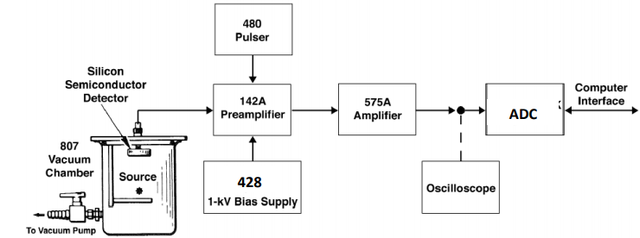
Figure 1 Experimental Setup

System Linearity Verification
In order to test the linear response of our experimental system a Pulser and an oscilloscope were introduced. There were two sets on measurments, one where the Pulser value varied while the amplifier value held fixed, and one where the Pulser held fixed while the varying the amplification. The amplification varying measurement was done with emphasis on the value that was fixed in the later sections, where coarse = 20 and fine ranges from 2.5 to 12.5. Assuming the width of the output is a consequence of normally distributed background noise, a Gaussian function was fit to each peak. The mean value of the Gaussian was chosen to represent each channel peak, and the error of it was taken to be the FWHM of the Gaussian. Taking FWHM as the error is justified by noticing the relatively narrow and high peaks which are the result of the accurate Pulser pulses. To perform the Gaussian fit, error in counts was taken to be Poissonian while the resolution errors of the Pulser and amplification errors were neglected. A linear fit was conducted between the found mean values and the Pulser/amplification values as can be seen in figure (2).

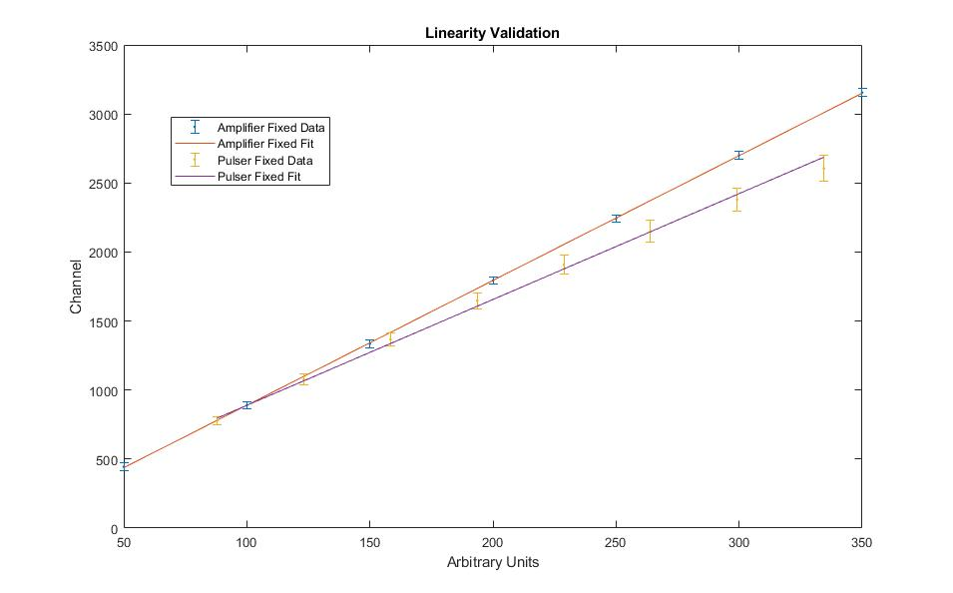
Figure 2 Linear validation of the experimental system. The fit was performed according to $y=a+bx$. Arbitrary Units were achieved by multiplying the fine, coarse and pulser values.
The following table summarizes the results:
Fit | $$χ_{red}^{2}$$ | $$P-Value$$ | $$NDF$$ | $$a [a.u]$$ | $$b [a.u]$$
Varying Pulser | 0.03 | $$0.99$$ | $$5$$ | $$-14.5±23.3$$ | $$9.04±0.10$$
Varying Amplifier | $$0.41$$ | $$0.86$$ | $$6$$ | $$122±41$$ | $$7.7±0.2$$
Table 1 – Summary of the Linear Validation results. All errors are statistic.
The goodness of fit values validate the linearity assumption about the system, although the given values may indicate error overestimation. In the residual plots in Appendix A there can be seen parabolic like trends which can show the linear fit is not correct for large values of amplification. We may notice the lines do intersect at around 100 A.U and the slope are different. In addition, the Gaussian like curves in Figure ( 8), Appendix A, are getting larger as the amplification value grows, as expected from a resolution broadening device. Due to the said above, choosing too high amplification values might cause unwanted errors, however the Varying Pulser measurement has more value then the Varying Amplifier one, as it simulates the next experimental procedures better. Also, the lines do not intersect the (0,0) point which can resemble of some instability in the system. This will not be of our concern as we work within a higher amplification regime.
Bias Supply Dependence
In order to maximize the measurement efficiency, an initial goal of the experiment was set to find the influence of the bias supply voltage on the measurements. For that, spectral measurements of $Am_{95}^{241}$ were conducted using a set of different bias supply voltages. Each of those measurements was then fitted to a gaussian in order to find the channel corresponding to the gamma decay energy (the gaussian mean channel). The gaussian mean channel was then plotted against the bias voltage:
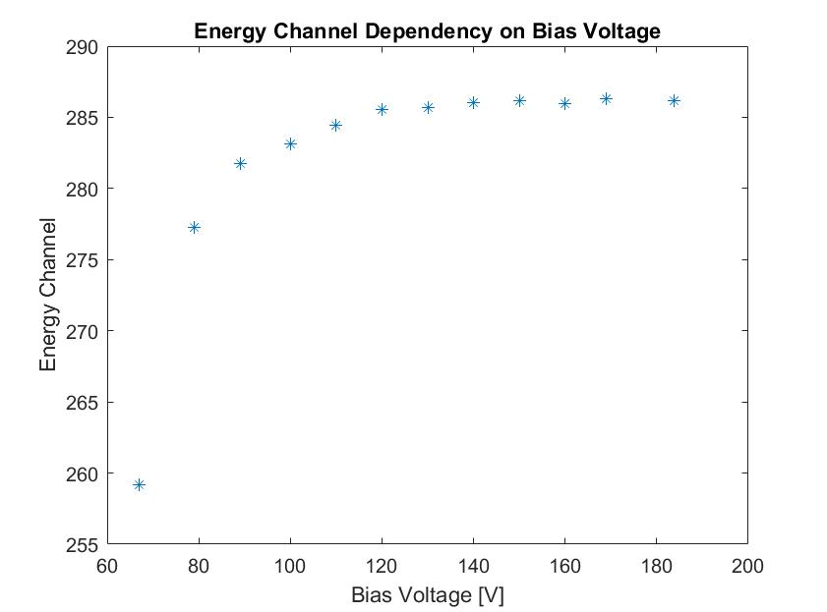
Figure 3 Energy channel dependency on bias voltage.
This shows a quick reach of a plateau at high enough energies. Thus, the rest of the measurements were conducted using a bias voltage of $180 V$, ensuring an almost maximal system efficiency.
Energy Calibration
In order to find the relation between the channel number and the corresponding energy value, three radioactive sources with known spectra (Appendix B) were tested as can be seen in figure ( 4). The measurements were done over long periods of time ($Ba\sim 89 h, Cs\sim 27 h,Am\sim 23 h$) as the detector has high efficiency in detecting beta decay and lower one for gamma decay. The highest peak on the right does not account for gamma radiation and can be viewed as system noise. The peaks emerge from a continuous beta decay, thus, to each dominant peak which corresponds to a dominant gamma decay mode, a Gaussian with a noise exponential factor was fit: $y=ae^{-bx}+ce^{-\frac{{\left(x-μ\right)}^{2}}{2σ^{2}}}$.
The amplification values were set to allow the maximum resolution in the energy range relevant to the Thallium’s beta decay and were kept constant for the rest of the experiment. This was achieved by retaking the measurements multiple times with different amplification values and examining the energy value of the $Cs_{55}^{137}$ peak as it has the closest decay mode to the energy range of interest. The mean peak error values were taken to be $\frac{σ}{\sqrt{N}}$ where $σ$ is the standard deviation of a single Gaussian fit and N is the number of measurements(=counts) in the Gaussian subtracted by the beta spectrum noise. Subsequently, A linear fit was performed to get the mean channel versus energy as can be seen in figure (4).
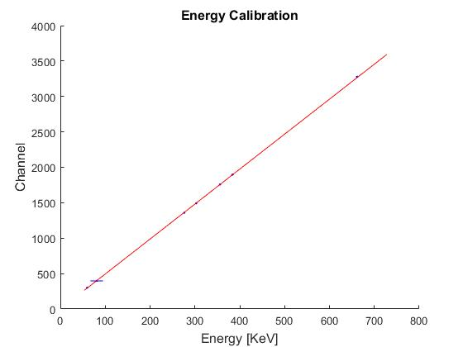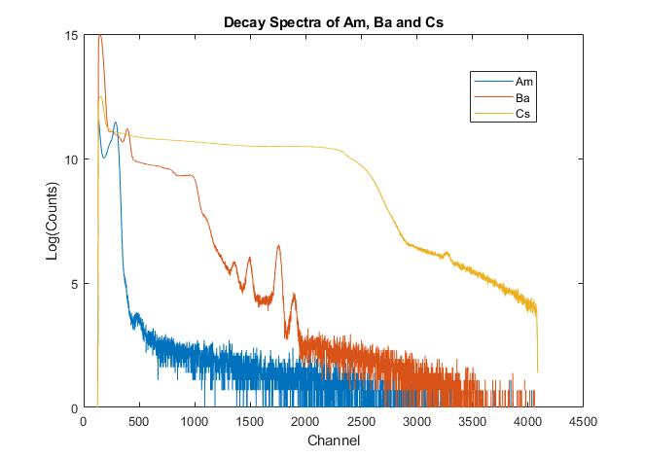
Figure 4 Energy Spectrum Calibration – Left: Linear fit of ADC channel number as a function as a function of the gamma decay energy for $Ba_{56}^{133}, Cs_{55}^{137} and Am_{95}^{241}$, Right: Energy Spectrum of the sources.
$$χ_{red}^{2}$$ | $$P-Value$$ | $$NDF$$ | $$a [KeV]$$ | $$b [KeV]$$
0.29 | $$0.91$$ | $$5$$ | $$-0.0002±31$$ | $$4.936±0.09$$
Table 2 – Summary of the Energy Calibration results. All errors are statistic.
The $χ_{red}^{2}$ is lower then 1 which is suggesting overestimation of errors. To test the linear fit we have performed another linear fit where the errors of the channel means were taken from the Gaussian fits. These errors appear to be larger, although the fit parameters resemble similar results (Appendix D). The first linear fit was chosen as the $a$ value is closer to 0 then in the other fit as we would expect theoretically. The small disagreement and of the two error estimations and the low value of $χ_{red}^{2}$can be explained by the inappropriate choice of the noise fit function. A better choice would be a function which takes into account the closeness of adjacent peaks, for example, the three middle peaks in the $Ba$ spectrum. However, for the current experimental procedures, it is sufficient enough to get the energy – channel relationship from the first fit using $E=\frac{ch-a}{b}$ as $a,b$ do not vary much from different error estimations. Moreover, no trend can be seen in the residual plot at appendix C.
Noise Reduction in Thallium Spectrum
According to [4] the Q-value of $Th_{81}^{204}$ $β$ decay is $763.72±18 KeV$. However, in our experiment the $β$ decay energies went beyond $800 KeV$. This can be explained by a phenomenon closely related to the trend change occurring around $750 KeV$ which can be seen in figure (5). While ideally, each $β$ particle would generate one measurement (=count) in the detector, sometimes $β$ particles with close release times may be counted as one particle as the detector has finite time resolution for one measurement. This double count phenomenon causes measurement of impossible otherwise energies (There might be also triple, and quadruple counts but the probability for these is much lower). In order to remove this unwanted effect, a linear fit was conducted to the range between 810 and 770 $KeV$. The lower bound was chosen as such in order to solely consider this phenomenon without the $β$ decay interference, and the upper bound was chosen by qualitatively inspecting the graph in this range and looking for a value which does not exceed the measurement limits. The error in counts was taken to be statistical, while the error in the energy values was calculated by standard propagation of uncertainty ((25) in [5]) using the values achieved in the energy calibration linear fit.
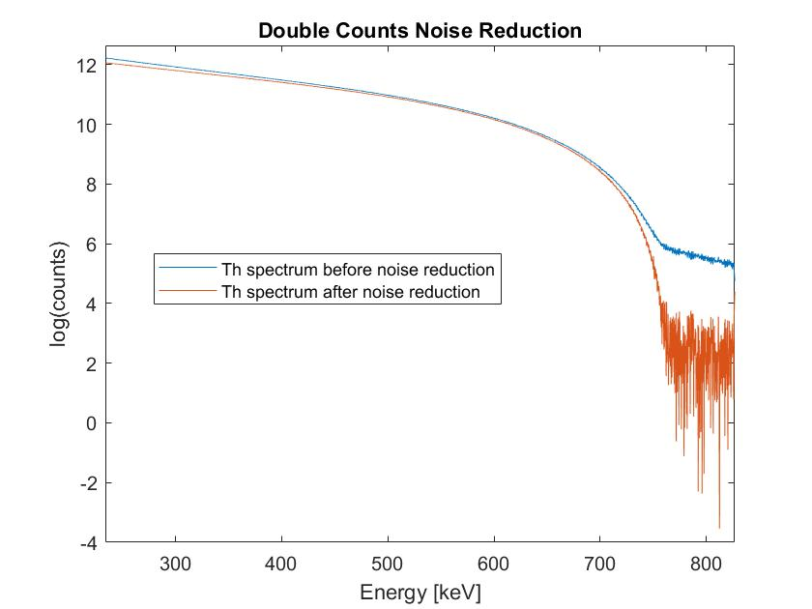
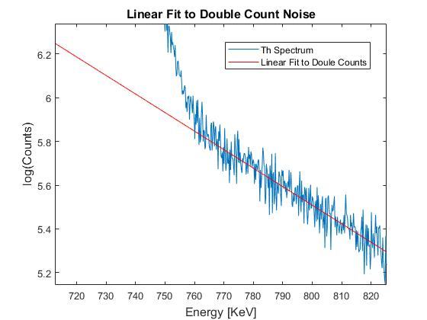
Figure 5 Left: Linear fit for reduction of Double Count noise. Right: resulting Th spectrum without double counts.
$$χ_{red}^{2}$$ | $$P-Value$$ | $$NDF$$ | $$a [KeV]$$ | $$b [KeV]$$
0.0004 | $$1$$ | $$196$$ | $$12±20$$ | $$-0.008±0.015$$
Table 3 – Summary of the Linear Beta spectrum noise reduction results. All errors are statistic.
The extremely small $χ_{red}^{2}$ value is a result of large Poissonian and parameter errors achieved in the previous section. The linear trend appears to be noisy. The resulting spectrum after the reduction indeed has trend change around ~760 and the counts number is greatly reduced as expected. It should be noted that some counts in the reduced spectrum have come negative, which is not physical.

Neutrino Mass Upper Bound
The analysis of the beta spectrum of ${Tl}_{81}^{204}$ is a mean of acquiring an upper bound of the electron’s neutrino mass. In order to do so, a fit according to (1.6) had been performed using three different approximations of Fermi’s function:
- A complete neglection of the coulomb interaction:
$$F\left(Z,T\right)=1$$
- A Non-relativistic approximation [5]:
$$F\left(Z,T\right)=\frac{2πη}{1-\exp\left(-2πη\right)}$$
Where $η=\frac{αZE}{pc}$ is the normalized momentum, and $α≈1/137$ is the fine structure constant.
- A relativistic approximation carried by numeric calculations [6]:
$$F\left(Z,T\right)=\sqrt{A+\frac{B}{T}}$$
Where for $Tl_{81}^{204}$ the constants were found to be: $A=161.9399$ (dimensionless) and $B=403.5753$ (in units of an electron’s rest energy).
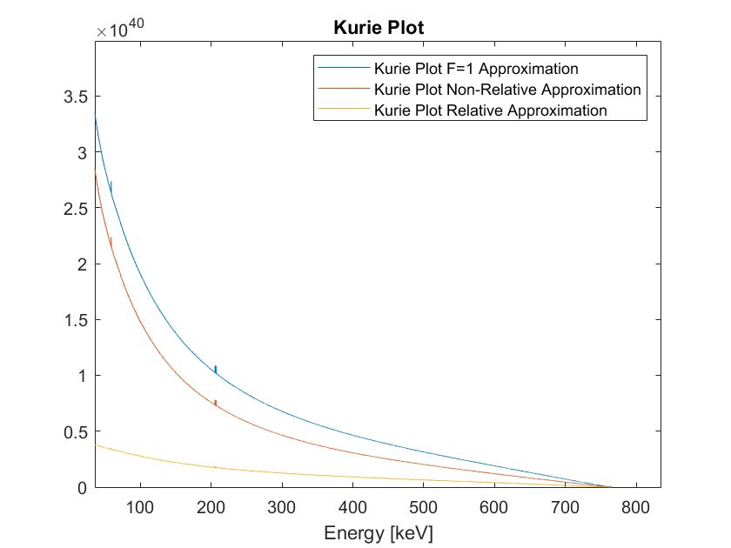
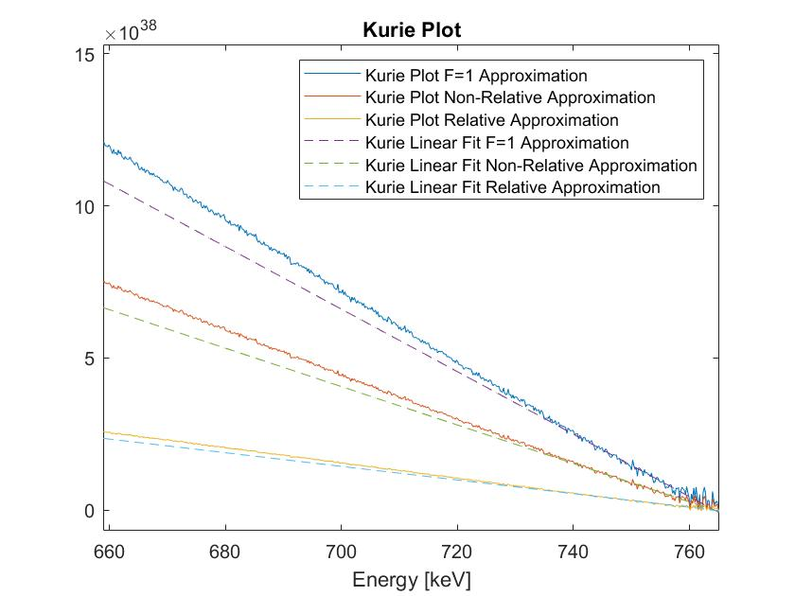
Using these approximations, three Kurie plots were obtained by feeding the noise-reduced spectrum into the right hand of (1.6). linear fits were performed as per (1.6) in the vicinity of the Kurie plot’s coincidence with the energy (x) axis. The exact range for which the fits were conducted was determined by that which resulted in satisfactory goodness of fit measures. It was found to be, in terms of keV, $740≤T≤761$. The error in the energy was taken as a standard resolution error. The error in the beta spectrum counts N was calculated as the standard deviation of poisson distribution $\sqrt{N}$. The errors in the Kurie plots were calculated using the customary indirect errors formula).
Figure 6 Left: Kurie plots of different fermi functions. Right: Kurie plots and their linear approximations, enlarged.
From the fit results we calculated $Q= -\frac{a}{b}$, where a and b are the linear fit parameters. Its error was calculated using the conventional indirect errors formula.
The fit results and their corresponding values of Q are as follows:
$$F$$ | $$a [a.u]$$ | $$b [a.u]$$ | $$χ_{red}^{2}$$ | $$p_{value}$$ | $Q$ [keV]
Unity | $$7.843*{10}^{39} ± 5.5*{10}^{37}$$ | $$-1.0261*{10}^{37} ± 5.2*{10}^{34}$$ | $$1.0$$ | $$0.48$$ | $$764.3±6.6$$
Non-relativistic | $$4.824*{10}^{39} ± 3.4*{10}^{37}$$ | $$-6.312*{10}^{36} ± 3.2*{10}^{34}$$ | $$1.0$$ | $$0.48$$ | $$764.3±6.6$$
Relativistic | $$1.711*{10}^{39} ± 1.2*{10}^{37}$$ | $$-2.238*{10}^{36} ± 1.1*{10}^{34}$$ | $$1.0$$ | $$0.49$$ | $$764.4±6.7$$
Table 4 – Fit results of the linear approximations of Kurie plots.
The goodness of fit parameters clearly infers that, near the intersection, the relationship between Kurie plot and the energy of the electron is indeed linear.
The theoretical value of Q is [7]:
$$Q_{theoretical}=763.72±0.18 keV$$
The upper bound on the neutrino mass was then calculated according to (1.5). The errors are trivially calculated with the formula of indirect errors. The results are:
F | Unity | Non-relativistic | Relativistic
Neutrino mass upper bound [keV] | $$-1.0±6.6$$ | $$-1.0±6.6$$ | $$-1.0±6.7$$

This is an unexpected result, which can be attributed to the large relative errors in the experiment among other things which will be discussed in the next section. The residuals, which can be seen in appendix E, contain no trends.
Conclusions
This experiment was aimed at achieving an upper bound of neutrino mass. The results are unsatisfactory, as the neutrino mass turned out to be negative, which is not physical. We suspect that the model for the noise is not complete, but have not been able to come up with any viable additions or alternatives. This suspicion stems from the result that the noise reduced spectrum contains negative counts at the tail. This is highly unphysical, and consequently impacts the Kurie plot. With those points in mind, the experiment did not fail completely, due the fact that positive neutrino mass values are well within the range of a standard error.
Another concerning matter is the homogeneity of the results for different Fermi functions. One trivial explanation for it is that the effects taken into consideration by the second and third approximations are negligible. Another explanation could be in the unattained noise having a larger effect than the corrections, lowering their apparent significance.
Linearity validation of the system had very large errors due to small measurement times and near system limit amplification values. High amplification values mean higher resolution, however too much resolution can spread the measurements too much and negatively affect the phenomenon evaluation, as may be seen in our experiment. We can notice parabolic like trends in the residual plots in appendix A, and suspect that the system may lose part of it linear behavior close to the channel limits, but more measurements of linearity close to the edges are required to justify it.
Furthermore, Using $γ$ decay in order to calibrate channel-energy relation for $β$ decay may cause large errors as the detector is not designed for $γ$ decay. Even after removing the double count noise, the spectrum still remains noisy near the Q-value energy, which hints at a problem with the detector. Moreover, it might be that the neutrino mass is so small that it cannot be detected by conventional measurement apparatus, including the detector in our experiment. Thus, for continuing the experiment one should use a better detector, suitable to overcome this problem. Finally, longer measurement times are required in order to get more accurate measurements and an upper bound.

- References:
[1] A. Das and T. Ferbel, Introduction to nuclear and particle physics, 2nd ed., World Scientific, River Edge N.J., 2003.
[2] EVIDENCE FOR NEUTRINO MASS: A DECADE OF DISCOVERY by KARSTEN M. HEEGER
[3] K.S. Krane, "Introductory Nuclear Physics", John Wiley & Sons, 1988.
[4] http://nucleardata.nuclear.lu.se/toi/nucSearch.asp
[5] https://www.webassign.net/question_assets/unccolphysmechl1/measurements/manual.html
[6] P Venkataramaiah et al 1985 J. Phys. G: Nucl. Phys. 11 359
[7] Henry Becquerel National Laboratry, http://www.nucleide.org/DDEP_WG/Nuclides/Tl-204_tables.pdf

Appendix A
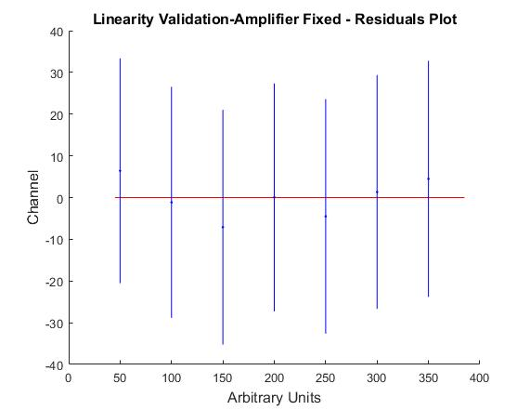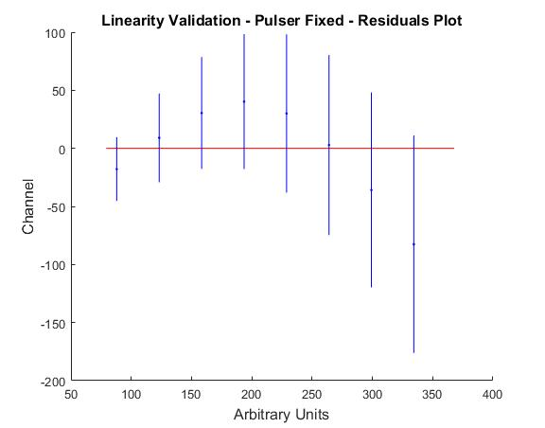
Figure 7 Right side - Linearity validation residuals plot for fixed amplifier values. Left side - Linearity validation residuals plot for fixed pulser values.
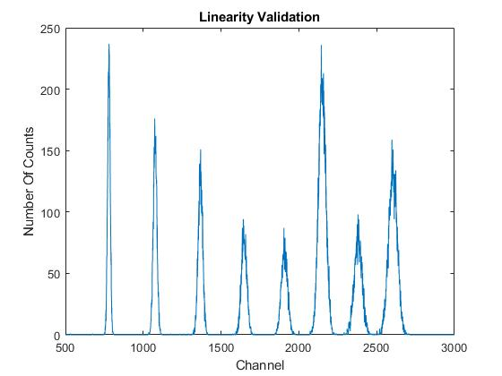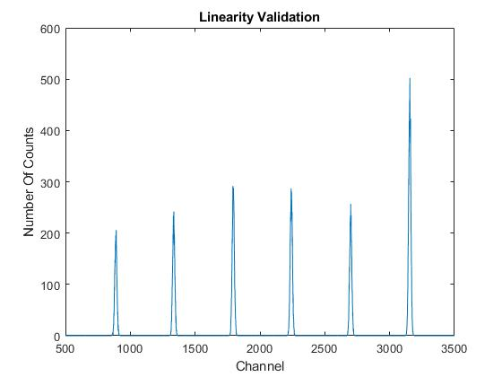
Figure 8 Left side - Number of counts vs Channel when Pulser is fixed. Right side - Number of counts vs Channel when Amplifier is fixed.
Appendix B
$$Source$$ | $$Energy [KeV]$$
$$Ba_{56}^{133}$$ | $$80.997, 276.398, 302.853, 383.851$$
$$Cs_{55}^{137}$$ | $$661.657$$
$$Am_{95}^{241}$$ | $$59.5412$$

Table 7 List of radioactive sources that were used in the experiment for energy calibration. The errors were used from [4]
Appendix C
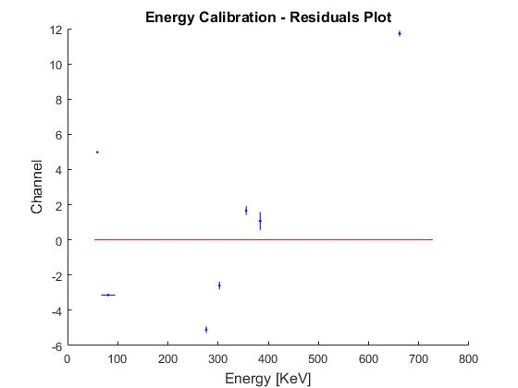
Figure 9 Residual plot of the linear fit of energy vs. channel

Appendix D

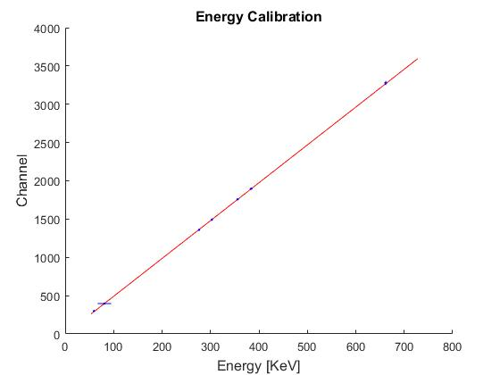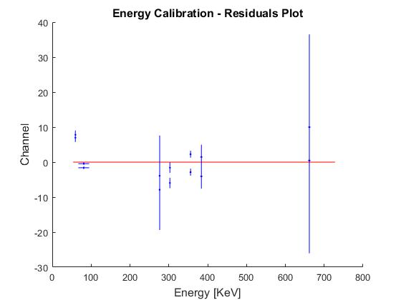
Figure 10 Energy Spectrum Calibration – Linear fit of ADC channel number as a function as a function of the gamma decay energy for $Ba_{56}^{133}, Cs_{55}^{137} and Am_{95}^{241}$
$$χ_{red}^{2}$$ | $$P-Value$$ | $$NDF$$ | $$a [KeV]$$ | $$b [KeV]$$
0.19 | $$0.96$$ | $$5$$ | $$-3.3±11.6$$ | $$4.94±0.43$$
Table 8 – Summary of the Energy Calibration results. All errors are statistic.

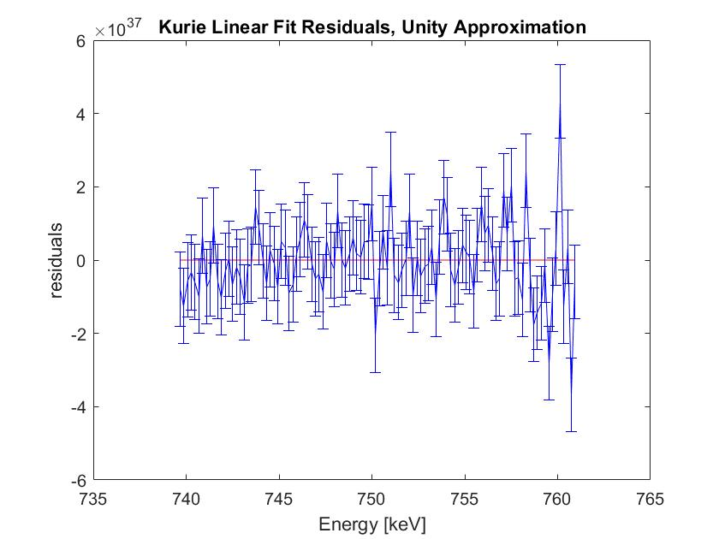
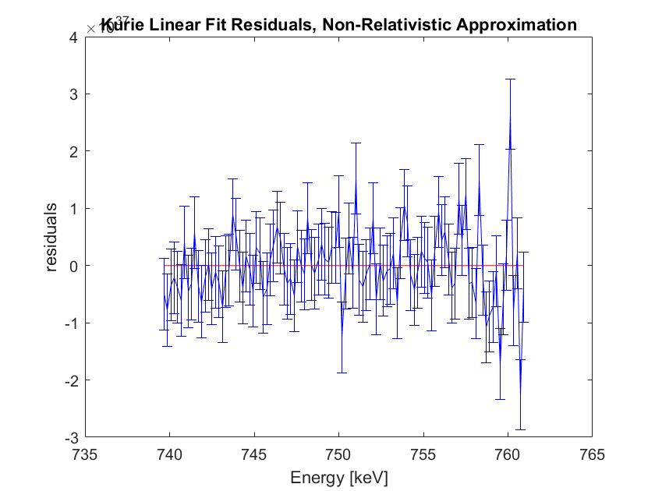
Appendix E
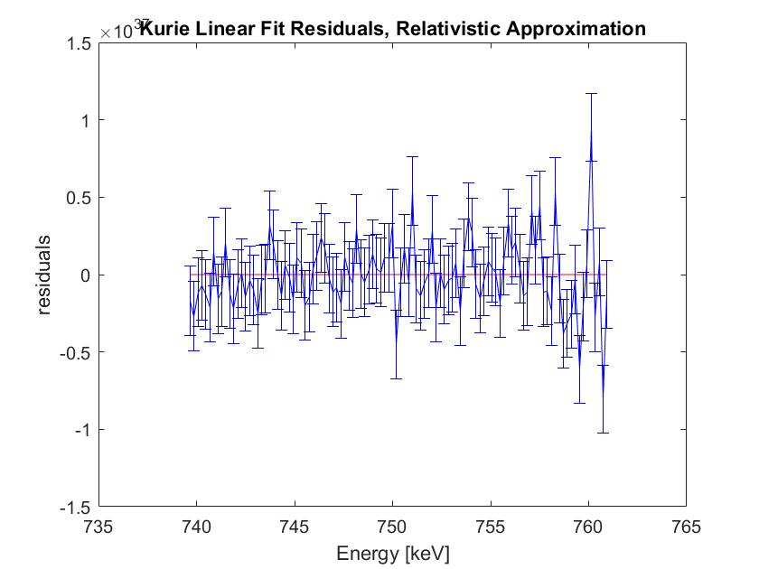

Figure 11 Residual plots for linear fits of Kurie plots. Top left: Unity Fermi function. Top right: Non-relativistic Fermi function. Bottom: Relativistic Fermi function.

That is, $χ_{red}^{2}$ close enough to 1, where in turn “enough” is determined by whether $0.5<p_{value}<0.95$.

