FTNT-FEF8F57D-CDD4-41D4-8E4E-AFD7D0E68D25

Effective and Efficient Security for Small/Medium Businesses and Distributed Enterprises
To be effective against today’s evolving threat landscape, your security solution needs to reliably control network traffic through awareness of applications, users, and content. To be efficient, it needs to be consolidated, simple to manage, and easily scalable.
FortiGate/FortiWiFi entry-level next gen firewalls enable and secure your organization with:

Top-rated protection tested by NSS Labs, Virus Bulletin, and AV Comparatives

Deep visibility and granular control of applications, devices, and users

Simplified security with easy-to-manage, single-platform solution

Actionable reports to enforce policies, understand targeted attacks, and meet compliance

Fortinet entry-level next gen firewalls
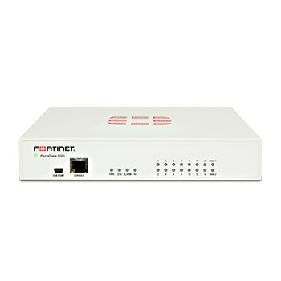

FortiGate 90-60 Series
FortiGate 90 - 60 series appliances deliver up to 3.5 Gbps of firewall throughput, plus multiple, integrated 1 GE ports. This combination of performance, port density, and consolidated security features offers an ideal platform for small and medium businesses as well as distributed enterprises.
Datasheets: 90, 60
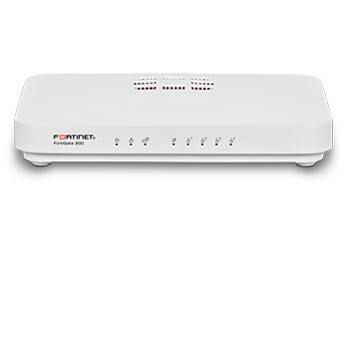

FortiGate 50-30 Series
The FortiGate 50 - 30 series appliances deliver up to 16 Gbps of firewall throughput plus multiple, integrated 1 GE ports. This combination of performance, port density, and consolidated security offers an ideal platform for branch locations.
Datasheets: 50, 30
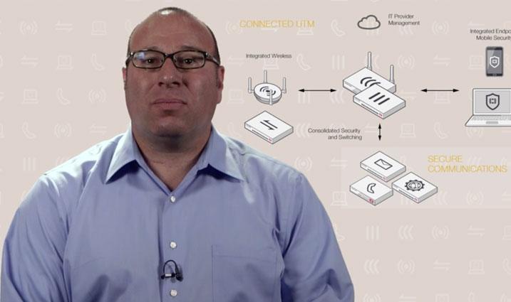

Simplify and Secure Your Small Business Network
Today's Small and Medium Businesses rely on a patchwork of IT and Security products. This video briefly describes how Fortinet's FortiGate Connected UTM reduces costs and increases business agility to accelerate the growth of your business.
Watch Now

Get better protection, deeper visibility, and superior performance
To provide consistently top-rated security, greater visibility, and unmatched performance, we give you the unique combination of the most advanced threat intelligence from FortiGuard Labs with our intuitive FortiOS Operating System, and purpose-built FortiASIC processors.


Consolidated, Intuitive Control with FortiOS


Accelerated Performance with FortiASIC


Industry-leading Security with FortiGuard
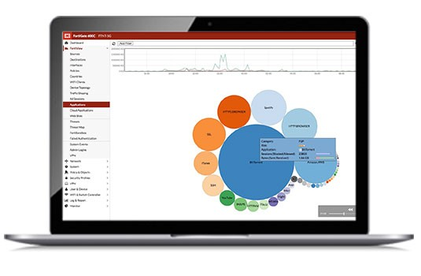

Protect your entire network with one OS
Increase security coverage while simplifying management across your physical, virtual, and cloud deployments.
FortiOS gives you one-click visibility into network traffic and one-click controls to take immediate action.
Learn More

FortiGate next gen firewall features
FortiGuard Security Subscription Services enable visibility and control for next generation protection against advanced threats, including zero day attacks.
The following features work together to give you intelligent, effective network security:
- Application and user-identity awareness
- Content security with integrated intrusion prevention, antivirus, and web filtering
- SSL encryption/decryption
- Advanced threat detection and remediation
Additional critical defense subscriptions can be easily added. You can choose individual services, or get access to all available services with the Enterprise Bundle.

