When we download the binary for random junks, we get an x86_64 executable that seems reasonably straightforward.
Essentially, the program is taking some sort of operation at the top, which we can ignore, reversing and "encrypting" it, and then printing the resulting string. We can see this when we run the program.
`?em wonk uoy oD !!!olleH !sdnatsrednu eno on taht yrots gib a evah I dnA !RACIE si eman yM !edoc ym si siht dnA`
This is followed by two extremely long pieces of text, the second of which looks more like a target for a flag than anything else. More on that later. So, we want to get to the initial string so that we can (probably!) get the flag from that initial string. There are two operations we need to stop from happening: the string reverse and the encryption. The string reverse block is simple. Use your decompiler of choice (I'm partial to Binary Ninja) to replace the strrev() call with a no-operation and do this for all four calls.
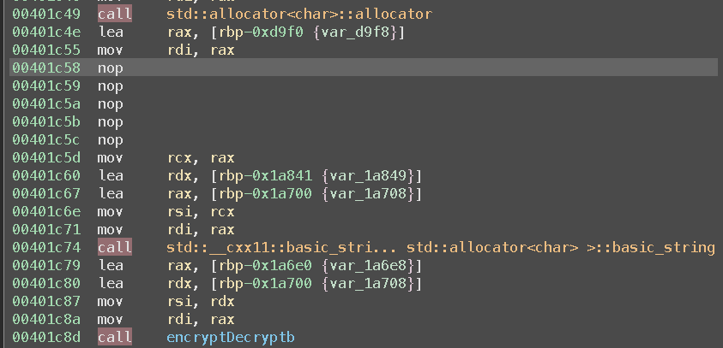
Once this is done, we get a slightly nicer output, but the final print still looks wrong, and we get nothing out of it in terms of converting to another binary or file type, nor do we get a flag string. So, we need to reverse the encryption. Looking at the top, we can see that the so-called encryption isn't really encryption at all. It's an XOR operation with some number, which is different for each encrypt call. This is very easy to stop without using a no-operation patch (because there's a chance that it could mess something else up, so best to take the lowest-impact approach), because an XOR with zero will simply result in an output of the original input.
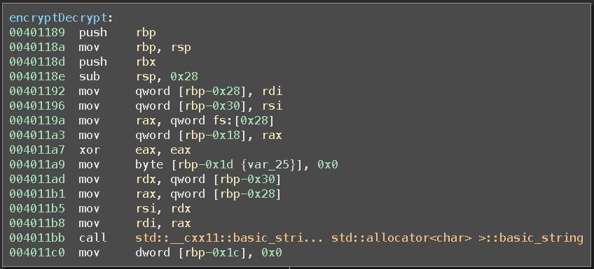
Once this is done, we're ready to run our patched binary. On a hunch, I decoded the file using `xxd -p -r <copiedtext></copiedtext> <targetfile></targetfile>` and used `file` on the output, expecting to see another binary. However, `file h h: PNG image data, 862 x 171, 8-bit/color RGB, non-interlaced` tells us otherwise. It's an image, and viewing the image normally shows that it contains the flag.
