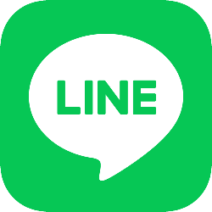

**Registration** **Line**

**for Nova.ChatsConnector**

1. **Open link:** [**https://account.line.biz/**](https://account.line.biz/) **and Create New Business account. You can create an account through your mobile app or email. In this manual further registration is described for email.**

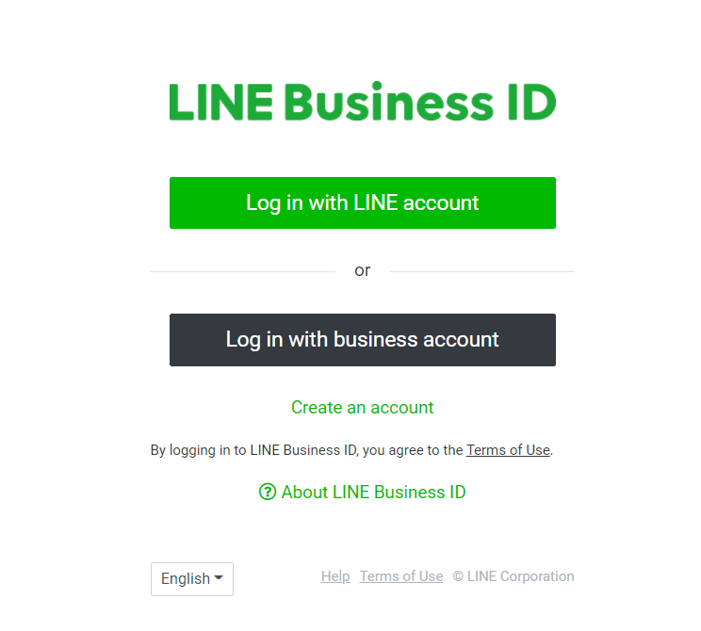

1. **Register new Account through email**

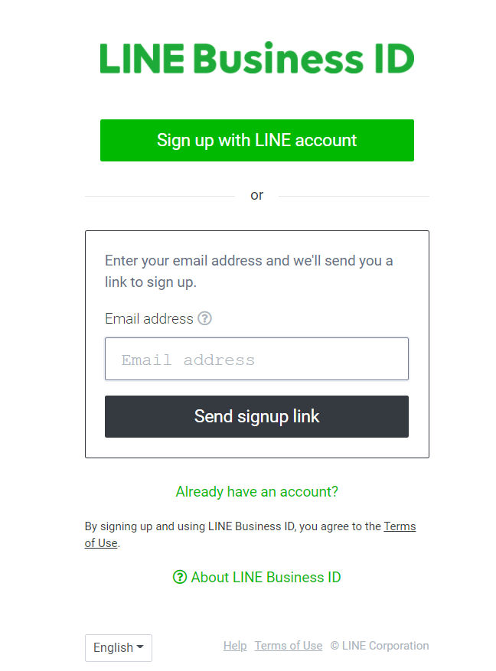

1. **Create a new one and add needed information about your company** 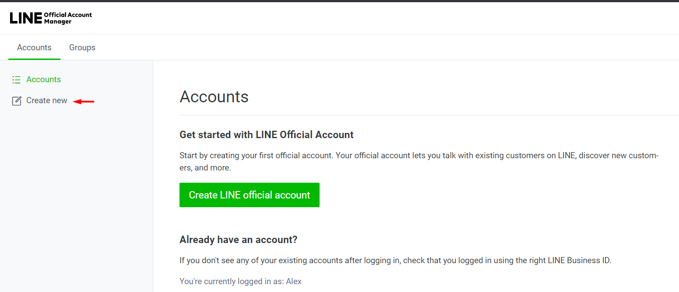

A letter will be sent to the email specified earlier. Click the Continue button in this email

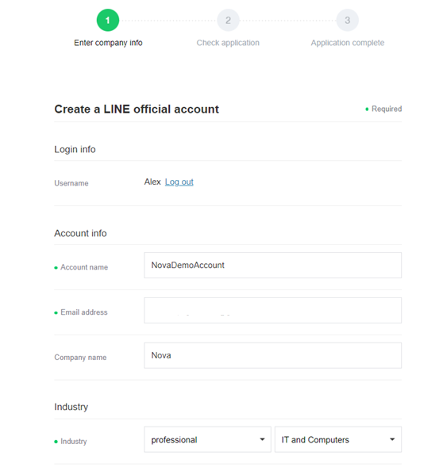

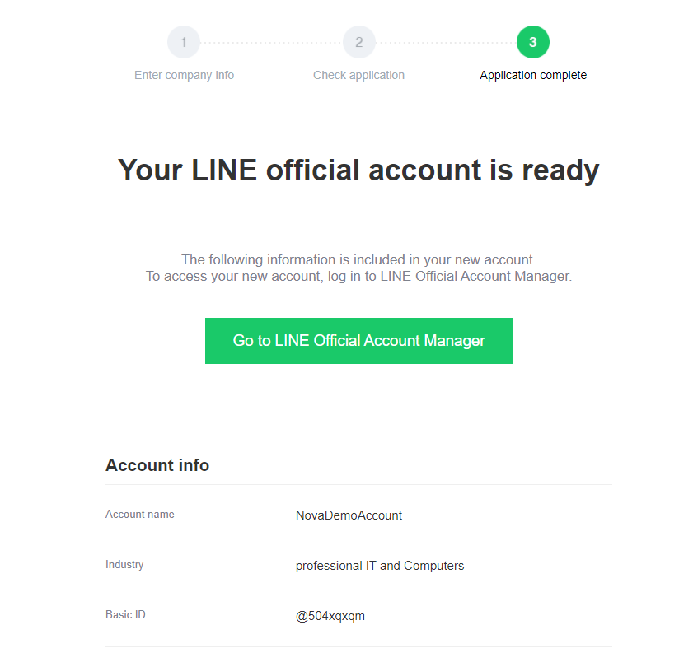

1. **Open link:** [**https://developers.line.biz/console/**](https://developers.line.biz/console/) **and create a Provider and obtain a Token that should be sent to us**

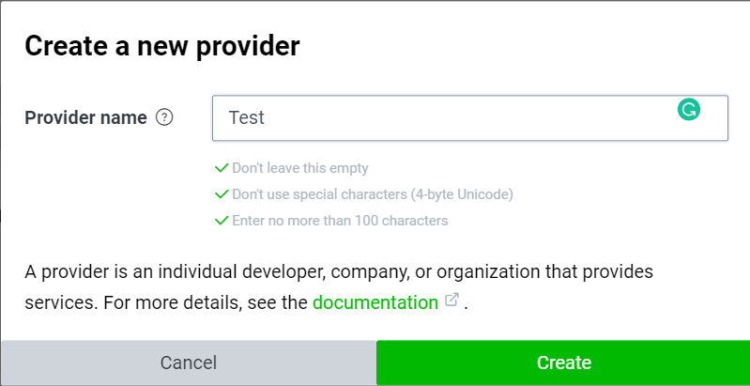

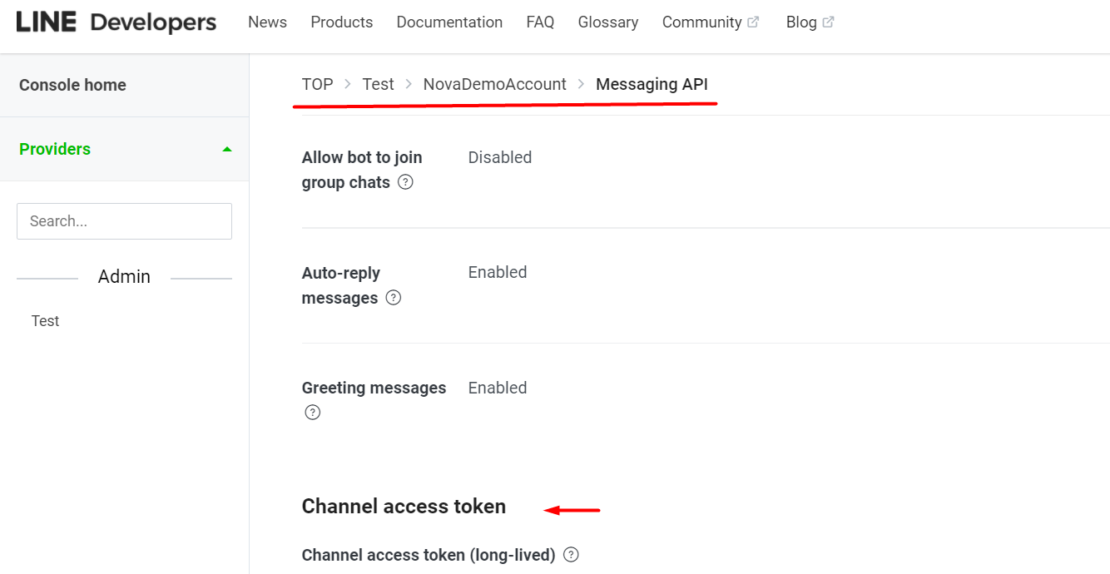

1. 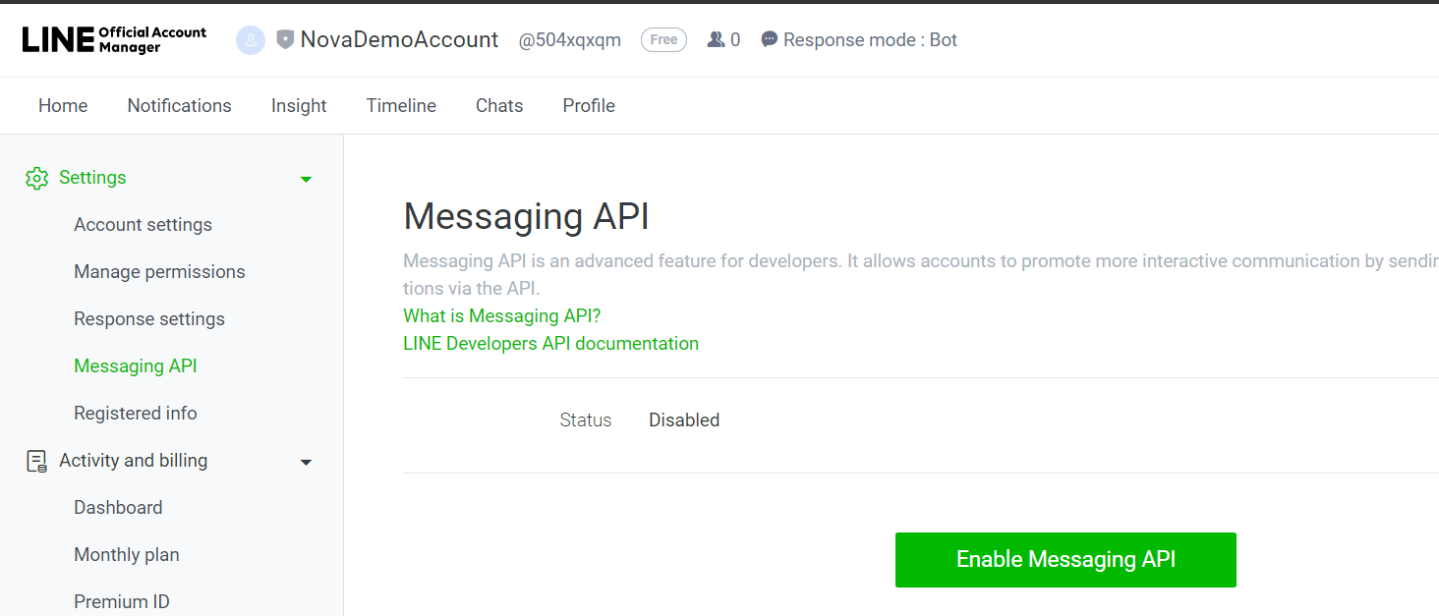**Return to** [**https://manager.line.biz/**](https://manager.line.biz/) **and enable Messaging API, fill needed info.**
2. **Send your Channel Secret to us and we will send your webhook. Place our webhook to your account’s settings:**

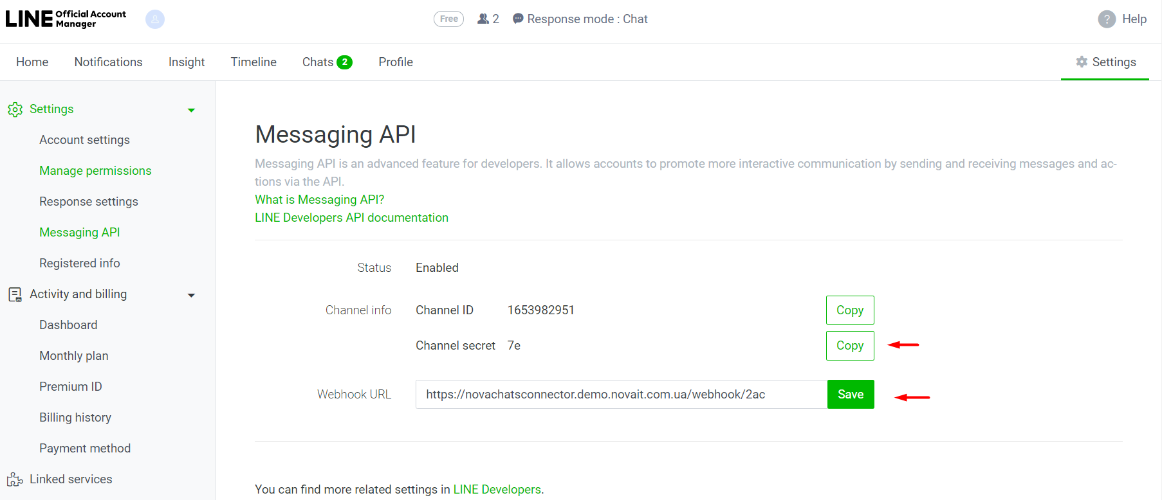

1. **After adding the webhook let us know and we will check how it’s work.**