**Registration** **Facebook Messenger** 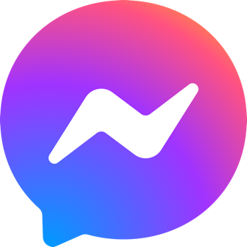

**for Nova.ChatsConnector**

1. **Create account on a Facebook**

<https://facebook.com>

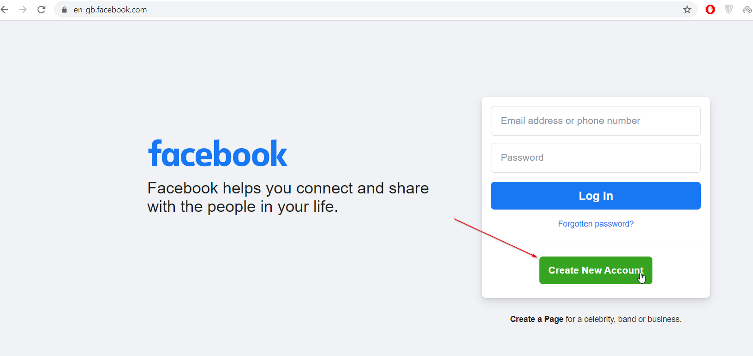

1. **Create account on Facebook Business Manager**

<https://business.facebook.com/overview>

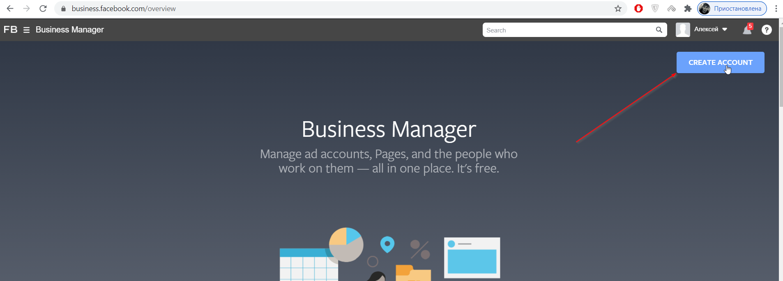

1. **Create application on Facebook developers page**

<https://developers.facebook.com/quickstarts/?platform=web>

Press “Skip and Create App ID”

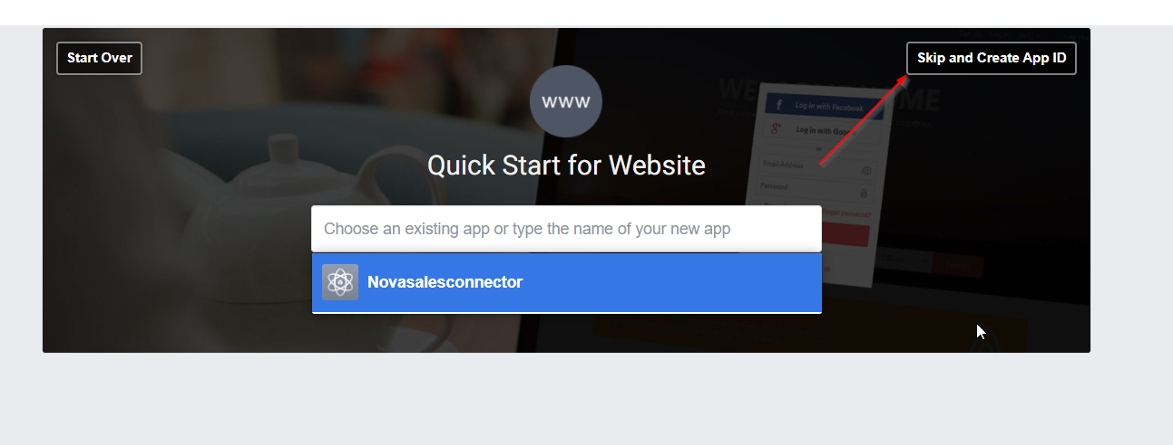

1. **Select an app type and press continue:**

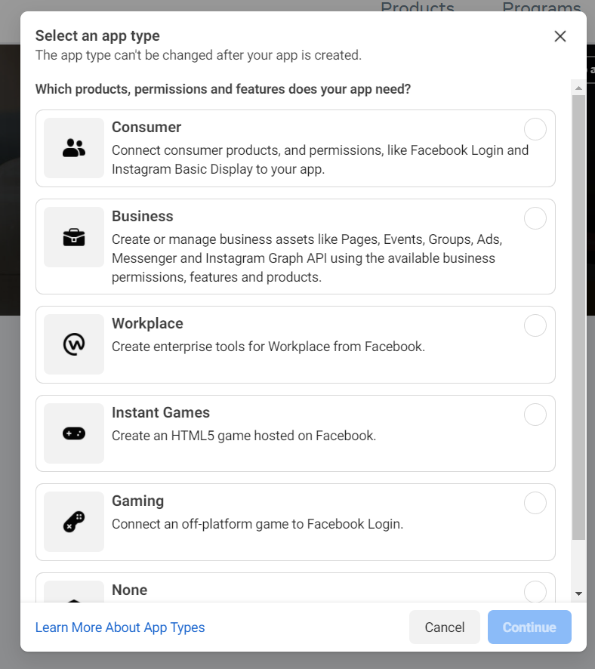

1. **Select App Display Name, App Contact Email, choice App Purpose and press Create App**

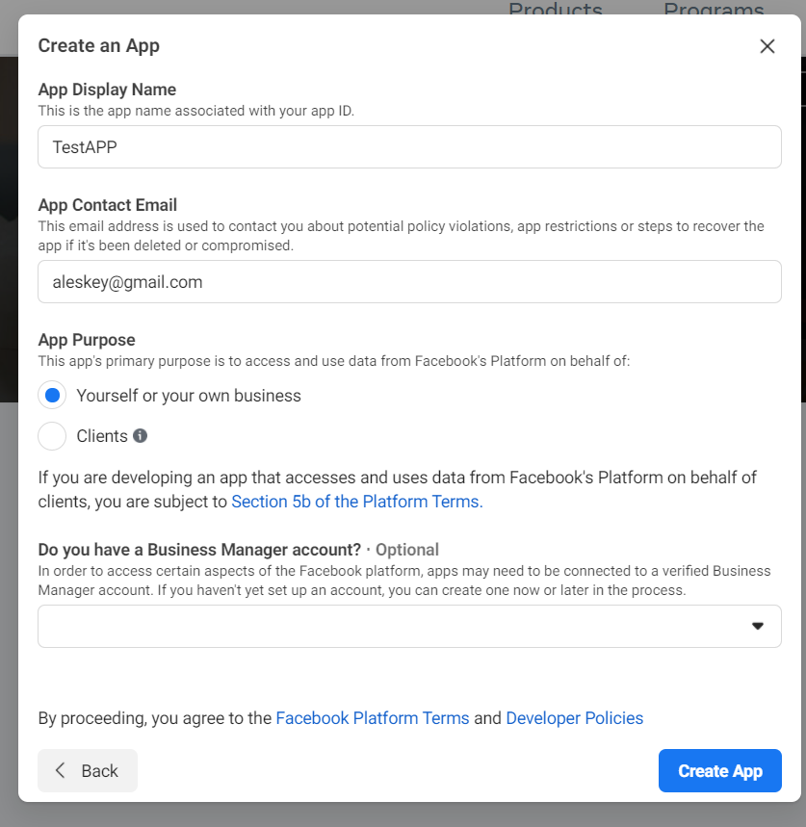

1. **On the opened page press Dashboard and search “Messenger” and press Set Up**

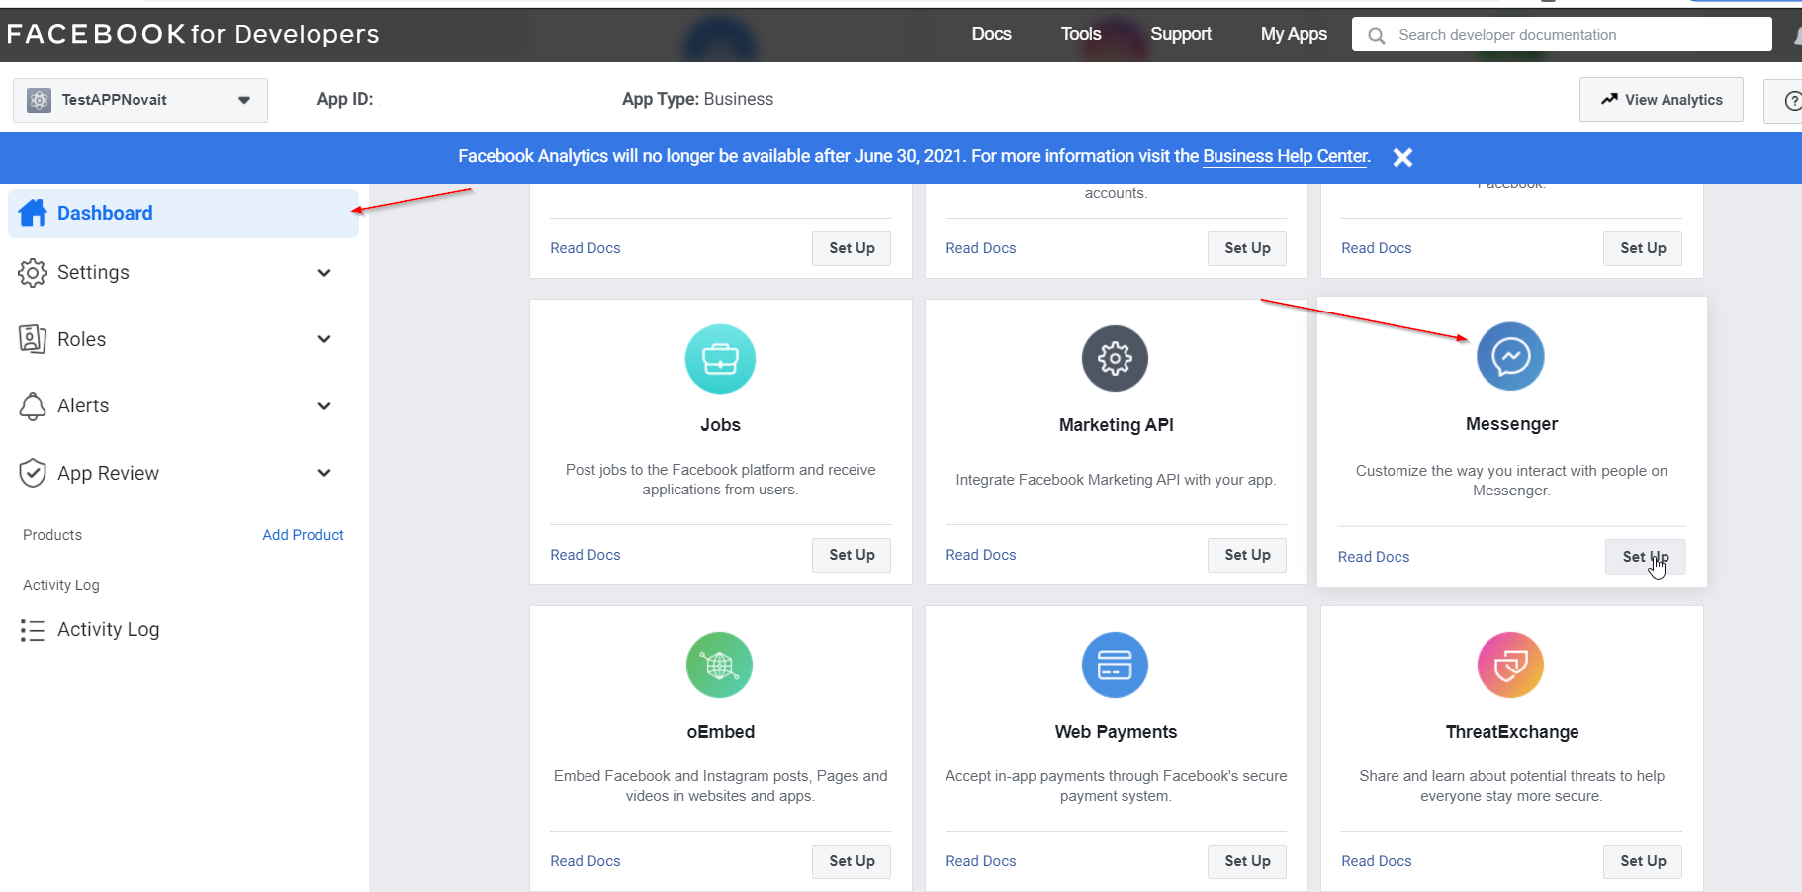

1. **Then search topic “Access Tokens” and press Create New Page**

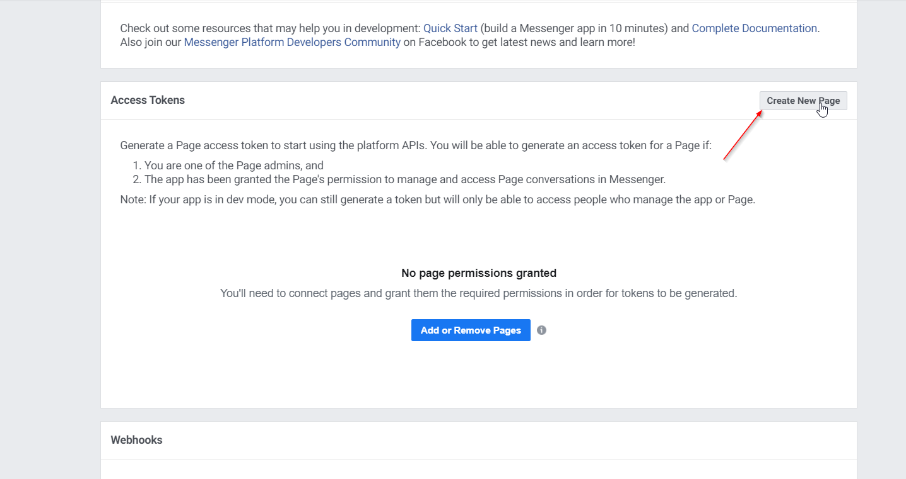

1. **Select Page name, Category and press Create Page**

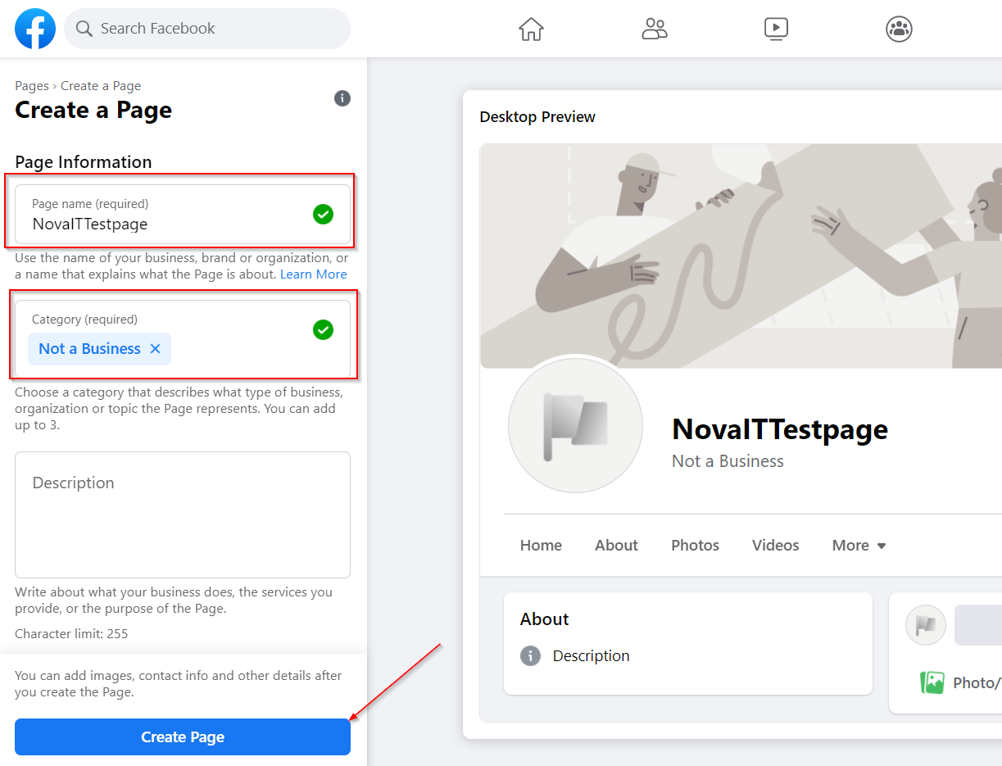

1. **Open** [**https://developers.facebook.com/apps**](https://developers.facebook.com/apps) **and select your Application**

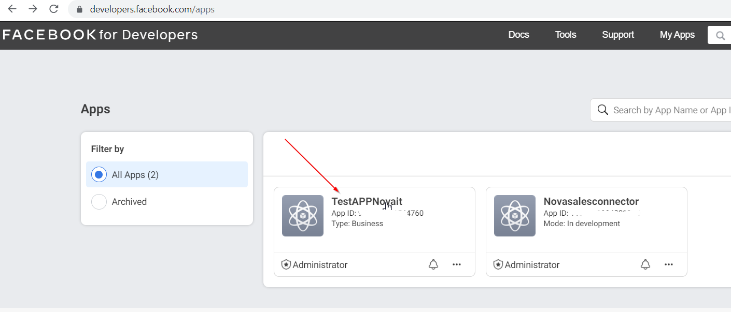

1. **Then press Messenger/Settings**

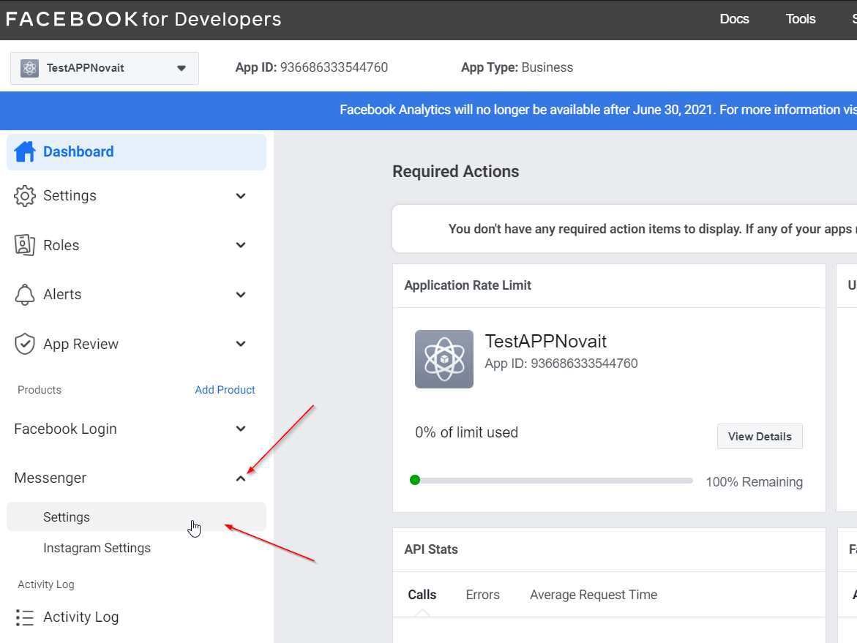

1. **Search “Access Tokens” and press Add or Remove Pages then select your page and press Next, Done, Ok**

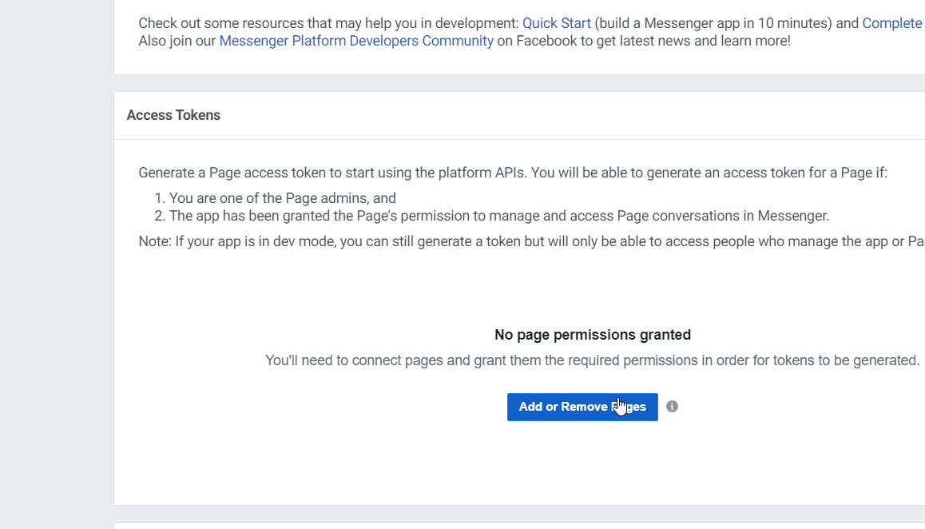

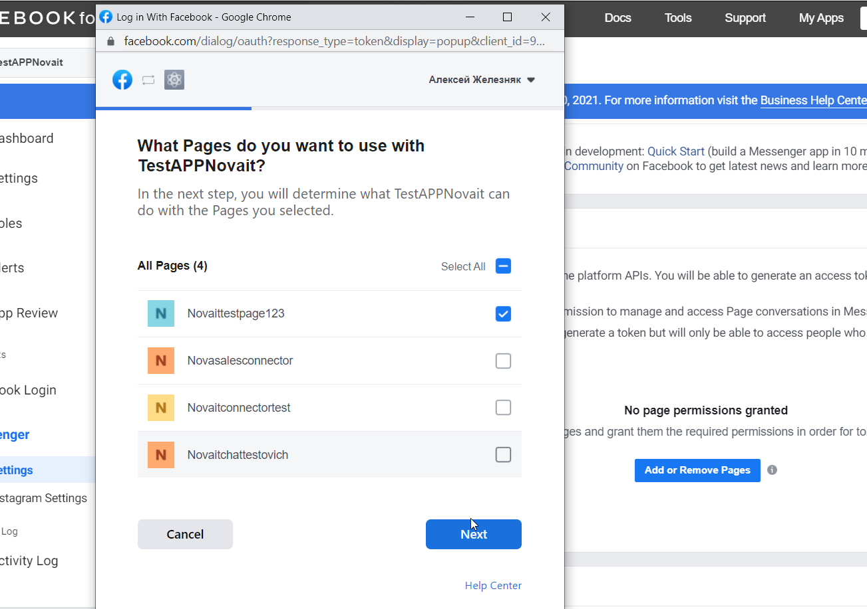

1. **On the next step press “Generate Token” and Copy, Save generated token at the NotePad (or any text editor)**

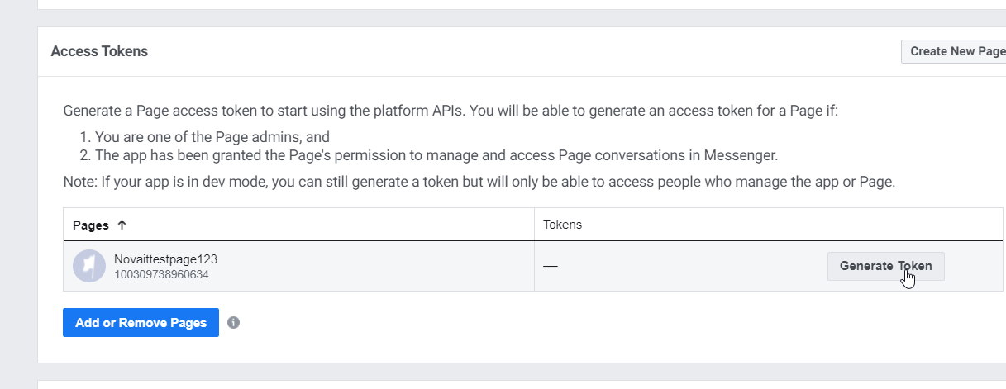

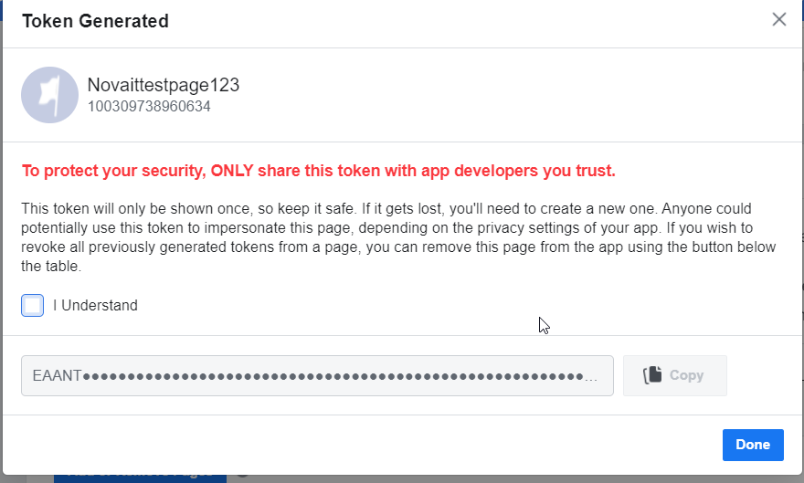

1. **Open** [**https://developers.facebook.com/apps/**](https://developers.facebook.com/apps/) **select your Application, then press Settings/Basic**

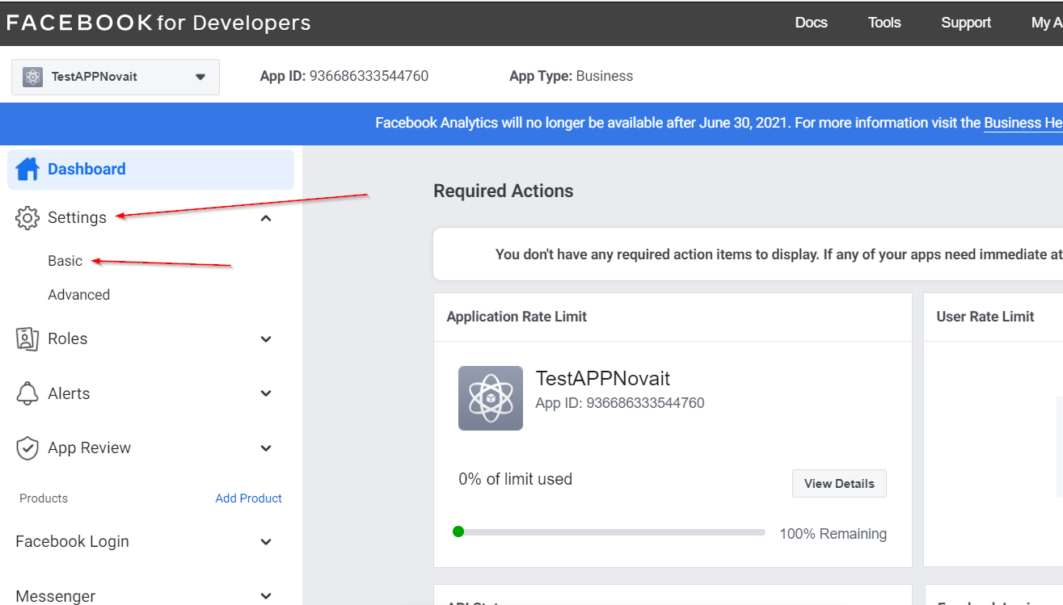

1. **On the opened page search App Secret, then press Show button**

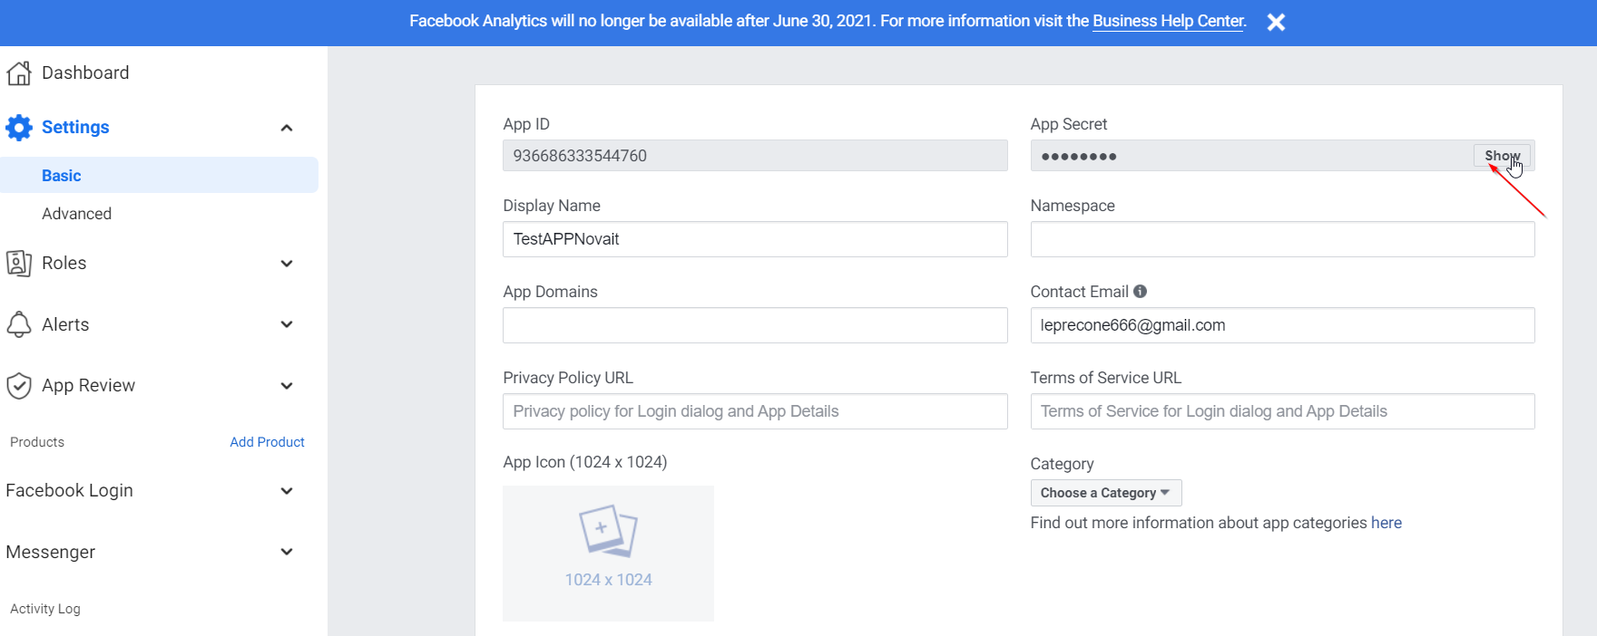

1. **Copy App Secret and save it on the NotePad**
2. **Generate verifyToken - Confirmation token, which you must generate yourself (e.g. through a password generator) "usually a 14-digit password"**
3. **Send to us Token, App Secret and verifyToken from NotePad**

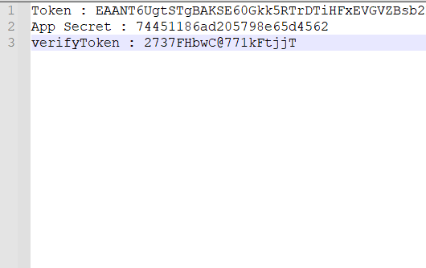

1. **On the next step we send to you webhook (for example:** [**https://novachatsconnector.demo.novait.com.ua/webhook/5d1036e5-93bb-4095-91fe-f1572b2850ec**](https://novachatsconnector.demo.novait.com.ua/webhook/5d1036e5-93bb-4095-91fe-f1572b2850ec)**)**
2. **Open** [**https://developers.facebook.com/apps/**](https://developers.facebook.com/apps/) **select your application, press on toolbar Messenger/Settings**

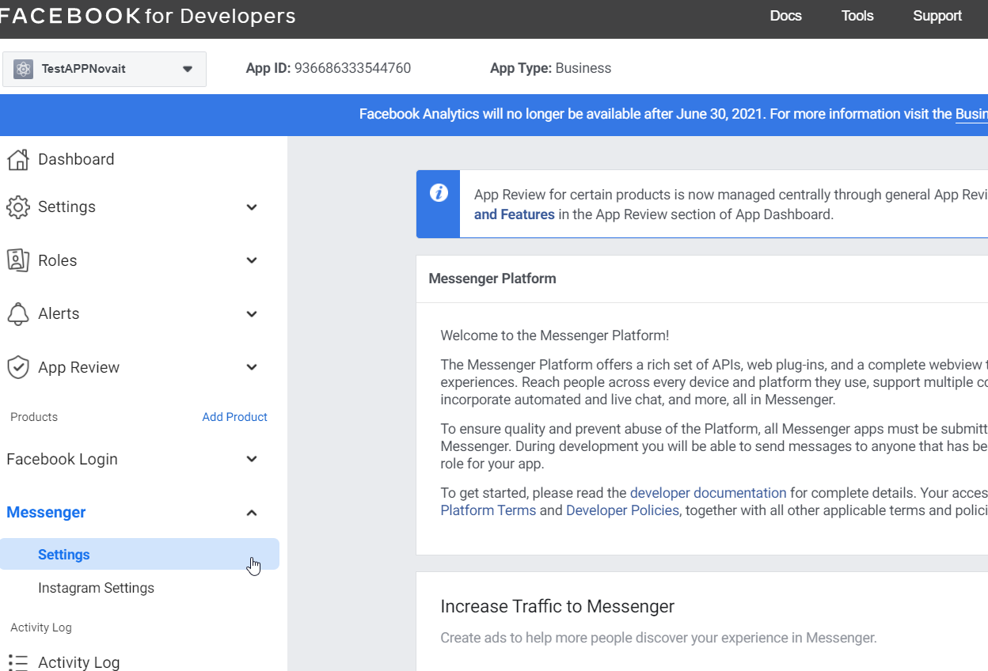

1. **Then search Webhooks and press Add Callback URL**

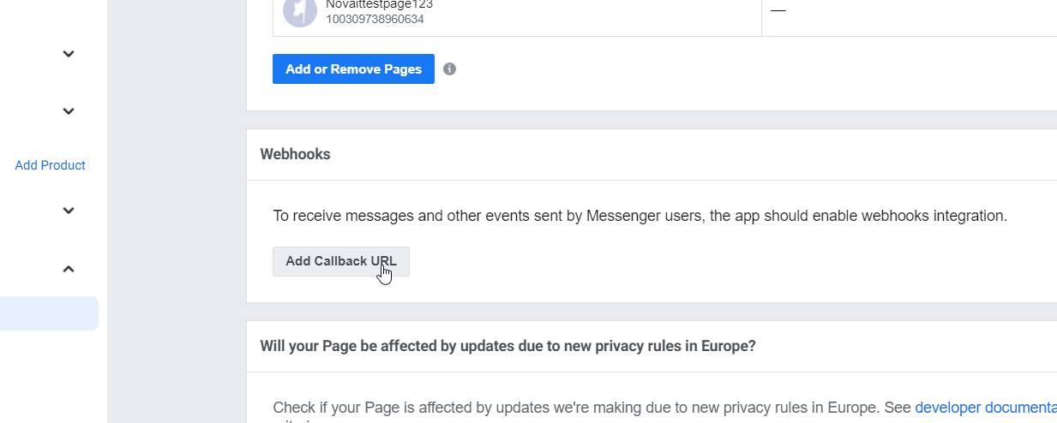

1. **Type our webhook URL and verifyToken on the opened window and press Verify and Save**

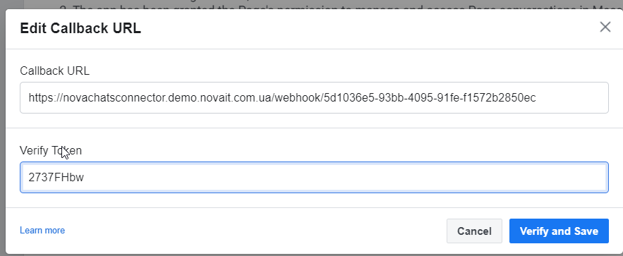

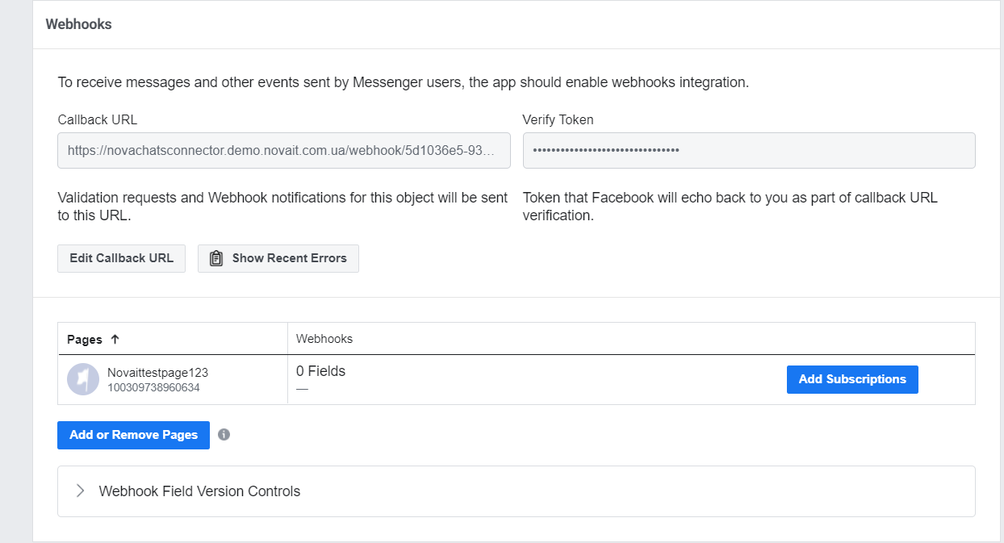

1. **Now we need add subscriptions on the page**

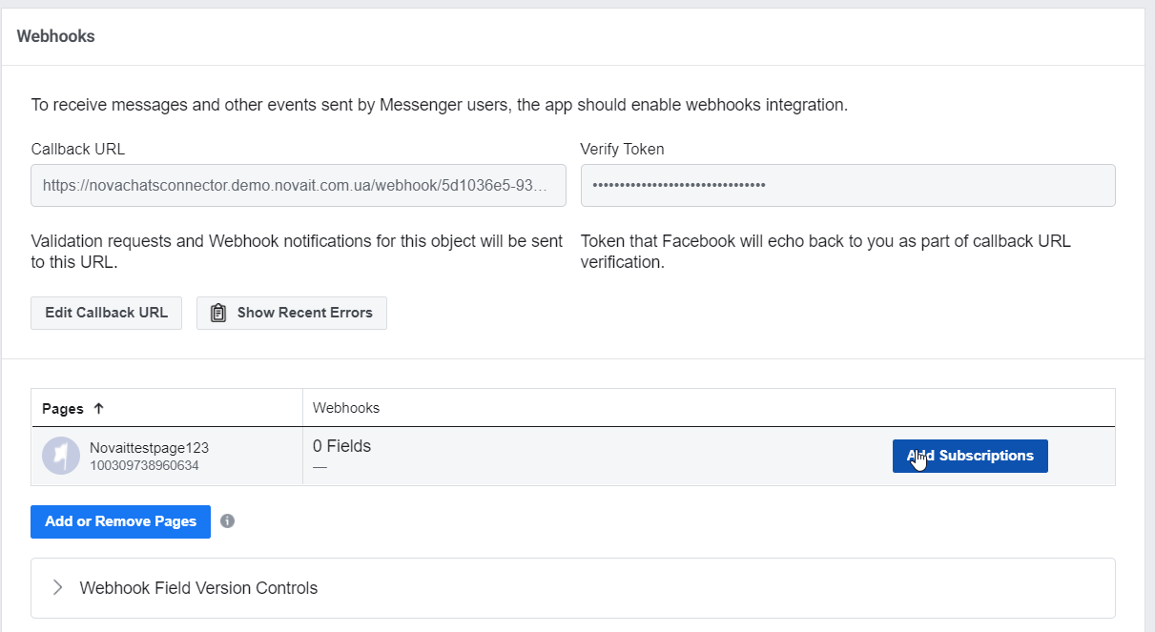

1. **Press Add Subscriptions and add fields – messages, messaging_postbacks, messaging_optins, message_deliveries and press Save**

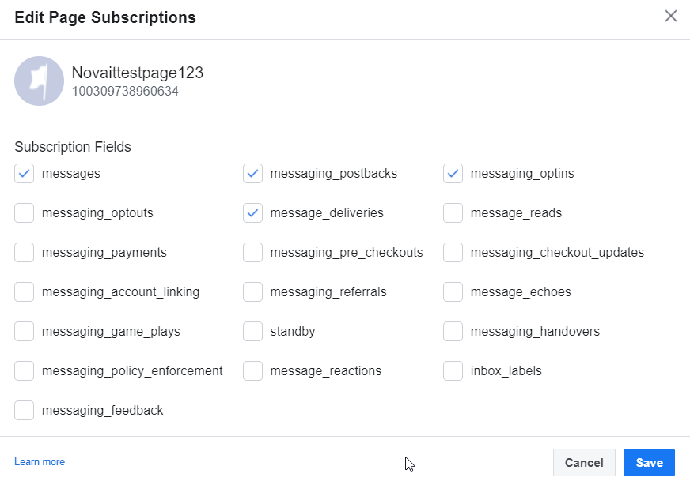

1. **Now we can write on the agent workstation**
2. **Open your Facebook page and press on Messenger icon**

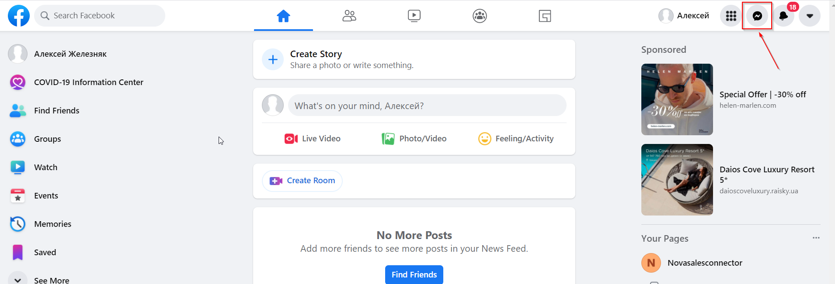

1. **Then on the search write your Business Page name and press on it, now you can write test message and receive it on the Genesys agent workstation**

