1.

SELECT COUNT ()

FROM Customers

WHERE Country='Germany';

Ответ: 11 клиентов из Германии.

2.

SELECT COUNT ()

FROM Customers

WHERE CustomerName LIKE '%e';

Ответ: имена 14 клиентов оканчиваются на на 'e'.

3.

INSERT INTO Customers

VALUES ('99','Aka_corp','Akimenko Olegka','Gorachaya 49','Nsk','301136','Russia');

SELECT * FROM [Customers]

Where CustomerID='99'

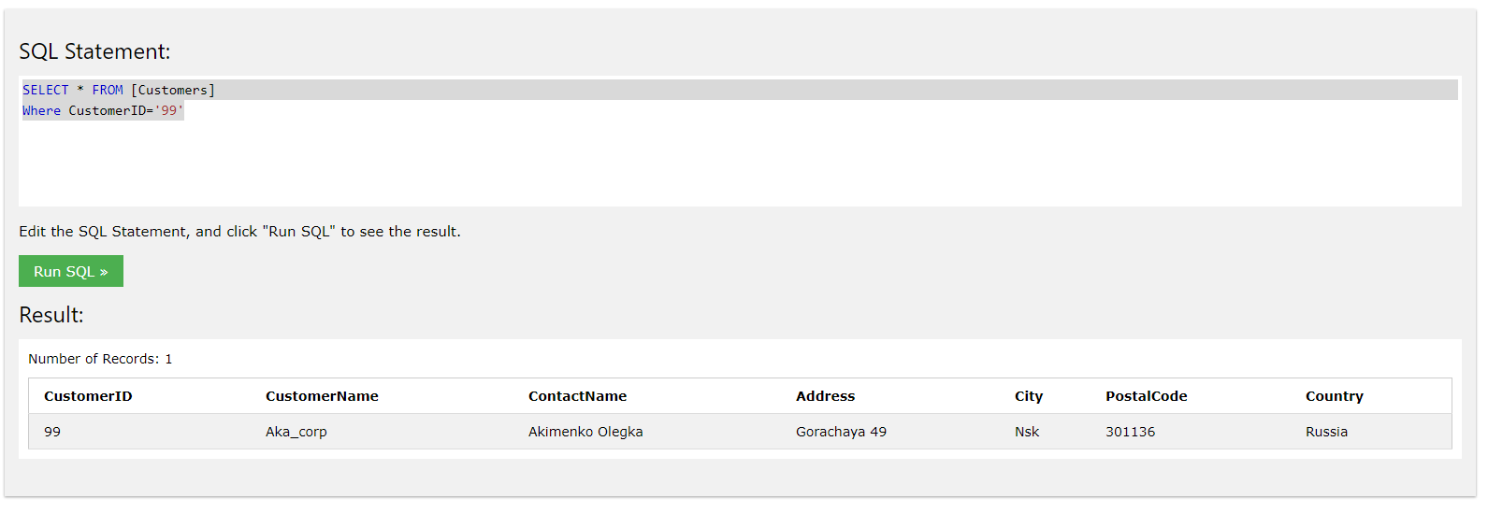

4.

UPDATE Customers

SET ContactName = 'Schalun Bolshoy'

WHERE CustomerID = 99;

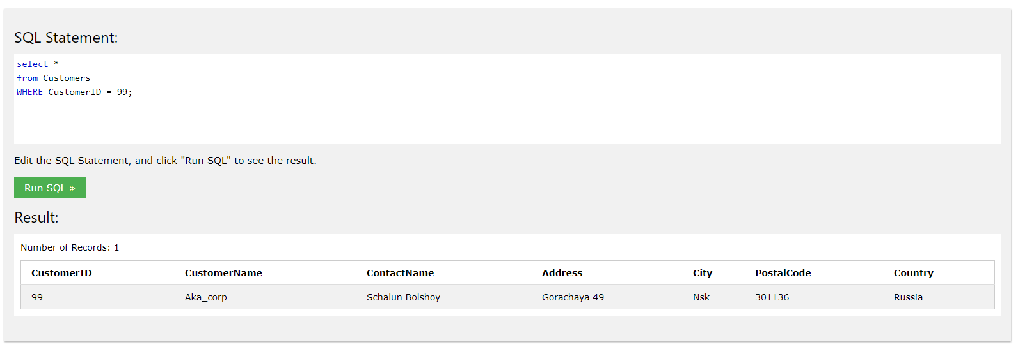

5.

DELETE FROM Customers

WHERE City='Nantes';

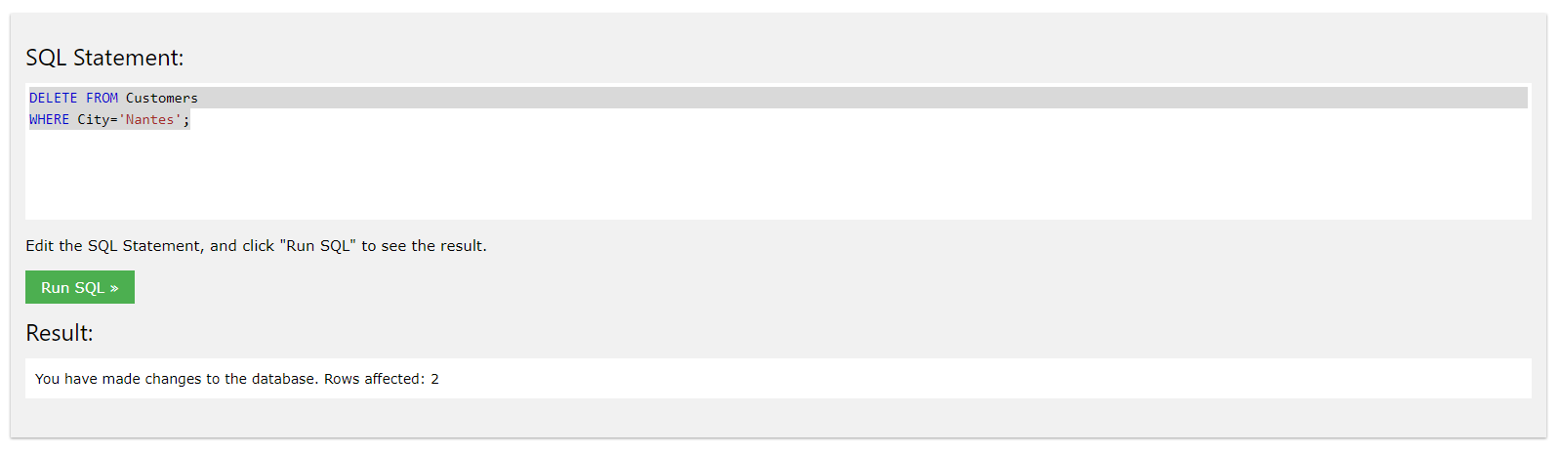

select *

FROM Customers

WHERE City='Nantes';

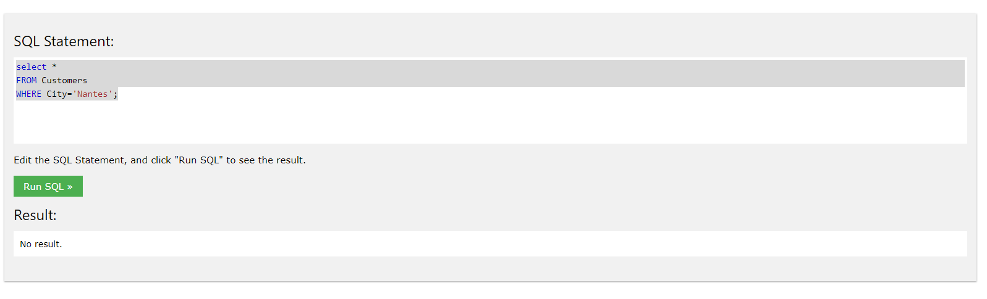

Ответ: нет результатов.

6.

SELECT Orders.OrderID, Employees.FirstName='Steven'

FROM Orders

INNER JOIN Employees ON Orders.EmployeeID = Employees.EmployeeID

ORDER BY Employees.FirstName desc;

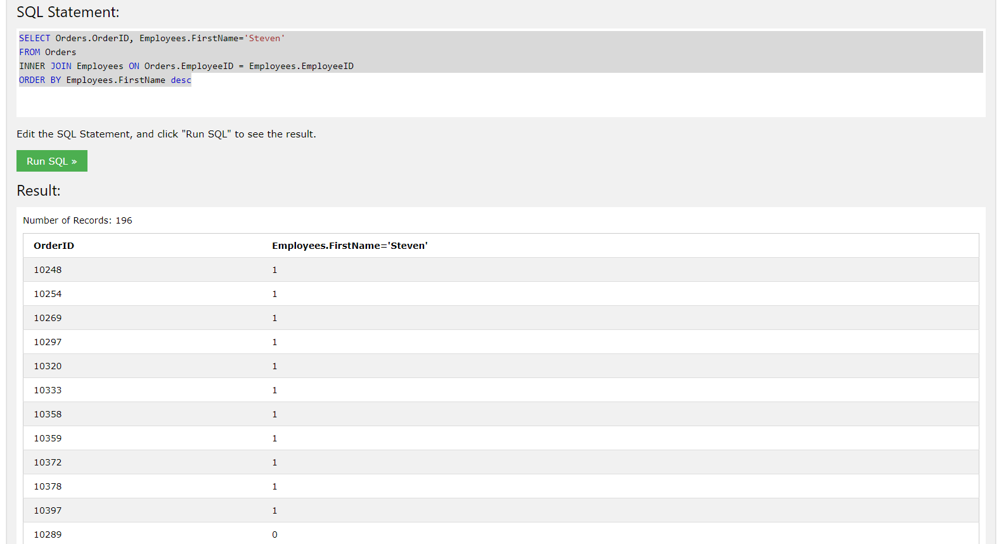

Ответ:

10248, 10254, 10269, 10297, 10320, 10333, 10358, 10359, 10372, 10378, 10397