**[SQL]**

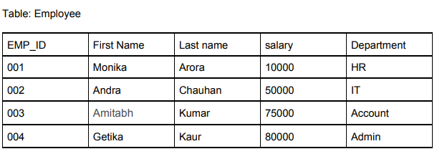

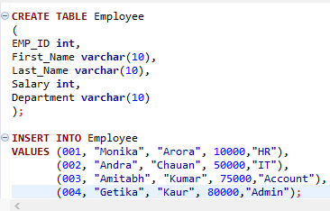

*A. Write an SQL query to print the DEPARTMENT from the Employee table after removing white spaces from the left side?*

**SELECT LTRIM(Department) FROM Employee;**

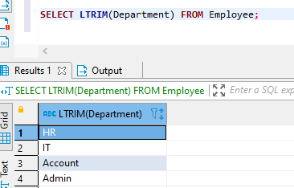

*B. Write an SQL query to print the FIRST_NAME and LAST_NAME from the Employee table into a single column COMPLETE_NAME. A space char should separate them?*

**select CONCAT(first_name, ' ', last_name) complete_name**

**from employee**

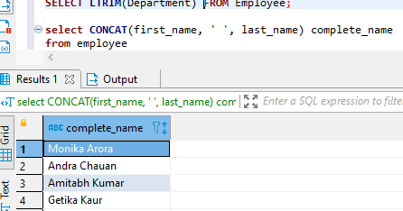

*C. Write an SQL query to print details of the Workers whose FIRST_NAME ends with ‘h’ and contains six alphabets.*

**select \***

**from Employee**

**where first_name LIKE '%____h'**

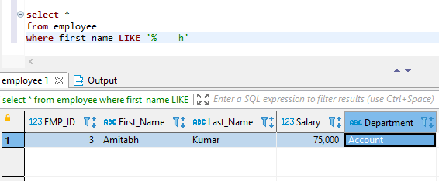

*D. Write an SQL query to show only odd rows from a table.*

**select \***

**from employee**

**where MOD(emp_id, 2)=1**

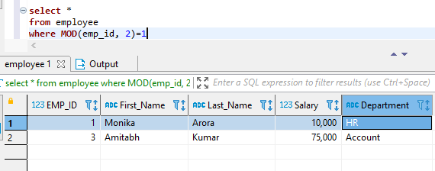

*E. Write an SQL query to fetch three min salaries from a table.*

**select salary**

**from employee**

**limit 3**

