Assignment AS#2

Part A: download and put into HDFS/user/training using HUE for steps 1 & 2

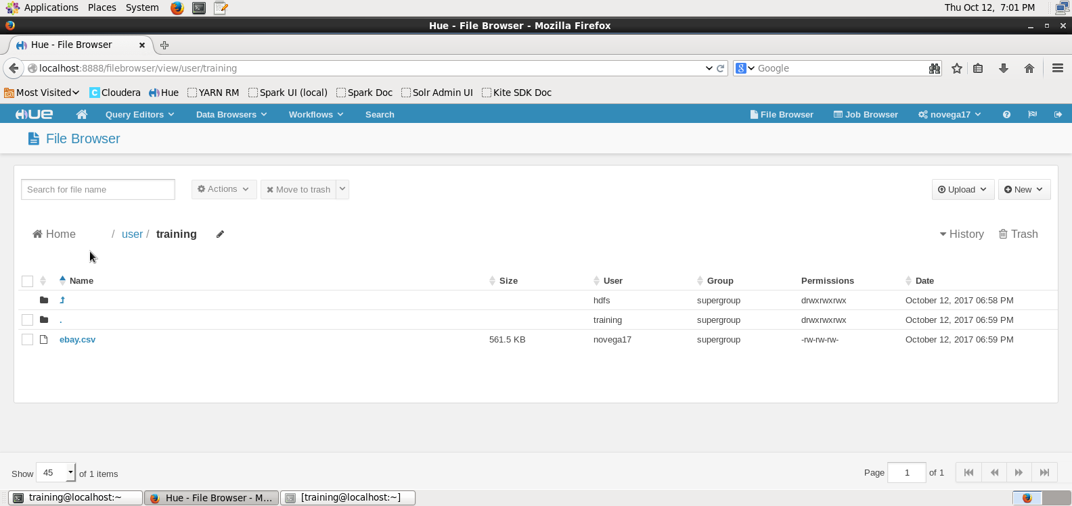

3

At the $:

spark-shell

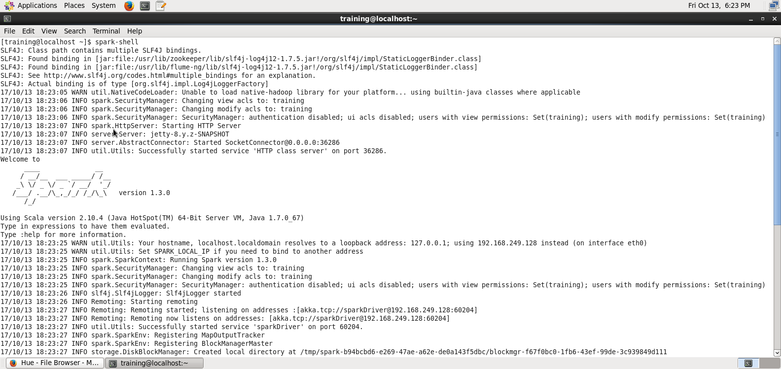

4

val sqlContext=new org.apache.spark.sql.SQLContext(sc)

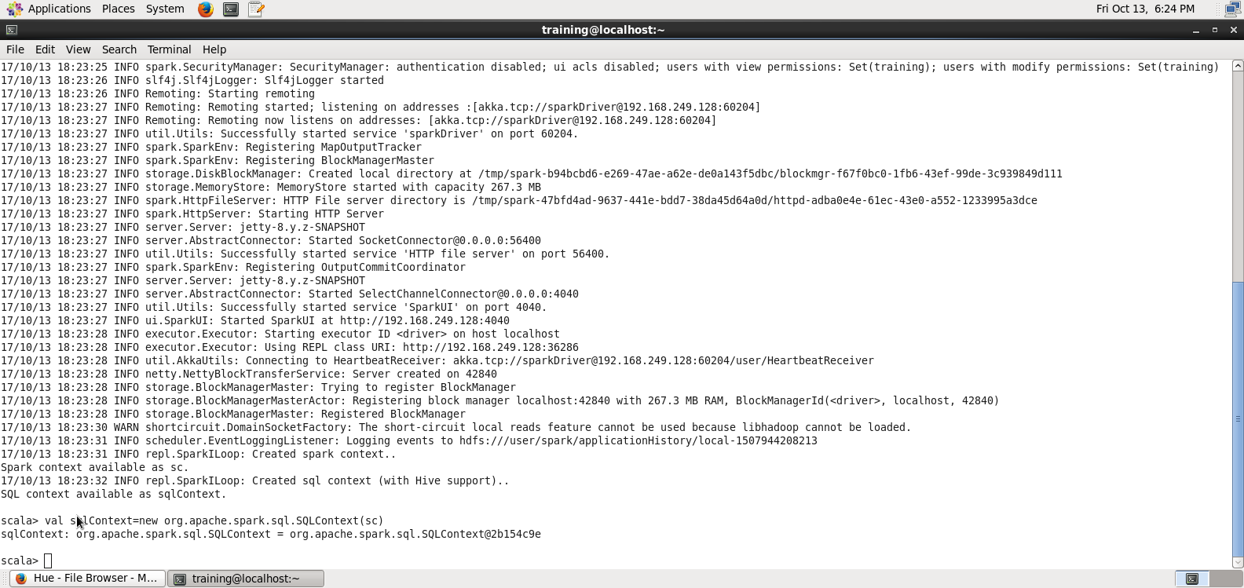

import sqlContext.implicits._

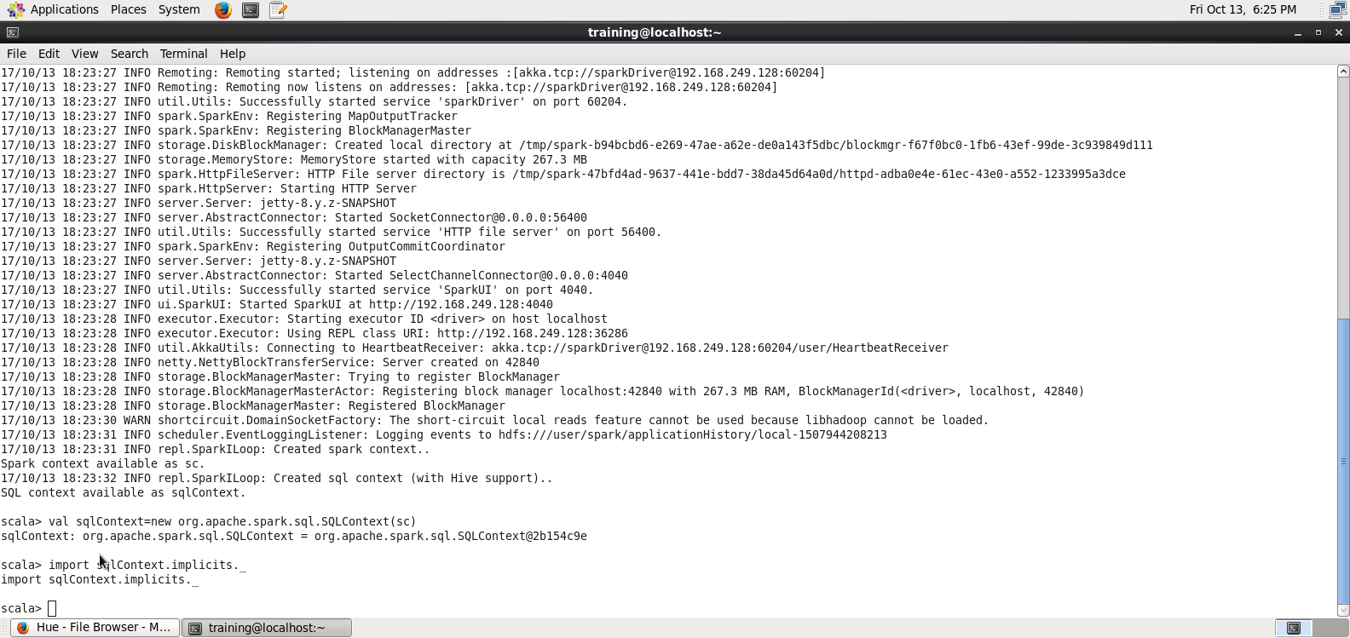

import org.apache.spark.sql._

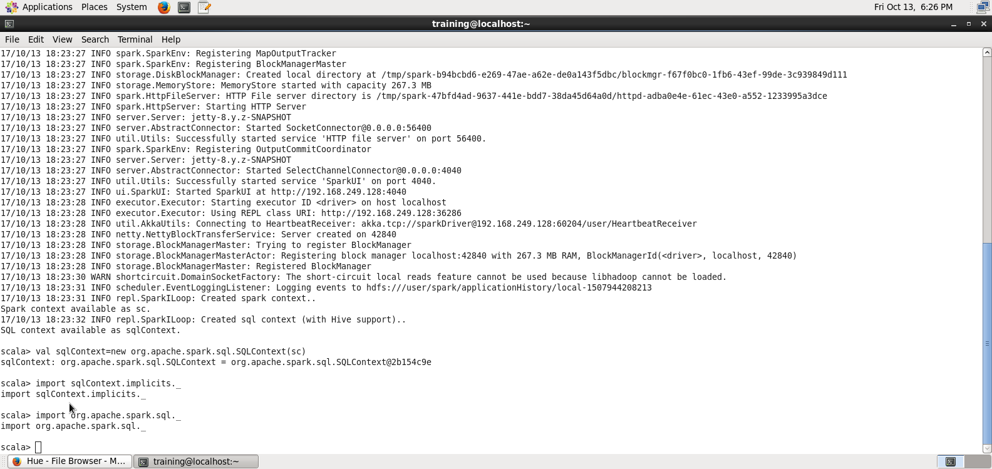

5

####wrong val mydata = sc.textFile("file:/user/training/ebay.csv")

val ebayText = sc.textFile("hdfs:///user/training/ebay.csv")

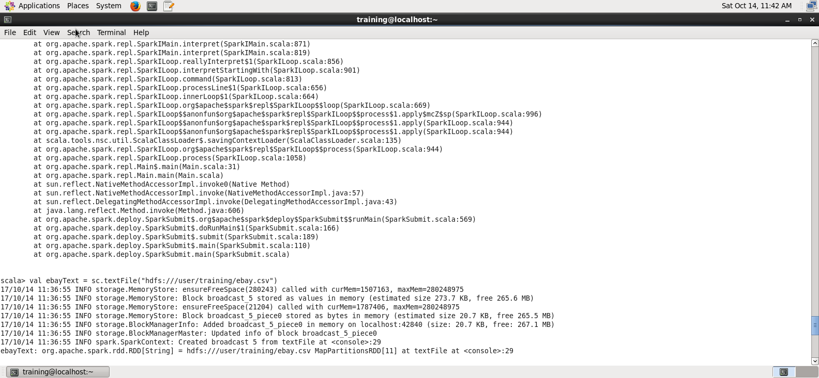

6

ebayText.first

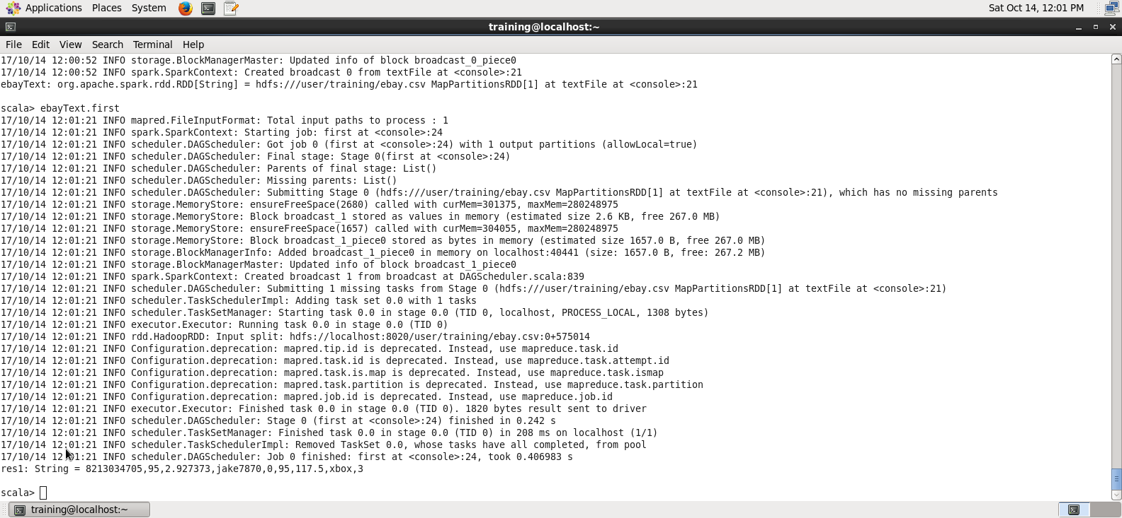

7

case class Auction(auctionid:String, bid: Float, bidtime: Float, bidder: String, bidderrate: Integer, openbid: Float, price: Float, item: String, daystolive: Integer)

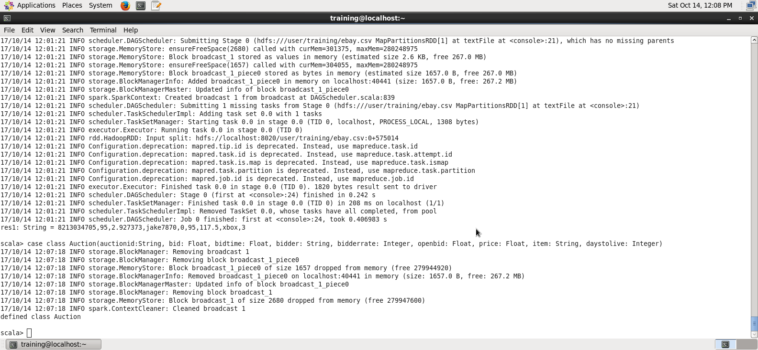

8

val ebay = ebayText.map(_.split(",")).map(p =>

Auction(p(0),p(1).toFloat,p(2).toFloat,p(3),p(4).toInt,p(5).toFloat,p(6).toFloat,p(7),p(8).toInt))

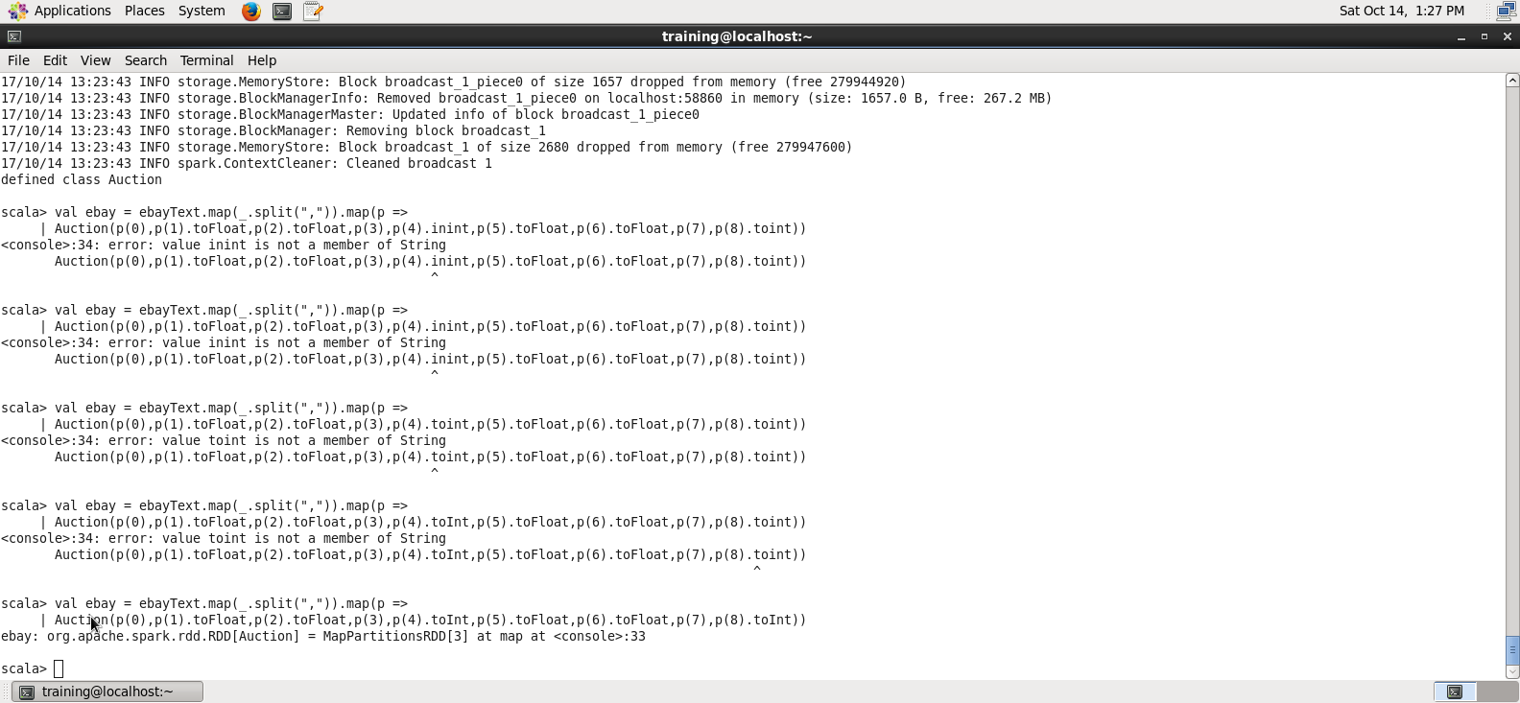

9

###ebayText.first

ebay.first()

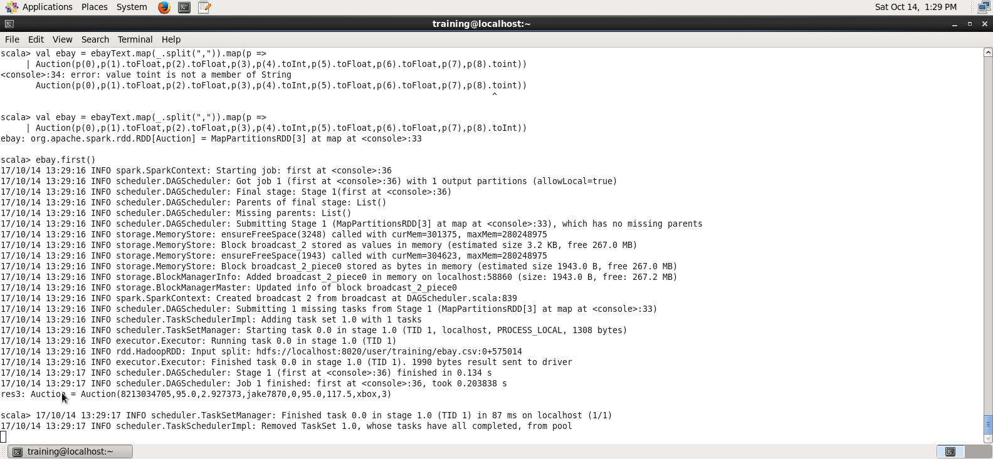

10

ebay.count()

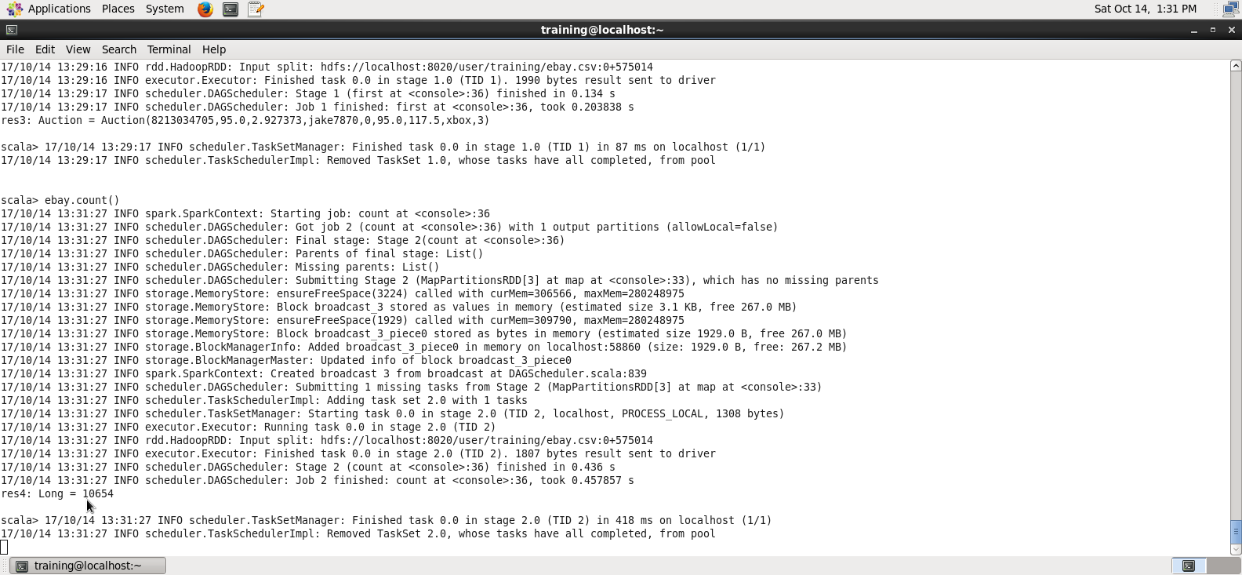

11

import sqlContext.implicits._

val auction = ebay.toDF()

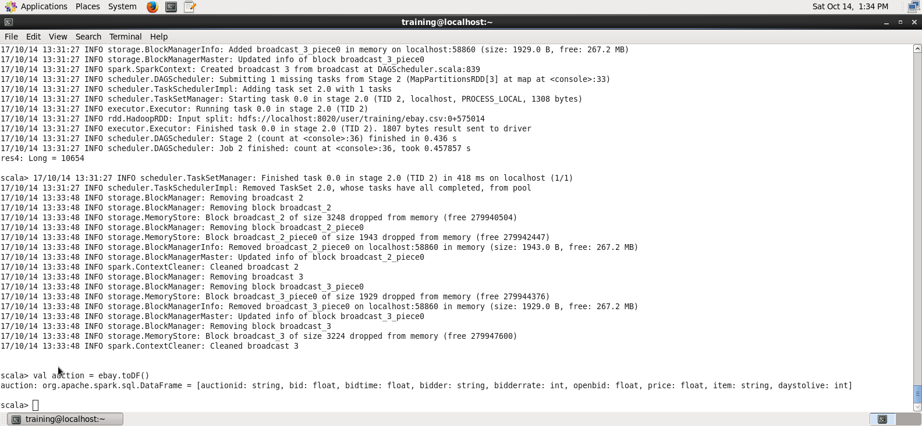

**PartB AS2**

**12**

auction.show()

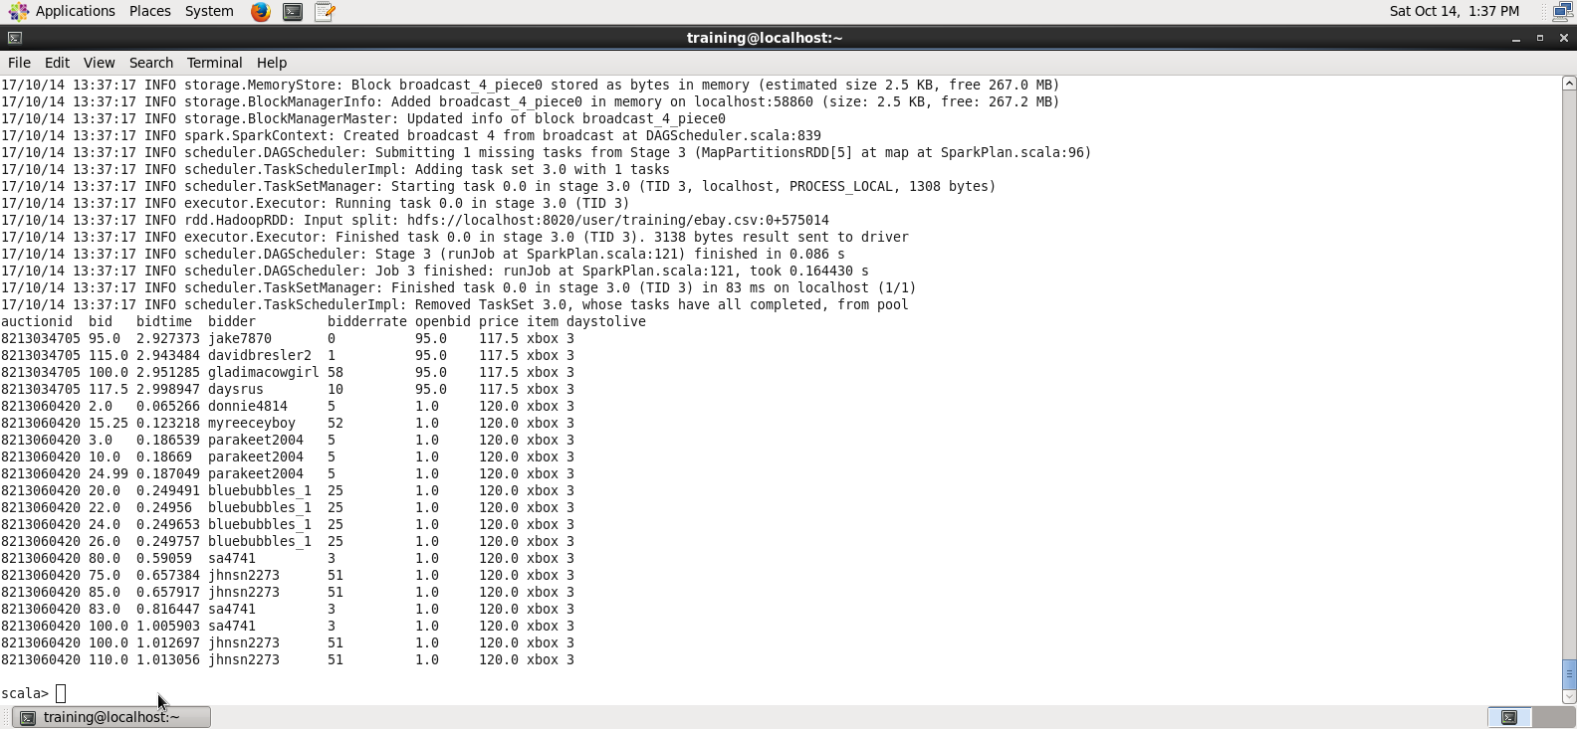

**13**

auction.printSchema()

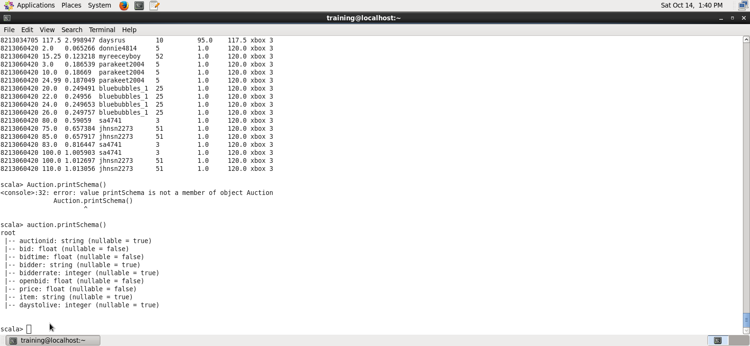

**14**

auction.select("auctionid").distinct.count

answer 627

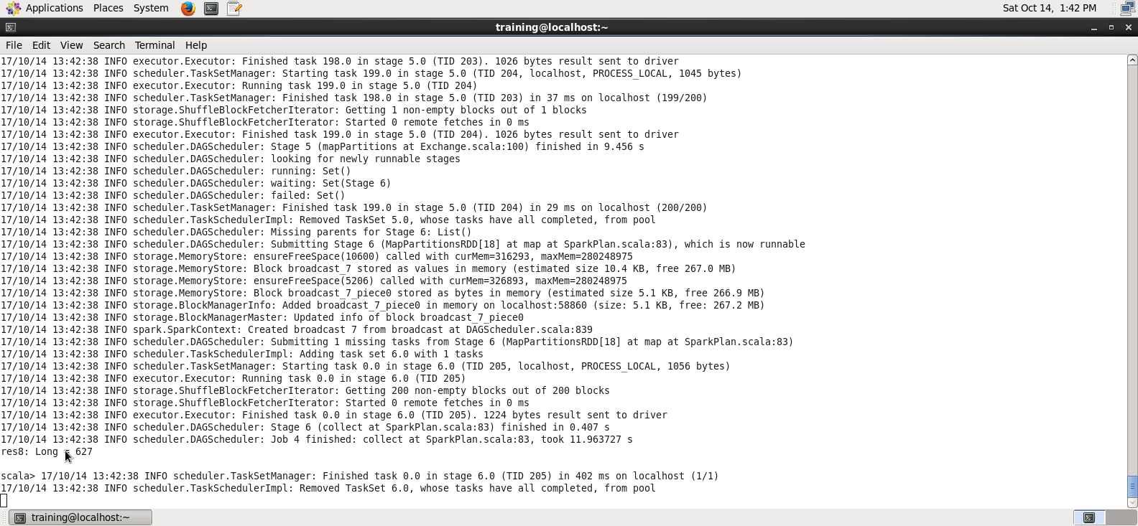

**15**

auction.groupBy("auctionid", "item").count.show

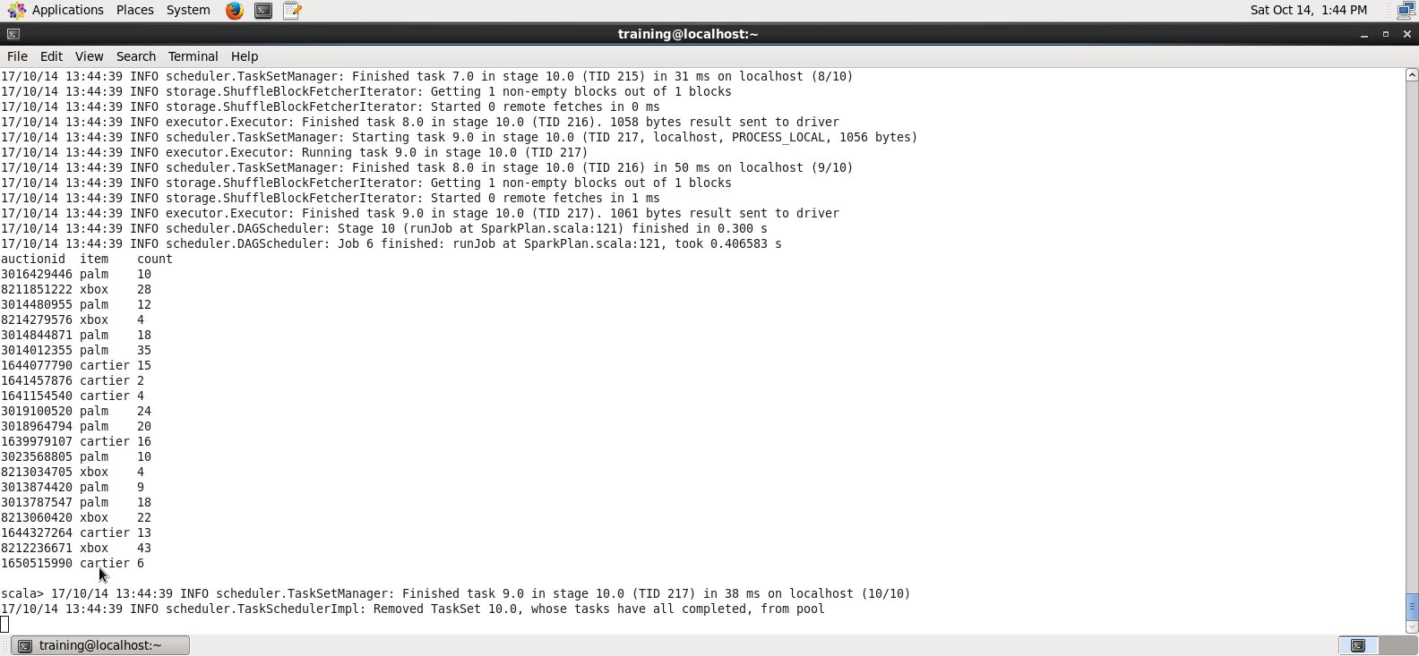

**16**

auctionb.groupBy("item", "auctionid").count.agg(avg("count"))

auction.show()

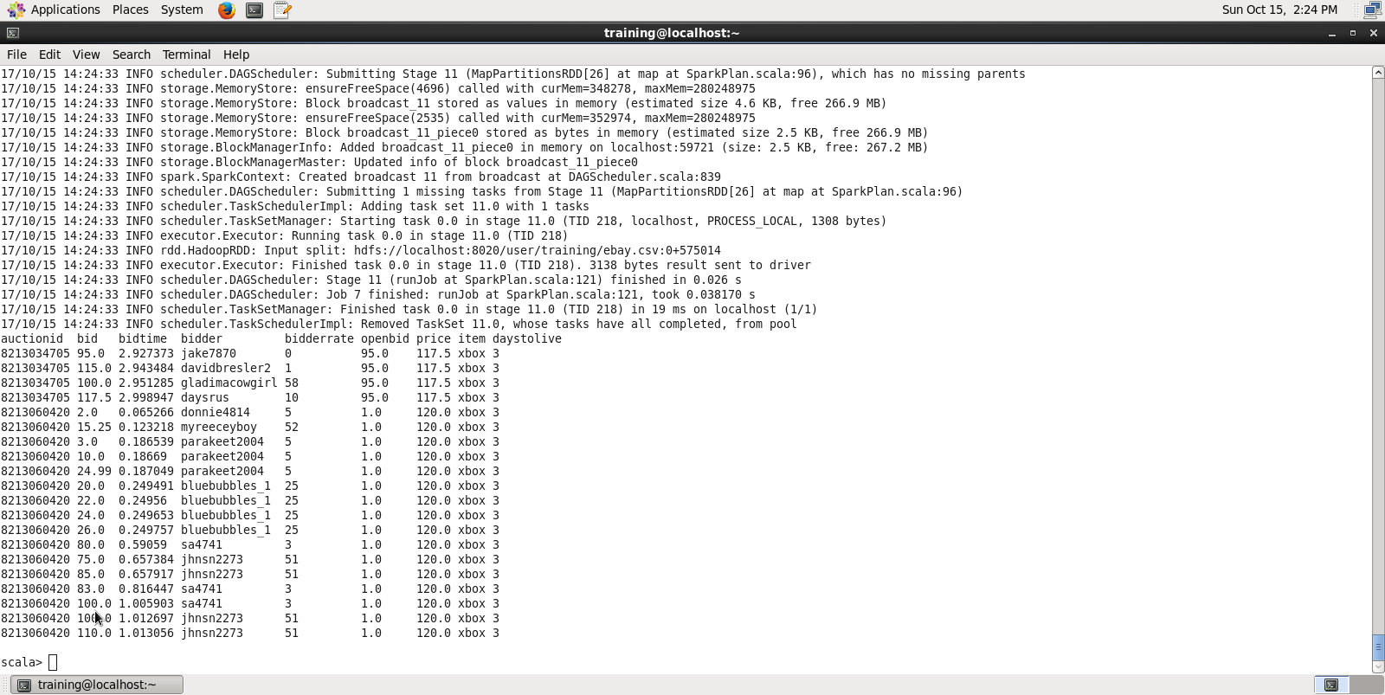

auction.groupBy("item", "auctionid").count.agg(max("count"))

auction.show()

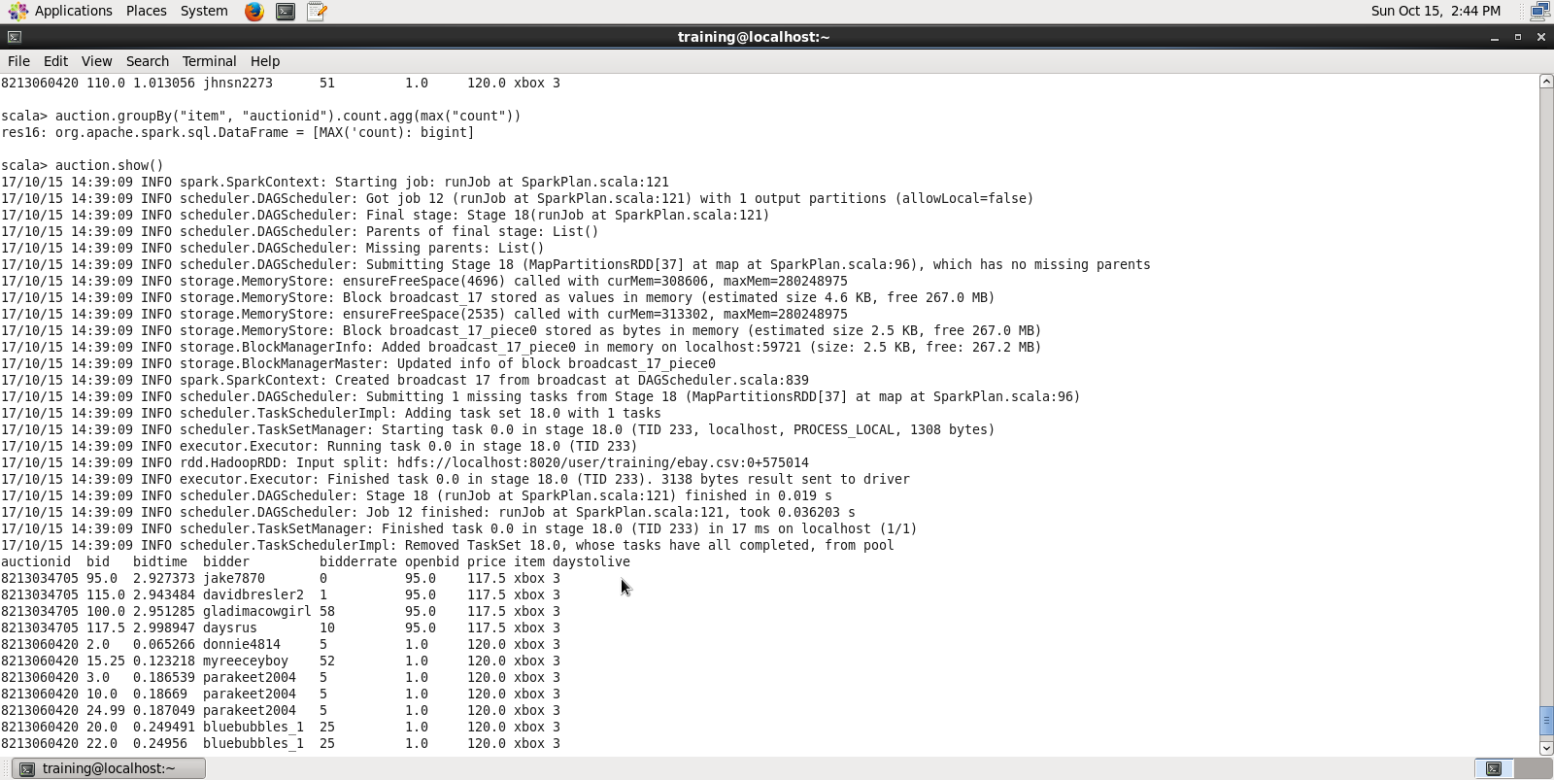

**17**

val cnote= auction.filter("price > 100")

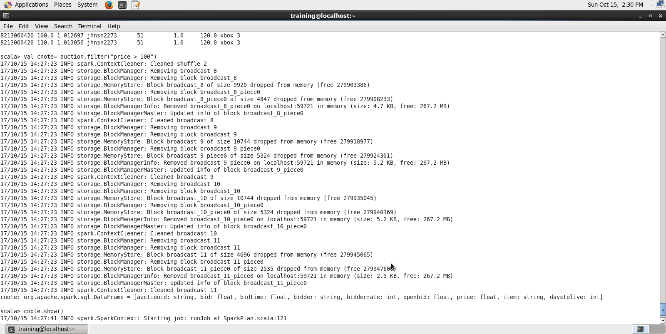

**18**

cnote.show()

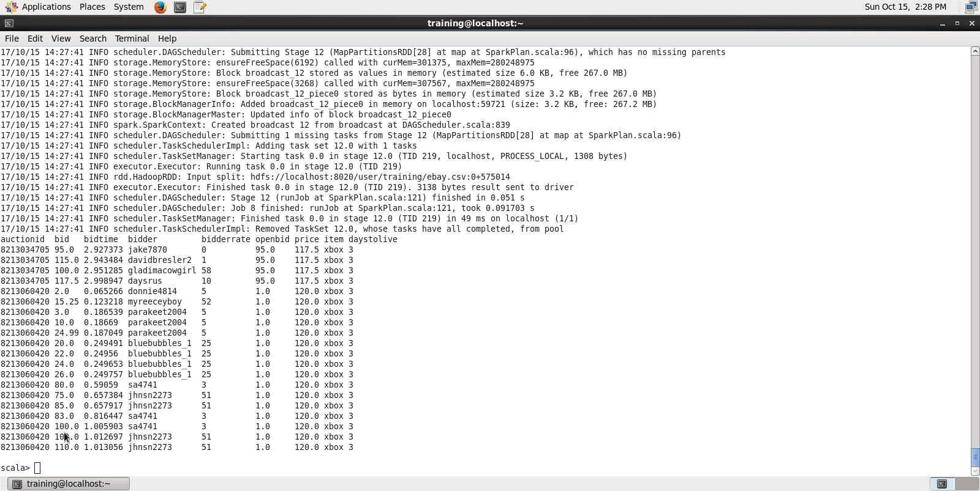

**19**

auction.registerTempTable("auction")

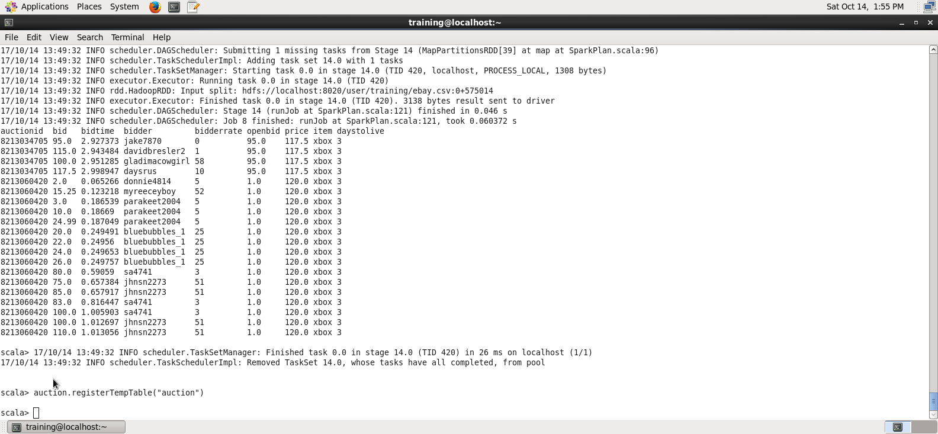

**20**

val answer =sqlContext.sql("SELECT auctionid, item, count(bid) FROM auction GROUP BY auctionid, item")

**21**

answer.show()

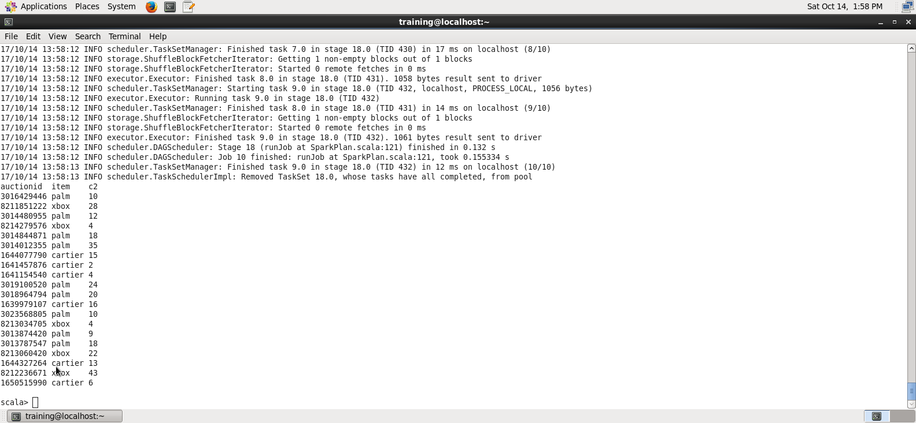

**22**

**val answer = sqlContext.sql(**"**SELECT auctioned, MAX(price) from auction GROUP BY item**"**)**

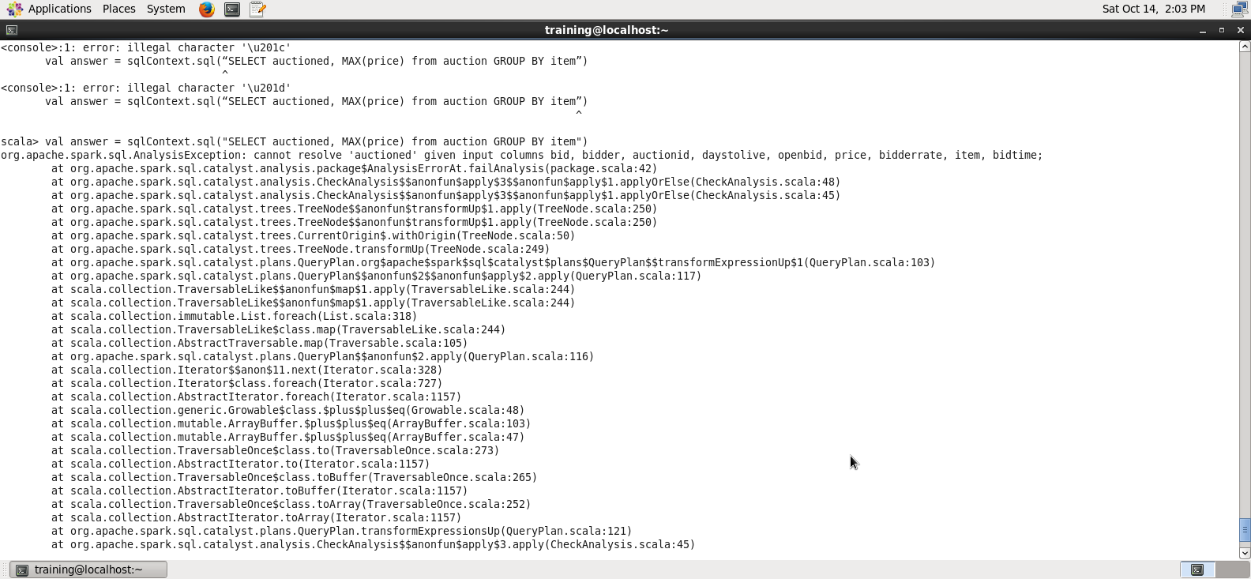

**answer.show()**

