# Data needed

* A GDB containing the latest eTally data
* A GDB containing the latest ORNL data with the following layers:
  1. Bua
  2. Ssa
  3. Hamlet area

If processing multiple States, merge the settlement layers for each type using **Merge** tool.

# Run the tool GetUniqueSettlements (VTS)

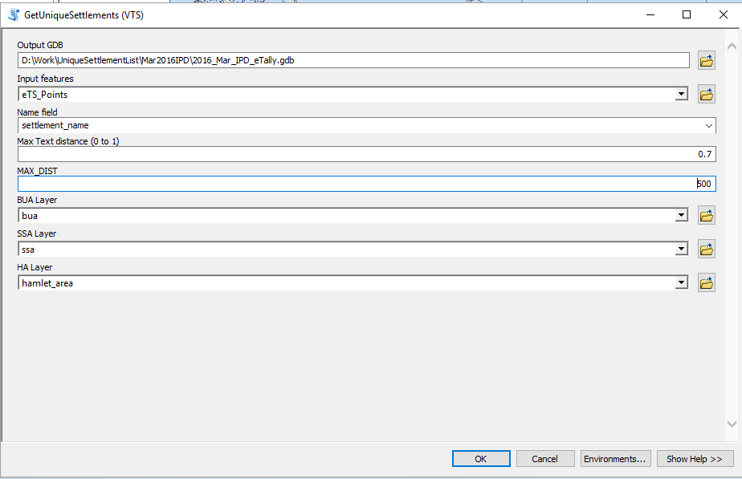

After the tool succeeds, rename the FeatureClass UniqueGroups to UniqueGroups_VTS.

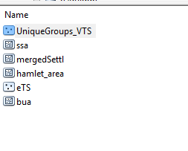

**DURATION:** ~ 1h30 for 10 States (84’000 eTS points)

# Run the tool GetUniqueFeatures

Select by Attribute all the eTS points where RefGlobalID is null

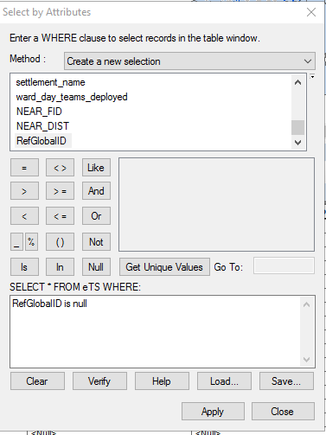

Run the tool GetUniqueFeatures where Input FeatureClass is the eTS layer with the selected points.

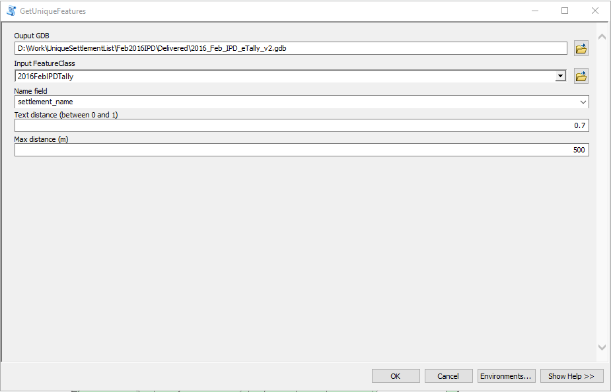

**DURATION:** ~1 minute for 10 States (2000 remaining eTS points)

# Manual postProcessing

* Merge the results of the previous 2 processing into one FeatureClass

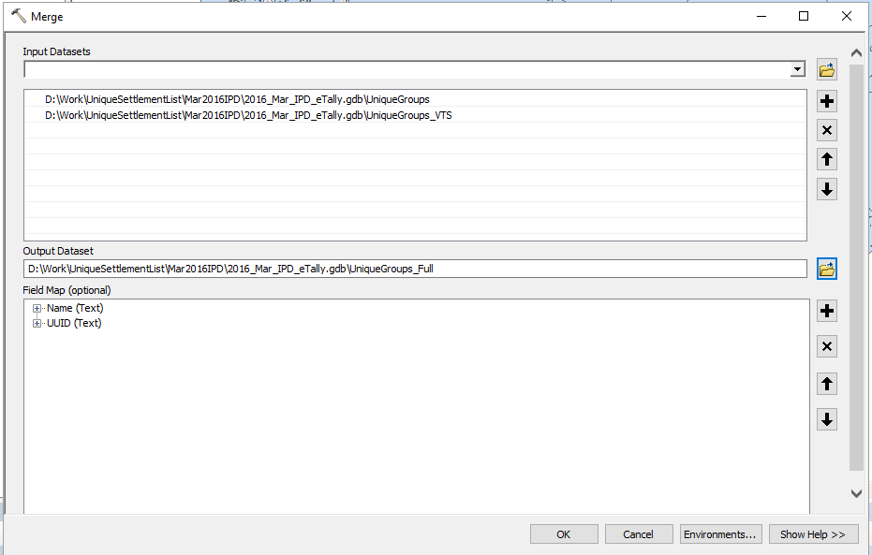

* Use calculate field to bring wardCode, wardName, LGACode, LGANAme, StateCode, StateName.
  1. Add the previous fields to UniqueGroup_Full
  2. Join UniqueGroup_Full with eTS points

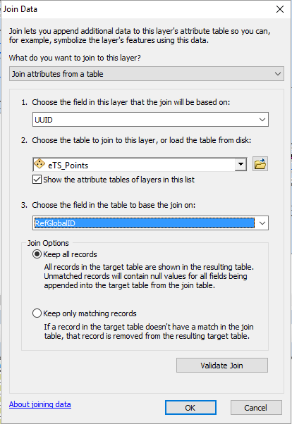

# Prepare delivery package

1. Create a new GDB named: *YYYY*_*MMM*_IPD_eTally.gdb (eg: 2016_Feb_IPD_eTally.gdb)
2. Copy in this gdb the settlements merged for all States (bua, ssa, ha)
3. Copy in this gdb the eTS points FeatureClass
4. Copy in this gdb the UniqueGroups_Full featureClass
5. Rename UniqueGroups_Full to Settlements

Deliver a MXD+GDB with the following:

