Footer

Link

Link

Product Page

Shopping Cart

Routes

Header

App.js

Shopping Cart Page

Logo

Total

Price

Price

Price

X Qty

X Qty

X Qty

Image

Image

Image

Footer

Pay Now

Product Page

Logo

Link

Footer

Image

Details

Add to Cart

Image

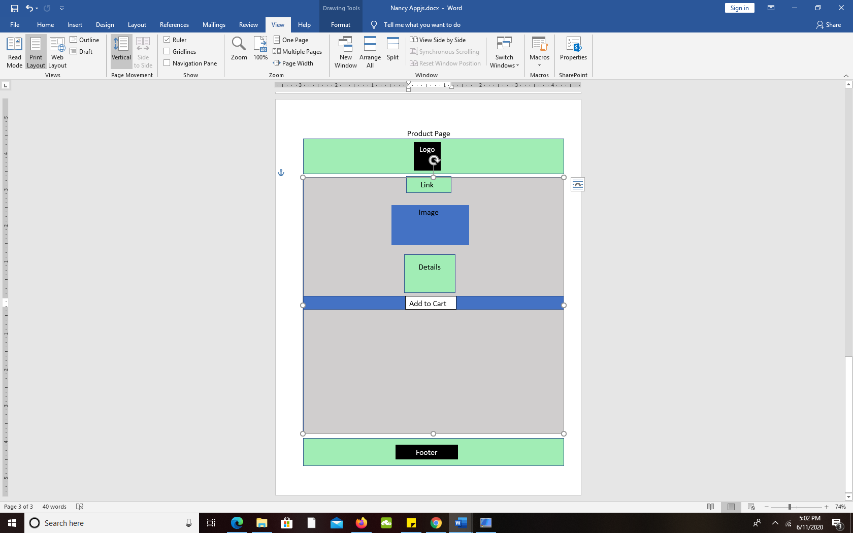

Add to Cart

Details