Table 1a. Characteristics of Alarm Events
Characteristic | All Alarms | Technical Alarms | Clinical Alarms
Events, n (%) | 193,852 (100%) | 134,739 (69.5%) | 59,113 (30.5%)
Alarm density (/bed/day) | 82.9 | 57.7 | 25.3
Priority
ADVISORY, n (%) | 135,783 (70%) | 134,134 (99.6%) | 1,649 (2.8%)
WARNING, n (%) | 57,847 (29.8%) | 605 (0.4%) | 57,242 (96.8%)
CRISIS, n (%) | 222 (0.1%) | 0 (0%) | 222 (0.4%)
Silenced alarms
Silenced, n (%) | 5,759 (3%) | 914 (0.7%) | 4,845 (8.2%)
Time-to-Silence, median [IQR], sec | 20 [10-49] | 206 [17-3025] | 18 [10-36]
Alarm duration
Duration, median [IQR], sec | 6 [1-20] | 4 [1-17] | 12 [4-23]
The study was conducted in a surgical ward comprising 41 monitored beds (12 high-acuity, 29 general) over a 57-day observation period (July 15 – September 9, 2025). Technical alarms indicate device or signal artifacts (e.g., SpO2 probe disconnection, electrode failure, signal loss). Clinical alarms indicate physiological parameter deviations or arrhythmias. Alarm density was calculated as total events divided by the number of monitored beds and observation days. Time-to-silence was calculated only among silenced alarms (silenced = TRUE). IQR, interquartile range.

Table 1b. Response Characteristics of Clinical Alarms Stratified by Priority Level
Characteristic | ADVISORY | WARNING | CRISIS
Events, n (% of clinical alarms) | 1,649 (2.8%) | 57,242 (96.8%) | 222 (0.4%)
Events, n (% of ALL alarms) | 1,649 (0.9%) | 57,242 (29.5%) | 222 (0.1%)
Silenced, n (%) | 61 (3.7%) | 4,626 (8.1%) | 158 (71.2%)
Time-to-silence, median [IQR], sec | 19 [12-69] | 19 [10-37] | 8 [6-12]
Duration, median [IQR], sec | 18 [10-19] | 11 [4-23] | 31 [9-37]
Ward zone
High-acuity zone, n (%) | 770 (46.7%) | 8,150 (14.2%) | 105 (47.3%)
General zone, n (%) | 879 (53.3%) | 49,092 (85.8%) | 117 (52.7%)
Priority levels are defined by the bedside monitoring system: ADVISORY indicates a low-urgency physiological deviation; WARNING indicates a potentially serious condition requiring attention; CRISIS indicates a life-threatening condition requiring immediate intervention. Time-to-silence was calculated only among silenced alarms. The proportion of each priority level relative to all alarms (including technical) reflects the signal-to-noise ratio faced by nursing staff. Ward zone classification: high-acuity zone comprised 12 beds; general zone comprised 29 beds. IQR, interquartile range.
Figure 1. Temporal distribution of clinical alarms by hour of day and day of week

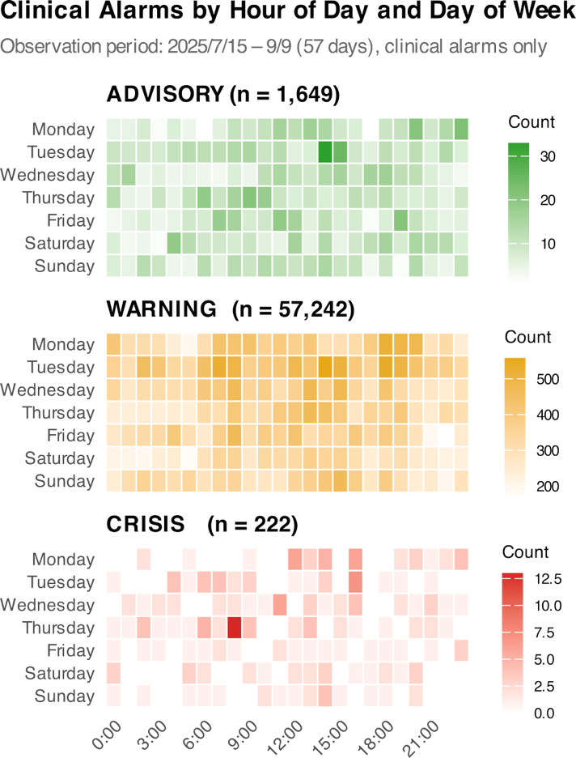
Heatmap showing the distribution of clinical alarms across hours of the day (x-axis, 0–23h) and days of the week (y-axis, Monday to Sunday), stratified by priority level (ADVISORY, WARNING, CRISIS). Each cell represents the total alarm count for that hour–day combination over the 57-day observation period (July 15 – September 9, 2025). Color intensity reflects alarm frequency; higher counts appear in darker shades. Only clinical alarms are included (N = 59,113). Daytime clustering (approximately 08:00–20:00) is apparent across all priority levels, consistent with patient care activity patterns.

Table 2. Observed alarm silencing rates by priority level and alarm burden quartile
Priority | Q1 (0–9) | Q2 (9–18) | Q3 (18–31) | Q4 (31–97)
ADVISORY | 3.3% [2.3–4.9]  (n=777) | 2.8% [1.6–4.9]  (n=394) | 5.2% [3.1–8.5]  (n=271) | 4.8% [2.6–8.7]  (n=207)
WARNING | 10.6% [10.1–11.2]  (n=13,921) | 8.4% [8.0–8.9]  (n=14,329) | 7.6% [7.2–8.1]  (n=14,455) | 5.8% [5.4–6.2]  (n=14,537)
CRISIS | 70.4% [59.7–79.2]  (n=81) | 69.1% [56.0–79.7]  (n=55) | 76.9% [63.9–86.3]  (n=52) | 67.6% [50.8–80.9]  (n=34)
Values are observed silencing rates (%) with 95% Wilson confidence intervals. Alarm burden quartiles represent the number of clinical alarms in the same ward in the preceding 30 minutes (Q1: 0–9, Q2: 9–18, Q3:18–31, Q4: 31–97 alarms/30 min). N per cell indicates the number of clinical alarms in that stratum. Total N = 59,113. ADVISORY alarms are underrepresented because most are generated by a small number of beds with vpersistent low-priority signals. CRISIS alarms maintained silencing rates of 68–77% across all burden quartiles, whereas WARNING silencing rates declined monotonically from 10.6% (Q1) to 5.8% (Q4).

Figure2. Alarm silencing rate and time-to-silence by alarm priority level
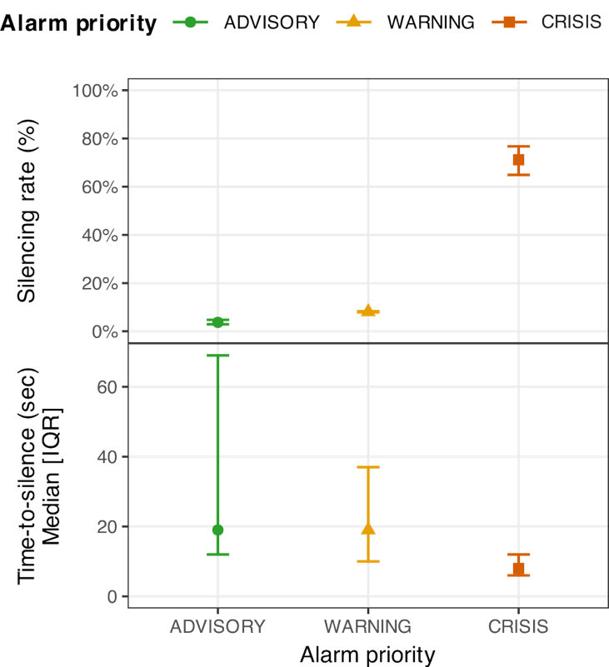
(A) Observed silencing rates (%) with 95% Wilson confidence intervals by alarm priority
level (ADVISORY, WARNING, CRISIS). (B) Median time-to-silence (seconds) with
interquartile range (IQR) among silenced alarms, by priority level.
N = 59,113 clinical alarms (Panel A);
n = 4,845 silenced alarms (Panel B).

Figure 3. Alarm silencing rate by alarm burden and priority level: evidence for resilient priority discrimination
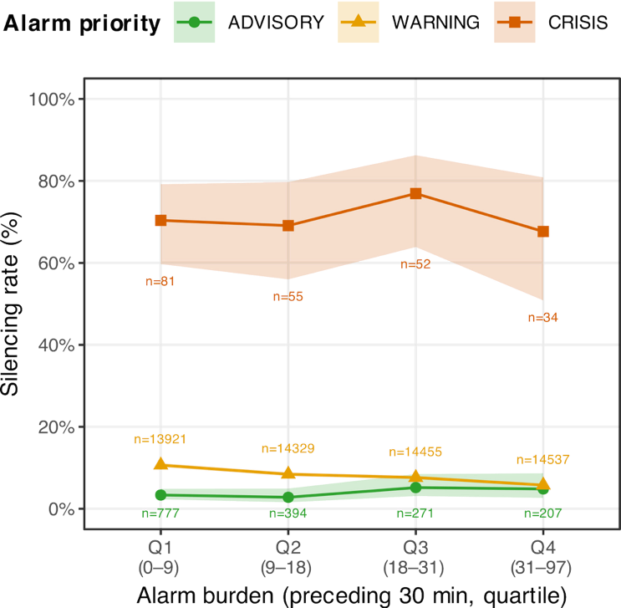
Observed alarm silencing rates (%) with 95% Wilson confidence intervals, stratified by alarm priority (ADVISORY, WARNING, CRISIS) and alarm burden quartile (Q1–Q4). Alarm burden represents the number of clinical alarms in the same ward in the preceding 30 minutes (Q1: 0–9, Q2: 9–18, Q3: 18–31, Q4: 31–97 alarms/30 min). Lines connect median values within each priority group. N = 59,113 clinical alarms.

Table 3. Mixed-effects logistic regression: association between alarm burden, priority, and nurse silencing response
Variable | OR | 95% CI | p-value
Alarm priority (ref: ADVISORY)
WARNING | 4.94 | 3.357 – 7.271 | <0.001
CRISIS | 74.842 | 40.409 – 138.617 | <0.001
Alarm burden × priority interaction
Per alarm increase (ADVISORY) | 1.011 | 0.993 – 1.029 | 0.236
Per alarm increase × WARNING | 0.978 | 0.960 – 0.996 | 0.015
Per alarm increase × CRISIS | 1 | 0.972 – 1.029 | 0.999
Covariates
Zone: high-acuity (ref: general) | 1.461 | 0.971 – 2.198 | 0.069
Shift: evening (ref: day) | 0.78 | 0.706 – 0.861 | <0.001
Shift: night (ref: day) | 1.459 | 1.365 – 1.560 | <0.001
Weekend (ref: weekday) | 1.141 | 1.065 – 1.222 | <0.001
Ward: West 11 (ref: West 10) | 1.489 | 1.010 – 2.195 | 0.044
Random effect
Bed-level variance | 0.302
Mixed-effects logistic regression model with bed-level random intercept. The outcome is nurse-initiated alarm silencing (yes/no). Alarm burden is defined as the number of clinical alarms in the same ward in the preceding 30 minutes, excluding the index alarm. Interaction terms between alarm burden and priority level test whether the effect of burden on silencing probability differs across priority strata. OR = odds ratio; CI = confidence interval. N = 59,113 clinical alarms (July 15 – September 9, 2025). AIC = 31,653.3.

Table S1. Sensitivity analysis of mixed-effects logistic regression results across alarm burden time windows
Variable | 5-min window | 10-min window | 30-min window
Alarm priority (ref: ADVISORY) | NA | NA | NA
WARNING | 4.494 (3.189–6.333); p<0.001 | 4.707 (3.295–6.725); p<0.001 | 4.94 (3.357–7.271); p<0.001
CRISIS | 95.476 (53.072–171.76); p<0.001 | 88.793 (48.683–161.95); p<0.001 | 74.842 (40.409–138.617); p<0.001
Alarm burden × priority interaction | NA | NA | NA
Per alarm increase (ADVISORY) | 1.036 (0.962–1.115); p=0.354 | 1.026 (0.984–1.07); p=0.227 | 1.011 (0.993–1.029); p=0.236
Per alarm increase × WARNING | 0.92 (0.854–0.991); p=0.029 | 0.949 (0.909–0.989); p=0.014 | 0.978 (0.96–0.996); p=0.015
Per alarm increase × CRISIS | 0.935 (0.825–1.059); p=0.29 | 0.974 (0.906–1.047); p=0.472 | 1 (0.972–1.029); p=0.999
Covariates | NA | NA | NA
Zone: high-acuity (ref: general) | 1.435 (0.953–2.16); p=0.084 | 1.447 (0.962–2.176); p=0.076 | 1.461 (0.971–2.198); p=0.069
Shift: evening (ref: day) | 0.782 (0.708–0.863); p<0.001 | 0.782 (0.708–0.864); p<0.001 | 0.78 (0.706–0.861); p<0.001
Shift: night (ref: day) | 1.469 (1.374–1.57); p<0.001 | 1.468 (1.374–1.57); p<0.001 | 1.459 (1.365–1.56); p<0.001
Weekend (ref: weekday) | 1.146 (1.069–1.228); p<0.001 | 1.146 (1.07–1.228); p<0.001 | 1.141 (1.065–1.222); p<0.001
Ward: West 11 (ref: West 10) | 1.519 (1.03–2.241); p=0.035 | 1.512 (1.026–2.228); p=0.037 | 1.489 (1.01–2.195); p=0.044
AIC | 31653.7 | 31662.1 | 31653.3
Results of mixed-effects logistic regression models with bed-level random intercepts, estimated using three definitions of alarm burden: the number of clinical alarms in the same ward in the preceding 5, 10, or 30 minutes (excluding the index alarm). The outcome is nurse-initiated alarm silencing (yes/no). Interaction terms test whether the effect of alarm burden on silencing probability differs by priority level. The 30-minute window was selected as the primary analysis window based on the lowest AIC (31,653.3) and clinical plausibility (30 minutes approximates atypical nursing care cycle). Results were consistent across all time windows: CRISIS alarms showed no significant attenuation of silencing response with increasing burden (p = 0.290–0.999), whereas WARNING alarms showed a significant negative association in all windows (p = 0.014–0.029), supporting the robustness of the primary findings.
OR = odds ratio; CI = confidence interval; AIC = Akaike information criterion.
N = 59,113 clinical alarms (July 15 – September 9, 2025).

Table S2. Sensitivity analysis using total alarm burden (clinical + technical alarms combined)
Variable | Primary (clinical burden, 30-min) | Sensitivity (total burden, 30-min)
Alarm priority (ref: ADVISORY) | NA | NA
WARNING | 4.94 (3.357–7.271); p<0.001 | 4.007 (2.917–5.505); p<0.001
CRISIS | 74.842 (40.409–138.617); p<0.001 | 48.528 (28.236–83.402); p<0.001
Alarm burden × priority interaction | NA | NA
Per alarm increase (ADVISORY) | 1.011 (0.993–1.029); p=0.236 | 1.001 (0.998–1.004); p=0.535
Per alarm increase × WARNING | 0.978 (0.96–0.996); p=0.015 | 0.997 (0.994–1); p=0.06
Per alarm increase × CRISIS | 1 (0.972–1.029); p=0.999 | 1.009 (1.001–1.018); p=0.023
Covariates | NA | NA
Zone: high-acuity (ref: general) | 1.461 (0.971–2.198); p=0.069 | 1.499 (0.978–2.299); p=0.063
Shift: evening (ref: day) | 0.78 (0.706–0.861); p<0.001 | 0.82 (0.748–0.898); p<0.001
Shift: night (ref: day) | 1.459 (1.365–1.56); p<0.001 | 1.581 (1.477–1.693); p<0.001
Weekend (ref: weekday) | 1.141 (1.065–1.222); p<0.001 | 1.06 (0.989–1.136); p=0.098
Ward: West 11 (ref: West 10) | 1.489 (1.01–2.195); p=0.044 | 1.541 (1.026–2.313); p=0.037
AIC | 31,653.30 | 31,649.40
The primary analysis used clinical-only alarm burden (alarm_burden) as the exposure variable, defined as the number of clinical alarms in the same ward in the preceding 30 minutes. This sensitivity analysis substitutes total alarm burden (alarm_burden_total), which includes both clinical and technical alarms. Technical alarms do not produce audible alerts at the bedside in this ward setting and therefore do not directly contribute to the auditory cognitive load experienced by nursing staff; alarm_burden_total should be interpreted as a ward-level workload indicator rather than a measure of perceived alarm noise.
OR = odds ratio; CI = confidence interval; AIC = Akaike information criterion.
N = 59,113 clinical alarms (July 15 – September 9, 2025).

Figure S1. Clinical alarm distribution by ward zone, hour of day, and day of week
Six-panel heatmap comparing the temporal distribution of clinical alarms between the high-acuity zone (12 beds) and the general zone (29 beds), stratified by priority level (rows: ADVISORY, WARNING, CRISIS) and ward zone (columns: high-acuity, general). Each cell represents the total alarm count for a given hour–day combination over the 57-day observation period. Color scales are unified within each priority row to allow direct zone comparison. The high-acuity zone shows markedly higher ADVISORY and CRISIS alarm density relative to bed count, reflecting the greater clinical complexity of patients in that area.

Figure S3.

