Table 1a. Characteristics of Alarm Events
Characteristic | All Alarms | Technical Alarms | Clinical Alarms
Events, n (%) | 193,852 (100%) | 134,739 (69.5%) | 59,113 (30.5%)
Alarm density (/bed/day) | 82.9 | 57.7 | 25.3
Priority
ADVISORY, n (%) | 135,783 (70%) | 134,134 (99.6%) | 1,649 (2.8%)
WARNING, n (%) | 57,847 (29.8%) | 605 (0.4%) | 57,242 (96.8%)
CRISIS, n (%) | 222 (0.1%) | 0 (0%) | 222 (0.4%)
Silenced alarms
Silenced, n (%) | 5,759 (3%) | 914 (0.7%) | 4,845 (8.2%)
Time-to-Silence, median [IQR], sec | 20 [10-49] | 206 [17-3025] | 18 [10-36]
Alarm duration
Duration, median [IQR], sec | 6 [1-20] | 4 [1-17] | 12 [4-23]
The study was conducted in a surgical ward comprising 41 monitored beds (12 high-acuity, 29 general) over a 57-day observation period (July 15 – September 9, 2025). Technical alarms indicate device or signal artifacts (e.g., SpO2 probe disconnection, electrode failure, signal loss). Clinical alarms indicate physiological parameter deviations or arrhythmias. Alarm density was calculated as total events divided by the number of monitored beds and observation days. Time-to-silence was calculated only among silenced alarms (silenced = TRUE). IQR, interquartile range.

Table 1b. Response Characteristics of Clinical Alarms Stratified by Priority Level
Characteristic | ADVISORY | WARNING | CRISIS
Events, n (% of clinical alarms) | 1,649 (2.8%) | 57,242 (96.8%) | 222 (0.4%)
Events, n (% of ALL alarms) | 1,649 (0.9%) | 57,242 (29.5%) | 222 (0.1%)
Silenced, n (%) | 61 (3.7%) | 4,626 (8.1%) | 158 (71.2%)
Time-to-silence, median [IQR], sec | 19 [12-69] | 19 [10-37] | 8 [6-12]
Duration, median [IQR], sec | 18 [10-19] | 11 [4-23] | 31 [9-37]
Ward zone
High-acuity zone, n (%) | 770 (46.7%) | 8,150 (14.2%) | 105 (47.3%)
General zone, n (%) | 879 (53.3%) | 49,092 (85.8%) | 117 (52.7%)
Priority levels are defined by the bedside monitoring system: ADVISORY indicates a low-urgency physiological deviation; WARNING indicates a potentially serious condition requiring attention; CRISIS indicates a life-threatening condition requiring immediate intervention. Time-to-silence was calculated only among silenced alarms. The proportion of each priority level relative to all alarms (including technical) reflects the signal-to-noise ratio faced by nursing staff. Ward zone classification: high-acuity zone comprised 12 beds; general zone comprised 29 beds. IQR, interquartile range.
Figure 1. Figure 1. Temporal distribution of alarm events by alarm type and clinical priority
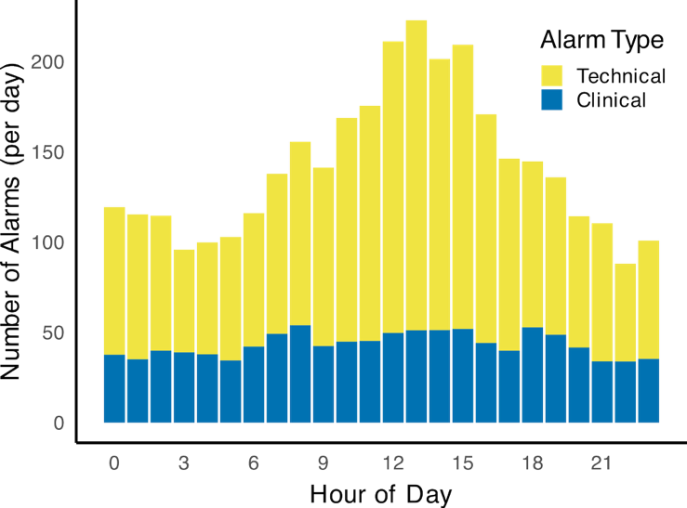
(A) (B)
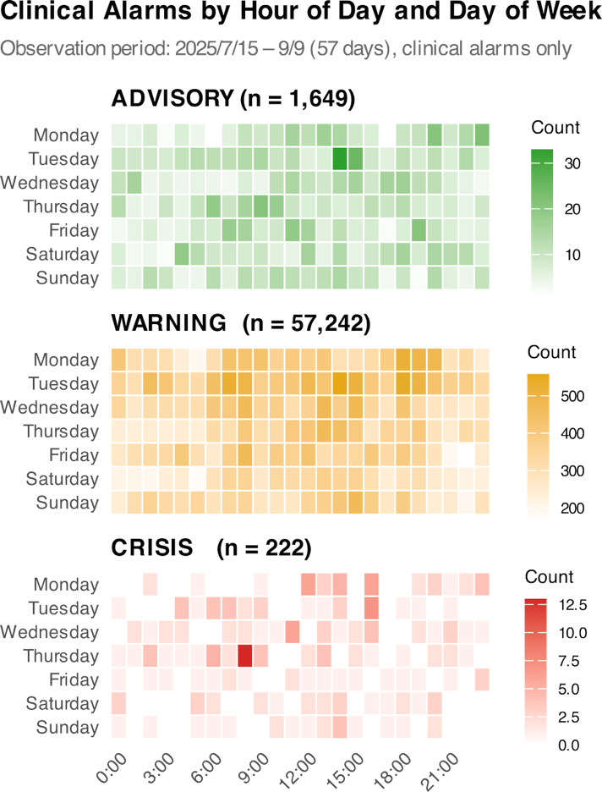

(A) Mean number of alarm events per day by hour of day (0–23h), stratified by alarm type (Technical, yellow; Clinical, blue). Data represent the 57-day observation period (July 15 – September 9, 2025). (B) Heatmap showing the distribution of clinical alarms across hours of the day (x-axis) and days of the week (y-axis, Monday to Sunday), stratified by priority level (ADVISORY, WARNING, CRISIS). Each cell represents the total alarm count for that hour–day combination over the observation period. Color intensity reflects alarm frequency. N = 193,852 total alarms (Panel A); N = 59,113 clinical alarms (Panel B).
Table 2. Observed alarm silencing rates by priority level and alarm burden quartile
Priority | Q1 (0–9) | Q2 (9–18) | Q3 (18–31) | Q4 (31–97)
ADVISORY | 3.3% [2.3–4.9]  (n=777) | 2.8% [1.6–4.9]  (n=394) | 5.2% [3.1–8.5]  (n=271) | 4.8% [2.6–8.7]  (n=207)
WARNING | 10.6% [10.1–11.2]  (n=13,921) | 8.4% [8.0–8.9]  (n=14,329) | 7.6% [7.2–8.1]  (n=14,455) | 5.8% [5.4–6.2]  (n=14,537)
CRISIS | 70.4% [59.7–79.2]  (n=81) | 69.1% [56.0–79.7]  (n=55) | 76.9% [63.9–86.3]  (n=52) | 67.6% [50.8–80.9]  (n=34)
Values are observed silencing rates (%) with 95% Wilson confidence intervals. Alarm burden quartiles represent the number of clinical alarms in the same ward in the preceding 30 minutes (Q1: 0–9, Q2: 9–18, Q3:18–31, Q4: 31–97 alarms/30 min). N per cell indicates the number of clinical alarms in that stratum. Total N = 59,113. ADVISORY alarms are underrepresented because most are generated by a small number of beds with vpersistent low-priority signals. CRISIS alarms maintained silencing rates of 68–77% across all burden quartiles, whereas WARNING silencing rates declined monotonically from 10.6% (Q1) to 5.8% (Q4).

Figure 2. Alarm silencing rate, time-to-silence, and post-silence recurrence by alarm priority level
(A) (B)
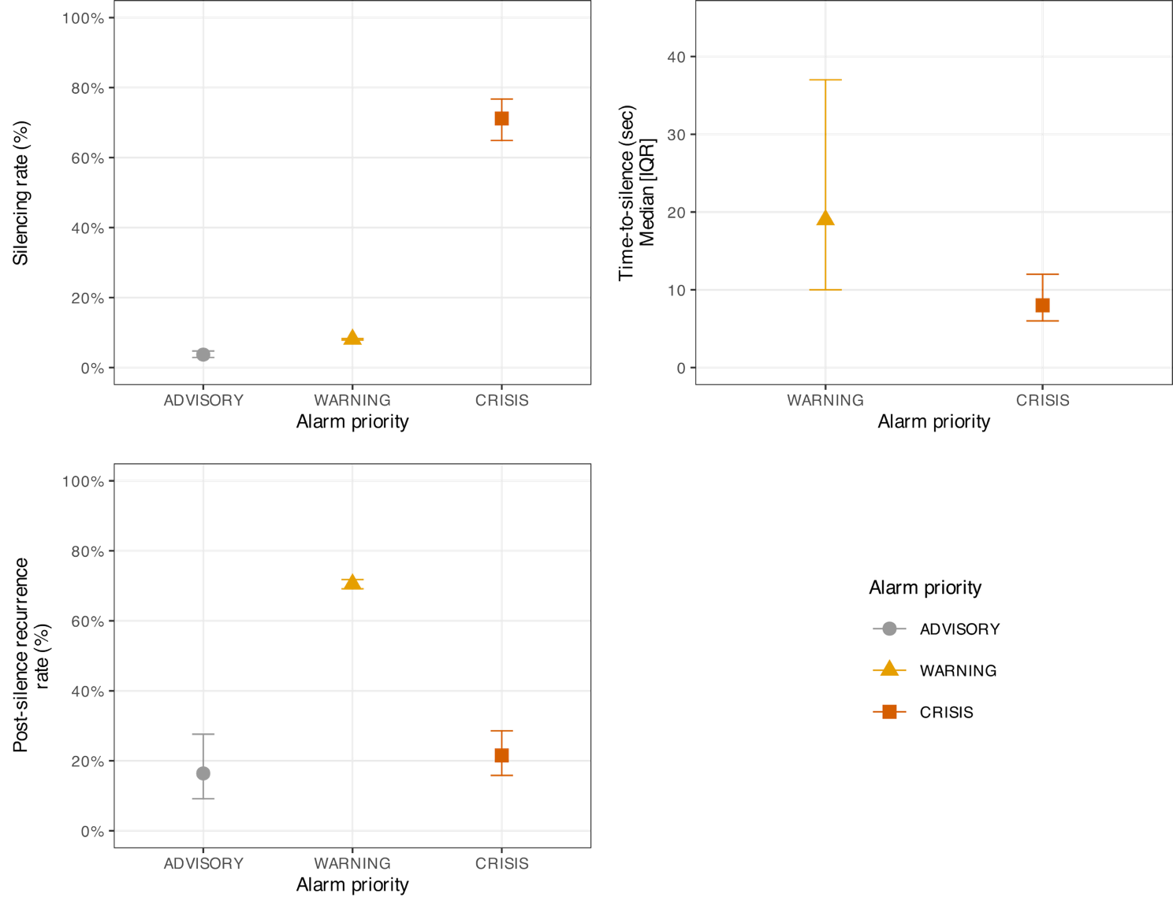
(A) Observed silencing rates (%) with 95% Wilson confidence intervals by alarm priority level (ADVISORY, WARNING, CRISIS). (B) Median time-to-silence (seconds) with interquartile range (IQR) among silenced alarms, by priority level; ADVISORY alarms (n = 61; median 19 [IQR 12–69] s) are shown in Panels A and C only, as the small sample size precluded reliable IQR estimation. (C) Post-silence recurrence rate (%) with 95% Wilson confidence intervals, defined as the proportion of silenced alarms followed by a recurrence of the same parameter at the same bed within 5 minutes. Panels B and C are restricted to silenced alarms.
N = 59,113 clinical alarms (Panel A);
n = 4,784 silenced alarms (Panel B, ADVISORY excluded);
n = 4,845 silenced alarms (Panel C) .

Figure 3. Asymmetric effects of alarm burden on silencing rate and post-silence recurrence by priority level
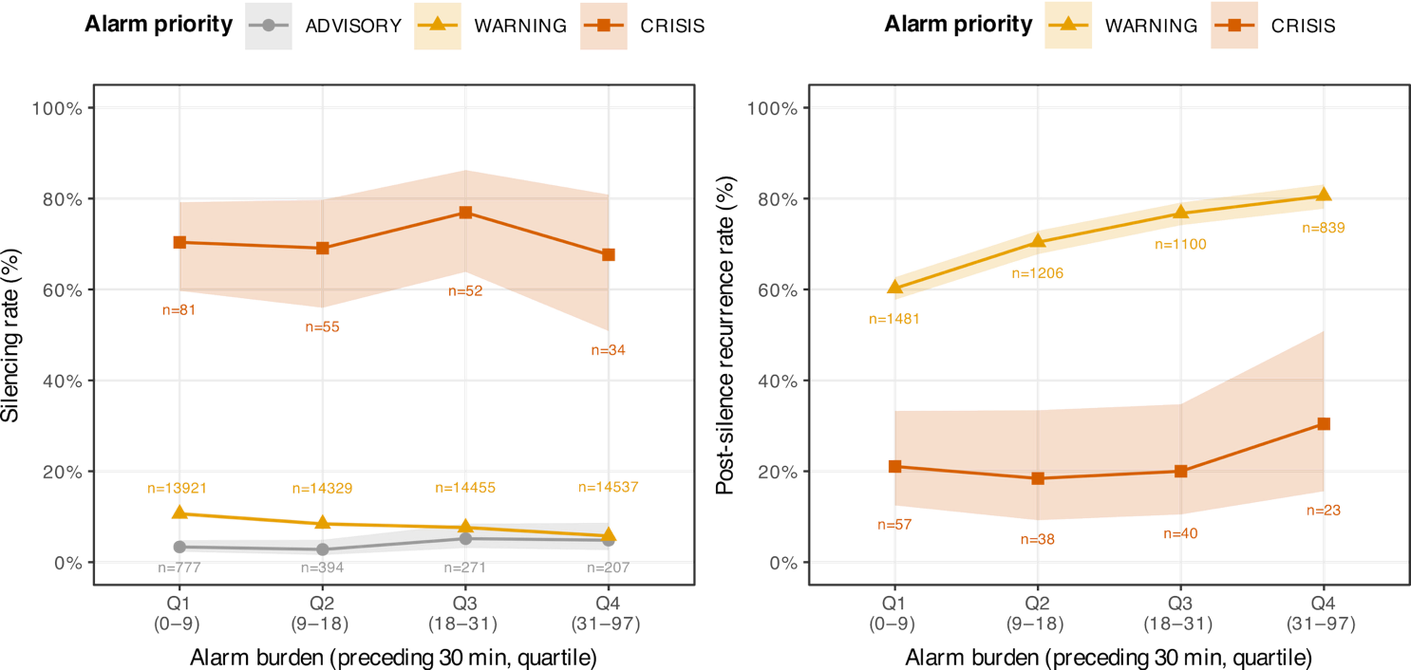
(A) Observed silencing rates (%) with 95% Wilson confidence intervals, stratified by alarm priority (ADVISORY, WARNING, CRISIS) and alarm burden quartile (Q1–Q4). (B) Post-silence recurrence rates (%) with 95% Wilson confidence intervals for WARNING and CRISIS alarms, defined as the proportion of silenced alarms followed by recurrence of the same parameter at the same bed within 5 minutes. Panel B is restricted to silenced alarms (n per cell shown adjacent to each point). Alarm burden quartiles represent the number of clinical alarms in the same ward in the preceding 30 minutes (Q1: 0–9, Q2: 9–18, Q3: 18–31, Q4: 31–97 alarms/30 min). Shaded ribbons represent 95% Wilson confidence intervals. N = 59,113 clinical alarms (Panel A); n = 4,845 silenced alarms (Panel B).
Table 3. Mixed-effects logistic regression: association between alarm burden, priority, and nurse silencing response
Variable | OR | 95% CI | p-value
Alarm priority (ref: ADVISORY)
WARNING | 4.94 | 3.357 – 7.271 | <0.001
CRISIS | 74.842 | 40.409 – 138.617 | <0.001
Alarm burden × priority interaction
Per alarm increase (ADVISORY) | 1.011 | 0.993 – 1.029 | 0.236
Per alarm increase × WARNING | 0.978 | 0.960 – 0.996 | 0.015
Per alarm increase × CRISIS | 1 | 0.972 – 1.029 | 0.999
Covariates
Zone: high-acuity (ref: general) | 1.461 | 0.971 – 2.198 | 0.069
Shift: evening (ref: day) | 0.78 | 0.706 – 0.861 | <0.001
Shift: night (ref: day) | 1.459 | 1.365 – 1.560 | <0.001
Weekend (ref: weekday) | 1.141 | 1.065 – 1.222 | <0.001
Ward: West 11 (ref: West 10) | 1.489 | 1.010 – 2.195 | 0.044
Random effect
Bed-level variance | 0.302
Mixed-effects logistic regression model with bed-level random intercept. The outcome is nurse-initiated alarm silencing (yes/no). Alarm burden is defined as the number of clinical alarms in the same ward in the preceding 30 minutes, excluding the index alarm. Interaction terms between alarm burden and priority level test whether the effect of burden on silencing probability differs across priority strata. OR = odds ratio; CI = confidence interval. N = 59,113 clinical alarms (July 15 – September 9, 2025). AIC = 31,653.3.

Table S1. Distribution of alarm events by alarm class and parameter type
Category | Parameter | ADVISORY | WARNING | CRISIS | Total
--- Technical Alarms (n = 134,739) ---
Signal / Device | SpO2 probe disconnection | 94477 (70.1%) | — | — | 94477 (70.1%)
Signal / Device | Electrode disconnection | 22696 (16.8%) | — | — | 22696 (16.8%)
Signal / Device | Wireless signal loss | 16809 (12.5%) | 364 (0.3%) | — | 17173 (12.7%)
Signal / Device | Unanalyzable signal | — | 241 (0.2%) | — | 241 (0.2%)
Signal / Device | NIBP measurement failure | 152 (0.1%) | — | — | 152 (0.1%)
 | Total | 134134 (99.6%) | 605 (0.4%) | 0 (0.0%) | 134739 (100.0%)
--- Clinical Alarms (n = 59,113) ---
Cardiac rhythm | Ventricular fibrillation | — | — | 109 (49.1%) | 109 (0.2%)
Cardiac rhythm | Ventricular tachycardia | — | — | 69 (31.1%) | 69 (0.1%)
Cardiac rhythm | Asystole | — | — | 44 (19.8%) | 44 (0.1%)
Cardiac rhythm | VPC Run | 1574 (95.5%) | — | — | 1574 (2.7%)
Cardiac rhythm | Tachycardia | — | 8022 (14.0%) | — | 8022 (13.6%)
Cardiac rhythm | Bradycardia | — | 979 (1.7%) | — | 979 (1.7%)
Cardiac rhythm | Pulse rate (via SpO2) | — | 1900 (3.3%) | — | 1900 (3.2%)
Oxygenation | SpO2 | 23 (1.4%) | 44413 (77.6%) | — | 44436 (75.2%)
Respiratory | Respiratory rate / Apnea | — | 1496 (2.6%) | — | 1496 (2.5%)
Hemodynamic | NIBP | 46 (2.8%) | 5 (0.0%) | — | 51 (0.1%)
Hemodynamic | NIBP (systolic) | — | 426 (0.7%) | — | 426 (0.7%)
Other | Other | 6 (0.4%) | 1 (0.0%) | — | 7 (0.0%)
 | Total | 1649 (100.0%) | 57242 (100.0%) | 222 (100.0%) | 59113 (100.0%)
Values are n (%) within each alarm class. Technical alarms indicate device or signal artifacts; clinical alarms indicate physiological parameter deviations or arrhythmias. Technical alarm percentages are calculated as proportions of all technical alarms (n = 134,739); clinical alarm percentages are calculated as proportions of all clinical alarms (n = 59,113). "—" indicates no alarms of that parameter were recorded at this priority level. "Other" includes EtCO2, arterial pressure, and temperature parameters (T1, T2, body temperature), each contributing fewer than 3 events. Alarm parameters were recorded as displayed on the central monitoring system and were not modified by the investigators.
Table S2. Sensitivity analysis of mixed-effects logistic regression results across alarm burden time windows
Variable | 15-min window | 30-min window | 45-min window
Alarm priority (ref: ADVISORY) | NA | NA | NA
WARNING | 4.457 (3.089–6.432); p<0.001 | 4.94 (3.357–7.271); p<0.001 | 5.134 (3.459–7.621); p<0.001
CRISIS | 70.934 (38.964–129.136); p<0.001 | 74.842 (40.409–138.617); p<0.001 | 77.941 (41.394–146.753); p<0.001
Alarm burden × priority interaction | NA | NA | NA
Per alarm increase (ADVISORY) | 1.011 (0.979–1.045); p=0.497 | 1.011 (0.993–1.029); p=0.236 | 1.009 (0.996–1.022); p=0.169
Per alarm increase × WARNING | 0.971 (0.939–1.003); p=0.078 | 0.978 (0.96–0.996); p=0.015 | 0.983 (0.97–0.995); p=0.007
Per alarm increase × CRISIS | 1.007 (0.955–1.062); p=0.791 | 1 (0.972–1.029); p=0.999 | 0.998 (0.978–1.019); p=0.868
Covariates | NA | NA | NA
Zone: high-acuity (ref: general) | 1.454 (0.966–2.191); p=0.073 | 1.461 (0.971–2.198); p=0.069 | 1.466 (0.976–2.203); p=0.066
Shift: evening (ref: day) | 0.782 (0.708–0.864); p<0.001 | 0.78 (0.706–0.861); p<0.001 | 0.777 (0.703–0.858); p<0.001
Shift: night (ref: day) | 1.467 (1.372–1.568); p<0.001 | 1.459 (1.365–1.56); p<0.001 | 1.45 (1.356–1.55); p<0.001
Weekend (ref: weekday) | 1.147 (1.07–1.229); p<0.001 | 1.141 (1.065–1.222); p<0.001 | 1.137 (1.061–1.219); p<0.001
Ward: West 11 (ref: West 10) | 1.507 (1.021–2.224); p=0.039 | 1.489 (1.01–2.195); p=0.044 | 1.485 (1.008–2.187); p=0.045
AIC | 31672.8 | 31653.3 | 31652
Results of mixed-effects logistic regression models with bed-level random intercepts, estimated using three definitions of alarm burden: the number of clinical alarms in the same ward in the preceding 15, 30, or 45 minutes (excluding the index alarm). The outcome is nurse-initiated alarm silencing (yes/no). Interaction terms test whether the effect of alarm burden on silencing probability differs by priority level. The 30-minute window was selected as the primary analysis window based on clinical plausibility (30 minutes approximates a typical nursing care cycle); the AIC difference between the 30-minute and 45-minute windows was negligible (ΔAIC = 1.3). Results were consistent in direction across all time windows: CRISIS alarms showed no significant attenuation of silencing response with increasing burden (p = 0.868–0.999), and WARNING alarms showed a negative association that reached significance in the 30-minute and 45-minute windows (p = 0.007–0.015), supporting the robustness of the primary findings.
OR = odds ratio; CI = confidence interval; AIC = Akaike information criterion. N = 59,113 clinical alarms (July 15 – September 9, 2025).
Table S3. Sensitivity analysis using total alarm burden (clinical + technical alarms combined)
Variable | Primary (clinical burden, 30-min) | Sensitivity (total burden, 30-min)
Alarm priority (ref: ADVISORY) | NA | NA
WARNING | 4.94 (3.357–7.271); p<0.001 | 4.007 (2.917–5.505); p<0.001
CRISIS | 74.842 (40.409–138.617); p<0.001 | 48.528 (28.236–83.402); p<0.001
Alarm burden × priority interaction | NA | NA
Per alarm increase (ADVISORY) | 1.011 (0.993–1.029); p=0.236 | 1.001 (0.998–1.004); p=0.535
Per alarm increase × WARNING | 0.978 (0.96–0.996); p=0.015 | 0.997 (0.994–1); p=0.06
Per alarm increase × CRISIS | 1 (0.972–1.029); p=0.999 | 1.009 (1.001–1.018); p=0.023
Covariates | NA | NA
Zone: high-acuity (ref: general) | 1.461 (0.971–2.198); p=0.069 | 1.499 (0.978–2.299); p=0.063
Shift: evening (ref: day) | 0.78 (0.706–0.861); p<0.001 | 0.82 (0.748–0.898); p<0.001
Shift: night (ref: day) | 1.459 (1.365–1.56); p<0.001 | 1.581 (1.477–1.693); p<0.001
Weekend (ref: weekday) | 1.141 (1.065–1.222); p<0.001 | 1.06 (0.989–1.136); p=0.098
Ward: West 11 (ref: West 10) | 1.489 (1.01–2.195); p=0.044 | 1.541 (1.026–2.313); p=0.037
AIC | 31,653.30 | 31,649.40
The primary analysis used clinical-only alarm burden (alarm_burden) as the exposure variable, defined as the number of clinical alarms in the same ward in the preceding 30 minutes. This sensitivity analysis substitutes total alarm burden (alarm_burden_total), which includes both clinical and technical alarms. Technical alarms do not produce audible alerts at the bedside in this ward setting and therefore do not directly contribute to the auditory cognitive load experienced by nursing staff; alarm_burden_total should be interpreted as a ward-level workload indicator rather than a measure of perceived alarm noise.
OR = odds ratio; CI = confidence interval; AIC = Akaike information criterion.
N = 59,113 clinical alarms (July 15 – September 9, 2025).

Table S4. Sensitivity Analysis: Mixed-effects Logistic Regression Model Including Lagged Alarm Burden (1–2 Hours Prior)
Variable | OR (95% CI) | p-value
Alarm priority (ref: ADVISORY) | NA
WARNING | 4.961 (3.374–7.295) | p<0.001
CRISIS | 75.157 (40.572–139.224) | p<0.001
Immediate alarm burden × priority interaction | NA
Per alarm increase, immediate (ADVISORY) | 1.014 (0.996–1.032) | p=0.138
Per alarm increase, immediate × WARNING | 0.977 (0.96–0.995) | p=0.012
Per alarm increase, immediate × CRISIS | 1 (0.972–1.029) | p=0.988
Lagged alarm burden (1–2 hours prior) | NA
Per alarm increase, lagged (ADVISORY) | 0.997 (0.996–0.999) | p<0.001
Covariates | NA
Zone: high-acuity (ref: general) | 1.468 (0.981–2.197) | p=0.062
Shift: evening (ref: day) | 0.773 (0.7–0.854) | p<0.001
Shift: night (ref: day) | 1.439 (1.346–1.539) | p<0.001
Weekend (ref: weekday) | 1.137 (1.061–1.218) | p <0.001
Ward: West 11 (ref: West 10) | 1.474 (1.005–2.163) | p=0.047
AIC | 31640.3
This model extends the primary analysis (Table 3) by adding alarm burden measured 1–2 hours prior to each alarm event as an additional covariate, to examine cumulative fatigue effects distinct from immediate alarm load. Immediate burden × priority interactions and all covariates from the primary model were retained.
OR = odds ratio; CI = confidence interval. Random intercepts were specified at the bed level. AIC = Akaike Information Criterion.

Figure S1. Temporal distribution of alarm events by alarm type and hour of day
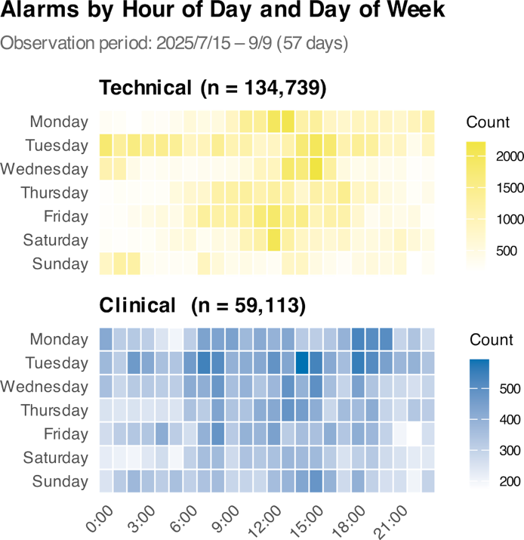
Two-panel heatmap showing the distribution of all alarm events across hours of the day (x-axis, 3-hour intervals) and days of the week (y-axis, Monday to Sunday), stratified by alarm type: Technical alarms (upper panel, yellow; n = 134,739) and Clinical alarms (lower panel, blue; n = 59,113). Each cell represents the total alarm count for that hour–day combination over the 57-day observation period (July 15 –September 9, 2025). Color scales are independent between panels to reflect the substantial difference in total counts. Technical alarms show marked daytime clustering, particularly on weekdays, consistent with care-related device interactions; clinical alarms exhibit a more uniform distribution across hours.
Figure S2. Bed-level random intercepts from the mixed-effects logistic regression model
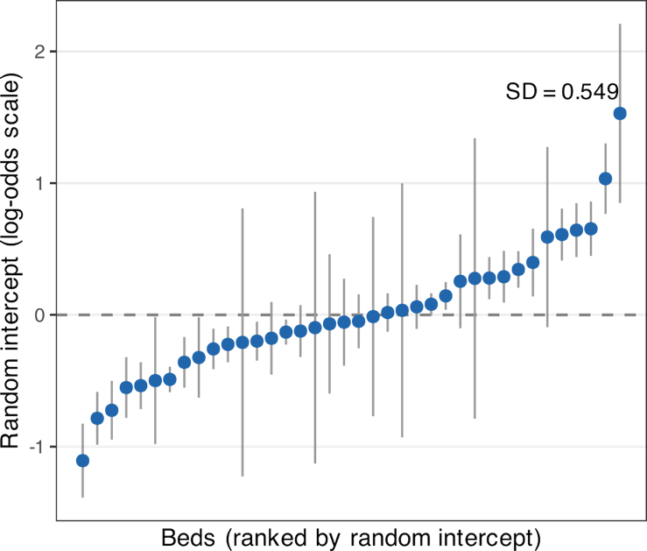
no single bed location disproportionately drives the overall findings. Because bed occupancy changed over the observation period, the random intercept reflects a combination of location-specific factors (e.g., proximity to the nursing station, habitual patient assignment) rather than individual patient characteristics.

