Response to Reviewers’ Comments
TGRS-2025-06384
Dear Editor and Reviewers,
We would like to take this opportunity to thank the Editor and the Reviewers for the constructive comments and valuable suggestions. We have revised our manuscript carefully and thoroughly. Please find our point-by-point responses to the comments below. For the ease of your further review, the changes in the revised version have been highlighted. We thank you again for your valuable time and efforts in reviewing our manuscript. We look forward to your favorable consideration.

I. RESPONSE TO THE COMMENTS OF REVIEWER 1
Reviewer: 1
This paper presents UDRsNet, an end-to-end unsupervised deep learning framework for UAV image stitching, consisting of unsupervised image alignment using progressive homography and thin-plate spline transformations; and unsupervised image fusion using a soft-mask-based blending strategy. The results show strong performance and is supported by ablation studies.
While the technical contributions appear significant, the manuscript requires improvements in both clarity and presentation. The following points should be addressed:
Comments 1: The writing requires editing in multiple sections. Issues include, but are not limited to:
- “… (UAVs) has emerged …” => “have”
- “… (UAVs) … due to its operational …” => “their”
- “… imagery acquired … suffers … ” => “suffer”
- “… adaptive feathering and seamless blending” => feathering?
- “our fussion” => Typo
- “averge fusion” => Typo
- Inconsistent or incorrect capitalization is present throughout the manuscript.
- The first mention of datasets (e.g., UDIS-D) and modules (e.g., USFNet) should include proper references.
- Instead of “ours”, it is better practice to use “Proposed” or the given name of the method.
Response: We sincerely thank you for your valuable comments. Regarding the points you raised, we make the necessary edits and corrections to improve the clarity and accuracy of the writing. Specifically:
Revision 1: In response to your comments regarding the incorrect use of singular and plural forms a), b), and c), we have thoroughly reviewed the manuscript, checking it word by word. We have made the necessary corrections to all identified errors.
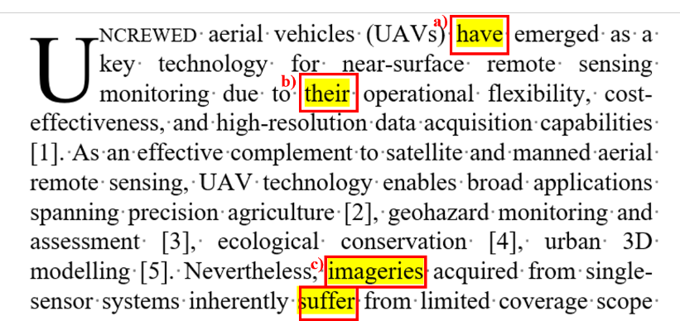
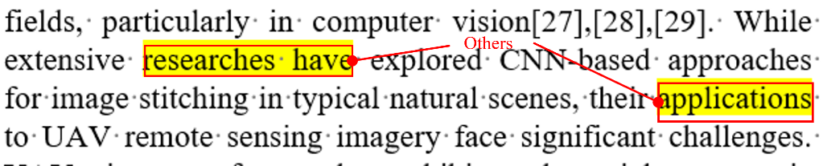
Revision 2: For the suggestion (d). Our intention is to convey that the network can achieve seamless blending of aligned images through adaptive feathering, enabled by estimating soft masks. However, we realize that the expression in the manuscript was unclear, which caused confusion for the reader. We deeply apologize for this and have made the necessary revision. The updated sentence is as follows:
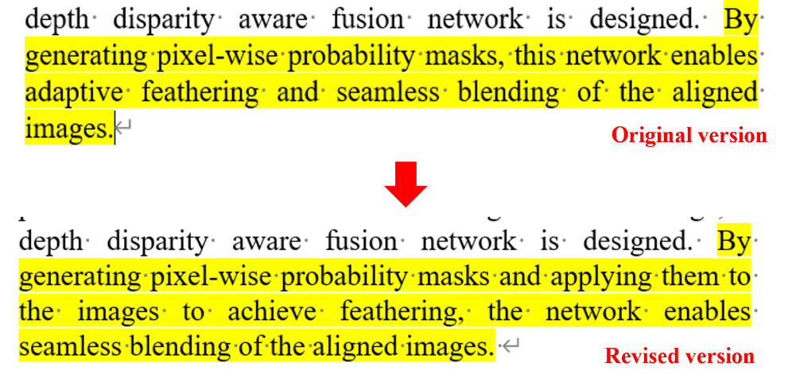
Revision 3: Regarding points (e) and (f), we acknowledge that both involve typographical errors. For point (e), we have already made changes based on reviewer’s suggestions (i), so we will not repeat those here. As for point (f), we have made the following correction:
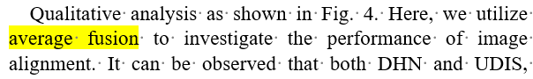
Revision 4: In response to your comment in g) , we review the manuscript and make corrections where the capitalization is inconsistent, including in the tables where there were discrepancies between rows and columns.
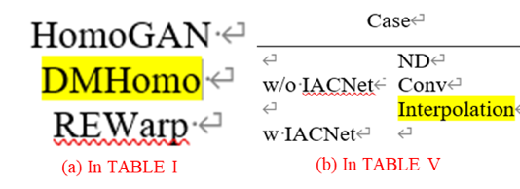
Revision 5: In response to your suggestion h), we have added proper references at the first mention of the datasets in the manuscript. Additionally, we have reviewed and corrected instances where modules proposed by other researchers were mentioned but not properly cited. The specific changes are illustrated in the attached figure.
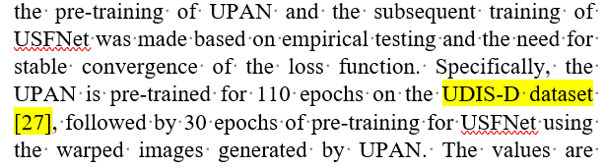
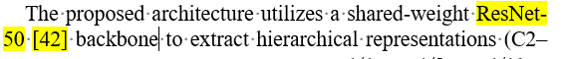
Revision 6: In response to your suggestion in point (i), we have made careful revisions. We have replaced all non-academic terms such as "ours" in the figures, tables, and text with the model name proposed in this manuscript or the term "proposed." A portion of the revisions is shown in the attached figure.
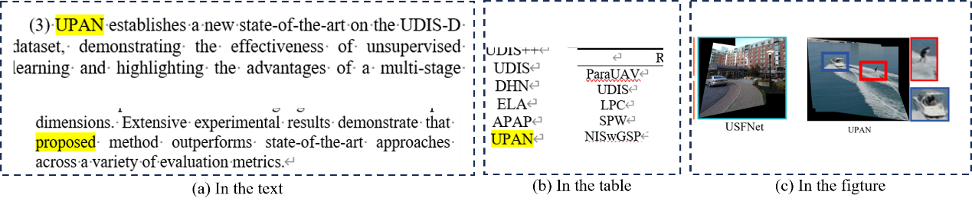

Comments 2: The rightmost term in eq. 2 should be defined. Please clarify what represents and how it is computed. While this appears to refer to thin-plate bending energy, the specific formulation should be made explicit.
Response:
We sincerely appreciate the reviewer’s helpful comment. In response to the suggestion regarding the rightmost term in equation (2), we have clarified its definition and computation. Specifically, the term represents the thin-plate bending energy, which is quantified by the second-order partial derivatives of the deformation. We have explicitly stated the corresponding formulation in the revised manuscript, as highlighted in the figure.
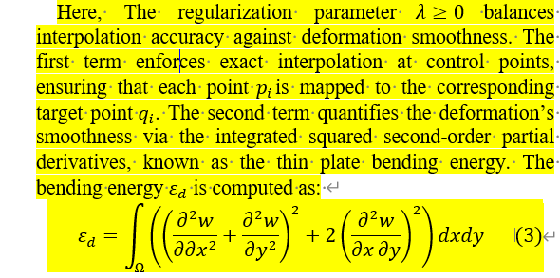

Comments 3: For presentation purposes, I would suggest authors share representative examples of the images of the ParaUAV dataset.
Response:
We sincerely thank the reviewer for this valuable suggestion. In the manuscript, we have introduced a set of representative examples from the ParaUAV dataset to improve the presentation of the manuscript. The images shown in the figure various scenes covered by the dataset, and we believe this will offer a clearer understanding of the dataset’s diversity.
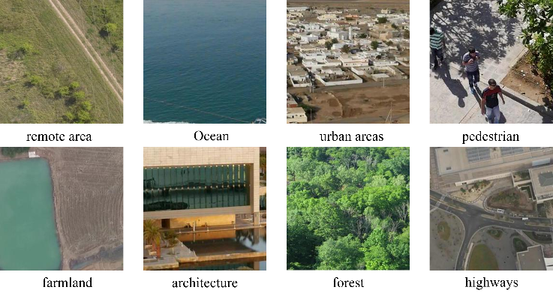

Comments 4: “6512 training and 636 test samples”? What about validation? How is overfitting avoided without validation?
Response:
We appreciate the reviewer’s insightful question regarding the absence of a separate validation set. We divide our response into two parts for clarity.
Question1. What about validation?
Answer 1: In unsupervised image alignment tasks, most commonly used datasets (e.g., UDIS-D and DunHuang-Stitch) do not include a separate validation set. This mainly stems from two considerations:
First, datasets for image stitching are generally small in scale. In such cases, it is preferable to allocate as much data as possible to model training rather than holding out a validation subset. Second, the goal of image alignment is not to predict predefined labels but to ensure that two overlapping images become visually consistent after transformation. This is also why we evaluate alignment quality in the overlapping regions using PSNR and SSIM. However, since there is no objective ground-truth alignment available, using PSNR or SSIM directly as evaluation criteria during training would cause metric leakage — the model might learn to optimize toward these evaluation metrics themselves, which would invalidate the fairness of evaluation.
From the perspective of validation usage, a validation set is typically employed for hyperparameter tuning to obtain the optimal model. In our work, however, we did not adjust any training-related hyperparameters (e.g., learning rate, optimizer type, or scheduling). We directly adopted the standard settings commonly used in prior works. For the relative weights of different loss terms, we only ensured that they remained in the same numerical scale throughout training to maintain stability and balance.
As for model selection, we simply used the model obtained when the unsupervised loss converged as our final version for testing. The test set was used only for post-training evaluation, not for any model tuning. If the model were overfitted, this would naturally result in degraded PSNR/SSIM performance on the test set. Nevertheless, our method achieves superior results compared with previous works, even without hyperparameter fine-tuning, which further demonstrates the robustness and solidity of the proposed approach.
Based on these considerations, no separate validation set was used in our dataset configuration.
Question2. How is overfitting avoided without validation?
Answer 2: During training, one common issue in unsupervised deep models is performance instability, which can arise from gradient explosion or excessive parameter updates, finally leading to overfitting or divergence. To address this, we apply gradient clipping to constrain the magnitude of gradients and stabilize optimization:
This operation prevents the gradients from exceeding a specified threshold (max_norm=3), ensuring smooth parameter updates and avoiding abrupt performance fluctuations.
In addition, we employ an strategy: training is terminated once the total unsupervised loss becomes stable and no longer decreases significantly. This prevents the model from over-adapting to the training data while maintaining generalization.

Comments 5: In a related comment, how are the number of epochs and other such parameters set? The choice of the number of epochs is not justified. How were these values chosen? Additionally, hyperparameters (e.g., learning rate decay schedule, regularization terms) should also be discussed or summarized in a table for reproducibility.
Response:
Many thanks for the comment. We divide the Revision into two parts.
Revision 1: In the original manuscript, only the epoch values were reported, but the rationale behind these choices was not clearly stated. We have now revised the paper to clarify this point (see the highlighted text in the figure). The selection of the epoch numbers is based on the convergence behavior of the loss function, as explained in our response to Comment 4. Specifically, we train each stage until the total unsupervised loss becomes stable, indicating that the model has reached a converged state. The reported epoch values correspond to this convergence point, determined empirically through multiple trials to ensure stable performance. In addition, we have added the details of the Adam optimizer hyperparameters used during training, including the learning rate and exponential decay rate, to enhance reproducibility and transparency.
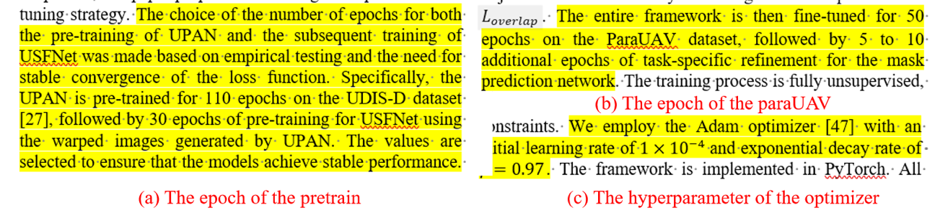
Revision 2: We sincerely appreciate the reviewer’s valuable comment. Through this feedback, we realized that the loss parameters and their corresponding weights were not explicitly described in the original manuscript. We have now revised the paper to include these details, ensuring greater transparency and reproducibility. Furthermore, the rationale behind the selection of each loss weight ratio has already been explained in our response to Comment 4, where we clarified that the loss components were balanced to maintain comparable numerical scales and achieve stable convergence during training.
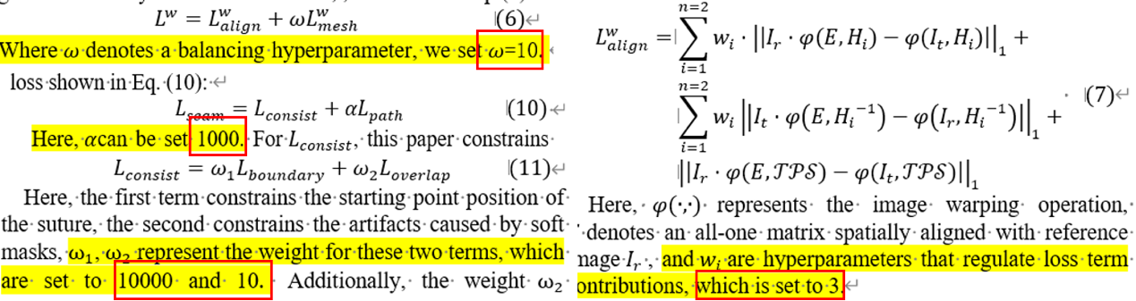

Comments 6: The statement that “the method … reduced memory consumption and accelerates training …” cannot be inferred from Table II. Training and inference times for the proposed method, and the methods used for performance comparison purposes, should be provided in the manuscript.
Response:
We sincerely appreciate the reviewer’s insightful comments. Our original intention is to emphasize that the model fine-tuned on the ParaUAV dataset achieves faster training and lower memory consumption, while maintaining performance comparable to (and better than) models trained from scratch. However, as the reviewer rightly pointed out, our initial version lacked quantitative evidence to support this claim. We have expanded and clarified this section in the revised manuscript. Specifically, we conducted additional experiments to verify our statement: on an RTX 4090 GPU (27 GB memory), training from scratch leads to out-of-memory errors, whereas the fine-tuning strategy runs smoothly and efficiently at approximately 6 minutes per epoch. Moreover, on an RTX 8000 GPU, fine-tuning also yields shorter per-epoch training time compared with full retraining.
These results collectively demonstrate that our fine-tuning strategy is both memory-efficient and computationally faster, which better supports our original claim and improves the rigor and readability of the manuscript.
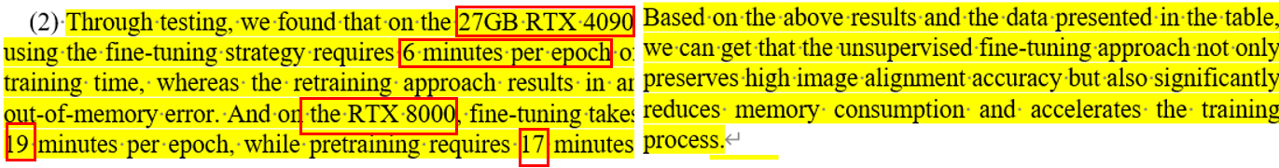

Comments 7: The MLLM part need further clarifications. What multimodal LLM was used? Was it used via prompting or fine-tuning? Etc.
Response:
We sincerely appreciate the reviewer’s valuable comment. We realized that our previous explanation in Section E was overly verbose and did not clearly convey the role of the MLLMs. Our intention is to illustrate that, with the rapid increase in model size, MLLMs have developed powerful visual understanding and reasoning capabilities. In image stitching tasks, the absence of ground-truth labels makes it difficult to directly quantify stitching quality, while traditional metrics such as PIQE and NIQE only provide indirect evaluations of image quality. To address this limitation, we leverage the MLLM’s visual reasoning ability and design a comprehensive prompting strategy to guide the model in automatically evaluating stitched images, thereby replacing labor-intensive manual assessment and yielding more consistent and interpretable judgments. However, our paper does not clearly articulate this point. Following the reviewer’s suggestion, we have revised the manuscript to include a figure-text integrated explanation, which more intuitively illustrates the workflow and purpose of the MLLM in our quality assessment framework.
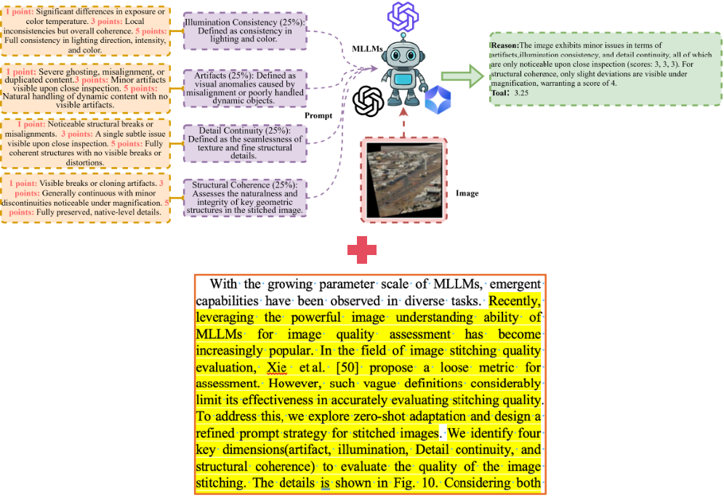

Comments 8: For transparency and reproducibility, I strongly recommend that the authors release both the ParaUAV dataset and the source code for UDRsNet.
Response:
We sincerely appreciate the reviewer’s attention to transparency and reproducibility, and we fully understand and agree with the importance of this suggestion. Ensuring the transparency and reproducibility of research is a fundamental requirement in scientific endeavors.
In response to your recommendation, we have made the key code and test dataset available at https://github.com/noviceor/UDRsNet. Regarding the complete dataset and full source code, we are currently unable to release all associated data, as the paper has not yet been officially published. However, we plan to gradually make more data and relevant resources available as the paper is officially released, ensuring that our research remains transparent and reproducible.

