Data Technician
Week 5 Workbook
Cloud Computing and Azure Data Fundamentals

Name:
Course Date:
Table of contents
Day 1: Task 1 3
Day 1: Task 2 4
Day 1: Task 3 5
Day 1: Task 4 6
Day 2: Task 1 7
Day 2: Task 2 8
Day 2: Task 3 (if finished Day 2 Task 2 early) 12
Day 3: Task 1: Activity: Azure Services 13
Day 3: Task 2: Skillable 15
Day 3: Task 3: Skillable 16
Day 4: Task 1: Skillable 17
Day 4: Task 2: Skillable (Optional) 18
Day 4: Task 3 (Optional) 18
1. Scenario Background 18
2. Data Laws and Regulations 18
3. Azure Service Recommendations 19
4. Data Types and Data Modelling 19
5. Data Storage Formats and Structures in Azure 20
6. Additional Considerations 20
Submission Guidelines: 20
Course Notes 22
Additional Information 22

Day 1: Task 1

Please research and complete the below questions relating to key concepts of cloud.

Be prepared to discuss the below in the group following this task.

What can cloud computing do for us in the real-world? | With Cloud computing, you can store, access, and process data and applications over the internet instead of relying on local computers or servers. It supports services such as online banking, video streaming, file storage, and remote working.
How can it benefit a business? | For businesses, cloud computing benefits include reduced IT costs, scalability, increased flexibility, improved data security, easier collaboration, and faster deployment of applications and services. It lets employees access systems and data from anywhere, supporting remote work, any device, and hybrid work environments.
What’s the alternative to cloud computing? | The main alternative to cloud computing is on-premises infrastructure (traditional computing), where a company owns and maintains its own servers and data centres.
What cloud providers can we use, what are their features and functions? | The most popular cloud providers are Microsoft Azure, AWS and Google Cloud Platform. AWS offers the widest range of cloud services, Azure integrates well with Microsoft's ecosystem, such as Microsoft 365, and Google Cloud is known for its strengths in data analytics, AI, and machine learning. These platforms help businesses reduce IT costs and quickly scale resources.

Day 1: Task 2

Read the information on this page: Explore the pricing calculator - Training | Microsoft Learn

Activity: Explore different scenarios
- Visit this page Pricing Calculator | Microsoft Azure
- Choose Estimate templates

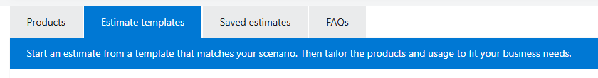
- Start estimate for Design an enterprise BI solution
Implement a pipeline that moves data from an on-premises data warehouse to a cloud and then use a business intelligence (BI) model to serve the data.
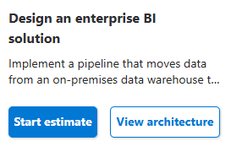

- Explore the services and the cost.

Cost of a Design an enterprise BI solution | 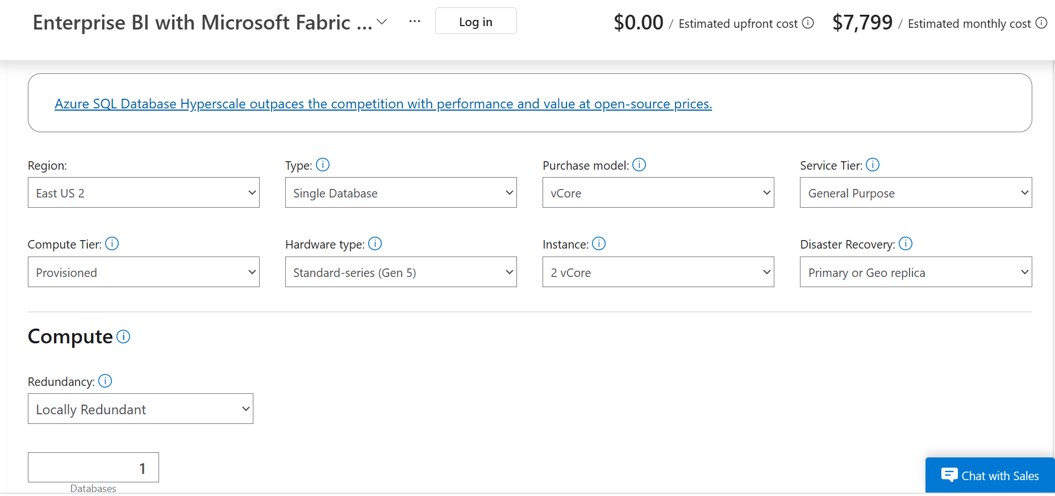  The cost estimate is based on the Azure services selected in the pricing calculator. In this Enterprise BI solution, Azure SQL Database is configured using a General-Purpose tier with 2 vCores, alongside other BI services such as Microsoft Fabric, data storage, and analytics components. The total estimated monthly cost is $7,799, demonstrating how enterprise BI costs depend on compute power, storage requirements, redundancy, and reporting capabilities.

Day 1: Task 3

Please research the below cloud offerings, explain what they are and examples of use cases.

Cloud Offerings | Explain what it is | When / how might you use this service in the real-world?
IaaS (Infrastructure as a service) | IaaS provides virtualised computing resources such as servers, storage, and networking over the internet. The cloud provider manages the physical hardware, while the customer manages the operating system, applications, and data. | IaaS is useful when a business needs to host websites, applications, or data without investing in physical servers.  The company can rent virtual machines and infrastructure from a cloud provider, allowing it to scale resources easily while reducing hardware and maintenance costs  Examples: Microsoft Azure Virtual Machines; AWS EC2; Google Cloud Compute Engine
PaaS (Platform as a service) | PaaS provides a platform for developing, testing, and deploying applications without managing the underlying infrastructure. The cloud provider manages servers, operating systems, and runtime environments. | PaaS is useful when a software development team needs to build and deploy an application quickly without managing the underlying infrastructure. Rather than setting up and maintaining servers, databases, and operating systems, the team can use a cloud platform that provides all the tools and services needed for development, testing, and deployment. This reduces complexity, saves time, and enables developers to focus on creating and improving the application.
SaaS (Software as a service) | SaaS delivers ready-to-use software applications over the internet. Users access the software through a web browser without installing or managing the application themselves. | SaaS is useful when businesses need ready-to-use software that employees can access from anywhere without having to install, manage, or update applications themselves. It enables users to work with cloud-based tools such as email, file storage, and collaboration platforms through a web browser, making remote work and teamwork more efficient.

Day 1: Task 4

Please research the below terms and explain what they are, when they would be appropriate and a real-world example of where it could be implemented (i.e. what type of organisation).

Public Cloud | A public cloud is a cloud computing environment where services and resources are provided over the internet by a third-party provider and shared among multiple customers.  It is ideal for organisations that prioritise cost-effectiveness, flexibility, and scalability, as it eliminates the need to purchase and maintain physical infrastructure.  Common users of public cloud services include startups, small and medium-sized enterprises (SMEs), and online retailers.
Private Cloud | A private cloud is a cloud computing environment dedicated exclusively to a single organisation.  It is ideal for organisations that require high levels of security, privacy, and regulatory compliance, as it provides greater control over data, infrastructure, and access.  Private clouds are commonly used by banks, hospitals, and government agencies that handle sensitive or confidential information.
Hybrid Cloud | A hybrid cloud is a cloud computing environment that combines both public and private cloud services.  It is ideal for organisations that need to keep sensitive data and critical applications in a private cloud while taking advantage of the scalability, flexibility, and cost savings of the public cloud.  Hybrid clouds are commonly used by large retailers and enterprise businesses that require a balance between security, compliance, and operational efficiency.
Community Cloud | A community cloud is a cloud computing environment shared by multiple organisations with similar security, compliance, or operational requirements. It is ideal when organisations need to collaborate securely while sharing resources and adhering to common standards or regulations. Community clouds are commonly used by groups such as NHS trusts, universities, and government departments that need secure data sharing and collaboration across organisations.

Day 2: Task 1
You are a Cloud Consultant hired by a client. You will identify the most suitable cloud service model for a client requiring control over infrastructure, estimate potential cloud costs, and explain the benefits of cloud adoption.
🏭 Client – "DataCore Enterprises"
- A large enterprise wants to move its internal database servers to the cloud.
- They already have IT staff.
- They want full control over operating systems and storage configuration.
Questions for you:
- Which service model suits them? (IaaS, PaaS, Saas)
For DataCore Enterprises, Infrastructure as a Service (IaaS) is the most suitable cloud service model because it provides full control over operating systems, storage, networking, and server configurations while eliminating the need to manage physical hardware. They already have an IT team that can manage and maintain the infrastructure. With IaaS, the cloud provider manages the physical hardware, while the company manages the virtual machines, operating systems, applications, and data. IaaS also offers the scalability, reliability, and cost efficiency benefits of cloud computing.
- How can they estimate the cost of using cloud services?
To estimate the cost: use a cloud provider's pricing calculator, such as those offered by Microsoft Azure, AWS, or Google Cloud, considering variables including:
- Number and size of virtual machines (CPU and memory)
- Storage requirements
- Database services
- Network traffic and bandwidth
- Backup and disaster recovery services
- Software licensing costs
By entering these variables into a pricing calculator, the organisation can forecast monthly or annual cloud expenditure.

- What are the possible benefits of using cloud services?
  - Scalability: Resources can be increased or reduced as business needs change.
  - Cost Efficiency: Eliminates large upfront investments in physical servers.
  - Reliability: Cloud providers offer high availability and redundancy.
  - Flexibility: IT staff can access and manage systems remotely.
  - Security: Leading cloud providers offer advanced security features and monitoring.
  - Disaster Recovery: Backups and recovery options help minimise downtime and data loss.

- Bonus: What might be potential risks?
Potential risks include:
  - Data breaches or cyberattacks if security controls are not configured correctly.
  - Cloud service outages that may temporarily affect access to systems.
  - Vendor lock-in, making it difficult to switch providers later.
  - Unexpected costs due to excessive resource usage.
  - Compliance and data residency requirements that must be carefully managed.

Day 2: Task 2

Describe, with examples, the three major areas that the Computer Misuse Act deals with.

Area | Description | Example
Unauthorised Access to Computer Material | An illegal act when someone accesses a computer, network, or data without permission, even if no damage is caused. | Using someone else's login credentials to access a company database without authorisation.
Unauthorised Access with Intent to Commit Further Offences | This occurs when someone gains access to a computer or network without permission and does so to commit another crime. The unauthorised access is used as a way to carry out activities such as fraud, identity theft, or stealing money. | Hacking into a bank account to steal money or personal information.
Unauthorised Acts to Impair a computer | An illegal act when someone modifies, disrupts, damages, or impairs the operation of a computer system or data, including spreading malware. | Sending malicious software to a company’s networks, such as a virus, ransomware attack, or denial-of-service (DoS), to attack its systems and prevent employees from accessing important files and services.

The computer misuse act 1990 is an act where an individual can be criminalised because of computer related offense. Describe three extra powers that the Police and Justice Act 2006 (Computer Misuse) has added.

Description
The Police and Justice Act 2006 strengthened the Computer Misuse Act 1990 by making it illegal to:
1. Making, Supplying or Obtaining Hacking Tools

It became an offence to create, distribute, sell, or possess software and tools designed for committing computer misuse offences. These include password-cracking programs and malware creation tools.

Example: Selling password-cracking software designed to gain unauthorised access to computer systems.
2. Tougher Penalties for Unauthorised Access

The Act increased the penalties for hacking and unauthorised access to computer systems, allowing courts to impose more severe punishments on offenders.

Example: A hacker accessing a company's database without permission could face a longer prison sentence than under the original Act.

3. Interfering with Computer Systems: The Act made it an offence to deliberately disrupt or impair a computer system, even if no permanent damage is caused.

Example: Sending malicious software that stops employees from accessing company files or using essential service

Look at the below website to answer the questions:
https://www.gov.uk/personal-data-my-employer-can-keep-about-me

Write down three items of data which a company can store about an employee.
Three examples of employee data that a company can store are:
  - Name - Used to identify the employee in company records.

  - Address - Used for contact and employment administration purposes.

  - National Insurance Number - Used for payroll, tax, and National Insurance contributions.

Give three more examples of data that an employer can only store if they first get the employee’s permission.
Other examples include
(i) date of birth,

(ii) qualifications, work experience,

(iii) emergency contact details, training records, and employment history.

Conduct further research to answer the below questions.

Question | Answer
Provide one example of: Copyright infringement | Copying and distributing a copyrighted film, song, book, or software without the permission of the copyright owner.  Example: Downloading and sharing a paid movie illegally online.
Provide one example of: Plagiarism | Using someone else's work, ideas, or words and presenting them as your own without giving credit.  Example: Copying information from a website into an assignment and submitting it without citing the source.
What are two consequences of copyright infringement and software piracy? | - Legal action, including fines or prosecution.  - Financial losses for the creators and companies that own the copyrighted material.
Give three possible consequences for individuals when using pirated software | - Malware or viruses that can damage devices or steal personal data.  - No access to updates or technical support, leaving software vulnerable to security risks.  - Legal penalties, such as fines or other enforcement actions for using illegal software copies.
Listed below are some laws which we have covered today:
1. Computer Misuse Act 1990
2. Police and Justice Act 2006 (Computer Misuse)
3. Copyright, Designs and Patents Act 1988
4. Copyright (Computer Programs) Regulations 1992
5. The Health and Safety (Display Screen Equipment) Regulations 1992
6. Data Protection Act 2018
7. Consumer Rights Act 2015

- Insert a number in the first column of each row to match each of the statements with one of the above Acts.

- One of statements is incorrect and not illegal. For this statement, write ‘Not illegal’.

Act number | Clause
4 | With some exceptions, it is illegal to use unlicensed software
7 | Any product, digital or otherwise, must be fit for the purpose it is supplied for
1 | Unauthorised modification of computer material is illegal
‘Not illegal’ | It is illegal to create or use a hacking tool for penetration testing
6 | Personal data may only be used for specified, explicit purposes
5 | Employers must provide their computer users with adequate health and safety training for any workstation they work at
2 | It is illegal to distribute hacking tools for criminal purposes
3 | It is illegal to distribute an illicit recording
6 | Personal data may not be kept longer than necessary
1 | Gaining unauthorised access to a computer system is illegal
5 | Employers must ensure that employees take regular and adequate breaks from looking at their screens
2 | It is illegal to prevent or hinder access (e.g. by a denial-of-service attack) to any program or data held in any computer
6 | Personal data must be accurate and where necessary kept up to date

Day 2: Task 3 (if finished Day 2 Task 2 early)

Please complete this activity to the best of your ability. This is an introduction to Azure Cloud Computing. You can skip Exercises as we will complete day later. Sing in using bootcamp email to save your progress.
Introduction to Cloud Infrastructure: Describe Azure Architecture and Services - Training | Microsoft Learn

Screenshot of XP
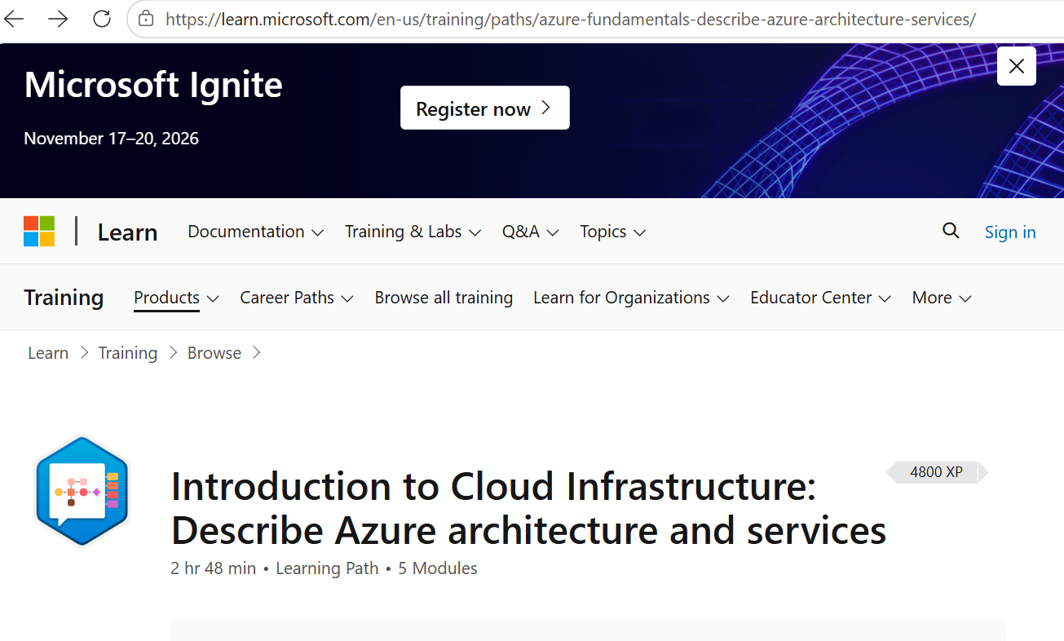4800 XP

Day 3: Task 1: Activity: Azure Services
Research 3 of the following Azure Services and write a brief description of their main points.
Use Azure products website or search online: Directory of Azure Cloud Services | Microsoft Azure
- API Management
- Application Insights
- Azure Active Directory
- Azure Rights Management
- Batch
- BizTalk Services
- Data Factory
- HDInsight
- StorSimple
- Operational Insights

Service 1 -
For data analytics, I use:

- Azure Data Factory is a cloud-based data integration service that allows organisations to collect, transform, and move data from multiple sources into a centralised location/repository, such as a data warehouse, for reporting, business intelligence, and advanced analytics.

Service 2 -
- HDInsight is Azure’s managed open-source analytics service for processing large datasets using popular open-source frameworks such as Apache Spark, Hive and Kafka. It helps organisations to process and analyse both structured and unstructured data efficiently, making it well suited for big data and advanced analytics workloads.

Service 3 -
- Application Insights is a monitoring tool within Azure Monitor that collects real-time data from applications, including performance metrics, usage patterns, user behaviour, and error tracking. The information helps organisations identify issues, optimise performance, and improve the user experience.

Challenge: Explain if any other Azure Cloud service might benefit you or your business.
Service -
API Management allows organisations to publish, secure, monitor, and manage APIs. In data analytics projects, APIs are often used to connect applications and external data sources, making data available for analysis. It complements services such as Data Factory and HDInsight by securely connecting and exposing data through APIs for analytics solutions.

Azure Simulators
Learn by doing it! Each simulation below links out to an interactive lab that you can complete, just as if you were in a real Azure environment! Access any simulation you wish, as often as you wish.

- CREATE A RESOURCE GROUP
In this simulation, you will be guided, step-by-step, through the process of creating a new resource group in Microsoft Azure, using the Azure Portal.

- DEPLOY A WINDOWS VM
In this simulation, you will be guided, step-by-step, through the process of provisioning a new Windows virtual machine in Microsoft Azure, via the Azure Portal.

- PROVISION A STORAGE ACCOUNT
In this simulation, you will be guided, step-by-step, through the process of provisioning a new General Purpose V2 storage account in Azure, using the Azure Portal.

- DEPLOY AN AZURE FILE SHARE
In this simulation, you will be guided through the process of creating an Azure file share, called myfileshare in an existing storage account.

Day 3: Task 2: Skillable

Please complete the below lab (1) Explore Azure SQL Database and paste evidence of the completed lab in the box provided.

  - Visit https://leeptalent.learnondemand.net/
  - Sign into your account
  - Select activity DP-900T00-A Introduction to Microsoft Azure Data
  - Find and Launch Explore Azure SQL Database
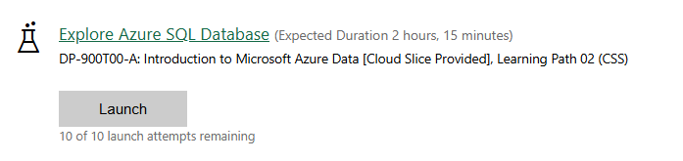

You can watch this video on how to complete the lab.
Lab 1 Explore Azure SQL Database.webm

Completed Lab | 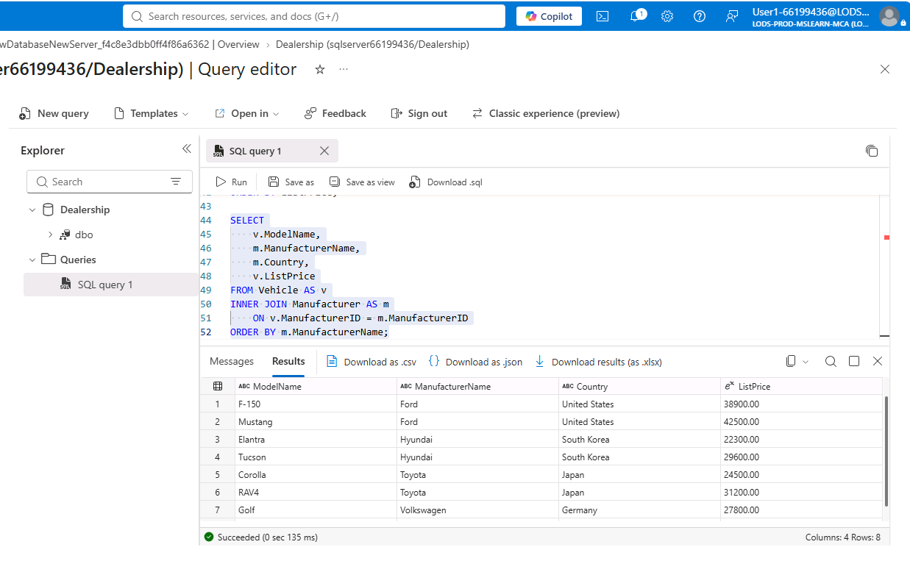
This is the last SQL Query, and I have completed the last two instructions to clean up the resource group.
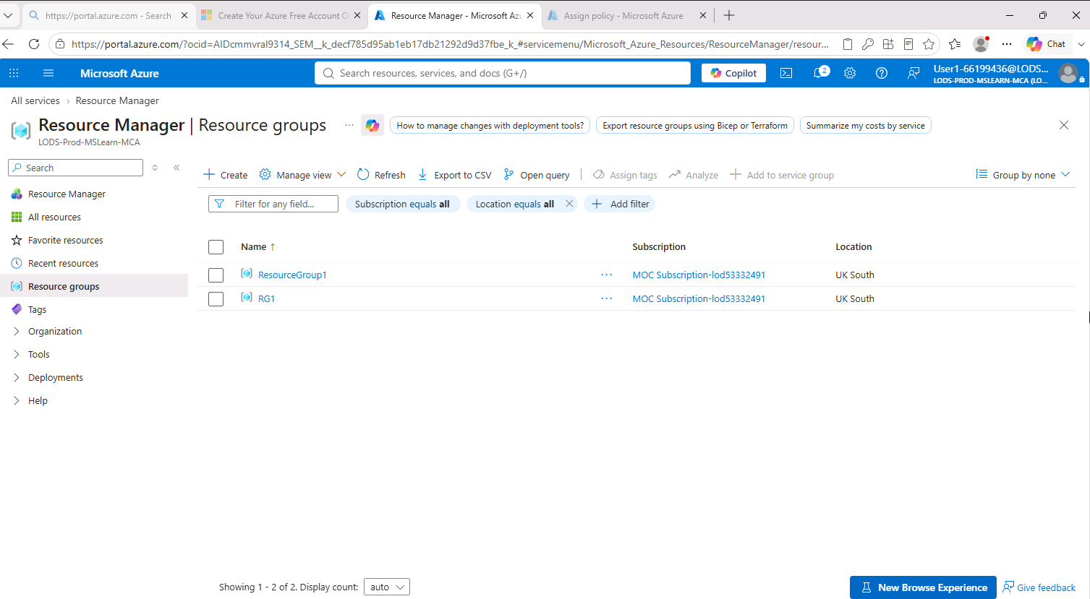

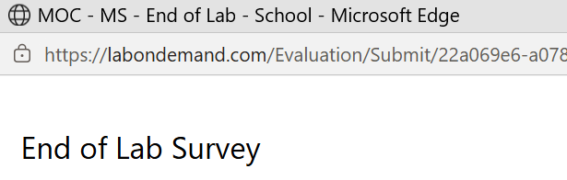

Day 3: Task 3: Skillable

Please complete the below lab (2) Explore Azure Storage for non-relational data and paste evidence of the completed lab in the box provided.

  - Visit https://leeptalent.learnondemand.net/
  - Sign into your account
  - Select activity DP-900T00-A Introduction to Microsoft Azure Data
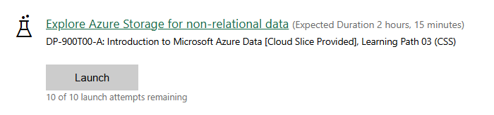
  - Find and Launch Explore Azure Storage for non-relational data.

You can watch this video tutorials on how to complete the labs.
Part 1: Explore Storage Account: Azure Lab 2 Storage Account.mp4
Part 2: Explore Azure Cosmos DB Azure Lab 2 Azure Cosmos DB.webm

Completed Lab | Azure Storage file name on Azure Storage for non-relational data  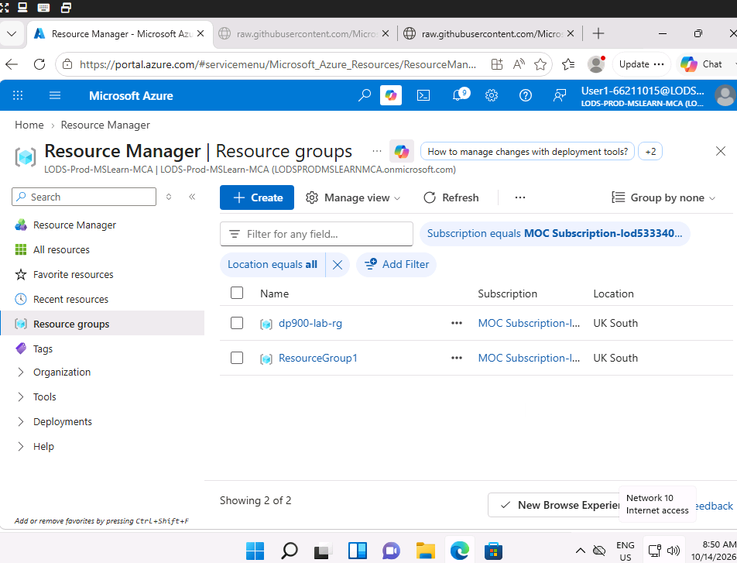  Azure Cosmo DB file name  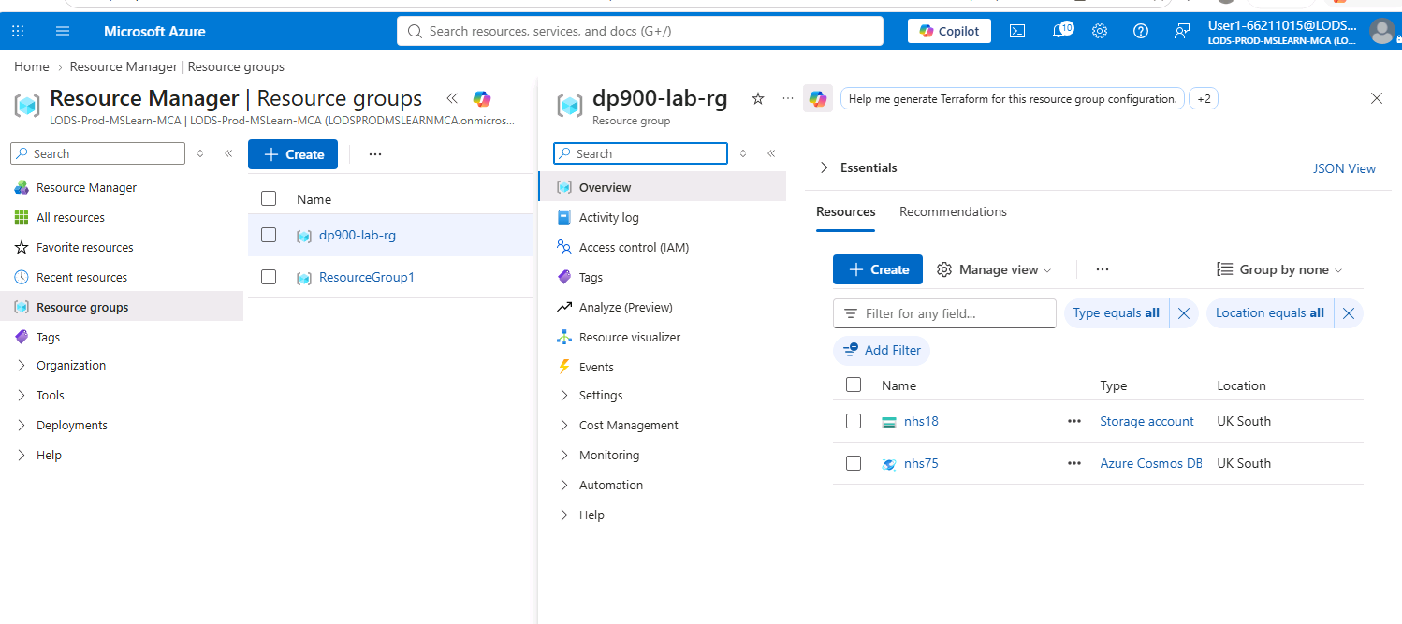  I have completed the Lab to Azure Storage for non-relational data and Azure Cosmo DB.

Day 4: Task 1: Skillable
Please complete the below lab (3) Explore fundamentals of large-scale data analytics and paste evidence of the completed lab in the box provided.

  - Visit https://leeptalent.learnondemand.net/
  - Sign into your account
  - Select activity DP-900T00-A Introduction to Microsoft Azure Data
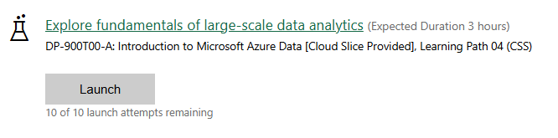
  - Find and Launch Explore Azure Storage for non-relational data Explore fundamentals of large-scale data analytics

You can watch this video on how to complete the lab.
Part 1: Azure Lab 3 Part 1 Explore data analytics in Microsoft Fabric.webm
Part 2: Azure Lab 3 Part 2 Explore real-time analytics in Microsoft Fabric.webm
Part 3: Azure Lab 3 Part 3 Explore fundamentals of data visualization Power BI.webm

Completed lab | Green Taxi  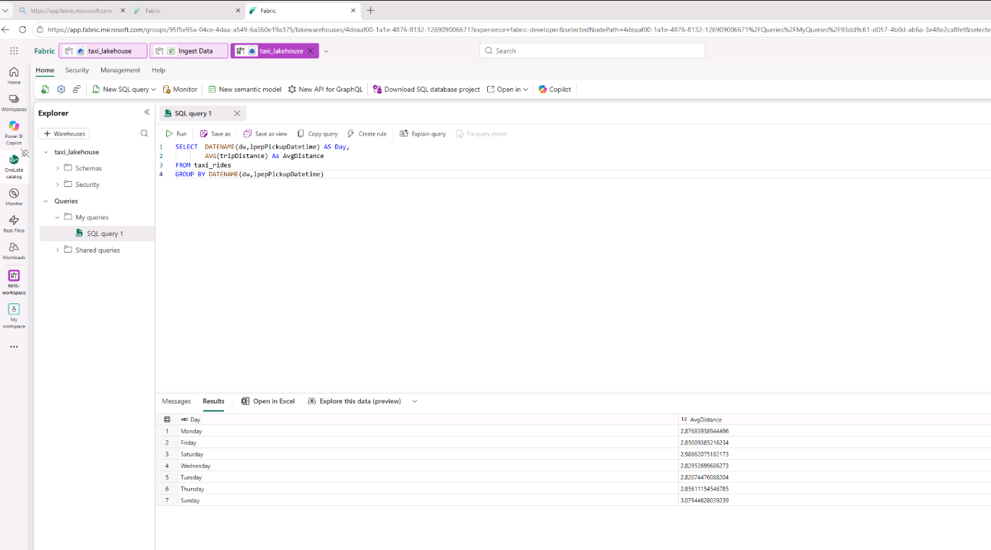  Yellow Taxi  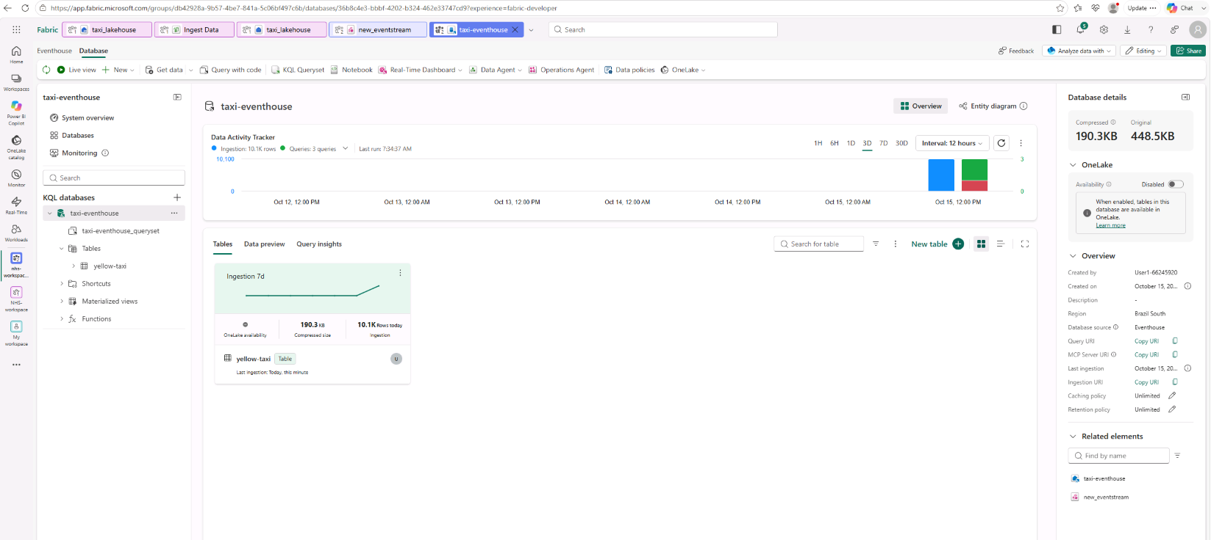  Power BI  I cannot install it, so I cannot complete the work.

Day 4: Task 2: Skillable (Optional)

After completing all the labs, you can complete the Azure DP-900 practice exam and paste your result below – this is open book and please research and discuss your answers as a team.
  - Visit https://leeptalent.learnondemand.net/
  - Sign into your account
  - Select activity DP -900T00-A Introduction to Microsoft Azure Data
  - Find and Launch Practice Assessment: DP-900T00-A Microsoft Azure Data Fundamentals
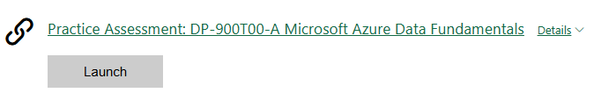

Completed lab | 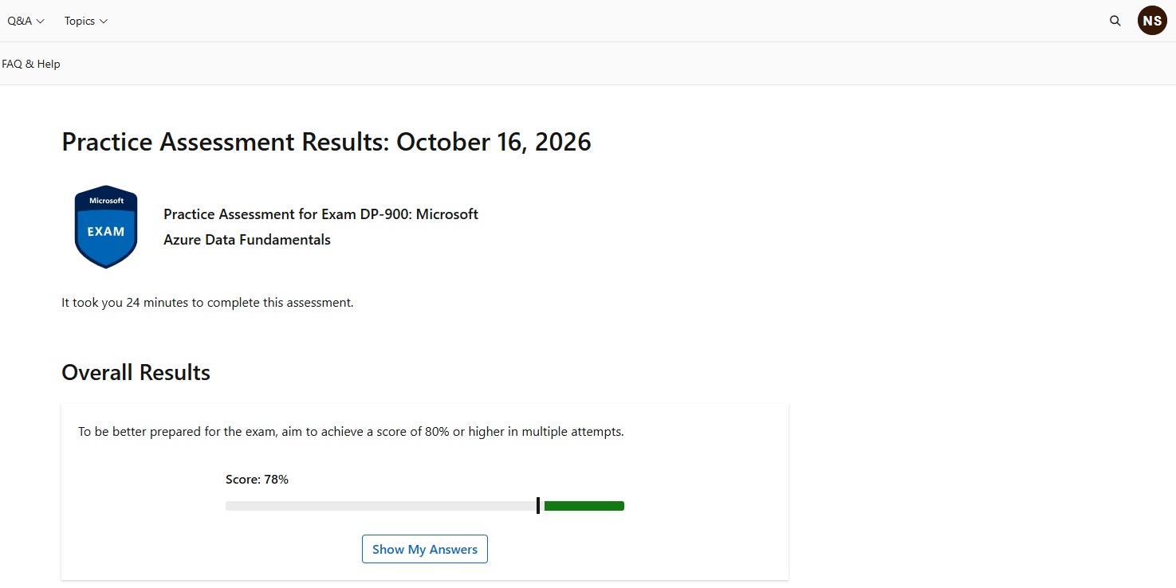

Day 4: Task 3 (Optional)

1. Scenario Background
"Paws & Whiskers" is a growing pet shop that aims to improve its business by analysing sales, customer information, and inventory data. Currently, the data is collected manually or stored in spreadsheets. Management is interested in transitioning to Microsoft Azure to streamline data storage, analysis, and reporting, enabling them to make data-driven decisions.

2. Data Laws and Regulations
Identify and explain the data laws and regulations relevant to handling customer data within the proposal. Ensure you cover the following points:
- GDPR Compliance: Highlight the importance of adhering to the General Data Protection Regulation (GDPR), particularly as it relates to storing and processing customer information.
- Data Protection Act (DPA) 2018: Outline how the DPA 2018 may affect the way "Paws & Whiskers" collects and stores data, ensuring compliance with UK laws on data privacy.
- Other Industry Standards: Research any additional data protection standards or regulations that may apply to pet shop data, particularly if they involve sensitive or payment information.

3. Azure Service Recommendations
Recommend Microsoft Azure services that would suit the company’s data analysis needs and explain why these services are suitable. Your recommendations should include:
- Data Storage: Identify suitable storage options, such as Azure Blob Storage or Azure SQL Database, and discuss the benefits of each for storing large datasets, including inventory, sales transactions, and customer details.
- Data Analysis Tools: Recommend tools such as Azure Machine Learning for customer behaviour analysis or Azure Synapse Analytics for analysing sales trends.
- Data Integration and Automation: Explain how services like Azure Data Factory could automate data collection and integration processes, improving efficiency.

4. Data Types and Data Modelling
Define the types of data "Paws & Whiskers" will need to work with and describe your approach to data modelling:
- Data Categories: Identify key data types, such as customer demographics, transaction history, pet inventory, and product categories.
- Data Modelling Approach: Outline how you would structure this data using a relational model or a data warehouse approach, considering factors like tables, entities, relationships, and primary keys.

5. Data Storage Formats and Structures in Azure
Discuss how you would store data within Azure and the formats you would recommend:
- Data Formats: Specify recommended formats (e.g., CSV for raw data imports, JSON for structured data, Parquet for analytics) and explain why these formats are suitable for specific data types.
- Data Security and Encryption: Include recommendations for securing data using Azure’s built-in encryption features and access controls to ensure compliance with data privacy regulations.

6. Additional Considerations
Provide any other considerations that might enhance data handling and efficiency in Azure, such as:
- Backup and Disaster Recovery: Outline a backup plan using Azure Backup or Azure Site Recovery to safeguard against data loss.
- Data Visualisation: Discuss potential use of Power BI within Azure for creating dashboards that provide management with real-time insights into sales and customer trends.
- Future Scalability: Comment on how Azure services can scale as the business grows, accommodating larger datasets and more complex analyses.

Submission Guidelines:
- Structure: Ensure your report is well-organised, with sections for each task (e.g., Data Laws, Azure Services, Data Types, etc.).
- Formatting: Include headings, bullet points where appropriate, and any visuals or diagrams that support your explanations.
- References: Cite any resources or regulations referenced in the report.
- Length: Aim for 1500-2000 words.

Additional Resources
- DataCamp Recommended Courses
- Understanding Microsoft Azure - DataCamp Learn
- Introduction to Azure - DataCamp Learn
- Understanding Cloud Computing - DataCamp Learn
- Introduction to Microsoft Fabric - DataCamp Learn

- Introduction to Microsoft Azure Data: In this course, students will gain foundational knowledge of core data concepts and related Microsoft Azure data services.
Course DP-900T00-A: Introduction to Microsoft Azure Data - Training | Microsoft Learn

- Explore how to implement data analytics solutions on a single platform with Microsoft Fabric. Integrate, transform, and store data to train AI models and create insightful reports.
Get started with Microsoft Fabric - Training | Microsoft Learn

- Azure Data Fundamentals Flashcards
Azure Data Fundamentals Flashcards | Quizlet

- Learn the Fundamentals of Microsoft Fabric in 38 minutes
Learn the Fundamentals of Microsoft Fabric in 38 minutes

- View expert-led demos to quickly learn how to get started and accomplish your goals with Azure services
Watch Azure Demos to Get Started | Microsoft Azure

- Practice Assessment for Exam DP-900: Microsoft Azure Data Fundamentals
Practice Assessment | Microsoft Learn

Course Notes

It is recommended to take notes from the course, use the space below to do so.

END OF WORKBOOK

Please check through your work thoroughly before submitting and update the table of contents if required.

Please send your completed work booklet to your trainer.

