Data Technician
Workbook
Week 1 Excel

Name:
Course Date:
Table of contents
Day 1: Task 1 3
Day 2: Task 1 4
Day 2: Task 2 5
Day 3: Task 1 6
Day 3: Task 2 7
Dataset: 7
Step 1: Create a Pivot Table 7
Step 2: Use the SWITCH Function 7
Submission: 8
Day 3: Task 3 9
Course Notes 10
Additional Resources 11
Additional formation 12

Day 1: Task 1

Please research and complete the below boxes on common laws and regulations that must be followed when working with customers data, use the below bulleted list to support your answers.

- What is it
- Why is it important
- Provide a real-world example of how you can follow it
- How does it impact working with data
- What could happen if you breached it

Data Protection Act | Data Protection Act was enacted in 2018, along with UK GDPR, in which required organisations/institutions to ensure that all processing data are being using fairly, lawfully, and transparently for specific, explicit and legitimate purposes. All data should be treated in accurate and up to date, ensuring the security data from loss, theft, or unauthorized access. These acts were taken for safeguards individual privacy and prevent third party use the data for harm, such as financial fraud, discrimination, theft or emotional distress. The Data Protection Act was introduced to give individuals clear rights over information to know how data is used, access, copies or erasure.
GDPR | GDPR is stand for the General Data Protection Regulation is a security law that regulates how organisations collect, process and store personal data. To do so, organisations must have a clear and consent before collection any personal data, by explaining clearly what data they collect and why they need it. If there are data breaches, the organisation must report them immediately. This regulation is in place to ensure the proper protection of individual data and that it is used is taking with fully responsibility and only for useful purposes.
Freedom of Information Act | It’s the UK Law regulated in 2000 to give any person the legal right to request recorded information held by public authorities, including emails, letters, phone logs, and CCTV footage. It’s taken to promotes transparency, such as to lets citizens see how public money is spent and how decisions are made; to support democracy, to informed citizens regarding governments and public leaders' accountability; build people trust and pushes organisations to be more open by default rather than secretive.
Computer Misuse Act | Law related to hacking and cybercrime, focussing on three core activities including (i) unauthorised access, such as logging into a computer, server, or account without permission; (ii) breaking into a system for a further crime, such as fraud, data theft or blackmail. (iii) Unauthorised modification, such as destroying, altering or deleting data, or introducing malware like viruses and ransomware.

Day 2: Task 1

Please research and complete the following tasks within the retail-sales_dataset.xlsx document, paste a print screen into the provided boxes below:

- Using the ‘filter’ function, filter ‘Age’ to ‘largest to smallest’. Sort results by Transaction ID to revert to original sorting order.
- Using the ‘SUM’ function, show me the commission total in cell ‘P10’
- Using the ‘AVERAGE’ function, show me the average commission in cell ‘P11’

Print screen 1 | 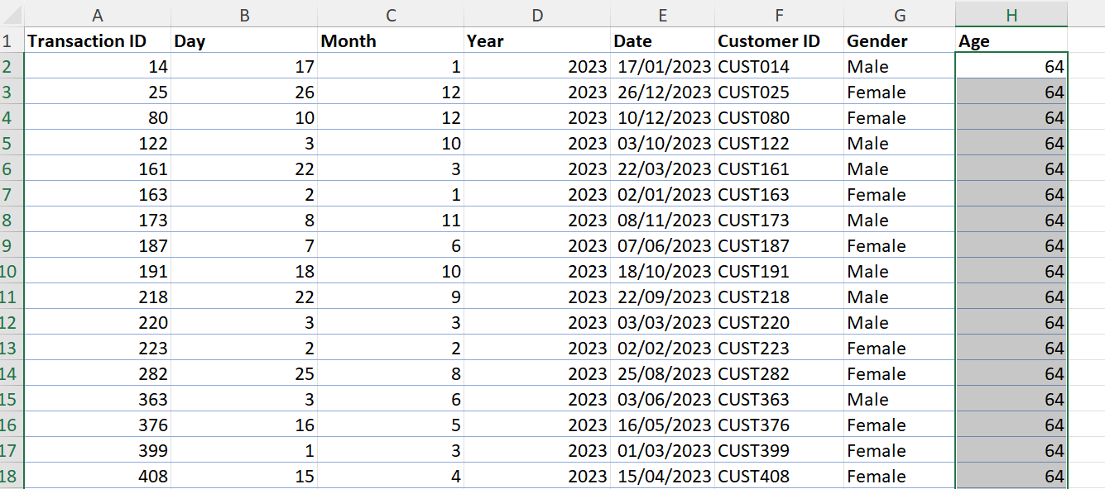
Print screen 2 | SUM function of Product Sales  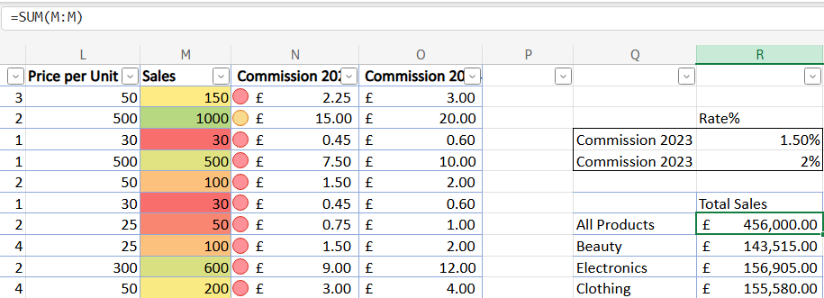
Print screen 3 | 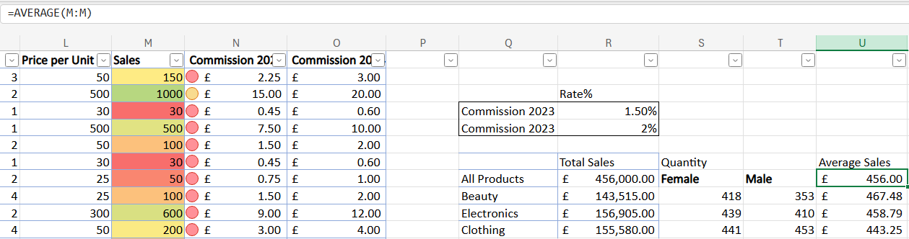

Day 2: Task 2

Using the skills developed today, have some fun with the data set you have imported. Paste your work below and enjoy!

Print screen 1 | Using conditional formatting to present sales scales (e.g., High, Medium, Low Revenue), which are also reflected in the commission attributes.  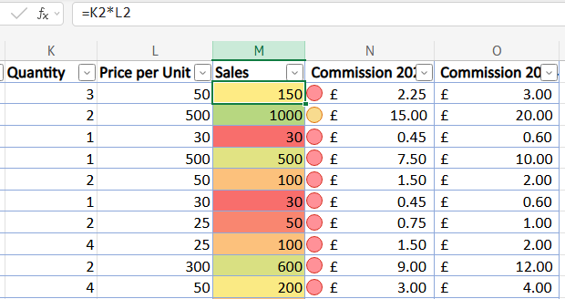
Print screen 2 | Using a pivot table from the above dataset (i.e., the retail-sales dataset) to display the sales figures across different category of products:  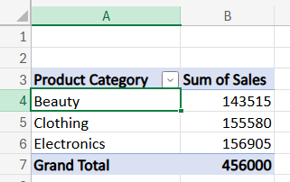
Print screen 3 | Using a pivot table and Bar Charts from the above dataset (i.e., the retail-sales dataset) to display the sales figures across different categories of products by gender:  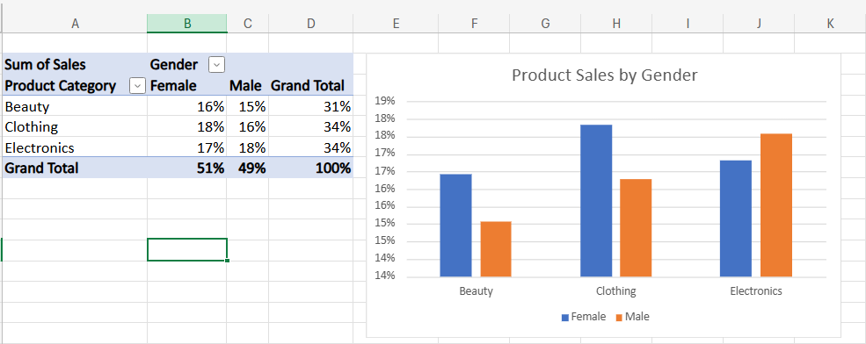
Print screen 4 | Using a pivot table, bar charts and slicers from the above dataset (i.e., the retail-sales dataset) to display the sales figures across different product categories by gender and generation:  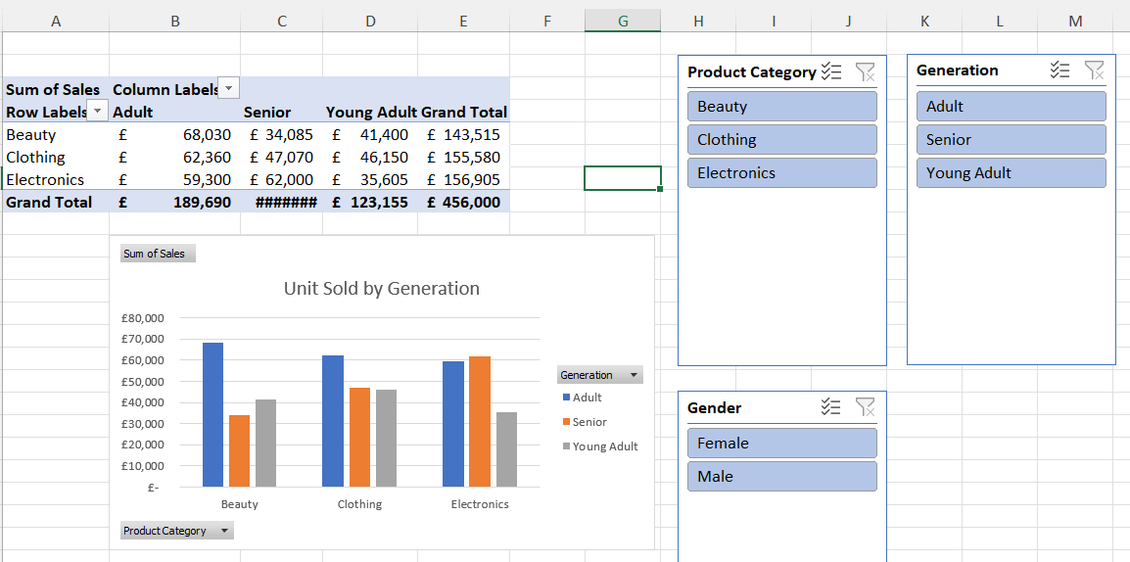

Day 3: Task 1

Please open and make an online copy of the dataset ‘Bike_Sales_Pivot_Lab.xlsx from here.

The lab instructions can be found here Bike Sales Pivot Tables.docx . Do not worry if you do not complete the lab, just working with data and playing with the pivot table will be good experience.

Please paste your final pivot table below and complete the reflection questions:

Print screen 1
In which Age Group does Germany have customers? | 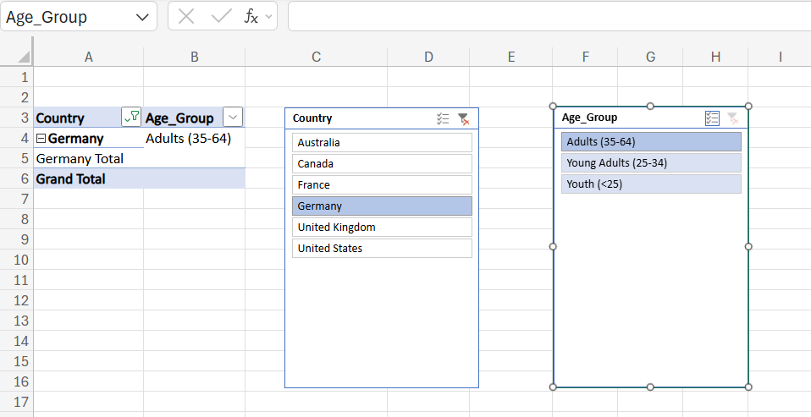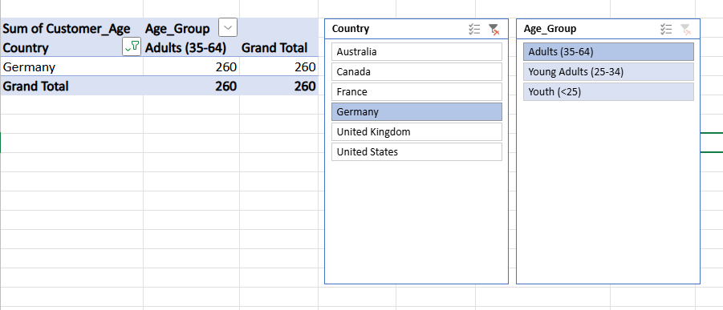
What country has sales in all markets? | Australia has sales in all markets  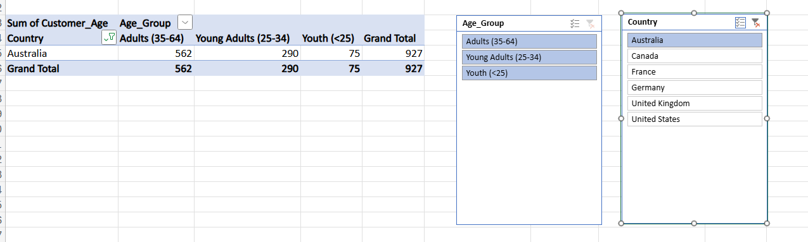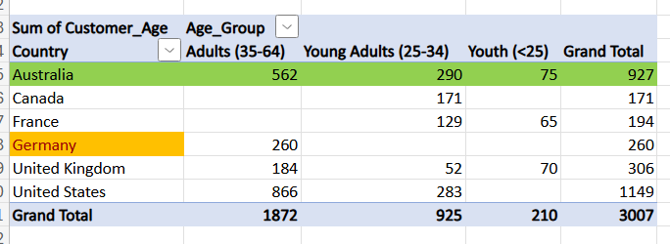
What is the most profitable country by age group, and gender? | United States is the most profitable country  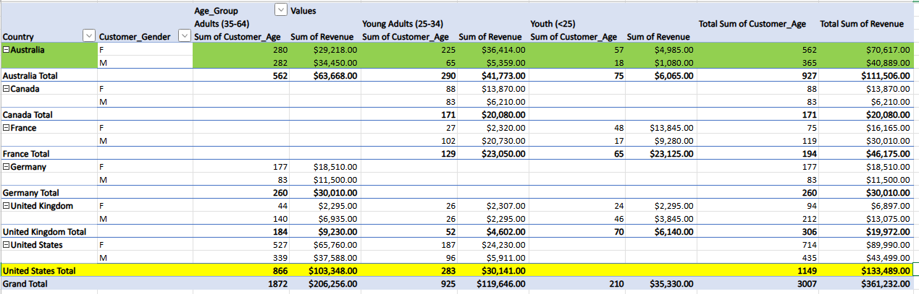
Any other findings?

Day 3: Task 2
The dataset below tracks the sales performance of different products in various counties in England. Please paste the dataset into a blank Excel workbook. Your task is to:
- Create a Pivot Table to summarise the data by county and product.
- Use the SWITCH function to categorise products based on their sales volume.

Dataset:
County | Product | Sales Volume
Yorkshire | Laptops | 500
Yorkshire | Smartphones | 200
Cornwall | Laptops | 700
Cornwall | Printers | 400
Lancashire | Smartphones | 150
Lancashire | Laptops | 600
Essex | Printers | 800
Essex | Smartphones | 300
Durham | Laptops | 250
Durham | Printers | 300
Greater Manchester | Smartphones | 600
Greater Manchester | Laptops | 400

Step 1: Create a Pivot Table
- Select the dataset (columns A to C).
- Insert a Pivot Table to summarise the data by County in the rows and Products in the columns. Use Sales Volume as the value to be summarised.

Step 2: Use the SWITCH Function
In a new column next to your data, use the SWITCH function to categorise products based on Sales Volume as follows:
  - For sales greater than 600: "High"
  - For sales between 300 and 600: "Medium"
  - For sales less than 300: "Low"
SWITCH Function Example:
=SWITCH(TRUE, C2 > 600, "High", C2 >= 300, "Medium", "Low")

- Apply this formula to each row and check if the products are categorised correctly.

Submission:
- A completed Pivot Table summarising sales by county and product.
- A new column in the dataset categorising products by sales volume using the SWITCH function.
  - Please paste your completed work below

Print screen 1 | - Pivot Table result  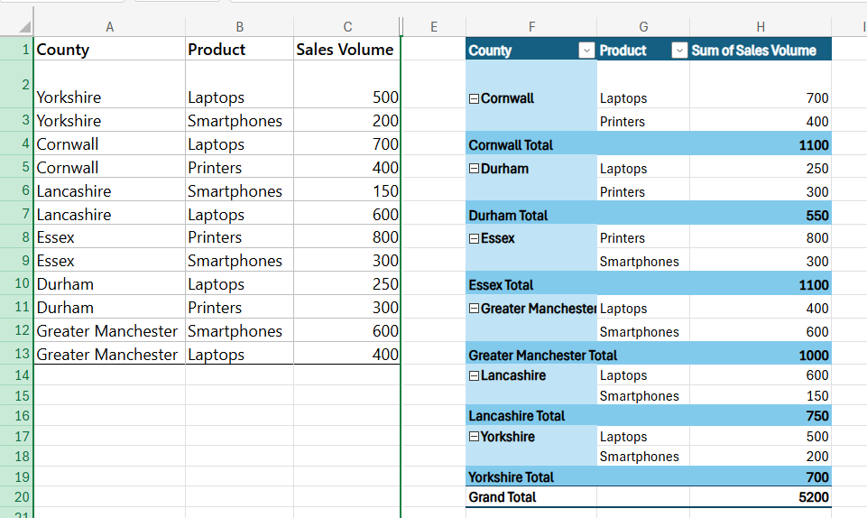  - SWITCH function figure  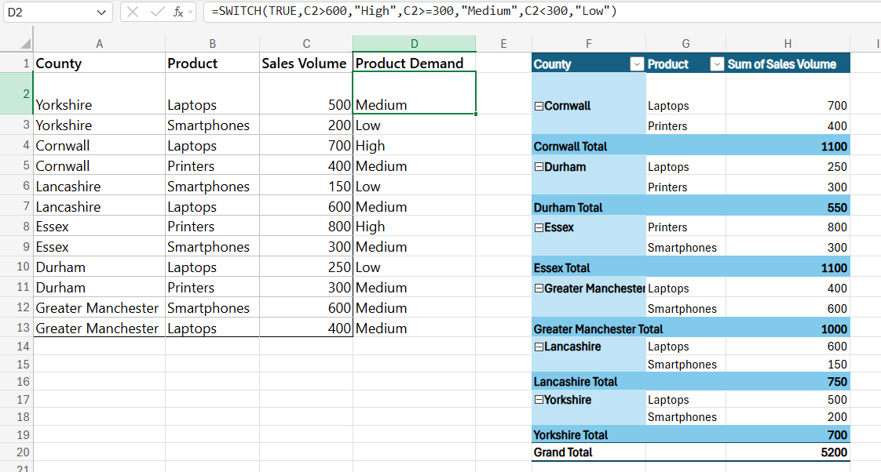

Day 3: Task 3

Please open and make an online copy of the dataset ‘Bike_Sales_Visualizations_Lab.xlsx from here.

The lab instructions can be found here Bike Sales Visualization Lab.docx. Do not worry if you do not complete the lab, just working with data and playing with the charts will be good experience.

Please paste your results below:

Print screen 1 | 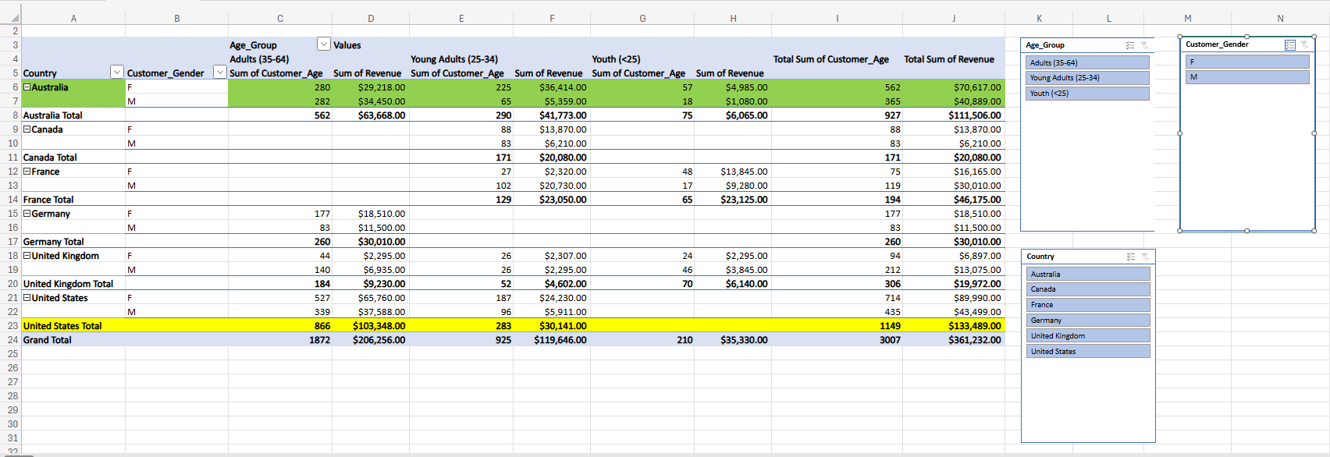

Course Notes

It is recommended to take notes from the course, use the space below to do so, or use the revision guide shared with the class:

Additional Resources
You can explore the additional resources to support your learning.

- DataCamp recommended courses.
  - Understanding GDPR - DataCamp Learn
  - Introduction to Excel - DataCamp Learn
  - Data Analysis in Excel - DataCamp Learn
  - Data Preparation in Excel - DataCamp Learn
  - Data Visualization in Excel - DataCamp Learn

- Introduction to Data Analytics Essentials
This data analytics essentials course teaches you the fundamental tools of a data analyst. You will learn to transform, organize, and visualize data with spreadsheet tools such as Excel.

- Excel Formulas and Functions Tutorial
Formulas can be used to perform simple math using +,-,*, or / to add, subtract, multiply or divide. Excel also comes built-in with over 300 functions that can be used to perform complex math, lookup values, work with text, and much more. This section will cover creating simple formulas, cell references, strings of text, and keyboard shortcuts.

- Excel Exercises Dashboard
Our bite-sized, interactive lessons make Excel skills easy to learn and remember.

- 100+ Excel Interview Questions & Answers To Make You Job Ready
This guide can also be used by interviewers who want to gauge the Excel skill of the candidates in the interview.

- ❎ How to use Excel - YouTube
In these step-by-step tutorials, learn how to use Microsoft Excel. Find out how to get started with MS Excel in under 10 minutes. Learn about Pivot Tables, formulas and functions, vlookup, shortcuts. Also, find out about the latest new features and the top tips and tricks.

- Use Excel skills (Filter, Sort, Conditional Formatting, Functions, VLOOKUP, Pivot Tables, Pivot Charts, and Slicers) to analyse global sales data and uncover key insights.
- Find exercises here Global Superstore Data Challenge.docx
- Open dataset global_superstore_2016.xlsx in Excel online and create an online copy.

- In this free Excel tutorial, learn how to create formulas and charts, use functions, format cells, and do more with your spreadsheets.
Free Excel Tutorial at GCFGlobal

Additional formation
We have included a range of additional links to further resources and information that you may find useful, these can be found within your revision guide.
How to share Excel workbook.webm

END OF WORKBOOK

Please check through your work thoroughly before submitting and update the table of contents if required.

Please send your completed work booklet to your trainer by submitting in MS Teams Assignment page.

