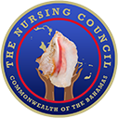
Nursing Council Website
Stakeholder Handover

Public Website
Prepared for
The Nursing Council of the Commonwealth of The Bahamas
Prepared by
Novio Group
Prepared
August 17, 2026
Website URL
https://nursingcouncilbahamas.com



PUBLIC WEBSITE

Purpose of this Handover
This document formally presents the Nursing Council's public website for stakeholder review, acceptance, and ongoing content ownership. It records what the public can access, what has been updated, and which items still require Council approval or supply.

Current Delivery Status
A complete public website is available for stakeholder review across desktop and mobile layouts.
The site presents the Council's mandate, statutory functions, history, governance, public nurse registry, education oversight, licensed agencies, legal resources, public news links, forms, and contact information.
Placeholder form entries remain intentionally marked until the Council supplies approved downloadable files.

Stakeholder Readiness
Review names, titles, photographs, dates, institutional details, agency listings, and legal document labels for formal accuracy.
Confirm the approved public forms and any documents that must replace placeholders before publication.
Assign Council owners for legal, education, agency, news, forms, and governance content.
Complete final link, spelling, image, accessibility, and mobile acceptance checks before public approval.

Public Navigation and Visual Presentation
Primary navigation prioritizes Home, About, Education, Agencies, and News.
The public nurse registry and indexing guidance remain available through prominent service actions and footer links.
Page heroes use consistent Council-blue gradients, approved imagery, and concise service-focused headings.
The document covers only the public website experience.

PUBLIC WEBSITE

Homepage
The homepage introduces the Council as the official regulatory authority and directs visitors to high-demand services.
Prominent service actions support immediate access to Council records and registration pathways.
Service cards guide visitors to registration, licence renewal, agency information, legal resources, forms, and contact support.
Council-approved nursing imagery and a consistent blue visual system establish the public brand.
A complete full-page capture follows on one page. The website footer is excluded to keep the public content in focus.

FULL-PAGE CAPTURE
Homepage
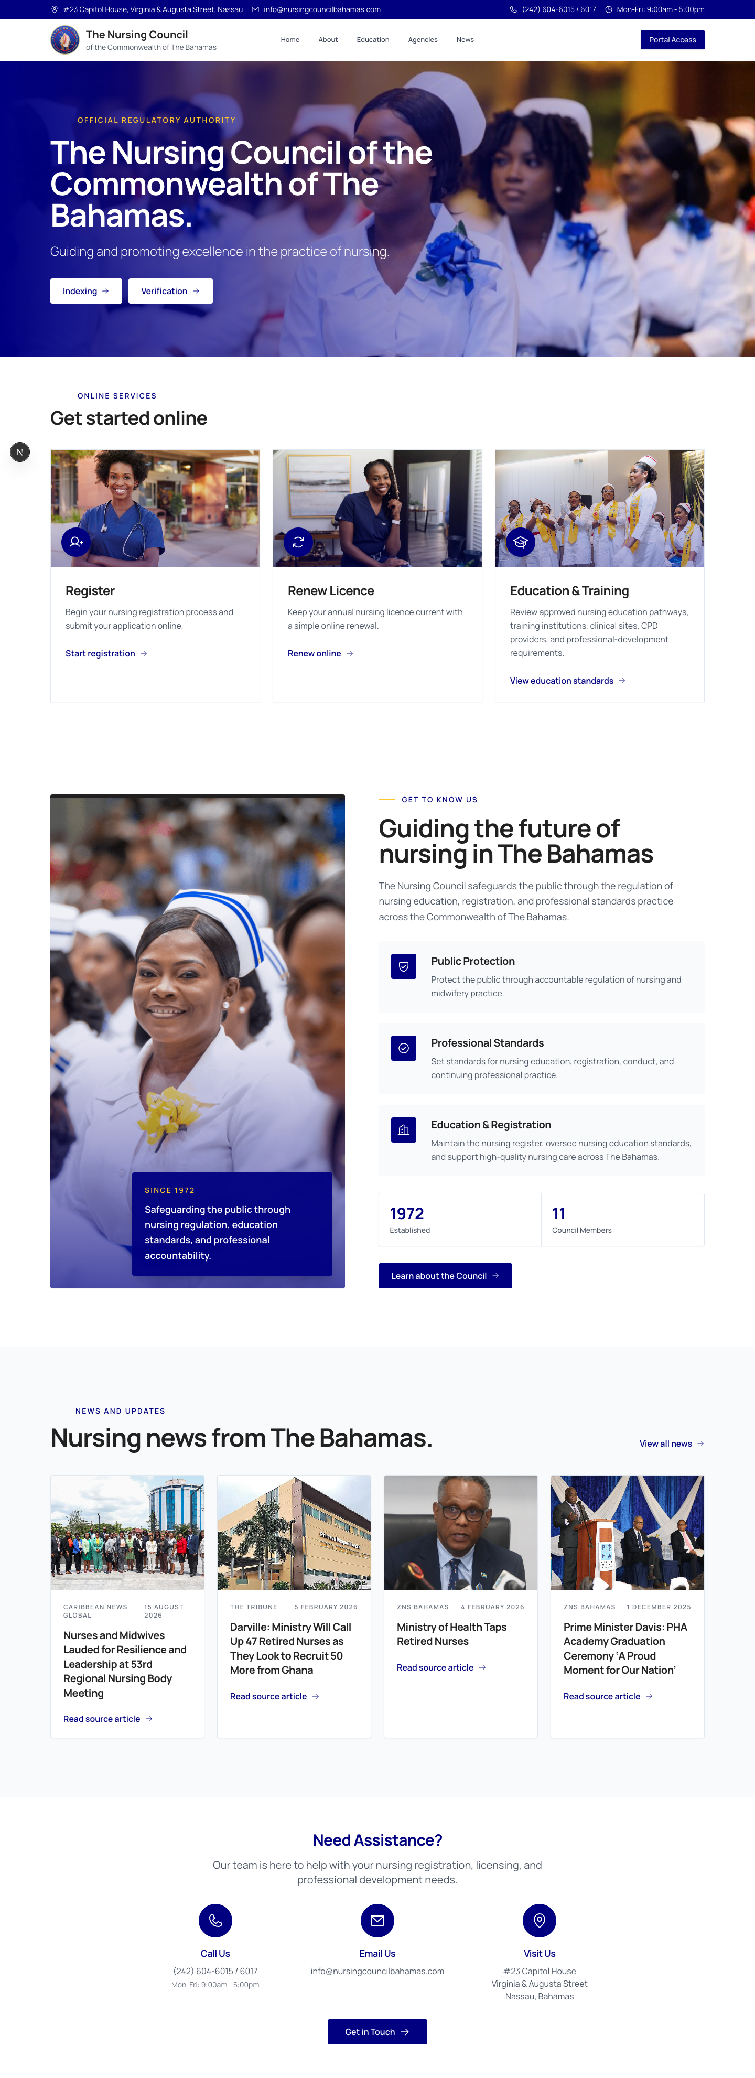
Complete page capture shown without the website footer.

PUBLIC WEBSITE

About the Nursing Council
The About page explains the Council's public-protection purpose, mandate, mission, vision, and guiding values.
The Council's 24 statutory functions are grouped into six readable public themes.
The 2025 Code of Ethics is summarized and linked as an official Council document.
Historical content records the Council's formation, the transition to the 2023 Act, the development of nursing agency oversight, and the Council's administrative leadership.
A complete full-page capture follows on one page. The website footer is excluded to keep the public content in focus.

FULL-PAGE CAPTURE
About the Nursing Council
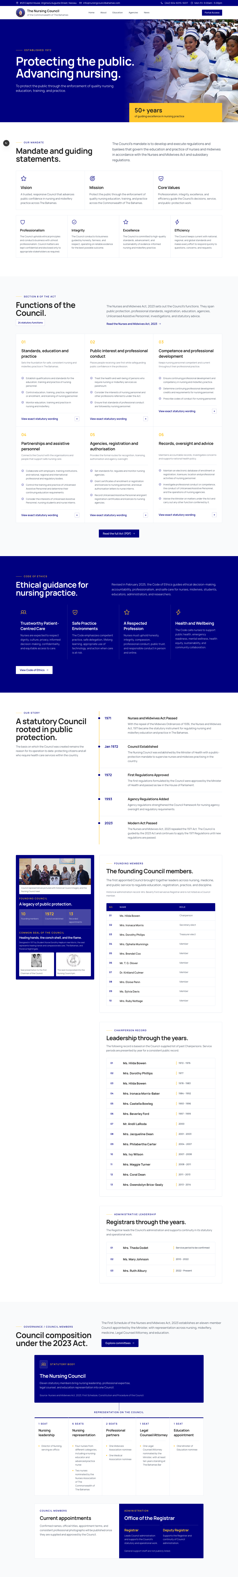
Complete page capture shown without the website footer.

ABOUT

Governance and Council History
Governance is presented as an eleven-member statutory Council with clearly separated representation and administration.
Representation is organized across nursing leadership, nursing representatives, professional partners, legal counsel, and education.
The Registrar and Deputy Registrar appear under Administration rather than as Council members.
Confirmed appointment names, professional titles, terms, and consistent photographs remain subject to Council supply and approval.
This content appears within the complete About the Nursing Council page capture supplied with the preceding section.

ABOUT

Historical Record and Leadership
The Council's history is organized as a public record rather than a single text block.
The timeline covers the 1971 Act, establishment in 1972, early regulations, agency regulation, and the 2023 Act.
Founding members, the Common Seal, historical photographs, past chairpersons, and past registrars are presented together as the Council's legacy.
Historical captions and service periods should receive a final Council accuracy review.
This content appears within the complete About the Nursing Council page capture supplied with the preceding section.

PUBLIC WEBSITE

Education and Training
The Education page explains the Council's oversight of approved nursing education pathways.
Approved training institutions and programmes are presented as readable institution profiles rather than a spreadsheet.
Clinical learning sites are organized with recognizable institution branding where available.
Indexing guidance supports students, graduates, and applicants entering Council records.
A complete full-page capture follows on one page. The website footer is excluded to keep the public content in focus.

FULL-PAGE CAPTURE
Education and Training
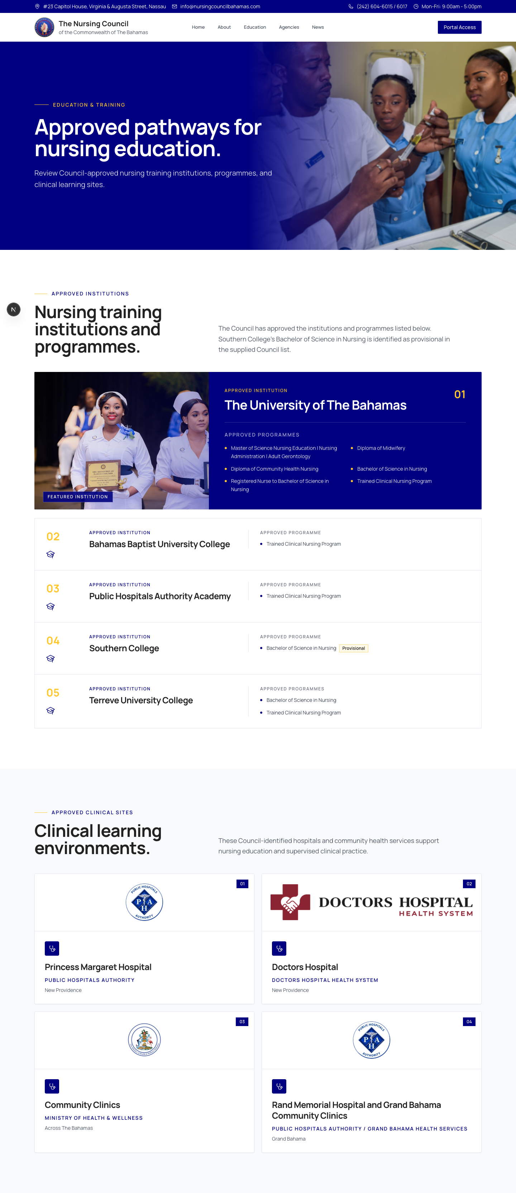
Complete page capture shown without the website footer.

PUBLIC WEBSITE

Licensed Nursing Agencies
The Agencies page explains agency licensing, compliance, and the Council's current public agency listing.
Current agencies are identified using the Council-supplied names and available brand imagery.
The page describes the licensing pathway without publishing unapproved fees or forms.
Agency application and renewal documents remain pending Council supply.
A complete full-page capture follows on one page. The website footer is excluded to keep the public content in focus.

FULL-PAGE CAPTURE
Licensed Nursing Agencies
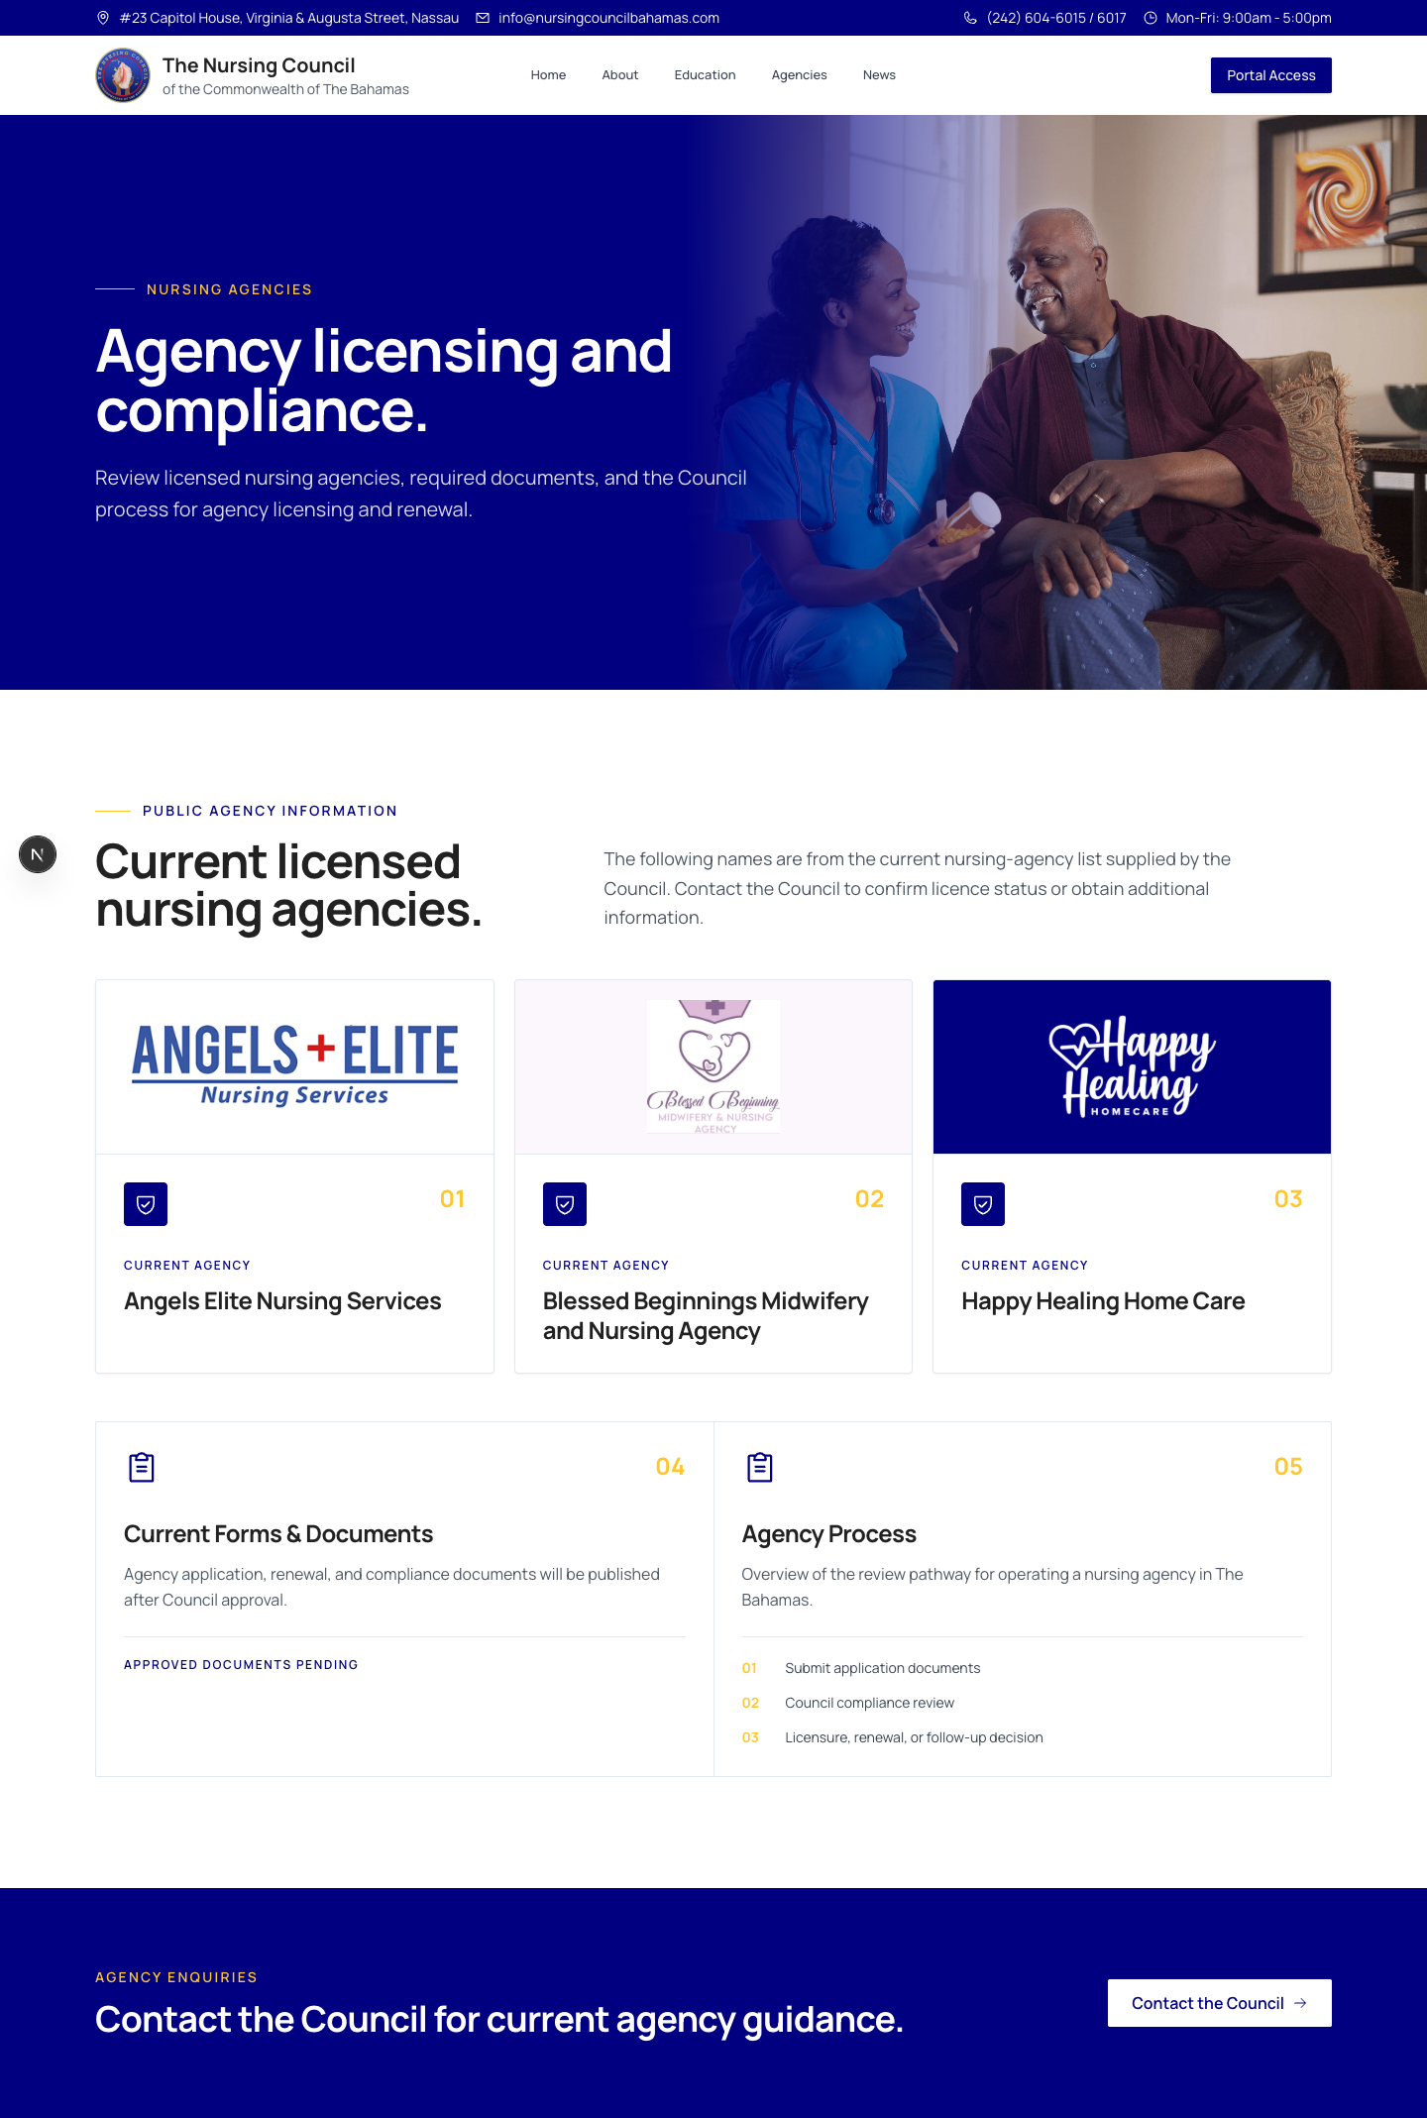
Complete page capture shown without the website footer.

PUBLIC WEBSITE

Legal and Regulatory Resources
The Legal page provides direct public access to the current statutory framework and professional guidance.
The Nurses and Midwives Act, 2023 replaces the former 1971 Act as the primary Act displayed on the website.
The 2024 Appointed Day Notice and the 2025 Code of Ethics are organized as separate official resources.
Additional regulations and proposed regulatory material will be added only after formal Council approval.
A complete full-page capture follows on one page. The website footer is excluded to keep the public content in focus.

FULL-PAGE CAPTURE
Legal and Regulatory Resources
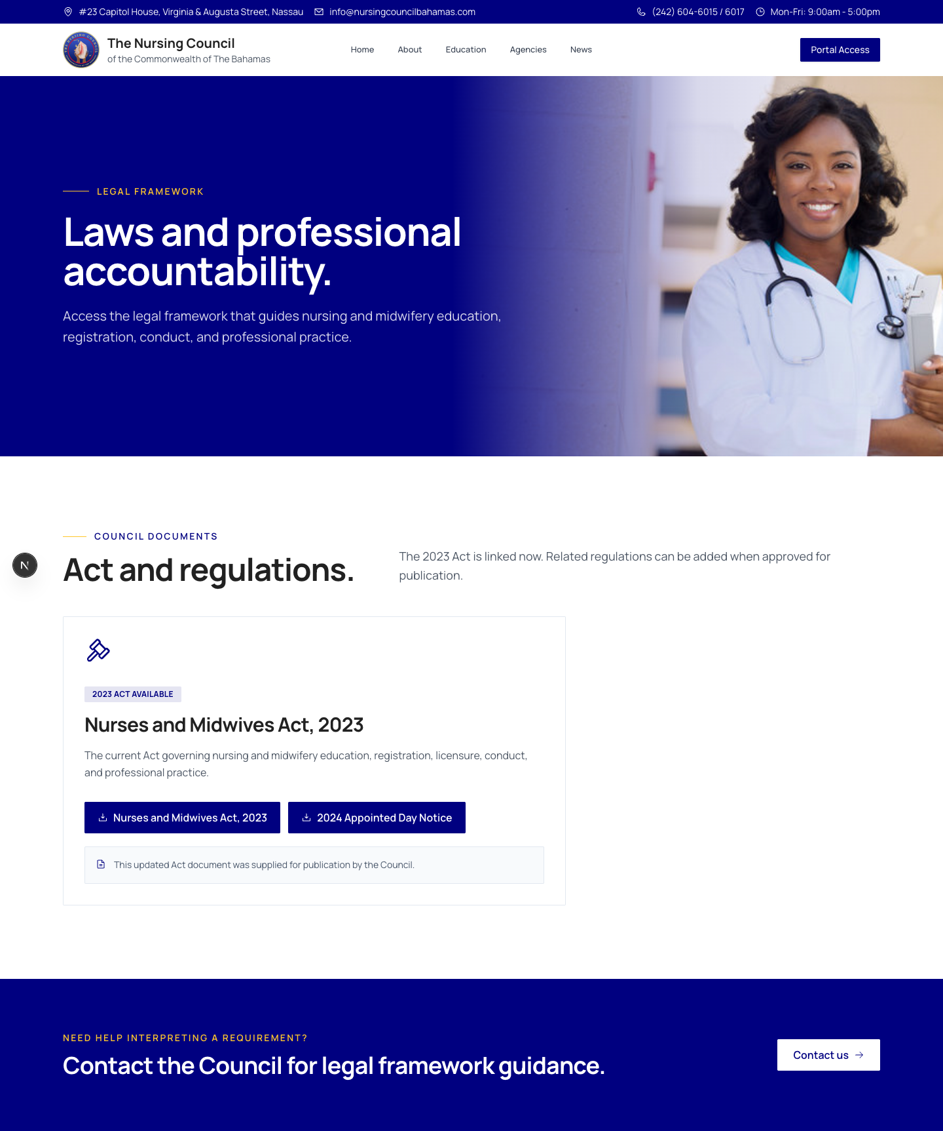
Complete page capture shown without the website footer.

PUBLIC WEBSITE

News and Updates
The News page curates Council-relevant nursing and midwifery coverage from established external sources.
Each card links visitors to the original publisher rather than reproducing third-party articles on the Council website.
Article images, titles, dates, and source labels help visitors assess the linked material before leaving the site.
The page can be maintained as a selective public-information channel rather than a full newsroom.
A complete full-page capture follows on one page. The website footer is excluded to keep the public content in focus.

FULL-PAGE CAPTURE
News and Updates
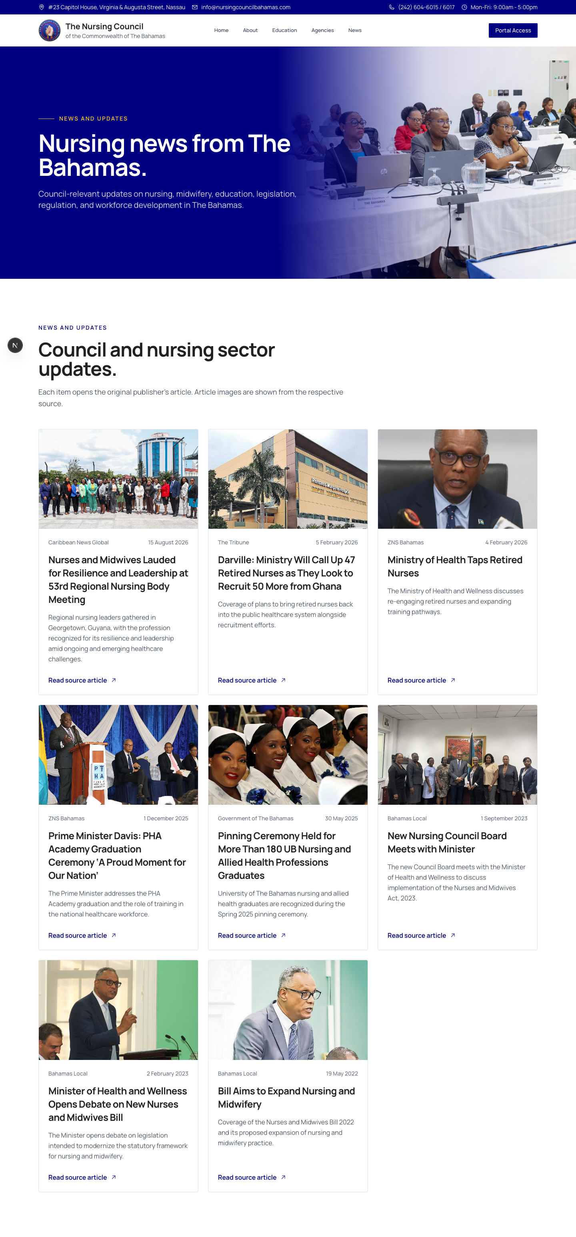
Complete page capture shown without the website footer.

PUBLIC WEBSITE

Forms and Documents
The Forms page provides a modern directory organized by purpose and intended audience.
Forms are grouped for registration, education, professional development, agencies, and Unlicensed Assistive Personnel.
Current entries are clearly treated as placeholders until approved PDF files are supplied.
Before publication, every form should be checked for the current seal, wording, fields, and legal requirements.
A complete full-page capture follows on one page. The website footer is excluded to keep the public content in focus.

FULL-PAGE CAPTURE
Forms and Documents
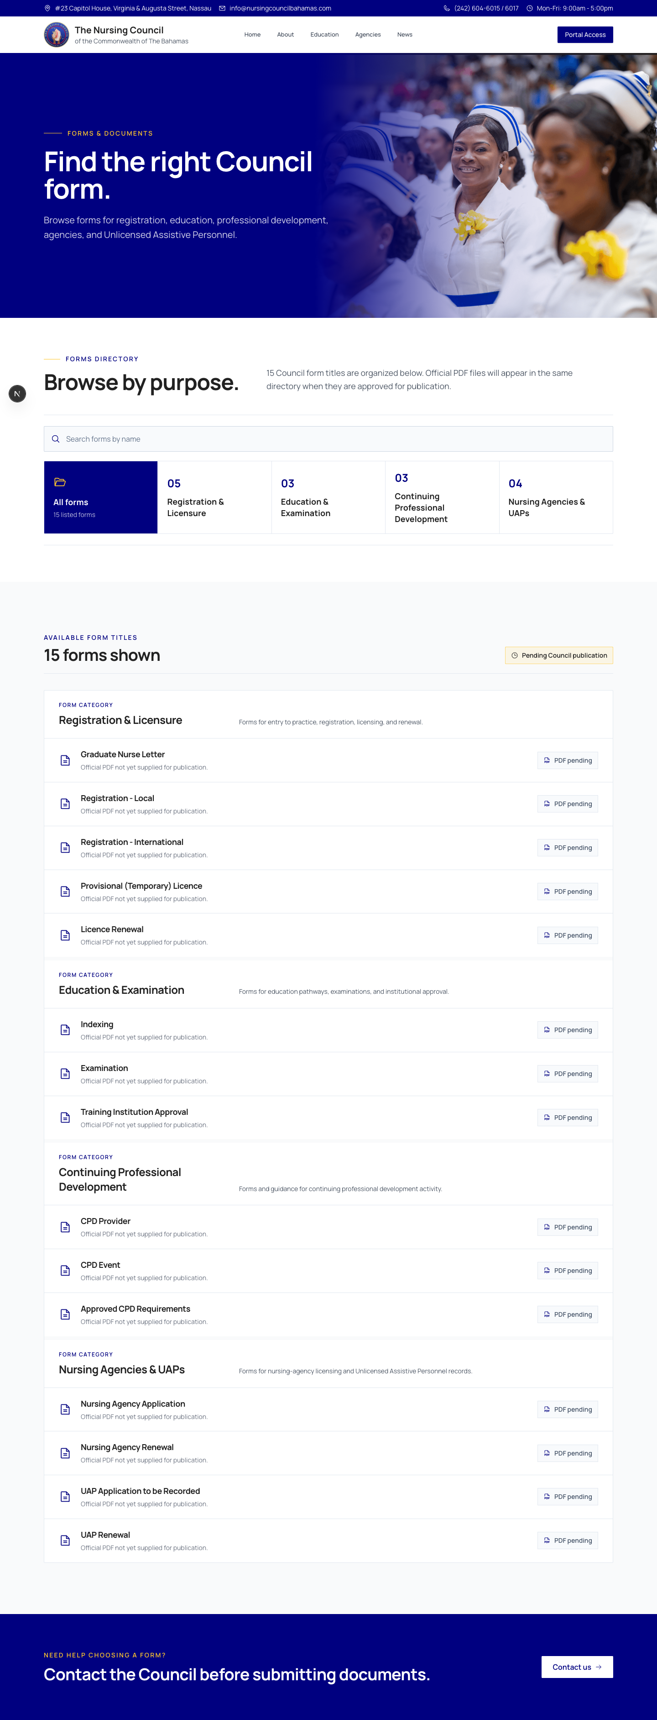
Complete page capture shown without the website footer.

PUBLIC WEBSITE

Student and Applicant Indexing
The Indexing page gives students and applicants a clear route into Council records.
The page distinguishes indexing from registration and explains who should use the service.
Requirements and next steps are presented in a structured, scan-friendly format.
The public action remains accessible from service buttons and the footer rather than the main navigation row.
A complete full-page capture follows on one page. The website footer is excluded to keep the public content in focus.

FULL-PAGE CAPTURE
Student and Applicant Indexing
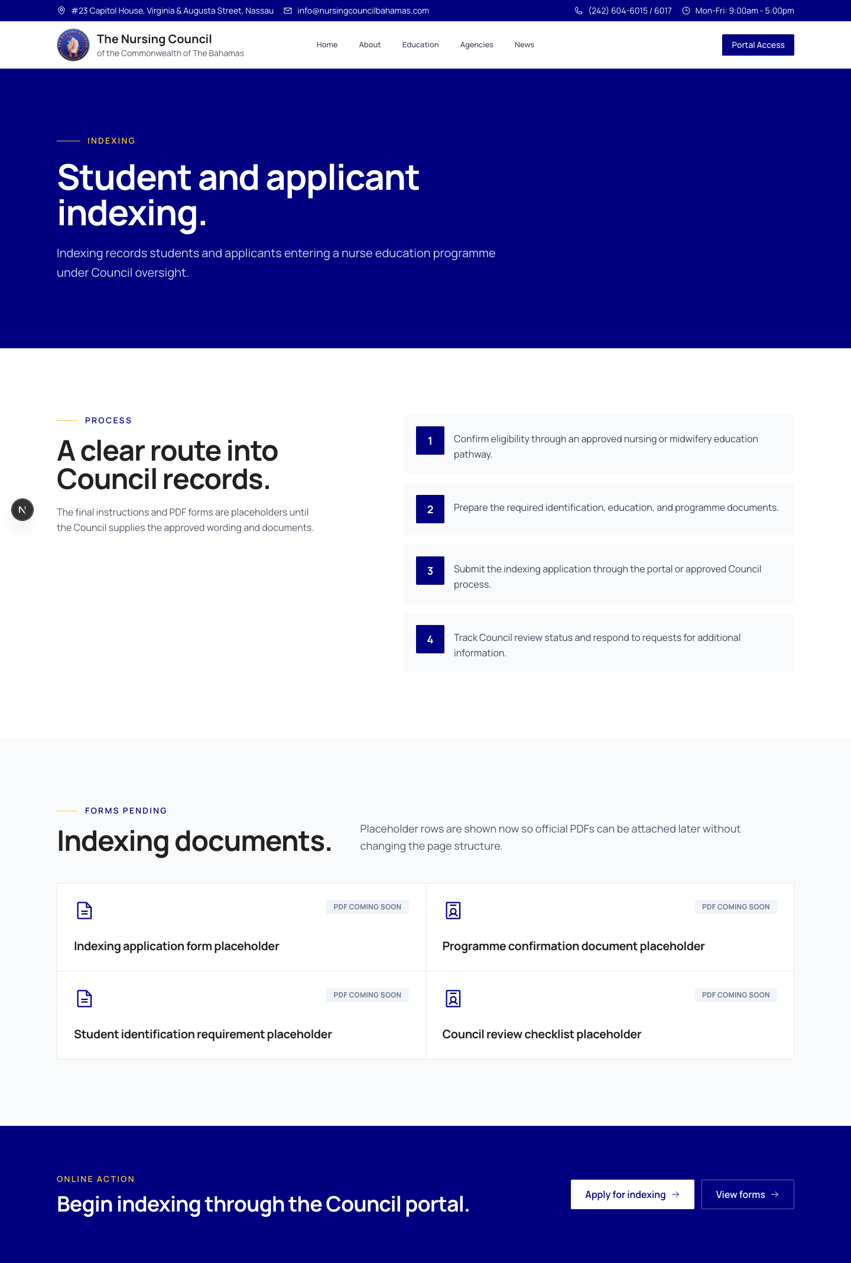
Complete page capture shown without the website footer.

PUBLIC WEBSITE

Public Nurse Registry
The Nurse Registry is a dedicated public page for searching the Council's published historical register.
Visitors can search by nurse name, registration number, registration type, or original registration year.
Only limited public fields are displayed: name, registration type, registration number, and original registration year.
The page clearly states that a registry listing is not proof of a current, active, unrestricted licence or good standing.
A complete full-page capture follows on one page. The website footer is excluded to keep the public content in focus.

FULL-PAGE CAPTURE
Public Nurse Registry
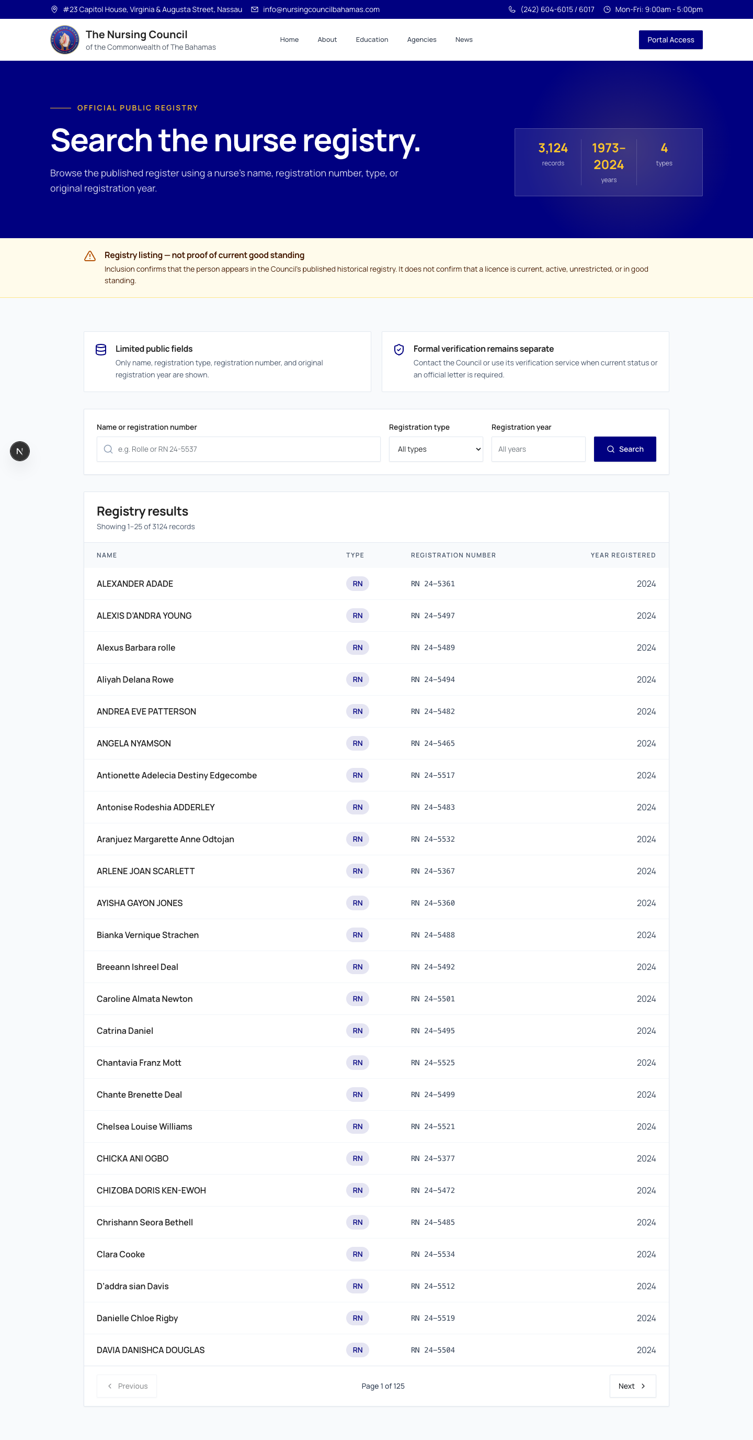
Complete page capture shown without the website footer.

PUBLIC WEBSITE

Committees
The Committees page presents the Council's six areas of focused oversight.
Education, Examination, Finance, Registration, Standards and Practice, and Disciplinary and Penal Cases are clearly identified.
Each committee has a concise public description without publishing internal meeting or contact details.
The hierarchy connects committee work to the Council's regulatory and public-protection mandate.
A complete full-page capture follows on one page. The website footer is excluded to keep the public content in focus.

FULL-PAGE CAPTURE
Committees
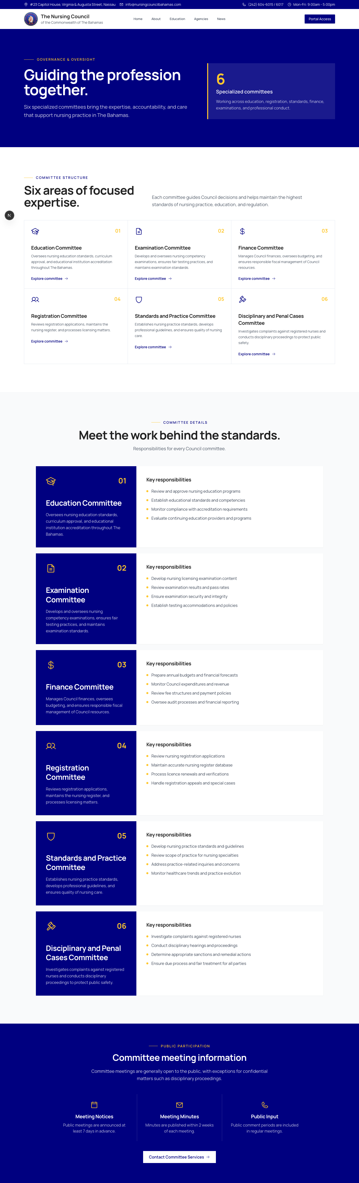
Complete page capture shown without the website footer.

PUBLIC WEBSITE

Contact and Public Help
The Contact page consolidates the Council's address, telephone numbers, email address, and office hours.
Contact cards provide clear call, email, and visit options.
The page avoids unsupported response-time promises and directs visitors to the appropriate Council channel.
Final stakeholder review should confirm all published contact details before approval.
A complete full-page capture follows on one page. The website footer is excluded to keep the public content in focus.

FULL-PAGE CAPTURE
Contact and Public Help
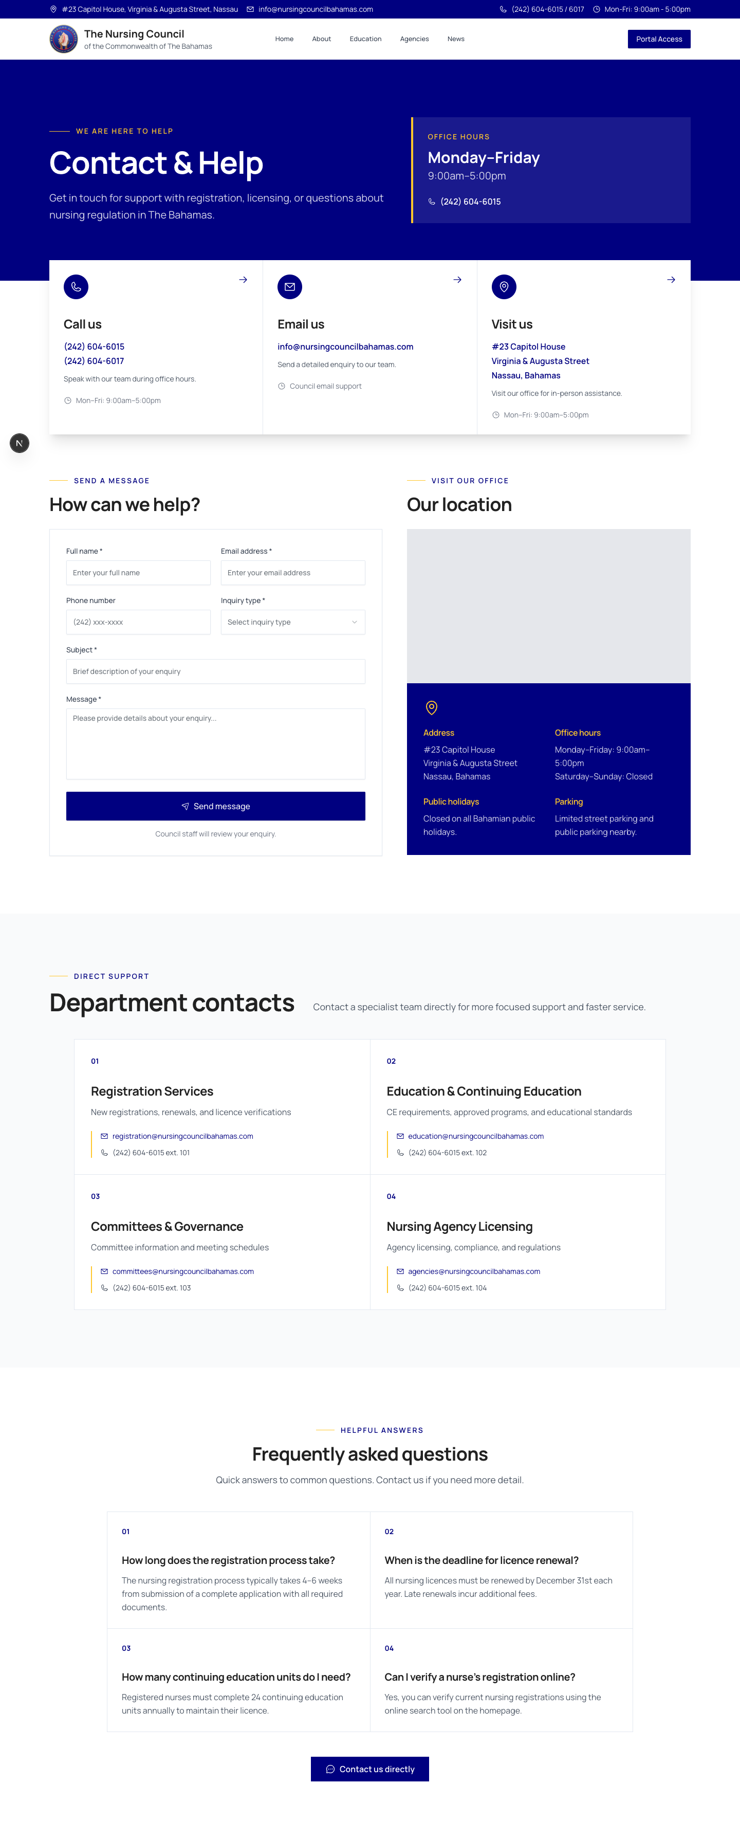
Complete page capture shown without the website footer.

HANDOVER SUMMARY

Recent Public Website Improvements
The current website reflects the Council's accumulated review feedback and content supplied through August 2026.
Updated the visual system with Council-blue page heroes, consistent image treatment, Manrope typography, and restrained four-pixel corner radii.
Replaced major homepage, education, agencies, legal, news, and service-card imagery with approved or Council-supplied alternatives.
Expanded the About page with mandate, mission, vision, core values, 24 statutory functions, Code of Ethics guidance, Council history, the Common Seal, founding members, past chairpersons, historical registrars, and statutory governance.
Separated Council Members from Administration and presented the eleven-seat statutory composition established by the 2023 Act.
Modernized the training-institution, programme, clinical-site, agency, news, and forms directories for easier public scanning.
Replaced the former Act link with the Nurses and Midwives Act, 2023 and organized supporting legal resources.
Added the searchable public nurse registry, public indexing guidance, committee information, and updated contact details.
Removed unapproved fees, outdated calls to action, internal committee schedules, unsupported response promises, and content requested for removal during stakeholder review.
Scope Note
This handover covers the public-facing website only. Internal staff materials and procedures are outside this document.

BEFORE PUBLICATION

Outstanding Content and Stakeholder Actions

Content Still Required
Approved individual names, official titles, appointment terms, and consistent professional photographs for the current eleven-member Council.
Final approved downloadable forms and agency application or renewal documents to replace placeholders.
Any approved regulations, proposed regulations, or related legal notices that the Council wishes to publish.
Final corrections or additions to the approved training institutions, programmes, clinical sites, and licensed agency lists.
Any further historical captions, dates, photographs, or records required for the Council archive.
Final confirmation of the public contact details, social links, and ongoing news-link selection process.

Stakeholder Decisions and Actions
Approve the public page structure, naming, navigation, imagery, and overall presentation.
Confirm the statutory and historical accuracy of all Council, Act, regulation, committee, and governance content.
Supply and approve every form before its public download action is enabled.
Confirm named content owners and a routine review schedule for each public section.
Complete final desktop, mobile, link, spelling, accessibility, and form acceptance checks.

ONGOING GOVERNANCE

Content Ownership and Review Cadence
The Council should assign one accountable owner for each public content area and keep a simple record of approvals and review dates.
Content area | Recommended owner | Review cadence
Council, governance, mandate, history | Registrar / Council Executive | Quarterly and after appointments
Act, regulations, ethics, legal notices | Registrar with Legal Counsel/Attorney | On every legal change; quarterly check
Public nurse registry | Registrar / Registration team | After every approved registry update
Training institutions, programmes, clinical sites | Education and Registration teams | Quarterly
Licensed nursing agencies | Agency licensing lead | Monthly or after licence changes
Forms and public documents | Responsible service owner | Before release and at every revision
News, photographs, public notices | Council communications owner | Monthly
Contact information and office hours | Council administration | Monthly

Recommended Review Record
Record the page or document reviewed, the owner, the approval date, and the next review date.
Remove or correct information promptly when appointments, laws, programmes, licences, forms, or contact details change.
Use only photographs and documents the Council is authorized to publish.

ACCEPTANCE

Stakeholder Sign-off
The undersigned confirm that the Nursing Council public website has been reviewed against the Council's approved content and publication requirements. Any exceptions should be recorded below and assigned an owner and completion date.
☐ Public website structure, navigation, imagery, and presentation accepted
☐ Council, governance, history, legal, and ethics content accepted
☐ Education, training, clinical-site, and agency content accepted
☐ Public registry, forms, indexing, committees, and contact content accepted
☐ Outstanding items accepted into the post-handover action list
Name and title ____________________________________________________________________
Signature ____________________________________________________________________
Date ____________________________________________________________________
Approved publication date ____________________________________________________________________

Exceptions or Conditions

