Tweet Sentiment Documentation

# Author & Developer: Novi Trisjaniar

Tweet Sentiment is an Android app that can be used to retrieve tweets online based on user input (up to 15 tweets).

# Feature

* Searching tweets online (only find tweets in English language)
* Classifying tweets into positive and negative with simple classification algorithm (Naïve Bayes)

# Screen Shots Program



1. Splash screen with float up animation



1. Search Twitter



1. Loading Twitter List with ProgressDialog

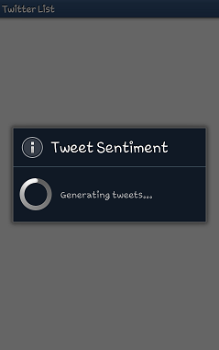

1. Displaying Twitter List and classifying the tweets into positive and negative using Naïve Bayes

 

The first figure is trying to find out tweets about “greyhound”. The second is requesting tweets about “Dove”. The TextView that has yellow star contains a positive tweet whereas the blue star represents a negative tweet.

# Library Used

The app uses Twitter4j as the java library for Twitter API. In order to make authorized calls to Twitter’s API, the app use an OAuth access token on behalf of a Twitter user.

# Naïve Bayes Classification

Training Data:

negative.txt

positive.txt

Classification class:

TextClassification.java

Basically, what the class does is reading the training data and storing it into variables. After finishing reading the clean data and generating stop words (common words such as the, is, at, which, etc.), the data is processed to create two HashLists which map each word to the total number of that word in each class. This process takes a while since there are about 3000 words to be processed. As the way to make the data-generating process faster, the developer implement Runnable Threads to generate HashLists. Based on [android performance tips](http://developer.android.com/training/articles/perf-tips.html), the developer also use enhanced For Loop (for-each) syntax to make the loop process faster.

The class also provides getClass function that calculate the probability of each class and return the class that has higher probability in string value.

# Links

Twitter4j: <http://twitter4j.org/en/>