**12/10/2019**

**Admin:**

>> sign up as per taxivaxi

>> 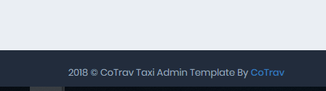

>> Dashboard as per taxivaxi dashboard data – API

>>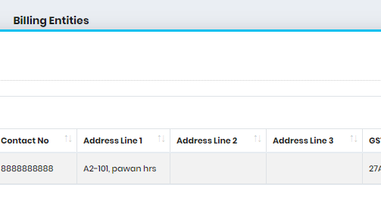

Address merge to single column using BR

>>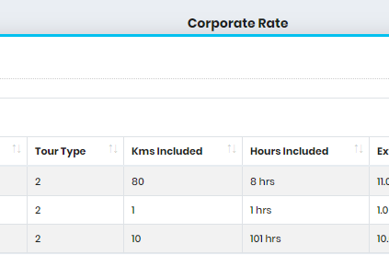

Tour type – local/radio/outstation,

>>

Group/sub group authenticator details while adding

>>group/ subgroup addition msg getting displayed on nxt page…. (I think cookie is not getting expired … add expiration after 2secs )

>>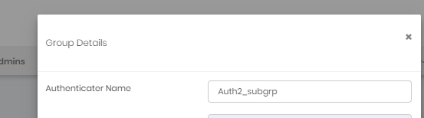

Subgroup detail page title is group detail… change it to Subgroup details…

Please check form titles for all the options

>>Admin addition duplicate email error not displayed / change operator name to company name in list view

>>wherever CID/EID change it to company ID

>> 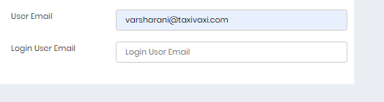

Add SPOC form – donot show login user email in the form

Save the same data in user email in db

>> 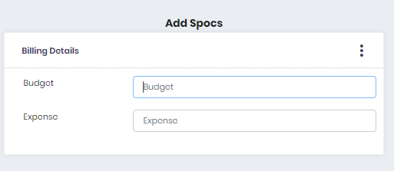

Remove expense field , merge budget field to general information section and default value to 0

Change label to is_single_employee… and default should be No

Cannot edit is_single_employee from no to yes

>>SPOC - remove delete and add activate/deactivate

>>keep footer fixed

>>unable to add new spoc

>> Add employee form – No dropdown options for gender, home city (no google maps sync), DOB (no calender popup), is Active default value should be yes, designation should be under general information, employee edit – is active not fetching correct value – possibility of employee getting deactivated

>>Add Booking (low priority)

>> Active bookings detail page not working… Eg - Hotel

>>Please check the titles… Hotel pages has flight booking title….bus booking page has taxi details title

>> Booking ID segregation by CT…. TRN,HTL,FL….whatever…

>> 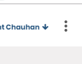 remove the 3 dots part from top right corner… as it is not at all useful.

>> All input box in details for view should be disabled.

**Approver 1:**

>> Footer is not fixed.

>>please hide group/sub group/SPOC tabs for approver

>>please remove admins tab from approver

>>show employees only under his group

>> All input box in details for view should be disabled.

**14-10-2019**

**SPOC:**

>> Please hide group/sub group/admins tab

>> Under employees show list of all employees with thr spocs

>> All input box in details for view should be disabled.

>>Assessment code mgmt is not thr in admin portal, hence not able to find it under add booking form in SPOC portal

**18-10-2019**

>> Sign up form icons not visible

>> Footer not fixed

>> Dashboard as per taxivaxi dashboard data – API

>>