## Summary:
When the permissions are the same, sandboxie can't limit the operation of the software,affected systems:win7/win10

## Steps To Reproduce:
no1.Sandboxie running program function:
The official website to download sandboxie 5.30 installation,run cmd in the sandbox, then switch to the system32 directory, run the control.exe command in cmd to open the control panel, select the uninstaller, uninstall sandboxie,after clicking uninstall, sandboxie will stop the service, and then repeat the operation once, the sandboxie will be successfully uninstalled.

## Supporting Material/References:

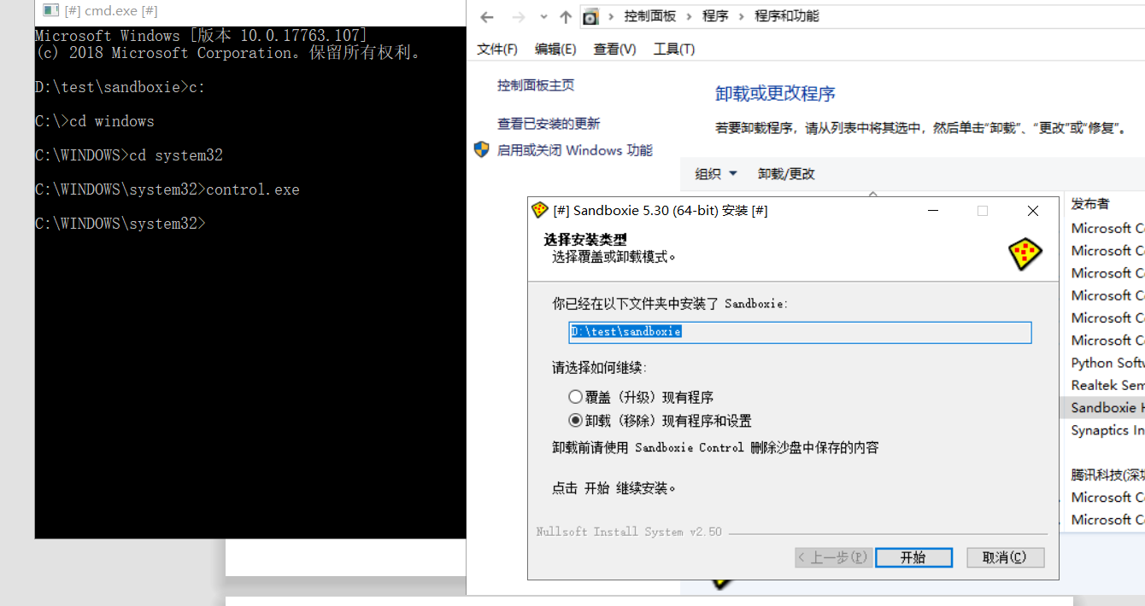
Next one:

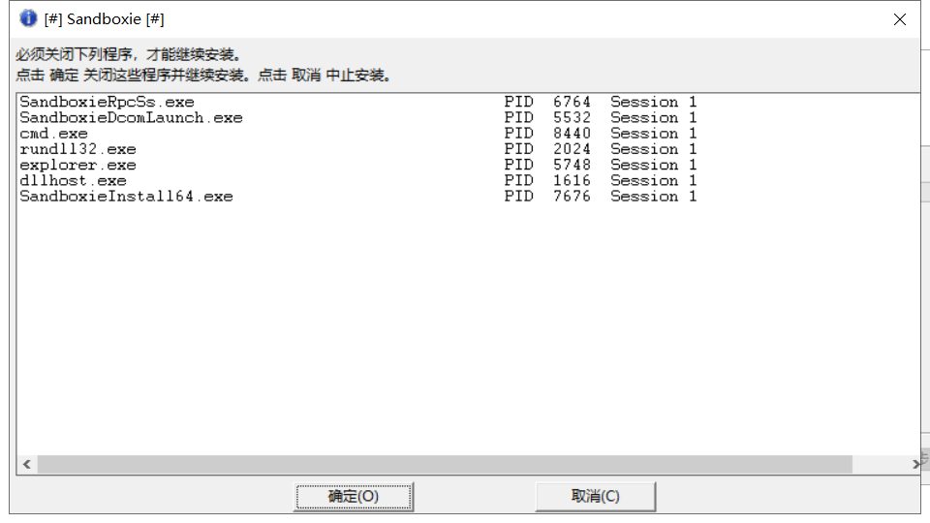
Next:
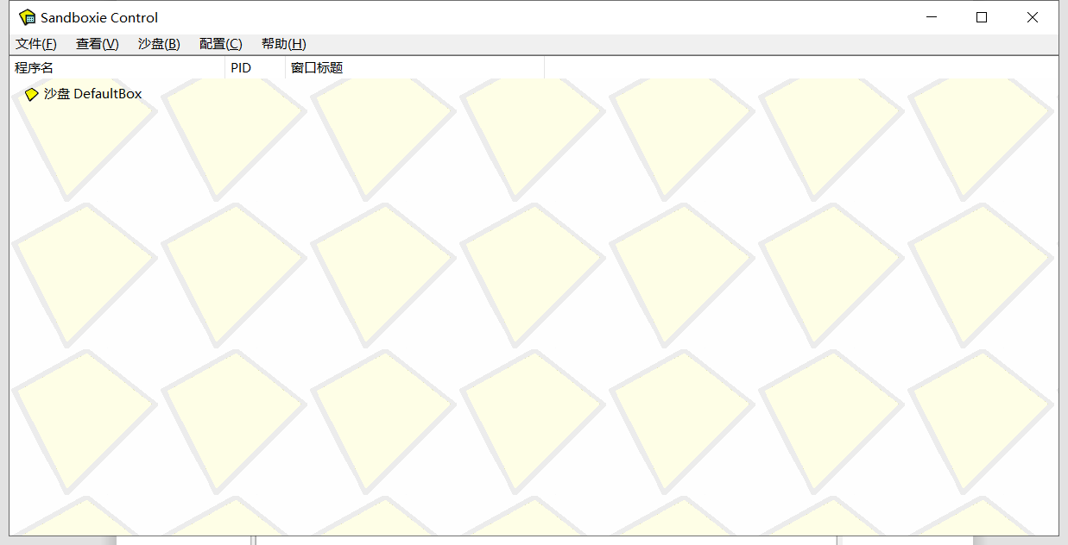
Ps：Run powershell to open the control panel directly to uninstall:
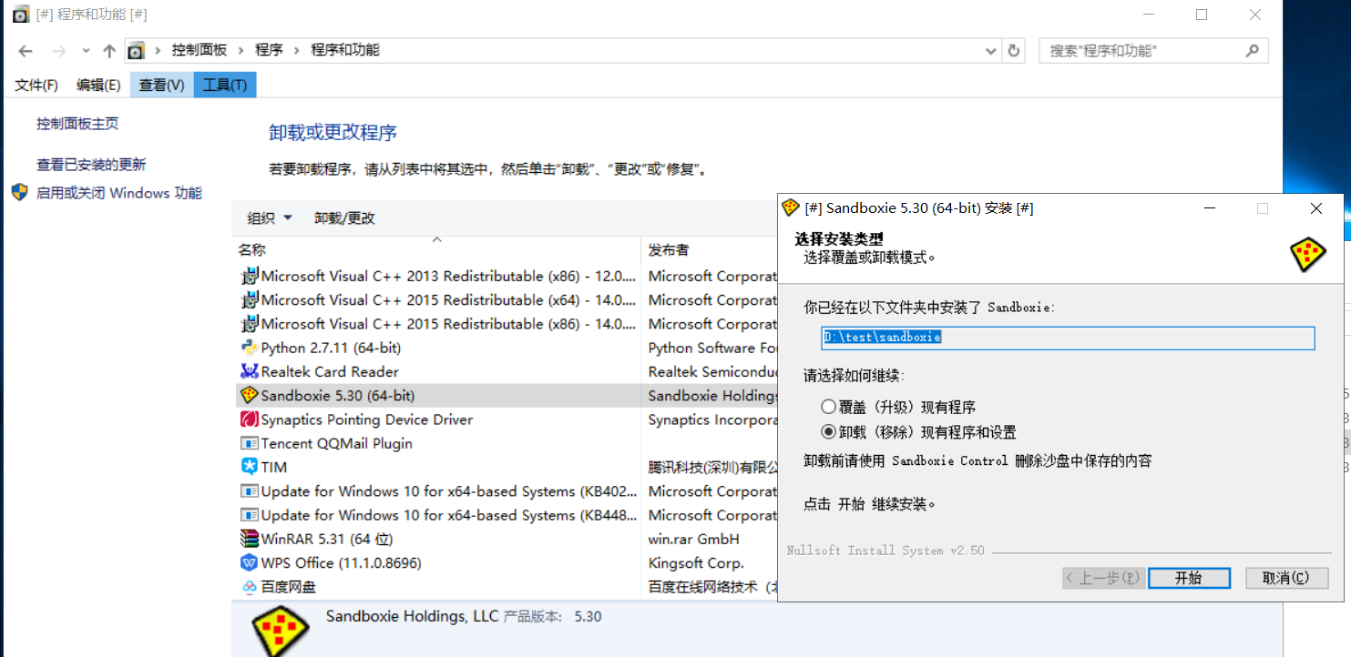

No.2 Sandboxie running webpage function:
You can pause the sandboxie service by downloading the sandboxie installation in your browser and selecting Uninstall in the Upgrade and Uninstall options.
