Simulation study protocol

Aims of the study:
The aim of this simulation study is to evaluate and compare already implemented statistical methods for summarizing linear-segmented relationships. In particular, we will look at the “10” pattern, that is, a 2-segment linear relationship between the response and the explanatory variable, with the first segment having a non-zero slope, and the second segment being a plateau (null slope).
The data will be simulated based on the application of SDI trajectories in patients after psilocybin intake (see Stenbæck et al., 2021). The Subjective Drug Intensity (SDI) is a Patient Reported Outcome (PRO) used after psilocybin intake to assess the intensity of patients’ feeling over time during the experiment. It is a bounded integer scale from 0 to 10. Typically, the experiment goes through 3 distinct phases: onset of psychoactive effects, peak plateau, return to normal state of consciousness (“101” pattern / trapezoid). The study focuses on the “10” pattern because one of the statistical methods only allow a single breakpoint.
This simulation study protocol was widely written based on the recommendations of Morris et al. (DOI: 10.1002/sim.8086).

Software used to perform simulation
Datasets generation, computation of statistical methods and analysis of results will be conducted in R programming language (version 4.3.1 (2023-06-16)).

Statistical methods to be evaluated
Two statistical methods are to be evaluated during this simulation study:
- Linear mixed model with a single estimated breakpoint (`segmented` R package, function `segmented.lme` - ref: https://doi.org/10.1177/1471082X13504721). This statistical method only allows for a single breakpoint in the relationship between SDI and time.
- Linear model with breakpoint estimation (`segmented` R package, function `segreg`). ref: https://doi.org/10.1002/sim.1545
- Linear model with breakpoint estimation (`lmbreak` R package, function `mlmbreak`).
The last two methods are very similar implementations of the same model, only the optimizers differ a bit, yielding slightly different results for some individuals, and close to the same for most of them (see R script mixedBreak/test/compare-lmb-seg.R for comparison on SDIpsilo dataset).
Only one of the two? If yes, `segreg` might be more interesting for breakpoint CI > coverage can then be evaluated + breakpoint CI overlapping each other or one end of the time range.

Methods for generating the dataset
Data generating model will be based on breakpoint average coordinates and standard deviation. Distance between breakpoints is simulated with a Lognormal distribution, and SDI height level is simulated independently with a truncated normal distribution.
Having specified the population level trajectory, the individual true trajectory will be derived by adding noise to the breakpoints’ coordinates. From this true individual trajectory, we add noise to compute the noised trajectory, which we then round to the closest integer to simulate the measured SDI on a 0-10 scale.
A pattern “10” will be simulated, that is, a 2-segment linear relationship between SDI and time, with the first segment having a non-zero slope, and the second segment being a plateau (null slope).
Complete method for generating the datasets is described in Appendix A simSDI.docx.

Scenarios to be investigated
For having a relevant comparison of the 2 methods, we searched for scenarios in which a given method works well, or faces its limits. This gives us at least 4 scenarios since we are evaluating two methods. Each scenario is expected to give results that are:
- Good for both methods: Large sample sizes (n.obs >= 50) with long and stable plateaus (more measurement times and less noise during the plateau phase)
- Good for `segreg` but not for `segmented.lme`: Low sample size may affect the mixed model since the pooled estimates will be less precise. Shorter plateau may also affect methods in the same way since the plateau is not enforced in the mixed model.
- Good for `segmented.lme` but not for `segreg`: Low variability on the breakpoint may give similar performance, but more interesting results for the mixed approach, with the population-level breakpoint estimate.
- Poor for both methods: High level of noise on the score should be a factor affecting similarly both methods.
The number of observations in each dataset is of major interest since most studies on psychedelics currently have small sample size (typically n<50).

Simulation plan:

Range of values for simulation parameters
The simulation parameters have been chosen on the prior belief of what could influence the performances of the statistical methods. Several values of parameters have been tested to find the appropriate scenarios described in the previous section, whilst most of them have been chosen based on the reproduced analysis of the SDIpsilo data from (Stenbæck et al., 2021), or from the original article itself.
Simulation parameter | Nb of distinct values | List of values
Number of observations in the dataset n.obs | 6 | 10, 15, 20, 25, 50 ,100
Breakpoints distribution (means) | 1  1  3 | Break 0: fixed at (t = 0 min ; SDI = 0)  Break 1: (t = 77 min; SDI = 9.3)  Break 2 – break 1: (t = 32, 78, 143 min)
Breakpoints distribution (standard deviation) | 1  3  3 | Break 0: fixed (not random)  Break 1: (sd.t = 5, 15, 33; sd.SDI = 1)  Break 2 – break 1: (sd.t = 5, 15, 33)
Noise level on the measured score | 3  1 | Slope phases: 0.5, 1, 2  Plateau phases: 0.25
Time of measurements | 1 | Normally distributed every 20 min with sd = 2.  First measurement is fixed at t = 0 min.
Number of repetitions for each scenario n.sim | 1 | 559  Assuring a 1% Monte Carlo SE on coverage and 15% missing data
TOTAL number of scenarios | 486  14 | Fully factorial plan  “One-at-a-time” plan
Number of generated datasets (559*TOTAL) | 243 000  7 000 | Fully factorial plan  “One-at-a-time” plan
Table 6.1 - Simulation plan. Bold values are the reference used when another factor is varying
The number of repetitions for each scenario was derived using the following formula:
$$n_{sim}=\sqrt{\frac{\hat{Cover.}*(1-\hat{Cover.})}{Monte Carlo \hat{SE_{req}}}}$$
With a 95% nominal coverage probability and a 1% Monte Carlo Standard Error (SE) on the coverage probability, we get $n_{sim}=475$ repetitions. Assuming 15% of missing data (based on smaller simulations, this number inflates to $n_{sim}=559$ repetitions per scenario.

Type of plan
In order to save computational time, we decided to run the simulation on a “One-at-a-time” plan. That is to say, we will only vary one factor at a time, keeping all of the others fixed. The so called “case-based” scenario correspond to the bold values in the Table 1.
This choice has an impact on the way we can report the results, which is further explained in the last Section of this document.

Specification of the starting seeds – errors handling
To guarantee reproducibility of the results, the seed will be pre-computed once with a random seed (date and time at which this paragraph is written). The seed will be set at every iteration before generating the dataset, and stored at the end of each iteration. This also allows for re-running a specific part of the simulation, namely when errors occurred.
```r
set.seed(20041418)
nsimAll <- n.sim * n.scenario # n.sim= nb of repetitions for each scenario simulated
allseeds <- sample.int(n = .Machine$integer.max, size = nsimAll, replace=FALSE)
```
Errors during models’ estimation will be caught and reported using tryCatch() statement. They will be explored after the end of the simulation thanks to seed management.

Estimates and summary measures
The main estimands are the breakpoints themselves, since they completely specify the trajectory. From them we can derive the clinically interesting parameters, that are: onset slope, duration of plateau (and return to normal consciousness slope, not part of this simulation since we focus on the “10” pattern).
For every model computed, we will systematically report:
- Breakpoints individual estimates + average estimate and random effect (only `segmented.lme`)
- Breakpoints 95% confidence intervals and standard error.
- Eventual occurring errors that will be explored at the end of the simulation (convergence failure, singular convergence, others). These errors will be caught with R `tryCatch()` statement, and their count and frequencies will be reported for every method and scenario tested.

Criteria to evaluate the performance of methods
Three main criteria are of interest regarding the breakpoint’s estimation: bias, accuracy and coverage probability. If we reuse the same notations as in Morris et al., 2017, then can define the quantity of interest and their Monte Carlo SE as follows:
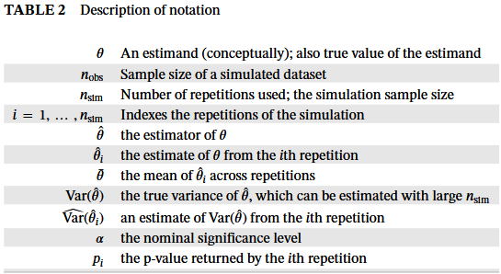
Figure 8.1 - Table 2 in (Morris et al., 2017), DOI: 10.1002/sim.8086
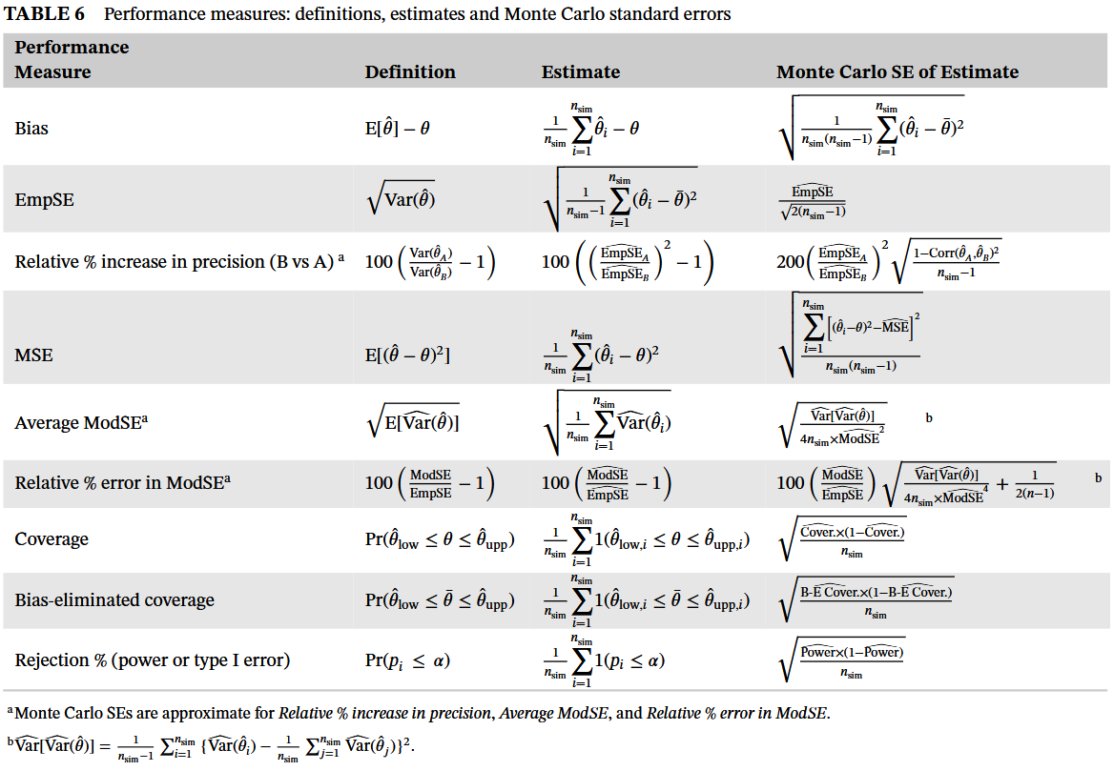
Figure 8.2 - Table 6 in (Morris et al., 2017), DOI: 10.1002/sim.8086
In this table, only rejection is not of interest to us, since we do not evaluate any statistical test. In our case, $\hat{θ}$ is the breakpoint time coordinate and has two components. The associated variability is $\sqrt{Var(\hat{θ})}$. The SDI scale coordinate of breakpoint is of slightly lesser interest to us, since it is not directly estimated by the methods, even though one could argue that this component is critical for deriving slopes, which are the clinically relevant parameters.

Presentation of the simulation results

Missing values
The number of missing values (for example due to nonconvergence), will be the first assessed performance measure. These may happen for several reasons, especially during the computation of statistical methods, and likely not completely at random. Data produced under repetitions for which one of the methods returns a missing estimate will be explored to try to understand why it happened. Reasons found will be reported in a table. If a meaningful proportion of estimates is missing (5% for us, threshold allocated in derivation of $n_{sim}$), it could impact estimated performance. In such a case, extending the simulation study to increase the number of repetitions will be considered.

Graphical exploratory analysis
Before undertaking formal analysis of the performance measurements, graphical exploratory analysis will be helpful in assessing some characteristics of the simulated datasets, namely:
- The distribution of $\hat{θ_{i}}$ and $\hat{SE}(\hat{θ_{i}})$ with a univariate plot for each data-generating model and method.
- Bivariate outliers, with a bivariate plot of $\hat{θ_{i}}$ vs $\hat{SE}(\hat{θ_{i}})$ for each data-generating model and method.
- Correlation between methods and systematic differences with a bivariate plot of $\hat{θ_{i}}$ SE(θi)for both methods.
- Agreement between methods and real parameters with the limits-of-agreement (or Bland-Altmann) plot for each method. Comparator will be the true values of the parameter for $\hat{θ_{i}}$ SE(θi)That is the difference against θi$θ$.
- Issues with coverage with a zip plot: a plot of confidence intervals ranked by $|z_{i}|$, with $z_{i}≔(\hat{θ_{i}}-θ)/ModSE_{i}$.

Performance measurements estimates and Monte Carlo SE
The simulation study being itself an experiment, there is an uncertainty due to the finite number of repetitions $n_{sim}$ we run. Therefore, the Monte Carlo Standard Error will be reported along every performance measure estimates. Estimates will be reported with the maximum accuracy allowed by the Monte Carlo SE (i.e. as many decimal points as the first non-zero digit in the Monte Carlo SE).
The “one-at-a-time” plan has an important impact on the way we can report the results. For the main factors, both qualitative and quantitative summary will be done (Ex: when noise level on score increases, the MSE is higher: XX for segmented and YY for lmbreak). Considering second-order interactions, only the quantitative summary will be reported (Ex: since MSE increases with lower plateau and higher noise on score, one can expect that the 2 factors varying in this direction at the same time will result in an even higher MSE). Such predictions will be verified by running the simulation for the corresponding data-generating model. Third-order interactions will be considered negligible.
Performance measures will be reported on a lollipop plot with the 95% Monte Carlo CI for every method. We suspect that the `segreg` model will work better on the data since it properly enforces the plateau in the model, so we will present precision gain with `segmented.lme` as comparator method. Performance measures will also be separately presented in a table for every method and data-generating model, estimates and Monte Carlo SE.
Finally, breakpoints 95% CI overlapping one of the ends of the time domain will be also reported. In that case, one might consider not having a breakpoint and modelling the relationship between the SDI and time as a regular linear model. This is more of a methodological consideration on breakpoint model, since the number of breakpoints in the relationship between a response and explanatory variable might not always be obvious, nor the same across patients. Some have very short to no plateau at all (1 break), some have trailing observations at the end (i.e. sort of “ending low plateau” - 3 breaks).

