Simulating SDI trajectories from R
To simulate SDI trajectories from known breakpoints normal distributions, the way to proceed is the following 2-step process:
- trueTraj: Specify the population-level average of breakpoints parameter.
Population-level specification includes breakpoints average coordinates, and times of measurement during the experiment (i.e. on average, when are the patient solicited for SDI).
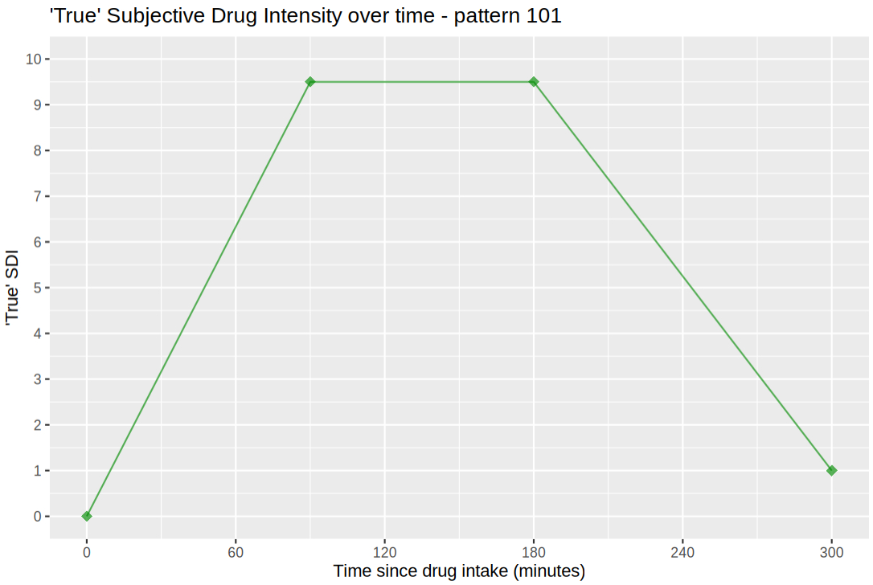
Figure 1 - Default plotting method for object of class `trajTruth`

- noiseTraj: Simulate individuals by specifying the level of noise on each parameter.
The noise level for the parameters is considered as the standard deviation for the normally distributed parameters listed below:
- times: sd on the times of measurements during the simulated experiment
- score: noise added on top of the true theoretical individual trajectory (final score variable is rounded to closest integer)
- breakpoints: sd of normal distribution of breakpoints. Needs to be specified for both x and y coordinates, which are simulated independently.
Other parameters include:
- break.x.dist: minimum between-breakpoints distance on the time axis
- outlier.prob: individual probability of having exactly one outlier observation. Outliers are simulated as a drop of 1-3 points in score, to mimic the impact of going to the bathroom during the experiment.
- na.prob: observation probability of being a missing value
- n.trail: number of trailing observations at the end of the trajectory. Ignored if simulated pattern already ends with a plateau. Exact number may vary individually due to noise on the time of measurement.
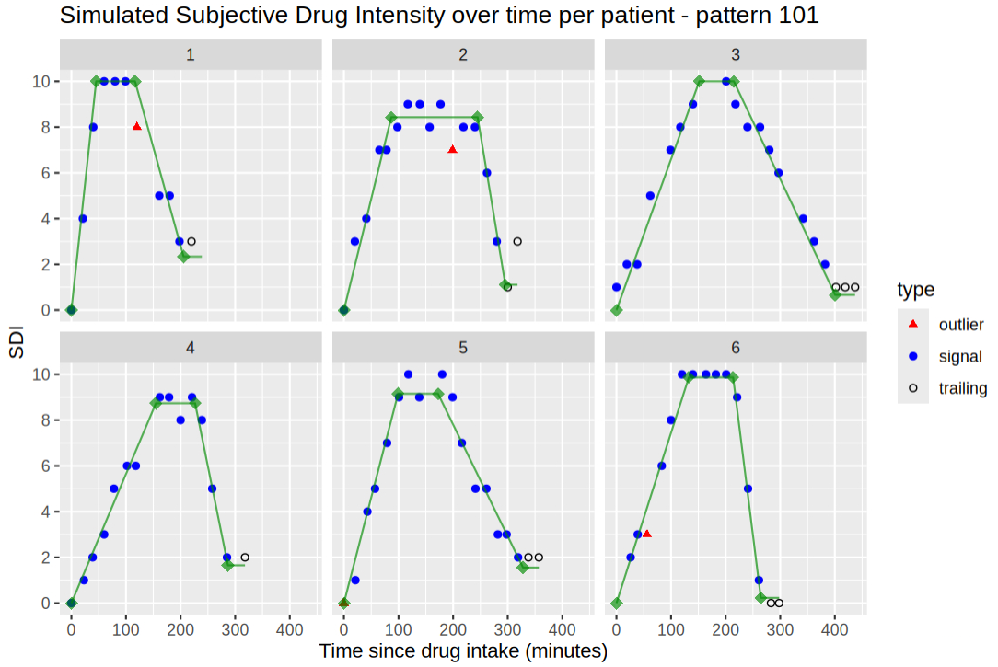
Figure 2 - Default plotting method for object of class `trajData`
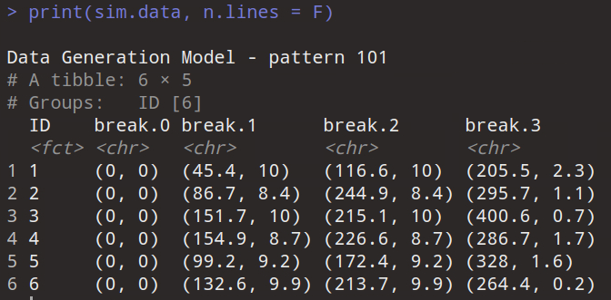
Describe features of function on the graph and the printed output.
Outlier on ind. 1, 2, 6. Nb of trailing observations may vary depending on noise on time measurements.
101 for illustrating but also works with different kinds of pattern: 11, 101, 111, 1010, 1011, etc.

