Simulation study report
See this document for the full protocol.

Missing values

Counts of missing data
Error messages, interpretations, count and frequencies for each method is reported in the following table:
ID | Error meaning + “message” \ Methods | Linear mixed model with one breakpoint | Linear breakpoint model with plateau
1 | Initializing mixed model may be over-specified  "nlminb problem, convergence error code = 1  message = singular convergence (7)" | 1347 / 7826 (17.2%) | -
2 | "system is computationally singular: reciprocal condition number = *close_machine_zero_nb*" | 4 / 7826 (<0.1%) | -
3 | Miss-specified data structure  "$ operator is invalid for atomic vectors" | - | 23 / 7826 (0.3%)
4 | "Not enought information for the fit: \n too many psi/small sample/replicated data" | - | 122 / 7826 (1.6%)
5 | "psi values too close each other. Please change (decreases number of) starting values" | - | 48 / 7826 (0.6%)
6 | "starting psi out of the range.. see 'alpha' in seg.control." | - | 9 / 7826 (0.1%)
 | Total | 1351 / 7826 (17.3%) | 202 / 7826 (2.6%)
Table 1 – Reasons and counts (proportion in %) of missing estimates during the simulation study
The number of missing estimates for the mixed model is important (17.3%). It especially exceeds the prior proportion assumption of 15%, whence the need for extending the simulation study to achieve sufficient precision. Moreover, 15% is an average missing estimates per scenario, the proportion might depend more or less on the data-generating mechanism – CHECK across scenario.
With a new conservative assumption of 20% of missing data, we would need an additional $n_{add}=35$ repetitions per scenario to achieve the desired Monte Carlo Standard Error (SE).
For the patient-wise model, a fewer number of errors occurred during estimation (202/7826). We have to highlight the fact that due to the code architecture, these correspond to error at the patient level, and not the dataset level. However, errors are thrown are the dataset level nonetheless, yielding missing data.
At least two errors (ID 3 and 6) could have probably been avoided but happened with small probability and were not encountered during test runs.
It is majorly due to singular convergence during the initial linear mixed model estimation.

Common causes – simultaneous errors
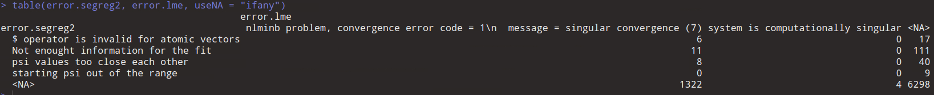
Prop of errors in common, or only for a single method. Table with the errors in common.

Simultaneous errors for both methods occurred for 25 datasets out of 7826 (0.3%), due to singular convergence for the mixed model, and 3 different reasons for the patient-wise model.

Data produced under failed iterations

Graphical exploratory analysis
5 plots described in protocol

Performance measurements estimates and Monte Carlo SE
Table with performance (Monte Carlo Standard Error (SE)) in cells. In columns, the two methods, in row, the varying factors. The results from reference scenario will be repeated over every factor for better readability of the results, with a grey font / visual indication that results are repeated.

