Projekt ”Snake” CAD/CAM

Sylwia Nowak

# Założenia projektu

Projekt zakładał reprezentację tzw. snake’a w programie komputerowym oraz umożliwienie symulacji działania obiektu. Reprezentowany obiekt powinien posiadać 1 koniec unieruchomiony w przestrzeni. Pozostałe części powinny zachowywać się jak w rzeczywistości. Każdy pojedyńczy segment snake’a posiada możliwośc obrotu wokół 2 osi definiowanych przez boki segemntów sąsiadujących. Dodatkową funkcjonalnością jest umożliwienie symulacji zachowania snake’a po uchwyceniu za ostatni ruchomy segment.

# Wykonanie

Projekt został wykonany w technologii .Net 4.0 z użyciem XNA 4.0. Każdy segment snake’a reprezentowany jest przez oddzielną figurę 3d składającą się z 8 jednostkowych trójkątnych powierzchni (faces). Do reprezentacji przycisków wykorzystano własną implementację komponentu oraz napisu textowego. Za generowanie widoku aplikacji odpowiada silnik snake’a obsługujący wszystkie przyciski.

Aplikacja umożliwia obracanie wokół wszystkich osi segmentów snak’a (prócz pierwszego segmentu przytwierdzonego w przestrzeni). Istnieją 2 typy obrotu: wokół tzw. prawego boku i lewego. Aplikacja nie zawiera dodatkowej funkcjonalności związanej z symulacją pociągnięcia snake’a za ruchomy koniec. Jeżeli obrót spowodowałby nałożenie się 2 segmentów z większą niż założono dokładnością snake stoi w miejscu.

# Instrukcja użytkownika

Wyjście z aplikacji możliwe jest nie tylko przez naciśnięcie przycisku close ale również wciśnięcie na klawiaturze ESC. Klikanie przycisku ROTATE RIGHT/LEFT zmienia kierunek obrotu segmentu. Przyciski +/- zmieniają ilość stopni jednego obrotu. ZOOM IN/OUT, RIGHT/LEFT, UP/DOWN odpowiadają za poruszanie się kamery w przestrzeni. CLEAR powoduje przywrócenie ilości stopni do 10 oraz wyprostowanie snake’a do pozycji początkowej. Przyciski L1-L9 odpowiadają za obroty wokół osi „lewych”, R1-R8 odpowiadają za obroty wokół osi „prawych”. Dostępne osi obrotowe zaczynając od końca utwierdzonego w przestrzeni to L1, R1, L2, R2, ...., R8, L9. Pojedynczy klik na przycisk Li lub Ri powoduje wykonanie pojedynczego obrotu zgodnie z wybranym kierunkiem (ROTATE RIGHT/LEFT) oraz ilością stopni.

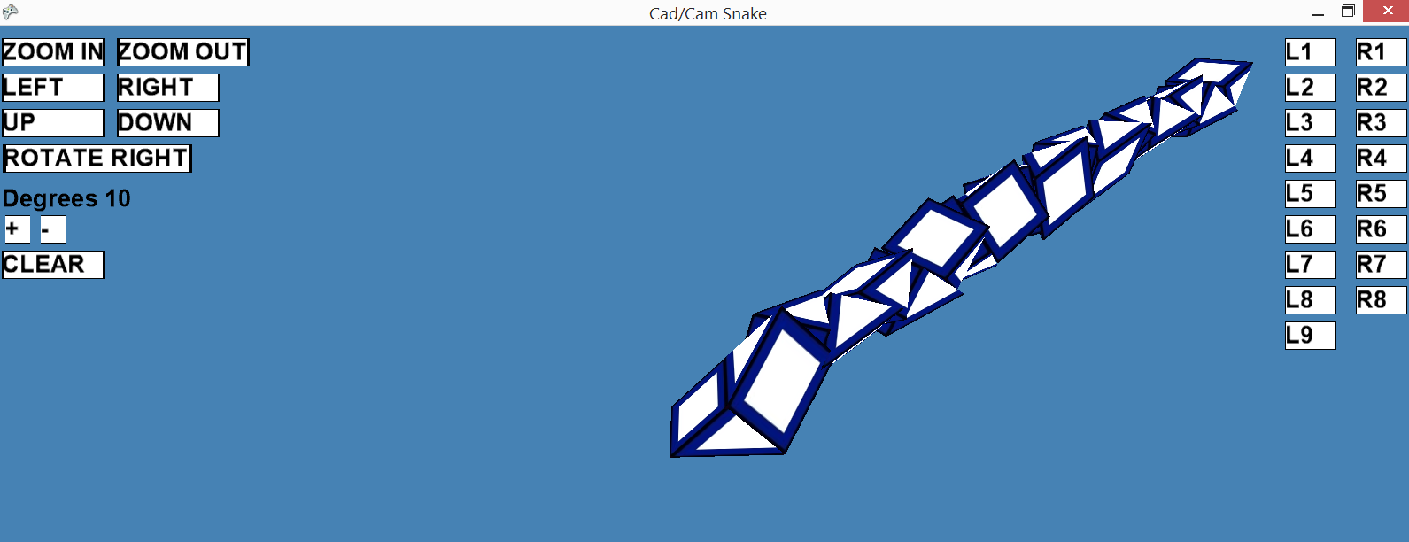

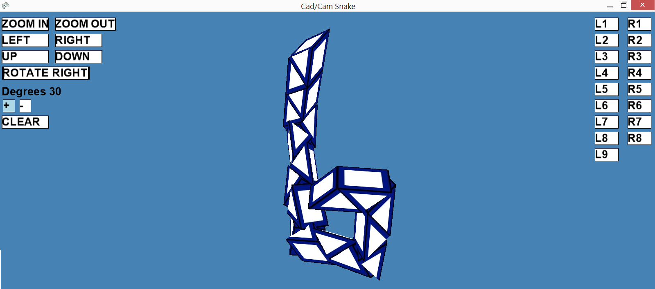

# Dokumentacja xml

Wygenerowana dokumentacja kodu źródłowego:

<?xml version="1.0"?>

<doc>

<assembly>

<name>CADCAM</name>

</assembly>

<members>

<member name="T:CADCAM.Component">

<summary>

Base class for elements drawn with spritebatch.

</summary>

</member>

<member name="M:CADCAM.Component.#ctor">

<summary>

Initializes a new instance of the <see cref="T:CADCAM.Component"/> class.

</summary>

</member>

<member name="M:CADCAM.Component.#ctor(Microsoft.Xna.Framework.Graphics.Texture2D,Microsoft.Xna.Framework.Color,Microsoft.Xna.Framework.Vector2,Microsoft.Xna.Framework.Vector2,System.Single)">

<summary>

Initializes a new instance of the <see cref="T:CADCAM.Component"/> class.

</summary>

<param name="texture">The texture.</param>

<param name="color">The color.</param>

<param name="position">The position.</param>

<param name="scale">The scale.</param>

<param name="angle">The angle.</param>

</member>

<member name="M:CADCAM.Component.Draw(Microsoft.Xna.Framework.Graphics.SpriteBatch)">

<summary>

Draws the specified sprite batch.

</summary>

<param name="spriteBatch">The sprite batch.</param>

</member>

<member name="F:CADCAM.Button.Click">

<summary>

The click function.

</summary>

</member>

<member name="M:CADCAM.Button.#ctor(CADCAM.BState,Microsoft.Xna.Framework.Graphics.Texture2D,Microsoft.Xna.Framework.Color,Microsoft.Xna.Framework.Vector2,Microsoft.Xna.Framework.Vector2,System.Single,System.Double,Microsoft.Xna.Framework.Color,Microsoft.Xna.Framework.Graphics.SpriteFont,System.String)">

<summary>

Initializes a new instance of the <see cref="T:CADCAM.Button"/> class.

</summary>

<param name="state">The state.</param>

<param name="texture">The texture.</param>

<param name="color">The color.</param>

<param name="position">The position.</param>

<param name="scale">The scale.</param>

<param name="angle">The angle.</param>

<param name="timer">The timer.</param>

<param name="textColor">Color of the text.</param>

<param name="spriteFont">The sprite font.</param>

<param name="text">The text.</param>

</member>

<member name="M:CADCAM.Button.#ctor(Microsoft.Xna.Framework.Graphics.Texture2D,Microsoft.Xna.Framework.Color,Microsoft.Xna.Framework.Graphics.SpriteFont,System.String,Microsoft.Xna.Framework.Color)">

<summary>

Initializes a new instance of the <see cref="T:CADCAM.Button"/> class.

</summary>

<param name="texture">The texture.</param>

<param name="color">The color.</param>

<param name="spriteFont">The sprite font.</param>

<param name="text">The text.</param>

<param name="textColor">Color of the text.</param>

</member>

<member name="M:CADCAM.Button.#ctor">

<summary>

Initializes a new instance of the <see cref="T:CADCAM.Button"/> class.

</summary>

</member>

<member name="M:CADCAM.Button.Update(System.Int32,System.Int32,System.Double,System.Boolean,System.Boolean)">

<summary>

Updates the state of button depends of mouse position on screen.

</summary>

<param name="mx">The mx of mouse position.</param>

<param name="my">My of mouse position.</param>

<param name="frameTime">The frame time.</param>

<param name="mPressed">if set to <c>true</c> [mouse pressed].</param>

<param name="prevMPressed">if set to <c>true</c> [previous mouse pressed].</param>

</member>

<member name="M:CADCAM.Button.Draw(Microsoft.Xna.Framework.Graphics.SpriteBatch)">

<summary>

Draws the specified sprite batch.

</summary>

<param name="spriteBatch">The sprite batch.</param>

</member>

<member name="M:CADCAM.Button.OnClick(System.Double)">

<summary>

Called when [click].

</summary>

<param name="timer">The timer.</param>

</member>

<member name="M:CADCAM.Button.CheckIfButtonContainsPoint(System.Int32,System.Int32)">

<summary>

Checks if button contains point.

</summary>

<param name="x">The x position of point.</param>

<param name="y">The y position of point.</param>

<returns></returns>

</member>

<member name="M:CADCAM.Button.CheckIfTextureContainsPoint(System.Single,System.Single,System.Int32,System.Int32)">

<summary>

Checks if texture contains point.

</summary>

<param name="tx">The tx of texture.</param>

<param name="ty">The ty of texture.</param>

<param name="x">The x of point.</param>

<param name="y">The y of point.</param>

<returns></returns>

</member>

<member name="M:CADCAM.Button.CheckIfRectangleContainsPoint(System.Single,System.Single,System.Int32,System.Int32)">

<summary>

Checks if rectangle of button contains point.

</summary>

<param name="tx">The tx of rectangle.</param>

<param name="ty">The ty of rectangle.</param>

<param name="x">The x of point.</param>

<param name="y">The y of point.</param>

<returns></returns>

</member>

<member name="T:CADCAM.BState">

<summary>

Enum for representing button state.

</summary>

</member>

<member name="T:CADCAM.Label">

<summary>

Simple label without texture, only string drawing enabled.

</summary>

</member>

<member name="M:CADCAM.Label.#ctor(Microsoft.Xna.Framework.Graphics.SpriteFont,System.String,Microsoft.Xna.Framework.Color,Microsoft.Xna.Framework.Vector2,Microsoft.Xna.Framework.Vector2,System.Single)">

<summary>

Initializes a new instance of the <see cref="T:CADCAM.Label"/> class.

</summary>

<param name="spriteFont">The sprite font.</param>

<param name="text">The text.</param>

<param name="color">The color.</param>

<param name="position">The position.</param>

<param name="scale">The scale.</param>

<param name="angle">The angle.</param>

</member>

<member name="M:CADCAM.Label.#ctor(Microsoft.Xna.Framework.Graphics.SpriteFont,System.String,Microsoft.Xna.Framework.Color)">

<summary>

Initializes a new instance of the <see cref="T:CADCAM.Label"/> class.

</summary>

<param name="spriteFont">The sprite font.</param>

<param name="text">The text.</param>

<param name="color">The color.</param>

</member>

<member name="M:CADCAM.Label.Draw(Microsoft.Xna.Framework.Graphics.SpriteBatch)">

<summary>

Draws the specified sprite batch.

</summary>

<param name="spriteBatch">The sprite batch.</param>

</member>

<member name="M:CADCAM.Program.Main(System.String[])">

<summary>

The main entry point for the application.

</summary>

</member>

<member name="T:CADCAM.CadCamGame">

<summary>

This is the main type for your game

</summary>

</member>

<member name="M:CADCAM.CadCamGame.Draw(Microsoft.Xna.Framework.GameTime)">

<summary>

This is called when the game should draw itself.

</summary>

<param name="gameTime">Provides a snapshot of timing values.</param>

</member>

<member name="M:CADCAM.CadCamGame.LoadContent">

<summary>

LoadContent will be called once per game and is the place to load

all of your content.

</summary>

</member>

<member name="M:CADCAM.CadCamGame.Update(Microsoft.Xna.Framework.GameTime)">

<summary>

Allows the game to run logic such as updating the world,

checking for collisions, gathering input, and playing audio.

</summary>

<param name="gameTime">Provides a snapshot of timing values.</param>

</member>

<member name="M:CADCAM.RotationMatrix.#ctor(System.Single,System.Single,System.Single,System.Single,System.Single,System.Single,System.Single)">

<summary>

Initializes a new instance of the <see cref="T:CADCAM.RotationMatrix"/> class.

</summary>

<param name="a">x-coordinate of a point on the line of rotation.</param>

<param name="b">y-coordinate of a point on the line of rotation.</param>

<param name="c">z-coordinate of a point on the line of rotation.</param>

<param name="uUn">x-coordinate of the line's direction vector (unnormalized).</param>

<param name="vUn">y-coordinate of the line's direction vector (unnormalized).</param>

<param name="wUn">z-coordinate of the line's direction vector (unnormalized).</param>

<param name="theta">The angle of rotation, in radians.</param>

</member>

<member name="M:CADCAM.RotationMatrix.LongEnough(System.Single,System.Single,System.Single)">

<summary>

Check whether a vector's length is less than <see ref="TOLERANCE"/>

</summary>

<param name="u">The vector's x-coordinate.</param>

<param name="v">The vector's y-coordinate.</param>

<param name="w">The vector's z-coordinate.</param>

<returns>length = Math.sqrt(u^2 + v^2 + w^2) if it is greater than <see ref="TOLERANCE"/> or -1 if not.</returns>

</member>

<member name="T:CADCAM.SnakeEngine">

<summary>

Engine repsonsible for buttons handling and showing snake.

</summary>

</member>

<member name="M:CADCAM.SnakeEngine.#ctor(Microsoft.Xna.Framework.Graphics.Texture2D,Microsoft.Xna.Framework.Graphics.SpriteFont)">

<summary>

Initializes a new instance of the <see cref="T:CADCAM.SnakeEngine"/> class.

</summary>

</member>

<member name="M:CADCAM.SnakeEngine.GenerateClickListeners(Microsoft.Xna.Framework.Graphics.Texture2D,Microsoft.Xna.Framework.Graphics.SpriteFont)">

<summary>

Generates the click listeners for all position buttons.

</summary>

<param name="buttonTexture2D">The button texture2d.</param>

<param name="buttonTextSpriteFont">The button text sprite font.</param>

</member>

<member name="M:CADCAM.SnakeEngine.FindCenterOfRotation(System.Boolean,System.Int32)">

<summary>

Finds the center of rotation and rotation axis.

</summary>

<param name="isRight">if set to <c>true</c> [rotation is right direction].</param>

<param name="figure">The figure number.</param>

<returns>Two points on rotation axis, one on right face other on bottom/top</returns>

</member>

<member name="M:CADCAM.SnakeEngine.Rotate(Microsoft.Xna.Framework.Vector3[],System.Int32,System.Boolean)">

<summary>

Rotates figure from specified base tetrahedron around axis

through middle of one of "side's" figures.

</summary>

<param name="rotationMiddle">The rotation middle's.</param>

<param name="figure">The start figure number.</param>

<param name="isRight">if set to <c>true</c> [rotation is right direction].</param>

</member>

<member name="M:CADCAM.SnakeEngine.CheckIfAnythingIsOverLapping">

<summary>

Checks if anything is over lapping.

</summary>

<returns></returns>

</member>

<member name="M:CADCAM.SnakeEngine.CheckColision(Microsoft.Xna.Framework.Vector3,Microsoft.Xna.Framework.Vector3,Microsoft.Xna.Framework.Vector3,Microsoft.Xna.Framework.Vector3,Microsoft.Xna.Framework.Vector3,Microsoft.Xna.Framework.Vector3)">

<summary>

Checks the colision of two faces.

</summary>

<param name="t1A">The first point of triangle 1.</param>

<param name="t1B">The second point of triangle 1.</param>

<param name="t1C">The third point of triangle 1.</param>

<param name="t2A">The first point of triangle 2.</param>

<param name="t2B">The second point of triangle 2.</param>

<param name="t2C">The third point of triangle 2.</param>

<returns></returns>

</member>

<member name="M:CADCAM.SnakeEngine.CheckIfTriangleIsOnOneSideOfAnotherTriangle(Microsoft.Xna.Framework.Vector3,Microsoft.Xna.Framework.Vector3,Microsoft.Xna.Framework.Vector3,Microsoft.Xna.Framework.Vector3,Microsoft.Xna.Framework.Vector3,Microsoft.Xna.Framework.Vector3)">

<summary>

Checks if triangle is on one side of another triangle.

</summary>

<param name="t1A">The first point of triangle 1.</param>

<param name="t1B">The second point of triangle 1.</param>

<param name="t1C">The third point of triangle 1.</param>

<param name="t2A">The first point of triangle 2.</param>

<param name="t2B">The second point of triangle 2.</param>

<param name="t2C">The third point of triangle 2.</param>

<returns></returns>

</member>

<member name="M:CADCAM.SnakeEngine.CheckIfTriagleIsUnderOtherTriangle(Microsoft.Xna.Framework.Vector3,Microsoft.Xna.Framework.Vector3,Microsoft.Xna.Framework.Vector3,Microsoft.Xna.Framework.Vector3,Microsoft.Xna.Framework.Vector3,Microsoft.Xna.Framework.Vector3)">

<summary>

Checks if triagle is under other triangle.

</summary>

<param name="t1A">The first point of triangle 1.</param>

<param name="t1B">The second point of triangle 1.</param>

<param name="t1C">The third point of triangle 1.</param>

<param name="t2A">The first point of triangle 2.</param>

<param name="t2B">The second point of triangle 2.</param>

<param name="t2C">The third point of triangle 2.</param>

<returns></returns>

</member>

<member name="M:CADCAM.SnakeEngine.InitializeEffect(Microsoft.Xna.Framework.Graphics.BasicEffect,Microsoft.Xna.Framework.Graphics.Texture2D)">

<summary>

Initializes the effect (loading, parameter setting,

and technique selection) used for the 3D model.

</summary>

</member>

<member name="M:CADCAM.SnakeEngine.InitializeTransform(System.Single,System.Single)">

<summary>

Initializes the transforms used for the 3D model.

</summary>

</member>

<member name="M:CADCAM.SnakeEngine.Update(Microsoft.Xna.Framework.GameTime,Microsoft.Xna.Framework.Graphics.BasicEffect,System.Int32,System.Int32)">

<summary>

Updates the specified game time.

</summary>

<param name="gameTime">The game time.</param>

<param name="basicEffect">The basic effect.</param>

<param name="windowWidth">Width of the window.</param>

<param name="windowHeight">Height of the window.</param>

</member>

<member name="M:CADCAM.SnakeEngine.Draw(Microsoft.Xna.Framework.Graphics.SpriteBatch,Microsoft.Xna.Framework.GameTime)">

<summary>

Draws the specified sprite batch.

</summary>

<param name="spriteBatch">The sprite batch.</param>

<param name="gameTime">The game time.</param>

</member>

<member name="M:CADCAM.SnakeEngine.CreateVertexBuffer(Microsoft.Xna.Framework.GraphicsDeviceManager)">

<summary>

Creates the vertex buffer.

</summary>

<param name="graphics">The graphics.</param>

</member>

<member name="M:CADCAM.SnakeEngine.InitializeTetrahedron(System.Int32,System.Boolean)">

<summary>

Initializes the tetrahedron.

</summary>

<param name="figure">The figure number.</param>

<param name="isUp">Define direction of bottom of figure</param>

</member>

<member name="T:CADCAM.Triangle">

<summary>

Base class for representing single tringle

</summary>

</member>

</members>

</doc>