**Part 1: Bias and Noise**

Taking samples and Noise as variance

***Accelerometer***

* Bias: [0.04230337829589844, -0.08600277709960938, 9.739888958740234]
  + Rounded: [0.0423, -0.0860, 9.74]
* Noise: [4.58502718248954E-4, 9.69409790625795E-5, 5.685786921105773E-5]
  + Rounded: [4.59e-4, 9.69e-5, 5.69e-5]

***Gyroscope***

* Bias: [2.274169921875E-5, 3.23486328125E-6, -1.08642578125E-6]
  + Rounded: [2.27e-5, 3.23e-6, -1.09e-6]
* Noise: [2.3132960960268976E-7, 1.7802209034562111E-7, 1.7246551126241682E-7]
  + Rounded: [2.31e-7, 1.78e-7, 1.72e-7]

**Part 2: Plot the tilt over the duration of 5 minutes**

Only Accelerometer

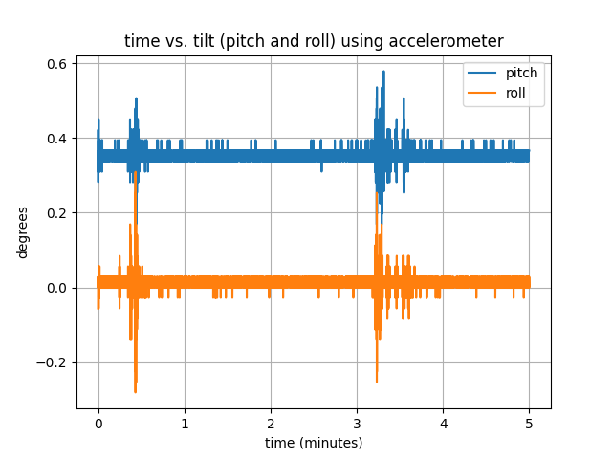

Only Gyroscope

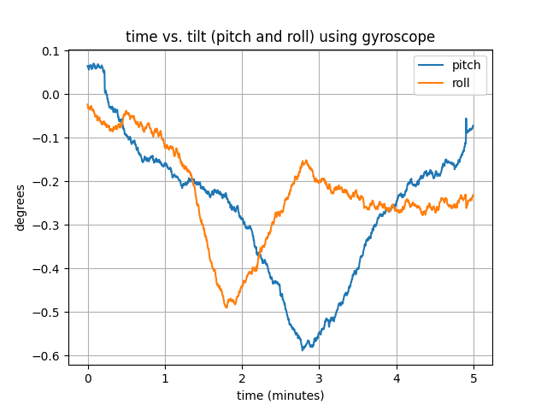

Using both Accelerometer and Gyroscope with Complementary Filter

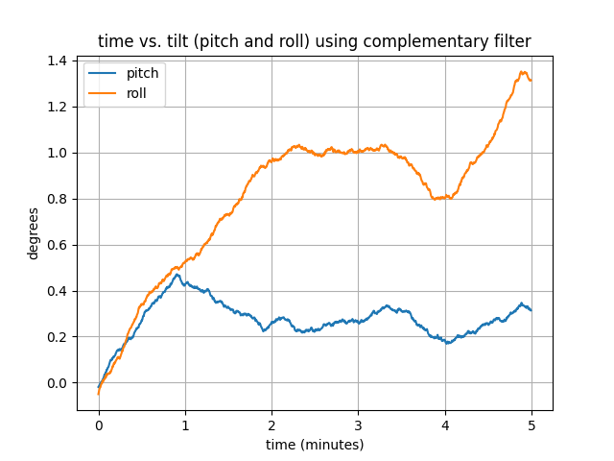

**Part 3: Is a video**

Note that the order of angles for tilt are [Pitch, Roll] and uses a complementary filter.

Video is on Canvas and also here: <https://github.com/nowei/cse562/blob/master/hw_submissions/cse562hw2.mp4>

**GitHub repo**: <https://github.com/nowei/cse562/tree/master/hw2>