Project : Memory augmentation for RL Tuning PID controller

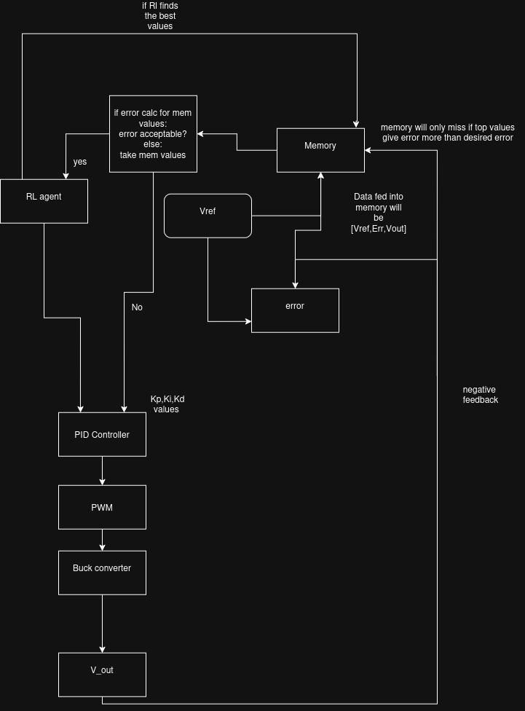
overall Architecture:

Overall working:
The basic idea of whole system if to mimic Brain and Habits pathway that humans follow. RL tuning is the brain part of the system (does the thinking and finding Error) and Memory is the habit part that reduces computational needs of RL when solving same issue or maybe similar issue using Linear Regression.

Memory Architecture:
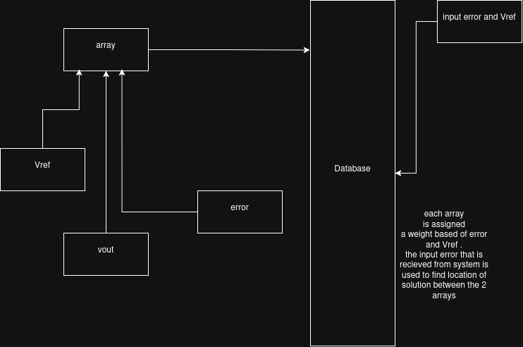

Memory architecture overview:
array is only stored if those value were successful in bring Voltage with no overshoot and minimum disturbance to Vref. During extreme noise RL agent does the heavy lifting and previous arrays with same [Vref,error,Vout] end up being replaced. Weights for searching become W1= Vref and W2=err.

The Memory will have dynamic amount of Data points . The amount of data pts will be constrained in max and min of the range of Vref that can be produced based of Vin in the Buck converter. Memory does not only store data points but also perform linear regression ( Error vs KP , KI , KD) to find the value of the 3 and apply them to get best result .
*Linear regression is only trusted after certain amount of Data points are achieved(eg. 10)

