Memory-Augmented RL for PID Tuning

Buck Converter Voltage Regulation — Architecture & Progress

1. Core Idea
The system mimics the brain/habit pathway humans use for skill acquisition:
- RL Agent (“brain”) — does the actual thinking. Given a situation (Vref, error), it decides how to respond. Used when no trustworthy shortcut exists yet, or when conditions are novel or extreme.
- Memory (“habit”) — a lightweight, cheap shortcut that reduces how often RL needs to run, by recognizing situations similar to ones already solved and reusing / generalizing that experience instead of recomputing from scratch.
This keeps the system fast in familiar territory and only pays RL's full computational cost when genuinely needed.
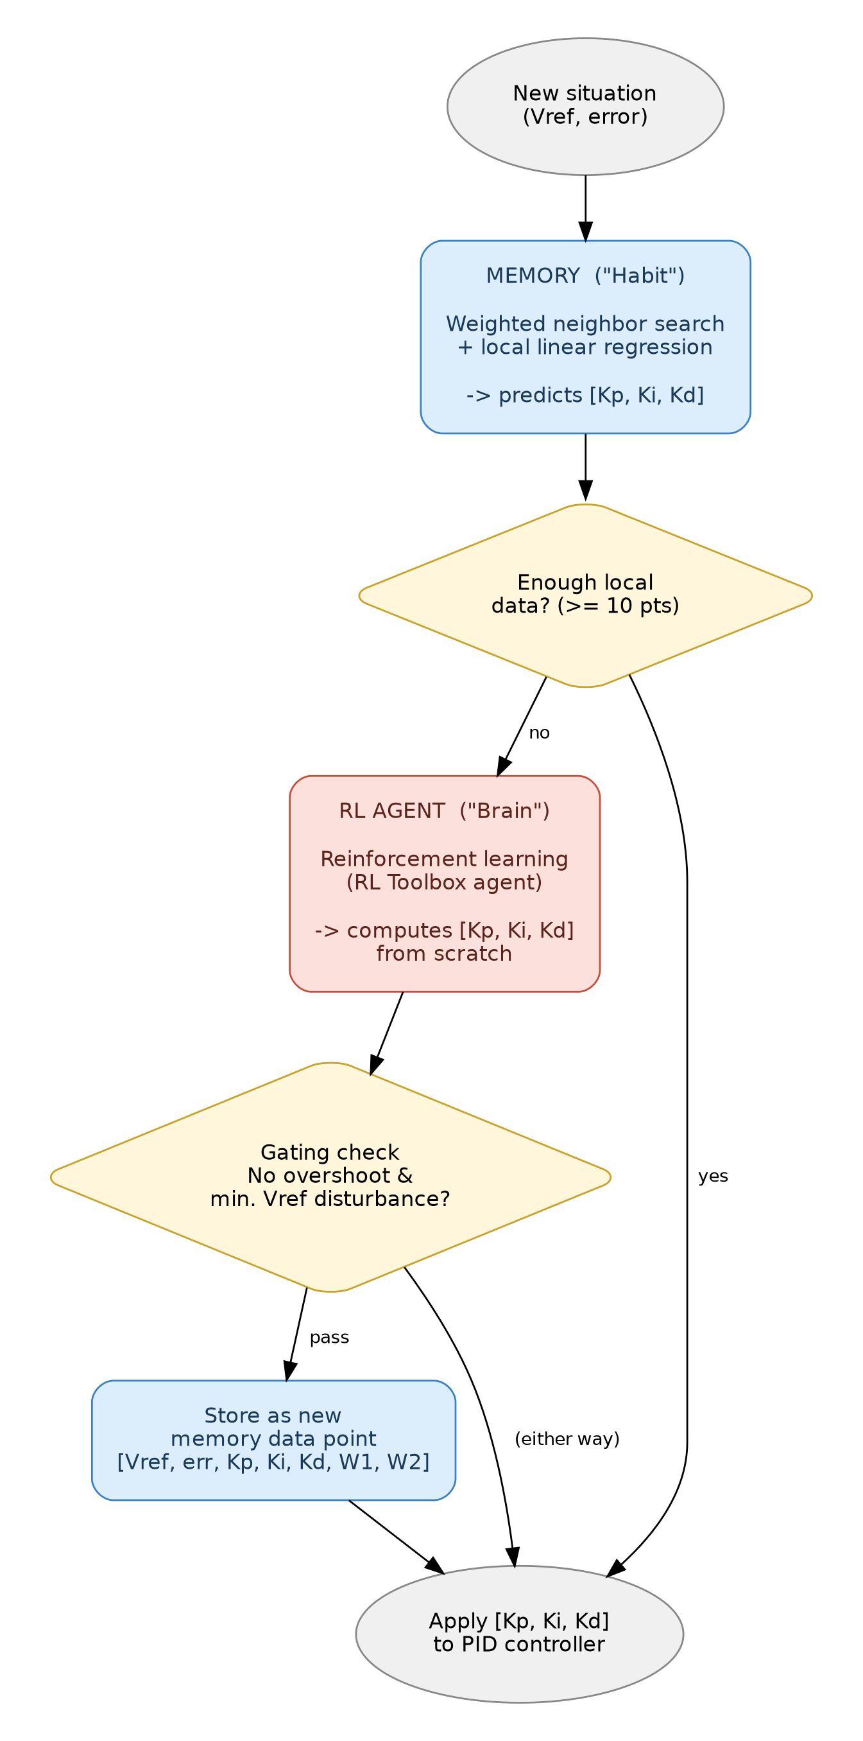
Figure 1 — Brain / habit arbitration flow

2. What RL Actually Controls
RL does not output the plant's duty cycle directly. Instead, RL tunes the tuner: it outputs PID gains [Kp, Ki, Kd], and a real PID controller does the moment-to-moment control math using those gains. This keeps control interpretable while RL's job is choosing good gains for the current operating situation.
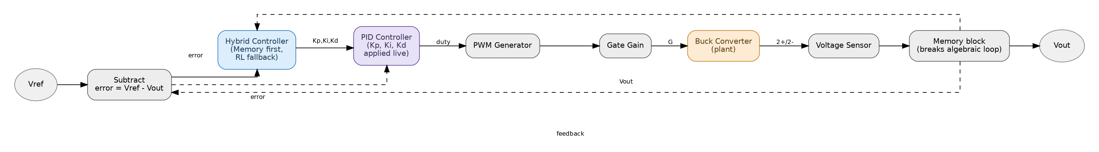
Figure 2 — Closed-loop signal path: Vref → PID (gains supplied live) → plant → feedback

3. Plant Model (Validated)
- Buck converter built using Simscape Electrical's inbuilt Buck Converter block — switching-level, not averaged — chosen for research-grade fidelity over simulation speed.
- Signal chain: PID output (duty cycle) → PWM Generator → Simulink-PS Converter → Gate Gain → G port.
- Physical chain: DC Voltage Source → 1+/1- → Buck Converter → 2+/2- → Resistor (load), Voltage Sensor tapped across 2+/2-.

Issues found and resolved
- Gate threshold: the switch's 6V threshold was higher than the PWM's native pulse amplitude, so the switch never closed. Fixed with a Gate Gain block scaling the pulse above threshold.
- Switching frequency: initial 1kHz switching sat too close to the LC filter's natural resonant frequency (~1.6kHz for L=100µH, C=100µF), causing severe ringing instead of filtering. Fixed by raising switching frequency to 100kHz.
- Solver stall: default solver stalled on the stiff switching dynamics. Fixed using ode23t with Max step size = 1e-6.
Verified: open-loop step response of duty cycle → Vout settles near the theoretical Vout ≈ D × Vin, confirming plant fidelity. All physical values live in config/plant_params.m, loaded automatically via the model's InitFcn callback — no hardcoded numbers in block dialogs.

4. Closed-Loop Control (Validated)
Vref (Constant) and a Subtract block compute error = Vref − Vout. The placeholder proportional-only controller was replaced with a real PID Controller block (Source: external), exposing live P, I, D input ports — ready for manual constants now, and RL agent output later.

Algebraic loop issue (resolved)
The closed loop (Vout → error → PID → duty → G → plant → Vout, all within one instant) triggered an algebraic loop warning, worsened by the plant's discontinuous ideal switch. Fixed by inserting a Memory block in the feedback path (after the Voltage Sensor's PS-Simulink Converter, before the Subtract block), breaking the instantaneous circular dependency with a one-sample delay.

Manually tuned baseline
Kp = 0.3, Ki = 2, Kd = 1 — settles close to Vref with controlled overshoot and clean settling, though a small steady-state gap remained at the point tuning was paused. This is kept as a reference point rather than perfected by hand, since manual gain-searching is exactly what RL is meant to replace.

5. RL Agent (Design, Not Yet Built)
- Toolbox: MATLAB's inbuilt Reinforcement Learning Toolbox agent (continuous action space — DDPG / TD3).
- Training vs. runtime separation: training only happens in scripts/run_training.m. The runtime path (+brain/RLAgentWrapper.m) only loads a trained agent and calls getAction() — it never re-triggers training.
- Observation (3-dim): [Vref, error, Vout].
- Action (3-dim, continuous): [Kp, Ki, Kd], bounded roughly Kp ∈ [0, 2], Ki ∈ [0, 50], Kd ∈ [0, 5] (from manual-tuning experience; refinable during training setup).
- Reward: tied to the same acceptance logic as memory's gatingCriteria — penalizes overshoot and Vref disturbance.

6. Memory Architecture (Design, Not Yet Built)

6.1 What gets stored
Each accepted data point:
[ Vref, error, Kp, Ki, Kd, W1, W2, timestamp ]
A point is only stored if it passes gatingCriteria (no overshoot, minimal disturbance to Vref) after RL solves it.

6.2 Per-point weights (W1, W2)
Computed once, at storage time, via a local perturbation test:
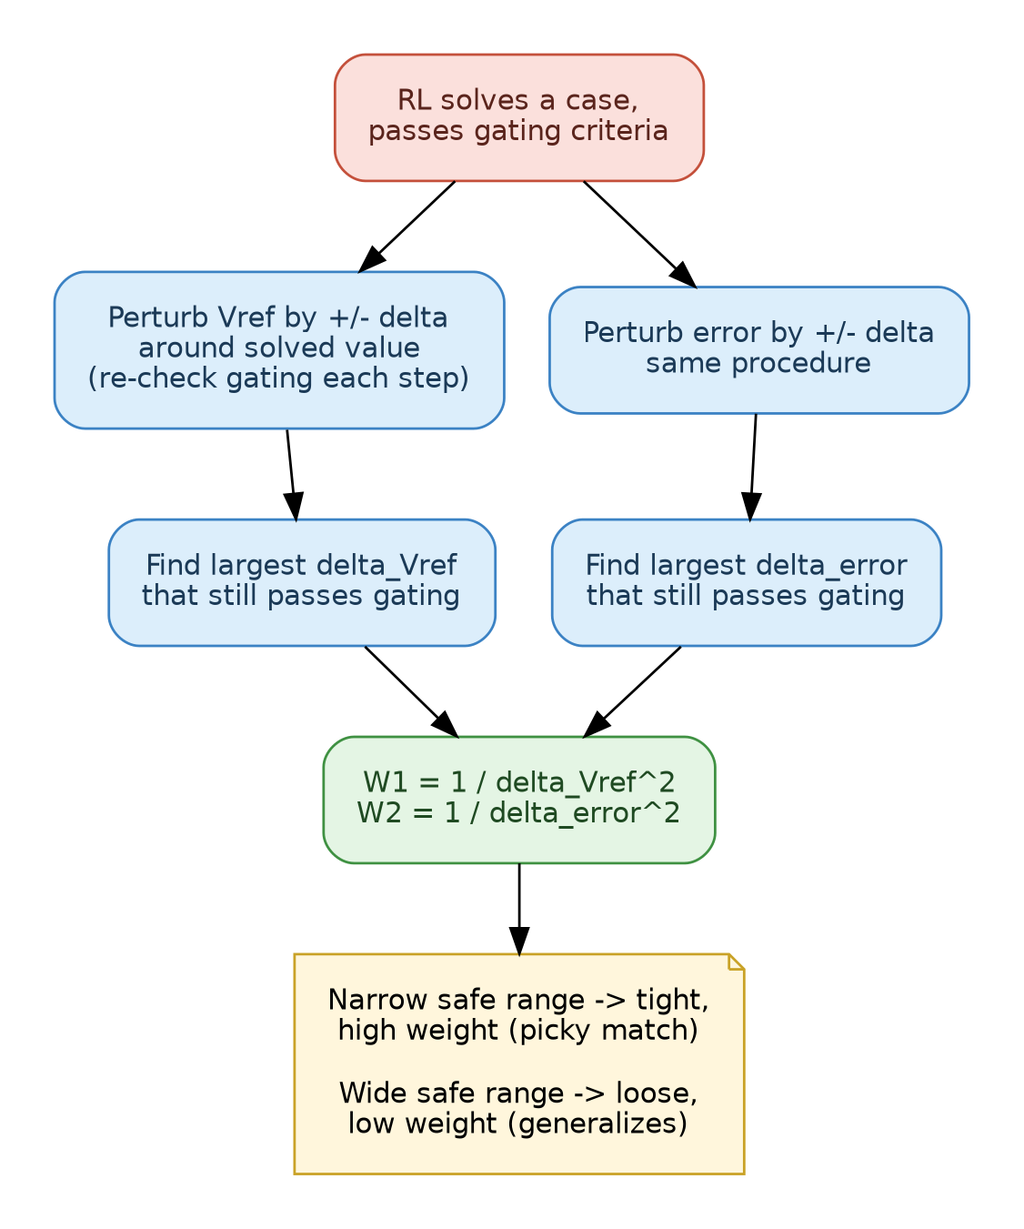
Figure 3 — Per-point weight derivation via perturbation test
Interpretation: a point that only works in a narrow band gets a tight, high-weight (picky) match region; a point that's robust across a wide range gets a low weight (generous) match region. Each stored point defines its own “trust ellipse” rather than using one global threshold.

6.3 Query algorithm (two-stage)
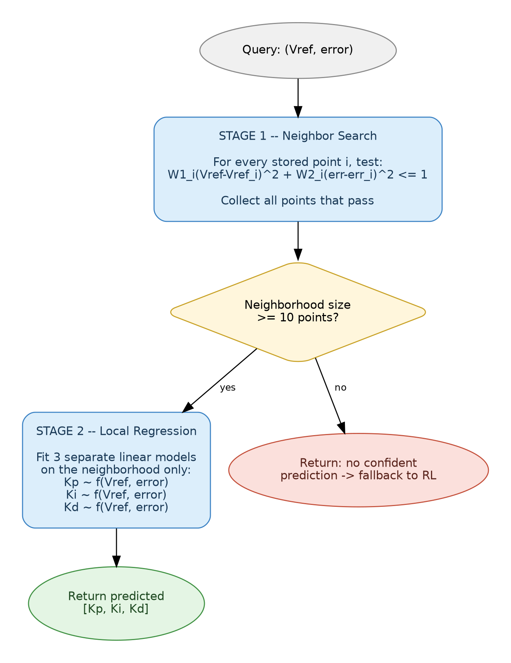
Figure 4 — Two-stage memory query: neighbor search, then local regression
Stage 1 — Neighbor search: for a query (Vref, error), include every stored point i satisfying:
W1_i × (Vref − Vref_i)² + W2_i × (error − error_i)² ≤ 1
This is a fixed per-point threshold test (not a fixed top-K) — neighborhood size varies naturally with how densely that region of operation has been explored.
Stage 2 — Local regression: if neighborhood size ≥ 10 points, fit three separate linear regressions, each predicting one gain from (Vref, error): Kp ~ f(Vref, error), Ki ~ f(Vref, error), Kd ~ f(Vref, error) — fit only on the local neighborhood, not the whole bank. If neighborhood size < 10, memory reports no confident prediction and HybridController falls back to RL. If RL's result passes gating, it is stored as a new point, growing the neighborhood over time.

6.4 Replacement / pruning
During extreme or noisy conditions, RL does the heavy lifting, and any existing stored point(s) sharing essentially the same [Vref, error] signature get replaced by the new solution.

7. Arbitration — HybridController
query (Vref, error)
-> habit.neighborSearch -> habit.localRegression
-> if confident: use predicted [Kp, Ki, Kd]
-> if not confident: call brain.RLAgentWrapper.getAction()
-> if result passes gatingCriteria: habit.MemoryStore.add(...)

8. Folder Structure
PID-Memory-RL/
├── models/ plant_model.slx, controller_harness.slx, hardware_target.slx
├── +brain/ RLAgentWrapper.m, rewardFunction.m, observationSpec.m,
│ actionSpec.m, agents/ (trained .mat files)
├── +habit/ MemoryStore.m, deriveWeights.m, neighborSearch.m,
│ localRegression.m, gatingCriteria.m, store/
├── +controller/ HybridController.m
├── config/ plant_params.m, rl_hyperparams.m, memory_thresholds.m
├── scripts/ run_training.m, run_simulation.m, run_hardware_test.m
├── tests/
├── results/ (gitignored)
└── docs/ architecture.md (this document)

9. Build Order / Progress
Component | Purpose | Status
models/plant_model.slx | Buck converter plant, open-loop, validated | Done
config/plant_params.m | Centralized parameters (Vin, L, C, R, Fsw, etc.) | Done
Closed-loop PID (in plant_model.slx) | Vref/error wiring, external PID gains, algebraic loop fixed, manually tuned baseline | Done
+habit/gatingCriteria.m | Accept/reject rule for storing new points | Pending
+habit/MemoryStore.m | add() / query() orchestration | Pending
+habit/deriveWeights.m | Perturbation test -> W1, W2 | Pending
+habit/neighborSearch.m | Threshold-based neighborhood collection | Pending
+habit/localRegression.m | 3x linear regression on neighborhood | Pending
+brain/ (specs, reward, wrapper) | Observation/action specs, reward function | Pending
scripts/run_training.m | Train RL agent, save to +brain/agents/ | Pending
+controller/HybridController.m | Full arbitration: memory first, RL fallback | Pending
tests/ | Unit tests for gating, weights, search, regression | Pending
scripts/run_simulation.m, run_hardware_test.m | Runtime entry points | Pending

Next immediate step: build +brain/ (observation spec, action spec, reward function) and wire an RL Agent block into the model in place of the manual Kp/Ki/Kd constants, then run first training.

