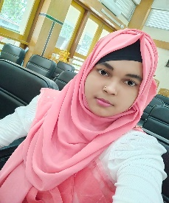
Nowrin Islam
G-mail: nowrinislam491@gmail.com
Mobile: +8801707662617
What’s app: 01707662617
Gopalgonj,Dhaka,Bangladesh

Summary
Frontend develpoer with 6 month of exprience buildingscalable web applications and specializing in API developer to Mobile and Web Apps Exrienced with all the stages of the SDLC for the dynamic web projects web project . Well versed in numerous frontend and backend technologies including HTML, CSS, Bootstrap,Javacript,Tailwind.

Exprience
- HTML(5+ month)
- CSS
- Bootstrap
- Javacript
- Tailwind
Education

Exam | Institution | Passing Year | GPA
Honor’s | Govt Bongobondhu College | 2022- | Running
HSC | MH Khan Degree | 2021 | 4.50
SSC | Durgapur High School | 2019 | 4.00

