Nowrin Islam
G-mail: nowrinislam491@gmail.com
Mobile: +8801707662617
WhatsApp:01707662617
Gopalgonj,Dhaka,Bangjadesh
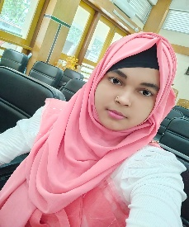

Summery

I'm Nowrin Islam. I am a web developer by a profession and design, build, and maintain websites and web applications. I specialize in coding languages like HTML,CSS, and frameworks to create user-friendly, responsive, and functionalwebsites tailored to client or business need.

Skill Highlight
- Microsoftword
- Microsoft Excel
- PowerPoint
- Adope Photoshop
- Computer Fundametal

Exprience
- HTM(5+ month)
- CSS
- Bootstrap
- Javacript
- Tailwind
Education
Exam | Institution | Passinng Year | GPA
Honours | Govt. Bongobandhu college,Gopalgonj
HSC | MH Khan Degree,College | 2021 | 4.50
SSC | Durgapur High School | 2019 | 4.00

