SADMC SHIELD
Anomaly Detection & Auto-Remediation SaaS for Microservices Architecture
SE801 Project
Midterm Technical Report
July 2026

1. Project Overview

1.1 Project Title
SADMC Shield — Anomaly Detection & Auto-Remediation SaaS for Microservices Architecture.

1.2 Problem Statement
As microservices architectures scale, individual services degrade in ways that are easy to miss until they cascade into outages — a runaway CPU, a slow memory leak, a creeping network delay. Detecting these failure modes manually is impractical: teams cannot watch every dashboard for every service around the clock, and by the time a human notices, users have already been affected. Existing monitoring stacks surface raw metrics well but stop short of recognising the anomaly, explaining it, and doing something about it. At the same time, teams need this capability without exposing their source code or business data to a third party, and without adding heavyweight infrastructure to every cluster they operate.

1.3 Objectives
- O1 — Continuous, Zero-Configuration Monitoring: Continuously monitor every microservice in a tenant’s Kubernetes cluster without manual configuration of individual services.
- O2 — ML-Based Anomaly Classification: Classify each service’s current health as NORMAL or one of three anomaly types (CPU_HOG, MEMORY_LEAK, NETWORK_DELAY) using a centrally-hosted machine-learning model.
- O3 — Autonomous Remediation: Automatically execute a corrective Kubernetes action (throttle, restart, or scale) for high-confidence anomalies, without waiting on a human operator.
- O4 — Privacy-Preserving, Zero-Trust Design: Keep all cluster-modifying logic and business data inside the tenant’s own cluster; only numerical metric vectors leave the cluster boundary.
- O5 — One-Command Onboarding: Let a tenant onboard an entire cluster with a single Helm command.
- O6 — Real-Time Observability: Give tenants a real-time dashboard of service health, live anomaly events, and remediation history.

1.4 Scope
In scope:
- Tenant SaaS platform: registration, authentication, API Key management, multi-tenant data isolation.
- A lightweight Python agent, distributed as a Helm chart, that runs inside a tenant’s Kubernetes cluster.
- Metrics collection via Prometheus (auto-detected, bundled, or existing) for CPU, memory, latency, request rate, and error rate.
- A supervised machine-learning model, trained offline and hosted in the SaaS backend, that classifies anomalies from metric feature vectors.
- Rule-based, agent-side remediation for three action types: CPU throttling, pod restart, and horizontal scale-up.
- A React dashboard with live WebSocket updates, metrics charts, and a remediation history log.
Out of scope:
- Non-Kubernetes deployment targets (bare VMs, serverless functions, on-premise mainframes).
- Remediation actions beyond throttle / restart / scale (e.g. automated code rollback, canary analysis, traffic shifting).
- Root-cause narrative generation or chat-based incident summarisation (a possible future LLM-based extension, see Section 7.3).

1.5 Deliverables
# | Deliverable | Description
1 | SaaS Backend | FastAPI control plane: auth, API Keys, metrics ingest, model inference, event persistence, WebSocket broadcast.
2 | Trained SADMC Model | Offline-trained classifier (sadmc_model_v1.pkl) + fitted MinMax scaler, packaged with the backend.
3 | In-Cluster Agent | Python agent (Docker image) performing discovery, metrics collection, inference calls, and rule-based remediation.
4 | Helm Chart | One-command installer for the agent, RBAC, and conditional Prometheus, published via GitHub Pages.
5 | React Dashboard | Tenant-facing SPA: auth pages, service health overview, live anomaly feed, metrics charts, remediation log.
6 | Documentation | Architecture reference, SRS, this technical report, and a reproducible demo script (Sock-Shop + anomaly injection).

2. Requirements Analysis

2.1 Functional Requirements (List)
ID | Functional Requirement
FR-1 | The system shall allow a visitor to register a tenant account with an organisation name, email, and password.
FR-2 | The system shall authenticate a tenant with email and password and issue a short-lived access token and a refresh token.
FR-3 | The system shall allow a tenant to generate, list, and revoke API Keys used to authenticate their in-cluster agent.
FR-4 | The system shall provide a Helm chart that installs the in-cluster agent, its RBAC resources, and (if configured) a bundled Prometheus instance with a single command.
FR-5 | The agent shall register itself with the SaaS backend using its API Key and receive a unique cluster identifier.
FR-6 | The agent shall automatically discover every Kubernetes Deployment in non-excluded namespaces, without manual per-service registration.
FR-7 | The agent shall collect CPU, memory, latency, request-rate, and error-rate metrics for every discovered service every 15 seconds.
FR-8 | The system shall classify each service’s metrics as NORMAL, CPU_HOG, MEMORY_LEAK, or NETWORK_DELAY with a confidence score.
FR-9 | The system shall persist every anomaly event with its metrics snapshot and timestamp.
FR-10 | The agent shall automatically execute a remediation action (throttle, restart, or scale) when an anomaly is classified above a confidence threshold, subject to a cooldown period.
FR-11 | The system shall report every remediation attempt (and its outcome) back to the SaaS backend for logging.
FR-12 | The dashboard shall display a live, real-time feed of anomaly and remediation events over WebSocket.
FR-13 | The dashboard shall display time-series charts of each service’s metrics and a searchable remediation history log.
FR-14 | The dashboard shall show an immediate alert (toast) when an anomaly is detected with confidence above 0.9.

2.2 Non-functional Requirements
Category | Requirement
Performance | Metrics ingestion and inference for a batch of services must complete well within the 15-second collection interval; the dashboard must reflect a new event within 5 seconds of it being reported.
Security | Passwords and API Keys must never be stored in plaintext (bcrypt hashing only); all traffic between agent and SaaS must use HTTPS with the X-API-Key header; all dashboard traffic must use a signed JWT Bearer token.
Privacy / Data Isolation | PostgreSQL Row-Level Security must guarantee that no tenant can query another tenant’s clusters, services, metrics, or anomaly events.
Scalability | The SaaS backend must support many tenants and clusters concurrently; metrics storage uses a TimescaleDB hypertable partitioned on time with a 90-day retention policy to bound storage growth.
Availability | The agent must continue local remediation logic even under transient network partition to the SaaS (best-effort; full historical logging resumes once connectivity is restored).
Usability | Onboarding a new cluster must require a single Helm command with only the API Key as a mandatory parameter.
Maintainability | The agent and SaaS backend are decoupled by a versioned REST/WebSocket API so either side can be redeployed independently.
Resource Efficiency | The in-cluster agent must remain lightweight (no ML model shipped in-cluster) so it imposes minimal CPU/memory overhead on the tenant’s cluster.

2.3 Stakeholders
Stakeholder | Role / Interest
Tenant Organisation (DevOps / SRE team) | Primary user of the platform; installs the agent, monitors the dashboard, and relies on automated remediation to reduce incident load.
Platform Engineering Team (project team) | Designs, builds, and operates the SaaS backend, the agent, the Helm chart, and the trained model; responsible for delivering the objectives in Section 1.3.
End Users of Tenant Services | Indirect beneficiaries — experience fewer outages and less degraded performance because anomalies are remediated automatically.
Cluster / Kubernetes Administrators | Grant RBAC permissions for the agent’s ServiceAccount and are accountable for what the agent is allowed to modify.
Course Supervisor / Evaluator | Assesses the project against the SE801 midterm and final deliverable criteria.

3. System Modeling

3.1 Use Case Diagram and Descriptions
Use case diagrams give a non-technical view of the overall system — who uses it (the actors) and what they can do (the use cases). The diagrams below progress from a high-level system overview to per-module detail, following the same actor set introduced in the End-to-End System Flow: the Tenant (dashboard user), the SADMC Agent (in-cluster process), Prometheus, the Kubernetes API, and the platform’s Inference Engine.

Level 0 — System Overview
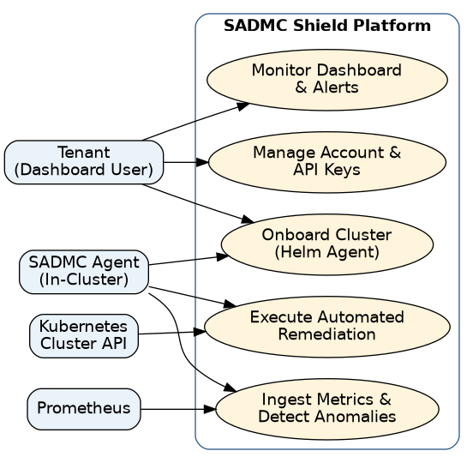
Figure 1: Use case diagram — Level 0: System overview
At the highest level, the Tenant manages their account and API Keys, onboards clusters, and monitors the dashboard, while the SADMC Agent — acting on behalf of the cluster — drives onboarding, metrics ingestion, and remediation. Prometheus supplies raw metrics and the Kubernetes API executes remediation actions.

Level 1 — Full System (Actor-Based)
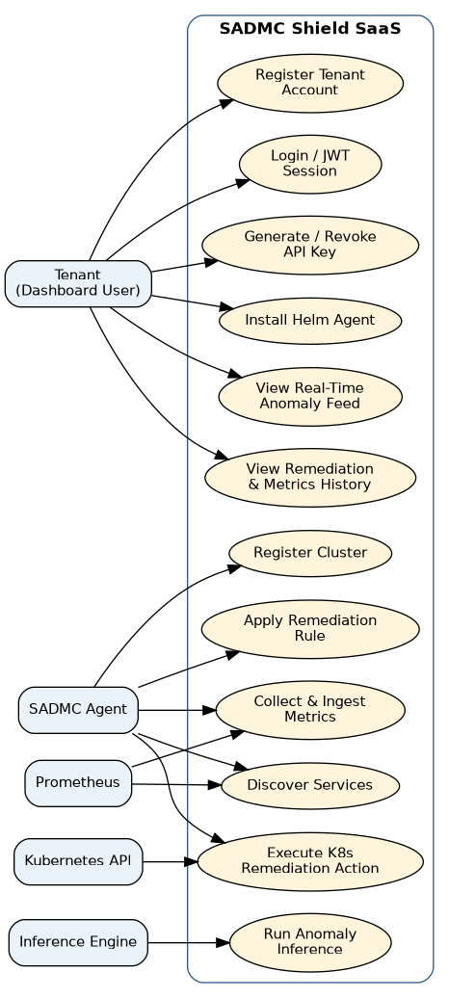
Figure 2: Use case diagram — Level 1: Full system, actor-based
The Level 1 diagram expands each Level 0 bubble into the concrete use cases each actor drives: the Tenant registers, logs in, manages API Keys, installs the agent, and watches the live feed and history; the Agent registers the cluster, discovers services, collects and ingests metrics, and applies and executes remediation; Prometheus feeds discovery and metrics collection; and the Inference Engine runs anomaly classification.

Level 1.1 — Authentication & Tenant Onboarding
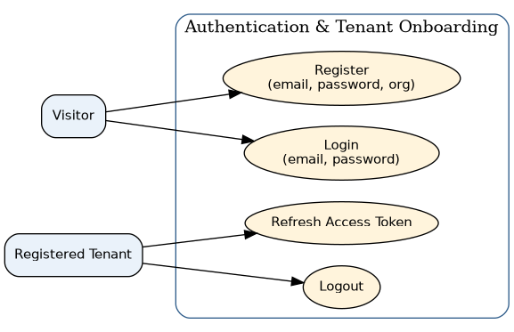
Figure 3: Use case diagram — Level 1.1: Authentication & Tenant Onboarding
Use Case Name: Authentication & Tenant Onboarding
Primary Actors: Visitor, Registered Tenant
Secondary Actors: —
Action – Reply
- Action: Visitor submits an organisation name, email, and password on the registration page.
- Reply: System validates the email format and uniqueness, hashes the password with bcrypt, and creates the tenant account.
- Action: Registered Tenant submits email and password on the login page.
- Reply: System verifies the credentials and issues an access token (15 min) and a refresh token (7 days).
- Action: Tenant’s access token expires while the session is active.
- Reply: System exchanges the refresh token for a new access token without requiring re-login.
- Action: Tenant logs out.
- Reply: System invalidates the stored refresh token.

Level 1.2 — API Key Management
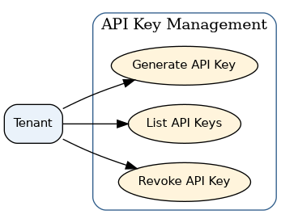
Figure 4: Use case diagram — Level 1.2: API Key Management
Use Case Name: API Key Management
Primary Actors: Tenant
Secondary Actors: —
Action – Reply
- Action: Tenant requests a new API Key.
- Reply: System generates a random 32-byte token, stores only its bcrypt hash, and displays the plaintext key once.
- Action: Tenant views their list of API Keys.
- Reply: System returns each key’s prefix, label, active status, and last-used timestamp — never the plaintext value.
- Action: Tenant revokes a key.
- Reply: System marks the key inactive; any agent still using it is rejected on its next request.

Level 1.3 — Cluster & Agent Onboarding
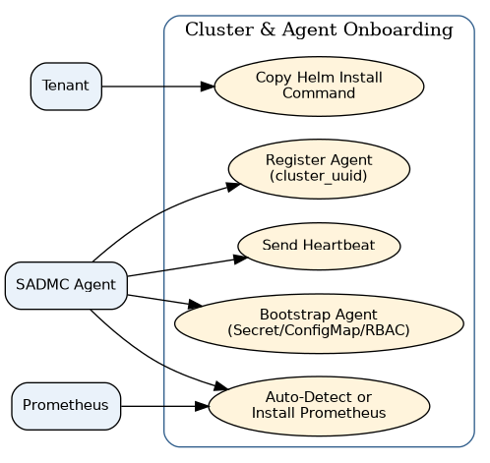
Figure 5: Use case diagram — Level 1.3: Cluster & Agent Onboarding
Use Case Name: Cluster & Agent Onboarding
Primary Actors: Tenant, SADMC Agent
Secondary Actors: Prometheus
Action – Reply
- Action: Tenant copies the pre-filled helm install command from the dashboard.
- Reply: System has embedded the tenant’s API Key and SaaS endpoint into the displayed command.
- Action: Helm install runs against the tenant’s cluster.
- Reply: Kubernetes creates the Secret, ConfigMap, RBAC resources, and agent Deployment; a bundled Prometheus is also created if required.
- Action: Agent pod starts and checks its configured Prometheus mode.
- Reply: Agent auto-detects an existing Prometheus service, uses the configured URL, or falls back to the bundled instance.
- Action: Agent calls the registration endpoint with its API Key.
- Reply: System validates the key, looks up the tenant, and returns a cluster_uuid for all future calls.
- Action: Agent sends a periodic heartbeat.
- Reply: System updates the cluster’s last_heartbeat and marks it active.

Level 1.4 — Metrics Ingestion & Anomaly Inference
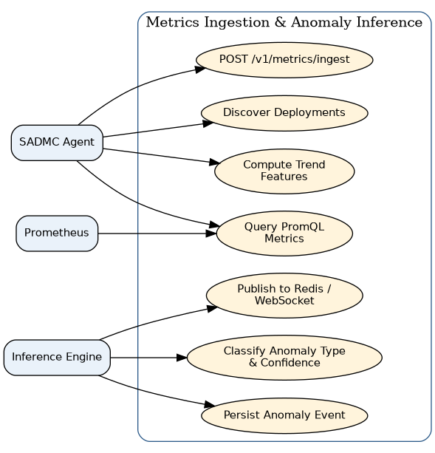
Figure 6: Use case diagram — Level 1.4: Metrics Ingestion & Anomaly Inference
Use Case Name: Metrics Ingestion & Anomaly Inference
Primary Actors: SADMC Agent, Inference Engine
Secondary Actors: Prometheus
Action – Reply
- Action: Agent lists all Deployments across non-excluded namespaces (every 15 seconds).
- Reply: System (agent-side) builds the current service list with names, namespaces, and replica counts.
- Action: Agent queries Prometheus for CPU, memory, latency, request rate, and error rate per service.
- Reply: Prometheus returns the current metric values; the agent derives cpu_trend and memory_trend from its rolling window.
- Action: Agent posts the metrics batch to /v1/metrics/ingest with its API Key.
- Reply: System validates the payload, runs the SADMC model against each service’s feature vector, and returns the anomaly type and confidence per service.
- Action: A returned result is classified as an anomaly.
- Reply: System persists an anomaly_events row and publishes it to the tenant’s Redis channel for the dashboard.

Level 1.5 — Automated Remediation
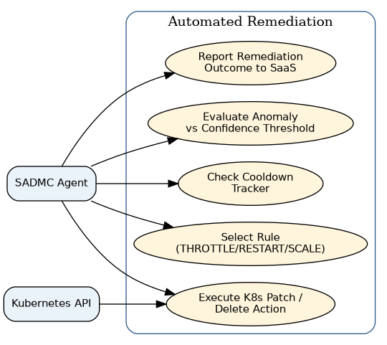
Figure 7: Use case diagram — Level 1.5: Automated Remediation
Use Case Name: Automated Remediation
Primary Actors: SADMC Agent
Secondary Actors: Kubernetes API
Action – Reply
- Action: Agent receives an anomaly result with confidence ≥ 0.85.
- Reply: Agent checks the cooldown tracker for that service and action.
- Action: Cooldown is clear for the service/action pair.
- Reply: Agent selects the rule for the anomaly type (THROTTLE_CPU, RESTART_POD, or SCALE_UP).
- Action: Agent executes the selected action.
- Reply: Kubernetes API patches the Deployment’s CPU limit, deletes its pods, or increases its replica count, as applicable.
- Action: Remediation action completes (or fails).
- Reply: Agent reports the action, its status, and duration back to the SaaS for dashboard logging.

Level 1.6 — Dashboard & Real-Time Monitoring
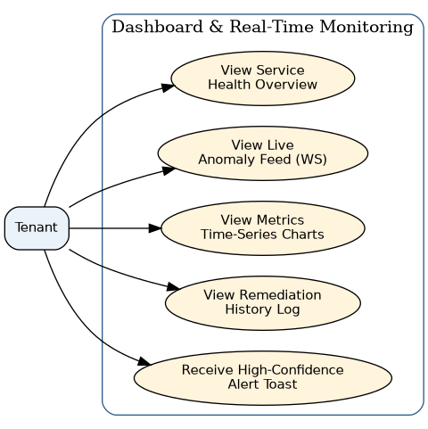
Figure 8: Use case diagram — Level 1.6: Dashboard & Real-Time Monitoring
Use Case Name: Dashboard & Real-Time Monitoring
Primary Actors: Tenant
Secondary Actors: —
Action – Reply
- Action: Tenant opens the dashboard and the browser connects to the events WebSocket.
- Reply: System pushes ANOMALY_DETECTED and REMEDIATION_EXECUTED frames as they occur, with no page refresh required.
- Action: Tenant views the service health overview.
- Reply: System shows each discovered service and its current status badge.
- Action: Tenant opens the metrics page for a service.
- Reply: System returns a time-series query (start, end, service_name) rendered as Recharts line charts.
- Action: Tenant opens the remediation log.
- Reply: System lists past remediation actions with service, action type, status, and duration.
- Action: An anomaly is detected with confidence above 0.9.
- Reply: System shows a toast notification naming the service and anomaly type, in addition to the feed entry.

3.2 Activity Diagram
Activity diagrams describe the dynamic behaviour of each module as a flow of actions and decisions — from an initial state to a final state. The following five diagrams cover the platform’s core modules; decision points are shown as diamonds and the paths are labelled with their conditions.

3.2.1 Tenant Registration & API Key Generation
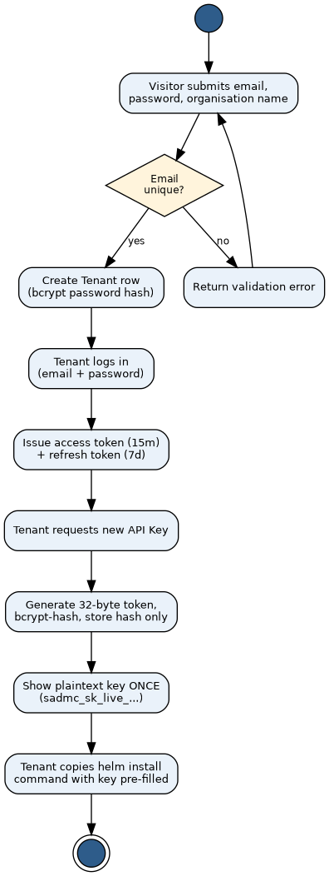
Figure 9: Activity diagram — Tenant Registration & API Key Generation
The flow validates that the submitted email is unique before creating the tenant record; an invalid submission returns to the registration form. Once logged in, generating an API Key produces a bcrypt-hashed token shown to the tenant exactly once, after which the tenant copies the pre-filled Helm install command.

3.2.2 Agent Bootstrap
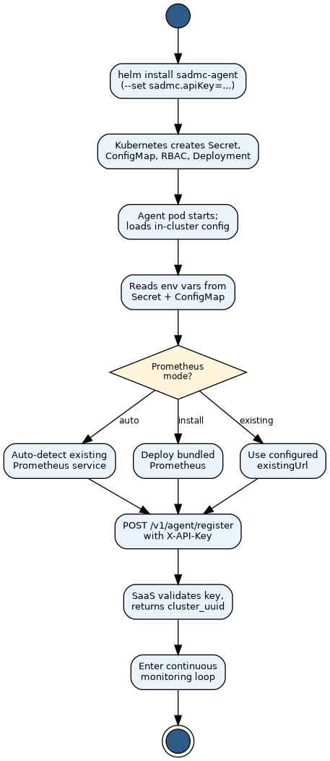
Figure 10: Activity diagram — Agent Bootstrap
Running the Helm install creates the Kubernetes resources and starts the agent pod, which reads its configuration from the injected Secret and ConfigMap. The flow then branches on the configured Prometheus mode — auto-detect, install a bundled instance, or use an existing URL — before all three paths converge on registering with the SaaS and entering the monitoring loop.

3.2.3 Continuous Monitoring Loop
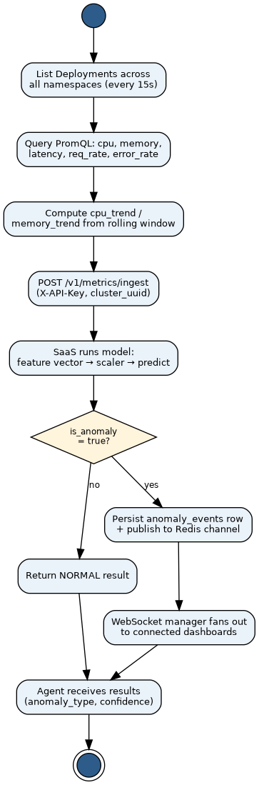
Figure 11: Activity diagram — Continuous Monitoring Loop
Every 15 seconds the agent discovers deployments, queries Prometheus, and computes trend features before sending the batch to the ingest endpoint. The platform runs inference and branches on whether the result is anomalous: a NORMAL result is simply returned, while an anomalous result is additionally persisted and published to connected dashboards over WebSocket.

3.2.4 Automated Remediation
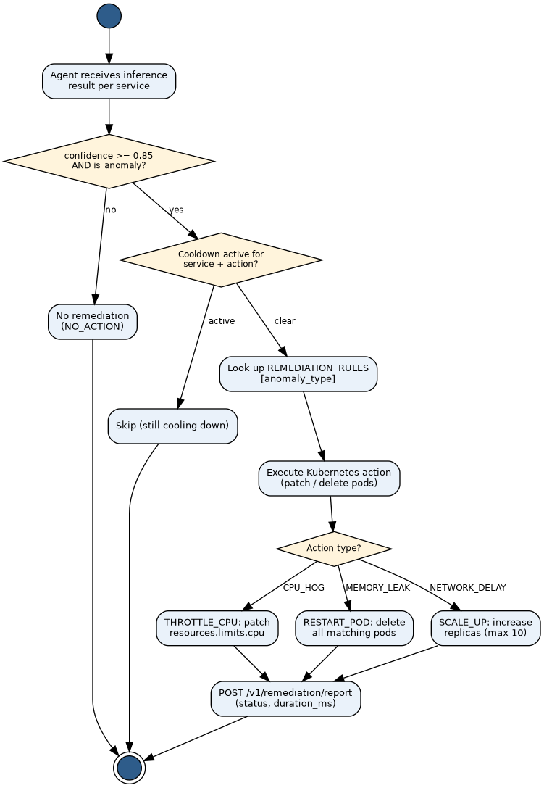
Figure 12: Activity diagram — Automated Remediation
The agent first checks the confidence threshold, then the cooldown tracker, before consulting the static rule table and branching on the anomaly type to throttle CPU, restart pods, or scale up replicas. Every executed action — and every skip — is reported back to the SaaS.

3.2.5 Dashboard Real-Time Update & Alerting
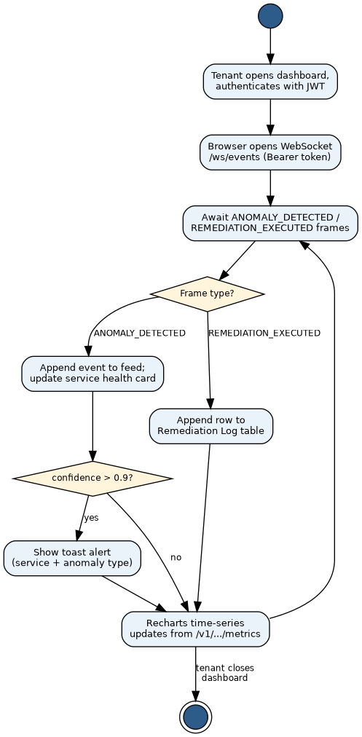
Figure 13: Activity diagram — Dashboard Real-Time Update & Alerting
Once the tenant’s browser opens the authenticated WebSocket, the flow loops on incoming frames, branching on whether the frame is a new anomaly or a remediation outcome, and further branching high-confidence anomalies into a toast alert before every path updates the relevant charts and tables.

4. Data & Information Modeling
SADMC Shield combines a traditional relational data model (for tenants, clusters, events, and metrics) with an AI-based classification component (for anomaly detection). Data-based modeling identifies the information the platform must store and manage, independent of how the software is built. Following the Pressman / Coad-Yourdon analysis method, we begin by listing every noun that appears in the requirement statements and usage scenarios, separate the nouns that belong to the problem space from those that belong only to the solution space, distil the problem-space nouns into a set of data objects, describe the relationships between those objects, capture them in an Entity-Relationship (ER) diagram, and finally give the concrete schema of each object. The AI-based anomaly classifier is then described separately via a dataset description.

4.1 ER Diagram / Database Schema

4.1.1 Noun Listing
Every noun drawn from the requirements is listed below and marked in the Problem / Solution Space column: P (Problem Space) — a concept essential to the application domain; it becomes a data object or an attribute of one. S (Solution Space) — a concept tied to a specific interface, action, external system, or file format; it does not, by itself, become stored data.
SL | Noun | Attributes | P / S
1 | Access |  | S
2 | Account (Tenant) |  | P
3 | Agent |  | S
4 | Alert |  | S
5 | Anomaly |  | S
6 | Anomaly event | cluster, service, type, confidence, snapshot, timestamp | P
7 | Anomaly type |  | P
8 | API |  | S
9 | API Key | hash, prefix, name, active flag, last used | P
10 | Authentication |  | S
11 | Cluster | uuid, k8s version, node count, agent version, status | P
12 | Confidence |  | P
13 | ConfigMap |  | S
14 | Cooldown |  | P
15 | CPU usage |  | P
16 | Credentials |  | S
17 | Dashboard |  | S
18 | Deployment (Kubernetes) |  | S
19 | Duration |  | P
20 | Email |  | P
21 | Error rate |  | P
22 | Feature vector |  | S
23 | Heartbeat |  | P
24 | Helm Chart |  | S
25 | Inference |  | S
26 | JWT / Access token |  | S
27 | Latency |  | P
28 | Memory usage |  | P
29 | Metric (time-series reading) | cpu, memory, latency, request rate, error rate, timestamp | P
30 | Namespace |  | P
31 | Organisation name |  | P
32 | Password |  | P
33 | Prometheus |  | S
34 | PromQL |  | S
35 | Refresh token |  | P
36 | Remediation action | action type, params, status, duration, error | P
37 | Report (analytics) | computed on demand — not stored | P (derived)
38 | Request rate |  | P
39 | RBAC / ServiceAccount |  | S
40 | Rule (remediation rule) |  | S
41 | Secret (Kubernetes) |  | S
42 | Service | name, namespace, last seen | P
43 | Session |  | S
44 | Status |  | P
45 | Subscription plan |  | P
46 | Tenant | organisation name, email, password hash, plan | P
47 | TimescaleDB |  | S
48 | Timestamp |  | P
49 | Token (API Key) |  | P
50 | WebSocket |  | S
51 | YAML (values.yaml) |  | S

4.1.2 Probable Data Objects
Consolidating the problem-space nouns — merging synonyms (account → tenant, run → anomaly event) and promoting the recurring, data-bearing concepts to objects — yields the following data objects, matching the platform’s PostgreSQL/TimescaleDB schema.
SL | Data Object | Attributes
1 | Tenant | id, organization_name, email, password_hash, subscription_plan, created_at
2 | ApiKey | id, tenant_id, key_hash, key_prefix, name, is_active, created_at, last_used_at
3 | Cluster | id, tenant_id, cluster_uuid, k8s_version, node_count, agent_version, status, last_heartbeat, created_at
4 | Service | id, cluster_id, service_name, namespace, last_seen
5 | AnomalyEvent | id, cluster_id, service_id, service_name, namespace, anomaly_type, confidence, metrics_snapshot, timestamp
6 | RemediationAction | id, anomaly_event_id, cluster_id, service_name, namespace, action_type, action_params, status, executed_at, duration_ms, error_message
7 | Metric | time, cluster_id, service_name, namespace, cpu_usage_percent, memory_usage_mb, network_latency_ms, request_rate, error_rate
Derived object — Report. The analytics report noun does not become a stored object: a report (HTTP-response-code-style anomaly distribution, service coverage, remediation success rate) is computed on demand from a Cluster together with its AnomalyEvent and RemediationAction rows. It is therefore a derived data object rather than a persistent one.

4.1.3 Relationship Between Data Objects
Parent Object | Relationship | Child Object | Cardinality
Tenant | owns | ApiKey | 1 : N
Tenant | owns | Cluster | 1 : N
Cluster | contains | Service | 1 : N
Cluster | produces | AnomalyEvent | 1 : N
Service | is subject of | AnomalyEvent | 1 : N
AnomalyEvent | triggers | RemediationAction | 1 : N
Cluster | captures | Metric | 1 : N
Every Cluster belongs to exactly one Tenant, and PostgreSQL Row-Level Security enforces this isolation at the database level so a tenant’s clusters, services, anomalies, and metrics are never visible across tenant boundaries.

4.1.4 ER Diagram
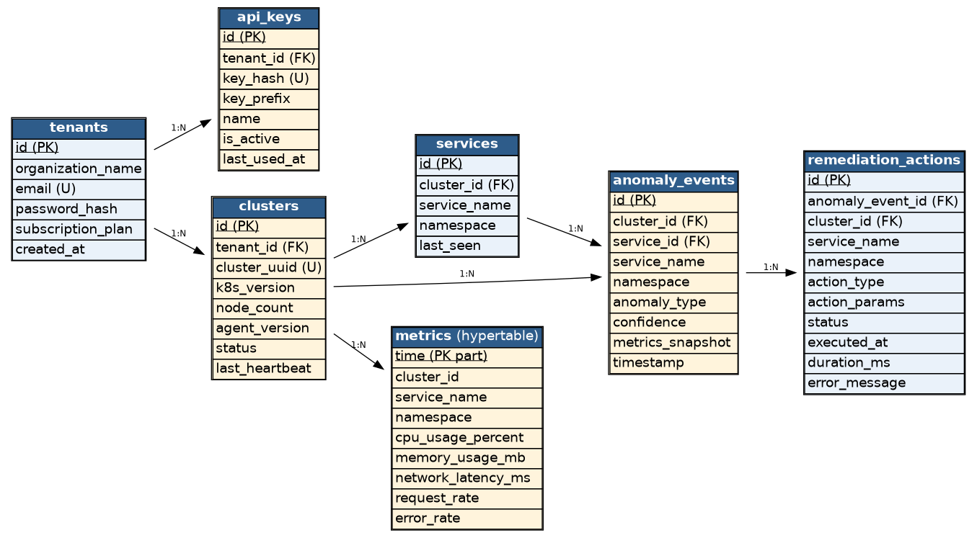
Figure 14: Entity-Relationship diagram
The diagram models the seven persistent entities as tables, their primary and foreign keys underlined or marked, and the 1:N cardinalities shown on the connecting edges. The metrics table is a TimescaleDB hypertable partitioned on time and subject to a 90-day retention policy.

4.1.5 Schema
The concrete schema of each data object, with data types. PK = primary key, FK = foreign key, U = unique. All identifiers are UUID unless noted.
Tenant
Attribute | Data type | Key / Notes
id | UUID | PK, default gen_random_uuid()
organization_name | VARCHAR(255)
email | VARCHAR(255) | U
password_hash | VARCHAR(255) | bcrypt hash
subscription_plan | VARCHAR(50) | default 'free'
created_at | TIMESTAMPTZ | default NOW()

ApiKey
table name: api_keys
Attribute | Data type | Key / Notes
id | UUID | PK
tenant_id | UUID | FK → Tenant, ON DELETE CASCADE
key_hash | VARCHAR(255) | U, bcrypt hash
key_prefix | VARCHAR(40) | first 20 chars, for display
name | VARCHAR(100) | nullable, user-defined label
is_active | BOOLEAN | default TRUE
created_at | TIMESTAMPTZ | default NOW()
last_used_at | TIMESTAMPTZ | nullable

Cluster
table name: clusters
Attribute | Data type | Key / Notes
id | UUID | PK
tenant_id | UUID | FK → Tenant, ON DELETE CASCADE
cluster_uuid | VARCHAR(100) | U — assigned on registration
k8s_version | VARCHAR(20) | nullable
node_count | INTEGER | nullable
agent_version | VARCHAR(20) | nullable
status | VARCHAR(20) | default 'active'
last_heartbeat | TIMESTAMPTZ | nullable
created_at | TIMESTAMPTZ | default NOW()

Service
table name: services
Attribute | Data type | Key / Notes
id | UUID | PK
cluster_id | UUID | FK → Cluster, ON DELETE CASCADE
service_name | VARCHAR(255)
namespace | VARCHAR(255)
last_seen | TIMESTAMPTZ | default NOW()
(cluster_id, service_name, namespace) |  | U (composite)

AnomalyEvent
table name: anomaly_events
Attribute | Data type | Key / Notes
id | UUID | PK
cluster_id | UUID | FK → Cluster, ON DELETE CASCADE
service_id | UUID | FK → Service, nullable
service_name | VARCHAR(255)
namespace | VARCHAR(255)
anomaly_type | VARCHAR(50) | NORMAL | CPU_HOG | MEMORY_LEAK | NETWORK_DELAY
confidence | FLOAT
metrics_snapshot | JSONB | raw metric values at detection time
timestamp | TIMESTAMPTZ | default NOW(); indexed with cluster_id, service_name

RemediationAction
table name: remediation_actions
Attribute | Data type | Key / Notes
id | UUID | PK
anomaly_event_id | UUID | FK → AnomalyEvent
cluster_id | UUID | FK → Cluster
service_name | VARCHAR(255)
namespace | VARCHAR(255)
action_type | VARCHAR(50) | THROTTLE_CPU | RESTART_POD | SCALE_UP
action_params | JSONB | e.g. cpu limit, replica increase
status | VARCHAR(20) | default 'pending' — pending/success/failed/skipped
executed_at | TIMESTAMPTZ | nullable
duration_ms | INTEGER | nullable
error_message | TEXT | nullable

Metric
table name: metrics — TimescaleDB hypertable, partitioned on time; 90-day retention policy
Attribute | Data type | Key / Notes
time | TIMESTAMPTZ | hypertable partition key (not null)
cluster_id | UUID | not null
service_name | VARCHAR(255) | not null
namespace | VARCHAR(255) | not null
cpu_usage_percent | FLOAT
memory_usage_mb | FLOAT
network_latency_ms | FLOAT
request_rate | FLOAT
error_rate | FLOAT

4.2 Dataset Description (AI-Based Component)
In addition to the relational schema above, the anomaly classifier is trained offline, outside the request path, and the resulting artefact (sadmc_model_v1.pkl) together with a fitted MinMax scaler is loaded by the SaaS backend at startup.
Attribute | Description
Feature vector (7 dims) | cpu_usage_percent, memory_usage_mb, network_latency_ms, request_rate, error_rate, cpu_trend, memory_trend.
Derived features | cpu_trend and memory_trend are computed by the agent from a rolling 10-reading window (current value minus value 10 readings ago), capturing gradual resource-exhaustion patterns a single reading cannot.
Target classes (4) | NORMAL, CPU_HOG, MEMORY_LEAK, NETWORK_DELAY.
Data sources | Labelled examples generated by running the Sock-Shop microservices benchmark under controlled load, combined with synthetic fault injection (CPU stress, memory-leak simulation, artificial network latency) to produce balanced examples of each anomaly class.
Preprocessing | All 7 features are scaled with a MinMax scaler fitted on the training set; the same fitted scaler is reused at inference time to keep training/serving distributions consistent.
Labelling method | Anomaly labels are assigned based on the known fault-injection ground truth (which stressor was active at each timestamp), not human annotation.
Class balance | Fault-injection duration is tuned to keep the three anomaly classes roughly balanced against a larger pool of NORMAL readings, avoiding a classifier that trivially always predicts NORMAL.
Note: as a midterm-stage report, the exact training-set size and train/validation/test split will be finalised and reported with measured accuracy, precision, and recall per class in the final report, once the fault-injection data collection pass is complete.

5. Software Design

5.1 Component Diagram
The system is organised into three deployable components — the in-cluster Agent, the SaaS Backend (control plane), and the React Dashboard — plus four external systems they depend on.
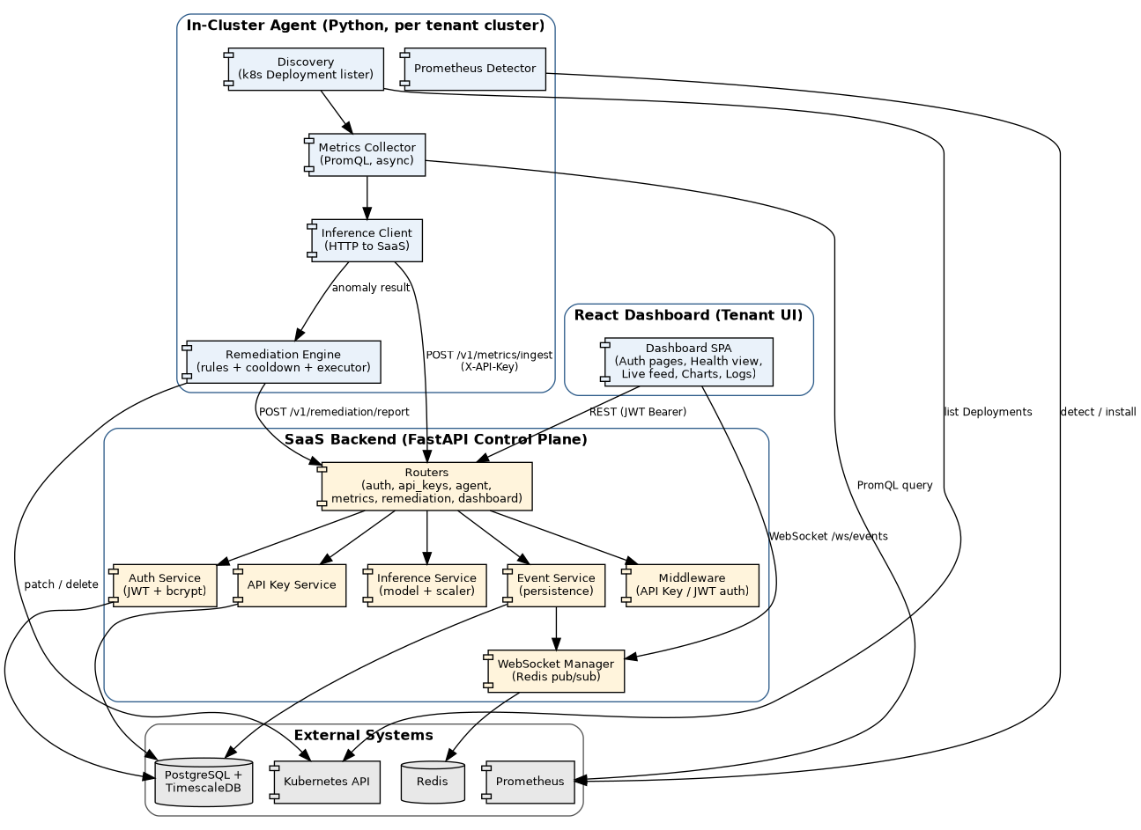
Figure 6: Component diagram
- In-Cluster Agent — Discovers Deployments via the Kubernetes API, queries Prometheus for metrics, sends batches to the SaaS, and independently executes remediation actions through the Kubernetes API using a static rule table.
- SaaS Backend — Exposes REST routers for auth, API Keys, agent registration, metrics ingestion, and remediation reporting; the Inference Service loads the trained model and scaler; the Event Service persists to PostgreSQL/TimescaleDB; the WebSocket Manager fans out events via Redis pub/sub.
- React Dashboard — Authenticates with JWT over REST for CRUD-style operations, and opens a WebSocket to the WebSocket Manager for the live anomaly feed and remediation log.

6. Software Architecture

6.1 Requirement Traceability Matrix
The matrix below traces each functional requirement (Section 2.1) to the use case that realises it, the design component responsible for it, and the preliminary test case that will verify it (Section 8).
FR ID | Use Case | Design Component | Test Case
FR-1 | Register Tenant Account | Auth Router + Auth Service | TC-01
FR-2 | Login / JWT Session | Auth Router + Auth Service | TC-02
FR-3 | Generate / Revoke API Key | API Keys Router + API Key Service | TC-03
FR-4 | Install Helm Agent | Helm Chart (templates, RBAC) | TC-04
FR-5 | Register Cluster | Agent Router + Agent (main.py) | TC-05
FR-6 | Discover Services | Agent — Discovery module | TC-06
FR-7 | Collect & Ingest Metrics | Agent — Metrics Collector | TC-07
FR-8 | Run Anomaly Inference | Inference Service (model + scaler) | TC-08
FR-9 | (persist anomaly event) | Event Service → PostgreSQL | TC-09
FR-10 | Apply Remediation Rule | Agent — Remediation Engine | TC-10
FR-11 | (report remediation outcome) | Remediation Router + Event Service | TC-11
FR-12 | View Real-Time Anomaly Feed | WebSocket Manager + Dashboard SPA | TC-12
FR-13 | View Remediation & Metrics History | Dashboard REST routes + Dashboard SPA | TC-13
FR-14 | (high-confidence toast alert) | Dashboard SPA (WebSocket handler) | TC-14

7. AI Engineering Design
SADMC Shield’s AI component is a classical supervised-learning classifier, not a generative or LLM-based system. It is applicable because anomaly detection is the project’s core value proposition.

7.1 AI Pipeline
Figure 7: AI inference pipeline
Raw metrics collected by the agent are enriched with two trend features derived from a rolling 10-reading window, then scaled with a fitted MinMax scaler, and passed through the trained classifier, which is loaded once at SaaS startup and kept in memory as a singleton for low-latency batch inference. The classifier returns both a predicted class and a confidence score (via predict_proba); only the agent — using the confidence score and a static rule table — decides whether and how to remediate, keeping the model’s role strictly limited to classification.

7.2 Model Selection
The feature space is small (7 numerical features) and the four target classes are separated by non-linear boundaries in metric-trend space (e.g. a slowly rising memory_trend vs. a sharp cpu_usage_percent spike), which ruled out purely linear approaches on their own.
Candidate | Considered | Verdict
Logistic Regression | Fast, interpretable baseline. | Rejected — underfits the non-linear class boundaries between anomaly types.
Random Forest Classifier | Ensemble of decision trees; handles non-linear boundaries and mixed feature scales well; exposes predict_proba for confidence scoring; robust to noisy metric readings; fast (sub-50ms) inference on small tabular inputs; trains well on modest dataset sizes without heavy tuning. | Selected — best balance of accuracy, latency, interpretability, and low data requirements for this project’s scope and timeline.
Gradient Boosting (e.g. XGBoost) | Typically highest tabular accuracy. | Considered as a stretch goal for the final report if the Random Forest baseline under-performs; adds tuning complexity not justified for the midterm baseline.
Neural Network (MLP) | Can model complex boundaries. | Rejected for this stage — needs more training data than is available from fault-injection runs to avoid overfitting, and offers no clear latency or accuracy advantage here.
The Random Forest classifier is therefore the baseline model for the midterm deliverable. Its feature-importance output will also be used during the final report to sanity-check that cpu_trend and memory_trend meaningfully contribute to distinguishing CPU_HOG and MEMORY_LEAK from transient noise.

7.3 Prompt Design
Not applicable to the current scope. SADMC Shield’s AI component is a supervised tabular classifier, not a prompt-driven or generative model, so there is no prompt template to design for the core detection pipeline. A future extension — out of scope for this project (Section 1.4) — could add an LLM-based module that takes a detected anomaly plus its metrics snapshot and generates a natural-language root-cause summary for the dashboard; if pursued, that module would require its own prompt design (e.g. a fixed system prompt constraining the model to cite only the provided metrics, with the anomaly type, confidence, and metrics_snapshot JSON injected as structured context) and would be evaluated separately from the classification model discussed above.

8. Preliminary Test Plan

8.1 Testing Objectives
- Verify that each functional requirement in Section 2.1 behaves as specified, using the acceptance criteria defined per implementation phase (Section 9).
- Verify that the anomaly classifier returns the correct anomaly_type for known, labelled input feature vectors before it is exposed via the API.
- Verify that multi-tenant data isolation holds — no tenant can read another tenant’s clusters, metrics, or anomaly events.
- Verify that the end-to-end detect-then-remediate loop completes within the target latency budget on a live cluster.
- Verify that the Helm chart installs cleanly both on a cluster with no existing Prometheus and on one with an existing Prometheus instance.

8.2 Features to be Tested
Test Case | Feature | Test Type | Priority
TC-01 | Tenant registration (email uniqueness, password hashing) | Unit + API | High
TC-02 | Login and JWT access/refresh token issuance | Unit + API | High
TC-03 | API Key generation, listing, and revocation | Unit + API | High
TC-04 | Helm install on a clean cluster and on a cluster with existing Prometheus | Integration (minikube) | High
TC-05 | Agent registration exchanging API Key for cluster_uuid | Integration | High
TC-06 | Service discovery across multiple namespaces | Integration (Sock-Shop) | Medium
TC-07 | Metrics collection and ingest payload correctness | Integration | High
TC-08 | Model inference returns correct anomaly_type for known vectors | Unit (Postman / pytest) | High
TC-09 | Anomaly event persistence and Redis publish | Integration | Medium
TC-10 | Rule-based remediation selection and cooldown enforcement | Integration (fault injection) | High
TC-11 | Remediation outcome reporting back to SaaS | Integration | Medium
TC-12 | Live WebSocket anomaly feed latency (< 5s) | End-to-end | High
TC-13 | Metrics charts and remediation history rendering | UI / manual | Medium
TC-14 | High-confidence toast alert triggering | UI / manual | Low
TC-15 | Row-Level Security — cross-tenant data isolation | Security | High

9. Timeline

Gantt Chart
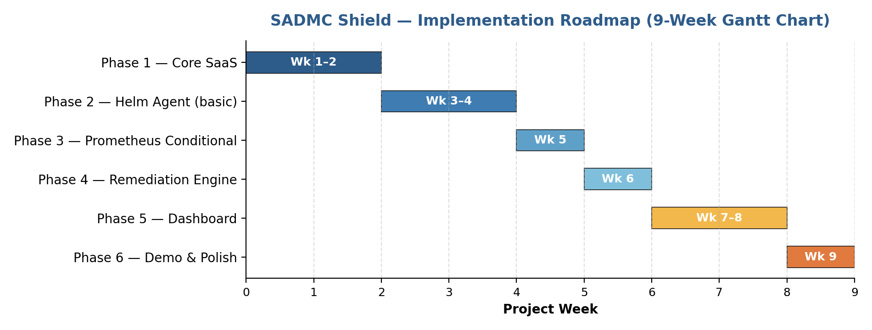
Figure 8: 9-week implementation roadmap
Phase | Weeks | Deliverables | Acceptance Criteria
Phase 1 — Core SaaS | 1–2 | Registration/login, JWT auth+refresh, API Key generation, PostgreSQL schema, model loaded as FastAPI endpoint, /v1/metrics/ingest working. | Postman: POST /v1/metrics/ingest returns correct anomaly_type for known input vectors.
Phase 2 — Helm Agent (basic) | 3–4 | Agent reads env vars; Kubernetes discovery; Prometheus metrics collection; sends to SaaS and receives results; Docker image published; Helm chart installs on minikube. | kubectl logs shows discovery + inference cycle every 15s on minikube with Sock-Shop.
Phase 3 — Prometheus Conditional | 5 | Auto-detection across namespaces; conditional Prometheus install; ServiceMonitor for pod scraping; existing-URL mode tested. | Helm install auto-installs Prometheus when absent AND skips install when one already exists.
Phase 4 — Remediation Engine | 6 | Rule table from ConfigMap; cooldown tracker; THROTTLE_CPU / RESTART_POD / SCALE_UP via k8s API; outcome reported to SaaS. | Inject CPU stress → CPU_HOG detected → CPU throttled within 60s → dashboard shows THROTTLE_CPU: success.
Phase 5 — Dashboard | 7–8 | React app with auth pages; service health overview; WebSocket anomaly feed; Recharts time-series graphs; remediation history table; API Key UI. | Browser shows an anomaly event within 5s of the agent reporting it; remediation log updates automatically.
Phase 6 — Demo & Polish | 9 | Helm repo on GitHub Pages; README with install steps; Sock-Shop demo with anomaly injection; presentation slides. | Full demo: fresh cluster → helm install → anomaly inject → dashboard shows detection + auto-remediation.

