**Location Privacy Lab Setup**

**Required Software (for MAC or WINDOWS):**

* XAMPP
* Android Studio
* Web Browser (Google Chrome recommended)

**Required Files**

* WebFiles.zip
* LocationPrivacy.zip

Unzip both the files and save the folders in an accessible location.

**Installing Software:**

1. **ZAMPP for WINDOWS**
   * In your web browser, go to <https://www.apachefriends.org/index.html>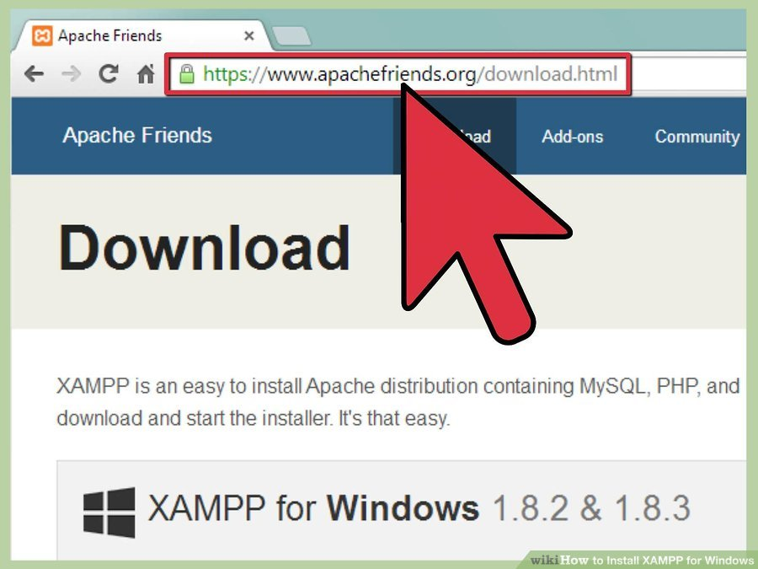
   * Click on the download link for XAMPP. 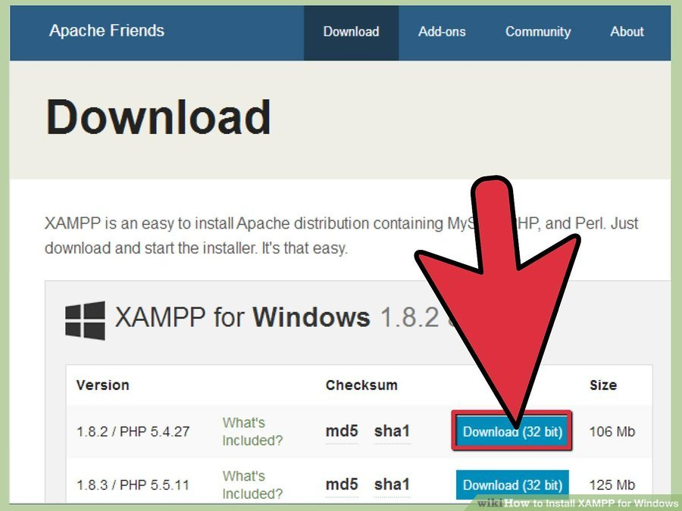
   * When prompted for the download, click "Save" and wait for your download to finish. 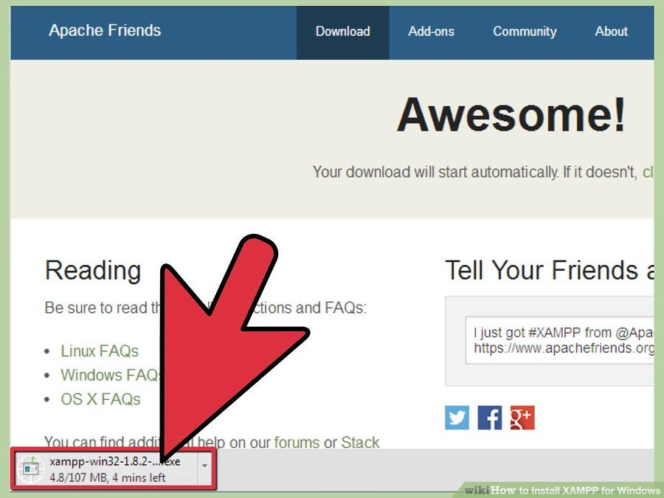
   * Open CD or DVD drive from My Computer. Install the program, and click on "Run." 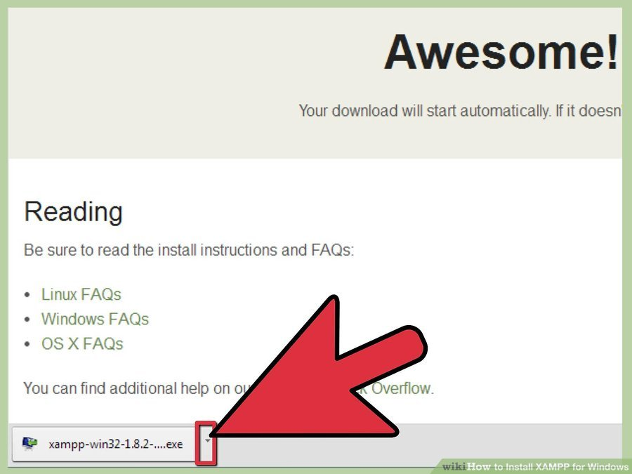
   * Accept the default settings. A command will open and offer an initial installation prompt. Just hit the Enter key, and accept the default settings. To simplify installation, just hit ENTER when prompted on the command line. You can always change settings, by editing the configuration files later. 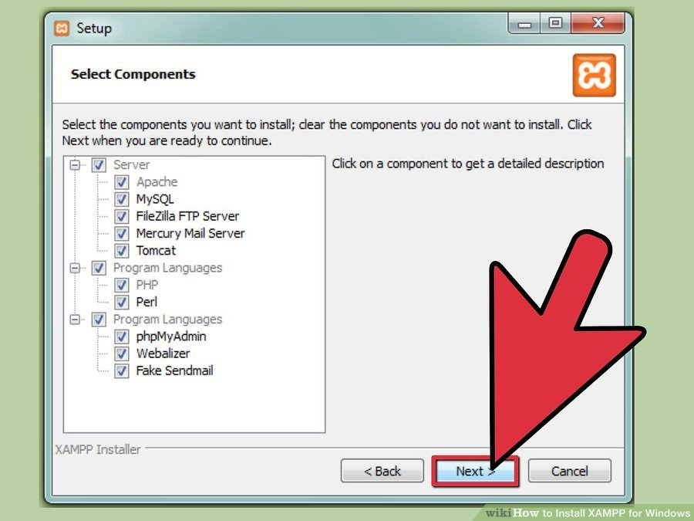
   * When your installation is complete, exit the command window by typing x on the command line. 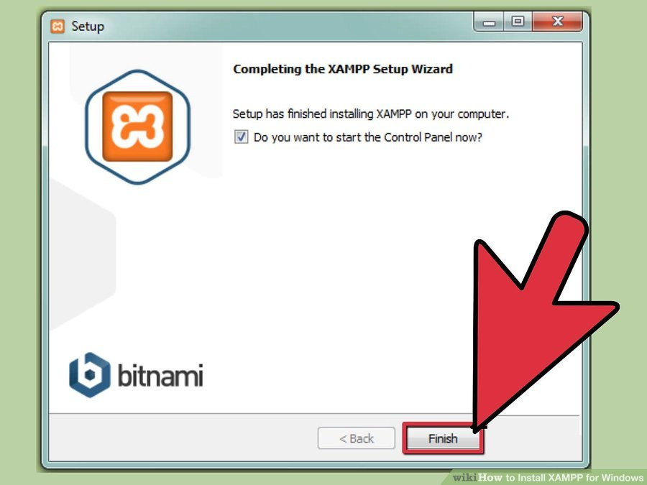
   * Start the XAMPP Control Panel. 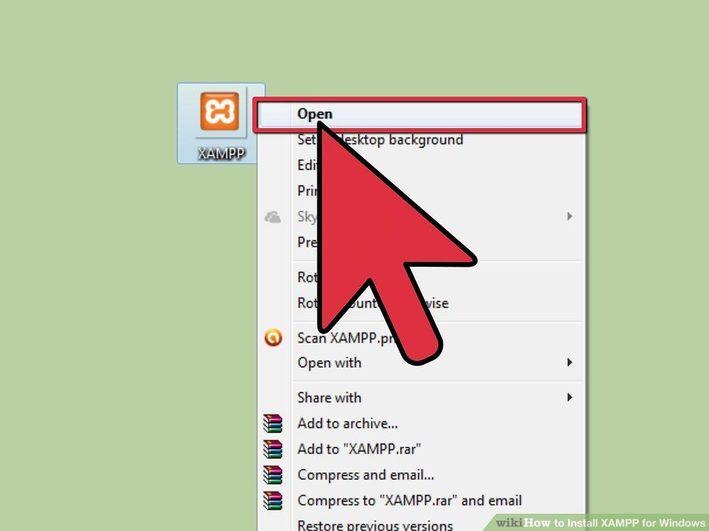
   * Start the Apache and MySQL components. You can also start the other components, if you plan to use them. 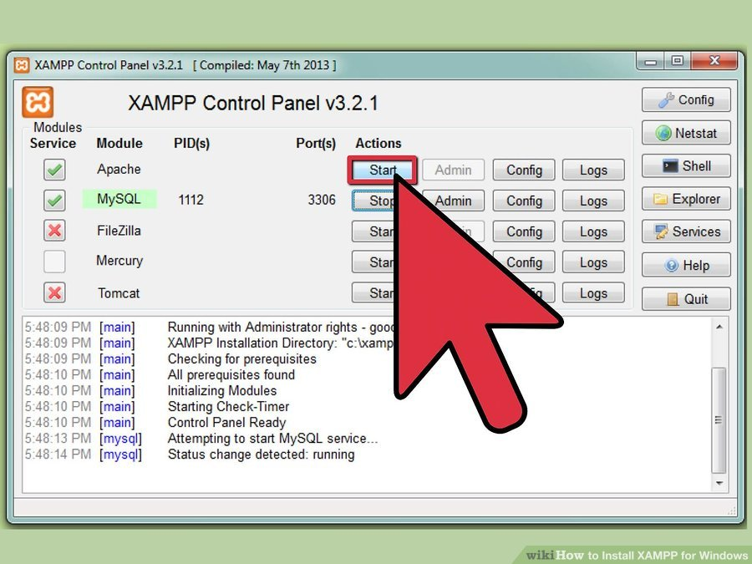
2. **XAMPP for MAC**
   * In your web browser, go to <https://www.apachefriends.org/index.html>
   * Open the downloaded file (the DMG-Image).
   * Drag and drop the XAMPP folder into your Applications folder. 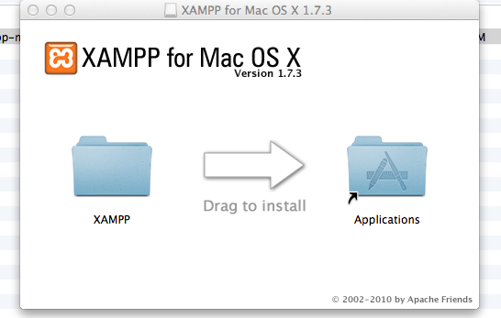
   * To start XAMPP simply open XAMPP Control (by going to /Applications/XAMPP/XAMPP Control in Finder) and start Apache and MySQL. 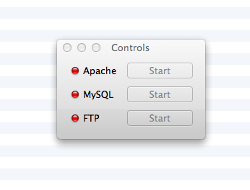

Testing your XAMPP installation

In your web browser, go to http://localhost. You should see the start page of XAMPP:

1. **Android Studio (mostly common for both Windows and MAC)**
   * In your web browser, go to <https://developer.android.com/studio/index.html>
   * Click on Download Android Studio.
   * Launch the downloaded installer. You will see the Android Studio Setup dialog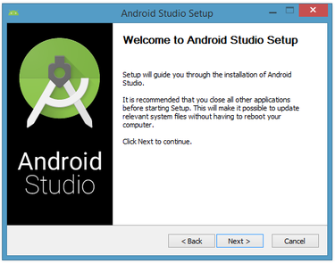
   * Click Next, that takes you to next dialog box where you can choose components to install. Keep defaults and click next. 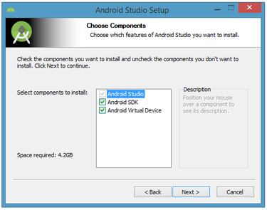
   * Now you will see the License Agreement, after reading that click on I Agree. 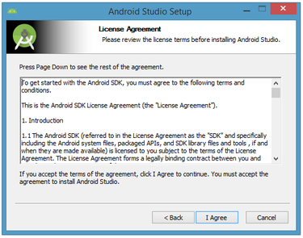
   * Next dialog box allows you to change the installation folder. Keep the defaults and click next.

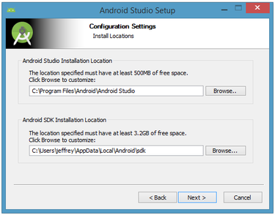

* + The following dialog ask you to create the shortcuts. The installer defaults to create the shortcuts. If you don’t want to create the shortcuts you can check the Do not create shortcuts box at the bottom and click next. 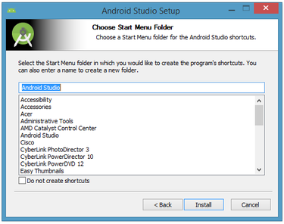
  + The resulting dialog box shows the progress of installing Android Studio and the Android SDK. Clicking the Show Details button will let you view detailed information about the installation progress.
  + The dialog box will inform you when installation has finished. When you click Next, you should see the following: 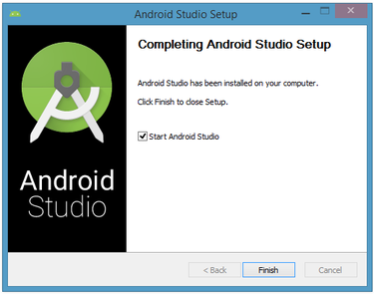
  + To complete your installation, leave the Start Android Studio box checked and click Finish.
  + Android Studio presents a splash screen when it starts running: 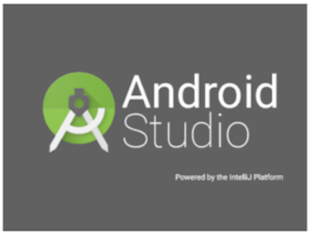
  + On your first run, you'll be asked to respond to several configuration-oriented dialog boxes. The first dialog box focuses on importing settings from any previously installed version of Android Studio. 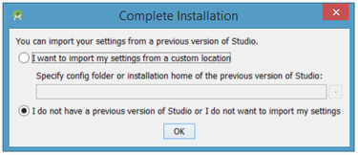
  + Click on the first option which was I want to import my settings from a custom location and browse to the config file provided in the zip file then click OK.
  + Android Studio will respond with a slightly enhanced version of the splash screen, followed by the Android Studio Setup Wizard dialog box: 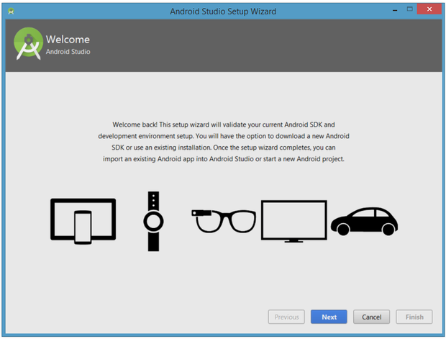
  + When you click Next, the setup wizard invites you to select an installation type for your SDK components. For now, I recommend you keep the default standard setting.

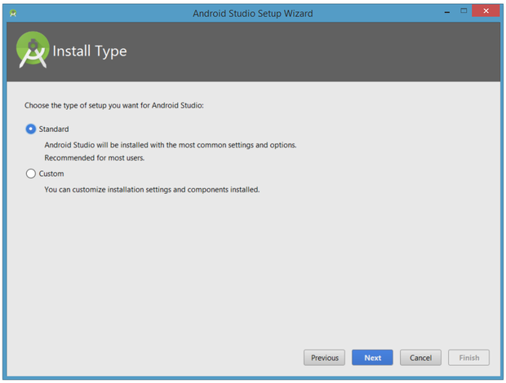

* + Click Next and verify your settings, then click Finish to continue. 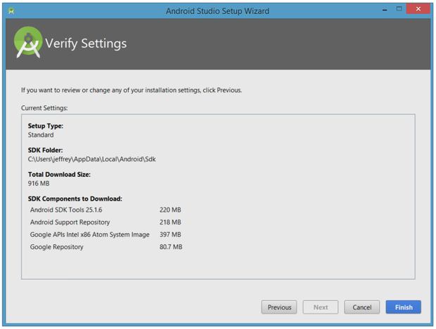
  + The wizard will download and unzip various components. Click Show Details if you want to see more information about the archives being downloaded and their contents.

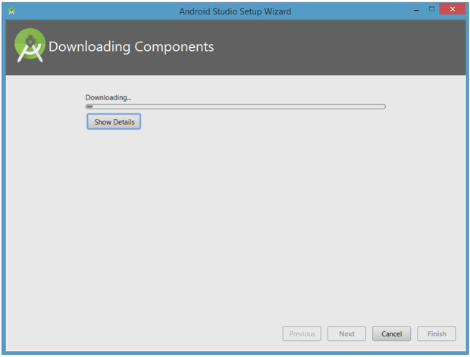

* + Finally, click Finish to complete the wizard. You should see the Welcome to Android Studio dialog box.

**Setting up the project**

1. **Android Client**
   * Once you finish the installation and can see the Welcome to Android Studio dialog box, click on the Open an existing Android Studio Project.
   * This is will ask you to browse to the existing project. Go the Location Privacy folder provided by us and select LocationPrivacy then click Next.
   * This will import the project and opens in the Android Studio.
2. **Run the Android Client**
   * Create AVD
     + AVD is an Android Virtual Device which will allow you to run the mobile applications developed in Android Studio.
     + Click on the Run app option in Run menu.
     + This will gives the Select Deployment Target dialog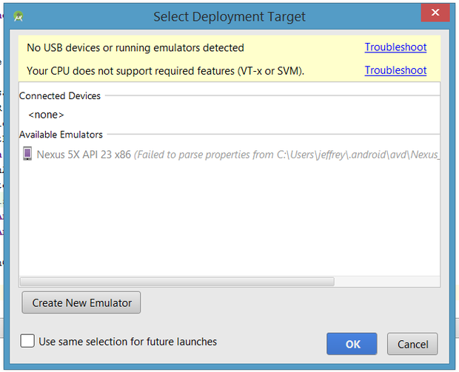
     + Click on Create New Emulator, if it is your first run. Now Android Studio responds with the Virtual Device Configuration dialog box showing a variety of emulators. Select Nexus 5 and click next.
     + Now, the dialog displays the list of operating system images available. 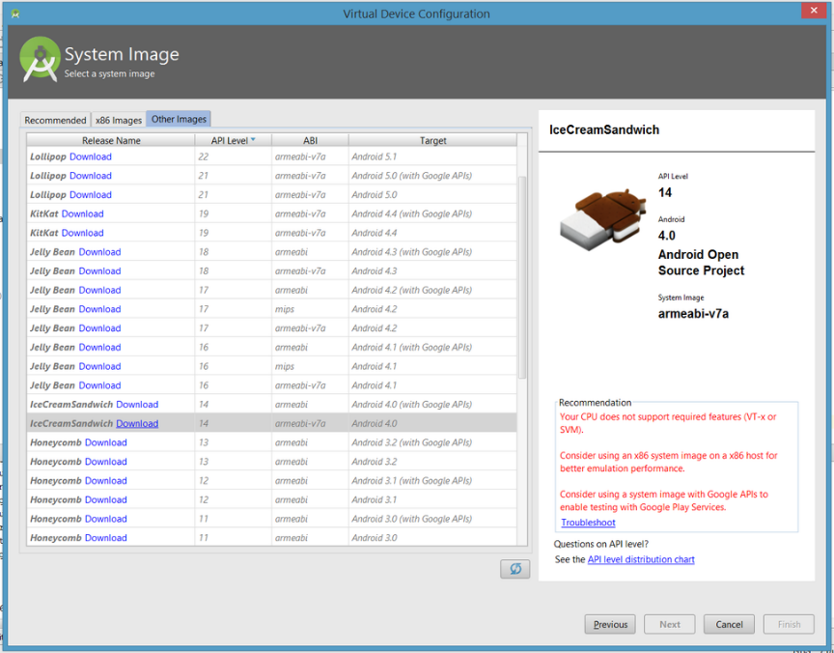
     + Once you've got your own emulator set up, you'll need to click the Download link to download the image, which isn't installed by default. After accepting the license agreement, click Next. The component installer starts downloading the components. 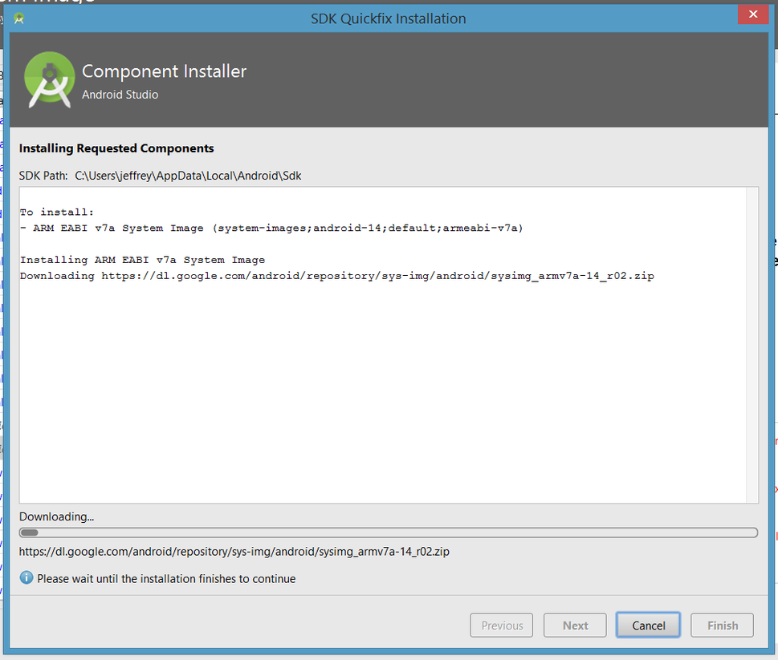
     + Select Lollipop API level 22 in the resulting list followed by Next. You can now configure an AVD.

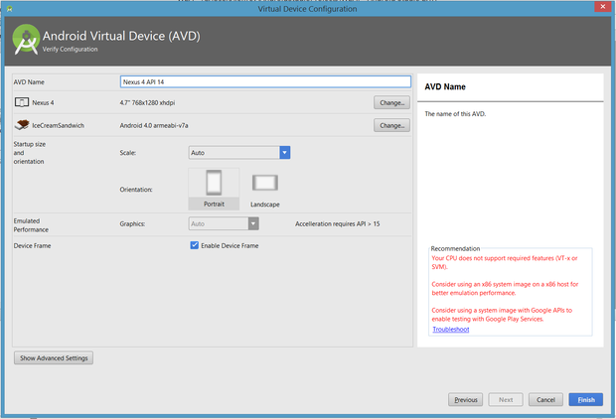

* + - Rename the AVD name to Nexus 5 API 22 and click Finish.
    - Select Run 'app' from the Run menu or select the green triangle icon on the tool bar. Once more, Android Studio responds with the Select Deployment Target dialog box. This time, highlight the Nexus 5 API 22 entry and click OK.
    - The emulator first presents a splash screen. After a few moments, this screen is replaced by a frame window for the Nexus 5 device.
    - And then you can see the Location Privacy app automatically running.

1. **Web Servers**
   * Location Based Server
     + Open the file explorer and navigate to C:\XAMPP\htdocs\ (for windows) or open finder then select Applications and then expand XAMPP and in that open htdocs (for MAC) and here paste the folder LocationPrivacy in LBS folder provide by us.
     + Now run the XAMPP control panel and start apache and MySQL.
     + Open the browser and go to localhost, this will display the index page.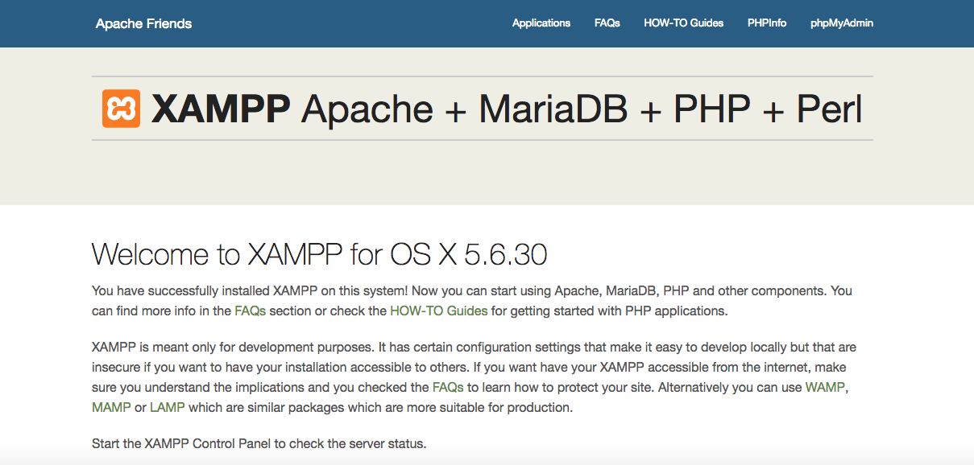
     + Click on the phpMyAdmin on the top right corner and then you will be taken to the phpMyAdmin page which can be used as a Database Management Tool.

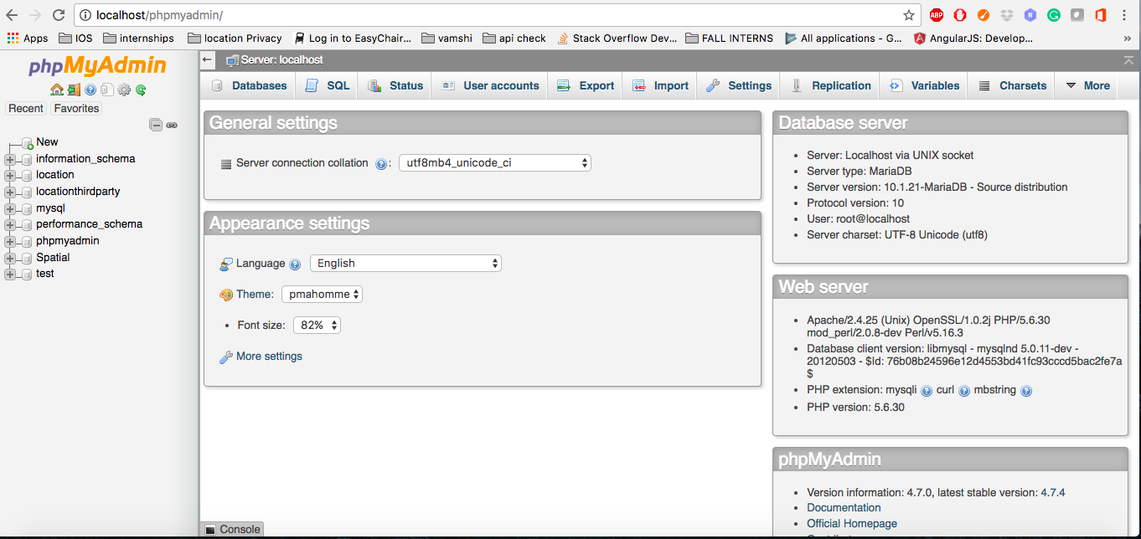

* + - Here click on new in left side of the page. 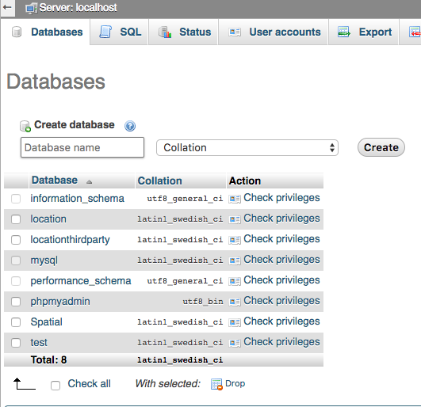
    - Give the Database name as location and then click Create. This is should create a database named location and will displayed on left side of your screen.
    - Now, click on the location and you will see something like this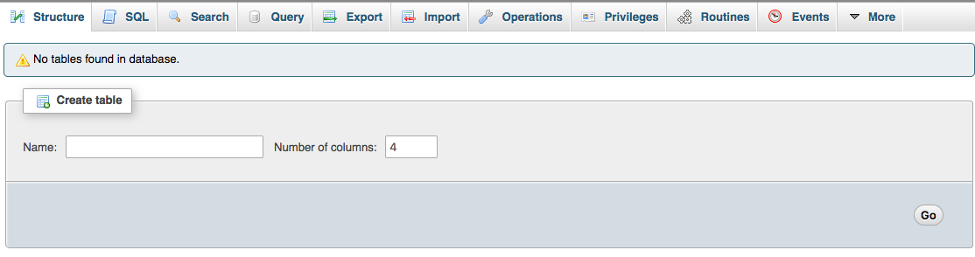
    - Now, click on import option in top menu and a page displays like below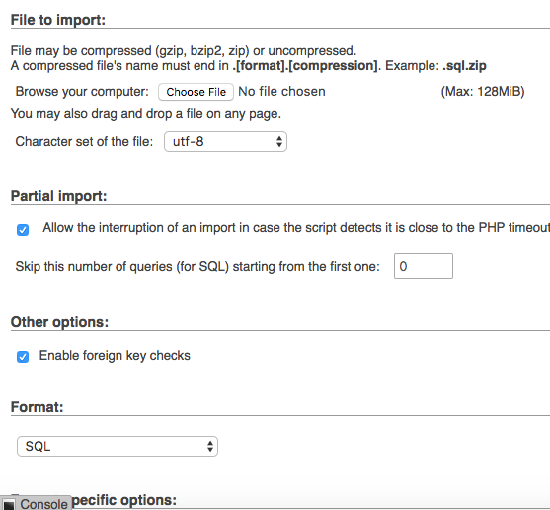
    - Click on Choose File and then browse to the location.sql file in LBS folder provided by us.
    - Then scroll down to the bottom and click on Go. This is will import all the tables into the database. And now the database was configured for LBS server.
  + Analytic Server
    - Click on New in left side of the page.
    - Give the Database name as locationthirdparty and then click Create. This is should create a database named locationthirdparty and will displayed on left side of your screen.
    - Now, click on the locationthirdparty, then click on import option in the top menu.
    - Here click on Chose File and browse to the locationthirdparty.sql file in Analytic Server folder provided by us.
    - Open the file explorer and navigate to C:\XAMPP\htdocs\ (for windows) or open finder then select Applications and then expand XAMPP and in that open htdocs (for MAC) and here paste the folder LocationPrivacyThirdParty in Analytic Server folder provide by us.

By this all the Software installation, Android Client and Server setup was done and the Location Privacy project was ready to be executed.