**Midterm Exam - CSE210 (Electronics I)**

**Department of CSE, Independent University, Bangladesh (IUB)**

**Autumn Term 2023, Date: 04-09-2023**

|  |  |
| --- | --- |
| **Name** |  |
| **Student ID** |  |
| **Section** |  |

* This paper contains 6 problems.
* Duration of the exam: 75 minutes.
* Total marks: 50
* This is a closed-book exam, and calculators are allowed.
* Student/s caught guilty of adopting any unfair means shall be expelled from the examination hall immediately and examination of such student/s including the outcome shall be terminated/cancelled right away

**Problem 1**

1. For Fig. 1 Determine I, V1, V2, and Vo .
2. Considering R1 = 0 Ω and DC source E1 is replaced by an AC source vi a sinusoide with peak value vm = 10 V, determine and sketch the output Vo .

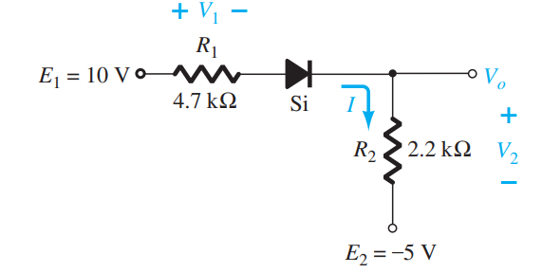

Figure 1

**Solution:**

**(a)**

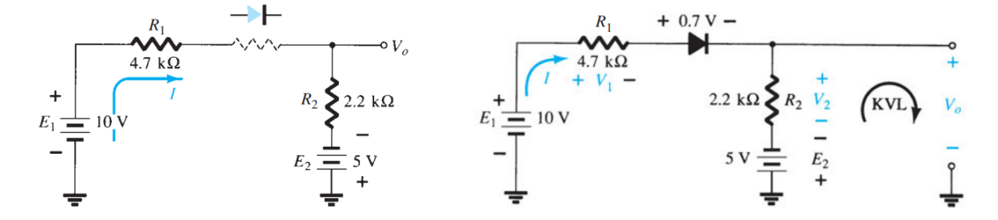

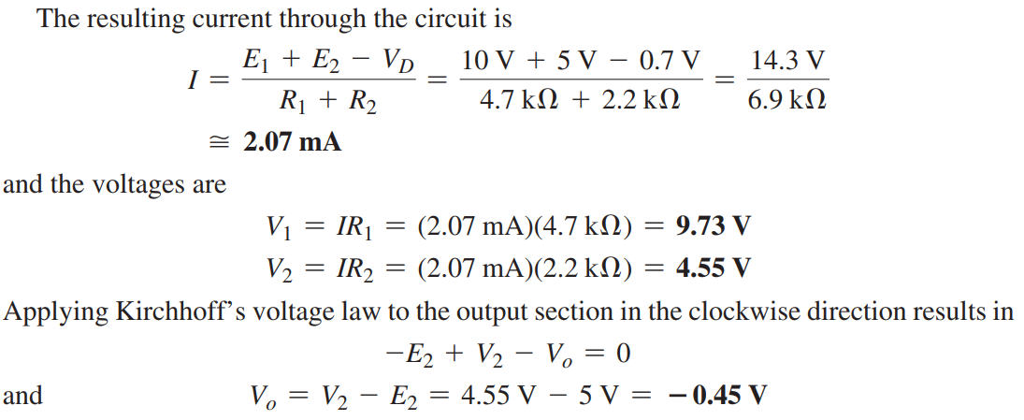

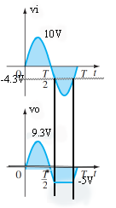The minus sign indicates that Vo has a polarity opposite to that of appearing in Fig 1.

(b)

**Problem 2**

Determine and sketch the output waveform for the network of Fig. 2 and calculate the output dc level (VDC) and the required PIV of each diode. In addition, determine the maximum current (Imax) through each diode.

Figure 2

Figure 2

**Solution:**

VDC = 0.636 x -98.6 V = -62.71 V

Imax = 98.6V/2.2KΩ = 44.81 mA

**Problem 3**

In the following network, there are two LEDs that can be used as polarity detectors. Apply a positive source voltage and a green light results. Negative supplies result in a red light.

1. Find the resistor R to ensure a current of 20 mA through the “on” diode for the configuration of Fig. 3. Note that both diodes have a reverse breakdown voltage of 3 V and an average turn-on voltage of 2 V.
2. Analyze the network if the green diode were to be replaced by a blue diode. Include appropriate figures for the analysis. Note that the forward bias required to turn on a blue diode is about 5 V.

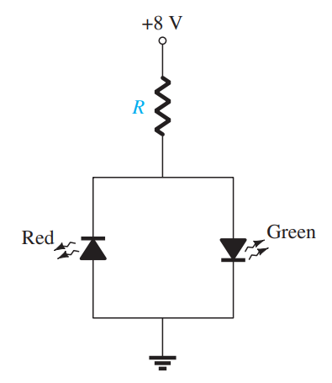

Figure 3

**Solution:**

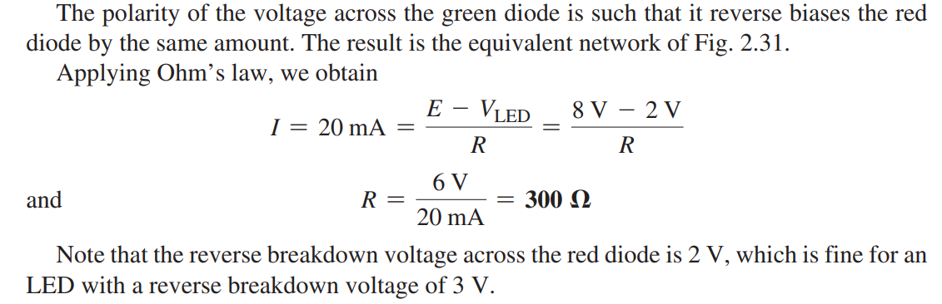

1. If the green diode were to be replaced by a blue diode, problems would develop, as shown in the following Fig.

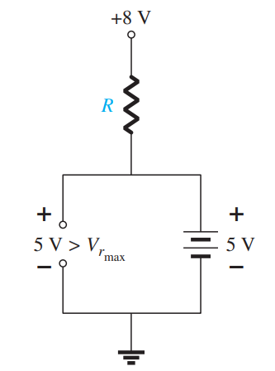

Recall that the forward bias required to turn on a blue diode is about 5 V. The result would appear to require a smaller resistor R to establish a current of 20 mA. However, note that the reverse bias voltage of the red LED is 5 V, but the reverse breakdown voltage of the diode is only 3 V. The result is the voltage across the red LED would lock in at 3 V as shown in the following Fig. The voltage across R would be 5 V and the current limited to 20 mA with a 250-ohm resistor but neither LED would be on.

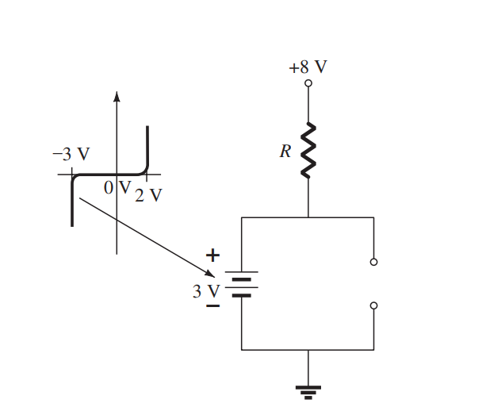

**Problem 4**

1. Prove that the voltage across the capacitor of the network in Figure 4 for the input indicated, during the discharging time does not discharge significantly.
2. For the network below: determine and sketch Vo for the input indicated.
3. Find the change in output if the diode is a silicon diode.

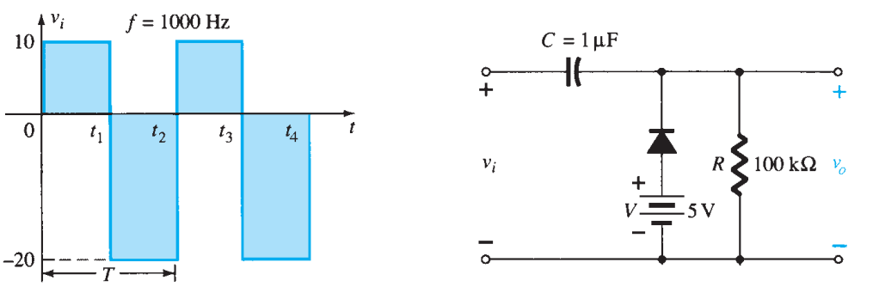

Figure 4

**Solution:**

1. T=1/f = 1/1000 Hz = 1 ms, T/2= 0.5 ms is the discharging time.



So the capacitor only discharge 10% during the discharge time

1. For the time period t1 to t2,

For the time period t2 to t3,

1. If the diode is considered as silicon diode,

For the period t2 to t3,

**Problem 5**

For the characteristics of Fig.5 :

(a). Determine the ac resistance at ID  = 2 mA.

(b). Determine the ac resistance at ID  = 25 mA.

(c). Compare the results of parts (a) and (b) to the DC resistances at each current level.

Figure 5

**Solution:**

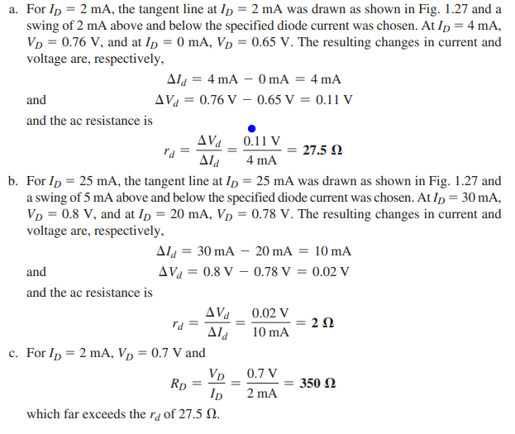

**Problem 6**

Using the characteristics of Fig. 6b , determine ID and VD for the circuit of Fig. 6a .

b. Repeat part (a) with R = 0.47 kΩ

c. Repeat part (a) with R = 0.68 kΩ

d. Is the level of VD relatively close to 0.7 V in each case?

How do the resulting levels of ID compare? Comment accordingly.

Figure 6