| **Table 1: Demographic Characteristics** |  |
| --- | --- |
| **Characteristic** | **N = 704***1* |
| Parent’s age (years) |  |
| < 25 | 13 (1.8%) |
| > 45 | 47 (6.7%) |
| 25–35 | 377 (54%) |
| 36–45 | 267 (38%) |
| Parent’s sex |  |
| Female | 551 (78%) |
| Male | 153 (22%) |
| Parent’s education level |  |
| Postgraduate | 175 (25%) |
| Primary | 35 (5.0%) |
| Secondary | 381 (54%) |
| Undergraduate | 113 (16%) |
| Employment status |  |
| Employed | 95 (13%) |
| Not employed | 503 (71%) |
| Self employed | 106 (15%) |
| Family type |  |
| Extended family | 147 (21%) |
| Nuclear family | 372 (53%) |
| Single parent family | 185 (26%) |
| Your average household income per month (BDT) |  |
| High (greater than 50000 BDT) | 139 (20%) |
| Low (less than 30000 BDT) | 160 (23%) |
| Middle (less than 50000 BDT) | 405 (58%) |
| Child’s sex |  |
| Female | 379 (54%) |
| Male | 325 (46%) |
| Child’s age (years) |  |
| < 5 | 37 (5.3%) |
| > 10 | 313 (45%) |
| 5–9 | 353 (50%) |
| Unknown | 1 |
| Number of children |  |
| >= 3 | 104 (15%) |
| 1 | 176 (25%) |
| 2 | 424 (60%) |
| Who is the leading child caregiver at home? |  |
| Father | 54 (7.7%) |
| Grandmother | 16 (2.3%) |
| Mother | 629 (89%) |
| Others | 5 (0.7%) |
| Are grandparents at home involved in treatment decisions when your child is ill? |  |
| Always | 34 (4.8%) |
| Never | 459 (65%) |
| Often | 54 (7.7%) |
| Sometimes | 157 (22%) |
| *1*n (%) | |

Table 1 shows the demographic characteristics of respondents. More than half (54%) parents’ age was 25 to 35. About 80% participants were female. More than half (54%) parents completed their secondary education. 71% parents were not employed. 53% of them belonged to nuclear family and 58% of them belonged to middle class and income was less than 50000 BDT. 54% were female child and 46% were male child. 60% parents had two children. 89% of their family had mother leading child caregiver at home.

**Table 2: Major Sources of Information**

| **Characteristic** | **N = 704***1* |
| --- | --- |
| Information provided by pharmaceutical companies leaflet | 78 (11%) |
| Information from prescribers | 607 (86%) |
| Information from dispensers | 252 (36%) |
| Information from nurses | 22 (3.1%) |
| Information given by a colleague | 34 (4.8%) |
| Information from University courses | 16 (2.3%) |
| Internet | 213 (30%) |
| Social media | 165 (23%) |
| Others | 89 (13%) |
| *1*n (%) | |

Table 2 outlines the major sources of information regarding antibiotics. 86% respondents reported that they got information from prescribers. Only 2% reports that they got information from University courses.

**Table 3: Level of Knowledge, Attitude, Practise regarding antibiotics**

| **Characteristic** | **N = 704***1* |
| --- | --- |
| Knowledge Level |  |
| Good | 22 (3.1%) |
| Moderate | 317 (45%) |
| Poor | 365 (52%) |
| Attitude Level |  |
| Negative | 124 (18%) |
| Positive | 209 (30%) |
| Uncertain | 371 (53%) |
| Practise Level |  |
| `Good Practise` | 250 (36%) |
| `Misuse | 454 (64%) |
| *1*n (%) | |

Table 3 represents the level of knowledge, attitude, practise regarding antibiotics among the respondents. A score was assigned to each parent based on the number of correct answers, with ranges for antibiotic knowledge (0–12), attitude (0–10), and practice (0–6). Based on the scores, knowledge levels were classified as poor, moderate, or good, while attitudes were categorized as negative, uncertain, or positive. Scores of 0–49% were classified as poor/negative, scores of 50–79% as moderate/uncertain, and scores of 80–100% as good/positive. In this study, practice-related questions assessed the appropriate or inappropriate use of antibiotics. A practice score below 80% indicated inappropriate use (misuse), while a score of 80% or higher indicated appropriate use (good use).

52% of them had poor level of knowledge whereas only 3% had good knowledge. 53% of the parents were uncertain attitude towards antibiotics and 30% had positive attitude towards antibiotic. More than half (64%) misused antibiotics.

| **Table 4: Factors Associated with Knowledge Level** |  |  |  |
| --- | --- | --- | --- |
| **Characteristic** | **log(OR)***1* | **95% CI***1* | **p-value** |
| Parent’s age (years) |  |  | **0.001** |
| < 25 | — | — |  |
| > 45 | -12 |  |  |
| 25–35 | -12 |  |  |
| 36–45 | -13 |  |  |
| Parent’s sex |  |  | 0.3 |
| Female | — | — |  |
| Male | 0.36 | -0.28, 1.0 |  |
| Parent’s education level |  |  | **<0.001** |
| Postgraduate | — | — |  |
| Primary | 2.2 | 1.2, 3.3 |  |
| Secondary | 0.92 | 0.52, 1.3 |  |
| Undergraduate | 0.33 | -0.18, 0.83 |  |
| Employment status |  |  | **<0.001** |
| Employed | — | — |  |
| Not employed | 1.2 | 0.52, 1.9 |  |
| Self employed | -0.13 | -0.74, 0.47 |  |
| Family type |  |  | 0.6 |
| Extended family | — | — |  |
| Nuclear family | 0.01 | -0.41, 0.43 |  |
| Single parent family | -0.18 | -0.67, 0.31 |  |
| Your average household income per month (BDT) |  |  | **0.005** |
| High (greater than 50000 BDT) | — | — |  |
| Low (less than 30000 BDT) | 0.87 | 0.35, 1.4 |  |
| Middle (less than 50000 BDT) | 0.48 | 0.06, 0.91 |  |
| Child’s sex |  |  | 0.7 |
| Female | — | — |  |
| Male | -0.06 | -0.39, 0.26 |  |
| Child’s age (years) |  |  | **0.023** |
| < 5 | — | — |  |
| > 10 | 0.95 | 0.18, 1.7 |  |
| 5–9 | 1.1 | 0.30, 1.8 |  |
| Number of children |  |  | >0.9 |
| >= 3 | — | — |  |
| 1 | -0.02 | -0.57, 0.53 |  |
| 2 | -0.07 | -0.54, 0.39 |  |
| Who is the leading child caregiver at home? |  |  | 0.2 |
| Father | — | — |  |
| Grandmother | 0.92 | -0.36, 2.2 |  |
| Mother | 0.66 | 0.07, 1.3 |  |
| Others | 0.30 | -1.7, 2.3 |  |
| *1*OR = Odds Ratio, CI = Confidence Interval | | | |

Table 4 shows the factors associated with level of knowledge regarding antibiotics. To identify the associated factors, ordinal logistic regression was conducted. This table showed that parents aged 36 to 45 had significantly lower odds ratio than aged 25 to 30. Parents education level, employment status, monthly income, number of children, child’s age variables were significantly associated with knowledge level.

| **Table 5: Factors Associated with Attitude Level** |  |  |  |
| --- | --- | --- | --- |
| **Characteristic** | **log(OR)***1* | **95% CI***1* | **p-value** |
| Parent’s age (years) |  |  | 0.3 |
| < 25 | — | — |  |
| > 45 | -0.61 | -1.9, 0.65 |  |
| 25–35 | -0.16 | -1.3, 0.93 |  |
| 36–45 | -0.44 | -1.6, 0.67 |  |
| Parent’s sex |  |  | **0.002** |
| Female | — | — |  |
| Male | 0.88 | 0.31, 1.5 |  |
| Parent’s education level |  |  | 0.065 |
| Postgraduate | — | — |  |
| Primary | -0.14 | -0.91, 0.65 |  |
| Secondary | -0.49 | -0.86, -0.12 |  |
| Undergraduate | -0.23 | -0.70, 0.25 |  |
| Employment status |  |  | **0.049** |
| Employed | — | — |  |
| Not employed | 0.48 | -0.10, 1.1 |  |
| Self employed | -0.23 | -0.78, 0.32 |  |
| Family type |  |  | 0.4 |
| Extended family | — | — |  |
| Nuclear family | 0.03 | -0.35, 0.40 |  |
| Single parent family | -0.21 | -0.63, 0.20 |  |
| Your average household income per month (BDT) |  |  | 0.3 |
| High (greater than 50000 BDT) | — | — |  |
| Low (less than 30000 BDT) | -0.28 | -0.74, 0.17 |  |
| Middle (less than 50000 BDT) | 0.03 | -0.35, 0.40 |  |
| Child’s sex |  |  | 0.3 |
| Female | — | — |  |
| Male | 0.14 | -0.15, 0.44 |  |
| Child’s age (years) |  |  | 0.8 |
| < 5 | — | — |  |
| > 10 | -0.07 | -0.79, 0.63 |  |
| 5–9 | -0.16 | -0.86, 0.52 |  |
| Number of children |  |  | 0.8 |
| >= 3 | — | — |  |
| 1 | 0.02 | -0.48, 0.51 |  |
| 2 | 0.10 | -0.31, 0.52 |  |
| *1*OR = Odds Ratio, CI = Confidence Interval | | | |

Table 5 shows the factors that are associated with the level of attitude. This analysis reported that employment status and parents’ sex were significantly associated with attitude level towards antibiotic.

| **Table 6: Factors Associated with Practice Level** |  |  |  |
| --- | --- | --- | --- |
| **Characteristic** | **Beta** | **95% CI***1* | **p-value** |
| Parent’s age (years) |  |  |  |
| < 25 | — | — |  |
| > 45 | 0.42 | 0.12, 0.72 | **0.006** |
| 25–35 | 0.26 | 0.01, 0.52 | **0.046** |
| 36–45 | 0.25 | -0.02, 0.52 | 0.065 |
| Parent’s sex |  |  |  |
| Female | — | — |  |
| Male | 0.00 | -0.13, 0.14 | >0.9 |
| Parent’s education level |  |  |  |
| Postgraduate | — | — |  |
| Primary | -0.07 | -0.24, 0.10 | 0.4 |
| Secondary | 0.05 | -0.04, 0.13 | 0.3 |
| Undergraduate | 0.09 | -0.02, 0.20 | 0.094 |
| Employment status |  |  |  |
| Employed | — | — |  |
| Not employed | 0.01 | -0.13, 0.14 | >0.9 |
| Self employed | -0.09 | -0.22, 0.03 | 0.2 |
| Family type |  |  |  |
| Extended family | — | — |  |
| Nuclear family | 0.03 | -0.06, 0.11 | 0.6 |
| Single parent family | -0.01 | -0.11, 0.09 | 0.8 |
| Your average household income per month (BDT) |  |  |  |
| High (greater than 50000 BDT) | — | — |  |
| Low (less than 30000 BDT) | -0.21 | -0.32, -0.10 | **<0.001** |
| Middle (less than 50000 BDT) | -0.23 | -0.32, -0.14 | **<0.001** |
| Child’s sex |  |  |  |
| Female | — | — |  |
| Male | -0.06 | -0.13, 0.01 | 0.083 |
| Child’s age (years) |  |  |  |
| < 5 | — | — |  |
| > 10 | 0.10 | -0.06, 0.26 | 0.2 |
| 5–9 | 0.06 | -0.09, 0.22 | 0.4 |
| Number of children |  |  |  |
| >= 3 | — | — |  |
| 1 | 0.07 | -0.05, 0.18 | 0.3 |
| 2 | 0.01 | -0.08, 0.11 | 0.8 |
| Attitude Level |  |  |  |
| `Attitude Level`.L | 0.16 | 0.09, 0.22 | **<0.001** |
| `Attitude Level`.Q | -0.23 | -0.29, -0.16 | **<0.001** |
| Knowledge Level |  |  |  |
| `Knowledge Level`.L | -0.10 | -0.25, 0.04 | 0.2 |
| `Knowledge Level`.Q | 0.06 | -0.03, 0.15 | 0.2 |
| *1*CI = Confidence Interval | | | |

Table 6 represents the factors that are associated with the level of practice. Parents aged 25- 35 years (OR=0.42,95% CI= 0.12, 0.72, P-value= 0.06) had higher significant odds ratio than the aged greater than 45 years (OR=0.26, 95%CI=0.01, 0.52, P-value= 0.046 ). Additionally, those had less than income 30000 BDT and less than income 50000BDT were significantly associated with practice level.

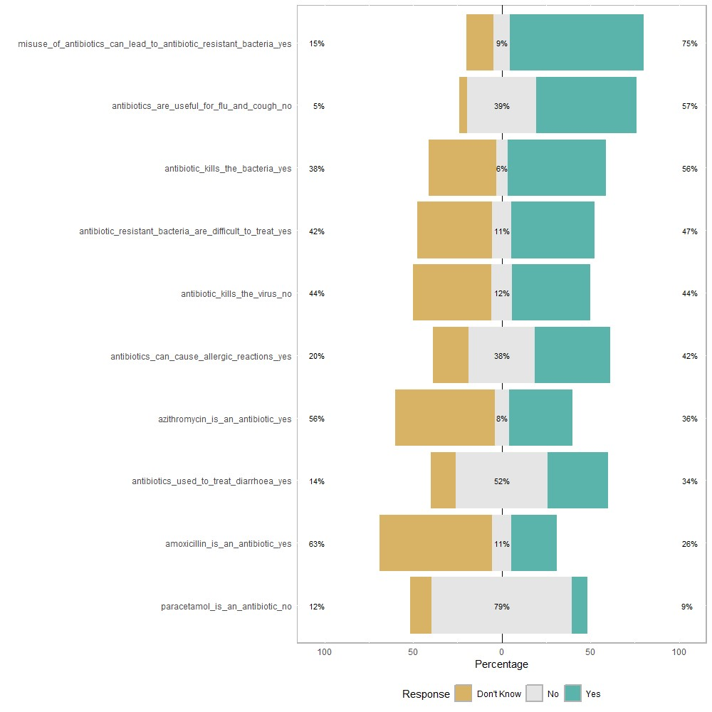

Figure1: Distribution of Knowledge of Antibiotic

Figure 1 represents the distribution of knowledge of antibiotic among the respondents. 75% respondents knew that misuse of antibiotic can lead antibiotic resistance. 63% of the respondents did not know that amoxicillin is an antibiotic. 52% respondents did not agree that antibiotic could be used for diarrheal treatment.

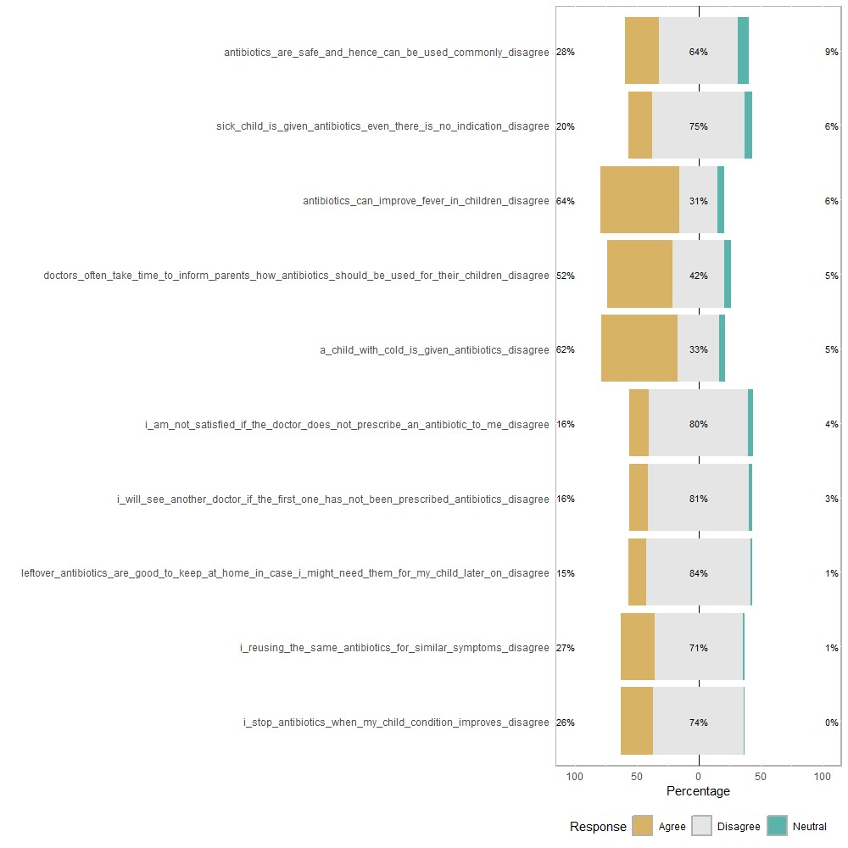

Figure 2: Distribution of Attitude towards Antibiotic

Figure 2 shows the distribution of attitude towards antibiotic usage among respondents. 64% of the respondents agreed that antibiotics can improve child’s fever while only 31% disagreed. More than half of the respondents (52%) agreed that doctors took time to describe parents how they should use antibiotics for children. 62% parents gave their children antibiotic when they suffered from cold.

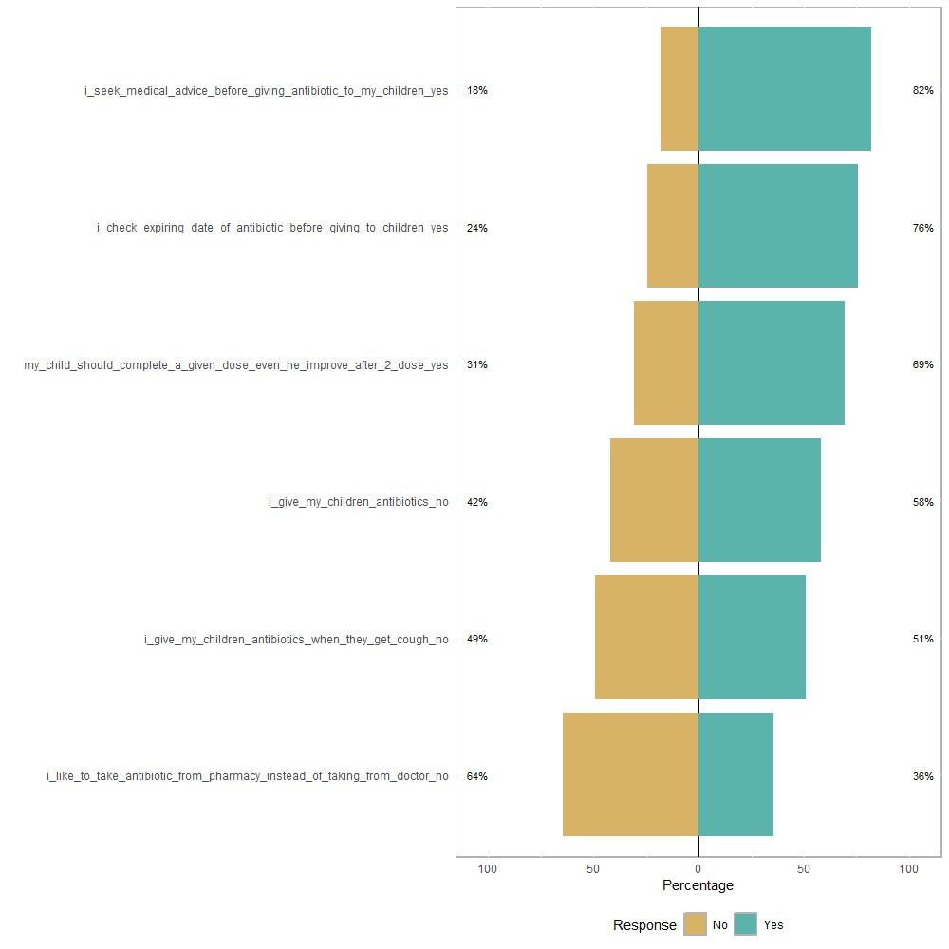

Figure 3: Distribution of Practice regarding Antibiotic

Figure 3 shows the distribution of practices regarding antibiotic among the school going children. 82% of the respondents reported that they sought medical care for taking antibiotics. Half of the parents reported that they gave antibiotics to their children when they got cough and 36% parents took the antibiotics from pharmacy instead of doctors.