Functional design

Introduction

Bizander is an online webstore based in The Netherlands but is expanding into France. Bizander is a one man company founded by Sander … . Bizander sells premium handmade shoulder bags, rucksacks, and normal bags as products. This document will show all the information about the online webstore.

Requirements

User requirements:

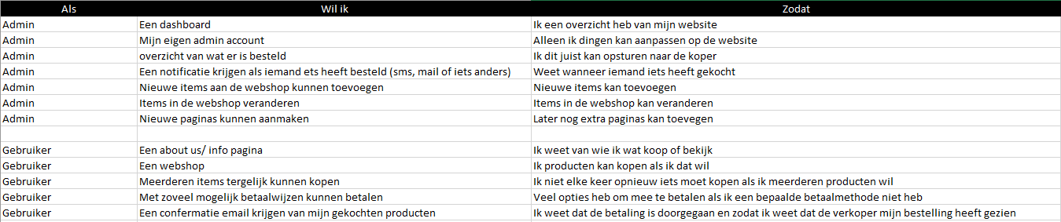

In this file you can see user can needs execute, what takes there are and why the user want to execute the tasks.

Functional requirements:

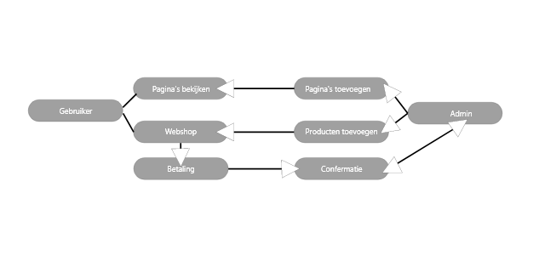

Non-Functional requirements:

An important non-functional requirement is that the website needs to be as clean as possible with an easy but clear path towards the webshop as this is the main focus of the website.