Functioneel ontwerp

Introduction

Robin Assistant is a new assistive software solution for people with special needs and their careers in performing everyday activities. It is used for different types of brain conditions: autism spectrum, Down syndrome, Alzheimer’s disease various forms of dementia, and other sorts of brain injuries. This document will show all information about the web-app dashboard project plan for the caretakers and the activity-app for the clients.

Requirements

User requirements:

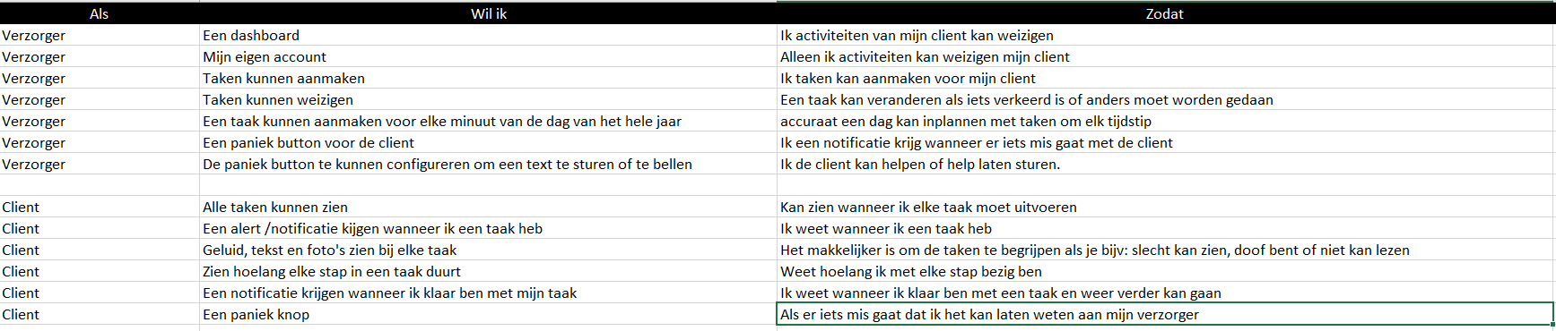In this file you can see user can needs execute, what takes there are and why the user want to execute the tasks.

Functional requirements:

The functional requirements of this project are in the use case diagram here down below. This shows all primary functions of the website and app.

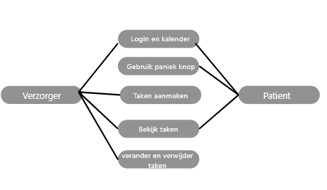

Non-Functional requirements:

an important non-functional requirement is that sound and video instructions for the user need to be as clear as possible, so the user won’t get confused and use the panic button.

Another important non-functional requirement is to make the website clean and easy. To prevent the user from getting distracted.

Also a non-functional requirement is that handicap users of the app don’t get distracted from anything else than the tasks they are given. So its clear what they need to do.