PROJECT SYNOPSIS: ULTRON
Standalone Battery-Powered AI Voice Assistant & Interactive Desk Buddy
“A cost-effective, portable desktop companion powered by Standard ESP32-S3, TP4056 Battery Circuit & Google Gemini Live”
1. INTRODUCTION: -
The ULTRON project is a custom-built, standalone conversational AI voice assistant designed to function as an interactive desktop companion and portable desk buddy. Engineered under a strict student academic budget of under ₹2,500, the system integrates a standard ESP32-S3 development board paired with an INMP441 I2S digital MEMS microphone, a MAX98357A I2S Class-D amplifier, a 3W dynamic speaker, a 0.96-inch SSD1306 OLED display for expressive eye animations, and an integrated 3.7V Lithium-Polymer (Li-Po) battery power management circuit. The system enables real-time, hands-free verbal dialogue, technical explanations, live web search retrieval, news updates, and audio playback completely standalone—without needing a permanent computer tether or phone connection.
Traditional commercial desktop companions and voice assistants (such as EMO, Vector, or smart home hubs) are cost-prohibitive, often retailing between ₹10,000 and ₹25,000, and require continuous AC wall power. Furthermore, DIY hobbyist setups often suffer from acoustic feedback loops where the microphone captures speaker output and interrupts the AI mid-sentence, as well as voltage brownouts when running on portable batteries. ULTRON solves these challenges by combining low-cost, readily available commercial off-the-shelf (COTS) components with Google's Gemini Live API over full-duplex WebSockets. By implementing a dedicated TP4056 Li-Po charging circuit with DW01A protection and on-chip Acoustic Echo Cancellation (AEC) and Voice Activity Detection (VAD) within the ESP32-S3 firmware, ULTRON delivers natural conversational pacing and portable battery autonomy within an affordable ₹1,690 total hardware budget.
2. PROBLEM STATEMENT: -
Commercial AI desktop companions and smart assistants are expensive, proprietary, and heavily tethered to AC wall power, smartphone companion apps, or running PC background software. Standard DIY voice assistants frequently suffer from power instability during Wi-Fi transmission bursts, rigid push-to-talk delays, or acoustic self-interruption, where the device's microphone picks up its own speaker audio and aborts playback prematurely.
There is a need for a low-cost (under ₹2,500), portable, and standalone voice assistant that connects directly to state-of-the-art conversational LLM backends over Wi-Fi, incorporates a dedicated rechargeable battery charging and regulation circuit for cordless desk mobility, utilizes digital I2S audio with Acoustic Echo Cancellation (AEC) for fluid dialogue, and renders expressive facial animations on a compact OLED screen.
3. OBJECTIVES: -
The objective of Project ULTRON is to develop an affordable, portable, and standalone AI voice assistant and interactive desk buddy combining low-cost edge hardware with Google Gemini Live cloud intelligence:
Cost-Effective Standalone Architecture — Build an autonomous AI companion entirely under a ₹2,500 budget using a standard ESP32-S3 development board without requiring a host PC or phone.
Gemini Live Conversational Voice — Connect to Google's Gemini Live API over Wi-Fi using secure full-duplex WebSockets for fluid, real-time spoken dialogue.
Integrated Battery Power & Charging Circuit — Incorporate a rechargeable 3.7V 1200mAh Li-Po battery with a TP4056 USB Type-C charging module, DW01A protection IC, and an SPDT slide power switch for safe, portable desk operation.
High-Sensitivity Audio Capture — Capture 24-bit digital PCM audio at 16 kHz using an INMP441 I2S MEMS microphone for clean speech recognition up to 2.0 meters away.
Acoustic Echo Cancellation (AEC) — Implement on-device DSP echo cancellation and Voice Activity Detection (VAD) so the AI does not hear or interrupt its own speaker playback.
High-Fidelity Audio Playback — Convert digital audio streams into crystal-clear vocal responses, chimes, and music playback via a MAX98357A I2S Class-D amplifier and 3W speaker.
Expressive Visual Eye Animations — Display animated vector eye expressions (blinking, listening, happy, curious) on a 0.96-inch 128x64 SSD1306 OLED over 400 kHz Fast-Mode I2C.
Compact Form-Factor Readiness — Design the electrical layout so that all components and the battery easily assemble onto a compact perfboard substrate for future enclosure packaging.
4. SYSTEM ARCHITECTURE: -
The system operates on a four-stage architecture engineered for stable battery power delivery, low-latency digital audio streaming, deterministic edge processing, and high-fidelity output. This architecture coordinates power regulation, continuous I2S digital audio sampling, secure WebSocket communication, and procedural OLED graphics:
Battery Power & Regulation Circuit
TP4056 USB Type-C Charging Module — Accepts 5V DC via USB-C to charge the Li-Po cell at up to 1A CC/CV, while onboard DW01A and FS8205A ICs protect against overcharge (>4.28V), over-discharge (<2.8V), and short-circuit faults.
3.7V 1200mAh Li-Po Battery & SPDT Switch — Powers the system untethered for ≈ 18.4 hours. An in-line SPDT slide switch provides zero-leakage physical power cutoff, feeding the ESP32-S3 5V/VIN pin and 3.3V LDO regulator rail shunted by decoupling reservoir capacitors.
Data Acquisition Layer
INMP441 I2S MEMS Microphone — Continuously captures 24-bit digital PCM voice input at 16 kHz over an independent I2S bus with high signal-to-noise ratio.
Hardware User Buttons — Momentary tactile inputs for manual wake/interrupt and hardware mute functionality.
Processing & Connectivity Layer
Standard ESP32-S3 Board — Dual-core Xtensa LX7 MCU @ 240 MHz with 8MB PSRAM and 16MB Flash. Manages 2.4 GHz Wi-Fi, TLS encryption, WebSocket packets, Acoustic Echo Cancellation (AEC), and Voice Activity Detection (VAD).
Actuation, Monitoring & Cloud AI Layer
Google Gemini Live Engine — Processes bidirectional conversational voice tokens over full-duplex WebSockets, providing high-speed contextual responses.
0.96" SSD1306 OLED Display — Renders 128x64 procedural animated robotic eyes and system connectivity indicators over 400 kHz Fast-Mode I2C.
MAX98357A I2S Amp & 3W Speaker — Decodes digital PCM audio directly into analog vocal playback with >92% Class-D power efficiency.
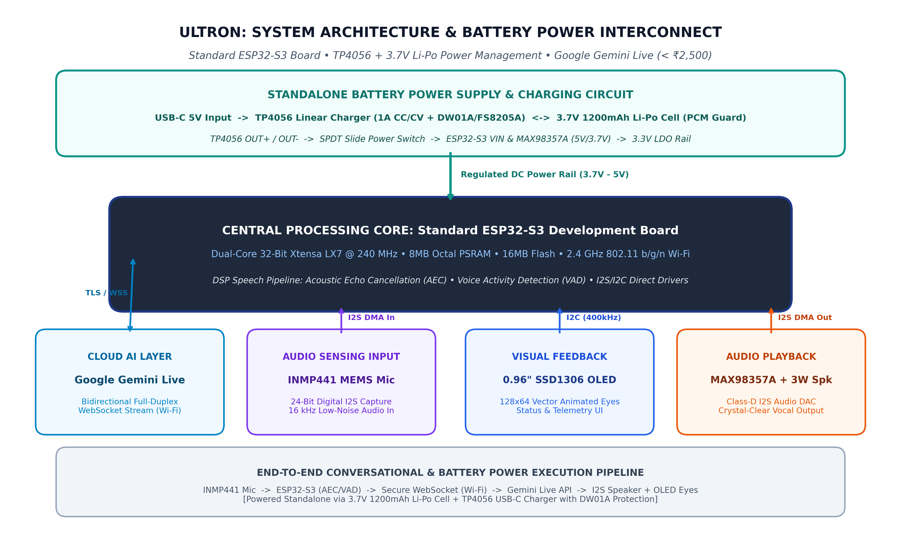
Figure 4.1: High-Level System Architecture and Battery Power Interconnect Diagram.
5. HARDWARE REQUIREMENTS: -
Component | Specification / Model | Purpose
ESP32-S3 Dev Board | Standard Dual-Core LX7 @ 240MHz, 8MB PSRAM, 8MB/16MB Flash | Central compute node; runs FreeRTOS, AEC/VAD DSP, Wi-Fi WebSockets, and I2S/I2C buses.
I2S MEMS Microphone | INMP441 Omnidirectional Digital I2S Microphone (24-bit PCM) | Captures clean room acoustics and user voice commands up to 2.0 meters away.
I2S Audio Amplifier | MAX98357A Class-D I2S DAC Audio Amplifier (3.2W Output) | Converts incoming digital PCM voice frames into clean, high-efficiency analog audio.
Dynamic Speaker | 40mm Dynamic Loudspeaker (4Ω / 8Ω, 3 Watt continuous) | Delivers crisp vocal output, conversational responses, status chimes, and music playback.
OLED Display | 0.96-inch Monochrome I2C SSD1306 Display (128x64, 3.3V) | Displays animated robotic eyes (blinking, happy, listening) and status icons.
Rechargeable Battery | 3.7V 1200mAh 1S Li-Po Pouch Cell with onboard PCM circuit | Supplies portable power for standalone desktop operation without continuous wall power.

6. SOFTWARE REQUIREMENTS: -
Arduino IDE 2.x / ESP-IDF — Primary C++ development and firmware flashing environment with OPI PSRAM and CPU frequency set to 240 MHz.
Google Gemini Live API — Cloud conversational Large Language Model backend enabling bidirectional full-duplex spoken interactions.
WebSocketsClient & WiFiClientSecure — Maintains a persistent, low-latency TLS WebSocket connection between the ESP32-S3 and Google servers over Wi-Fi.
ESP-SR (AEC & VAD) — Espressif speech recognition framework providing Acoustic Echo Cancellation and Voice Activity Detection to prevent speaker feedback.
Adafruit_SSD1306.h & Adafruit_GFX.h — Manages the 0.96-inch OLED screen, rendering real-time coordinate vector animations for expressive robotic eyes.
ESP32 I2S Audio Driver (driver/i2s.h) — Configures dual DMA controllers for 24-bit microphone capture (INMP441) and digital audio DAC output (MAX98357A).
WiFi.h & ArduinoJson.h — Manages 2.4 GHz wireless network connectivity and serializes configuration JSON payloads.
7. APPLICATION: -
Interactive Study & Desk Companion: Sits on a student's study desk to answer questions, explain engineering concepts, translate languages, and provide motivating interactive companionship.
Hands-Free Laboratory Assistant: Assists electronics technicians, programmers, and students whose hands are busy with tools, answering technical inquiries and performing calculations verbally.
Desktop Audio & Entertainment Buddy: Plays music streams, tells topical jokes, provides daily news summaries, and shares weather updates upon verbal request.
Focus & Productivity Coach: Acts as an ambient productivity companion, setting pomodoro focus timers, reminders, and study schedules without phone screen distractions.
Low-Cost Educational AI Robotics Platform: Functions as an accessible open-source testbed for students to learn I2S digital audio protocols, DSP echo cancellation, and real-time cloud WebSocket streaming.
8. ADVANTAGES: -
Extremely Cost-Effective (< ₹2,500): Total component hardware bill of materials is approximately ₹1,690, which is 80% to 90% cheaper than commercial robotic desktop companions.
Cordless Portable Operation: Onboard 3.7V Li-Po battery and TP4056 USB-C charging enable untethered placement anywhere on a study desk or workbench.
Completely Standalone & PC-Free: Connects directly to the cloud over Wi-Fi; does not require a running laptop, desktop computer, or active smartphone tether.
Full-Duplex Natural Voice with AEC: Acoustic Echo Cancellation prevents the microphone from catching speaker audio, allowing natural conversational interruption mid-sentence.
Pure Digital I2S Audio Chain: Pairs the INMP441 MEMS microphone with the MAX98357A Class-D amplifier to eliminate analog line hum and RF interference.
Expressive Visual Eye Feedback: The 0.96-inch OLED screen renders dynamic procedural eye expressions that give the assistant an engaging, lifelike personality.
Safe Power Management: DW01A and FS8205A protection ICs safeguard the battery against overcharge, over-discharge, and current spikes.
9. CONCLUSION: -
Project ULTRON successfully proves that an expressive, intelligent, and standalone AI voice assistant can be realized without expensive hardware or permanent computer tethering. By integrating a standard ESP32-S3 development board with an INMP441 digital microphone, MAX98357A Class-D amplifier, SSD1306 OLED display, TP4056 Li-Po battery management circuit, and Google's Gemini Live API, the system achieves real-time spoken conversation, animated facial feedback, cordless mobility, and on-chip Acoustic Echo Cancellation. Built well within an accessible ₹2,500 budget (total BOM ≈ ₹1,690), ULTRON demonstrates the power of modern edge IoT microcontrollers in making conversational artificial intelligence affordable, interactive, and practical for everyday student workspaces.
10. FUTURE SCOPE: -
Compact 3D-Printed Desktop Enclosure: Design and fabricate a custom snap-fit pocket/desktop chassis to house the ESP32-S3, battery, and modules in a clean, unified consumer-grade form factor with an acoustic speaker chamber.
On-Device Wake-Word Detection: Integrate lightweight edge wake-word models (such as ESP-SR 'Hey ULTRON') to enable voice-activated hands-free waking from deep sleep.
Smart Home IoT Appliance Actuation: Utilize Gemini function calling to allow ULTRON to verbally control Wi-Fi smart plugs, relays, and room lighting.
Local Edge Fallback Mode: Incorporate lightweight on-device speech synthesis and offline intent recognition for basic tasks during internet connection dropouts.
Capacitive Touch Interactions: Add capacitive touch pads on the outer enclosure to allow pet-like responses and instant mood changes when touched.
11. REFERENCES: -
[1] Espressif Systems, "ESP32-S3 Series Dual-Core Xtensa LX7 SoC Technical Reference Manual and Hardware Design Guidelines," 2024. [Online]. Available: https://www.espressif.com/
[2] Google Cloud, "Gemini Multimodal Live API Developer Guide & WebSocket Protocols," 2026. [Online]. Available: https://ai.google.dev/api/gemini-live
[3] InvenSense / TDK Corp., "INMP441 Omnidirectional Bottom-Port MEMS Microphone with Digital I2S Output Datasheet," Rev 1.1, 2016.
[4] Analog Devices / Maxim Integrated, "MAX98357A Tiny, Low-Cost PCM Class-D Audio Power Amplifier Datasheet," Rev 4, 2019.
[5] Solomon Systech Limited, "SSD1306 128 x 64 Dot Matrix OLED Driver with I2C Interface Reference Manual," Rev 1.1, 2018.
[6] NanJing Top Power ASIC Corp., "TP4056 1A Standalone Linear Li-Ion Battery Charger with Thermal Regulation in SOP-8," 2018.
[7] Espressif Systems, "ESP-SR: Speech Recognition, Voice Activity Detection (VAD) and Acoustic Echo Cancellation (AEC) Framework," 2024. [Online]. Available: https://github.com/espressif/esp-sr

