Evaluation and Comparative Analysis (with Bias Check)
Project: Publisher-Invariant Fake News Detection under Cross-Source Distribution
Group: F26-08
Members: Sanan Zahid (24L-2580), Noyan Siddiqui (24L-2593), Munam Ansari (24L-2525)
1. Evaluation Objective and Justification
Phase 3 trained the models and reported initial scores. Phase 4 measures how well they perform and whether they still work on publishers not seen during training. It also checks two risks: the model may recognise the publisher instead of fake news features, and it may treat sources unequally. The same three TF-IDF models and the majority baseline from Phase 3 are compared on a random split and a publisher-held-out split.
Phase 3 listed three next steps: report results separately for PolitiFact and GossipCop, analyse the model errors, and check the masking. Phase 4 carries out the first two and tests the publisher shortcut directly. Because about 74% of the articles are real, a model that always predicts real reaches 0.737 accuracy. F1, balanced accuracy and ROC-AUC are therefore the main scores. Balanced accuracy is the average of recall on the fake class and recall on the real class. ROC-AUC shows how well the model ranks fake articles above real ones.
2. Implementation Details
- Language: Python, executed in Google Colab.
- pandas and scikit-learn: data cleaning, TF-IDF, the models, the splits and the scores.
- Python standard library: re, html and urllib.parse, as in Phase 3.
- Code file: Phase4.ipynb.
3. Data and Evaluation Setup
The notebook loads fakenewsnet_cleaned_final.csv and applies the Phase 3 cleaning rules again. It also removes non-news domains (Wikipedia, social media, Amazon, PolitiFact itself) and articles under 50 words. This leaves 2,095 articles (548 fake, 1,547 real) from 385 publishers: 1,951 from GossipCop and 144 from PolitiFact. Fake is the positive class. The count is lower than the 2,379 articles used in Phase 3 because of this stricter cleaning.
Setting | Value
Split | 80% train / 20% test, 5 random seeds (Phase 3 used 10)
Random split | Shuffled, stratified by label
Publisher-held-out split | GroupShuffleSplit on publisher; the code checks that no publisher is in both sets
TF-IDF | Lowercase, 1 to 2 word phrases, min_df=2, max 50,000 features, fitted on training text only
Models | Logistic Regression (C=1.0), Linear SVM (C=0.5), Complement Naive Bayes (alpha=0.5), majority baseline
Text used | Title and article body, with publisher names masked

4. Evaluation Results
Table 1 shows the average of 5 runs on the masked article body. The random split is the easier test; the held-out split uses unseen publishers.
Model | Split | Acc | Bal. acc | Prec | Rec | F1 | ROC-AUC
Logistic Regression | Random | 0.822 | 0.740 | 0.699 | 0.567 | 0.625 | 0.836
Logistic Regression | Held-out | 0.815 | 0.735 | 0.652 | 0.573 | 0.604 | 0.815
Linear SVM | Random | 0.817 | 0.730 | 0.692 | 0.547 | 0.610 | 0.836
Linear SVM | Held-out | 0.814 | 0.726 | 0.661 | 0.546 | 0.594 | 0.825
Naive Bayes | Random | 0.775 | 0.580 | 0.873 | 0.169 | 0.283 | 0.768
Naive Bayes | Held-out | 0.756 | 0.541 | 0.880 | 0.085 | 0.153 | 0.749
Majority baseline | Both | 0.737 | 0.500 | 0.000 | 0.000 | 0.000 | 0.500

The best model is Logistic Regression on masked body text, with held-out F1 0.604. This is in line with Phase 3, where it also had the highest F1 (0.602 held-out). The main observations are as follows.
- Linear SVM is within 0.01 F1 of Logistic Regression, so the two are almost tied.
- Body text is better than titles alone. Held-out F1 is 0.604 vs 0.561 for Logistic Regression and 0.594 vs 0.558 for SVM. Title models find more fake articles but also flag more real ones.
- Naive Bayes on body text labels almost everything real (held-out recall 0.085). On titles it works better (held-out F1 0.552).
- All models beat the baseline, but F1 stays near 0.6, so about four in ten fake articles are still missed.
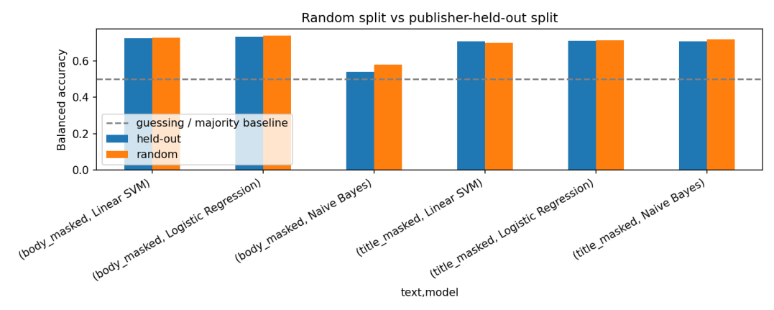
Figure 1: Balanced accuracy, random vs publisher-held-out split. The dashed line is chance (0.5).
5. Random vs Publisher-Held-Out Performance
The drop is the random score minus the held-out score. A positive value means the model is worse on unseen publishers.
Model (masked body) | F1 drop (mean / std) | Bal. acc drop | ROC-AUC drop
Logistic Regression | 0.021 / 0.110 | 0.005 | 0.021
Linear SVM | 0.015 / 0.089 | 0.004 | 0.010
Naive Bayes | 0.129 / 0.042 | 0.040 | 0.019

For Logistic Regression and SVM the average drop is much smaller than the spread between seeds, so the held-out penalty cannot be measured with this data. Only Naive Bayes shows a steady drop. This confirms the Phase 3 finding that the models generalise reasonably to unseen publishers. The spread comes from the test sets: held-out sets average 509 articles (std 230) with a fake share of 0.263 (std 0.081), depending on which publishers are placed in the test set.
6. Error Analysis
Real articles are rarely misclassified (false positive rate about 0.10 on GossipCop). The main error is missed fake articles. Table 2 shows publishers with at least 15 articles, from Logistic Regression with publisher-grouped 5-fold cross-validation (FPR = false positive rate, FNR = false negative rate).
Publisher | n | Fake rate | Pred. fake rate | FPR | FNR | Acc
dailymail.co.uk | 203 | 0.22 | 0.30 | 0.21 | 0.40 | 0.75
hollywoodreporter.com | 75 | 0.12 | 0.01 | 0.00 | 0.89 | 0.89
variety.com | 71 | 0.15 | 0.03 | 0.00 | 0.82 | 0.87
deadline.com | 36 | 0.08 | 0.00 | 0.00 | 1.00 | 0.92
theguardian.com | 31 | 0.23 | 0.06 | 0.04 | 0.86 | 0.77
express.co.uk | 17 | 0.35 | 0.18 | 0.18 | 0.83 | 0.59
newidea.com.au | 30 | 0.97 | 1.00 | 1.00 | 0.00 | 0.97
eonline.com | 23 | 1.00 | 0.52 | n/a | 0.48 | 0.52

Entertainment-trade and mainstream outlets (Hollywood Reporter, Variety, Deadline, Billboard, The Guardian) have false negative rates of 0.82 to 1.00. Their high accuracy mostly comes from the real-news majority. Daily Mail has the highest false positive rate among large publishers (0.21). Values of 0 or 1 come from outlets that are almost one class, such as newidea.com.au, where one article changes the rate.
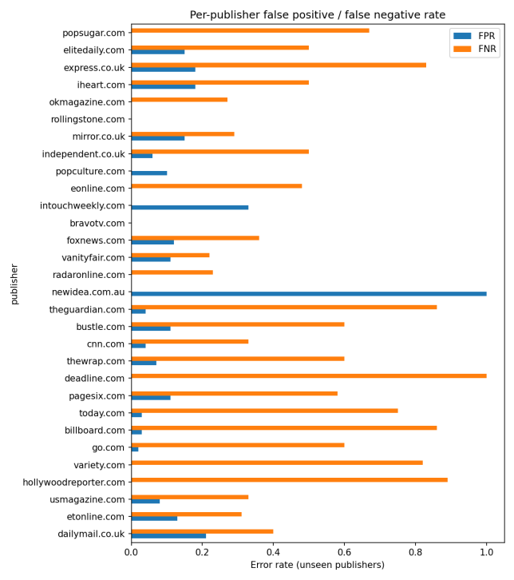
Figure 2: Per-publisher false positive (FPR) and false negative (FNR) rates on unseen publishers.
7. Bias and Fairness Check
Publisher shortcut. A model that sees only the publisher name should be useless if publishers carry no label information.
Input | Split | Bal. acc | F1 | ROC-AUC
Publisher name only | Random | 0.635 | 0.455 | 0.701
Publisher name only | Held-out | 0.500 | 0.000 | 0.515
Masked body text (LR) | Random | 0.741 | 0.625 | 0.838
Masked body text (LR) | Held-out | 0.737 | 0.618 | 0.829

The publisher name alone beats chance on a random split, so it is a real shortcut. On held-out publishers it falls to exactly chance. The text model barely changes (0.741 to 0.737), so it does not mainly depend on the publisher.
Bias between sources. This is the source-wise check that Phase 3 left open. The model is much weaker on PolitiFact than on GossipCop.
Source (held-out) | n | Fake rate | Pred. fake rate | FPR | FNR | Acc
GossipCop | 1,951 | 0.24 | 0.22 | 0.10 | 0.40 | 0.83
PolitiFact | 144 | 0.51 | 0.20 | 0.04 | 0.65 | 0.65

Half of the PolitiFact articles are fake, but the model predicts only 20% as fake and misses 65% of them. PolitiFact is only 7% of the data, so training is dominated by GossipCop language.
Which words drive predictions. Fake-leaning features are celebrity names and tabloid wording (kanye, jenner, pitt, kardashian, “source”, “insider”). Real-leaning features are show words (season, episode, series). Publisher words in the top 100 features drop from 4 with plain text to 2 with masked text, so masking removes outlet names while the other top terms stay the same. The model mostly learns topic and style, not the outlet.
8. Challenges and Limitations
- Imbalanced data. About 26% of the articles are fake, and PolitiFact is only 7% of the data.
- Few articles per publisher. Many of the 385 publishers have few articles, so held-out scores depend on which publishers are in the test set. Per-publisher rates are unreliable for small groups.
- Fewer seeds. Phase 4 uses 5 seeds and 2,095 articles (Phase 3 used 10 seeds and 2,379), so numbers differ slightly. Five seeds do not prove statistical significance.
- Simple masking rule. The rule may miss publisher clues or remove useful words.
9. Summary
Measure | Result
Articles evaluated | 2,095
Fake / real | 548 / 1,547
GossipCop / PolitiFact | 1,951 / 144
Publishers | 385
Seeds per experiment | 5
Best model | Logistic Regression, masked body text
Best held-out F1 / ROC-AUC | 0.604 / 0.815
Publisher-only model, held-out balanced accuracy | 0.500 (chance)
Highest FNR by source | PolitiFact, 0.65 (GossipCop 0.40)

Next steps: collect more PolitiFact articles, balance training by source, make sure both labels appear in every held-out test set, tune the decision threshold to raise recall, and add confidence intervals with more seeds. This project does not use RAG.
Files: Phase4.ipynb (code), phase4_all_runs.csv (score of every run), phase4_summary.csv (averages), phase4_drop_table.csv, phase4_publisher_shortcut.csv, phase4_publisher_bias.csv, phase4_chart_models.png and phase4_chart_publishers.png.

