**Syphilis**

*Model structure*

Markov cohort model simulates progression of primary syphilis infection to tertiary syphilis. Our model structure aligns with the model configurations in previous syphilis modeling studies. The model consists of 10 states; primary, secondary, tertiary syphilis, early and late latent syphilis, early and late neurosyphilis, and dead. Everyone starts at primary syphilis.

* Markov cohort model

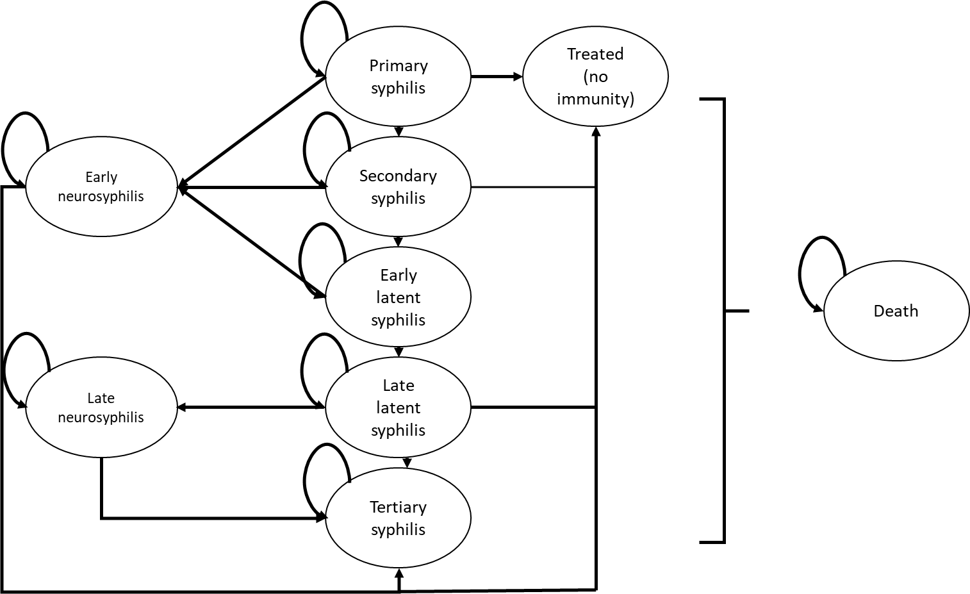

* Health states

|  |  |
| --- | --- |
| Health State | Definition |
| Primary syphilis | The first stage of syphilis that presents painless sores. Symptoms usually lasts 3-6 weeks |
| Secondary syphilis | Secondary stage of syphilis that involves skin rashes, lesions in mouth, vagina, or anus. Usually mid symptoms but often involves mild systemic symptoms such as fever, sore throat, headache, muscle aches, and fatigue. |
| Early latent syphilis | Presence of serological evidence for syphilis without clinical manifestations of syphilis. Infection occurred within the past 12 months |
| Late latent syphilis | Presence of serological evidence for syphilis without clinical manifestations of syphilis. Infection occurred more than 12 months ago |
| Tertiary syphilis | Untreated syphilis that leads to systemic symptoms affecting multiple organ systems including blood vessels (cardiovascular syphilis), skins, bone, and liver (late benign syphilis). Patients with tertiary syphilis have consequent long-term disability |
| Early neurosyphilis | Early stage of syphilis infection in central nerve system, mostly asymptomatic but can have acute meningitis (headache, fever, and stiff neck) |
| Late neurosyphilis | Late stage of syphilis infection in central nerve system, involving seizure, ataxia, aphasia, paresis, tabe dorsalis Resulted in long-term disability |
| Treated | Those who were treated in syphilis stages earlier than tertiary syphilis |
| Dead | People who died from baseline mortality or disease-specific mortality |

* Tree structure below illustrates events that lead one health state to another.

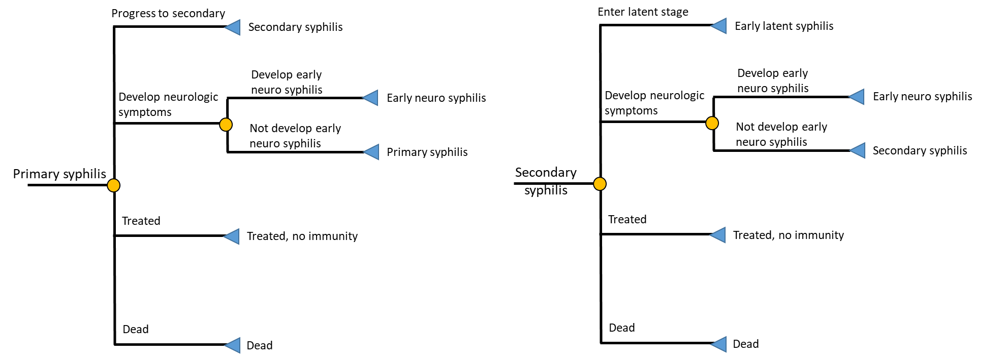

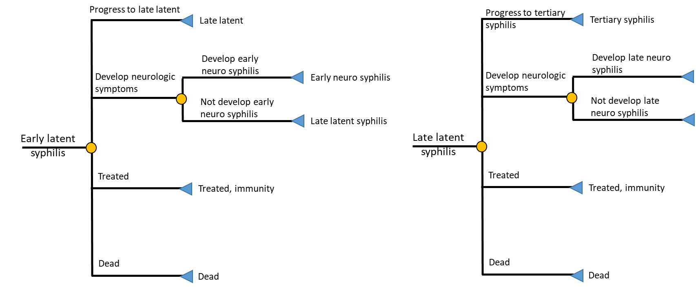

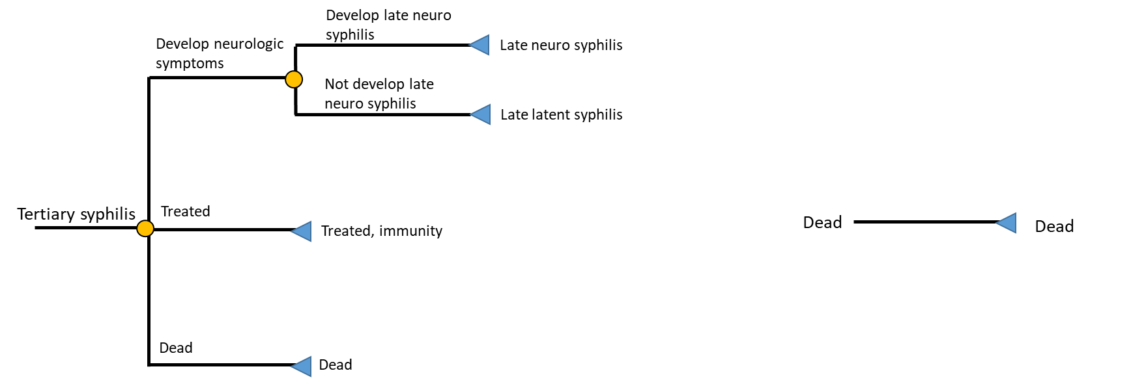

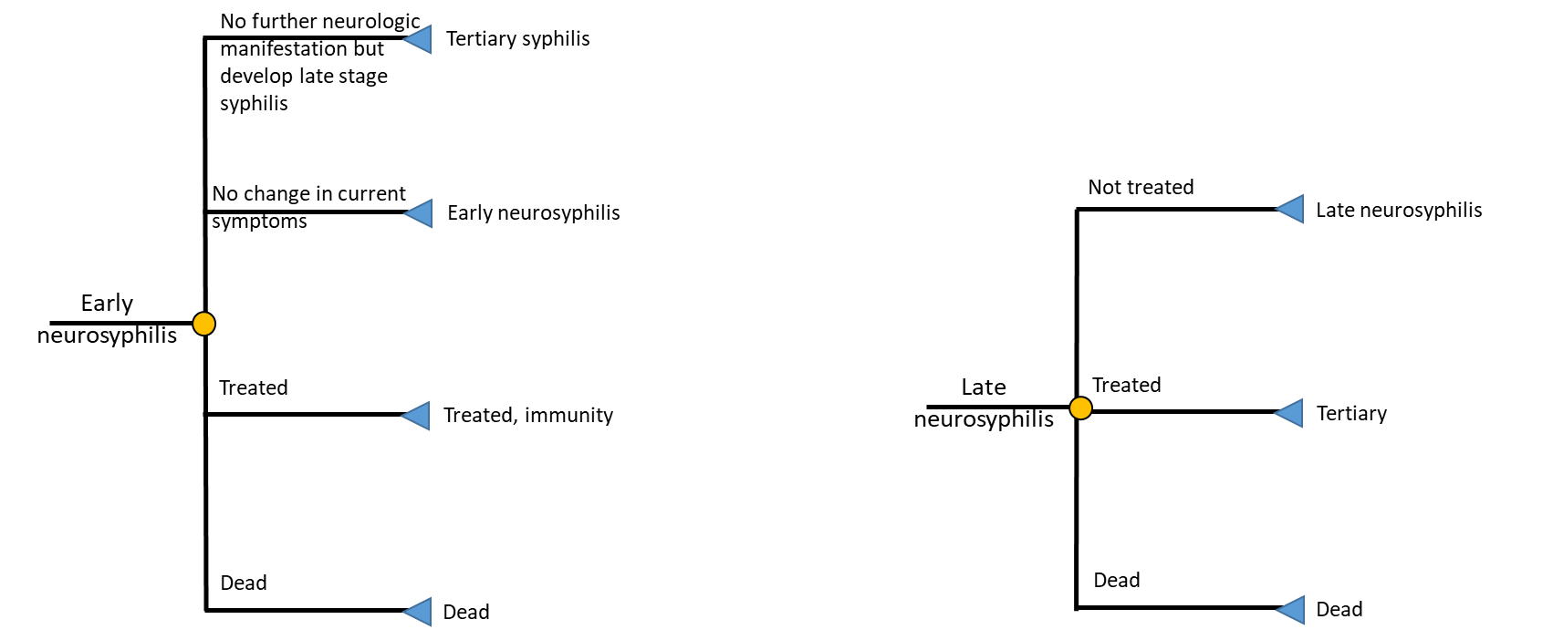

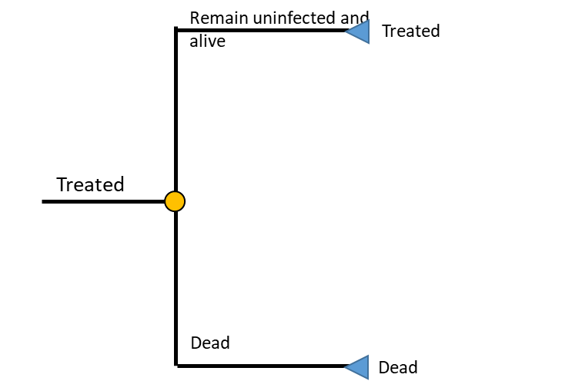

* For pregnant women, we added a tree structure to describe the stage of syphilis at pregnancy, screening and treatment coverage which will determine the risk of vertical transmission and consequent adverse pregnancy outcomes. Among pregnant women who are infected with syphilis, ‘infection during pregnancy’ indicates the subpopulation who have early stage syphilis (primary, secondary, or early latent). Most of pregnant women receive screening during first trimester and treatment if test positive. Those who failed to have screening and appropriate treatment have the risk of vertical transmission and consequent adverse pregnancy outcomes, whereas those who received screening and treatment would not have those outcomes. The risk of vertical transmission is very low among women who are in late stage of syphilis (late latent and tertiary, ‘Infection before pregnancy’).

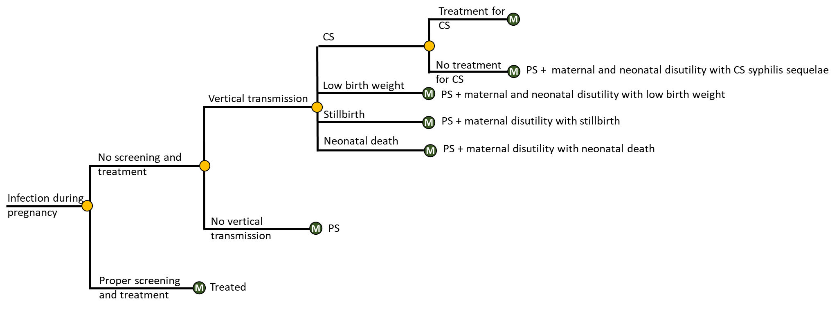

(CS: congenital syphilis; PS: Primary Syphilis)

*Assumptions*

* We do not model reinfection as we measure health outcomes per infection not per infected person (re-infection will be counted as a new infection)
* Sensitivity of the syphilis test is perfect (combination of antibody testing and antigen testing has fairly high sensitivity)
* Late neurosyphilis results in lifetime disutility and enter tertiary syphilis in the next cycle if treatment is successful
* Tertiary syphilis will have treatment every month but can be unsuccessful. Those who failed to get successful treatment will have higher mortality whereas those who received treatment successfully will have normal level of mortality but live with lifetime disutility (cannot go back to treated state)
* Rate of mother-to-baby transmission is higher if infection occurred during pregnancy
* Pregnancy does not alter the natural history of syphilis in women except for screening and treatment coverage
* Pregnant women who are screened for syphilis during the first trimester will receive effective treatment and hence do not have the risk of vertical transmission and other adverse pregnancy outcomes (Inclusion of syphilis screening in antenatal care by law and simple operation of treatment support this assumption)
* Adverse pregnancy outcomes occur one-time utility loss for mothers
* Congenital syphilis will be treated in any time during lifetime.
* Natural history of syphilis among men who have sex with men and men who have sex with women are the same except (maybe different screening frequency – higher screening rates among MSM)
* Baseline mortality for MSM population is same as that among MSW population (MSM population may have higher prevalence of HIV but in recent years, given improved mortality among HIV-infected patients, we here assume same all-cause mortality rate)

*Model variables (for all subpopulations)*

Variables below are applicable for all subpopulations of interest (MSM, MSW, non-pregnant women, pregnant women)

|  |  |
| --- | --- |
| Variable | Values [uncertainty] |
| **Natural history** |  |
| Average duration of infection stage (days) |  |
| Primary | 0.7 [0.25 – 3] |
| Secondary | 3.6 [0.5 – 6] |
| Early latent | 7.7 [3 – 11.4] |
| Probability of progressing from early neurosyphilis to tertiary syphilis | 0.25 [0.15 – 0.35] |
| Probability of developing neurologic symptoms | 0.33 [0.2 – 0.6] |
| Probability of developing neurosyphilis given neurologic involvement |  |
| Primary, secondary, early latent | 0.05 [0.03 – 0.09] |
| Late latent | 0.09 |
| Average time to develop tertiary syphilis (yr) | 20 [10 – 30] |
| Time to develop late neurosyphilis | 15 [2 – 30] |
| Probability of developing tertiary syphilis (gummatous and cardiovascular) | 0.25 |
| Probability of seeking treatment for syphilis symptoms |  |
| Primary | 0.35 |
| Secondary | 0.6 |
| Early latent | 0.1 |
| Late latent |  |
| Probability of recovery from symptomatic early neurosyphilis without disability, following treatment | 0.7 [0.54 – 0.83] |
| Probability of treatment failure |  |
| Primary, secondary, early latent | 0.05 [0 – 0.09] |
| Late syphilis (latent syphilis) | 0.19 [0.15 – 0.3] |
| **Mortality** |  |
| Tertiary | Age-specific hazard rate ratio from Tuskegee study |
| All other states | Age-specific baseline mortality |
| **Disutility of syphilis** |  |
| Primary | 0.0072 |
| Secondary | 0.041 |
| Early latent | 0 |
| Late latent | 0 |
| Neurosyphilis and tertiary | 0.094 |
| **Probability of seeking treatment for syphilis symptoms* (annual rate of screening and treatment)** | 0.11 |
| Primary (MSW) | 0.4 |
| Secondary (MSW) | 0.19 |
| Early latent (MSW) | 0.08 |
| Late latent (MSW) | 0.36 |
| Primary (MSM) | 0.4 |
| Secondary (MSM) | 0.19 |
| Early latent (MSM) | 0.08 |
| Late latent (MSM) | 0.11 |
| Primary (Non-pregnant women) | 0.4 |
| Secondary (Non-pregnant women) | 0.19 |
| Early latent (Non-pregnant women) | 0.08 |
| Late latent (Non-pregnant women) | 0.11 |
| **Probabilities of Screening and treatment for syphilis during pregnancy** |  |
| Attending antenatal care | 0.94 |
| Screening for syphilis during antenatal care visit | 0.85 |
| Receiving treatment for syphilis if test positive | 1 |
| Probability that treatment was successful | 0.9 |
| **Probability of vertical transmission if untreated** | 0.515 [0.4 – 0.7] |
| Probability of adverse pregnancy outcomes if vertical transmission occurred |  |
| Congenital syphilis |  |
| Low birth weight |  |
| Neonatal death |  |
| Still birth |  |
| **Disutility of mothers who have adverse pregnancy outcomes** |  |
| stillbirth | 0.08 [0.05 - 0.2] |
| Neonatal or infant death | 0.24 [0.2 - 0.3] |
| Congenital syphilis | 0.12 [0.1 - 0.3] |

***Results***

*Aggregated QALY loss due to syphilis*

We first calculated age-specific QALY losses (median age of an age bucket) and weighted them based on the proportion of total syphilis cases accounted by each age group.

|  |  |  |  |  |  |  |  |  |
| --- | --- | --- | --- | --- | --- | --- | --- | --- |
|  | **Weight** | | | **QALY Loss** | | | | |
|  | % of syphilis cases* (Male) | % of syphilis cases*  (Female) | Prevalence of pregnancy (%) | MSW | MSM | Non-pregnant women | Pregnant women | Weighted average among women |
| 0-4 | 0.00 | 0.13 | 0.00 | 3.166 | 3.115 | 3.361 | 0.960 | 3.361 |
| 5-9 | 0.00 | 0.03 | 0.00 | 2.939 | 2.892 | 3.133 | 0.896 | 3.133 |
| 10-14 | 0.02 | 0.38 | 0.04 | 2.720 | 2.667 | 2.904 | 0.832 | 2.903 |
| 15-19 | 4.06 | 8.79 | 11.03 | 2.485 | 2.445 | 2.676 | 0.768 | 2.466 |
| 20-24 | 17.59 | 22.78 | 11.03 | 2.269 | 2.232 | 2.451 | 0.705 | 2.259 |
| 25-29 | 22.44 | 21.36 | 15.01 | 2.058 | 2.025 | 2.229 | 0.642 | 1.991 |
| 30-34 | 16.04 | 14.75 | 15.01 | 1.849 | 1.819 | 2.009 | 0.580 | 1.794 |
| 35-39 | 11.70 | 11.58 | 4.79 | 1.641 | 1.615 | 1.791 | 0.519 | 1.730 |
| 40-44 | 7.46 | 7.58 | 4.79 | 1.434 | 1.411 | 1.575 | 0.459 | 1.522 |
| 45-54 | 13.96 | 8.97 | 0.00 | 1.113 | 1.095 | 1.238 | 0.364 | 1.238 |
| 55-64 | 5.46 | 3.14 | 0.00 | 0.920 | 0.731 | 0.839 | 0.252 | 0.839 |
| 65+ | 1.22 | 0.51 | 0.00 | 0.257 | 0.253 | 0.289 | 0.097 | 0.289 |
| Aggregated  QALY loss |  |  |  | **1.767** | **1.729** |  |  | **1.892** |

* Reported cases of primary and secondary syphilis (CDC)

QALY loss due to syphilis among men: (1-0.78) * 1.767 + 0.78 * 1.729 = **1.737 QALYs**

QALY loss due to syphilis among women: we weighted age-specific QALY loss among women based on the prevalence of pregnancy in each age group. Hence, the aggregated QALY loss among women is **1.892 QALYs**

[Things to add to this document]

* Parameter table with parameter values, ranges, and reference
* Intermediate outcomes (% of people who develop tertiary syphilis in age 60,70,80, % of people die from syphilis, others)
* Update results with discounted QALY loss
* Following up with Cathy

**Next step**

* Sensitivity analysis on model parameters and assumptions
* Faster disease progression for MSM population
* Higher baseline mortality for MSM compared to MSW (for now, multiplier = 1)
* Higher risk of syphilis for pregnant women