**Project Report**

**North East University Bangladesh**

Project Name: Gender Recognition by Voice

**Submitted to**

**Mr. Noushad Sojib**

Assist. Professor of CSE department, NEUB

**Submitted By**

Name : **Hamiduzzaman Noyon**

Reg no : 160303020004

Name: **Ahmed M A Mayeed**

Reg no: 160303020008

10th Semester

Course code : CSE 456

**Introduction:**

The human ear can easily detect the difference between a male or female voice within the first few spoken words. However, designing a computer program to do this turns out to be a bit trickier.

**Data Set:**

This database was created to identify a voice as male or female, based upon acoustic properties of the voice and speech.

The following acoustic properties of each voice are measured and included within the CSV:

* Meanfreq: mean frequency (in kHz)
* sd: standard deviation of frequency
* median: median frequency (in kHz)
* Q25: first quantile (in kHz)
* Q75: third quantile (in kHz)
* IQR: interquantile range (in kHz)
* skew: skewness (see note in specprop description)
* kurt: kurtosis (see note in specprop description)
* sp.ent: spectral entropy
* sfm: spectral flatness
* mode: mode frequency
* centroid: frequency centroid (see specprop)
* meanfun: average of fundamental frequency measured across acoustic signal
* minfun: minimum fundamental frequency measured across acoustic signal
* maxfun: maximum fundamental frequency measured across acoustic signal
* meandom: average of dominant frequency measured across acoustic signal
* mindom: minimum of dominant frequency measured across acoustic signal
* maxdom: maximum of dominant frequency measured across acoustic signal
* dfrange: range of dominant frequency measured across acoustic signal
* modindx: modulation index. Calculated as the accumulated absolute difference between adjacent measurements of fundamental frequencies divided by the frequency range
* label: male or female

**Sample Data:**

|  |  |  |
| --- | --- | --- |
| Name of properties | Data1 | Data2 |
| Mean Freq | 0.059780 | 0.179981 |
| sd | 0.064241 | 0.077964 |
| median | 0.03202 | 0.204276 |
| Q25 | 0.015071 | 0.127085 |
| Q75 | 0.090193 | 0.240377 |
| IQR | 0.075121 | 0.113291 |
| skew | 12.86346 | 2.76467 |
| kurt | 274.402905 | 12.822157 |
| Sp.ent | 0.893369 | 0.92742356 |
| sfm | 0.4919177 | 0.580274 |
| mode | 0 | 0.241551 |
| centroid | 0.05978 | 0.179981 |
| meanfun | 0.084279 | 0.162258 |
| minfun | 0.0157016 | 0.0168421 |
| maxfun | 0.275862 | 0.27586 |
| meandom | 0.00781 | 0.207331 |
| Min dom | 0.00781 | 0.05468 |
| Max dom | 0.00781 | 0.546875 |
| dfrange | 0 | 0.49218 |
| Mod indx | 0 | 0.3098412 |
| label | Male | Female |

**Steps:**

* The data was collected from Kaggle.com
* Extract the data into x and y.
* Running different algorithms for training.
* Predict the gender from testing data.

**\**

**Classification data:**

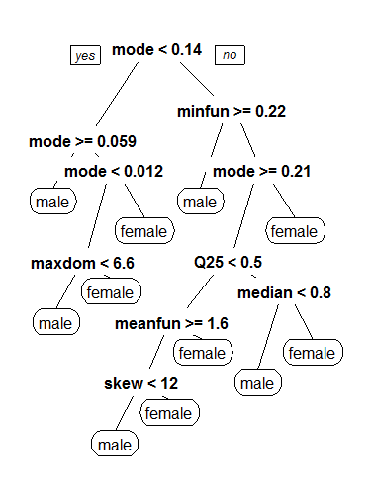

**Algorithms:**

* **Logistic Regression, accuracy: 90.69**
* **SVM, accuracy: 92.58**
* **Random Forest, accuracy: 98.42**

**Challenges:**

The problem arises in taking the voice and extract the features from the voice.

Screenshots:

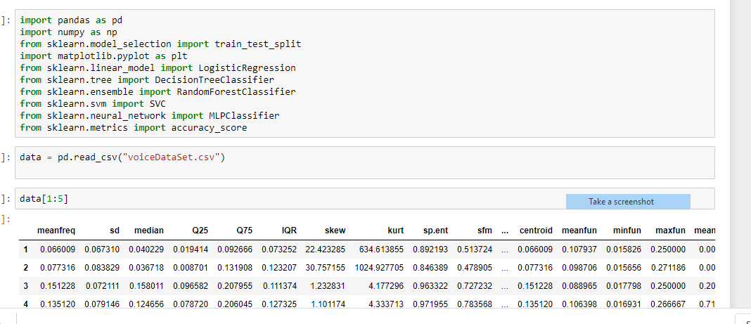1.

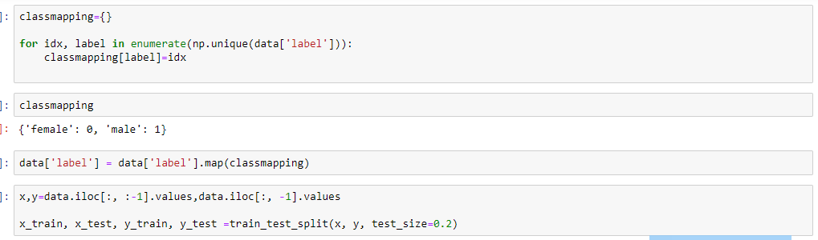2.

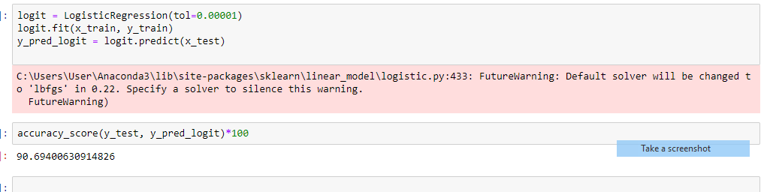

3.

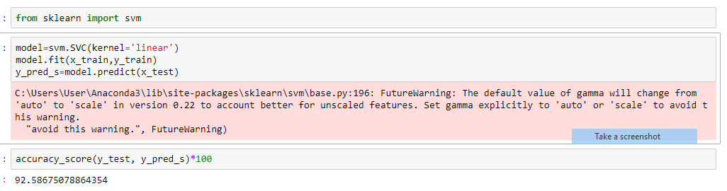4.

5.

