Assignment-12

Git version check:

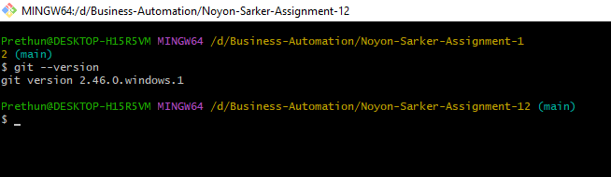

Git config details:

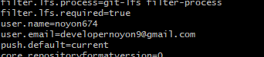

git status: Define the status of the directory

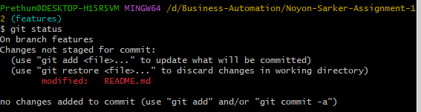

Git branch: shows how many branches here

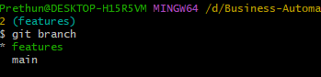

Git reset –hard HEAD^:

