1. **Prof. Dr. A B M Siddique Hossain** *(Dean, Faculty of Engineering, AIUB)  
     
   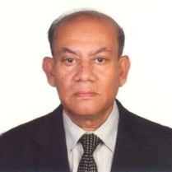*
2. **Prof. Dr. Md. Abdur Rahman** *(Director, Faculty of Engineering, AIUB)  
     
   *

1. **Chowdhury Akram Hossain *(****Senior Assistant Professor, Faculty of Engineering & Special Assistant, OSA)*