**Mentor:**  
1. **Md. Saniat Rahman Zishan** *(Senior Assistant Professor, Dept.  of EEE & CoE  
Special Assistant, OSA)  
  
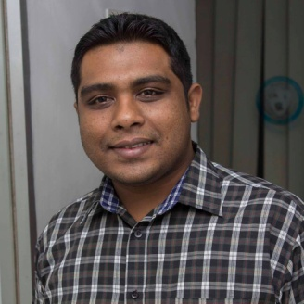*

**Motivators(Present):**1. **Safayet Ahmed** *(Lecturer, Faculty of Engineering, AIUB)*

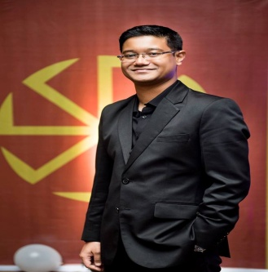

2. **Sumaiya Umme Hani** *(Senior Lecturer, Faculty of Engineering, AIUB)*

**Motivators(Ex):**1. **Syed Muhammad Baker** *(Lecturer, Faculty of Engineering, AIUB)  
  
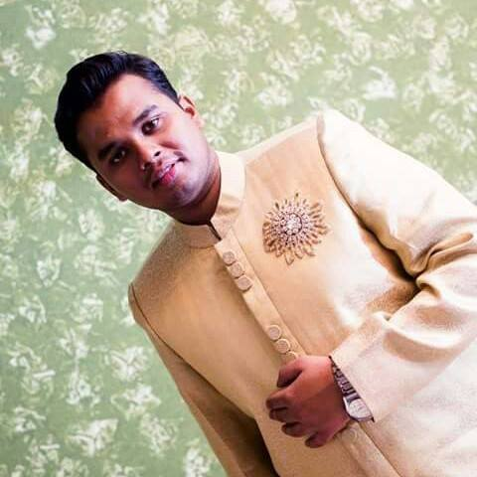*2. **Shahreen Hassan** *(Lecturer, Faculty of Engineering, AIUB)  
  
  
