Intergenerational Educational Mobility in Uzbekistan
Research Team
2026-04-03
Table of contents

Abstract
This paper studies intergenerational educational mobility in Uzbekistan using the 2010, 2016, and 2022-23 waves of the Life in Transition Survey (LiTS). It asks how strongly educational attainment is associated across generations, which household and regional characteristics are correlated with mobility, and what the 2022-23 child module suggests about household learning conditions during pandemic disruption.
The paper’s contribution is a reproducible multi-wave mobility profile built around descriptive and associational evidence. The national rank-rank slope rises from 0.133 in 2010 to 0.307 in 2016 and is 0.253 in 2022-23. A formal descriptive slope test rejects no change between 2010 and 2016 (p = <0.001) but not between 2016 and 2022-23 (p = 0.172). Parental-education missingness is concentrated in 2010; a transparent cell-based imputation sensitivity preserves the same cross-wave ordering, while extreme lower and upper bounds mainly widen uncertainty around the 2010 level. In nested pooled associational models, the 2016 persistence interaction remains positive across specifications, whereas the additional 2022 increment is not statistically distinguishable from either 2010 or 2016. The LiTS IV child module documents widespread disruption and household-based support, but adjusted parental-education gaps in education stoppage remain fragile across alternative split rules.
The results point to substantial educational persistence and to the importance of household support conditions. The statistically clearest strengthening is from 2010 to 2016; 2022-23 remains above the 2010 baseline, but the 2016-to-2022 difference is flatter and less precise. The child-module evidence does not identify a causal pandemic mechanism.

Introduction
Educational mobility links family background to the allocation of opportunity. When mobility is low, parental education remains a strong predictor of children’s schooling, and the distribution of skills is shaped more by inherited circumstance than by individual potential.
Uzbekistan is an important setting for this question. The country combines a young population, persistent regional inequality, and a policy agenda centered on human capital and productivity growth. At the same time, market transition, urbanization, higher-education expansion, and digital change have altered both the returns to schooling and the ways households support children’s learning.
This paper uses LiTS repeated cross-sections from 2010, 2016, and 2022-23 to provide a structured profile of intergenerational educational mobility in Uzbekistan. It makes three contributions. First, it documents national mobility patterns using a locked bundle of measures: a rank-rank slope, upward mobility, downward mobility, and same-category persistence. Second, it estimates a nested sequence of pooled associational models that separates pre-determined demographics from potentially endogenous current household controls. Third, it adds a short LiTS IV child-module extension on pandemic-era disruption and support patterns.
The claims are intentionally limited by design. Module A is descriptive, Module B is associational, and Module C is a bounded non-causal extension. Parental-education missingness is explicitly audited by wave, formal slope-difference tests are reported rather than inferred from visual gaps, and current household controls enter only as sensitivity layers rather than as clean pre-treatment adjustments. Descriptive persistence rises sharply from 2010 to 2016 and remains above the 2010 level in 2022-23, while the pooled persistence model indicates a clearer mid-period strengthening than any additional 2022 shift. The paper therefore emphasizes levels, correlates, and household constraints rather than a causal mechanism claim. Section 2 positions the paper in the literature, Section 3 describes the data and measurement choices, Sections 4-7 present the empirical design and results, and Sections 8-10 discuss interpretation, limitations, and conclusion.

Related Literature

Concepts and Measurement
Intergenerational educational mobility links family background to both equality of opportunity and the allocation of skills. When parental schooling strongly predicts children’s attainment, educational outcomes reflect inherited circumstances as well as effort and talent. For that reason, mobility matters not only as a fairness concern, but also as a compact way to ask whether schooling systems convert demographic growth and human potential into broadly shared opportunity or instead reproduce educational advantage across generations (Torche 2015; Causa and Johansson 2010; Neidhöfer et al. 2024).
The literature also cautions against treating any single statistic as a complete description of opportunity. Mobility measures summarize intergenerational association rather than recovering a full structural account of equality of opportunity, and recent evidence shows that cross-country rankings can move materially with coding choices, estimator selection, and sample definitions (Torche 2015; Strömberg and Engzell 2025). For a study built on repeated cross-sections with modest questionnaire differences across waves, that is a direct argument against relying on one headline number.
This paper therefore uses a locked bundle of category-based and rank-based measures. Category transitions retain an intuitive interpretation by asking whether respondents surpass, match, or fall below parental schooling categories. Rank-based measures are better suited to cross-wave comparison because they locate respondents within each wave’s educational distribution and are less sensitive to aggregate educational expansion and minor coding differences. The two families answer related but not identical questions: category rates preserve substantive interpretability, whereas rank-based persistence provides the preferred benchmark for comparing waves (Torche 2015; Weide et al. 2024; Strömberg and Engzell 2025).

Global Evidence and Developing-Country Patterns
Comparative evidence establishes three regularities. First, educational mobility varies widely across countries and cohorts rather than converging mechanically with development. Second, many developing settings still display lower average mobility than richer economies even after substantial educational expansion. Third, rising schooling access does not automatically weaken intergenerational persistence; broader participation can coexist with durable family-background gradients in who reaches upper-secondary and tertiary levels (Hertz et al. 2008; Weide et al. 2024; Duong 2024).
That point matters for interpretation. Expansion in average schooling is not itself evidence that opportunity has become less dependent on parental background. Earlier comparative work and more recent evidence from developing regions both show that cohort progress and persistent gradients can coexist for long periods (Chevalier, Denny, and McMahon 2009; Razzu and Wambile 2022). For the present paper, the lesson is that Uzbekistan should not be read through a simple modernization narrative in which broader access mechanically implies weaker educational inheritance.

Transition Economies, Comparator Settings, and the Uzbek Case
Transition settings are especially relevant because market liberalization, institutional restructuring, and uneven regional adjustment can alter both schooling opportunity and the household strategies through which education is reproduced. The post-socialist literature does not point to a single mobility path. Comparative evidence shows substantial heterogeneity across former socialist settings, and country studies suggest that common Soviet legacies do not determine later mobility outcomes on their own (Verashchagina 2012; Brück and Esenaliev 2018).
Kyrgyzstan is the closest Central Asian comparator in the published literature cited here, while Turkey provides a second disciplined comparison because it combines middle-income status with strong spatial disparities in school availability, household inputs, and educational inequality. Evidence from Turkey shows that mobility is higher in places with better schooling opportunity and stronger home resources, which helps motivate this paper’s attention to region, cohort, and place-based heterogeneity (Aydemir and Yazici 2019). Some comparator studies go further by exploiting reform-driven or provincial variation in schooling opportunity (Akarçay-Gürbüz and Polat 2017; Urbina 2018). Those papers are useful here not because the present study adopts their design, but because they clarify what a genuinely causal architecture would require and why the claims in this manuscript remain more limited. Broader evidence linking mobility to local development conditions likewise supports the inclusion of region and cohort effects while reinforcing an associational reading of the pooled coefficients (Guell et al. 2018; Neidhöfer et al. 2024).
Uzbekistan deserves separate attention rather than inference from neighboring settings or richer-country evidence alone. World Bank and UNICEF diagnostics point to persistent disparities across region, urban and rural location, gender, tertiary pathways, and the quality of household learning environments (World Bank 2018, 2024; UNICEF Uzbekistan 2020, 2024). These sources are not mobility designs, but they establish why parental education, place-based conditions, and household support capacity are plausible correlates of educational mobility in Uzbekistan and why a descriptive benchmark is policy-relevant even without a causal design. The tertiary margin is especially important. World Bank analysis of Uzbekistan’s higher-education system highlights long-standing constraints in access, quality, governance, and labor-market relevance (World Bank 2014). In a setting where bottlenecks remain strongest at advanced levels of schooling, intergenerational persistence may survive even when basic and secondary participation improve.
Recent mobility patterns also need to be read against a changed policy backdrop. Since 2017, Uzbekistan’s education system has moved through a broad reform cycle spanning preschool expansion, sector restructuring, renewed attention to quality and management, and major efforts to widen tertiary access. Official diagnostics and partnership documents frame this period as one of institutional reorganization and sustained reform priority rather than policy stasis (World Bank 2018; UNICEF 2024; UNICEF Uzbekistan 2024). For this paper, that context matters not as a source of clean treatment variation, but because the 2022-23 wave reflects an environment of expanded access and system change. At the same time, the reform literature continues to distinguish gains in access from the harder problems of quality, equity, and labor-market alignment (World Bank 2014, 2018). The manuscript therefore does not attribute observed mobility patterns to reforms; it treats reform as context that sharpens interpretation of cohort, place, and household differences.

Identification Limits and Contribution
The literature relevant to this project falls into three broad groups. One documents intergenerational mobility descriptively, using transition matrices, rank correlations, or related persistence measures to summarize how strongly children’s schooling tracks parental background. A second identifies causal effects of schooling access or reform by exploiting exogenous variation across place, cohort, or policy exposure. A third, especially after 2020, studies pandemic-era learning disruption and the unequal burden that school closures shifted back onto households (Urbina 2018; Alam and Tiwari 2020; Muñoz-Najar et al. 2021). These literatures are complementary, but they support different kinds of claims.
This paper belongs mainly in the first category. Its core evidence comes from repeated LiTS cross-sections rather than a panel following fixed families over time, so it can describe population-level persistence and estimate pooled correlates, but it cannot isolate within-family causal change or identify the effects of reforms. The same discipline applies to Module C. Global and Uzbekistan-specific pandemic evidence justifies asking whether lower-parent-education households report greater disruption, but the LiTS IV child module remains a small cross-sectional subsample and does not support a causal account of household mechanisms (Alam and Tiwari 2020; Muñoz-Najar et al. 2021; Iqbal and Patrinos 2025).
Taken together, the literature leaves a clear but modest empirical gap. Comparative work on intergenerational educational mobility is now extensive, developing-country evidence is growing, and post-socialist comparators are increasingly informative. For Uzbekistan, however, the evidence base remains weighted toward sector diagnostics and policy discussion rather than a reproducible multi-wave profile of how educational attainment is transmitted across generations. The contribution of this paper is therefore narrow by design but substantively useful: it provides a transparent benchmark for educational mobility in Uzbekistan using a locked bundle of persistence measures, a pooled associational framework, and a short descriptive child-module extension. Its aim is not to evaluate reforms or pandemic shocks, but to place Uzbekistan into the comparative mobility conversation with an empirical profile that is explicit about measurement choices, identification limits, and policy-relevant heterogeneity (Weide et al. 2024; Brück and Esenaliev 2018; World Bank 2018).

Data and Measurement

Core Data
The main source is the Life in Transition Survey (LiTS) for 2010, 2016, and 2022-23. These repeated cross-sections provide comparable information on respondents’ own education, parental education, age, sex, and place of residence. Regional labels are harmonized with a locked cross-wave mapping before pooled estimation; regional coverage still differs by wave, so regional results are interpreted as composition-conditional rather than fully balanced panel comparisons.
The analytical sample is restricted to respondents aged 25-64 so that own education is largely complete. Cohorts are grouped as 25-34, 35-44, 45-54, and 55-64. Weighted estimates are used throughout, and subgroup outputs are suppressed when the valid cell size is below 30.
The Household Budget Survey is used only as a supplementary source for context and construct validation, especially around household structure, migration, schooling expenses, tutoring, and internet access. Because direct parent-child linkage in HBS is only partially supported in the current audit, it is not the source of the intergenerational estimates reported here.

Education Measures
The paper uses two measurement families built from a common parental-education harmonization step. LiTS parental-schooling responses vary somewhat across waves in wording and granularity, so all observed mother and father responses are first mapped onto a common six-category ladder: no formal education, primary, lower secondary, upper secondary, post-secondary non-tertiary, and tertiary. In Modules A and B, when both parents are observed, the analysis uses the higher reported category as the parental education measure; when only one parent’s schooling is available, the observed value is retained. This rule keeps the main intergenerational comparison consistent across waves while limiting attrition from asymmetric parental reporting. Module C is narrower and uses the mean of observed mother and father years for the low-versus-high split, because a weighted median split built on the max-parent proxy would set the threshold at 16.0 years and leave 0 observations in the higher-parent comparison group. Appendix D2 shows that the rank-based national series is qualitatively stable under alternative parent constructions, although some category-based rates are more sensitive to whether the parent proxy uses the maximum, an average, or a single observed parent. The Module C split should therefore be read as a bounded within-module partition rather than as a directly comparable continuation of the max-parent gradient used in Modules A and B.
That harmonized ladder then supports two complementary measures. First, the paper constructs an ordered education score used for category-based mobility rates and pooled attainment regressions. Second, it converts both respondent and parental schooling into within-wave weighted percentile ranks for the rank-rank persistence models. The category-based outcomes preserve the intuitive language of upward mobility, downward mobility, and same-category persistence. The rank-based outcomes, by contrast, are better suited to cross-wave comparison because they are less sensitive to modest questionnaire differences and to aggregate educational expansion. Reporting both is therefore deliberate rather than redundant: one family preserves substantive interpretability, while the other provides the paper’s preferred cross-wave benchmark.

Mobility Outcomes
The main outcomes are:
- Rank-rank slope: the relationship between own education rank and parental education rank within each wave.
- Upward mobility: an indicator that own education exceeds parental education.
- Downward mobility: an indicator that own education is lower than parental education.
- Persistence: an indicator that own education remains at the same category as parental education.
These measures are reported nationally and, where the denominator permits, by subgroup.

Covariates
The pooled correlates models are estimated as a nested sequence. All specifications include region, cohort, and wave fixed effects. The minimal specification includes only the parental education term or interaction of interest. The demographic specification adds two clearly pre-determined controls, urban residence and female. The extended specification then adds current household variables that pass the project’s coverage screen. In the current data this extended layer includes migration exposure and multigenerational household structure; the household income proxy is still classified as potentially endogenous but is not retained in the active extended model because its cross-wave coverage is too uneven. The extended controls are therefore reported as sensitivity variables rather than as clean pre-treatment adjustments.

Pandemic Mechanism Variables
The 2022-23 LiTS child module is used to create descriptive indicators for remote-learning disruption, learning support, and home-learning constraints. These include switching to online learning, switching to hybrid learning, education stopping during COVID, school closure without online learning, shared-device use, support from mother, father, or relatives, and indicators for internet, device, cost, and time-balance challenges.
The mechanism sample is much smaller than the full LiTS IV sample. The child-module flow moves from 1006 Uzbekistan respondents in LiTS IV to 650 with child-module eligibility information, 186 with a child enrolled before COVID, and 183 with non-missing parental schooling. This extension is therefore used to illustrate patterns rather than to support broad generalization.

Empirical Strategy
The empirical strategy has three modules and uses one compact notation throughout. Let $Y_{iw}$ denote respondent $i$’s educational outcome in wave $w$, and let $P_{iw}$ denote parental education measured on the corresponding scale. In Module A, $Y_{iw}$ and $P_{iw}$ are within-wave education ranks. In Module B, $Y_{i}$ alternates across respondent rank, the harmonized education score, an indicator for upward mobility, and an indicator for same-category persistence; $P_{i}$ likewise denotes parental rank, the parental education score, or a set of parental education-category indicators. $U_{i}$ and $F_{i}$ indicate urban residence and female, $X_{i}$ collects migration exposure and multigenerational household structure, $D_{ti}$ is a wave indicator for $t∈\{2016,2022\}$ with 2010 as the omitted category, and $μ_{r}$, $λ_{c}$, and $τ_{w}$ denote region, cohort, and wave effects. In Module C, $L_{i}$ indicates low parental education.

Module A: Mobility Levels and Trends
The first module estimates national mobility levels by wave. Its core descriptive specification is:
$$Y_{iw}=α_{w}+β_{w}P_{iw}+ε_{iw}$$
where $Y_{iw}$ and $P_{iw}$ are respondent and parental education ranks within wave $w$. The coefficient $β_{w}$ is the within-wave persistence slope: larger values imply that respondent rank tracks parental rank more closely and therefore signal lower relative mobility. The same module also reports weighted rates of upward mobility, downward mobility, and same-category persistence on the harmonized categorical scale.

Module B: Correlates of Mobility
The second module estimates pooled correlates models with region, cohort, and wave fixed effects. Its pooled benchmark is:
Yi=α+βPi+t∈{2016,2022}​θtPi×Dti+ρ1Ui+ρ2Fi+Xi′γ+μr+λc+τw+εi
In the persistence-trend specification, $Y_{i}$ is respondent rank and $P_{i}$ is parental rank, so $θ_{t}$ captures whether the parent-child gradient in wave $t$ differs from 2010 after conditioning on controls and fixed effects. In the attainment model, $Y_{i}$ becomes the harmonized education score and $β$ is the conditional association between parental and respondent schooling. In the upward-mobility model, $P_{i}$ is replaced by parental education-category indicators, so the coefficients compare transition probabilities relative to the upper-secondary reference group. The persistence heterogeneity model keeps the same pooled structure but augments it with $P_{i}×U_{i}$, $P_{i}×F_{i}$, and $P_{i}×D_{2022,i}$. Throughout, the coefficients are interpreted as conditional associations rather than causal effects.

Module C: Pandemic-Era Mechanisms
The third module uses the 2022-23 child module to document disruption and household-support patterns by parental education group. In the main text, Module C is reported descriptively through weighted outcome rates and low-versus-high parental-education splits. Adjusted region-fixed-effects logits are retained only as appendix diagnostics because split support is unstable in this sample under stricter thresholds and alternative parent proxies. Module C is therefore interpreted as bounded descriptive evidence, not as a stable adjusted mechanism and not as a causal design.

Descriptive Results

Sample Composition and Completeness
Before turning to the mobility estimates, Table Table 1 establishes the analytical base by wave. The age-restricted Uzbekistan LiTS samples contain 1,157 respondents in 2010, 1,240 in 2016, and 794 in 2022-23. The 2022-23 wave is somewhat more female in the unweighted analytical sample, although the weighted estimation sample is much closer to balanced, while the cohort mix remains centered on the younger and middle adult cohorts in all three surveys.
Parental-education missingness is not uniform across waves. After harmonization, respondents’ own education is fully observed in all three waves, while weighted parental-education missingness is 17.4 percent in 2010, 4.3 percent in 2016, and 0.8 percent in 2022-23. Missing-parent cases are older and somewhat less educated in 2010 and 2016: the weighted age gap is about 2.564 years in 2010 and 7.517 years in 2016, while the weighted own-schooling gap is about -0.321 and -1.437 years, respectively. Missingness therefore threatens level comparability most clearly in the earliest wave rather than disappearing as a concern.
Table 1: Analytical sample composition and completeness by LiTS wave.
Wave | Valid N | Female share | Urban share | Cohort shares (25-34 / 35-44 / 45-54 / 55-64) | Own education missing | Parental education missing
2010 | 1,157 | 61.6 percent | 33.4 percent | 33.8 / 30.3 / 22.9 / 13.1 | 0.0 percent | 18.9 percent
2016 | 1,240 | 54.7 percent | 41.7 percent | 25.6 / 26.6 / 24.5 / 23.3 | 0.0 percent | 4.4 percent
2022-23 | 794 | 66.9 percent | 36.5 percent | 32.7 / 29.2 / 23.4 / 14.6 | 0.0 percent | 1.9 percent

Table Table 1 combines the published Tier A sample and completeness outputs with simple analytical-sample composition shares from the harmonized LiTS file. Appendix D3 adds missing-versus-observed diagnostics and simple sensitivity checks. A wave-by-cohort-by-sex-by-urban mode-imputation sensitivity moves the national rank-rank slopes to 0.115, 0.290, and 0.252, while even the extreme all-low and all-high assignments preserve the same wave ordering of the national slopes. The safest interpretation is therefore that parental-education missingness widens uncertainty around levels, especially in 2010, but does not mechanically create the 2016 peak.

National Mobility Metrics by Wave
Table Table 2 reports the paper’s locked national mobility measures in a by-wave layout. The rank-rank slope rises from 0.133 in 2010 to 0.307 in 2016 and is 0.253 in 2022-23; the corresponding 95 percent confidence intervals are [0.075, 0.190], [0.254, 0.359], and [0.195, 0.310]. The formal raw slope-difference test shows a statistically clear increase from 2010 to 2016 of 0.174 (p = <0.001), but a 2016-to-2022 change of only -0.054 (p = 0.172). Category-based rates tell a similar broad story, with persistence rising and downward mobility falling in the later waves.
The harmonized denominator is now aligned across the rank and category measures within each wave. In 2022-23, both the rank-rank slope and the category-based rates rely on 779 valid observations. The main caution is therefore inferential rather than mechanical: the 2022 national estimates remain noisier than the 2016 values, and several subgroup or regional intervals are wide.
Table 2: National mobility metrics by LiTS wave.
Wave | Rank-rank slope (95% CI) | Upward mobility | Downward mobility | Persistence | Valid N
2010 | 0.133 [0.075, 0.190] | 30.5 percent | 25.4 percent | 44.1 percent | 936
2016 | 0.307 [0.254, 0.359] | 25.6 percent | 18.1 percent | 56.3 percent | 1,186
2022-23 | 0.253 [0.195, 0.310] | 24.6 percent | 8.1 percent | 67.3 percent | 779

Table Table 2 and Figures Figure 1 and Figure 2 tell the same high-level story: educational persistence is substantial in every wave, the statistically clear descriptive increase occurs between 2010 and 2016, and the 2022-23 profile remains more persistent than the 2010 baseline without clearly exceeding the 2016 peak once uncertainty is shown.
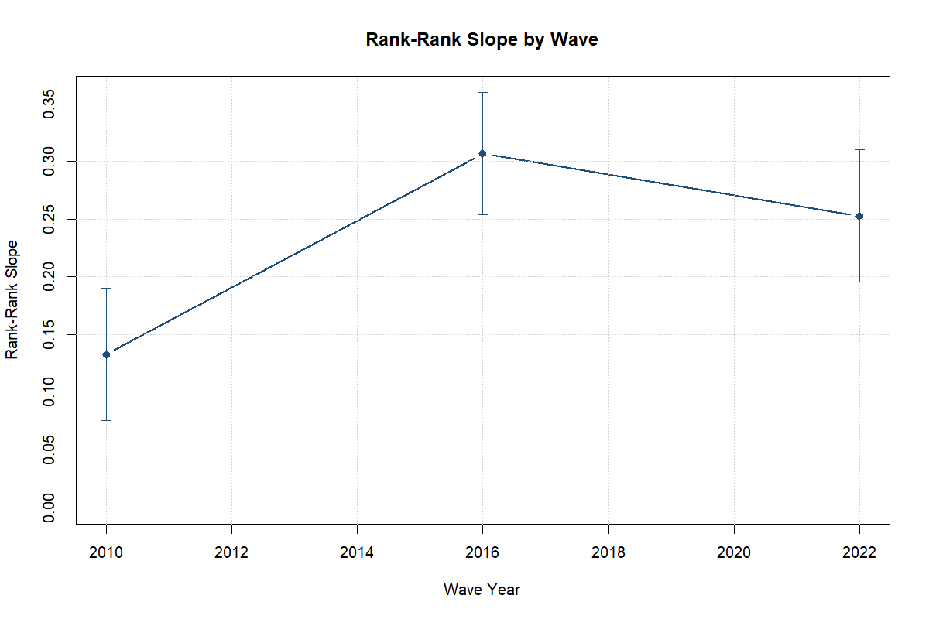
Figure 1: Rank-rank slope by LiTS wave.

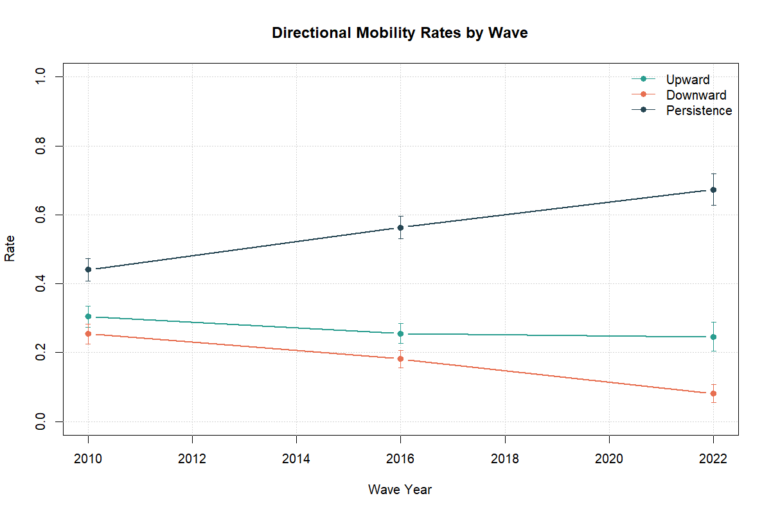
Figure 2: Directional mobility rates by LiTS wave.

Transition Structure
The by-wave rates are easier to interpret alongside the transition structure in Table Table 3. In both 2010 and 2016, respondents from lower-secondary and primary parental origins most often reach upper secondary, while respondents from upper-secondary parental origins remain concentrated in the same category. This is consistent with a system that permits some upward movement from lower origins but still exhibits strong persistence around the upper-secondary category that dominates the analytical sample.
The 2022-23 transition matrix remains thin at the lowest parental origins, but it is no longer confined to a single usable row. The tertiary parental-origin row shows 87.3 percent same-category persistence out of 503 valid cases, while the upper-secondary parental-origin row shows 63.0 percent movement into tertiary and 36.4 percent same-category persistence out of 263 valid cases. The main takeaway is that the transition evidence reinforces strong persistence at the top of the ladder while lower-origin 2022 rows remain too sparse for fine-grained inference.
Table 3: Transition structure for parental-origin categories with usable cell counts.
 | Wave | Parental origin | Own: Primary | Own: Lower secondary | Own: Upper secondary | Parent-origin N
2 | 2010 | Primary | 2.7 percent | 20.1 percent | 65.6 percent | 48
1 | 2010 | Lower secondary | 0.6 percent | 25.5 percent | 60.9 percent | 232
3 | 2010 | Upper secondary | NA | 18.0 percent | 69.7 percent | 433
5 | 2016 | Primary | NA | 14.2 percent | 56.1 percent | 39
4 | 2016 | Lower secondary | NA | 17.1 percent | 49.6 percent | 187
6 | 2016 | Upper secondary | NA | 6.0 percent | 64.3 percent | 429

Descriptive Heterogeneity

Cohort Profiles
Figure Figure 3 shows that the rank-based persistence gradient differs across cohorts, even though all cohort profiles remain positive. The youngest adult cohort moves from a slope of 0.181 in 2010 to 0.196 in 2022-23, while the oldest cohort stays closer to one quarter throughout the period. These are descriptive cross-cohort differences rather than cohort effects identified from a panel.
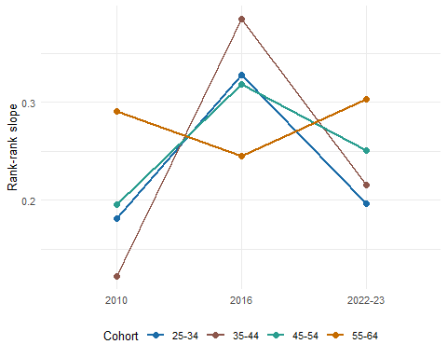
Figure 3: Rank-rank persistence by cohort and LiTS wave.
The main takeaway is that cohort profiles are heterogeneous in levels, but they do not overturn the broader descriptive picture of substantial persistence across all waves.

Regional Variation
Regional dispersion is most legible in the rank-based measure, because the 2022 category-based regional outputs remain sparse for many origin cells. Figure Figure 4 ranks the 2022-23 regional slopes and shows a wide descriptive spread around the national slope of 0.253. The highest observed persistence appears in Tashkent city at 0.734, while Khorezm region sits near 0.036. These regional differences are descriptive and several intervals remain wide, so they should be read as dispersion rather than ranked certainty.
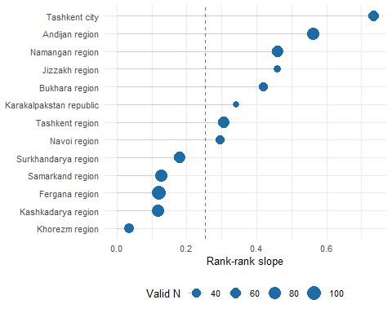
Figure 4: Regional dispersion in the 2022-23 rank-rank slope.
The main takeaway is that regional differences are descriptively large enough to matter for interpretation, even though the paper does not treat them as identified regional effects and several regional estimates remain imprecise.

Subgroup Split
Figure Figure 5 brings one existing subgroup visual into the main text. The urban-rural split is worth showing because it connects directly to the paper’s pooled correlates framework, but it should still be read as descriptive because the figure is based on the category-coded upward-mobility rate rather than the paper’s preferred rank-based trend benchmark.
The companion gender split is not promoted to the main text because the 2022-23 male category-mobility sample is only 260 with a weighted effective N of about 164.9, which makes that panel less informative than the urban-rural comparison.
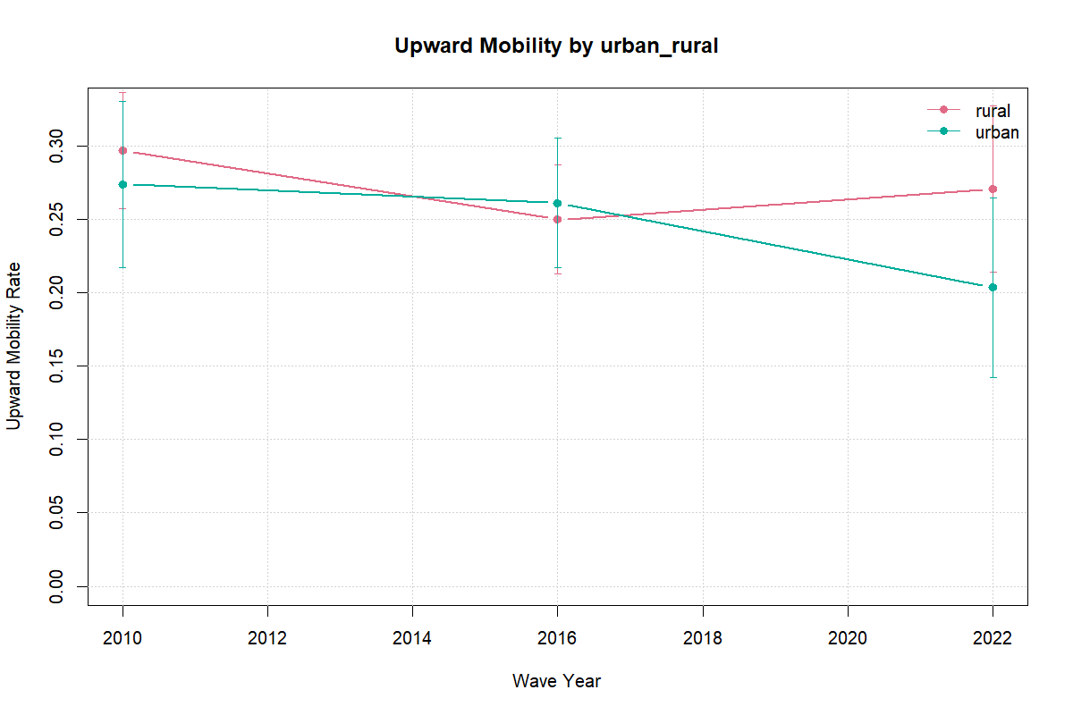
Figure 5: Upward mobility by urban and rural residence.
The main takeaway is that subgroup descriptives are useful for orientation, but the rank-based national series remains the most reliable summary of cross-wave mobility levels.

Correlates of Educational Mobility

Pooled Persistence-Trend Model
The pooled rank-based persistence models keep the same fixed-effects structure and vary only in how much additional adjustment is imposed. Across the three nested specifications, the implied conditional 2010 parent-child slope ranges from 0.139 to 0.154, the 2016 slope ranges from 0.310 to 0.314, and the 2022-23 slope ranges from 0.251 to 0.248. The substantive picture is stable across specifications: the conditional association is strongest in 2016, and the 2022-23 gradient is closer to 2016 than to a full reversal back to 2010.
The formal conditional tests mirror the descriptive ones. The 2010-to-2016 slope increase remains positive in the minimal, demographic, and extended specifications at 0.171, 0.156, and 0.160, with p-values <0.001, <0.001, and <0.001. By contrast, the 2016-to-2022 difference is negative but imprecise in all three specifications (-0.059, -0.062, and -0.065; p-values 0.286, 0.273, and 0.244). The pooled evidence therefore supports persistence and a mid-period strengthening more clearly than a monotonic worsening in every later wave.

Attainment-Score Model
The attainment-score regression shows the most stable parental association in the paper. The parental education score coefficient is 0.235 in the minimal model, 0.243 after adding urban residence and female, and 0.245 in the extended specification. This stability is useful substantively because it shows that the central parental-education association is not being created by the additional current household controls.
That result should still be read associationally. Urban residence and female are treated as background adjustment variables, while migration exposure and multigenerational household structure are current household characteristics that may themselves be shaped by education, migration, marriage, or later-life family responses. The extended specification is therefore a sensitivity layer rather than a cleaner design. The central correlates result is narrow but robust: parental educational background remains the strongest and most stable predictor in the pooled attainment model.

Raw Versus Conditional Trend Interpretation
The raw descriptive and conditional associational profiles are close. The national raw slopes are 0.133, 0.307, and 0.253, while the extended conditional slopes are 0.154, 0.314, and 0.248. Conditioning therefore does not overturn the headline profile or suggest that the 2016 peak is purely an artifact of observed demographic composition.
At the same time, the subgroup checks show that the descriptive increase is not uniform across every group. The 2010-to-2016 rise is larger and more precisely estimated among women, rural respondents, and the 35-44 cohort than among men, urban respondents, or the oldest cohort. The safest interpretation is therefore that the rise in persistence between 2010 and 2016 is only partly compositional and not equally strong in every subgroup, while the flatter 2016-to-2022 pattern should be read as a combination of composition and substantive change that the current repeated cross-sections cannot fully separate.

Upward Mobility Models
The upward-mobility linear probability models are retained as secondary associational diagnostics. They continue to show that upward transitions are mechanically more common from lower starting positions on the parental education ladder, but these category-based coefficients are not the paper’s preferred cross-wave trend evidence.
Because these models are anchored to a coarse six-category ladder and the same current household controls discussed above, they are best used to orient transition patterns rather than to motivate stronger design claims. Appendix D4 reports the fuller coefficient tables.

Heterogeneity in Persistence
The same-category persistence heterogeneity models are also retained as associational diagnostics rather than as headline evidence. They continue to show a positive association between parental education score and remaining in the same category, but those interaction patterns are more specification-dependent than the core rank-based and attainment results.
In particular, the positive 2022 interaction in these secondary category-based models does not overturn the more cautious reading from the preferred rank-based specifications: the paper’s strongest evidence is a 2010-to-2016 strengthening, not a clean step-up in every later wave. Table Table 4 summarizes the main nested parental coefficients.
Table 4: Nested associational estimates for the main parental coefficients.
 | Model | Specification | Term | Estimate | Std. Error | P-value
7 | Persistence trend | Demographic | Parent rank (2010 slope) | 0.153 | 0.041 | 0.002
8 | Persistence trend | Demographic | 2016 minus 2010 slope | 0.156 | 0.047 | 0.005
9 | Persistence trend | Demographic | 2022-23 minus 2010 slope | 0.095 | 0.067 | 0.180
10 | Attainment score | Demographic | Parent education score | 0.243 | 0.021 | <0.001
13 | Persistence trend | Extended | Parent rank (2010 slope) | 0.154 | 0.041 | 0.002
14 | Persistence trend | Extended | 2016 minus 2010 slope | 0.160 | 0.047 | 0.005
15 | Persistence trend | Extended | 2022-23 minus 2010 slope | 0.094 | 0.067 | 0.182
16 | Attainment score | Extended | Parent education score | 0.245 | 0.022 | <0.001
1 | Persistence trend | Minimal | Parent rank (2010 slope) | 0.139 | 0.037 | 0.003
2 | Persistence trend | Minimal | 2016 minus 2010 slope | 0.171 | 0.046 | 0.003
3 | Persistence trend | Minimal | 2022-23 minus 2010 slope | 0.112 | 0.064 | 0.106
4 | Attainment score | Minimal | Parent education score | 0.235 | 0.020 | <0.001

Household Support Environment from HBS
Supplementary HBS evidence is used here only to characterize the household support environment around schooling, not to replace the core LiTS intergenerational estimates. Across pooled HBS 2021-2025 households, 65.7 percent had an enrolled member, 62.6 percent reported positive education spending, 14.2 percent reported tutoring, 16.3 percent had an emigrant member, and 14.8 percent received remittances; internet access is observed for 79.7 percent of households in the 2021-2024 internet module. These patterns provide context for interpretation by showing that schooling support, migration-linked resources, and connectivity constraints sit inside the same household environment as the LiTS persistence patterns. A separate companion note extends the same HBS layer descriptively across years, urban-rural settings, regions, and high-versus-low expansion groupings without introducing HBS mobility estimates.
The HBS linkage diagnostics in Appendix H also show why HBS remains supplementary. Under a conservative co-resident linkage rule, only 9.3 percent of HBS adults ages 25-64 are linkable, and that linked sample is materially younger and much less female than the full adult sample. HBS therefore informs the household support environment, but it is not a direct substitute for the headline LiTS intergenerational estimates.
Table 5: Supplementary HBS household support environment, pooled 2021-2025.
Household support indicator | National | Urban | Rural
Households with enrolled members | 65.7 percent | 63.5 percent | 67.9 percent
Households with positive education spending | 62.6 percent | 60.3 percent | 64.9 percent
Households with tutoring | 14.2 percent | 14.2 percent | 14.1 percent
Households with emigrant member | 16.3 percent | 13.2 percent | 19.4 percent
Households receiving remittances | 14.8 percent | 11.9 percent | 17.8 percent
Remittance households using remittances for education | 19.6 percent | 20.3 percent | 19.1 percent
Households with internet access | 79.7 percent | 79.6 percent | 79.8 percent

Bounded LiTS IV Child Module Extension

Sample and Disruption Profile
The child-module extension is deliberately kept secondary to Modules A and B. It is based on 183 respondents with a child enrolled before COVID and non-missing parental schooling. Table Table 6 reports the sample flow.
Within this restricted sample, disruption and household substitution were substantial: 78.3 percent report education stoppage during COVID, 75.8 percent report at least one remote-learning challenge, and mothers are reported as the learning-support channel in 87.0 percent of cases. Additional descriptive splits and the fragility checks for the mechanism regressions are reported in the technical appendix so that the main text remains focused on the strongest facts.
The bridge from Modules A and B to Module C requires one explicit caveat. Modules A and B use the harmonized max-parent measure because it is the most stable adult-sample proxy across waves. Module C instead uses mean observed parent years only to create a low-versus-high split inside the much smaller 2022-23 child-module sample; under the max-parent weighted median rule, the higher-parent comparison group collapses to 0 observations. Module C should therefore be interpreted as a bounded within-module contrast, not as a directly comparable continuation of the main max-parent gradient.
Table 6: LiTS IV child-module sample construction for Uzbekistan.
Step | N
Uzbekistan LiTS IV respondents | 1006.0
Respondents with child module eligibility info (q713 non-missing) | 650.0
Respondents with child enrolled pre-COVID (q713 = yes) | 186.0
Mechanism sample with non-missing parental schooling | 183.0
Baseline parental-schooling median threshold (mean parent years) | 13.5
Baseline low-parent-education group size (mean parent years) | 114.0
Baseline higher-parent-education group size (mean parent years) | 69.0

Main Module C Takeaway
The main-text conclusion is descriptive. Under the baseline weighted median split, stoppage rates are nearly identical: 78.2 percent among children from lower-parent-education households versus 78.0 percent among those from higher-parent-education households. Together with the high overall disruption rates, this supports a practical reading centered on widespread household learning constraints rather than a precise adjusted parent-gap effect.
Appendix fragility diagnostics explain why adjusted split-based coefficients are not used as headline evidence. Under the strict <=9 split, the low-parent-education group falls to 7 observations (vs 176 in the comparison group), yielding a degenerate-support scenario (degenerate_low_group_support). Under the weighted median split with the project-wide max-parent proxy, the higher-parent group falls to 0 observations. Module C therefore contributes bounded descriptive evidence on household vulnerability and learning support, not a stable adjusted parental-education gradient and not causal evidence on pandemic mechanisms.

Discussion and Policy Implications
Three broad conclusions emerge from the analysis.
First, Uzbekistan exhibits substantial intergenerational educational persistence. Descriptive persistence rises strongly from 2010 to 2016 and remains above the 2010 level in 2022-23, but the statistically clear change is the 2010-to-2016 increase rather than the 2016-to-2022 comparison. The pooled rank-based associational models reproduce that same pattern across the minimal, demographic, and extended specifications.
Second, parental education is the most consistent predictor in the pooled correlates models. The main attainment association changes little when the specification moves from parental education alone to demographic adjustment and then to the extended household-control sensitivity. The data provide much less clear evidence that migration exposure or multigenerational household structure independently explain mobility once the core fixed effects are added, and those variables should not be given a causal interpretation in any case because they may themselves be endogenous to later-life outcomes.
Third, the pandemic mechanism evidence underscores the practical importance of household learning conditions. Device sharing, internet quality, and time- or cost-related constraints were common, and support was overwhelmingly provided by mothers. What the child module establishes most clearly is the scale of disruption and household substitution, not a robust adjusted stoppage gap by parental education.
These findings imply several policy priorities. The first is to reduce the degree to which educational attainment depends on parental background through earlier remedial support, stronger transitions across schooling stages, and wider access to quality secondary and post-secondary pathways. The second is to address spatial and household bottlenecks directly. Even without a precise pooled urban coefficient, the broader descriptive evidence points to local infrastructure, service access, and household support conditions as meaningful constraints on mobility.
The third priority is to strengthen household support capacity in periods of disruption. The child module shows that digital inclusion is not only a question of nominal internet access, but also of connection quality, device availability, and adults’ ability to help children learn. A related implication is that education policy should recognize mothers’ support burden as a real part of learning continuity rather than assume that home-based adjustment is costless inside the household.

Limitations
This paper has five main limitations.
First, the three LiTS waves are repeated cross-sections rather than a panel, so changes over time should be interpreted as changes in population-level patterns rather than changes within fixed families.
Second, parental-education missingness is concentrated in 2010 and is not random on observables: missing-parent cases are older and somewhat less educated in the earlier waves. The simple imputation and extreme-bound checks preserve the qualitative wave ordering, but they leave the 2010 level less tightly pinned down than the later waves.
Third, the comparability of some parental education information across waves is imperfect, which is why the rank-based measures are more reliable than some category-based comparisons.
Fourth, several 2022-23 subgroup and regional estimates remain noisy even after the harmonized denominator problem is resolved. The national 2022 profile is informative, but some disaggregated category-based and regional comparisons still have wide confidence intervals or sparse origin cells. Inference also relies on region-clustered standard errors without an extra small-sample correction, so marginal p-values should be read cautiously.
Fifth, the pandemic mechanism module is based on a limited child subsample and is not a causal design. Its adjusted parental-education coefficients are also fragile across weighting and threshold choices, so it is useful for describing disruption and support patterns rather than for establishing a stable mechanism.
These limitations do not undermine the central contribution of the paper, but they do shape the appropriate scope of the conclusions.

Conclusion
This paper provides structured multi-wave evidence on intergenerational educational mobility in Uzbekistan using LiTS 2010, 2016, and 2022-23. The results indicate substantial educational persistence across generations. The statistically clearest strengthening is from 2010 to 2016; 2022-23 remains above the 2010 baseline, but the 2016-to-2022 difference is flatter and less precise. The pooled associational models reproduce that same mid-period strengthening across nested specifications and continue to show parental education as the clearest predictor of children’s educational attainment.
The extension based on the LiTS IV child module shows that pandemic-era learning disruption was widespread and that household support, especially maternal support, was central to learning continuity. The same extension does not provide robust adjusted evidence that lower parental education raised the probability that education stopped during COVID.
The broader message is that improving educational mobility in Uzbekistan will require more than expanding formal access. It will require reducing the degree to which family background governs educational trajectories, especially through the unequal household conditions under which children study, recover from shocks, and convert schooling opportunities into completed attainment.

References
Akarçay-Gürbüz, Asli, and Seher Polat. 2017. “Schooling Opportunities and Intergenerational Educational Mobility in Turkey.” Working Paper. Piri Reis University; Yildiz Technical University.
Alam, Andaleeb, and Priyanka Tiwari. 2020. “Putting the ‘Learning’ Back in Remote Learning.” UNICEF Office of Global Insight; Policy. https://www.unicef.org/globalinsight/media/1086/file/UNICEF-Global-Insight-remote-learning-issue-brief-2020.pdf.
Aydemir, Abdurrahman B., and Huseyin Yazici. 2019. “Intergenerational Education Mobility and the Level of Development: Evidence from Turkey.” European Economic Review 116: 160–85. https://doi.org/10.1016/j.euroecorev.2019.04.003.
Brück, Tilman, and Damir Esenaliev. 2018. “Post-Socialist Transition and Intergenerational Educational Mobility in Kyrgyzstan.” Economics of Transition 26 (1): 61–89. https://doi.org/10.1111/ecot.12136.
Causa, Orsetta, and Asa Johansson. 2010. “Intergenerational Social Mobility in OECD Countries.” Working Paper 707. OECD Economics Department. https://doi.org/10.1787/223106258208.
Chevalier, Arnaud, Kevin Denny, and Dorren McMahon. 2009. “A Multi-Country Study of Inter-Generational Educational Mobility.” In Education and Inequality Across Europe, edited by Peter Dolton, Rita Asplund, and Erling Barth. Cheltenham: Edward Elgar.
Duong, Khanh. 2024. “What Really Matters for Global Intergenerational Mobility?” PLOS ONE 19 (6): e0302173. https://doi.org/10.1371/journal.pone.0302173.
Guell, Maia, Michele Pellizzari, Giovanni Pica, and Jose V. Rodriguez Mora. 2018. “Correlating Social Mobility and Economic Outcomes.” The Economic Journal 128 (612): F353–403. https://doi.org/10.1111/ecoj.12599.
Hertz, Tom, Tamara Jayasundera, Patrizio Piraino, Sibel Selcuk, Nicole Smith, and Alina Verashchagina. 2008. “The Inheritance of Educational Inequality: International Comparisons and Fifty-Year Trends.” The B.E. Journal of Economic Analysis & Policy 7 (2). https://doi.org/10.2202/1935-1682.1775.
Iqbal, Syedah Aroob, and Harry Anthony Patrinos. 2025. “Learning During the Pandemic: Evidence from Uzbekistan.” Prospects. https://doi.org/10.1007/s11125-025-09736-w.
Muñoz-Najar, Alberto, Alison Gilberto, Amer Hasan, Cristobal Cobo, João Pedro Azevedo, and Maryam Akmal. 2021. “Remote Learning During COVID-19: Lessons from Today, Principles for Tomorrow.” World Bank. https://documents.worldbank.org/en/publication/documents-reports/documentdetail/160271637074230077/remote-learning-during-covid-19-lessons-from-today-principles-for-tomorrow.
Neidhöfer, Guido, Matias Ciaschi, Leonardo Gasparini, and Jorge Serrano. 2024. “Social Mobility and Economic Development.” Journal of Economic Growth 29 (2): 327–59. https://doi.org/10.1007/s10887-023-09234-8.
Razzu, Giovanni, and Ayago Wambile. 2022. “Four Decades of Intergenerational Educational Mobility in Sub-Saharan Africa.” The Journal of Development Studies 58 (5): 931–50. https://doi.org/10.1080/00220388.2021.2008366.
Strömberg, Ely, and Per Engzell. 2025. “How Robust Are Country Rankings in Educational Mobility?” Sociological Science 12: 891–922. https://doi.org/10.15195/v12.a36.
Torche, Florencia. 2015. “Intergenerational Mobility and Equality of Opportunity.” Archives Européennes de Sociologie 56 (3): 343–71. https://doi.org/10.1017/S0003975615000181.
UNICEF. 2024. “Partnership Compact for Education Reform.” UNICEF Uzbekistan. https://www.unicef.org/uzbekistan/en/reports/partnership-compact-education-reform.
UNICEF Uzbekistan. 2020. “Situation Analysis of Children in Uzbekistan 2019/2020.” UNICEF Uzbekistan. https://www.unicef.org/uzbekistan/en/press-releases/unicef-launches-situation-analysis-uzbekistan-children-and-warns-covid-19-pandemic.
———. 2024. “Situation Analysis of Children and Adolescents in Uzbekistan.” UNICEF Uzbekistan. https://www.unicef.org/uzbekistan/en/reports/situation-analysis-children-and-adolescents-uzbekistan.
Urbina, Daniela R. 2018. “Intergenerational Educational Mobility During Expansion Reform: Evidence from Mexico.” Population Research and Policy Review 37 (3): 367–417. https://doi.org/10.1007/s11113-018-9466-4.
Verashchagina, Alina. 2012. “Education and Socioeconomic Mobility in Post-Communist Countries.” In Social Exclusion: Short and Long-Term Causes and Consequences, edited by Giuliana Parodi and Dario Sciulli. AIEL Series in Labour Economics. Heidelberg: Springer.
Weide, Roy van der, Christoph Lakner, Daniel Gerszon Mahler, Ambar Narayan, and Rakesh Gupta. 2024. “Intergenerational Mobility Around the World: A New Database.” Journal of Development Economics 166: 103167. https://doi.org/10.1016/j.jdeveco.2023.103167.
World Bank. 2014. “Uzbekistan: Modernizing Tertiary Education.” World Bank. https://hdl.handle.net/10986/27992.
———. 2018. “Uzbekistan Education Sector Analysis.” AUS0000586. World Bank. https://documents.worldbank.org/en/publication/documents-reports/documentdetail/648681587857648494/uzbekistan-education-sector-analysis-final-report.
———. 2024. “Country Gender Assessment: Uzbekistan.” World Bank. https://thedocs.worldbank.org/en/doc/752717e92c8ad1476bc6cb007bae8f1a-0080012024/original/uz-country-gender-assessment-2024-uz-pdf.pdf.

