Educational Opportunity in Uzbekistan Still Depends Too Much on Family Background
  - Why the next phase of reform should focus on equity in learning, transition, and completion
Research Team
2026-04-03
 Executive Summary
Uzbekistan has entered a new phase of education reform. Since 2017, the system has expanded, especially in tertiary education (World Bank 2014, 2018; UNICEF 2024; UNICEF Uzbekistan 2024). That progress matters. But expansion does not by itself equalize opportunity. This brief uses the project’s core evidence from LiTS 2010, 2016, and 2022-23 to ask how strongly children’s educational outcomes still depend on family background.
Three findings stand out. First, educational attainment still tracks parental education closely. The paper’s preferred rank-based persistence measure rises from 0.13 in 2010 to 0.31 in 2016 and is 0.25 in 2022-23. The clearest strengthening is from 2010 to 2016; the 2016-to-2022 pattern is flatter and less precise. Second, household conditions matter sharply when schooling is disrupted. In the LiTS IV child module, 76 percent of households report at least one remote-learning challenge, and mothers are reported as the main support channel in 87 percent of observed cases. Third, recent expansion should be welcomed, but larger systems do not automatically become fairer systems.
The policy takeaway is direct: the next phase of reform should focus not only on adding places, but on who can learn well, move through key transitions, enter tertiary education on fair terms, and complete it successfully.

Why This Matters Now
Uzbekistan’s education system has changed substantially since 2017. Sector diagnostics and reform documents describe broad restructuring, renewed attention to preschool and school quality, and a major push to widen access to higher education (World Bank 2014, 2018; UNICEF 2024; UNICEF Uzbekistan 2024). That shift is visible in the project’s verified administrative series. Between academic years 2019/20 and 2024/25, the number of higher education institutions rose from 119 to 222, total students rose from 440,991 to 1,432,810, and bachelor admissions rose from 128,730 to 360,110 (Statistical Agency under the President of the Republic of Uzbekistan 2025). Demand remained high as well: verified official data record 1.66 million bachelor applications in 2022/23 (Statistical Agency under the President of the Republic of Uzbekistan 2025).
Expanding access is essential in a country that wants stronger human capital, higher productivity, and broader opportunity. But once more students can enter the system, the policy question is no longer only how many places exist. It is also who is prepared to use them, who can afford to stay, and who reaches completion with meaningful learning.
That is why intergenerational educational mobility matters now. It is a practical test of whether opportunity is spreading beyond families that already have educational advantages. If parental background remains a strong predictor of attainment even after access expands, reform has reached only part of the equity problem.
The post-2017 reforms are important context for interpretation in this brief. They are not used here as causal proof. This project does not estimate the causal effect of reforms, university expansion, or admissions growth on mobility outcomes.

The Policy Problem
When educational attainment depends heavily on parental education, the costs are economic as well as social. Talent is filtered through family circumstances before it reaches the labor market. Students from less educated households are more likely to face weaker preparation, more fragile transitions between school stages, and greater risk of dropout when costs or shocks rise. Over time, that reduces the efficiency of public investment in education. A system can expand on paper while still underusing a large share of national ability.
For Uzbekistan, this is not an abstract concern. Recent reform documents place strong emphasis on quality, relevance, and inclusion (World Bank 2018, 2024; UNICEF Uzbekistan 2024). If family background continues to shape who advances and who completes, then educational expansion will deliver less than it could for inclusive growth.
The policy issue is not whether access should keep expanding. It should. The issue is whether the next stage of reform is equally serious about learning conditions, transition points, and completion risks for students from less advantaged homes. Mobility evidence helps identify that gap.

What The Evidence Shows

Finding 1. Educational attainment still tracks family background
The core message is straightforward: family background still matters strongly for educational attainment in Uzbekistan. The paper’s preferred rank-based measure of persistence rises from 0.13 in 2010 to 0.31 in 2016 and is 0.25 in 2022-23. The clearest strengthening is from 2010 to 2016; 2022-23 remains above the 2010 baseline, but the 2016-to-2022 difference is flatter and less precise.
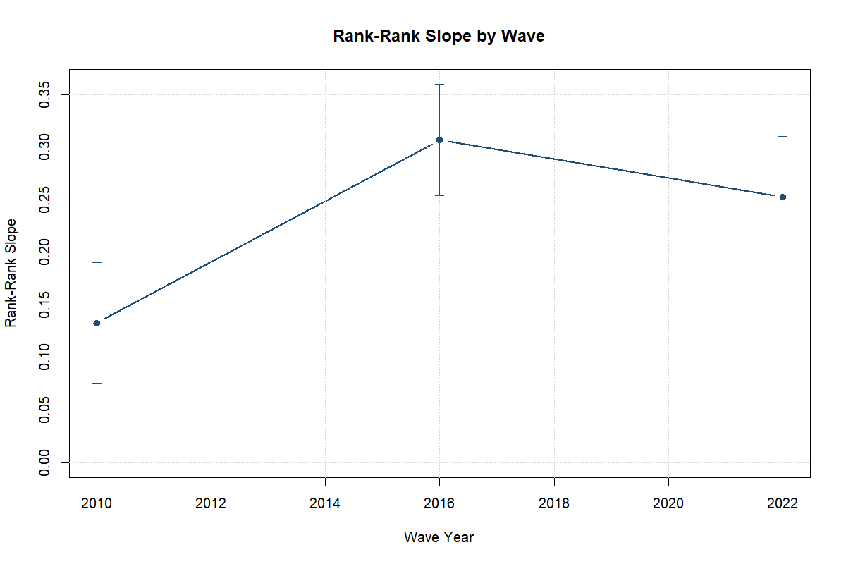
Educational persistence remains substantial across LiTS waves. Higher values indicate a stronger link between parental and own education rank.
The simpler category-based measures tell the same broad story. Same-category persistence rises from 44 percent in 2010 to 56 percent in 2016 and 67 percent in 2022-23. That series is useful as a directional check, but the rank-based measure remains the better cross-wave benchmark because it is less sensitive to category coding and educational expansion.
The pooled models reinforce that reading. Once the analysis adds cohort, region, and wave controls, the data support a stronger parent-child gradient in 2016 than in 2010. The 2022-23 gradient remains above the 2010 baseline, but it is less clearly distinct from 2016. The evidence is strongest on substantial persistence levels, not on a claim that mobility worsened monotonically in every later period.
Parental education is also the most stable predictor in the pooled attainment model. Other observed correlates, such as urban residence, migration exposure, and multigenerational household structure, are not estimated as consistently once the model includes the fixed effects and controls used in the project. For decisionmakers, the implication is simple: equalizing access alone does not break the link between parents’ schooling and children’s eventual attainment.
The transition matrix points in the same direction. In 2022-23, 87 percent of respondents from tertiary-educated households also reach tertiary education. That does not mean upward movement is absent. It means the top of the ladder remains highly secure for families already positioned there.

Finding 2. Household conditions shape learning, especially during disruption
The LiTS IV child module is not the main mobility design, but it adds a useful policy lens. It shows how much learning continuity can depend on household conditions when schooling is disrupted.
The first point is scale. In the Uzbekistan child-module sample, 78 percent report that a child stopped education during COVID at some point, 76 percent report at least one remote-learning challenge, 73 percent report internet-related difficulties, 63 percent report device-related constraints, and 61 percent report shared-device use. These are not minor frictions. They are large household barriers to sustaining learning.
The second point is substitution. Schooling continuity did not rest only on formal institutions. It shifted heavily onto families. Mothers are reported as the main learning-support channel in 87 percent of observed cases, while fathers are reported in only 4 percent. Learning continuity therefore depended heavily on unpaid support that is not evenly available across homes.
The descriptive splits also point in the same direction. Any remote-learning challenge is reported by 78 percent of lower-parent-education households, compared with 73 percent of higher-parent-education households. Internet challenges are also more common in the lower-parent-education group.
The brief also keeps an important boundary. The adjusted model for education stoppage does not show a stable parental-education gap once controls are added. The child-module evidence is therefore strongest on disruption, home-learning barriers, and household support burdens. It is not a causal estimate of pandemic effects, and it does not establish a robust adjusted stoppage mechanism by parental education alone.

Finding 3. Expansion in access does not automatically equalize opportunity
Uzbekistan’s recent expansion in tertiary access is real and policy-relevant. But the LiTS results show why expansion should not be treated as the same thing as equal opportunity. A system can become larger while family background still shapes who converts access into completed attainment.
Household context matters here. Supplementary HBS evidence is not used for the headline mobility estimates, but it helps show the environment in which students and families are making education decisions. Across pooled HBS 2021-2025 households, 63 percent report positive education spending, 14 percent report tutoring, 15 percent receive remittances, and about 80 percent report internet access. These indicators also vary across regions; for example, positive education spending ranges from about 54 percent to 69 percent in the pooled regional overlays. They are not mobility measures. They are signals that the costs of staying on track in education still sit partly inside the household.
That matters for reform design. When admissions expand, students from better-educated or better-resourced families are still more likely to benefit if they have stronger preparation, more information, more stable connectivity, more spending capacity, or more adult support at home. Expansion can widen opportunity. It does not guarantee that the newly available opportunity is used evenly.
The policy implication is not to slow expansion. It is to complete it. The next stage of reform should ask not only whether more students can enter the system, but whether students from less educated households can learn, transition, persist, and graduate on fair terms. That is the equity test this evidence puts on the table.

Policy Recommendations

A. Protect learning for students from lower-resource households
The first priority is early risk reduction. That means moving beyond broad access measures and intervening at the stages where students are most likely to fall behind: late primary to lower secondary, lower to upper secondary, and upper secondary to post-secondary entry.
Schools and local authorities should use short diagnostic assessments at the start of the academic year to identify students with learning loss and fund structured catch-up support rather than generic remediation. The highest-yield package is likely to include small-group tutoring, time-bound catch-up modules in core subjects, and transition support around exam years and school-stage changes. Where schools identify concrete constraints, support should extend beyond the classroom. Device lending, short-term connectivity support, transport or meal assistance, and simple caregiver guidance can all help protect continuity when the barrier is household-based rather than strictly academic.
This is especially important because the child-module evidence shows that learning shocks are absorbed inside households. Policy should not assume that every family can provide the same home support at the same cost.

B. Make tertiary expansion more equitable, not only larger
The second priority is to treat tertiary expansion as an equity agenda as well as a capacity agenda. New places matter. But the mobility evidence suggests that students from more educated families remain better positioned to convert those places into attainment.
In practice, that means focusing on access, persistence, and completion together. Outreach should target first-generation and non-tertiary-origin applicants earlier, while they are still in secondary school. Information on pathways, fees, scholarships, dormitory options, and admissions procedures should be provided through schools rather than left to informal networks. At entry, institutions should strengthen first-year academic advising, bridge support, and foundation modules for students arriving with weaker preparation. For students already admitted, small but predictable support can matter: need-based aid, dormitory access, transport support, and early-alert systems for dropout risk are often more useful than large but thinly spread programs.
The policy test should also change. Expansion should not be judged only by admissions counts or the number of institutions. It should be judged by whether students from less advantaged backgrounds enter, stay, and complete at higher rates over time.

C. Build an equity-monitoring system
The third priority is to monitor who benefits from expansion. Uzbekistan already has a reform narrative around access. It now needs a routine equity dashboard.
That dashboard should combine survey and administrative indicators. On the survey side, periodic modules should continue to capture parental education, household learning conditions, and key mobility benchmarks. On the administrative side, the Ministry and partner institutions should track regional and socioeconomic patterns in upper-secondary completion, tertiary entry, first-year retention, and graduation. Where possible, these indicators should be disaggregated by region, gender, and markers of disadvantage.
The point is not to create a large reporting burden. It is to make reform visible in equity terms. If admissions rise but persistence gaps do not narrow, policy should be able to see that quickly and respond.

Limits Of The Evidence
This brief relies mainly on descriptive and associational evidence from repeated LiTS cross-sections. It shows how strongly adult educational outcomes still track parental background and how household conditions shaped learning during disruption, but it does not identify the causal effect of post-2017 reforms, university expansion, or pandemic policy responses. The HBS layer is supplementary household context, not a source of headline intergenerational mobility estimates. The child-module extension is also based on a much smaller subsample and is best used to describe disruption and support patterns rather than to isolate a stable mechanism. Fuller methods, diagnostics, and robustness checks are reported in the companion main paper and technical appendix.

Data Sources And Further Reading
This brief draws primarily on LiTS 2010, 2016, and 2022-23 for intergenerational mobility, the LiTS IV child module for disruption and household-support patterns, supplementary HBS 2021-2025 context tables, and a verified official higher-education administrative series compiled for the project (Statistical Agency under the President of the Republic of Uzbekistan 2025).
For full methods, tables, and robustness checks, see the companion main paper and technical appendix in this project.

References
Statistical Agency under the President of the Republic of Uzbekistan. 2025. “Official Higher Education Administrative Series for Uzbekistan, Academic Years 2019/20–2024/25.”
UNICEF. 2024. “Partnership Compact for Education Reform.” UNICEF Uzbekistan. https://www.unicef.org/uzbekistan/en/reports/partnership-compact-education-reform.
UNICEF Uzbekistan. 2024. “Situation Analysis of Children and Adolescents in Uzbekistan.” UNICEF Uzbekistan. https://www.unicef.org/uzbekistan/en/reports/situation-analysis-children-and-adolescents-uzbekistan.
World Bank. 2014. “Uzbekistan: Modernizing Tertiary Education.” World Bank. https://hdl.handle.net/10986/27992.
———. 2018. “Uzbekistan Education Sector Analysis.” AUS0000586. World Bank. https://documents.worldbank.org/en/publication/documents-reports/documentdetail/648681587857648494/uzbekistan-education-sector-analysis-final-report.
———. 2024. “Country Gender Assessment: Uzbekistan.” World Bank. https://thedocs.worldbank.org/en/doc/752717e92c8ad1476bc6cb007bae8f1a-0080012024/original/uz-country-gender-assessment-2024-uz-pdf.pdf.

