Intergenerational Educational Mobility in Uzbekistan
  - Main Paper
Research Team
2026-03-27
Table of contents

Abstract
This paper studies intergenerational educational mobility in Uzbekistan using the 2010, 2016, and 2022-23 waves of the Life in Transition Survey (LiTS). The analysis asks three questions. First, how persistent is educational attainment across generations in Uzbekistan, and how has that persistence changed over time? Second, which household and regional characteristics are associated with higher or lower mobility? Third, what do pandemic-era child-learning disruptions in the 2022-23 LiTS child module suggest about the relationship between parental background and educational support during a period of severe schooling disruption?
The main contribution of the paper is to provide a reproducible multi-wave profile of educational mobility in Uzbekistan while keeping the interpretation of the evidence disciplined. The core analysis is descriptive and associational. A pandemic-era child-module extension is used as suggestive mechanism evidence rather than as a causal design. Across waves, the rank-rank association between parents’ and children’s educational position rises from 0.133 in 2010 to 0.299 in 2016 and 0.350 in 2022-23, indicating stronger persistence over time in the rank-based measure. Category-based mobility measures point in the same direction, although the valid 2022 denominator is much smaller and should be interpreted cautiously. In pooled regressions, parental education remains a strong predictor of attainment, while women have somewhat lower attainment scores conditional on controls. In the 2022-23 child module, remote-learning disruption was widespread and support was concentrated inside the household, especially among mothers. Low parental education is associated with a higher likelihood that a child’s education stopped during the pandemic, but these mechanism results are based on a limited subsample and should be treated as suggestive.
The findings imply that educational persistence remains substantial in Uzbekistan and that household-level constraints continue to shape mobility. Policy design should therefore emphasize equalization of educational opportunity through access, support capacity, and digital learning conditions, especially when shocks force learning back into the home.

1. Introduction
Educational mobility matters because it connects family background to the long-run allocation of talent. In a highly mobile society, children from low-education households can still acquire the skills needed to access high-productivity jobs and contribute to innovation-led growth. In a low-mobility society, family background remains a strong predictor of educational attainment, reinforcing inequality across generations.
This question is especially important in Uzbekistan. The country combines a young population, persistent regional inequality, and a policy agenda centered on human capital, technology adoption, and productivity growth. These conditions make educational mobility more than a distributional issue: it is also a growth issue. If educational opportunity remains strongly tied to parental background, the country risks underusing the potential of a large cohort of young people.
Uzbekistan also provides a substantively interesting setting for intergenerational mobility research. Family structure remains important, multigenerational living arrangements are common, migration affects household roles, and neighborhood-level social organization continues to influence everyday life. At the same time, market transition, urbanization, higher-education expansion, and digital change have reshaped the returns to schooling and the pathways through which parents support their children.
This paper provides a structured empirical assessment of intergenerational educational mobility in Uzbekistan using repeated LiTS cross-sections from 2010, 2016, and 2022-23. It makes three contributions.
First, it documents national trends in intergenerational educational persistence using a locked set of mobility measures: a rank-rank slope, upward mobility, downward mobility, and persistence probabilities. Second, it examines correlates of mobility using a disciplined set of household and regional controls. Third, it adds a short mechanism section using the 2022-23 LiTS child module to describe how pandemic-era learning disruption and support patterns varied by parental education.
The paper is deliberately cautious in its claims. The core evidence is descriptive and associational. The pandemic-era mechanism section is used to illustrate plausible household channels but is not interpreted causally. This is a feature rather than a weakness of the design: the paper is organized around the strongest parts of the available data rather than around claims the data cannot credibly support.
The rest of the paper proceeds as follows. Section 2 places the paper in the literature. Section 3 describes the data and variable construction. Section 4 sets out the empirical strategy. Section 5 presents the main results on mobility levels and trends. Section 6 reports the correlates analysis. Section 7 presents the pandemic-era mechanism evidence from LiTS IV. Section 8 discusses interpretation and policy implications. Section 9 concludes.

2. Related Literature

1. Intergenerational educational mobility and why it matters
The paper belongs to the literature on intergenerational educational mobility, which studies the association between parents’ schooling and the schooling ultimately attained by their adult children. This literature treats educational persistence as substantively important for two related reasons. First, schooling is one of the main channels through which socioeconomic advantage is reproduced across generations. Second, education is often measured more comparably than income or wealth in lower- and middle-income settings, making it a practical entry point for mobility analysis.
Classic comparative work shows that educational persistence differs sharply across countries and has not fallen uniformly over time. Hertz et al. (2008) document large regional differences in parent-child schooling correlations across a 42-country sample and show that the global average persistence in schooling remained substantial over roughly fifty years. OECD work by Causa and Johansson (2010) likewise shows that parental background remains strongly associated with educational and labor-market outcomes in most countries studied, while also emphasizing the potential role of policy and institutions in shaping mobility.
More recent cross-country evidence reinforces those points. The Global Database on Intergenerational Mobility (GDIM) assembled by van der Weide, Lakner, Mahler, Narayan, and Gupta (2024) extends education-mobility estimates to 153 economies and provides a global reference point for comparing levels and cohort patterns of mobility. For the present paper, the main lesson from the GDIM literature is not that Uzbekistan can be ranked precisely against every comparator, but that educational mobility in lower-income settings tends to remain more constrained than in richer ones and that country-specific evidence remains valuable where national studies are thin.

2. Measure choice: why this paper uses a small locked bundle of mobility measures
The mobility literature uses many related but non-identical measures. Some studies rely on parent-child schooling correlations or regressions in years of schooling. Others use categorical transition matrices, probabilities of upward movement, or rank-based measures. Torche (2015) is especially useful here because it explains that intergenerational mobility measures are informative about opportunity structures while also warning against treating them as exact stand-ins for a complete measure of equality of opportunity. That perspective fits the present paper closely.
The measurement issue matters even more because educational mobility estimates can be quite sensitive to operational choices. Strömberg and Engzell (2025) show that cross-country rankings in educational mobility can move substantially depending on coding, ranking, and modeling decisions. Their result does not imply that mobility measures are uninformative. Instead, it implies that a careful paper should avoid relying on a single headline metric. This is exactly why the present study uses a compact, pre-committed set of measures: a rank-rank slope, transition matrices, upward mobility, downward mobility, and same-category persistence. Together, these measures offer a more robust profile of mobility than any one metric alone.
This measure bundle also matches the data realities of the Uzbekistan study. Because the three LiTS waves differ somewhat in how parental education is recorded, a within-wave rank approach is useful for relative comparisons, while harmonized education categories are useful for transition matrices and interpretable mobility rates. The literature therefore supports the current design choice: use multiple transparent measures, explain what each one captures, and avoid overclaiming from any single statistic.

3. Transition and post-socialist settings
A second strand of the literature focuses on mobility in transition or post-socialist settings. This strand is especially relevant because Uzbekistan combines Soviet legacies, market transition, regional inequality, and rapid policy change. Yet the transition literature does not support a simple expectation such as “mobility must rise after socialism” or “transition necessarily reduces mobility.” Instead, it shows substantial variation across countries and cohorts.
Verashchagina’s comparative work on post-communist countries is useful in this respect. Across 13 countries in Central Europe and the former Soviet space, she finds no single long-run path of educational inheritance and notes that in several countries educational persistence strengthened during the transition period. Brück and Esenaliev (2018) provide the closest Central Asian comparator in their study of Kyrgyzstan using repeated surveys from 1993, 1998, and 2011. They find that Kyrgyzstan maintained relatively high educational mobility by regional standards, broadly comparable to Soviet-era levels, even as the country underwent difficult economic transition. This matters because it shows that a Central Asian transition economy can maintain substantial mobility under some conditions.
Turkey provides another useful comparator because it is a middle-income country with significant regional disparities and a large education expansion history. Aydemir and Yazici (2019) show that educational mobility in Turkey varies strongly with regional development and family background. Akarçay-Gürbüz and Polat (2017) go further by using exogenous provincial variation in schooling opportunities to estimate a causal effect of expanded schooling opportunity on mobility. Their paper is valuable here not because it should be copied directly, but because it clarifies what a stronger causal mobility design looks like: it requires validated external variation in schooling opportunities over place and time.
Taken together, this transition literature justifies the paper’s comparative framing. Uzbekistan should not be treated as a generic developing country case or as a mechanically predictable post-socialist case. It is better viewed as an under-documented transition setting in which mobility patterns are theoretically important and empirically open.

4. Uzbekistan context: why the case matters
The country-specific literature and policy diagnostics show why educational mobility is a particularly relevant question in Uzbekistan. World Bank and UNICEF sector analyses document that, before the post-2017 expansion of tertiary education, access to higher education in Uzbekistan was unusually constrained relative to both demand and comparator countries. The World Bank’s 2018 Uzbekistan Education Sector Analysis described tertiary gross enrollment as only about 9 percent in 2017/18, well below comparator CIS and OECD countries, despite high demand for admission. UNICEF’s 2021 sector analysis and later policy diagnostics show that the government has since moved to expand access, including through wider provision and the entry of foreign providers, but they also indicate that access and quality remain uneven.
Recent Uzbekistan diagnostics also highlight persistent inequality in the background conditions that shape educational opportunity. The 2023 UNICEF situation analysis emphasizes rural-urban disparities, migration pressures, and uneven access to services, while the World Bank’s 2024 country gender assessment underscores that education and labor-market trajectories remain shaped by social norms and gendered constraints. These sources do not estimate intergenerational mobility directly, but they make clear that educational opportunity is structured unevenly across households and places.
This is exactly where the current paper contributes. Existing Uzbekistan reports tell us a great deal about education policy, sector reform, access bottlenecks, and inequality in provision. What they do not provide is a reproducible, multi-wave profile of how strongly educational attainment remains associated with parental background. The contribution of the present paper is therefore not to replace those diagnostics, but to connect them to an intergenerational mobility framework.

5. Pandemic learning and the bounded role of Module C
The pandemic literature is relevant to this paper only in a limited way. It is not the center of the paper. Instead, it provides background for the 2022–23 child-module extension by explaining why household support, digital access, and remote-learning conditions became especially salient during school closures.
UNICEF’s 2020 brief on remote learning argues that home-based learning places new demands on parents and caregivers and notes that many are not prepared to manage learning at home. World Bank work on remote learning during COVID-19 similarly emphasizes teacher-parent communication, learning continuity, and support for parents as part of the home-learning environment. Survey-based studies from Latvia and Poland show that parents became learning agents during remote schooling and frequently reported needing more support, clearer communication, and better technical conditions.
Uzbekistan-specific pandemic evidence also points to the importance of household conditions, though the findings are more nuanced than a simple crisis narrative would suggest. Early World Bank reporting on school closures in Uzbekistan documented rapid emergency rollout of TV- and platform-based learning, while also highlighting equity concerns tied to devices, connectivity, and remoteness. More recent research by Iqbal, Patrinos, and coauthors (2025) finds that, unlike many countries, Uzbekistan did not experience average math learning losses in the observed sample, though the paper still reports heterogeneity linked to parental education and access to digital resources. For the present paper, this literature implies that pandemic-era household support and disruption patterns are worth describing, but it does not justify turning Module C into the headline contribution or treating it as a causal design.

6. Positioning the paper
The literature supports a narrow and disciplined positioning of the paper.
First, the paper belongs squarely to the descriptive and comparative mobility literature. Its most defensible contribution is to produce a transparent, multi-wave profile of educational persistence and mobility in Uzbekistan using a locked set of measures and clearly stated limitations.
Second, the paper’s measure strategy is well supported. The literature gives strong reasons to use both rank-based and category-based measures, and recent methodological work gives strong reasons not to lean on one measure alone.
Third, the paper’s scope relative to causal inference is appropriate. The transition and schooling-opportunity literatures show that credible causal claims about mobility require external variation that the current main paper does not yet have. The present design is therefore properly framed as descriptive and associational in Modules A and B, with Module C retained as a short suggestive extension.
Finally, Uzbekistan remains under-documented in the intergenerational mobility literature relative to both richer countries and some neighboring transition settings. That gap is enough to justify the paper on its own, provided the claims remain proportionate to the data. The right contribution is not “causal proof of reform success,” but rather a careful account of how educational attainment is reproduced across generations in a country where mobility is economically, socially, and politically consequential.

References used in this section
- Akarçay-Gürbüz, A., and S. Polat. 2017. Schooling Opportunities and Intergenerational Educational Mobility in Turkey: An IV Estimation Using Census Data.
- Aydemir, A. B., and H. Yazici. 2019. Intergenerational Education Mobility and the Level of Development: Evidence from Turkey.
- Brück, T., and D. Esenaliev. 2018. Post-socialist Transition and Intergenerational Educational Mobility in Kyrgyzstan.
- Causa, O., and Å. Johansson. 2010. Intergenerational Social Mobility in OECD Countries.
- Daniela, L., et al. 2021. Parents’ Perspectives on Remote Learning in the Pandemic Context.
- Hertz, T., T. Jayasundera, P. Piraino, S. Selcuk, N. Smith, and A. Verashchagina. 2008. The Inheritance of Educational Inequality: International Comparisons and Fifty-Year Trends.
- Iqbal, S. A., H. Patrinos, and coauthors. 2025. Learning during the pandemic: Evidence from Uzbekistan.
- Knopik, T., et al. 2021. Parental involvement in remote learning during the COVID-19 pandemic—Dominant approaches and their diverse implications.
- Meliboeva, N., H. Patrinos, and J. Teixeira. 2020. Uzbekistan: A timely response on learning during school closures.
- Muñoz-Najar, A., et al. 2021. Remote Learning During COVID-19: Lessons from Today, Principles for Tomorrow.
- Strömberg, E., and P. Engzell. 2025. How Robust Are Country Rankings in Educational Mobility?
- Torche, F. 2015. Intergenerational Mobility and Equality of Opportunity.
- UNICEF. 2020. Putting the ‘learning’ back in remote learning.
- UNICEF. 2021. Uzbekistan Education Sector Analysis.
- UNICEF. 2023. Situation Analysis of Children and Adolescents in Uzbekistan.
- van der Weide, R., C. Lakner, D. G. Mahler, A. Narayan, and R. Gupta. 2024. Intergenerational Mobility around the World: A New Database.
- Verashchagina, A. 2009/2012. Education and Socioeconomic Mobility in Post-Communist Countries.
- World Bank. 2018. Uzbekistan Education Sector Analysis.
- World Bank. 2024. Country Gender Assessment: Uzbekistan.

Scope and Identification Limits
The literature supports a cautious empirical stance for this paper.
The first reason is conceptual. Intergenerational mobility measures are informative about the strength of parent-child association, but they do not on their own identify a full causal model of equality of opportunity. Review work such as Torche (2015) argues that mobility statistics are most useful when they are interpreted as transparent descriptions of intergenerational association across time and place. More recent work reinforces the need for caution in interpretation: Strömberg and Engzell (2025) show that educational mobility rankings can vary substantially with coding and measurement choices. For this reason, the present paper uses a locked set of multiple measures and avoids translating a single mobility statistic into a sweeping normative claim.
The second reason is empirical. The core data for this paper are repeated cross-sections from LiTS, not a panel that follows the same parents and children over time. That means the paper can describe population-level persistence patterns across waves and cohorts, but it cannot trace within-family change under a fixed treatment regime. This is not a weakness if the claims remain aligned with the design. It becomes a problem only when repeated cross-sections are pushed into causal language they cannot sustain.
The third reason comes from the causal mobility literature itself. Studies that make stronger claims about the impact of schooling opportunities on intergenerational mobility typically rely on validated exogenous variation in policy or environment. Akarçay-Gürbüz and Polat (2017), for example, use historical provincial enrolment variation as an instrument in Turkey. That type of design requires an external region-time source of variation and a clear identification strategy. The current Uzbekistan paper does not yet have such an admin panel in hand for the main design. It is therefore more credible to state clearly that Modules A and B are descriptive or associational.
The fourth reason concerns the pandemic extension. The broader remote-learning literature strongly supports the relevance of household support, devices, connectivity, and parental readiness during school closures. But much of that literature is itself descriptive or quasi-experimental in narrow settings. The 2022–23 LiTS child module in this paper is best understood in that tradition: it can describe which disruption and support patterns are associated with parental background, but it cannot separately identify the causal effect of parental education from all other correlated household constraints.
Accordingly, the literature supports the following framing:
- Module A should be presented as a descriptive mobility profile.
- Module B should be presented as an associational correlates analysis.
- Module C should be explicitly labeled as suggestive household-mechanism evidence.
- Any reform-period or COVID-period DiD should remain outside the main paper unless a validated region-year administrative panel is later assembled.
This framing is not merely conservative; it is analytically cleaner. It allows the paper to make a strong and useful contribution—documenting educational persistence in an under-studied country—without overstating what the data can prove.

3. Data and Measurement

3.1 Core data
The main source is the Life in Transition Survey (LiTS) for 2010, 2016, and 2022-23. These repeated cross-sections provide comparable information on respondents’ own education, parental education, age, sex, place of residence, and regional identifiers, which makes them suitable for multi-wave mobility analysis.
The analytical sample is restricted to respondents aged 25-64 so that own education is largely complete. Cohorts are grouped as 25-34, 35-44, 45-54, and 55-64. Weighted estimates are used throughout, and subgroup outputs are suppressed when the valid cell size is below 30.
The Household Budget Survey is used as a supplementary source for context and construct validation, especially around household structure, migration, schooling expenses, tutoring, and internet access. However, because direct parent-child linkage in HBS is only partially supported in the current audit, HBS is not the main source of the intergenerational estimates reported here.

3.2 Education measures
The paper uses two related education measures.
First, it constructs a harmonized ordered education score from common categories: no formal education, primary, lower secondary, upper secondary, post-secondary non-tertiary, and tertiary. This score supports the categorical mobility measures and the attainment-score regressions.
Second, it constructs within-wave percentile ranks for respondents’ own education and parental education. These are used to estimate the rank-rank slope, which provides a compact measure of relative persistence. Because the exact parental measures differ somewhat across waves, the rank-based specification is preferable for comparability.

3.3 Mobility outcomes
The main outcomes are:
- Rank-rank slope: the relationship between own education rank and parental education rank within each wave.
- Upward mobility: an indicator that own education exceeds parental education.
- Downward mobility: an indicator that own education is lower than parental education.
- Persistence: an indicator that own education remains at the same category as parental education.
These measures are reported nationally and, where the denominator permits, by subgroup.

3.4 Covariates
The core covariates in the pooled correlates models are urban residence, female, migration exposure, and multigenerational household structure, with region, cohort, and wave fixed effects. These were selected through the project’s audit and coverage rules and represent the active set of non-core controls in the current design.

3.5 Pandemic mechanism variables
The 2022-23 LiTS child module is used to create descriptive indicators for remote-learning disruption, learning support, and home-learning constraints. These include switching to online learning, switching to hybrid learning, education stopping during COVID, school closure without online learning, shared-device use, support from mother, father, or relatives, and indicators for internet, device, cost, and time-balance challenges.
The mechanism sample is much smaller than the full LiTS IV sample. The child-module flow is as follows: 1006 Uzbekistan respondents in LiTS IV, 650 with child-module eligibility information, 186 with a child enrolled before COVID, and 183 with non-missing parental schooling. This extension is therefore used to illustrate patterns rather than to support broad generalization.

4. Empirical Strategy
The paper is organized into three modules.

4.1 Module A: mobility levels and trends
The first module estimates national mobility levels by wave. The core rank-based specification is:
[ R^{own}_{iw} = w + w R^{parent}{iw} + {iw} ]
where (R^{own}{iw}) is the respondent’s education rank and (R^{parent}{iw}) is the parental education rank in wave (w). A larger (_w) implies greater intergenerational persistence and lower relative mobility.
The module also reports the weighted rates of upward mobility, downward mobility, and persistence using harmonized education categories.

4.2 Module B: correlates of mobility
The second module estimates pooled correlates models with region, cohort, and wave fixed effects. The baseline pooled rank specification is:
[ R^{own}{i} = + R^{{parent}{i} + {2016}(R}{parent}{i} D_{2016}) + {2022}(R^{parent}{i} D_{2022}) + X_i + _r + _c + _w + _i ]
The paper also estimates:
- an attainment-score regression,
- an upward-mobility linear probability model,
- a persistence heterogeneity model with interactions for urban residence, female, and the 2022 wave.
These models are interpreted as correlates, not causal effects.

4.3 Module C: pandemic-era mechanisms
The third module uses the 2022-23 child module to examine whether disruption and support patterns differ by parental education. The baseline mechanism equation is:
[ M_i = + LowParentEdu_i + Urban_i + Male_i + (LowParentEdu_i Urban_i) + _r + _i ]
where (M_i) is a binary disruption or support outcome. These models are best treated as descriptive heterogeneity exercises rather than as identification strategies.

5. Mobility Levels and Trends

5.1 Rank-based persistence
The most stable headline measure in the paper is the rank-rank slope. It rises from 0.133 in 2010 to 0.299 in 2016 and 0.350 in 2022-23. This pattern indicates that the relationship between parental background and children’s educational rank strengthened over the period covered by the three surveys.
Taken literally, this result suggests lower relative mobility in the later waves than in 2010. The increase from 2010 to 2016 is substantial, and the 2022-23 estimate is higher again. The broad pattern is therefore one of persistent, and possibly increasing, dependence of educational attainment on parental background.

5.2 Category-based mobility measures
The category-based measures tell a similar story, though with an important caveat about denominator size.
In 2010, the weighted upward mobility rate is 26.2 percent, the downward mobility rate is 13.5 percent, and the persistence probability is 60.3 percent. In 2016, upward mobility is 24.7 percent, downward mobility is 5.8 percent, and persistence rises to 69.5 percent. In 2022-23, the category-based rates indicate 3.0 percent upward mobility, 1.6 percent downward mobility, and 95.3 percent persistence.
These 2022-23 category-based results should be treated carefully. The valid denominator for the rank-rank slope in 2022-23 is 782, but the valid denominator for the category-based mobility rates is only 124. The 2022 categorical estimates are therefore informative about the direction of the pattern but much weaker as precise national estimates.
National mobility metrics by LiTS wave.
 | Wave | Metric | Estimate | Valid N
1 | 2010 | Rank-rank slope | 0.133 | 936
2 | 2016 | Rank-rank slope | 0.299 | 1186
3 | 2022-23 | Rank-rank slope | 0.350 | 782
4 | 2010 | Upward mobility rate | 26.2 percent | 612
7 | 2016 | Upward mobility rate | 24.7 percent | 439
10 | 2022-23 | Upward mobility rate | 3.0 percent | 124
5 | 2010 | Downward mobility rate | 13.5 percent | 612
8 | 2016 | Downward mobility rate | 5.8 percent | 439
11 | 2022-23 | Downward mobility rate | 1.6 percent | 124
6 | 2010 | Persistence probability | 60.3 percent | 612
9 | 2016 | Persistence probability | 69.5 percent | 439
12 | 2022-23 | Persistence probability | 95.3 percent | 124

5.3 Interpretation
Even with that caveat, the evidence points in one direction: intergenerational educational persistence in Uzbekistan is high and does not appear to have weakened over time. The rank-based measures are the stronger basis for this conclusion because they use much larger valid samples and are less vulnerable to sparse category combinations.
The results do not by themselves show why persistence increased. Several possibilities remain open: shifts in cohort composition, uneven access to high-quality education across regions, differential expansion of tertiary pathways, or changes in the conversion of parental background into schooling advantage. The rest of the paper therefore turns to correlates rather than causal explanations.
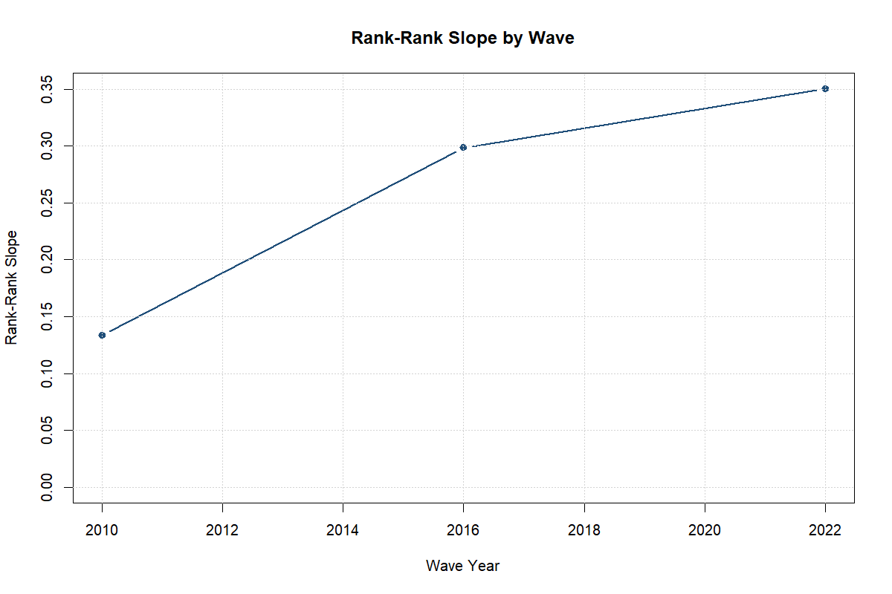
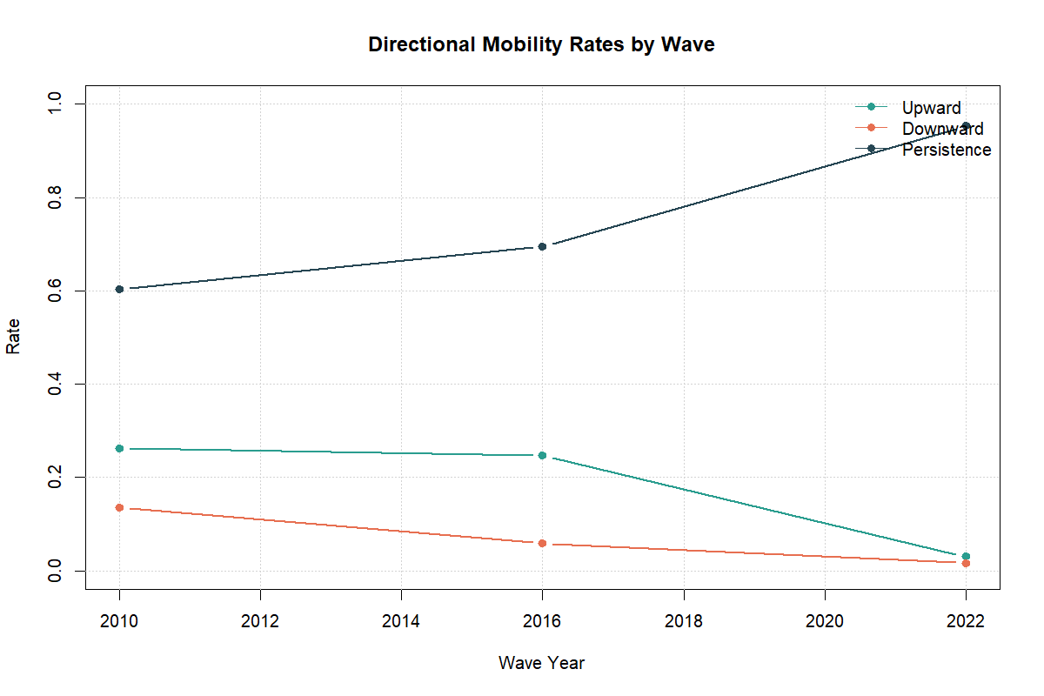

6. Correlates of Educational Mobility

6.1 Pooled persistence-trend model
The pooled rank-based persistence model does not provide statistically precise evidence that persistence changed relative to 2010 once the controls and fixed effects are added. The coefficient on parental rank is positive at 0.080, but the interaction terms for 2016 and 2022 relative to 2010 are not statistically distinguishable from zero in this specification (p = 0.670 and p = 0.680, respectively).
This result matters for interpretation. The descriptive by-wave rank-rank slopes clearly rise across the three surveys, but once the model adds region, cohort, wave fixed effects, and the selected covariates, the change in persistence over time is estimated less precisely. That suggests that part of the raw trend may reflect shifts in composition or limited power rather than a simple structural break.

6.2 Attainment-score model
The attainment-score regression shows a robust positive association between parental education and own educational attainment. The coefficient on parental education score is 0.082 and statistically significant (p = 0.002). This is the clearest correlates result in the paper: better-educated parents are associated with higher educational attainment among adult children even after adding fixed effects and the active covariates.
Among the covariates, the female coefficient is negative and statistically significant at -0.045, while the urban coefficient is positive but not statistically precise. Migration exposure and multigenerational household structure are not estimated precisely in this specification.
The main takeaway is that parental educational background remains the strongest predictor in the model. Household structure and migration may still matter, but the current data do not deliver equally strong statistical evidence for those channels in the core pooled attainment specification.

6.3 Upward mobility models
The upward-mobility linear probability models are useful mainly for showing where upward transitions are mechanically more likely. Relative to the upper-secondary reference group, respondents from primary-educated households and lower-secondary households have much higher estimated probabilities of upward mobility, with coefficients of 0.974 and 0.736, respectively.
The non-parental covariates in the upward-mobility models are weaker. Urban residence is close to zero, the female coefficient is negative but only marginally significant, migration exposure is not precise, and multigenerational household structure is positive but not strongly estimated.
These results suggest that most of the upward-mobility variation in the pooled model is driven by where the household starts in the parental education distribution rather than by the additional correlates included here.

6.4 Heterogeneity in persistence
The persistence heterogeneity model shows a strong positive association between parental education score and the probability of remaining in the same education category as one’s parents. The coefficient on parental education score is 0.512 and is precisely estimated.
There is some suggestive evidence that persistence is stronger in urban settings and weaker for women. The interaction between parent education and urban residence is positive at 0.076 and statistically significant (p = 0.052), while the interaction between parent education and female is negative at -0.081 and statistically significant (p = 0.029). By contrast, the interaction between parent education and the 2022 wave is not statistically precise.
A cautious reading is that parental education translates into same-category persistence across the entire sample, but the strength of that translation may vary by subgroup. In this dataset, the strongest subgroup evidence points to weaker persistence among women and somewhat stronger persistence in urban settings.
Selected pooled correlates estimates.
 | Model | Term | Estimate | Std. Error | P-value
1 | Persistence trend | Parent rank | 0.080 | 0.058 | 0.179
2 | Persistence trend | Parent rank x 2016 | 0.057 | 0.132 | 0.670
3 | Persistence trend | Parent rank x 2022-23 | -0.028 | 0.067 | 0.680
8 | Attainment score | Parent education score | 0.082 | 0.024 | 0.002
10 | Attainment score | Female | -0.045 | 0.020 | 0.034
13 | Upward mobility | Parent education: primary | 0.974 | 0.010 | <0.001
14 | Upward mobility | Parent education: lower secondary | 0.736 | 0.039 | <0.001
25 | Persistence heterogeneity | Parent education score | 0.512 | 0.035 | <0.001
30 | Persistence heterogeneity | Parent education score x urban | 0.076 | 0.037 | 0.052
31 | Persistence heterogeneity | Parent education score x female | -0.081 | 0.035 | 0.029

7. Pandemic-Era Mechanism Evidence from LiTS IV

7.1 Sample and descriptive patterns
The mechanism module should be read as a compact descriptive extension rather than a second paper. It is based on 183 respondents with a child enrolled before COVID and non-missing parental schooling.
Within this sample, disruption was widespread. About 93.0 percent report switching to online learning, 83.3 percent report switching to hybrid learning, 85.2 percent report school closure without online learning, and 78.3 percent report that the child stopped education during COVID. Roughly 75.8 percent report at least one remote-learning challenge.
Constraints were also common. Around 72.6 percent report internet challenges, 66.3 percent report cost-related challenges, 63.5 percent report device challenges, and 60.5 percent report shared-device use. These figures point to a demanding home-learning environment rather than to a smooth digital transition.
Learning support was overwhelmingly household-based. Mothers were reported as the support channel in 87.0 percent of cases, fathers in only 3.7 percent, and grandparents or relatives in 6.6 percent. The child module therefore suggests that schooling shocks were mediated above all by household support capacity, especially maternal support.
LiTS IV child-module sample construction for Uzbekistan.
Step | N
Uzbekistan LiTS IV respondents | 1006
Respondents with child module eligibility info (q713 non-missing) | 650
Respondents with child enrolled pre-COVID (q713 = yes) | 186
Mechanism sample with non-missing parental schooling | 183
Parental schooling median threshold (years) | 12
Baseline low-parent-education group size | 99
Baseline higher-parent-education group size | 87

7.2 Differences by parental education
The descriptive split by parental education does not suggest a single story for every outcome, but it does show meaningful differences. Children from lower-parent-education households are more likely to report that education stopped during COVID (81.5 percent versus 74.5 percent), more likely to rely on shared devices (63.5 percent versus 57.3 percent), and less likely to report switching to online learning (90.2 percent versus 96.3 percent) than children from higher-parent-education households.
By contrast, internet challenges are high in both groups, and maternal support is dominant in both. This reinforces the idea that the pandemic mechanism section is about bottlenecks inside the household rather than about a single sharp divide between high- and low-parent-education households.
Selected descriptive mechanism outcomes by parental education.
 | Outcome | Group | Estimate | Valid N
29 | Stopped education due to COVID | At or below median parent education | 81.5 percent | 99
28 | Stopped education due to COVID | Above median parent education | 74.5 percent | 87
35 | Child used shared device | At or below median parent education | 63.5 percent | 92
34 | Child used shared device | Above median parent education | 57.3 percent | 84
45 | Switched to online learning | At or below median parent education | 90.2 percent | 99
44 | Switched to online learning | Above median parent education | 96.3 percent | 87
25 | Internet challenge | At or below median parent education | 74.3 percent | 92
24 | Internet challenge | Above median parent education | 70.7 percent | 84
41 | Learning support from mother | At or below median parent education | 87.1 percent | 92
40 | Learning support from mother | Above median parent education | 86.9 percent | 84

7.3 Mechanism regressions
The regression-based mechanism results should be interpreted carefully, but a few patterns stand out.
First, low parental education is positively and significantly associated with the probability that a child’s education stopped during COVID. The corresponding coefficient is 1.040 with p = 0.003. This is the strongest and most interpretable mechanism result in the extension.
Second, the interaction between low parental education and urban residence is negative in the stoppage model at -0.962 and only marginally precise (p = 0.064), suggesting that some of the disadvantage associated with low parental education may be weaker in urban areas. This pattern is still too tentative for a strong substantive claim.
Third, for the broad remote-learning challenge indicator, the interaction between low parental education and urban residence is negative and statistically significant at -1.790 (p = 0.040), while the main effect of low parental education is not statistically precise. This again suggests that heterogeneity may matter more than simple average differences, but the small sample means the result should remain suggestive.
Overall, the mechanism extension supports a narrow conclusion: pandemic-era learning disruption was widespread, and households with lower parental education may have been more vulnerable on some key margins, especially education stoppage. But the evidence is too limited to support a larger causal interpretation.
Mechanism regression estimates from the LiTS IV child module.
Model | Term | Estimate | Std. Error | P-value
Switched to online learning | Low parent education | -2.143 | 1.499 | 0.153
Switched to online learning | Urban | -1.515 | 0.590 | 0.010
Switched to online learning | Male child | -2.339 | 1.841 | 0.204
Switched to online learning | Low parent education x urban | -1.313 | 1.250 | 0.293
School closed without online learning | Low parent education | 0.058 | 1.369 | 0.966
School closed without online learning | Urban | -0.994 | 0.958 | 0.300
School closed without online learning | Male child | -1.121 | 1.327 | 0.398
School closed without online learning | Low parent education x urban | 0.494 | 1.611 | 0.759
Stopped education due to COVID | Low parent education | 1.040 | 0.347 | 0.003
Stopped education due to COVID | Urban | -0.854 | 1.439 | 0.553
Stopped education due to COVID | Male child | -2.628 | 1.785 | 0.141
Stopped education due to COVID | Low parent education x urban | -0.962 | 0.519 | 0.064
Any remote-learning challenge | Low parent education | 0.648 | 0.739 | 0.381
Any remote-learning challenge | Urban | -0.294 | 0.323 | 0.363
Any remote-learning challenge | Male child | -2.402 | 1.160 | 0.038
Any remote-learning challenge | Low parent education x urban | -1.790 | 0.873 | 0.040

8. Discussion and Policy Implications
Three broad conclusions emerge from the analysis.
First, Uzbekistan exhibits substantial intergenerational educational persistence. The by-wave rank-rank slopes indicate that parental background remains an important determinant of educational position and may have become more strongly linked to children’s educational outcomes over time.
Second, parental education is the most consistent predictor in the pooled correlates models. The data provide less clear evidence that migration exposure or multigenerational household structure independently explain mobility once the core controls and fixed effects are added, although these factors may still matter through channels the present specifications do not capture well.
Third, the pandemic mechanism evidence underscores the practical importance of household learning conditions. Device sharing, internet quality, and time- or cost-related constraints were common, and support was overwhelmingly provided by mothers. This suggests that inequality in education is shaped not only by formal access to schools but also by what households can do when schools are disrupted or when learning increasingly depends on home resources.
These findings imply several policy priorities.
- Reduce the dependence of educational attainment on parental background. This requires support mechanisms that reach children before inequalities become locked in, including targeted remedial support, better transitions across schooling stages, and greater access to quality secondary and post-secondary pathways.
- Address spatial and household bottlenecks. Even when the pooled urban coefficient is imprecise, the broader evidence suggests that regional and household conditions matter. Policies should therefore focus on infrastructure, support services, and local inequalities rather than only on average national provision.
- Strengthen household support capacity in periods of disruption. The child module highlights that digital access is not only about whether a household has internet, but about quality, device availability, and the ability of adults to help children learn. Policies that support digital inclusion, device access, and flexible learning support can reduce the educational cost of future shocks.
- Treat mothers’ support burden as a real education policy issue. The mechanism evidence suggests that mothers carried most of the home-learning burden during the pandemic. Education policy and social policy should recognize this support role rather than assume that learning continuity is costless inside the household.

9. Limitations
This paper has four main limitations.
First, the three LiTS waves are repeated cross-sections rather than a panel, so changes over time should be interpreted as changes in population-level patterns rather than changes within fixed families.
Second, the comparability of some parental education information across waves is imperfect, which is why the rank-based measures are more reliable than some category-based comparisons.
Third, the 2022-23 category-based mobility estimates rely on a much smaller valid denominator than the 2022 rank-based measure. This means the apparent spike in persistence in 2022-23 should be interpreted as suggestive rather than definitive.
Fourth, the pandemic mechanism module is based on a limited child subsample and is not a causal design. It is useful for describing disruption and support patterns, but it should not be treated as evidence of the causal effect of parental education.
These limitations do not undermine the central contribution of the paper, but they do shape the appropriate scope of the conclusions.

10. Conclusion
This paper provides structured multi-wave evidence on intergenerational educational mobility in Uzbekistan using LiTS 2010, 2016, and 2022-23. The results indicate substantial educational persistence across generations and suggest that persistence remained high, and possibly increased, over the period studied. Parental education remains the clearest predictor of children’s educational attainment in the pooled correlates models.
The extension based on the LiTS IV child module shows that pandemic-era learning disruption was widespread and that household support, especially maternal support, was central to learning continuity. Lower parental education appears to be associated with a higher risk that education stopped during COVID, but these patterns should be treated as suggestive due to sample limits.
The broader message is that improving educational mobility in Uzbekistan will require more than expanding formal access. It will require reducing the degree to which family background governs educational trajectories, especially through the unequal household conditions under which children study, recover from shocks, and convert schooling opportunities into completed attainment.

