Assignment 4
Setup Bootstrap, xUnit, ILogger and Publish local server Screenshots

- Project Overview

This document describes the final enhancements implemented in the MovieCatalog web application as part of the final assignment.

Features
- Improved frontend styling using Bootstrap
- xUnit unit tests for services
- Application logging using ILogger
- Local deployment simulation using dotnet publish

- Frontend Styling Using Bootstrap
Bootstrap was integrated to modernize the UI and give the application a consistent, clean look across all pages.
The styling updates were applied directly in the views to improve usability and visual structure.
Key Improvements
- Bootstrap 5 CDN included in _Layout.cshtml to enable global styling.
- Navigation bar redesigned with Bootstrap classes for a cleaner header and responsive layout.
- Movie list tables updated using:
  - table, table-striped, table-hover,
which improve readability and highlight active rows.
- Buttons standardized so all actions (Create, Edit, Delete, Logout) follow consistent Bootstrap styles:
  - btn-primary, btn-secondary, btn-danger, btn-success

- Forms were fully refactored to use:
  - form-group for spacing and organization
  - form-control for input fields
  - Bootstrap’s validation indicators for user feedback
- Responsive layout adjustments, including spacing, margins, and container alignment to improve usability on different screen sizes.

- xUnit Tests
The tests are located in: MovieCatalog.Tests/
Tested Components
MovieService Tests
- CreateMovie_ShouldAddMovie
- GetMovieById_ShouldReturnCorrectMovie
- GetByUser_ShouldReturnOnlyUserMovies
- UpdateMovie_ShouldModifyMovie
- RemoveMovie_ShouldDeleteMovie
- GetAllMovies_ShouldReturnAllMovies
- UpdateNonExistingMovie_ShouldNotThrow
UserService Tests
- GetAll_ReturnsAllUsers
- Register_NewUser_ReturnsTrue
- Register_ExistingUser_ReturnsFalse
- Authenticate_ValidUser_ReturnsUser
- Authenticate_InvalidPassword_ReturnsNull
- Authenticate_NonExistentUser_ReturnsNull
- Register_PasswordIsHashed

JwtService Tests
- GenerateToken_ReturnsTokenWithUsernameClaim

How Tests Were Run
Using command:
dotnet test
All tests pass successfully.
Note : One default xUnit template test (UnitTest1.cs) is included automatically in the project. This explains why the test explorer shows one additional test beyond the 15 implemented tests.
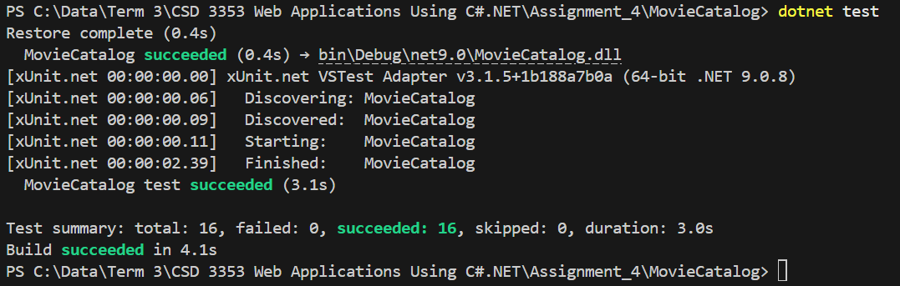

- Loggin with ILogger
Logging was added across controllers to track:
- Authentication attempts
- User actions (Create/Edit/Delete movies)
- Unauthorized access attempts
- Token validation errors
Controllers with logging:
- HomeController
- LoginController
- MoviesApiController
- MoviesController
- RegisterController

Examples of Log Messages
User accesses Movies Index:
info: MoviesController
User JOHN accessed Movies index.
Movie Creation:
info: MoviesController
User JOHN created movie: INCEPTION.
Unauthorized attempt:
warn: MoviesController
Unauthorized attempt to access Create Movie page.

Log Messages
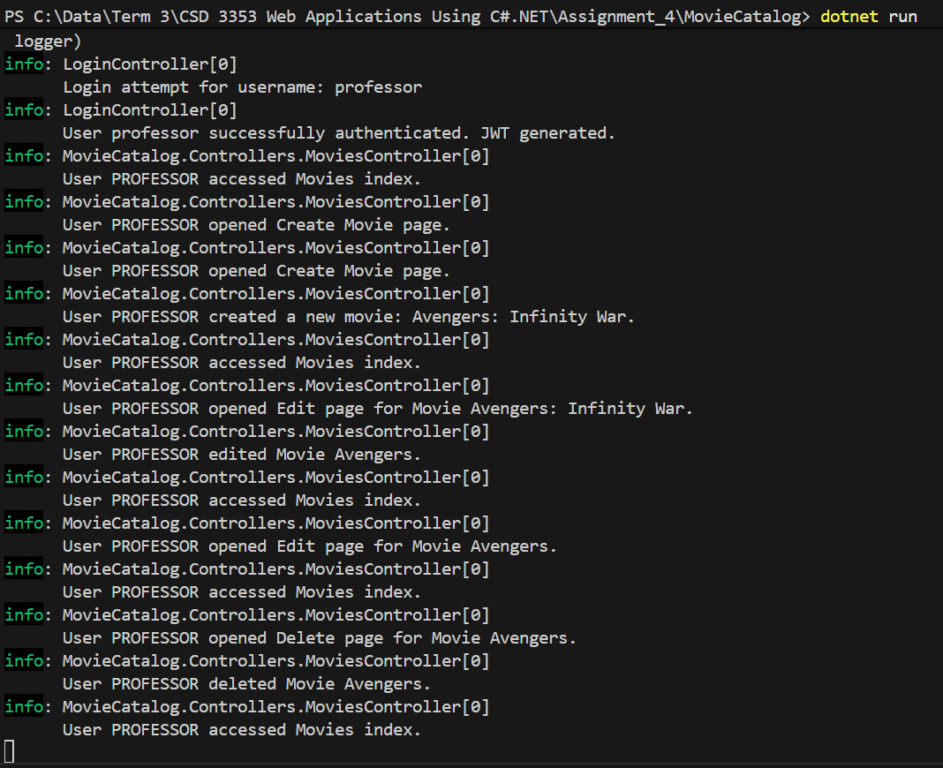

- Deployment Using dotnet publish
To simulate local deployment, the project was published using:
dotnet publish -c Release
This generated a production-ready version of the application located in:
bin/Release/net9.0/publish/

Local Execution
Inside the publish folder:
dotnet MovieCatalog.dll
The app starts on a Kestrel server:
Now listening on: http://localhost:5000

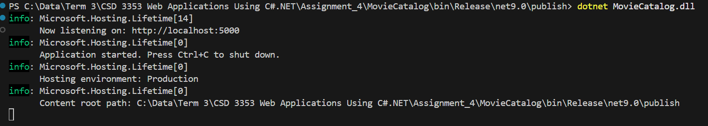

- Screenshots of Functionality

  - Executing dotnet run command
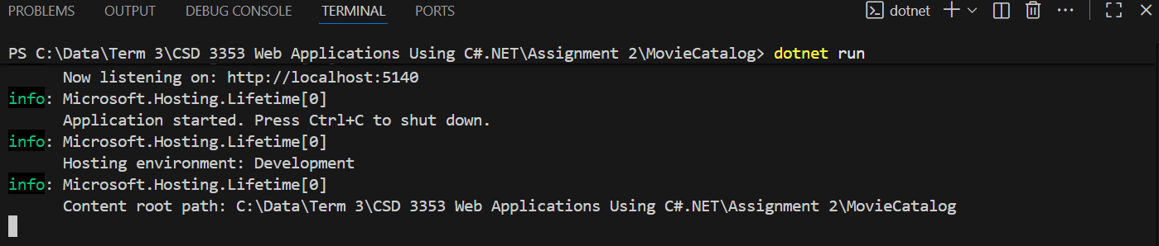

  - Entering the website http://localhost:5140/. Showing Login page.
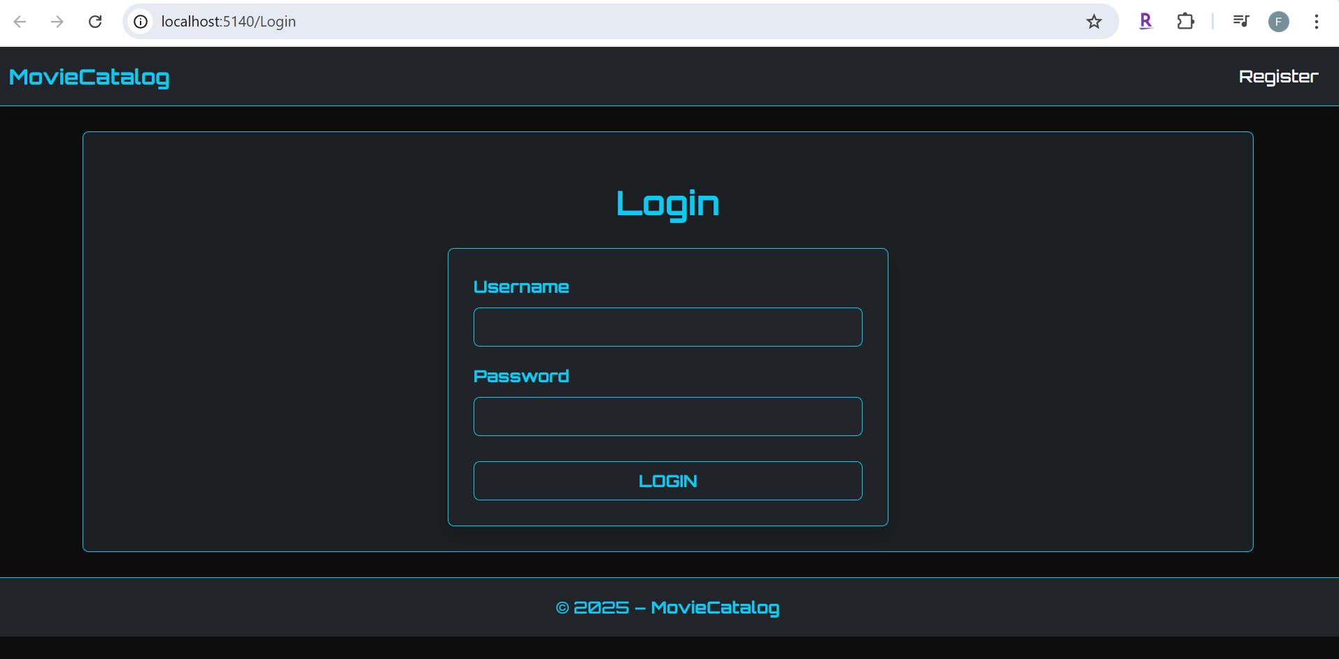

  - Showing Register page.
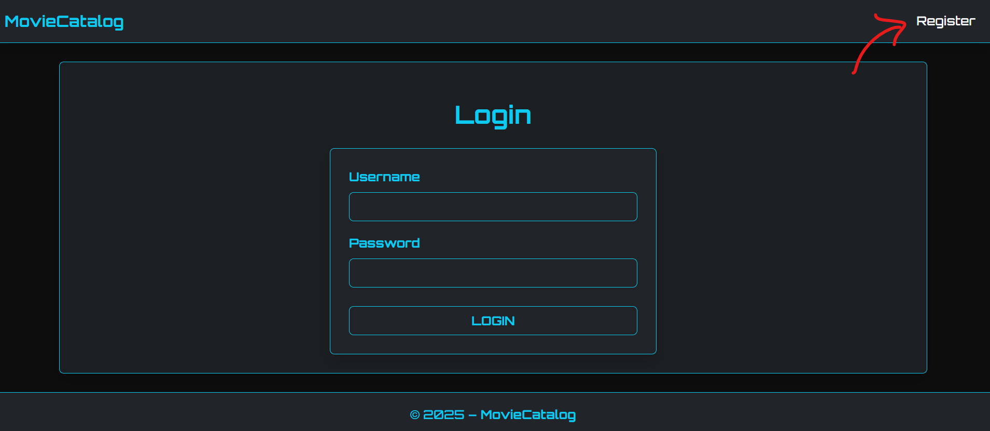
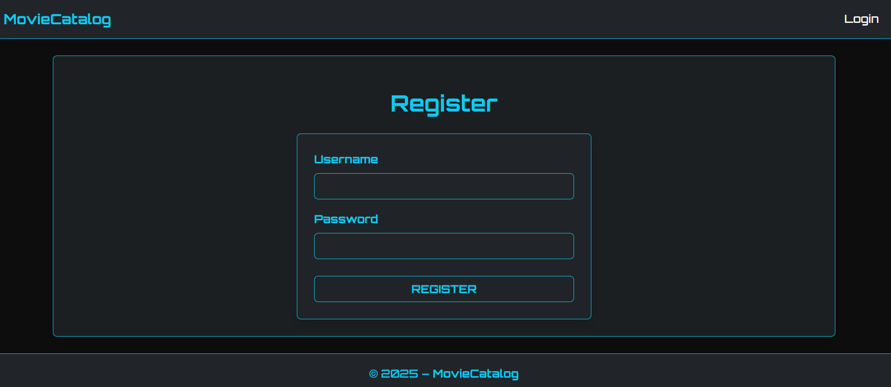

  - Registering new user “professor”, pass: 123456
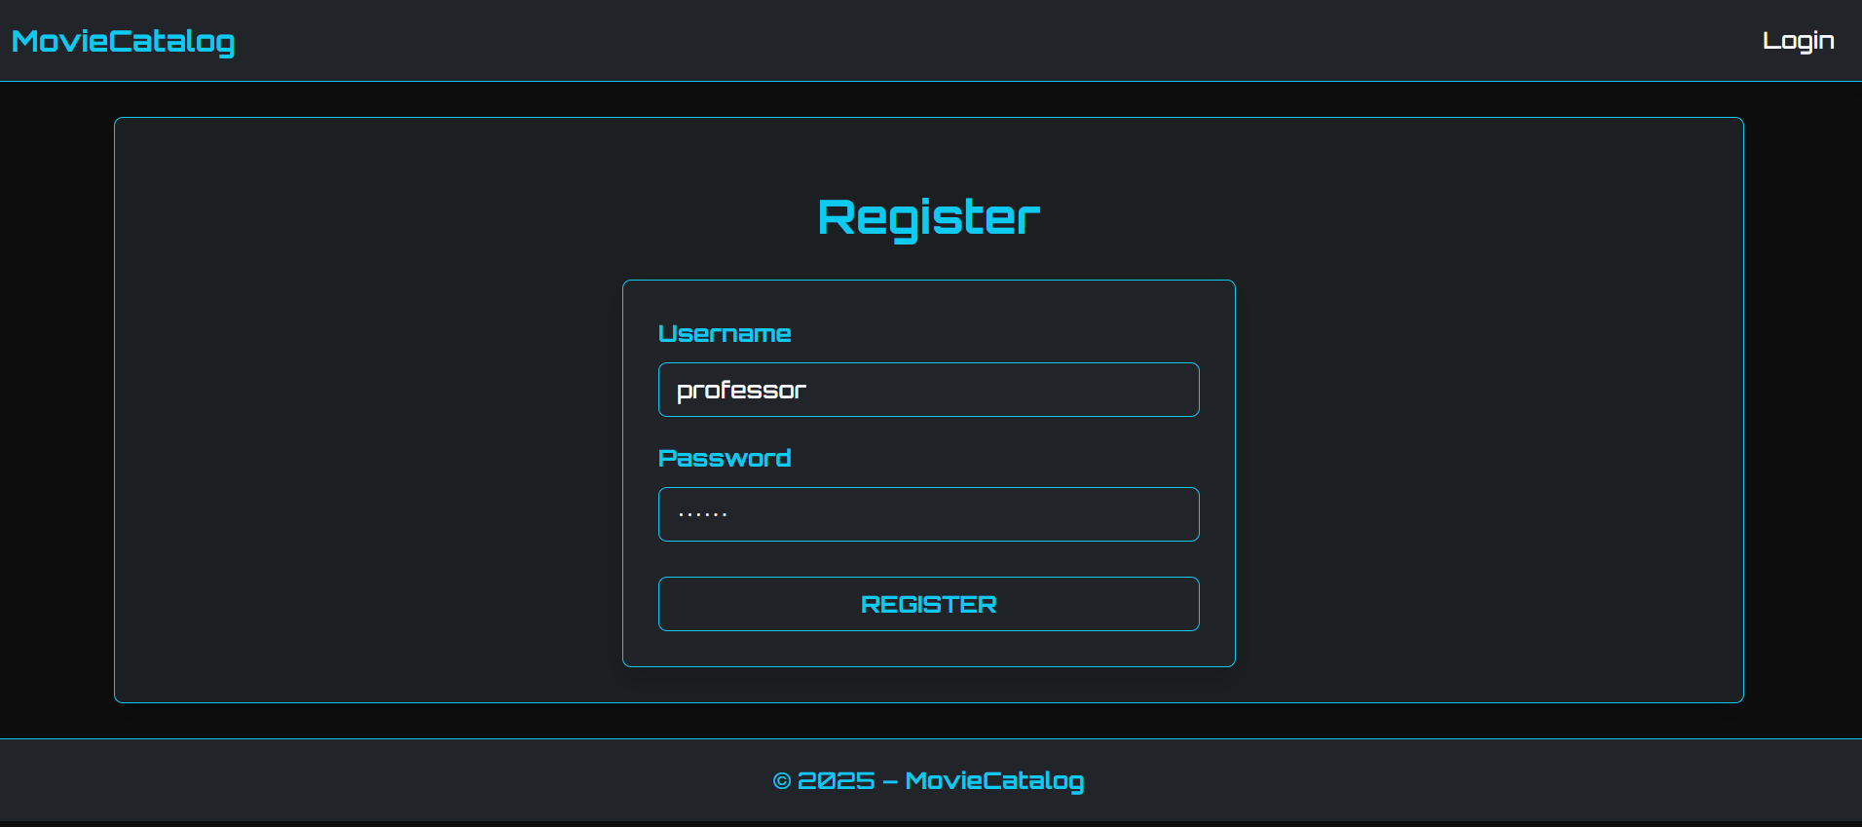

  - Login new user “professor”, pass: 123456
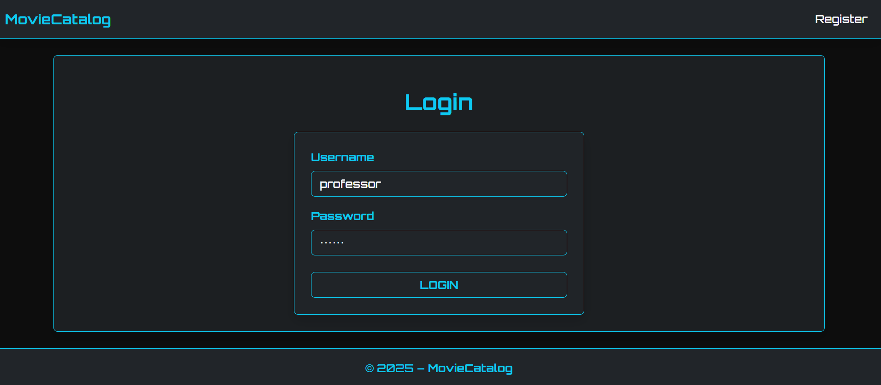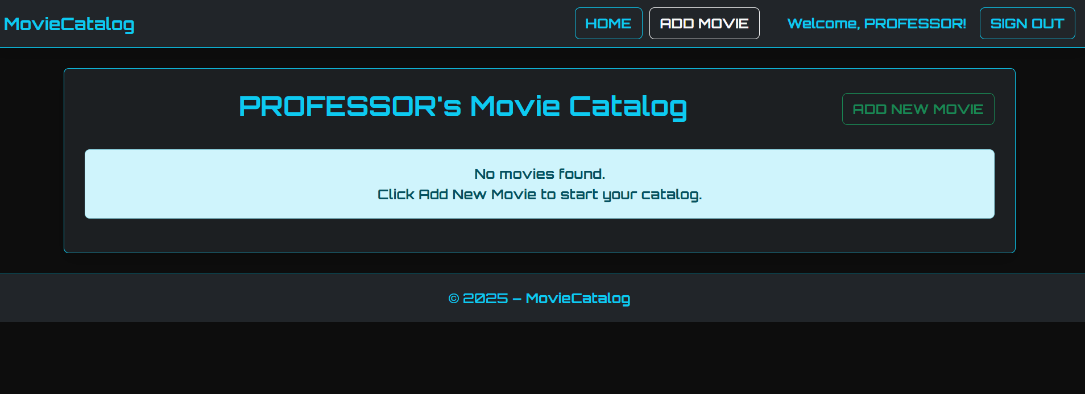
  - Adding a Movie
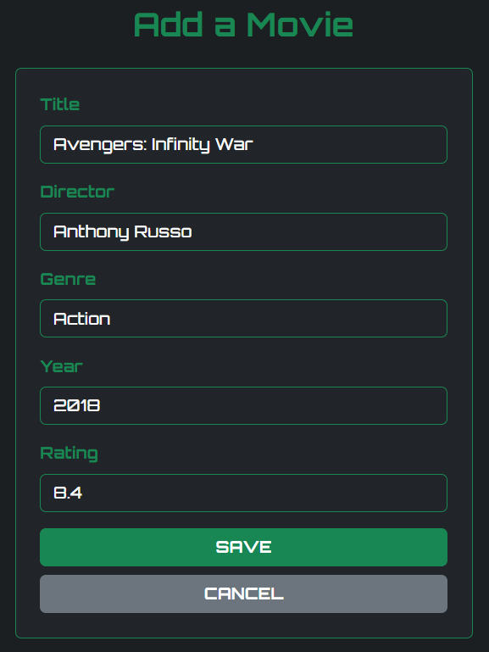

  - Displaying and testing the validation functionality. The Year and Rating fields are optional.

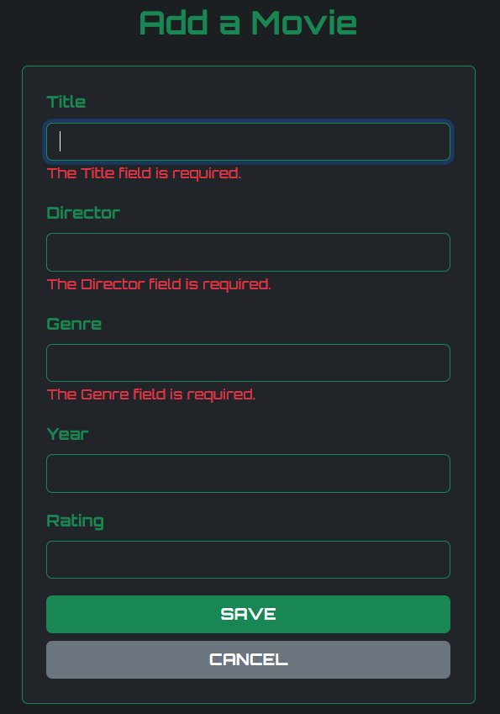

  - Displaying the movie “Avengers: Infinity War” added to the Movie catalog
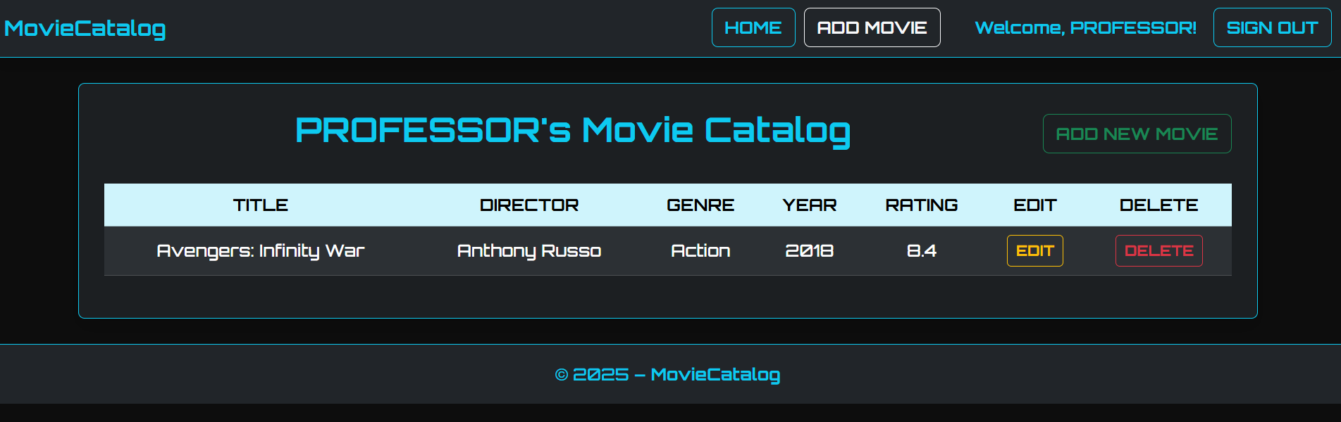

  - Editing the movie “Avengers: Infinity War”

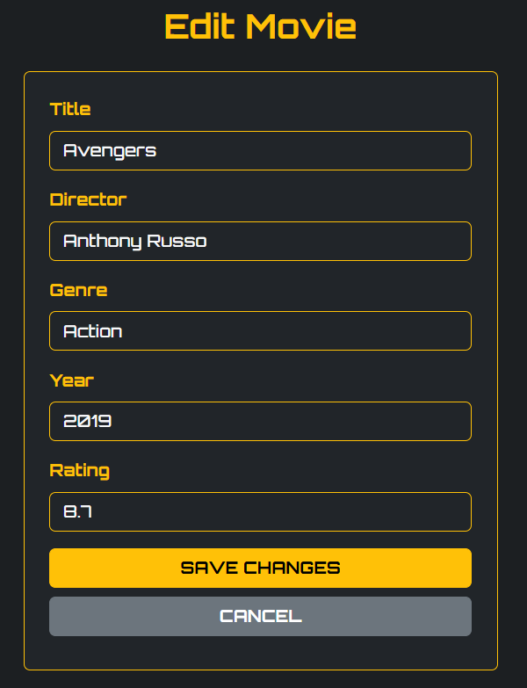

  - Displaying Movie List after editing the movie “Avengers” in the Movie catalog

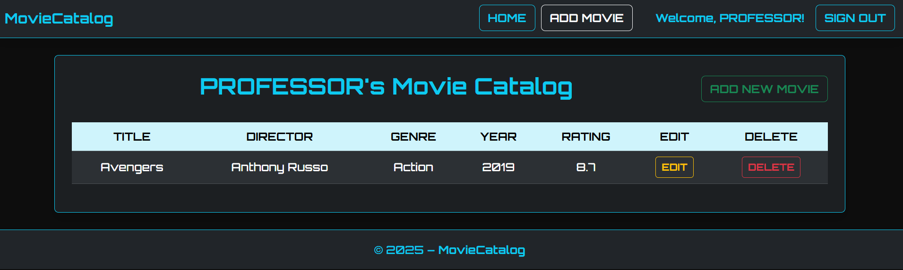

  - Deleting the movie “Avengers”

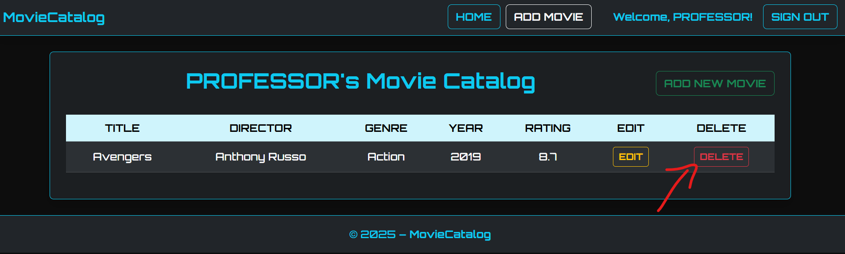

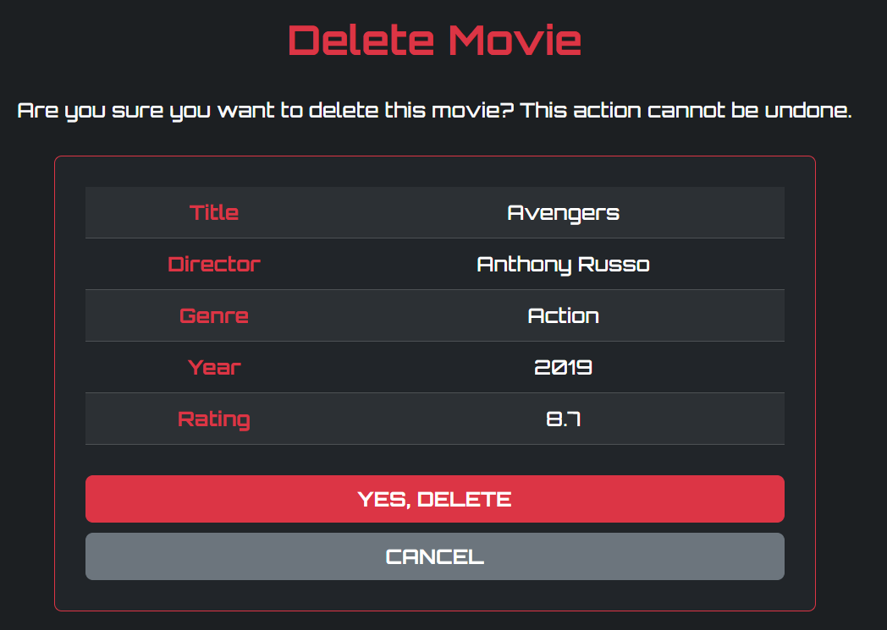

  - Displaying Movie catalog after deleting the movie “Avengers”

