Assignment 2
Setup Database, API Instructions and Screenshots

- Database Setup (Entity Framework Core with SQLite)
Steps followed to set up the database:
1. In Program.cs, the database context was configured:
builder.Services.AddDbContext<MovieCatalogContext>(options => options.UseSqlite(builder.Configuration.GetConnectionString("DefaultConnection")));
2. The EF Core context class 'MovieCatalogContext' was created with a DbSet<Movie> property.
3. In the Package Manager Console, the following commands were executed:
Add-Migration InitialCreateNew
Update-Database
4. This generated the SQLite database file MovieCatalog.db in the project directory.
5. The Movies table includes the following fields: Id, Title, Director, Genre, Year, and Rating.

- API Instructions

The project includes a RESTful Web API implemented in ASP.NET Core MVC to manage movie data. It supports CRUD operations (GET, POST, PUT, DELETE), allowing external applications to interact with the database.
Controller: MoviesApiController
Attributes: [ApiController], [Route("api/[controller]")]
Available Endpoints:
GET /api/MoviesApi - Retrieves all movies
GET /api/MoviesApi/{id} - Retrieves a movie by ID
POST /api/MoviesApi - Adds a new movie
PUT /api/MoviesApi/{id} - Updates an existing movie
DELETE /api/MoviesApi/{id} - Deletes a movie

Example JSON body for POST/PUT requests:
{
"title": "Inception",
"director": "Christopher Nolan",
"genre": "Sci-Fi",
"year": 2010,
"rating": 9.0
}
Swagger Integration:
Swagger provides a built-in UI for testing the API at /swagger.
Link: http://localhost:5140/swagger
Configuration in Program.cs includes:
builder.Services.AddEndpointsApiExplorer();
builder.Services.AddSwaggerGen();
app.UseSwagger();
app.UseSwaggerUI();

- Screenshots of Functionality

  - Executing dotnet run command

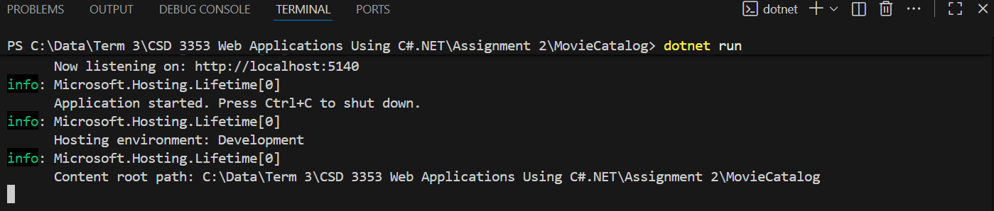

  - Entering the website http://localhost:5140/ or http://localhost:5140/Movies. Click the Add New Movie button.

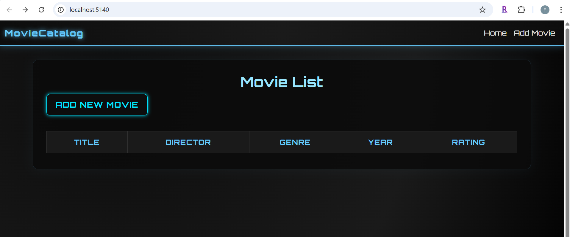

  - Adding a Movie

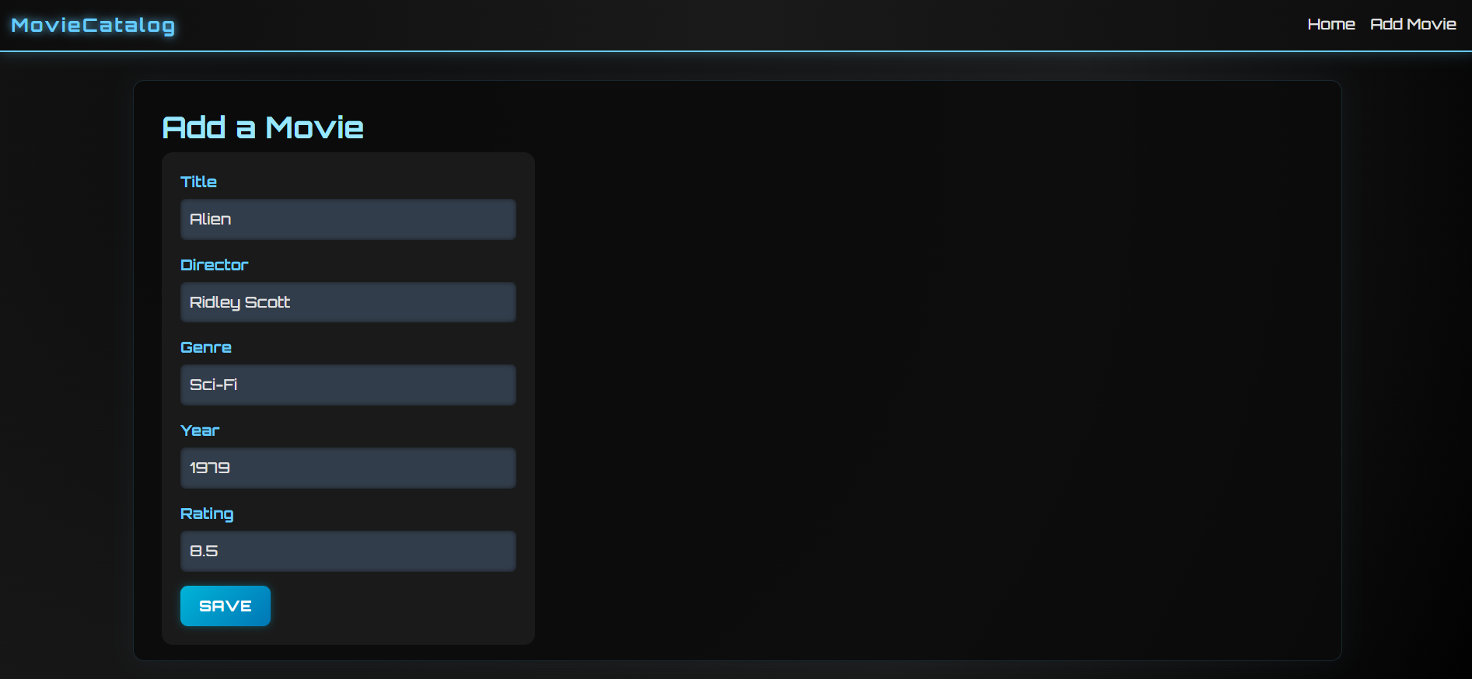

  - Displaying and testing the validation functionality. The Year and Rating fields are optional.

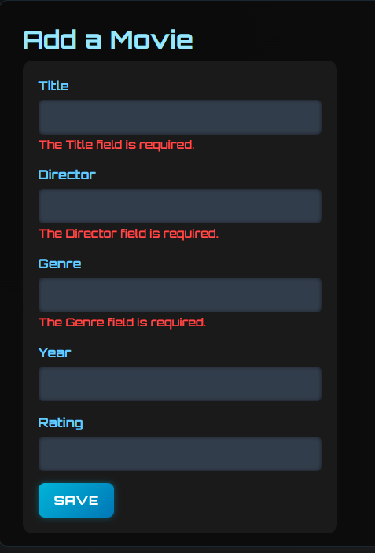

  - Displaying the movie “Alien” added to the Movie catalog

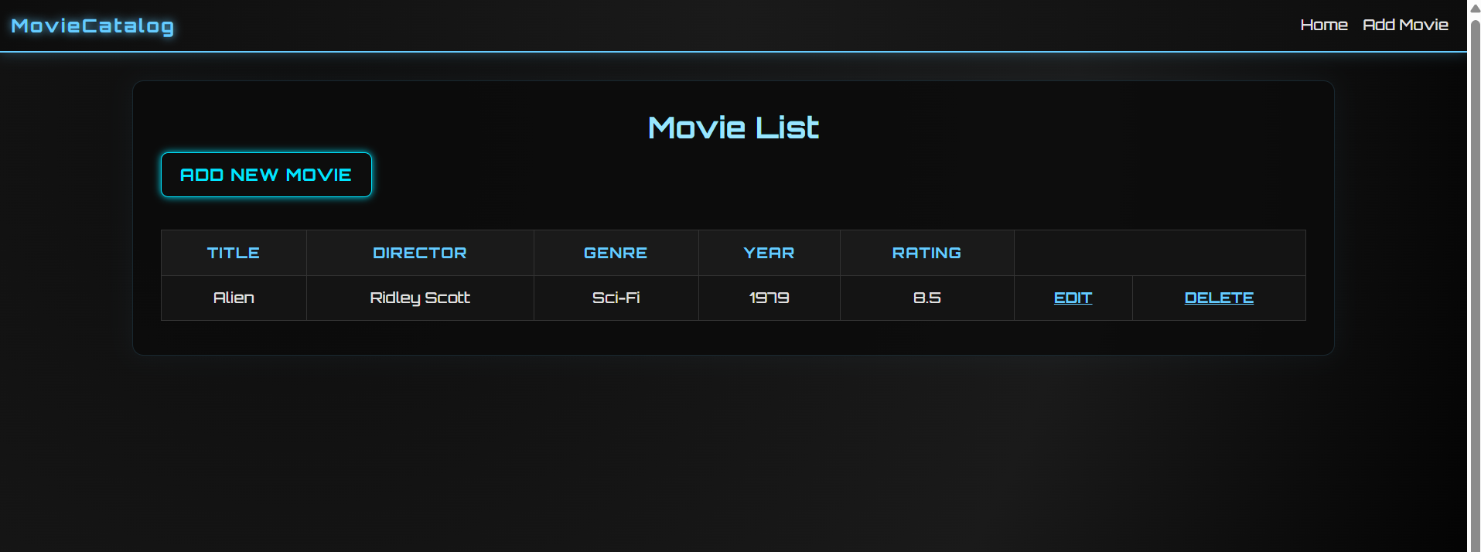

  - Editing the movie “Alien”

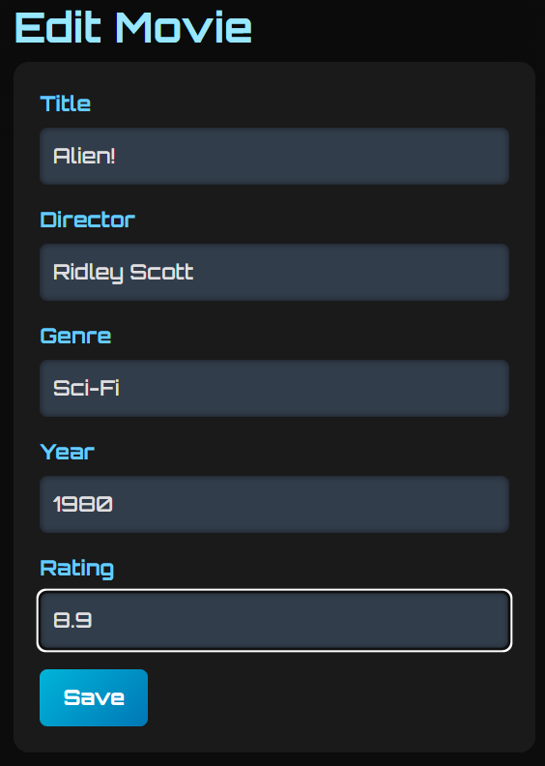

  - Displaying Movie List after editing the movie “Alien” in the Movie catalog

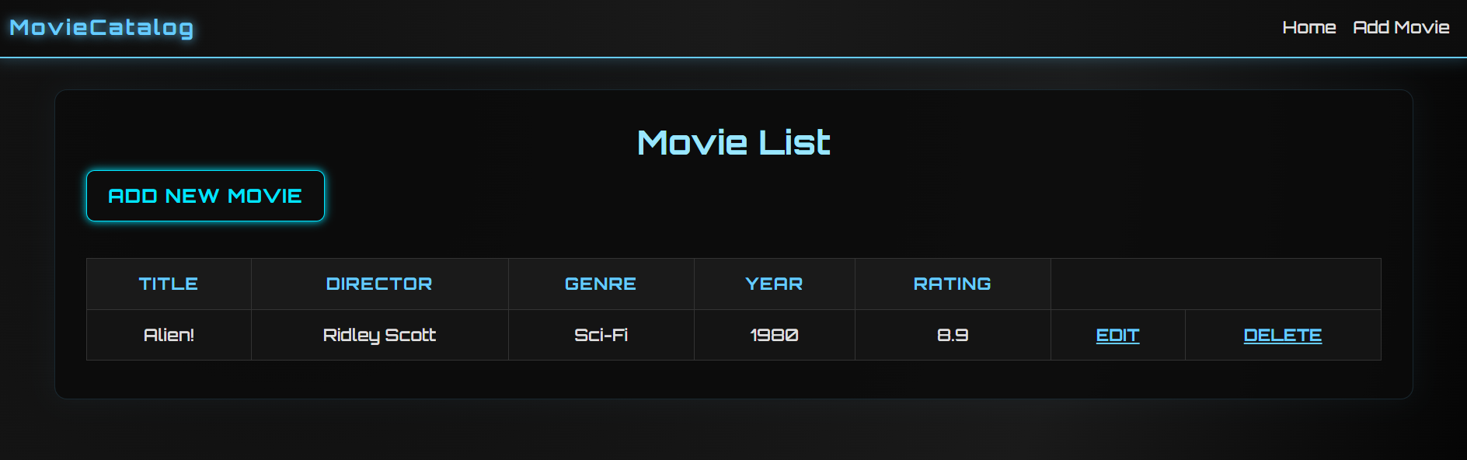

  - Deleting the movie “Alien”

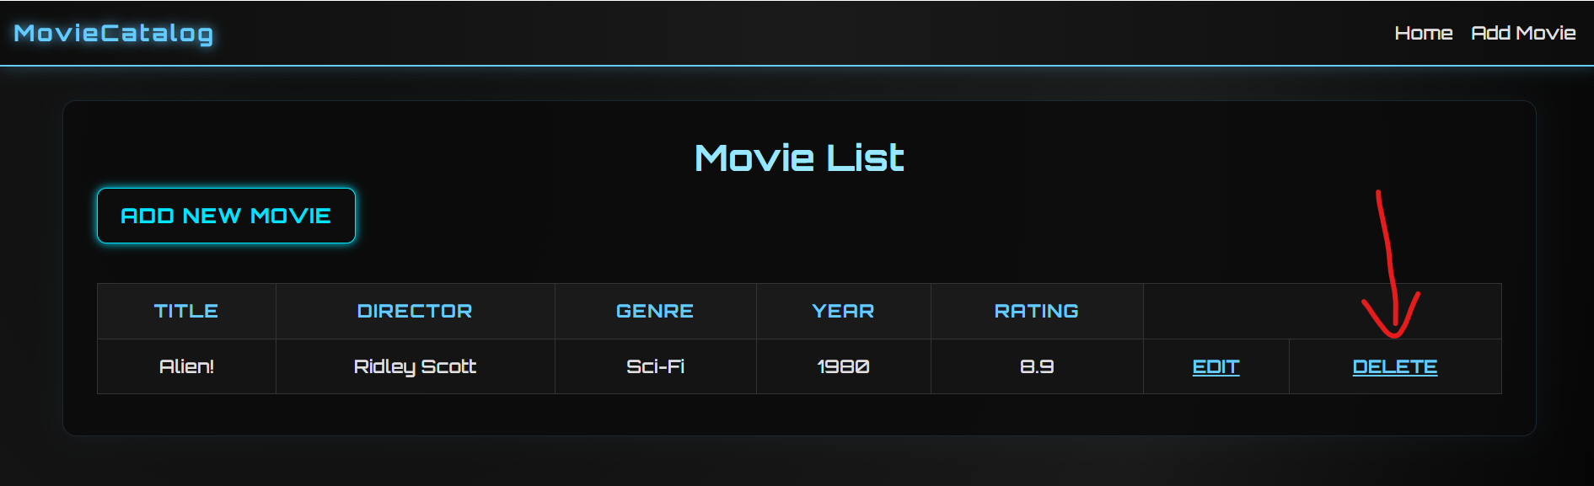

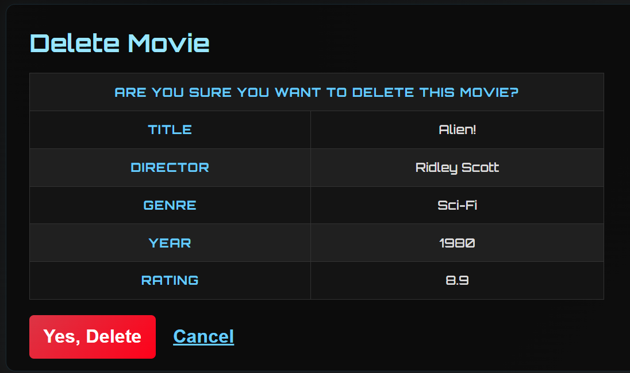

  - Displaying Movie catalog after deleting the movie “Alien”

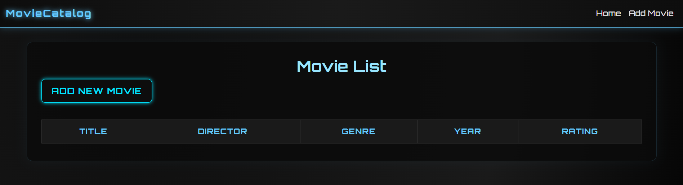

- API Test Screenshots

  - Swagger UI showing available endpoints

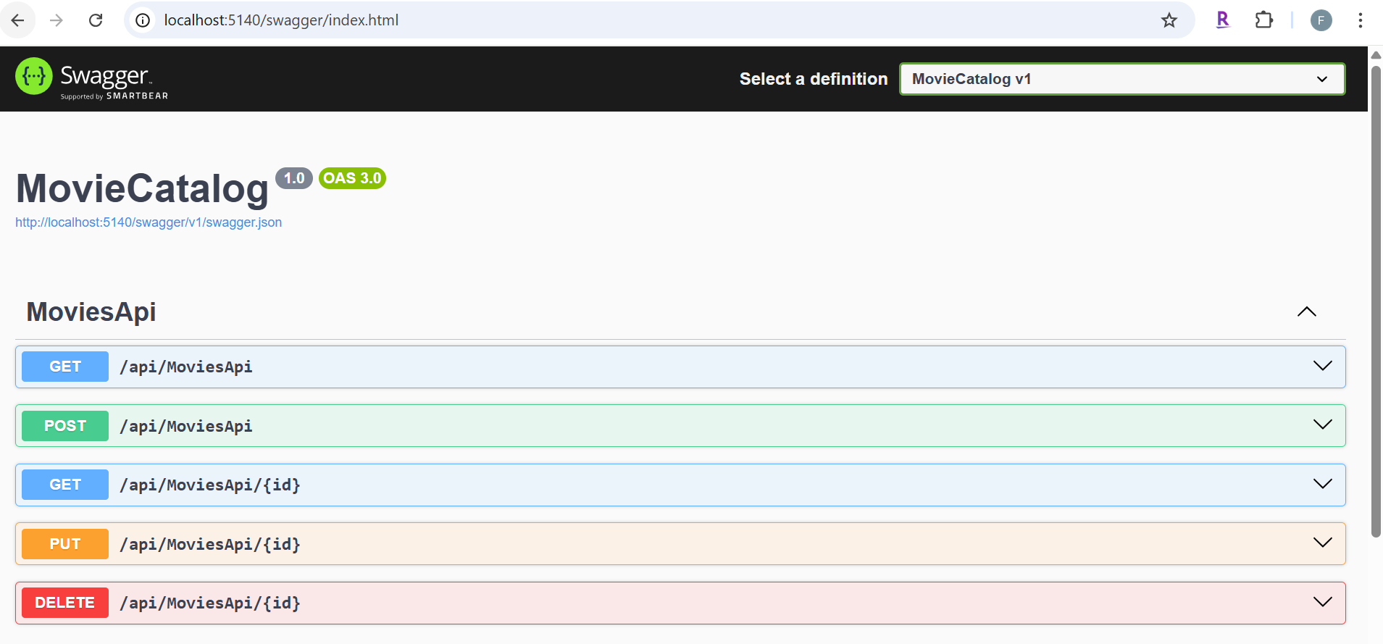

  - Example API Requests: Demonstrated CRUD operations using GET (retrieve movies), POST (add new movie), PUT (update existing movie), and DELETE (remove movie).

